Supporting Information:
An Efficient and Scalable Approach for the Synthesis of Piperazine based Glitazone and its Derivatives
Vijay Kumar Sharma ^{a,b}, Anup Barde ^{b, *}, Sunita Rattan ^{a, *}
ªAmity Institute of Applied Sciences, Amity University Uttar Pradesh, Sector-125, Noida, India
^{b} Integral Bio Sciences Pvt. Ltd. C-64, Hosiery Complex, Phase-II, Noida Uttar Pradesh, India

*Corresponding author: e-mail: srattan@amity.edu; anup.barde@ibs.net.in
Contents
- General information.………………………………………………………………..2
- Experimental Procedures and Compound Characterization…………………..2-12
- Analytical data ……………………………………………………………………19-32

General information:
¹H and ¹³C NMR spectra were recorded at 400 and 101 MHz instruments, respectively and spectral data were reported in ppm relative to tetramethylsilane (TMS) as the internal standard. LCMS’ were recorded with Single quadruple mass spectrometer using electrospray ionization (ESI). Melting point was determined on a Mettler Toledo Melting Point System.
General procedure for synthesis:
Step-1 Synthesis of tert-butyl 4-(6-chloropyrimidin-4-yl)piperazine-1-carboxylate (3):
To a solution of tert-butyl piperazine-1-carboxylate (1) (10 g, 0.05 mol, 1eq.) in 2-propanol (100 mL ) at 0 °C diisopropyl ethyl amine (30 g, 0.16 mol, 3 eq.) was added drop wise and allowed to stirred for 10 minute at same temperature. 2, 4-dichloropyrimidine (2) (8.8 g, 0.06 mol, 1.1 eq.) was added and reaction mixture was stirred at same temperature for 1h to form a suspension. TLC (40% ethyl acetate: hexane) showed that starting material was consumed. After completion, white solid was filtered, washed twice with 2-propanol (50 mL) and dried at 55 °C under vacuum for 3h to afford 10.9 g of 3 which was used for the next step. Yield-68%; Off white solid; Melting range: 115.7-117.2 °C; LC−MS (ESI) m/z calculated for C₁₃H₁₉ClN₄O₂ (M+H)⁺ :299.1; found: 299.0; ¹H NMR (400 MHz, DMSO-d₆): δ 8.35 (s, 1H), 6.96 (s, 1H), 3.61 - 3.65 (m, 4H), 3.41 - 3.45 (m, 4H), 1.42 (s, 9H); ¹³C NMR (101 MHz, DMSO-d₆): δ162.1, 159.1, 157.9, 153.8, 101.8, 79.2, 43.3, 43.3, 42.0, 42.0, 28.0, 28.0, 28.0.
Step-2 Synthesis of tert-butyl4-(6-((2-hydroxyethyl)n(methyl)amino)pyrimidin-4-yl)piperazine-1-carboxylate (5):
To a solution of 2-(methylamino)ethan-1-ol (4) (5g, 0.06 mol, 2 eq.) in DMF (50 mL) was added potassium fluoride (8.3 g, 0.1 mol, 3 eq.) and suspension was stirred at ambient temperature for five minute. Tert-butyl 4-(6-chloropyrimidin-4-yl)piperazine-1-carboxylate (3) (10 g, 0.03 mol, 1 eq.) was added in to this and reaction mixture was heated to 80 °C and stirred at same temperature for 16h. TLC (40% ethyl acetate: hexane) showed that starting material was consumed. After completion, reaction mixture was allowed to come to room temperature and water (100 mL) was added in to it. Reaction mixture was stirred for 30 minute to form a suspension. Suspension was filtered under vacuum, washed with water (50 mL x 2) and dried at 55 °C under vacuum for 16h to afford 9g of 5 as white solid. Yield-80%; Off white solid; Melting range: 90.7-92.9 °C; LC−MS (ESI) m/z calculated for C₁₆H₂₇N₅O₃ (M+H)⁺ :338.2; found: 338.1; ¹H NMR (400 MHz, CDCl₃-d₁): δ 8.14 (s, 1H), 5.45 (s, 1H), 4.70 (br. s, 1H), 3.80 (m, 2H), 3.70 (m, 2H), 3.62-3.52 (m, 8H), 2.99 (s, 3H), 1.48(s, 9H). ¹³C NMR (101 MHz, DMSO-d₆): δ 162.4, 162.3, 156.7, 153.9, 80.7, 79.0, 58.7, 51.3, 43.2, 43.2, 42.1, 42.1, 36.4, 28.1, 28.1, 28.1

Step-3 Synthesis of tert-butyl 4-(6-((2-(4-formylphenoxy)ethyl)(methyl)amino) pyrimidin-4-yl)piperazine-1-carboxylate (7):
To a solution of tert-butyl 4-(6-((2-hydroxyethyl) (methyl)amino)pyrimidin-4-yl)piperazine-1-carboxylate (5) (7.8 g, 0.02 mol, 1 eq.) in DMF (80 mL) was added crushed KOH ( 3.9 g, 0.07 mol, 1.3 eq.) and suspension was stirred at ambient temperature for 10 minute. 4-fluorobenzaldehyde (6) (3.7 g, 0.03 mol, 1.3 eq.) was added drop wise into it and reaction mixture was stirred at ambient temperature for 16h. TLC (40% ethyl acetate/Hexane) showed that starting material was consumed. After completion, reaction mixture was cooled to 0 °C and water (80 mL) was added drop wise in to it. Reaction mixture was stirred at same temperature for 15 minute. Solid obtained was filtered, washed with ice cold water and dried at room temperature under vacuum to afford 10 g of 7 which was used for next step. Yield-98%; white solid which melts to transparent oil on heating; LC−MS (ESI) m/z calculated for C₂₃H₃₁N₅O₄ (M+H)⁺ :442.2; found: 442.2; ¹H NMR (400 MHz, CDCl₃-d₁): δ 9.87 (s, 1H), 8.22 (s, 1H), 7.82 (d, J = 8.77 Hz, 2H), 6.99 (d, J = 8.77 Hz, 2H), 5.47 (s, 1H), 4.25 (t, J = 5.48 Hz, 2H), 4.02 (t, J = 5.48 Hz, 2H), 3.42 - 3.64 (m, 8H), 3.11 (s, 3H), 1.47 (s, 9H). ¹³C NMR (101 MHz, DMSO-d₆): δ 191.1, 163.3, 162.3, 156.7, 153.9, 133.1, 131.7, 131.7, 129.7, 114.8, 114.8, 80.9, 79.0, 66.2, 47.8, 43.3, 43.3, 42.2, 42.2, 36.5, 28.0, 28.0, 28.0.

Step-4 Synthesis of tert-butyl-4-(6-((2-(4-((2,4-dioxothiazolidin-5-ylidene)methyl) phenoxy)ethyl)(methyl)amino)pyrimidin-4-yl)piperazine-1-carboxylate (8):

A mixture of tert-butyl 4-(6-((2-(4-formylphenoxy)ethyl)(methyl) amino) pyrimidin-4-yl)piperazine-1-carboxylate (7) (8.0 g, 0.02 mol, 1eq.), 2,4-thiazolidinedione (3.2 g, 0.03 mole, 1.3 eq.), piperidine (0.8 mL, 0.01 mol, 0.3 eq.) and acetic acid (3.5 g, 0.06 mol, 3 eq.) were refluxed in toluene (80 mL) with a Dean-Stark water trap for 2h. TLC (60% ethyl acetate/Hexane) and LCMS showed that starting material was consumed. After completion, reaction mixture was allowed to come to ambient temperature and stirred for 30 minute to form a suspension. Solid was filtered, washed with hot toluene (40 mL x 2) and dried at 55 °C under vacuum for 16 h to afford 5.4 g of 8. Yield-55% ; Yellow solid ; Melting range: 193.5 -196.4 °C; LC−MS (ESI) m/z calculated for C₂₆H₃₂N₆O₅S (M+H)⁺ :541.2; found: 541.2; ¹H NMR (400 MHz, DMSO-d₆): δ 12.52 (br. s., 1H), 8.08 (s, 1H), 7.74 (s, 1H), 7.55 (d, J = 8.77 Hz, 2H), 7.10 (d, J = 8.77 Hz, 2H), 5.73 (s, 1H), 4.20 (m, 2H), 3.91 (m., 2H), 3.50 (m, 4H), 3.35 (m, 4H), 3.06 (s, 3H), 1.41 (s, 9H). ¹³C NMR (101 MHz, DMSO-d₆): δ 167.9, 167.5, 162.3, 162.3, 160.0, 156.7, 153.9, 131.8, 131.8, 125.6, 120.4, 115.3, 115.3, 89.6, 80.9, 79.0, 65.9, 47.8, 43.1, 43.1, 42.1, 42.1, 36.5, 28.0, 28.0, 28.0.

Step-5 Synthesis of tert-butyl 4-(6-((2-(4-((2,4-dioxothiazolidin-5-yl)methyl) phenoxy)ethyl)(methyl)amino)pyrimidin-4-yl)piperazine-1-carboxylate (9):

In a RBF, tert-butyl-4-(6-((2-(4-((2,4-dioxothiazolidin-5-ylidene)methyl)phenoxy)ethyl) (methyl)amino)pyrimidin-4-yl)piperazine-1-carboxylate (8) (5 g, 0.01 mol, 1eq.) was charged in methanol: water (10:1) (2.5 L). 10% Pd/C (0.2 mole %) was added at room temperature. The reaction mixture was stirred at 80 °C under hydrogen balloon for 72h. ¹H NMR showed that starting material was consumed. After completion, reaction mixture was cooled to ambient temperature and passed through a celite bed. Celite bed was washed with methanol (50 mL x 2) and filtrate was concentrated under reduced pressure to afford 5 g of 9 which was used as such for further reaction. Yield-100%; Beige solid ; LC−MS (ESI) m/z calculated for C₂₆H₃₄N₆O₅S (M+H)⁺ :543.2; found: 543.4 along with (M-56) fragment; ¹H NMR (400 MHz, DMSO-d₆): δ 11.99 (br. s., 1H), 8.19 (s, 1H), 7.15 (d, J = 8.33 Hz, 2H), 6.87 (d, J = 8.33 Hz, 2H), 5.80 - 5.86 (m, 1H), 4.86 (dd, J = 4.60, 8.55 Hz, 1H), 4.13 (m, 2H), 3.94 (m., 2H), 3.60 (m, 4H), 3.46 (m, 6H), 3.11 (s., 3H), 1.41 (s, 9H). ¹³C NMR (101 MHz, DMSO-d₆): δ 175.7, 171.7, 161.0, 157.4, 153.9, 130.4, 130.4, 128.8, 121.4, 114.3, 114.3, 89.7, 80.8, 79.2, 65.4, 53.0, 48.4, 43.7, 43.7, 42.5, 42.5, 37.1, 36.3, 28.1, 28.1, 28.1.

Step-6 Synthesis of 5-(4-(2-(methyl(6-(piperazin-1-yl)pyrimidin-4-yl)amino)ethoxy) benzyl)thiazolidine-2,4-dione (10):

To a suspension of tert-butyl4-(6-((2-(4-((2,4-dioxothiazolidin-5-yl)methyl)phenoxy) ethyl)(methyl)amino)pyrimidin-4-yl)piperazine-1-carboxylate (9) (5.0 g, 0.01 mol, 1eq.) in Isopropanol (50 mL) was added Hydrogen chloride solution, 4.0 M in Dioxane (5.0 mL, 0.02 mol, 2eq.) drop wise with constant stirring and reaction mixture was stirred at 60 °C for 2h. TLC (60% ethyl acetate/Hexane) and LCMS showed that starting material was consumed. Reaction mixture was allowed to come to ambient temperature and stirred at same temperature for 16 h. Solid obtained was filtered under vacuum. The compound was recrystallized in isopropanol (50 mL), washed with isopropanol (10 mL x 2) and dried at 55 °C under vacuum for 16h to afford 2.6 g of 11 as hydrochloride salt. Yield-60%; Yellow solid ; Melting range: 213.2-216.4 °C; LC−MS (ESI) m/z calculated for C₂₁H₂₆N₆O₃S (M+H)⁺ :443.2; found: 443.1; ¹H NMR (400 MHz, DMSO-d₆): δ 12.02 (s, 1H), 9.54 (s, 1H), 8.30 (s, 1H), 7.10 - 7.19 (m, 2H), 6.86 (d, J = 8.33 Hz, 2H), 6.01 (br. s., 1H), 4.87 (dd, J = 4.39, 8.77 Hz, 1H), 4.15 (d, J = 5.26 Hz, 2H), 4.00 (m, 2H), 3.92 (s, 3H), 3.29 (d, J = 18.42 Hz, 1H), 3.19 (m, 8H), 3.07 (d, J = 14.47 Hz, 1H). ¹³C NMR (101 MHz, DMSO-d₆): δ 175.7, 171.7, 157.1, 149.5, 133.2, 130.5, 130.5, 129.0, 114.4, 114.4, 89.7, 81.1, 65.2, 53.0, 53.0, 49.7, 41.9, 41.9, 38.3, 37.2, 36.2. Anal. calcd. for C₂₁H₂₇ClN₆O₃S: C, 52.66; H, 5.68; N, 17.55; Cl, 7.40 ; S, 6.69; found: C, 52.81; H, 5.70; N, 17.62; Cl, 7.43; S, 6.72.
Step-7 General procedure for alkylation of -(4-(2-(methyl(6-(piperazin-1-yl)pyrimidin-4-yl)amino)ethoxy)benzyl)thiazolidine-2,4-dione by reductive-amination (12 a-f):
To a solution of 5-(4-(2-(methyl(6-(piperazin-1-yl)pyrimidin-4-yl)amino)ethoxy) benzyl) thiazolidine-2,4-dione hydrochloride (10) (0.7 mmol, 1eq.) in methanol (3 mL) was added sodiumcyanoborohydride (3.5 mmol, 5 eq.) at 0 °C. Solution was stirred at same temperature for 15 minute. Carbonyl (11 a-f) (2.1 mmol, 3 eq.) was added in to this and reaction mixture was allowed to come to ambient temperature. Reaction mixture was stirred at ambient temperature for 3h. TLC (10% MeOH :DCM) and LCMS showed that starting material was consumed. 10% sodium hydroxide solution (2 mL) was added and organic layer was extracted in ethyl acetate (25 mL x 2). Combined organic layers were washed with water (10 mL x 2), dried over anhydrous sodium sulphate and concentrated under reduced pressure to get crude product. Crude product was purified by Combi-Flash {(Teledyne Isco) using Hi-Purit Flash Column Silica (NP) 12 gm, 60A°, Max Pressure: 350 psi (24 bar)} using 0 -5% MeOH: DCM to afford desired compound.
5-(4-(2-(methyl(6-(4-methylpiperazin-1-yl)pyrimidin-4-yl)amino)ethoxy)benzyl) thiazolidine-2,4-dionehydrochloride (12a).

After flash chromatography, compound was dissolved in methanol and 1.25 M HCl in ethanol (1.2 eq.) was added drop wise in to it. Reaction mixture was concentrated under reduced pressure and compound was re-crystallized in acetone to afford 13a as HCl Salt. Yield-50% ; off white solid; Melting range: 122.2 -124.6 °C; LC−MS (ESI) m/z calculated for C₂₂H₂₈N₆O₃S (M+H)⁺ :457.2; found: 457.5; ¹H NMR (400 MHz, DMSO-d₆): δ 11.89 (s, 1H), 8.05 (s, 1H), 7.07 - 7.18 (m, 2H), 6.85 (m, 2H), 5.74 (m, 1H), 4.83 (dd, J = 3.95, 8.77 Hz, 1H), 4.08 (m, 2H), 3.87 (m, 2H), 3.56, (m, 8H), 3.25 (m., 2H), 2.54 (s, 3H), 2.33 (s, 3H). ¹³C NMR (101 MHz, DMSO-d₆): δ 176.4, 172.2, 162.4, 157.5, 156.8, 130.5, 130.5, 128.9, 114.3, 114.3, 98.4, 89.8, 81.1, 65.6, 53.4, 53.4, 48.1, 44.4, 42.6, 42.6, 36.6, 36.5. Anal. calcd. for C₂₂H₂₉ClN₆O₃S: C, 53.60; H, 5.93; N, 17.05 ; Cl, 7.19; S, 6.50 found: C, 53.75; H, 5.95; N, 17.11; Cl, 7.18; S, 6.53.
5-(4-(2-((6-(4-ethylpiperazin-1-yl)pyrimidin-4-yl)(methyl)amino)ethoxy)benzyl) thiazolidine-2,4-dione (12b).
Yield-62.6% ; yellow solid ; LC−MS (ESI) m/z calculated for C₂₃H₃₀N₆O₃S (M+H)⁺ :471.2; found: 471.2; Melting range: 125.2 -128.6 °C; ¹H NMR (400 MHz, DMSO-d₆): δ 10.79 - 11.14 (s, br., 1H), 8.11 (s, 1H), 7.01 - 7.19 (m, 2H), 6.87 (m, 2H), 5.83 (s, 1H), 4.86 (dd, J = 4.39, 8.77 Hz, 1H), 4.07 (m, 2H), 2.75 - 3.96 (m, 17H), 1.15 (m, 3H). ¹H NMR (400 MHz, DMSO-d₆+D₂O): δ 8.07 (s, 1H), 7.12 (m, 2H), 6.83 (m, 2H), 5.79 (dd, J = 4.39, 8.77 Hz, 1H), 4.82 (m, 2H), 4.07 (m, 2H), 3.87 (m, 2H), 3.27 (m., 2H), 2.78 - 3.10 (m, 11H), 1.14 (m, 3H). ¹³C NMR (101 MHz, DMSO-d₆): δ 175.8, 171.8, 162.1, 157.1, 156.8, 133.3, 130.4, 130.4, 128.7, 114.3, 114.3, 98.5, 89.7, 81.3, 65.5, 53.1, 53.1, 50.9, 48.1, 41.8, 41.8, 36.3, 9.9. Anal. calcd. for C₂₃H₃₀N₆O₃S: C, 58.70; H, 6.43; N, 17.86; S, 6.81; Found: C, 58.80; H, 6.45; N, 17.91; S, 6.84
5-(4-(2-(methyl(6-(4-propylpiperazin-1-yl)pyrimidin-4-yl)amino)ethoxy)benzyl) thiazolidine-2,4-dione (12c).
Yield-51% ; off white solid; Melting range: 127.2 -129.8 °C; LC−MS (ESI) m/z calculated for C₂₄H₃₂N₆O₃S (M+H)⁺ :485.2; found: 485.2; ¹H NMR (400 MHz, DMSO-d₆): δ 11.74 (s, 1H), 8.05 (s, 1H), 7.14 (m, 1H), 6.86 (m, 2H), 5.69 (s, 1H), 4.81 - 4.88 (m, 2H), 4.07 (m, 2H), 3.87 (m, 2H), 3.51 (m., 4H), 3.39-2.90 (m, 9H), 2.27 (m, 2H), 1.46 (m, 2H), 0.88 (m, 3H). ¹³C NMR (101 MHz, DMSO-d₆): δ 176.8, 172.4, 162.5, 157.4, 156.8, 133.4, 130.4, 130.4, 128.9, 114.3, 114.3, 98.4, 89.7, 80.8, 65.6, 59.7, 53.5, 53.5, 52.4, 48.1, 43.5, 36.5, 19.3, 11.8; Anal. calcd. for C₂₄H₃₂N₆O₃S: C, 59.48; H, 6.66; N, 17.34; O, 9.90; S, 6.62; found: C, 59.59; H, 6.64; N, 17.40; S, 6.64.
5-(4-(2-((6-(4-isopropylpiperazin-1-yl)pyrimidin-4-yl)(methyl)amino)ethoxy) benzyl)thiazolidine-2,4-dionehydrochloride (12d).
After flash chromatography, compound was dissolved in methanol and 1.25 M HCl in ethanol (1.2 eq.) was added drop wise in to it. Volatiles were concentrated under reduced pressure and compound was re-crystallized in acetone to afford 13d as HCl Salt. Yield-69% ; off white solid; Melting range: 137.3 -139.7 °C; LC−MS (ESI) m/z calculated for C₂₄H₃₂N₆O₃S (M+H)⁺ :485.2; found: 485.2; ¹H NMR (400 MHz, DMSO-d₆: 12.07 (br. s., 1H), 8.29 (s, 1H), 7.04 - 7.20 (m, 2H), 6.76 - 6.94 (m, 2H), 6.09 (s, 1H), 4.87 (dd, J = 4.38, 8.77 Hz, 1H), 4.61 (m, 2H), 2.91 - 4.28 (m, 16H), 1.30 (m., 6H); ¹H NMR (400 MHz, DMSO-d₆ +D₂O): 8.28 (s, 1H), 7.14 (m, 2H), 6.85 (m, 2H), 4.85 (dd, J = 4.39, 8.77 Hz, 1H), 4.53 (br. m, 1H), 4.14 (m, 2H), 3.97 (m, 2H), 2.84 - 3.36 (m, 14H), 1.29 (m, 6H). ¹³C NMR (101 MHz, DMSO-d₆): δ 175.7, 171.7, 157.1, 157.0, 133.2, 130.4, 130.4, 128.9, 114.3, 114.3, 98.1, 81.1, 65.2, 57.0, 53.0, 53.0, 50.5, 48.9, 46.5, 46.5, 36.2, 16.3, 16.3. Anal. calcd. for C, 55.32; H, 6.38; N, 16.13; Cl, 6.80; S, 6.15; found: C, 55.39; H, 6.40; N, 16.19; Cl, 6.83; S, 6.17.
5-(4-(2-((6-(4-(cyclopropylmethyl)piperazin-1-yl)pyrimidin-4-yl)(methyl)amino) ethoxy)benzyl)thiazolidine-2,4-dione (12e).
Yield-71% ; off white solid; Melting range: 146.3 -149.5 °C; LC−MS (ESI) m/z calculated for C₂₅H₃₂N₆O₃S (M+H)⁺ :497.2; found: 497.2; ¹H NMR (400 MHz, DMSO-d₆): δ 11.40 - 11.68 (br, s, 1H), 8.07 (s, 1H), 7.15 (m, 2H), 6.88 (m, 2H), 5.76 (s, 1H), 4.85 (dd, J = 4.38, 8.77 Hz, 1H), 3.99 - 4.12 (m, 2H), 3.79 - 3.96 (m, 2H), 2.93 - 3.27 (m, 13H), 2.39 (m, 2H), 0.85 (m, 1H), 0.50 (m, 2H), 0.15 (m, 2H). ¹³C NMR (101 MHz, DMSO-d₆): δ 176.4, 172.2, 162.4, 157.4, 156.8, 130.4, 130.4, 128.8, 114.3, 114.3, 80.9, 65.6, 62.0, 53.3, 53.3, 51.8, 48.1, 42.9, 42.9, 36.6, 31.6, 7.3, 3.9, 3.9. Anal. calcd. for C₂₅H₃₂N₆O₃S: C, 60.46; H, 6.49; N, 16.92; S, 6.46; found: C, 60.53; H, 6.51; N, 16.96; S, 6.48
5-(4-(2-((6-(4-cyclobutylpiperazin-1-yl)pyrimidin-4-yl)(methyl)amino)ethoxy) benzyl)thiazoidine-2,4-dione (12f).
Yield-67% ; white solid; Melting range: 173.2 -176.4 °C; LC−MS (ESI) m/z calculated for C₂₅H₃₂N₆O₃S (M+H)⁺ :497.2; found: 497.2; ¹H NMR (400 MHz, DMSO-d₆): δ 12.04 (s, 1H), 8.05 (s, 1H), 7.16 (m, 2H), 6.86 (m, 2H), 5.71 (s, 1H), 4.85 (dd, J = 4.38, 8.77 Hz, 1H), 4.07 (m, 2H), 3.87 (m, 2H), 2.98 - 3.52 (m, 9H), 2.76 (m, 1H), 2.31 (m, 4H), 2.02-1.96 (m, 2H), 1.80 (m, 2H), 1.64 (m, 2H). ¹³C NMR (101 MHz, DMSO-d₆): δ 175.9, 171.8, 162.4, 157.4, 156.7, 133.3, 130.4, 130.4, 128.8, 121.3, 114.3, 114.3, 98.6, 80.9, 65.5, 59.3, 53.1, 53.1, 48.0, 42.9, 42.9, 36.3, 25.7, 25.7, 13.9. Anal. calcd for C₂₅H₃₂N₆O₃S: C, 60.46; H, 6.49; N, 16.92; S, 6.46; found: C, 60.56; H, 6.50; N, 16.97; S, 6.49.

Analytical data
3
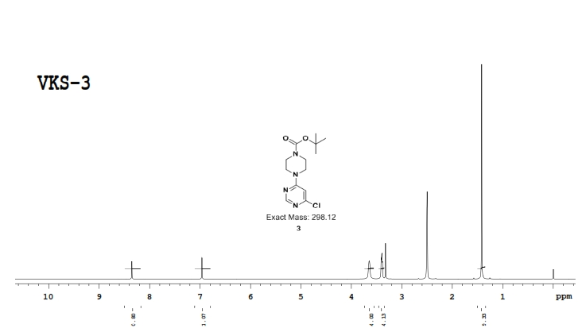

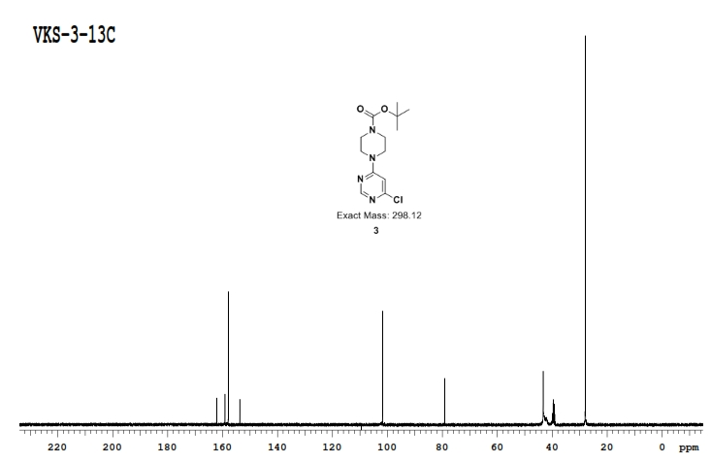
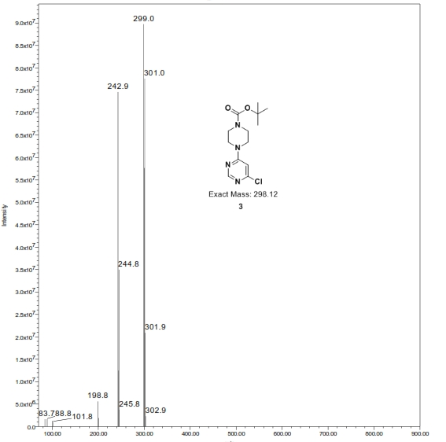

5
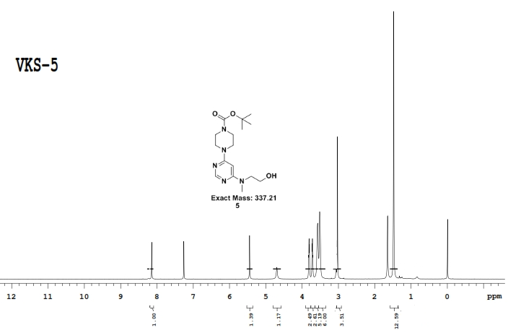
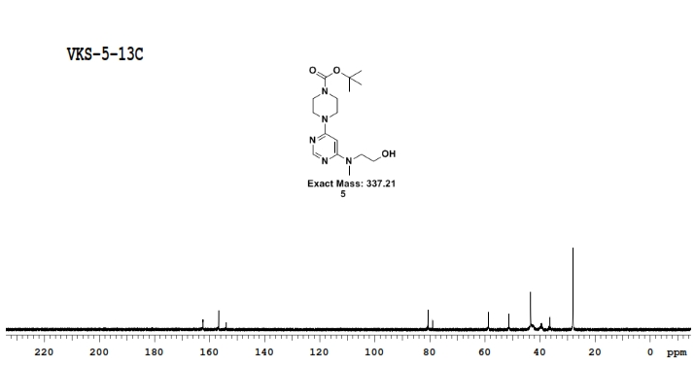
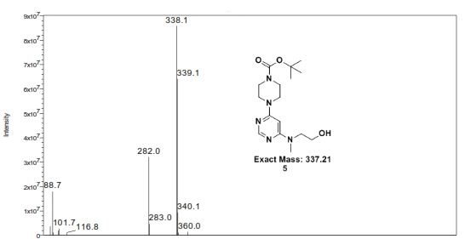
7
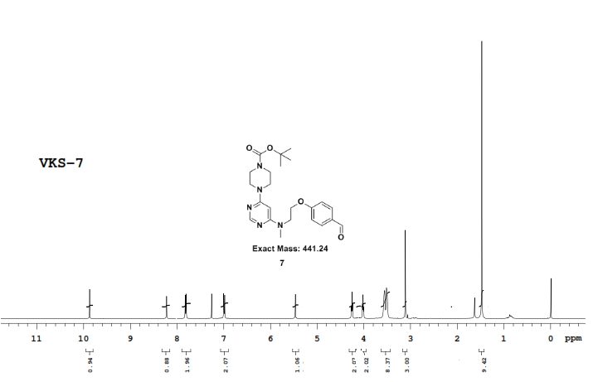

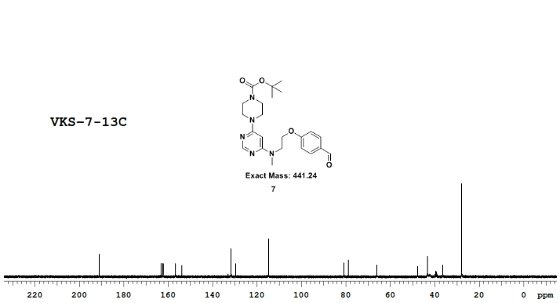
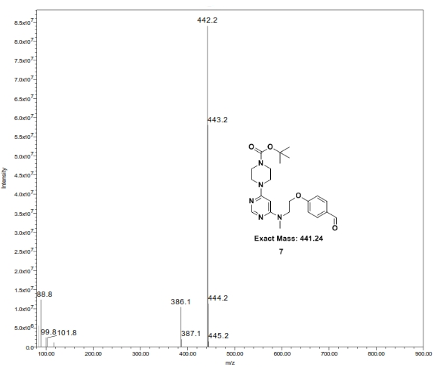

9
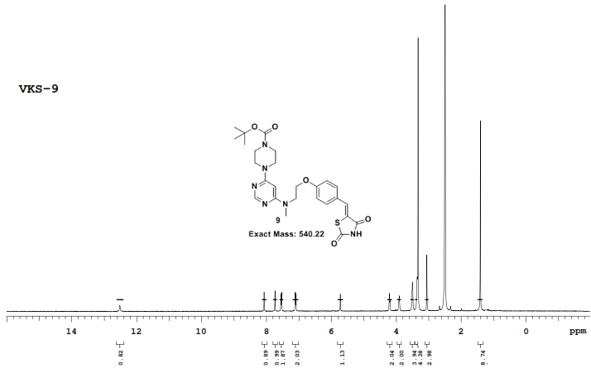

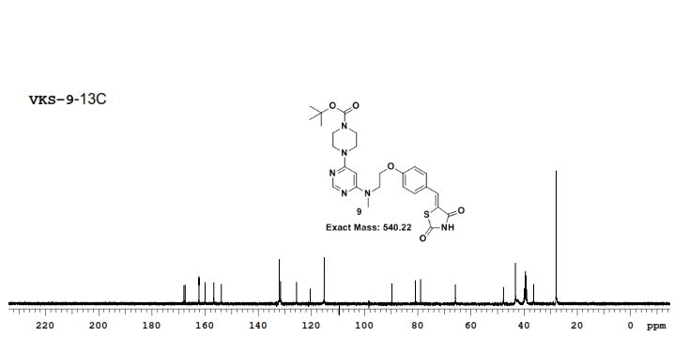

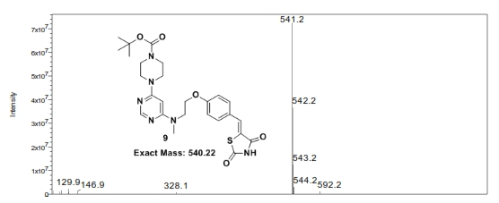

10
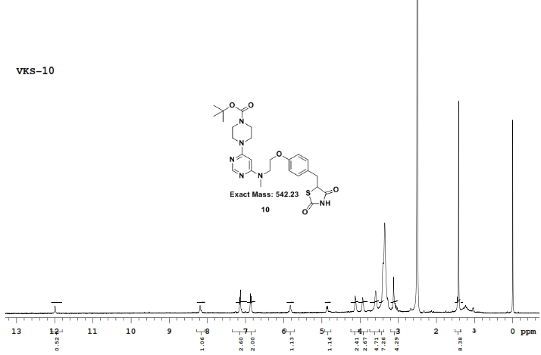
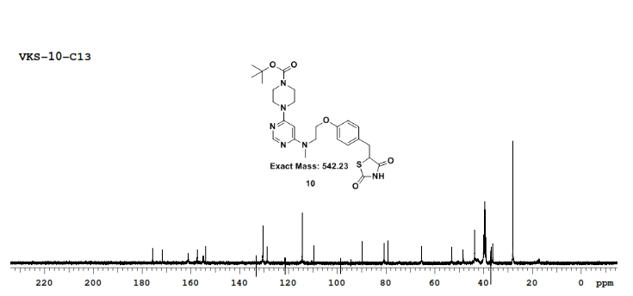

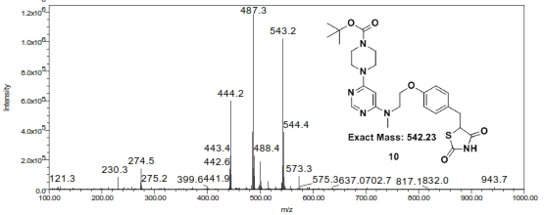

11
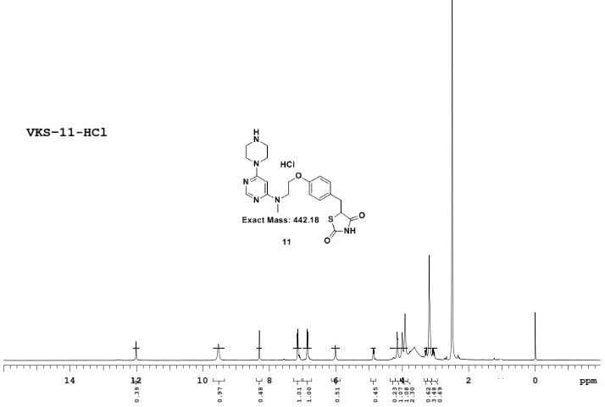

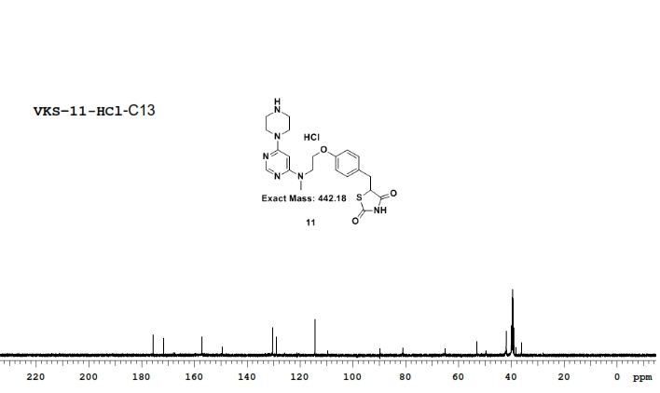
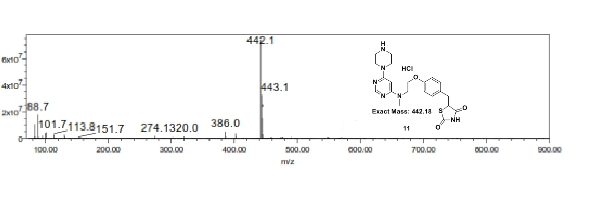

12a
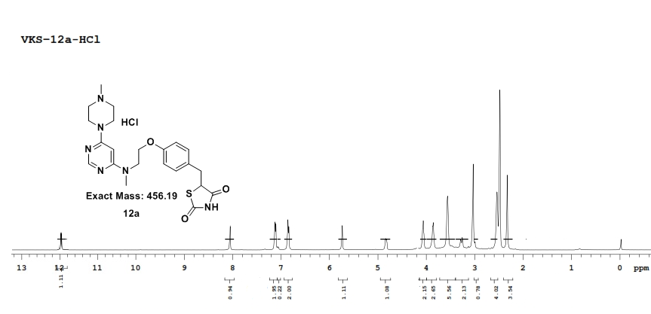
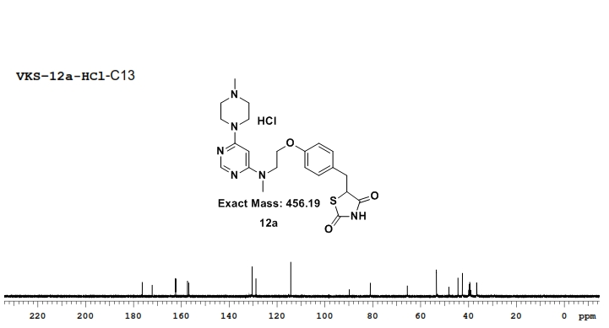

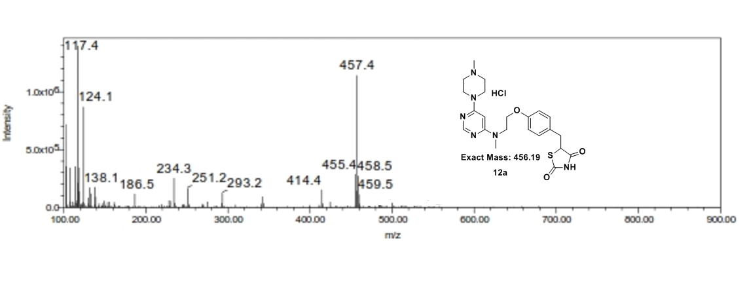

12b
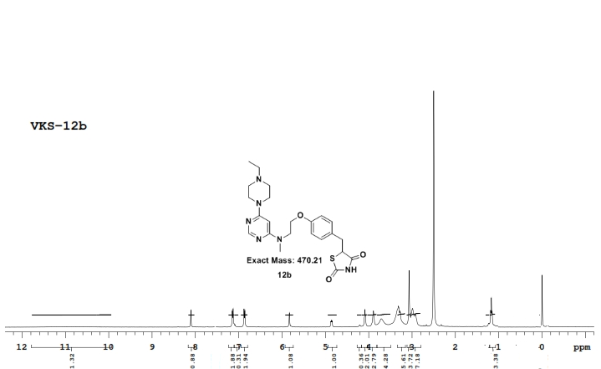

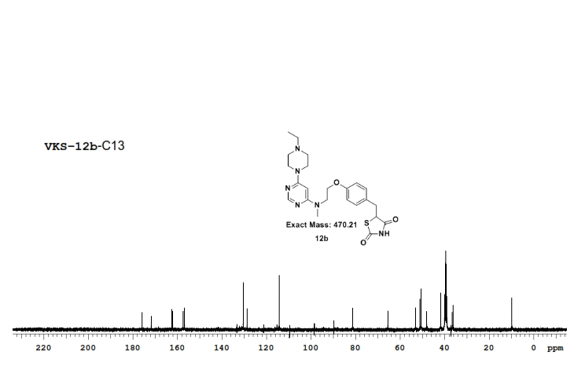
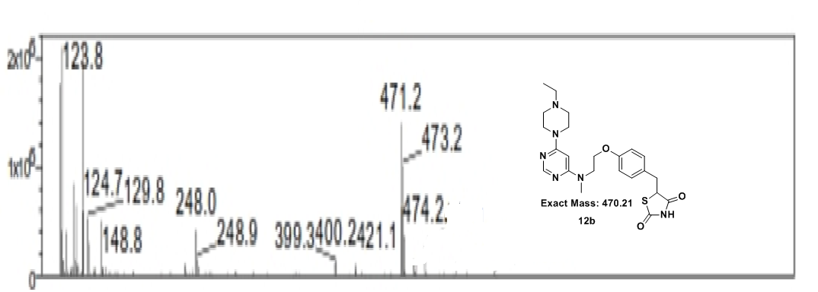

12c
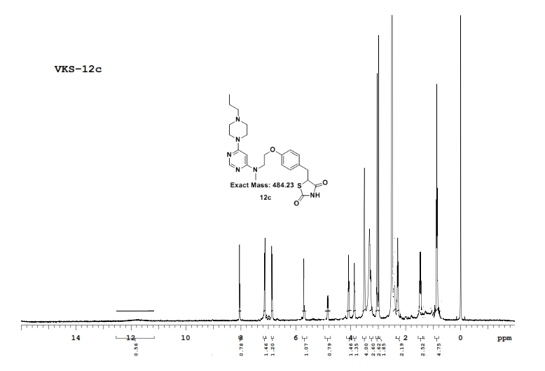
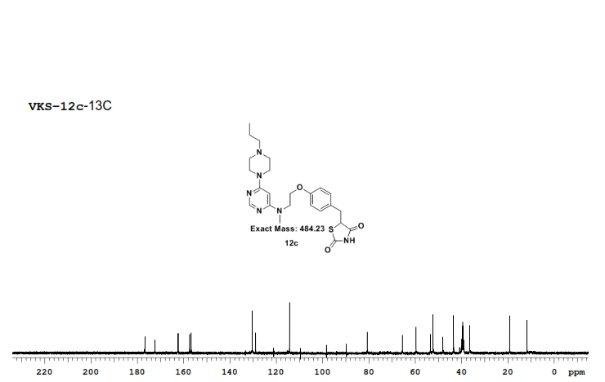

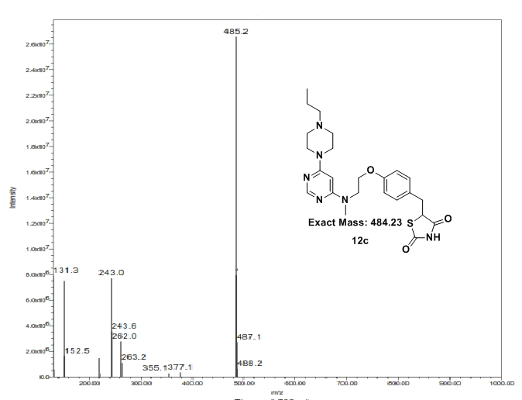
12d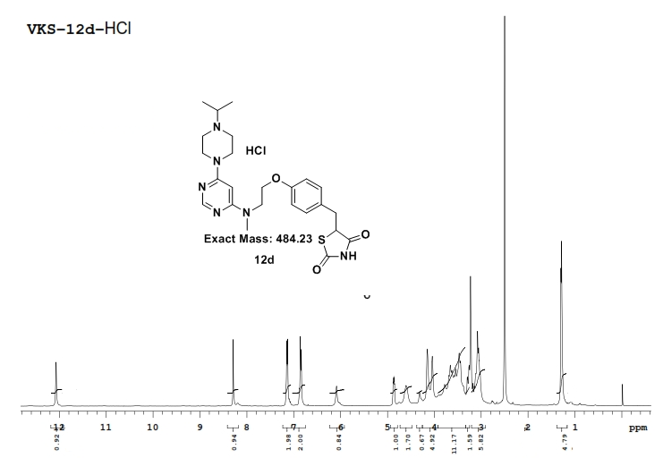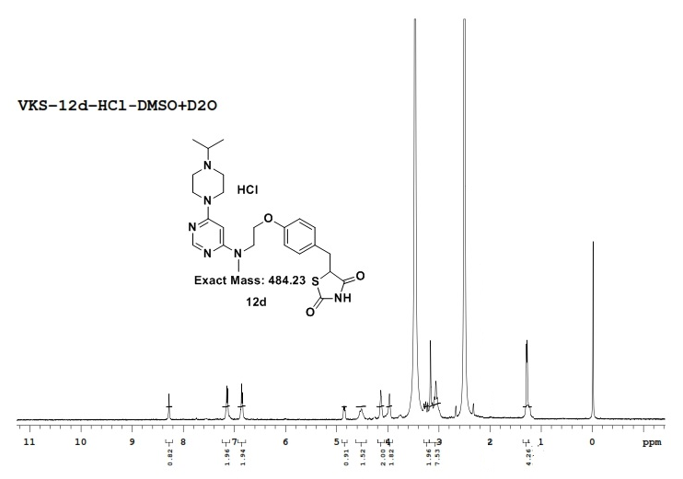
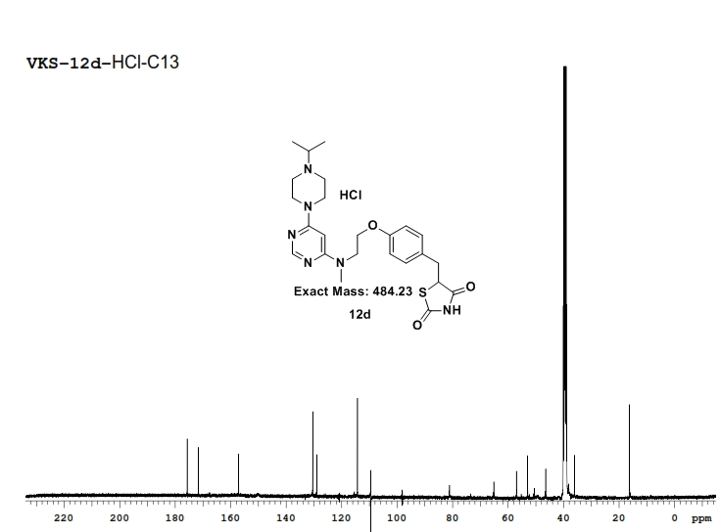

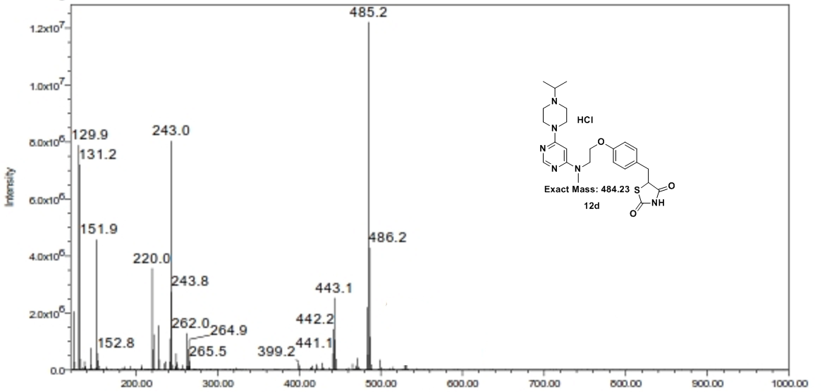

12e
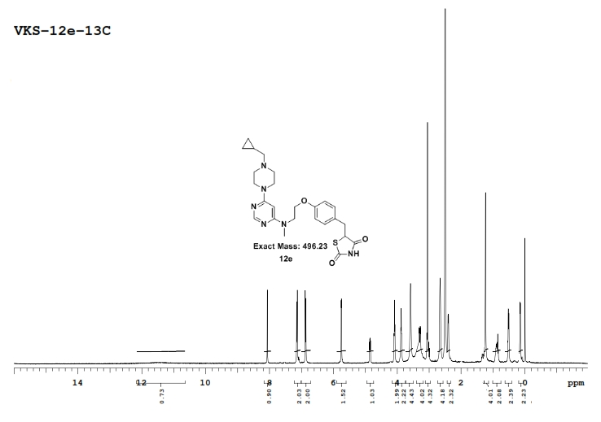
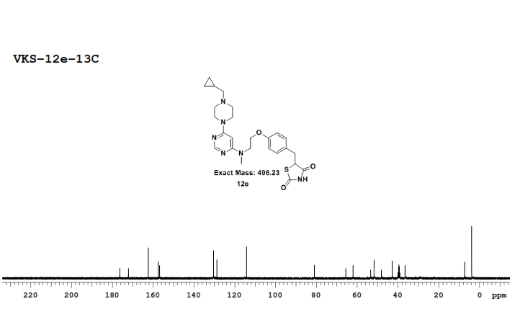
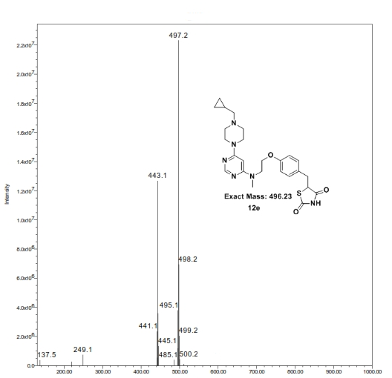
12f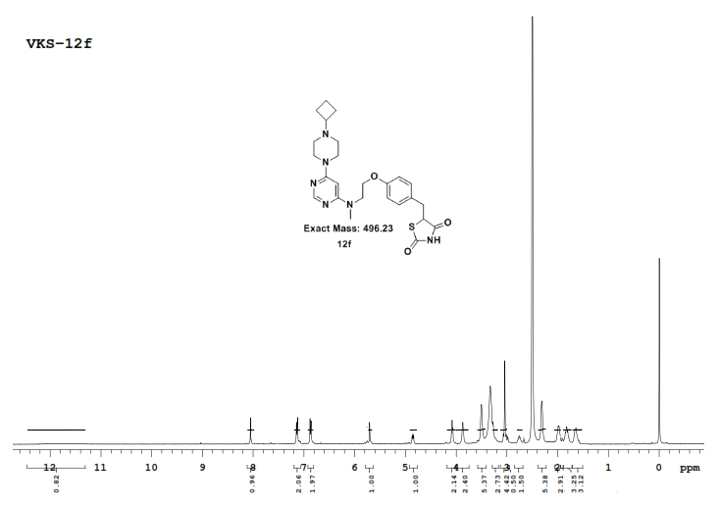
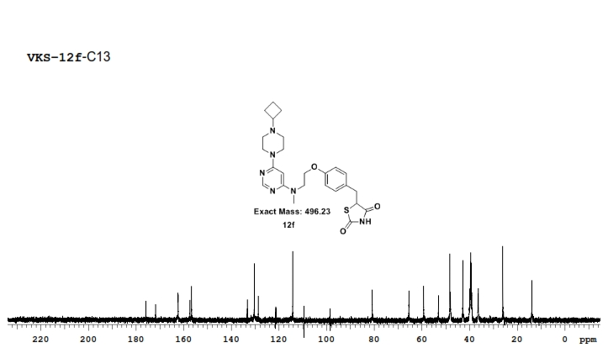

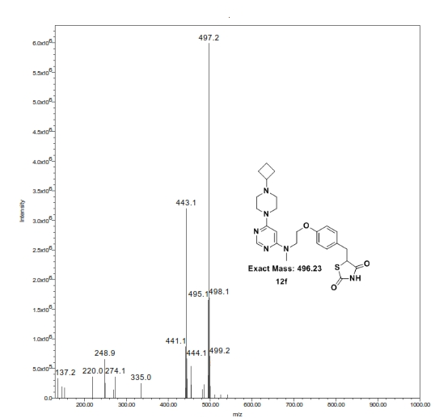

Elemental data