Supporting Information

Synthesis of functionalized γ-spiroiminolactones from isocyanides, acetylenic esters, and cyclopenta[a]acenaphthylen-8-ones

Issa Yavari | Maryam Safaei

Department of Chemistry, Tarbiat Modares University, PO Box 14115-175, Tehran, Iran

Contents

- The crystal structure and parameters for compound 4b…….…2
- ¹H and ¹³C NMR spectra for compounds 4…………………….…4-15

X‐ray crystal‐structure determination of 4b. Crystallographic data for the structure 4b have been deposited with the Cambridge Crystallographic Data Centre with CCDC number 1970625. Copies of the data can be obtained, free of charge, on application to the Cambridge Crystallographic Data Centre, 12 Union Road, Cambridge, CB2 1EZ, UK, (fax: +44 (0)1223 336033 or e‐mail:deposit@ccdc.cam.ac.uk).
Fig. 1 X-ray crystal structure of compound 4b
Table 1 - Crystal Data and Details of the Structure Determination
Crystal data
Chemical formula | C32H31NO9
Mr | 573.58
Crystal system, space group | Triclinic, P1
Temperature (K) | 293
a, b, c (Å) | 10.093 (2), 12.484 (3), 13.062 (3)
α, β, γ (°) | 66.37 (3), 85.19 (3), 83.10 (3)
V (Å3) | 1495.8 (7)
Z | 2
Radiation type | Mo Kα
μ (mm−1) | 0.09
Crystal size (mm) | 0.4 × 0.32 × 0.15
Data collection
Diffractometer | MAR345
Absorption correction | Multi-scan  R.H. Blessing, Acta Crystallogr., Sect A 1995, 51, 33-38
Tmin, Tmax | 0.933, 1.069
No. of measured, independent and  observed [I > 2σ(I)] reflections | 8868, 4477, 3968
Rint | 0.042
(sin θ/λ)max (Å−1) | 0.583
Refinement
R[F2 > 2σ(F2)], wR(F2), S | 0.079, 0.229, 1.07
No. of reflections | 4477
No. of parameters | 386
No. of restraints | 6
H-atom treatment | H-atom parameters constrained
Δρmax, Δρmin (e Å−3) | 0.74, −0.58

Experimental
Materials
The chemicals and solvents were purchased from Merck and used without additional purification. Melting points: Electrothermal-9100 apparatus. FTIR spectra were recorded on a Shimadzu IR‐460 instrument using the KBr self‐supported pellet technique. ¹H and ¹³C NMR spectra: Bruker DRX-300 Avance (for compounds 4a-4d and 4f-4i) and DRX-500 Avance (for compounds 4e and 4j) instruments using CDCl₃ as applied solvent; δ in ppm, J in Hz. Mass spectra obtained on a Finnigan‐MAT‐8430 EI‐MS apparatus at ionization potential of 70 eV. The melting points of the products were determined in open capillary tubes by using the Electrothermal‐9100 apparatus. Elemental analyses for C, H, and N were performed using a Heraeus CHN‐O‐Rapid analyzer.

General procedure for the synthesis of compounds 4
A mixture of alkyl isocyanides 1 (1.0 mmol), dialkyl acetylenedicarboxylates 2 (1.0 mmol), and dialkyl 8-oxo-8H-cyclopenta[a]acenaphthylene-7,9-dicarboxylates 3 (1.0 mmol), was stirred in MeCN (5 mL) at room temperature. After completion of the reaction as monitored by TLC (n‐hexane/EtOAc, 5:1), solvent was evaporated in vacuum, the resulting precipitate was filtered, and then washed with MeCN to give products 4.
Tetramethyl 5'-(tert-butylimino)-5'H-spiro[cyclopenta[a]acenaphthylene-8,2'-furan]-3',4',7,9-tetracarboxylate (4a)
Yellow powder; yield: (0.44 g, 81%). Mp: 172–173 °C. IR (KBr) (ν_{max}, cm⁻¹): 1744 (C=O), 1717 (C=O), 1690 (C=N), 1265 (C-O). ¹H NMR (300 MHz, CDCl₃): δ_{H} 1.29 (9 H, s, CMe₃), 3.61 (3 H, s, MeO), 3.90 (6 H, s, 2 MeO), 3.97 (3 H, s, MeO), 7.74 (2 H, t, ³J = 7.5 Hz, CH), 8.01 (2 H, d, ³J = 7.5 Hz, CH), 8.62 (2 H, d, ³J = 7.5 Hz, CH). ¹³C NMR (75 MHz, CDCl₃): δ_{C} 29.4 (CMe₃), 51.7 (2 MeO), 52.6 (MeO), 52.9 (MeO), 54.8 (C), 77.2 (C_{spiro}), 124.9 (C), 126.9 (2 CH), 128.5 (2 CH), 129.1 (2 C), 129.2 (2 CH), 131.3 (C), 139.6 (2C), 140.5 (C), 147.3 (C), 153.6 (C), 157.0 (2 C), 160.5 (C=O), 162.5 (2 C=O), 162.8 (C=O). EI/MS: m/z (%) = 545 (M⁺, 4), 529 (7), 393 (4), 337 (4), 282 (30), 193 (92), 105 (100). Anal. Calcd for C₃₀H₂₇NO₉: (545.54): C, 66.05; H, 4.99; N, 2.57%. Found: C, 65.75; H, 5.01; N, 2.60%.
7,9-Diethyl 3',4'-dimethyl 5'-(tert-butylimino)-5'H-spiro[cyclopenta[a]acenaphthylene-8,2'-furan]-3',4',7,9-tetracarboxylate (4b)
Yellow powder; yield: (0.51 g, 89%). Mp: 174–175 °C. IR (KBr) (ν_{max}, cm⁻¹): 1749 (C=O), 1725 (C=O), 1682 (C=N), 1269 (C-O). ¹H NMR (300 MHz, CDCl₃): δ_{H} 1.30 (9 H, s, CMe₃), 1.40 (6 H, t, ³J = 7.1 Hz, 2 Me), 3.61 (3 H, s, MeO), 3.95 (3 H, s, MeO), 4.27-4.40 (4 H, m, 2 CH₂O), 7.72 (2 H, t, ³J = 7.5 Hz, CH), 7.99 (2 H, d, ³J = 7.5 Hz, CH), 8.67 (2 H, d, ³J = 7.5 Hz, CH). ¹³C NMR (75 MHz, CDCl₃): δ_{C} 14.1 (2 Me), 29.7 (CMe₃), 52.6 (MeO), 52.8 (MeO), 54.9 (C), 61.1 (2 CH₂O), 77.2 (C_{spiro}), 125.2 (C), 127.0 (2 CH), 128.5 (2 CH), 129.2 (2 CH), 129.3 (2 C), 131.2 (C), 139.9 (2 C), 140.6 (C), 147.3 (C), 153.6 (C), 157.3 (2 C), 160.5 (C=O), 162.3 (2 C=O), 162.8 (C=O). EI/MS: m/z (%) = 573 (M+, 23), 558 (100), 453 (7), 408 (7), 324 (7), 279 (15). Anal. Calcd for C₃₂H₃₁NO₉: (573.59): C, 67.01; H, 5.45; N, 2.44%. Found: C, 66.71; H, 5.48; N, 2.47%.
3',4'-Diethyl 7,9-dimethyl 5'-(tert-butylimino)-5'H-spiro[cyclopenta[a]acenaphthylene-8,2'-furan]-3',4',7,9-tetracarboxylate (4c)
Yellow powder; yield: (0.45 g, 79%). Mp: 181–182 °C. IR (KBr) (ν_{max}, cm⁻¹): 1749 (C=O), 1725 (C=O), 1688 (C=N), 1269 (C-O). ¹H NMR (300 MHz, CDCl₃): δ_{H} 0.93 (3 H, t, ³J = 7.1 Hz, Me) 1.30 (9 H, s, CMe₃), 1.40 (3 H, t, ³J = 7.1 Hz, Me), 3.89 (6 H, s, 2 MeO), 4.02 (2 H, q, ³J = 7.1 Hz, CH₂O), 4.42 (2 H, q, ³J = 7.1 Hz, CH₂O), 7.73 (2 H, t, ³J = 7.5 Hz, CH), 7.99 (2 H, d, ³J = 7.5 Hz, CH), 8.63 (2 H, d, ³J = 7.5 Hz, CH). ¹³C NMR (75 MHz, CDCl₃): δ_{C} 13.4 (Me), 14.1 (Me), 29.7 (CMe₃), 51.7 (2 MeO), 54.9 (C), 61.4 (CH₂O), 61.9 (CH₂O), 77.2 (C_{spiro}), 124.9 (C), 126.9 (2 CH), 128.5 (2 CH), 129.1 (2 CH), 129.2 (2 C), 131.2 (C), 139.7 (2 C), 140.4 (C), 147.2 (C), 154.5 (C), 157.1 (2 C), 160.0 (C=O), 162.2 (C=O), 162.5 (2 C=O). EI/MS: m/z (%) = 573 (M+, 27), 558 (100), 517 (7), 439 (23), 407 (11), 338 (7), 278(7). Anal. Calcd for C₃₂H₃₁NO₉: (573.59): C, 67.01; H, 5.45; N, 2.44%. Found: C, 66.71; H, 5.46; N, 2.47%.
Tetraethyl 5'-(tert-butylimino)-5'H-spiro[cyclopenta[a]acenaphthylene-8,2'-furan]-3',4',7,9-tetracarboxylate (4d)
Yellow powder; yield: (0.54 g, 91%). Mp: 184–185 °C. IR (KBr) (ν_{max}, cm⁻¹): 1745 (C=O), 1721 (C=O), 1687 (C=N), 1263 (C=O). ¹H NMR (300 MHz, CDCl₃): δ_{H} 0.92 (3 H, t, ³J = 7.1 Hz, Me), 1.30 (9 H, s, CMe₃), 1.37 (3 H, t, ³J = 7.1 Hz, Me), 1.39 (6 H, t, ³J = 7.1 Hz, 2 Me), 4.02 (2 H, q, ³J = 7.1 Hz, CH₂O), 4.22-4.45 (6 H, m, 3 CH₂O), 7.72 (2 H, t, ³J = 7.5 Hz, CH), 7.98 (2 H, d, ³J = 7.5 Hz, CH), 8.67 (2 H, d, ³J = 7.5 Hz, CH). ¹³C NMR (75 MHz, CDCl₃): δ_{C} 13.4 (Me), 14.0 (3 Me), 29.7 (CMe₃), 54.8 (C), 61.0 (2 CH₂O), 61.3 (CH₂O), 61.7 (CH₂O), 77.2 (C_{spiro}), 125.4 (C), 127.0 (2 CH), 128.5 (2 CH), 129.1 (2 CH), 129.2 (2 C), 131.2 (C), 139.9 (2 C), 140.6 (C), 147.2 (C), 153.9 (C), 157.2 (2 C), 160.1 (C=O), 162.2 (C=O), 162.3 (2 C=O). EI/MS: m/z (%) = 601 (M+, 27), 586 (100), 556 (4), 466 (7), 421 (7), 393 (7), 293 (15). Anal. Calcd for C₃₄H₃₅NO₉: (601.64): C, 67.87; H, 5.86; N, 2.33%. Found: C, 67.57; H, 5.84; N, 2.36%.
3',4'-Di-tert-butyl 7,9-diethyl 5'-(tert-butylimino)-5'H-spiro[cyclopenta[a]acenaphthylene-8,2'-furan]-3',4',7,9-tetracarboxylate (4e)
Yellow powder; yield: (0.61 g, 94%). Mp: 188–189 °C. IR (KBr) (ν_{max}, cm⁻¹): 1735 (C=O), 1718 (C=O), 1654 (C=N), 1262 (C-O). ¹H NMR (500 MHz, CDCl₃): δ_{H} 1.11 (9 H, s, CMe₃), 1.29 (9 H, s, CMe₃), 1.40 (6 H, s, 2 Me), 1.61 (9 H, s, CMe₃), 4.22-4.33 (2 H, br m, CH₂O), 4.34-4.44 (2 H, br m, CH₂O), 7.73 (2 H, t, ³J = 7.5 Hz, CH), 7.98 (2 H, d, ³J = 7.5 Hz, CH), 8.70 (2 H, d, ³J = 7.5 Hz, CH). ¹³C NMR (125 MHz, CDCl₃): δ_{C} 13.1 (2 Me), 26.6 (CMe₃), 27.2 (CMe₃), 28.7 (CMe₃), 53.3 (CHN), 59.8 (2 CH₂O), 77.2 (C_{spiro}), 81.4 (C), 81.8 (C), 125.0 (C), 125.8 (2 CH), 127.4 (2 CH), 127.9 (2 C), 128.3 (2 CH), 130.1 (C), 139.4 (2 C), 139.5 (C), 145.9 (C), 152.7 (C), 155.8 (2 C), 158.3 (C=O), 160.4 (C=O), 161.4 (2 C=O). EI‐MS: m/z (%) = 657 (M+, 15), 642 (54), 586 (7), 530 (100), 440 (15), 394 (15), 310 (15). Anal. Calcd for C₃₈H₄₃NO₉: (657.75): C, 69.39; H, 6.59; N, 2.13%. Found: C, 69.04; H, 6.57; N, 2.15%.
Tetramethyl 5'-(cyclohexylimino)-5'H-spiro[cyclopenta[a]acenaphthylene-8,2'-furan]-3',4',7,9-tetracarboxylate (4f)
Yellow powder; yield: (0.47 g, 83%). Mp: 171–173°C. IR (KBr) (ν_{max}, cm⁻¹): 1752 (C=O), 1727 (C=O), 1649 (C=N), 1268 (C-O). ¹H NMR (300 MHz, CDCl₃): δ_{H} 1.17-1.74 (10 H, m, 5 CH₂), 3.61 (3 H, s, MeO), 3.61 (1 H, br m, CHN, overlapping with MeO), 3.90 (6 H, s, 2 MeO), 3.97 (3 H, s, MeO), 7.73 (2 H, t, ³J = 7.5 Hz, CH), 7.99 (2 H, d, ³J = 7.5 Hz, CH), 8.60 (2 H, d, ³J = 7.5 Hz, CH). ¹³C NMR (75 MHz, CDCl₃): δ_{C} 24.8 (2 CH₂), 25.7 (CH₂), 33.2 (2 CH₂), 51.8 (2 MeO), 52.6 (MeO), 53.0 (MeO), 56.4 (CHN), 77.2 (C_{spiro}), 124.8 (C), 126.9 (2 CH), 128.5 (2 CH), 129.1 (2 C), 129.3 (2 CH), 131.2 (C), 139.0 (2 C), 140.8 (C), 147.3 (C), 155.4 (C), 157.1 (2 C), 160.5 (C=O), 162.5 (2 C=O), 162.6 (C=O). EI/MS: m/z (%) = 571 (M+, 54), 539 (58), 507 (19), 474 (88), 446 (100), 426 (35), 383 (42). Anal. Calcd for C₃₂H₂₉NO₉: (571.57): C, 67.24; H, 5.11; N, 2.45%. Found: C, 66.94; H, 5.10; N, 2.47%.
7,9-Diethyl 3',4'-dimethyl 5'-(cyclohexylimino)-5'H-spiro[cyclopenta[a]acenaphthylene-8,2'-furan]-3',4',7,9-tetracarboxylate (4g)
Yellow powder; yield: (0.55 g, 92%). Mp: 176–178 °C. IR (KBr) (ν_{max}, cm⁻¹): 1752 (C=O), 1735 (C=O), 1653 (C=N), 1267 (C-N). ¹H NMR (300 MHz, CDCl₃): δ_{H} 1.16-1.30 (4 H, m, 2 CH₂), 1.38 (6 H, t, ³J = 7.1 Hz, 2 Me), 1.52-1.64 (2 H, m, CH₂), 1.65-1.84 (4 H, m, 2 CH₂), 3.61 (3 H, s, MeO), 3.61 (1 H, br m, CHN, overlapping with MeO), 3.95 (3 H, s, MeO), 4.33 (4 H, q, ³J = 7.1 Hz, 2 CH₂O), 7.72 (2 H, t, ³J = 7.5 Hz, CH), 7.99 (2 H, d, ³J = 7.5 Hz, CH), 8.67 (2 H, d, ³J = 7.5 Hz, CH). ¹³C NMR (75 MHz, CDCl₃): δ_{C} 14.0 (2 Me), 24.8 (2 CH₂), 25.7 (CH₂), 33.4 (2 CH₂), 52.6 (MeO), 52.8 (MeO), 56.5 (CHN), 61.1 (2 CH₂O), 77.2 (C_{spiro}), 125.2 (C), 127.0 (2 CH), 128.5 (2 CH), 129.2 (2 C), 129.3 (2 CH), 131.2 (C), 139.1 (2 C), 141.1 (C), 147.3 (C), 155.6 (C), 157.3 (2 C), 160.5 (C=O), 162.3 (2 C=O), 162.5 (C=O). EI/MS: m/z (%) = 599 (M+, 92), 566 (54), 501 (85), 473 (27), 441 (50), 397 (100), 309 (42). Anal. Calcd for C₃₄H₃₃NO₉: (599.63): C, 68.10; H, 5.55; N, 2.34%. Found: C, 67.80; H, 5.54; N, 2.36%.
3',4'-Diethyl 7,9-dimethyl 5'-(cyclohexylimino)-5'H-spiro[cyclopenta[a]acenaphthylene-8,2'-furan]-3',4',7,9-tetracarboxylate (4h)
Yellow powder; yield: (0.49 g, 82%). Mp: 179–180 °C. IR (KBr) (ν_{max}, cm⁻¹): 1741 (C=O), 1727 (C=O), 1687 (C=N), 1269 (C-O). ¹H NMR (300 MHz, CDCl₃): δ_{H} 0.94 (3 H, t, ³J = 7.1 Hz, Me), 1.12-1.33 (4 H, m, 2 CH₂), 1.39 (3 H, t, ³J = 7.1 Hz, Me), 1.51-1.64 (2 H, m, CH₂), 1.66-1.82 (4 H, m, 2 CH₂), 3.59-3.66 (1 H, m, CHN), 3.89 (6 H, s, 2 MeO), 4.02 (2 H, q, ³J = 7.1 Hz, CH₂O), 4.42 (2 H, q, ³J = 7.1 Hz, CH₂O), 7.72 (2 H, t, ³J = 7.5 Hz, CH), 7.99 (2 H, d, ³J = 7.5 Hz, CH), 8.61 (2 H, d, ³J = 7.5 Hz, CH). ¹³C NMR (75 MHz, CDCl₃): δ_{C} 13.5 (Me), 14.1 (Me), 24.7 (2 CH₂), 25.7 (CH₂), 33.2 (2 CH₂), 51.7 (2 MeO), 56.3 (CHN), 61.4 (CH₂O), 62.0 (CH₂O), 77.2 (C_{spiro}), 125.0 (C), 126.9 (2 CH), 128.5 (2 CH), 129.1 (2 C), 129.2 (2 CH), 131.2 (C), 139.2 (2 C), 140.7 (C), 147.2 (C), 155.5 (C), 157.0 (2 C), 160.1 (C=O), 162.1 (C=O), 162.6 (2 C=O). EI/MS: m/z (%) = 599 (M+, 42), 553 (30), 501 (100), 473 (19), 441 (77), 397 (38), 297 (23). Anal. Calcd for C₃₄H₃₃NO₉: (599.63): C, 68.10; H, 5.55; N, 2.34%. Found: C, 68.38; H, 5.57; N, 2.35%.
Tetraethyl 5'-(cyclohexylimino)-5'H-spiro[cyclopenta[a]acenaphthylene-8,2'-furan]-3',4',7,9-tetracarboxylate (4i)
Yellow powder; yield: (0.56 g, 90%). Mp: 183–184 °C. IR (KBr) (ν_{max}, cm⁻¹): 1746 (C=O), 1728 (C=O), 1689 (C=N), 1265 (C=O). ¹H NMR (300 MHz, CDCl₃): δ_{H} 0.92 (3 H, t, ³J = 7.1 Hz, Me), 1.12-1.31 (4 H, m, 2 CH₂), 1.38 (9 H, t, ³J = 7.1 Hz, 3 Me), 1.50-1.63 (2 H, m, CH₂), 1.65-1.83 (4 H, m, 2 CH₂), 3.60-3.66 (1 H, m, CHN), 4.02 (2 H, q, ³J = 7.1 Hz, CH₂O), 4.32 (2 H, q, ³J = 7.1 Hz, CH₂O), 4.42 (4 H, q, ³J = 7.1 Hz, 2 CH₂O), 7.72 (2 H, t, ³J = 7.5 Hz, CH), 7.98 (2 H, d, ³J = 7.5 Hz, CH), 8.68 (2 H, d, ³J = 7.5 Hz, CH). ¹³C NMR (75 MHz, CDCl₃): δ_{C} 13.5 (Me), 14.0 (3 Me), 24.7 (2 CH₂), 25.7 (CH₂), 33.4 (2 CH₂), 56.3 (CHN), 61.0 (2 CH₂O), 61.4 (CH₂O), 61.9 (CH₂O), 77.2 (C_{spiro}), 125.4 (C), 127.0 (2 CH), 128.5 (2 CH), 129.1 (2 C), 129.2 (2 CH), 131.2 (C), 139.2 (2 C), 141.0 (C), 147.2 (C), 155.7 (C), 157.3 (2 C), 160.0 (C=O), 162.0 (C=O), 162.3 (2 C=O). EI/MS: m/z (%) = 627 (M+, 61), 581 (100), 529 (92), 455 (88), 411 (77), 383 (23), 309 (46). Anal. Calcd for C₃₆H₃₇NO₉: (627.68): C, 68.89; H, 5.94; N, 2.23%. Found: C, 68.59; H, 5.96; N, 2.25%.
3',4'-Di-tert-butyl 7,9-diethyl 5'-(cyclohexylimino)-5'H-spiro[cyclopenta[a]acenaphthylene-8,2'-furan]-3',4',7,9-tetracarboxylate (4j)
Yellow powder; yield: (0.64 g, 95%). Mp: 186–187 °C. IR (KBr) (ν_{max}, cm⁻¹): 1744 (C=O), 1717 (C=O), 1689 (C=N), 1265 (C-O). ¹H NMR (500 MHz, CDCl₃): δ_{H} 1.11 (9 H, s, CMe₃), 1.22-1.32 (4 H, m, CH₂), 1.38 (6 H, t, ³J = 7.1 Hz, 2 Me), 1.40-1.50 (2 H, m, CH₂), 1.61 (9 H, s, CMe₃), 1.69-1.81 (4 H, m, CH₂), 3.60-3.70 (1 H, m, CHN), 4.27-4.39 (4 H, m, 2 CH₂O), 7.74 (2 H, t, ³J = 7.5 Hz, CH), 7.99 (2 H, d, ³J = 7.5 Hz, CH), 8.70 (2 H, d, ³J = 7.5 Hz, CH). ¹³C NMR(125 MHz, CDCl₃): δ_{C} 13.1 (2 Me), 23.4 (2 CH₂), 24.9 (CH₂), 26.5 (CMe₃), 27.2 (CMe₃), 32.4 (2 CH₂), 54.6 (CHN), 59.8 (2 CH₂O), 77.2 (C_{spiro}), 81.5 (C), 81.9 (C), 125.0 (C), 125.8 (2 CH), 127.5 (2 CH), 127.9 (2 C), 128.3 (2 CH), 130.1 (C), 137.6 (C), 141.2 (C), 145.9 (C), 154.4 (C), 155.9 (2 C), 158.4 (C=O), 160.0 (C=O), 161.4 (2 C=O). EI‐MS: m/z (%) = 683 (M+, 15), 642 (54), 586 (7), 530 (100), 440 (15), 394 (15), 310 (15). Anal. Calcd for C₄₀H₄₅NO₉: (683.79): C, 70.26; H, 6.63; N, 2.05%. Found: C, 69.92; H, 6.65; N, 2.06%.

¹H and ¹³C NMR spectra for compounds 4a-4j
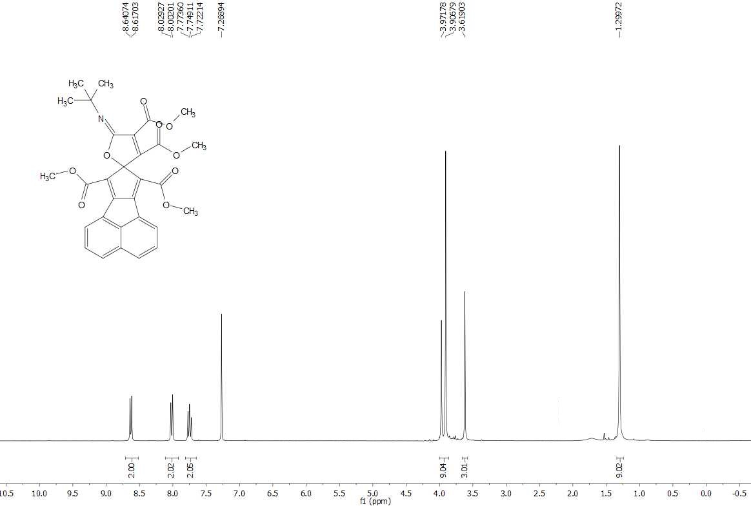
Figure S1 (300-MHz) ¹H NMR spectrum of compound 4a in CDCl₃
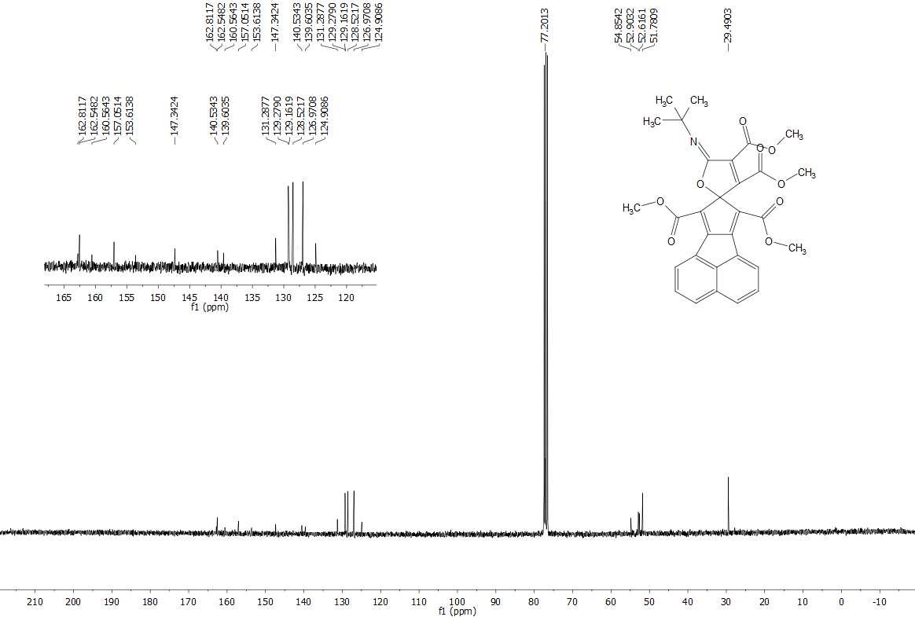
Figure S2 (75-MHz) ¹³C NMR spectrum of compound 4a in CDCl₃
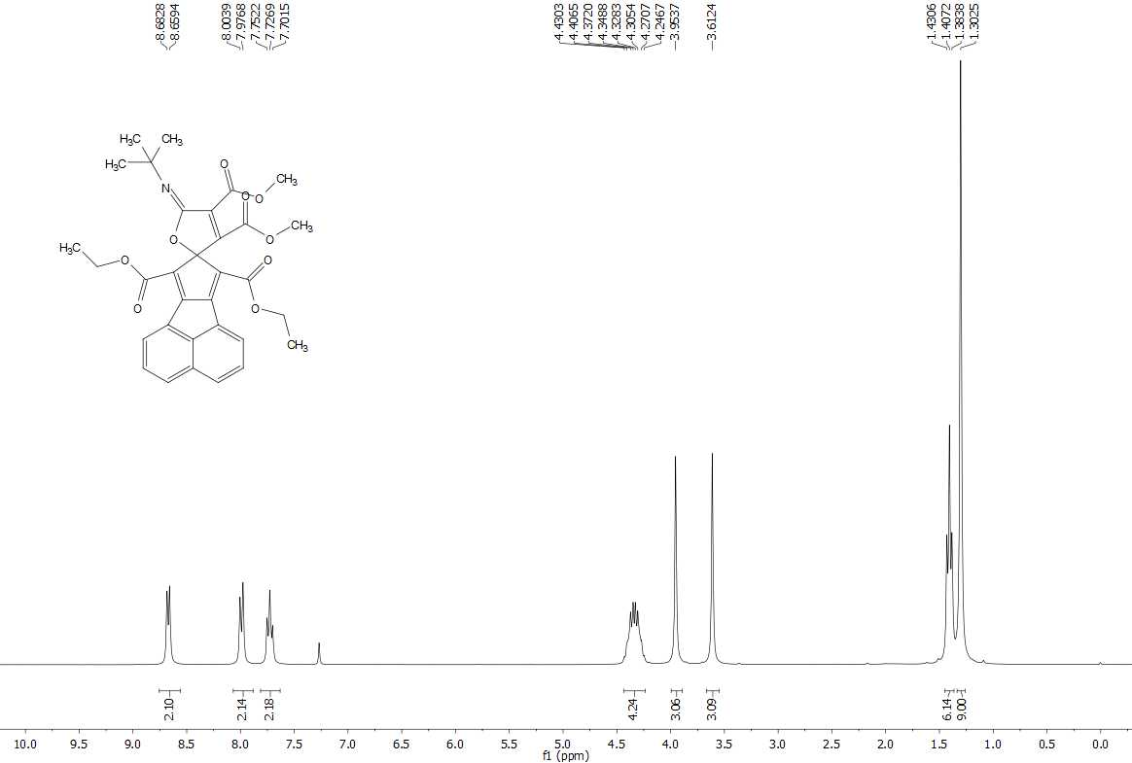
Figure S3 (300-MHz) ¹H NMR spectrum of compound 4b in CDCl₃
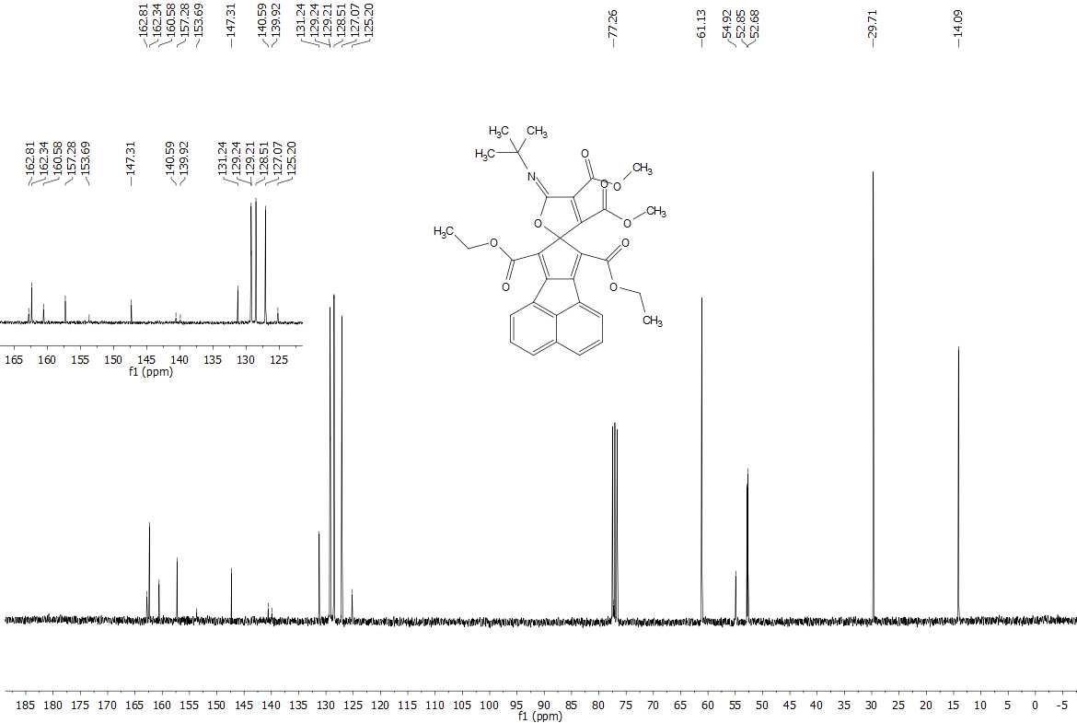
Figure S4 (75-MHz) ¹³C NMR spectrum of compound 4b in CDCl₃
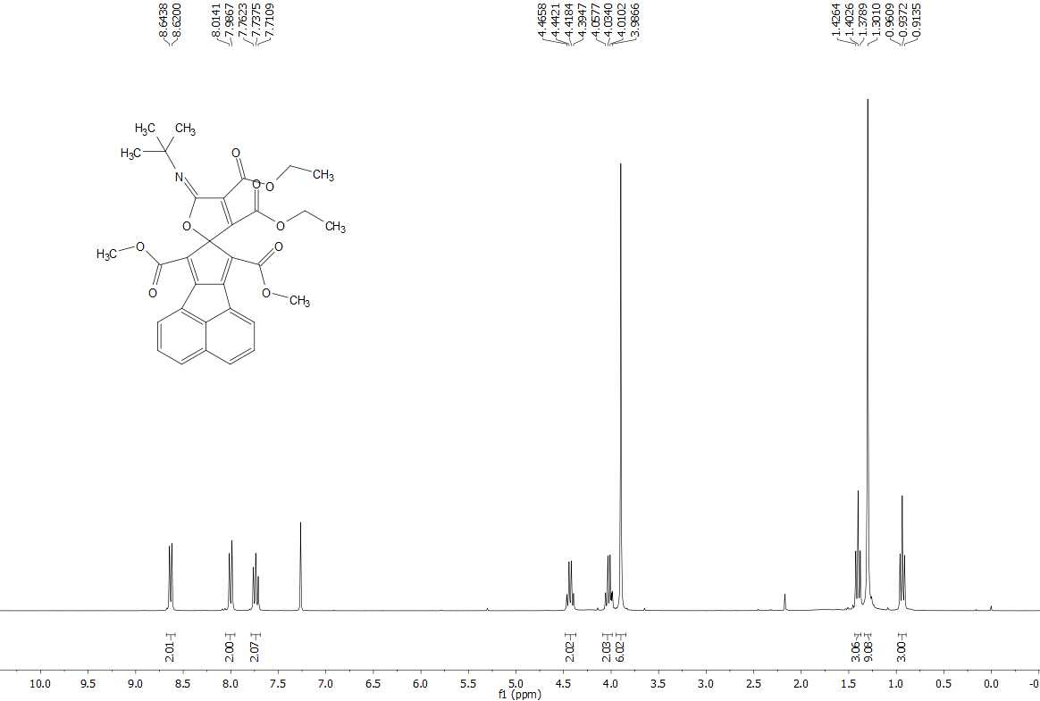
Figure S5 (300-MHz) ¹H NMR spectrum of compound 4c in CDCl₃
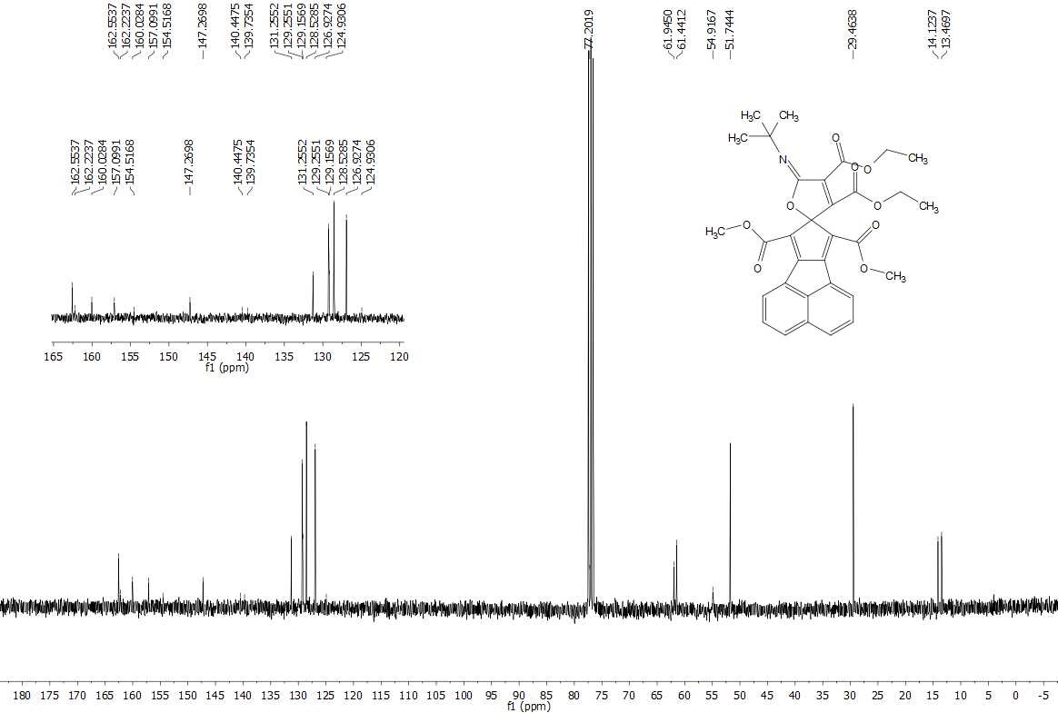
Figure S6 (75-MHz) ¹³C NMR spectrum of compound 4c in CDCl₃

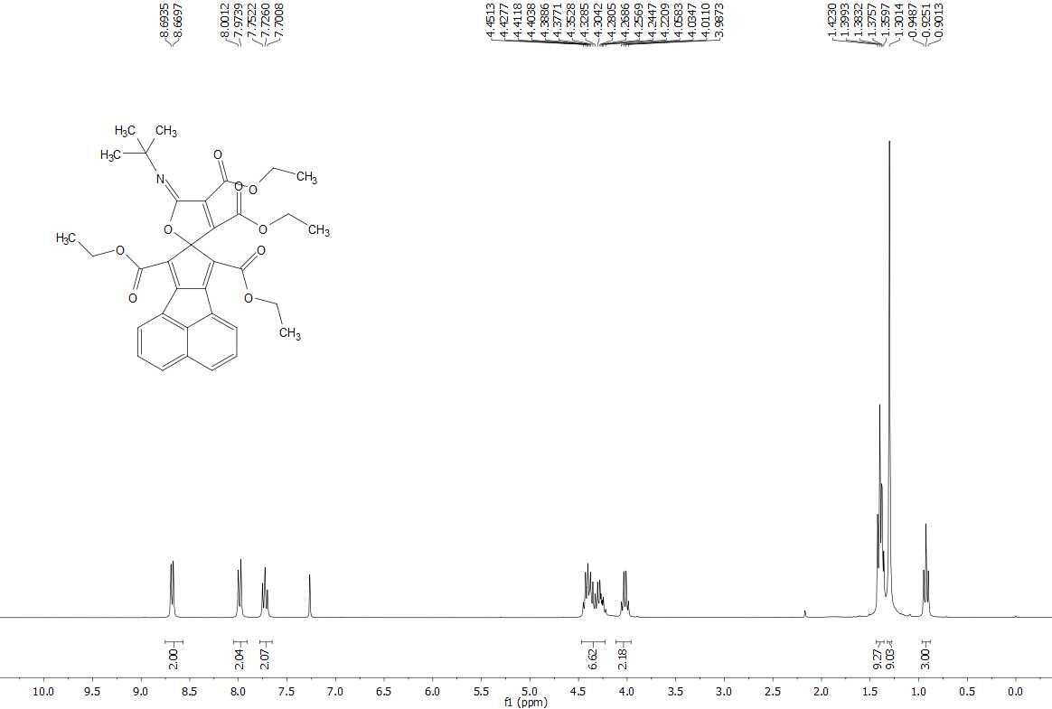
Figure S7 (300-MHz) ¹H NMR spectrum of compound 4d in CDCl₃
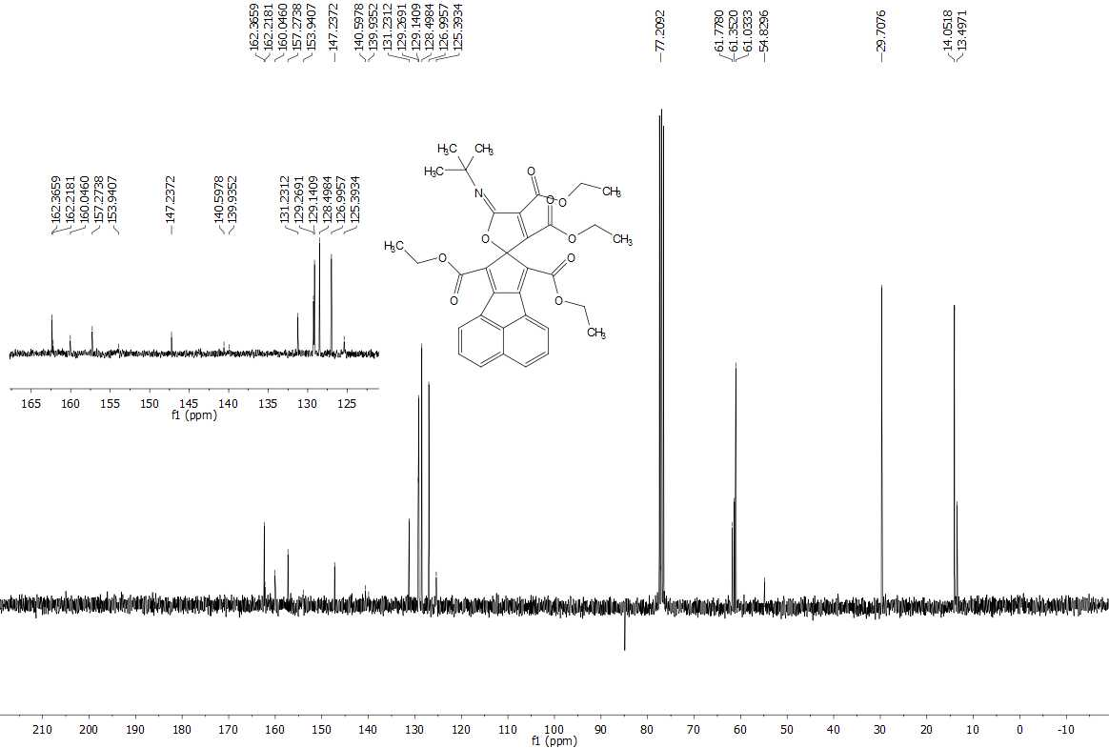
Figure S8 (75-MHz) ¹³C NMR spectrum of compound 4d in CDCl₃

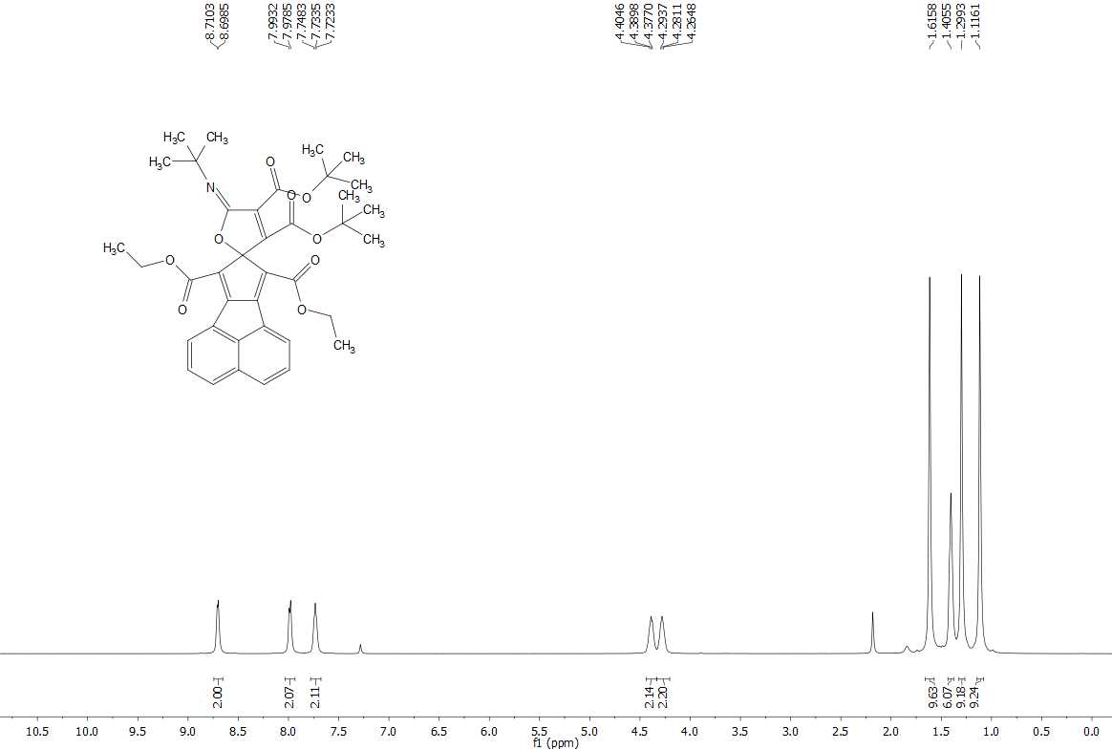
Figure S9 (500-MHz) ¹H NMR spectrum of compound 4e in CDCl₃
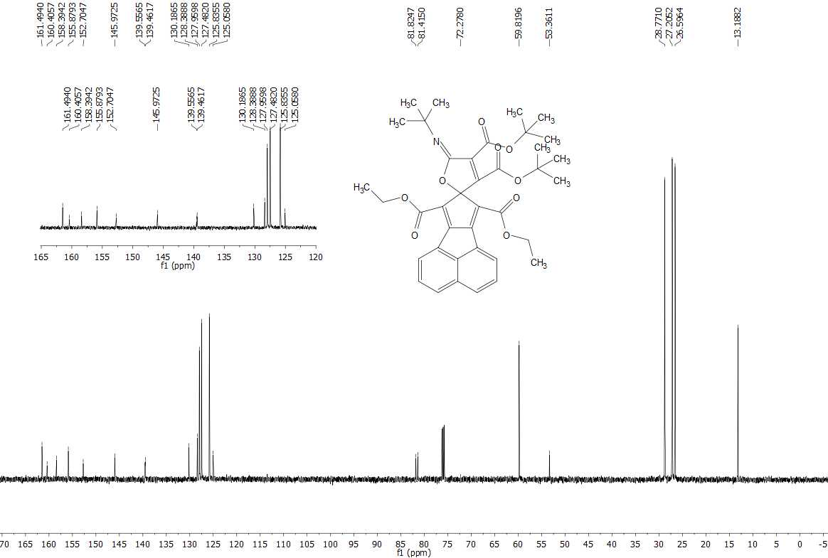
Figure S10 (125-MHz) ¹³C NMR spectrum of compound 4e in CDCl₃

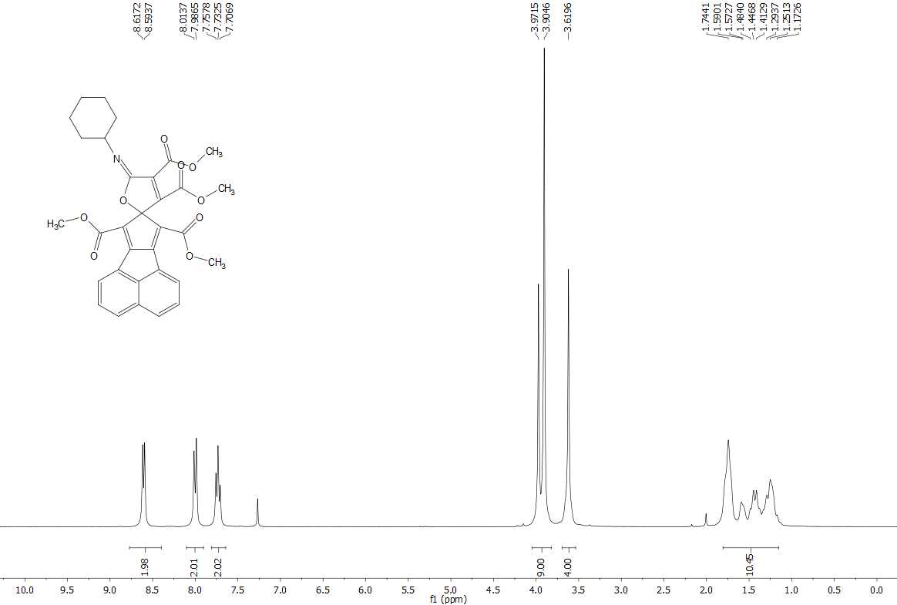
Figure S11 (300-MHz) ¹H NMR spectrum of compound 4f in CDCl₃
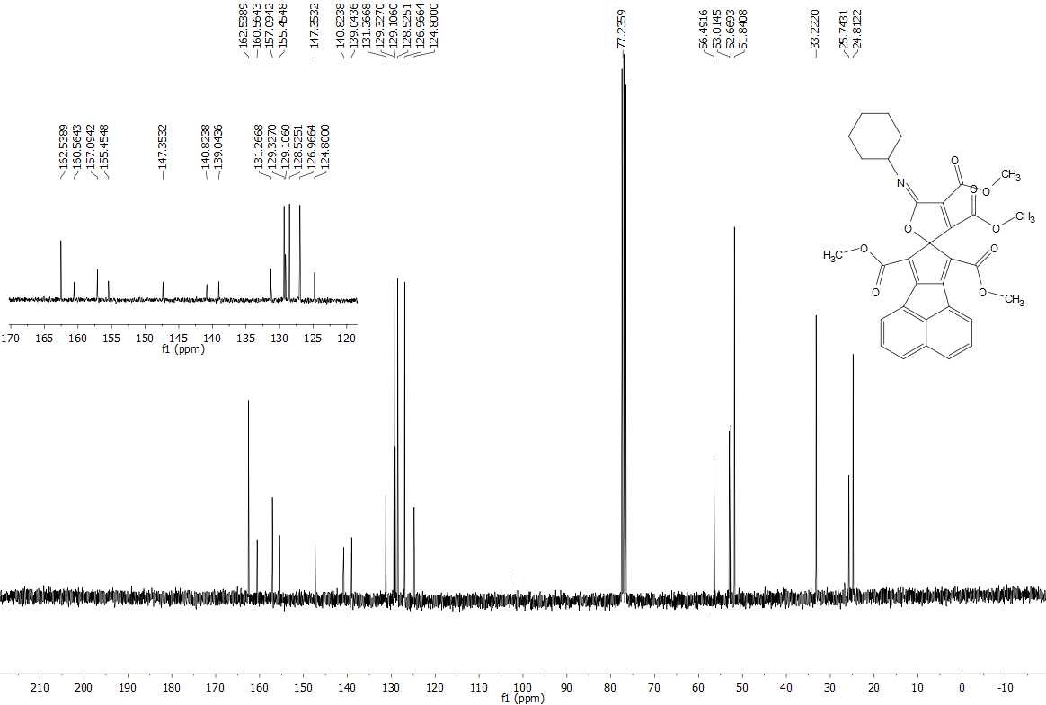
Figure S12 (75-MHz) ¹³C NMR spectrum of compound 4f in CDCl₃

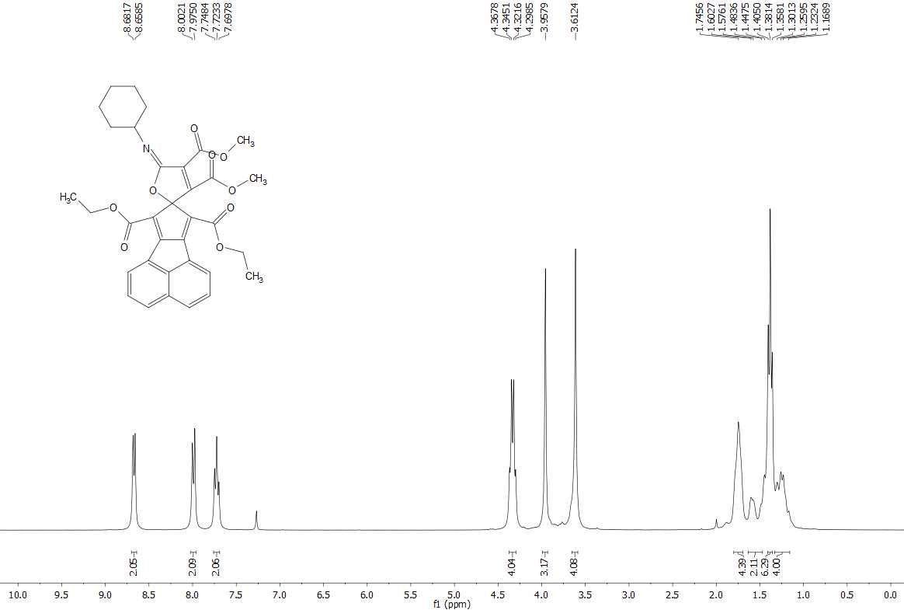
Figure S13 (300-MHz) ¹H NMR spectrum of compound 4g in CDCl₃
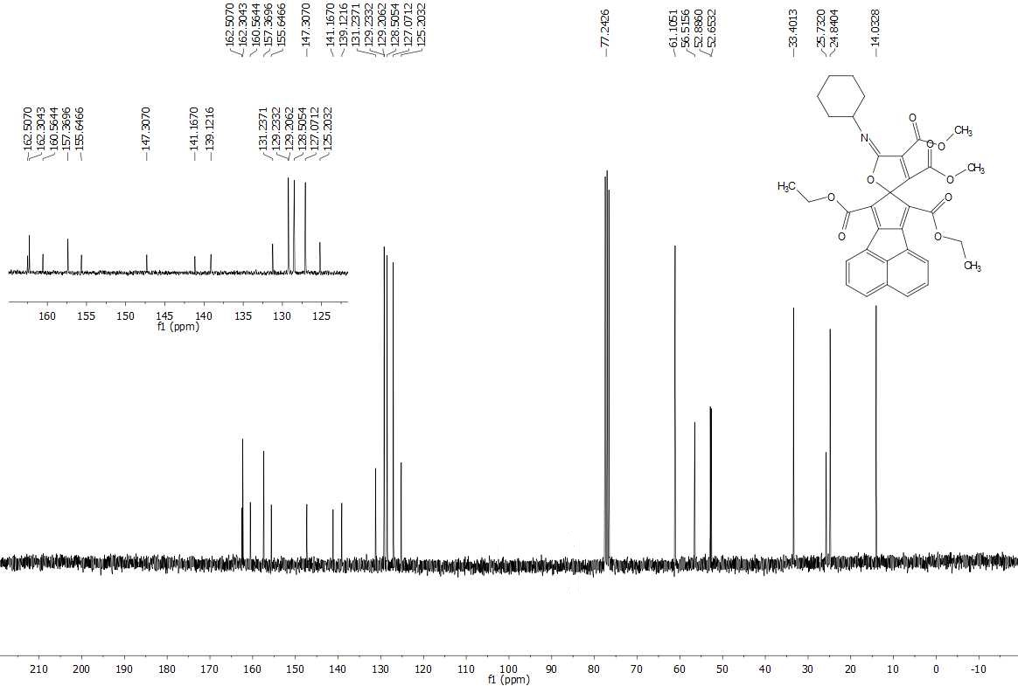
Figure S14 (75-MHz) ¹³C NMR spectrum of compound 4g in CDCl₃
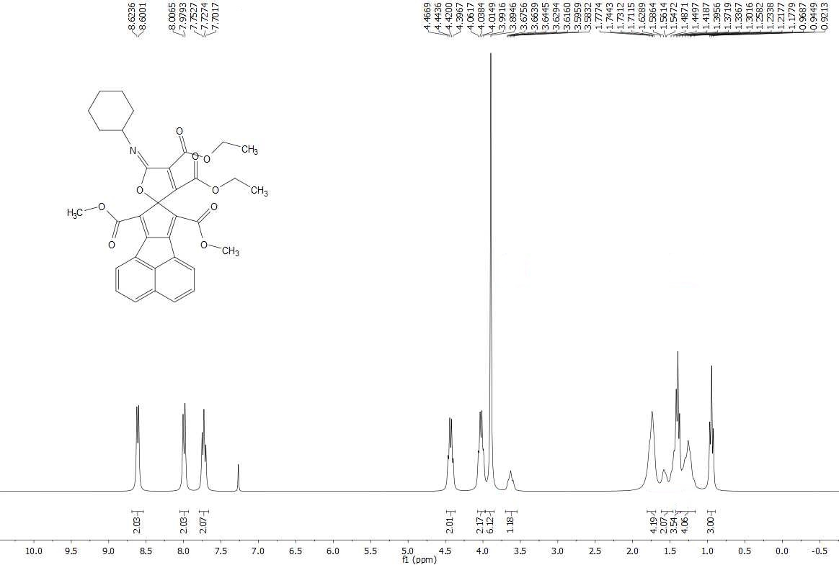
Figure S15 (300-MHz) ¹H NMR spectrum of compound 4h in CDCl₃
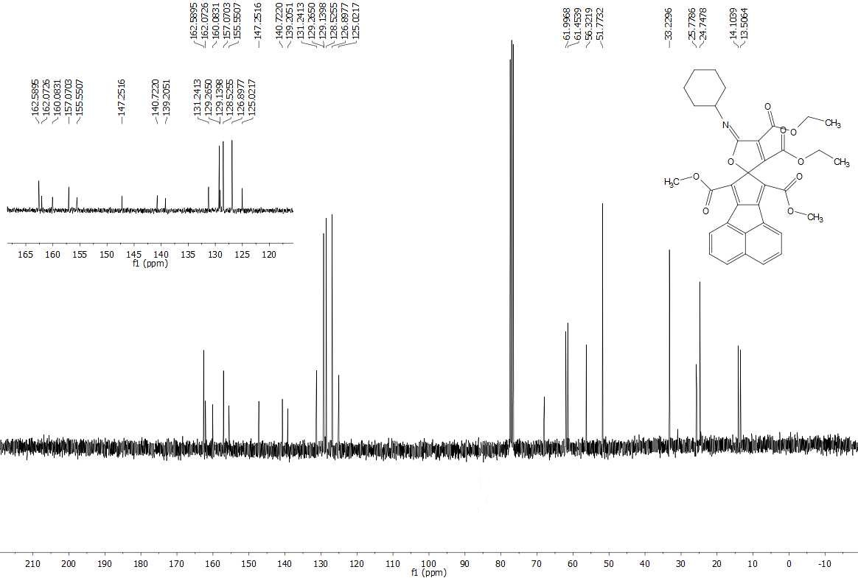
Figure S16 (75-MHz) ¹³C NMR spectrum of compound 4h in CDCl₃

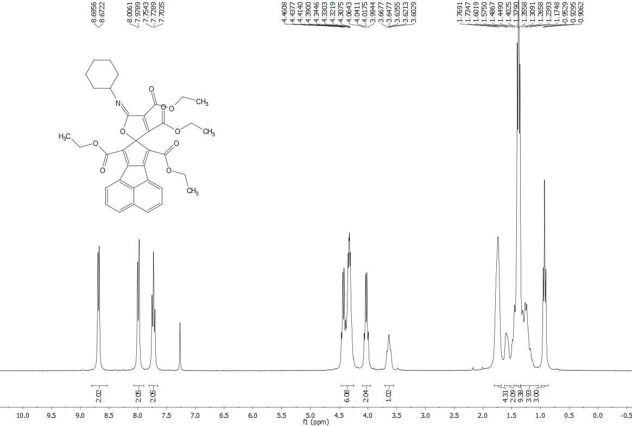
Figure S17 (300-MHz) ¹H NMR spectrum of compound 4i in CDCl₃
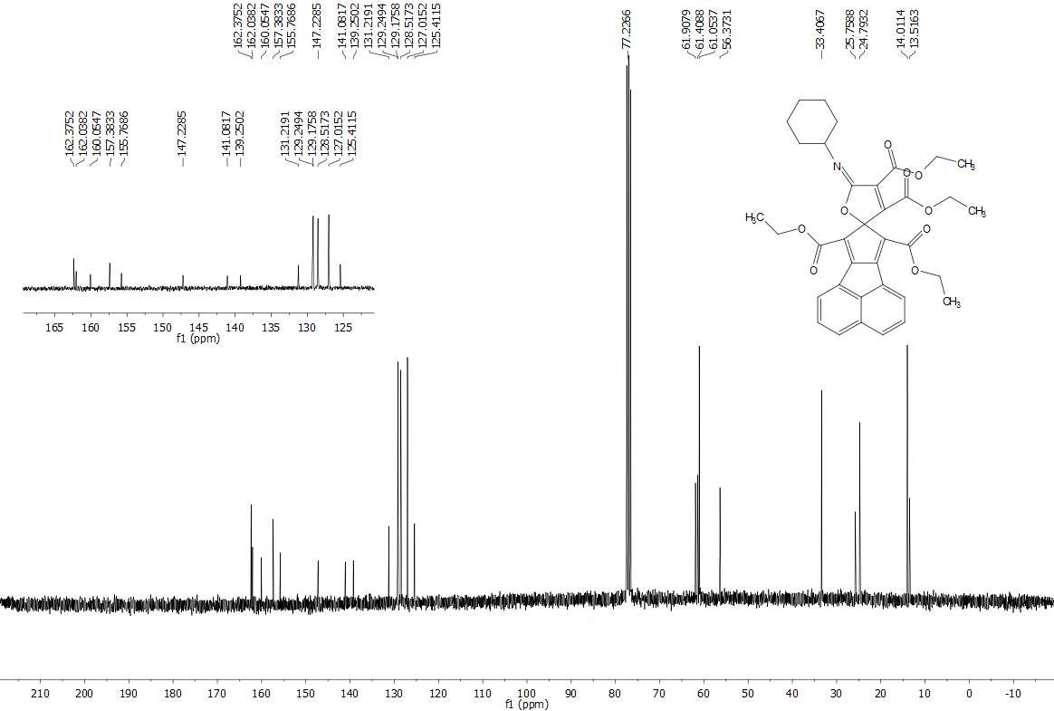
Figure S18 (75-MHz) ¹³C NMR spectrum of compound 4i in CDCl₃

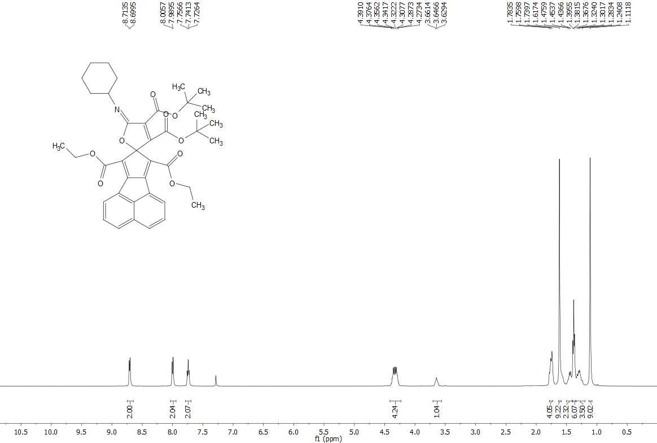
Figure S19 (500-MHz) ¹H NMR spectrum of compound 4j in CDCl₃
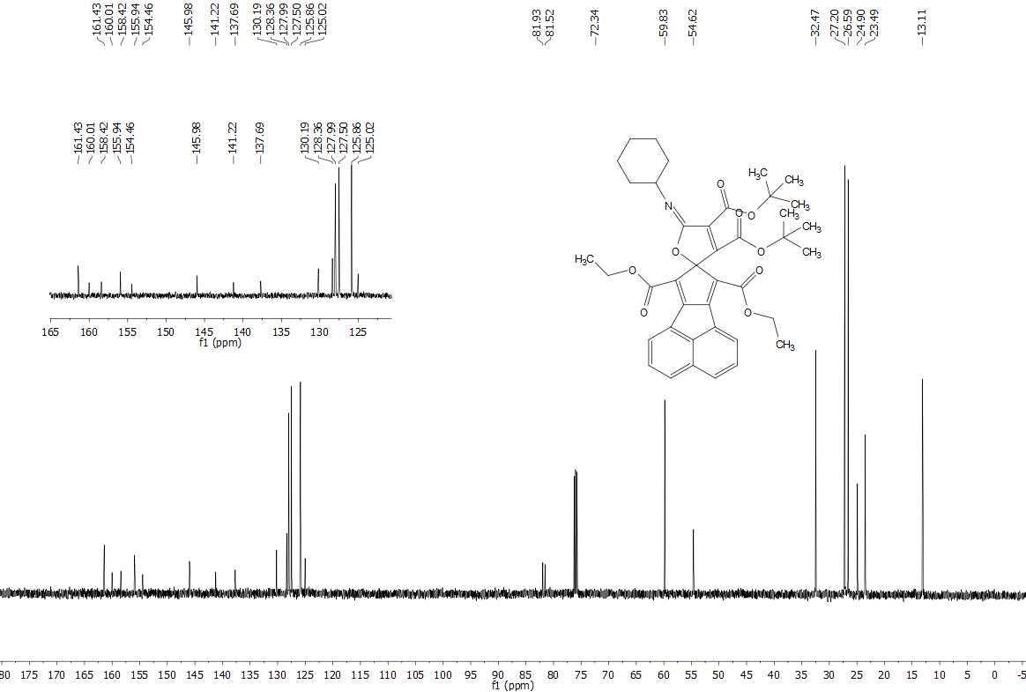
Figure S20 (125-MHz) ¹³C NMR spectrum of compound 4j in CDCl₃

