An efficient metal-free synthesis of carbodiimide tethered amino acid conjugates
Chinthaginjala Srinivasulu, Kuppi Reddy Gari Divya, Nagamangala Ramachandra Sagar and Vommina V Sureshbabu*
Peptide Research Laboratory, Department of Chemistry, Bangalore University, Bangalore 560 056, India.
E-mail: sureshbabuvommina@rediffmail.com, hariccb@gmail.com.
Contents

Experimental section
General procedure for the synthesis of α-/N^{β}-Cbz protected carbodiimide tethered amino acid conjugate
Characterization data of compounds
¹H, ¹³C NMR, HRMS and IR spectra of compounds
RP-HPLC Chromatograms of compounds

Experimental section

All chemicals were used as obtained from Sigma Aldrich, USA, and Spectrochem India. All the solvents were dried and purified using recommended procedures in the literature whenever necessary. High resolution mass spectra were recorded on a Micromass QTOF micromass spectrometer using electron spray ionization mode. ¹H NMR and ¹³C NMR spectra were recorded on a Bruker AMX 400 MHz and 100 MHz spectrometer, respectively. The RP-HPLC analysis of isomers was carried out by using an Agilent instrument (1200 series Agilent Chem Station) at λ = 254 nm; column: Phenomenex Lux Amylose-2 and Cellulose-1, pore size-5 μm, diameter × length = 4.6 × 250 mm; method: gradient 0.1% TFA water-acetonitrile; Flow rate: 1 mL/min in 30 min and Eclipse, XDB-C18, pore size-5 μm, diameter x length = 4.6 x 150 nm). TLC experiments were done using MERCK TLC aluminum sheets (silica gel 60 F254) and chromatograms were visualized by exposing in iodine chamber and in UV-lamp. Column chromatography was performed on silica gel (100-200 mesh) using ethyl acetate and hexane mixture as eluent.

General procedure for the synthesis of α-carbodiimide tethered amino acid conjugate
To a solution of α-isocyanide ester (1.2 equiv., 1.21g) in 1,4-dioxane (10 mL) were added I₂ (20 mol %, 0.5g) portions wise, tert-butyl hydroperoxide (2.0 equiv., 1.93g) and aniline (1.0 equiv., 1.0 g) derivatives. After addition, the mixture was allowed to reflux. When the reaction was complete (monitored by TLC), the mixture was cooled to room temperature, washed with 10% aq. Na₂S₂O₃ (3 × 15 mL) and the resulting solution was extracted with ethyl acetate. The combined organic layer was washed with brine, dried over anhydrous Na₂SO₄, filtered and concentrated under reduced pressure. The residue was purified by column chromatography (silica gel 100-200 mesh) with 1% - 5% ethyl acetate and hexane to afford corresponding title compounds.
General procedure for the synthesis of N^{β}-Cbz protected carbodiimide tethered amino acid conjugate

To a solution of N^{β}-Cbz-protected amino alkyl isocyanide (1.2 equiv., 2.12g) in 1,4-dioxane (10 mL) were added I₂ (30 mol %, 1.03g) portions wise, tert-butyl hydroperoxide (2.0 equiv., 1.46g) and aniline (1.0 equiv., 1.0 g) derivatives. After addition, the mixture was allowed to reflux for 4 h. After completion of reaction(monitored by TLC),the mixture was cooled to room temperature, washed with 10% aq. Na₂S₂O₃ (3 × 15 mL) and the resulting solution was extracted with ethyl acetate. The combined organic layer was washed with brine, dried over anhydrous Na₂SO₄, filtered and concentrated under reduced pressure. The residue was purified by column chromatography (silica gel 100-200 mesh) with 8% - 12% ethyl acetate and hexane to afford corresponding title compounds.

Characterization data:
(2S)-methyl 3-phenyl-2-(((phenylimino)methylene)amino)propanoate (3a)
Light yellow oil; Yield 86%; IR (ν, cm⁻¹): 2129 (-N=C=N-), 1746 (C=O); ¹H NMR (400 MHz, DMSO-d₆): δ 7.33-6.93 (m, 10H), 4.74 (dd, J = 8 Hz, 4 Hz, 1H), 3.75 (s, 3H), 3.18 (dd, J = 16 Hz, 4 Hz, 1H), 3.08 (dd, J = 16 Hz, 8 Hz, 1H); ¹³C NMR (100 MHz, DMSO-d₆): δ 171.4, 139.7, 136.7, 130.6, 129.8, 128.8, 128.3, 127.3, 126.6, 125.8, 60.3, 53.1, 39.5; HRMS: calcd. For C₁₇H₁₆N₂O₂H [M+H]⁺: 281.1290, found: 281.1290.
(2R)-methyl 3-phenyl-2-(((phenylimino)methylene)amino)propanoate (3a*)
Light yellow oil; Yield 84%; ¹H NMR (400 MHz, DMSO-d₆): δ 7.33-6.92 (m, 10H), 4.75 (dd, J = 8 Hz, 4 Hz, 1H), 3.75 (s, 3H), 3.18 (dd, J = 12 Hz, 4 Hz, 1H), 3.08 (dd, J = 12 Hz, 8 Hz, 1H); ¹³C NMR (100 MHz, DMSO-d₆): δ 171.4, 139.7, 136.7, 130.6, 129.8, 128.8, 127.3, 126.6, 125.4, 124.1, 60.2, 53.1, 39.5; HRMS: calcd. For C₁₇H₁₆N₂O₂H [M+H]⁺: 281.1290, found: 281.1290.
(2S)-methyl 2-((((4-bromophenyl)imino)methylene)amino)-3-methylbutanoate (3b)
Light yellow oil; Yield 82%; IR (ν, cm⁻¹): 2126 (-N=C=N-), 1740 (C=O); ¹H NMR (400 MHz, DMSO-d₆): δ 7.53-7.49 (m, 2H), 7.11-7.08 (m, 2H), 4.35 (d, J = 8 Hz, 1H), 3.73 (s, 3H), 2.24-2.16 (m, 1H), 0.98 (d, J = 8 Hz, 3H), 0.86 (d, J = 8 Hz, 3H); ¹³C NMR (100 MHz, DMSO-d₆): δ 171.5, 139.8, 136.5, 132.8, 126.1, 117.4, 64.9, 53.2, 31.8, 19.8, 17.2; HRMS: calcd. for C13H₁₅BrN2O2H [M+H]⁺: 311.0395, found: 311.0392.
(2S)-methyl 2-((((4-methoxyphenyl)imino)methylene)amino)-3-methylbutanoate (3c)
Light yellow oil; Yield 88%; IR (ν, cm⁻¹): 2127 (-N=C=N-), 1741 (C=O); ¹H NMR (400 MHz, DMSO-d₆): δ 7.13-7.11 (m, 2H), 6.94-6.92 (m, 2H), 4.27 (d, J = 4 Hz, 1H), 3.75 (s, 6H), 2.25-2.19 (m, 1H), 1.02 (d, J = 4 Hz, 3H), 0.91 (d, J = 8 Hz, 3H); ¹³C NMR (100 MHz, DMSO-d₆): δ 171.7, 157.1, 137.6, 132.3, 128.2, 127, 125.8, 125, 64.8, 55.7, 53, 31.9, 19.7, 17.3; HRMS: calcd. for C14H₁₈N2O₃H [M+H]⁺: 263.1396, found: 263.1396.
(2S)-methyl 4-methyl-2-(((m-tolylimino)methylene)amino)pentanoate (3d)
Light yellow oil; Yield 86%; IR (ν, cm⁻¹): 2124 (-N=C=N-), 1744 (C=O); ¹H NMR (400 MHz, DMSO-d₆): δ 7.46-7.22 (m, 2H,), 7.00-6.96 (m, 2H), 4.39 (t, J = 8 Hz, 1H), 3.74 (s, 3H), 2.29 (s, 3H), 1.83-1.76 (m, 1H), 1.67 (t, J = 8 Hz, 2H), 0.94 (dd, J = 8 Hz, 1.2 Hz, 6H); ¹³C NMR (100 MHz, DMSO-d₆): δ 172.4, 139.7, 139.4, 136.8, 129.7, 126.2, 124.6, 121.2, 57.8, 53.1, 42.7, 25.1, 23.1, 21.7, 21.2; HRMS: calcd. for C15H₂₀N2O2H [M+H]⁺: 261.1603, found: 261.1601.
(2S)-methyl 2-((((2-chlorophenyl)imino)methylene)amino)propanoate (3e)
Light yellow oil; Yield 81%; IR (ν, cm⁻¹): 2139 (-N=C=N-), 1743 (C=O); ¹H NMR (400 MHz, DMSO-d₆): δ 7.49-7.16 (m, 4H), 4.53 (qt, J = 8 Hz, 1H), 3.74 (s, 3H), 1.48 (d, J = 8 Hz, 3H); ¹³C NMR (100 MHz, DMSO-d₆): δ 172.2, 137, 135, 130.4, 128.6, 126.6 (2C), 126.2, 54.9, 53.2, 20; HRMS: calcd. for C11H11ClN2O₂Na [M+Na]⁺: 261.0407, found: 261.0407.
(2S)-methyl 2-phenyl-2-(((p-tolylimino)methylene)amino)acetate (3f)
Light yellow oil; Yield 84%; IR (ν, cm⁻¹): 2108 (-N=C=N-), 1742 (C=O); ¹H NMR (400 MHz, DMSO-d₆): δ 7.45-7.37 (m, 5H), 7.17 (d, J = 8 Hz, 2H), 7.08 (t, J = 8 Hz, 2H), 5.57 (s, 1H), 3.70 (s, 3H), 2.29 (s, 3H); ¹³C NMR (100 MHz, DMSO-d₆): δ 171, 138.1, 137.2, 136.5, 135.9, 130.5, 129.4, 129.1, 127.5, 124, 62.3, 53.5, 20.9; HRMS: calcd. for C17H16N2O₂Na[M+Na]⁺: 303.1109, found: 303.1107.
(2S,3R)-methyl 2-((((4-bromophenyl)imino)methylene)amino)-3-methylpentanoate (3g)
Light yellow oil; Yield 87%; IR (ν, cm⁻¹): 2126 (-N=C=N-), 1740 (C=O); ¹H NMR (400 MHz, DMSO-d₆): δ 7.52 (t, J = 8 Hz, 2H), 7.14-7.10 (m, 2H), 4.40 (d, J = 4 Hz, 1H), 3.75 (s, 3H), 2.0-1.94 (m, 1H), 1.27-1.17 (m, 2H), 0.98 (d, J = 8 Hz, 3H), 0.88 (t, J = 8 Hz, 3H); ¹³C NMR (100 MHz, DMSO-d₆): 171.6, 139.8, 136.4, 132.8, 126.1, 117.4, 64.4, 53.1, 38.4, 24.6, 16.5, 11.8.
(2S,3R)-methyl 3-methyl-2-(((m-tolylimino)methylene)amino)pentanoate (3h)
Light yellow oil; Yield 82%; IR (ν, cm⁻¹): 2126 (-N=C=N-), 1741 (C=O); ¹H NMR (400 MHz, DMSO-d₆): δ 7.45-6.95 (m, 4H), 4.34 (d, J = 4 Hz, 1H), 3.75 (s, 3H), 2.29 (s, 3H), 1.98-1.95 (m, 1H), 1.40-1.37 (m, 2H), 0.99 (d, J = 8 Hz, 3H), 0.89 (t, J = 8 Hz, 3H); ¹³C NMR (100 MHz, DMSO-d₆): δ 171.6, 139.9, 139.4, 136.7, 129.7, 126, 124.5, 121.1, 64.2, 53, 38.6, 24.7, 21.2, 16.5, 11.8; HRMS: calcd. for C15H20N2O₂Na[M+Na]⁺: 283.1422, found: 283.1422.
(2S)-methyl 2-((((4-cyanophenyl)imino)methylene)amino)-2-phenylacetate (3i)
Yellow oil; Yield 76%; ¹H NMR (400 MHz, DMSO-d₆): δ 7.65-7.39 (m, 9H), 5.21 (s, 1H), 3.73 (s, 3H); ¹³C NMR (100 MHz, DMSO-d₆): δ 171.6, 144.3, 138.8, 137.7, 132.8, 129.2, 128.9, 128.8, 127, 119.3, 114.3, 69.2, 54.1; HRMS: calcd. for C17H13N3O₂H [M+H]⁺: 292.1086, found: 292.0602.
benzyl ((2S)-1-phenyl-3-(((m-tolylimino)methylene)amino)propan-2-yl)carbamate (6a)
Yellow oil; Yield 82 %; IR (ν, cm⁻¹): 3397 (-NH-), 2128 (-N=C=N-); ¹H NMR (400 MHz, DMSO-d₆): δ 7.91 (s, 1H), 7.70-7.22 (m, 14H), 5.26 (dd, J = 8 Hz, 8 Hz, 2H), 4.10-3.98 (m, 1H), 3.70 (dd, J = 8 Hz, 4 Hz, 1H), 3.61 (dd, J = 8 Hz, 4 Hz, 1H), 2.91 (dd, J = 8 Hz, 4 Hz, 1H), 2.75 (dd, J = 8 Hz, 4.5 Hz, 1H), 2.16 (s, 3H); ¹³C NMR (100 MHz, DMSO-d₆): δ 156.3, 151, 140.3, 139.4, 138.7, 136.1, 129.7, 129.6, 128.7, 128.2, 127.9, 126.3, 125.9, 125, 124.5, 121, 65.6, 53.9, 49.8, 38.3, 21.3; HRMS: calcd. for C25H25N3O₂H [M+H]⁺: 400.2025, found: 400.2024.
benzyl ((2S)-1-((((4-methoxyphenyl)imino)methylene)amino)propan-2-yl)carbamate (6b)
Yellow oil; Yield 86 %; IR (ν, cm⁻¹): 3301 (-NH-), 2119 (-N=C=N-); ¹H NMR (400 MHz, DMSO-d₆): δ 7.42 (s, 1H), 7.34-6.84 (m, 9H), 4.94 (dd, J = 18 Hz, 12 Hz, 2H), 3.71 (s, 3H), 3.41-3.37 (m, 1H), 1.26 (d, J = 8 Hz, 2H), 1.11 (d, J = 8 Hz, 3H); ¹³C NMR (100 MHz, DMSO-d₆): δ 156.9, 156.1, 137.4, 136.7, 132.8, 128.7, 128.2, 128.1, 124.7, 115.2, 65.7, 55.7, 51, 48, 18.7; HRMS: calcd. for C19H21N3O₃H [M+H]⁺: 340.1661, found: 340.1659.
benzyl ((2S)-3-methyl-1-(((phenylimino)methylene)amino)butan-2-yl)carbamate (6c)
Yellow oil; Yield 81 %; ¹H NMR (400 MHz, DMSO-d₆): δ 8.23 (s, 1H), 7.75-7.28 (m, 10H), 5.24 (s, 2H), 3.53-3.48 (m, 1H), 2.98 (dd, J = 8 Hz, 8 Hz, 1H), 2.75 (dd, J = 12 Hz, 8 Hz, 1H), 1.77-1.69 (m, 1H), 0.86 (d, J = 8 Hz, 6H); ¹³C NMR (100 MHz, DMSO-d₆): δ 158.6, 140.6, 137.6, 134.6, 128.1, 127.9, 127, 126.2, 125.8, 124.9, 67.8, 61.3, 50.2, 31.6, 19.4, 18.1; HRMS: calcd. for C20H23N3O₂H [M+H]⁺: 338.1869, found: 338.1867.

HRMS, ¹H NMR, ¹³C NMR and IR spectra for the title compounds
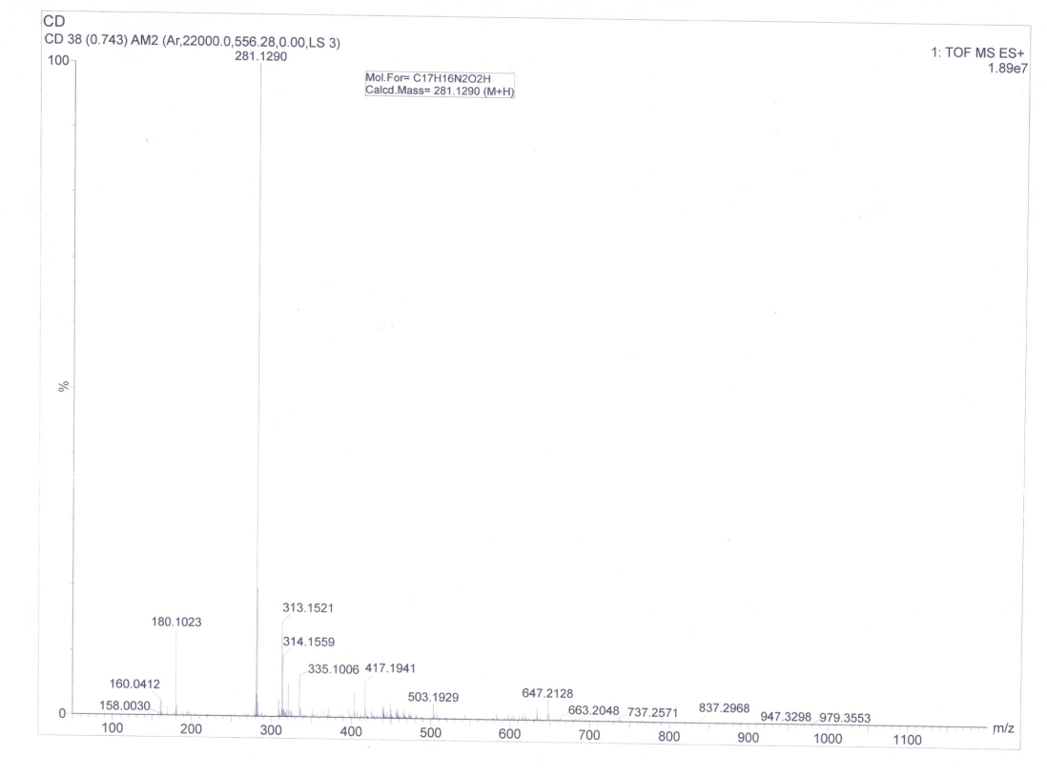
HRMS spectrum of compound 3a

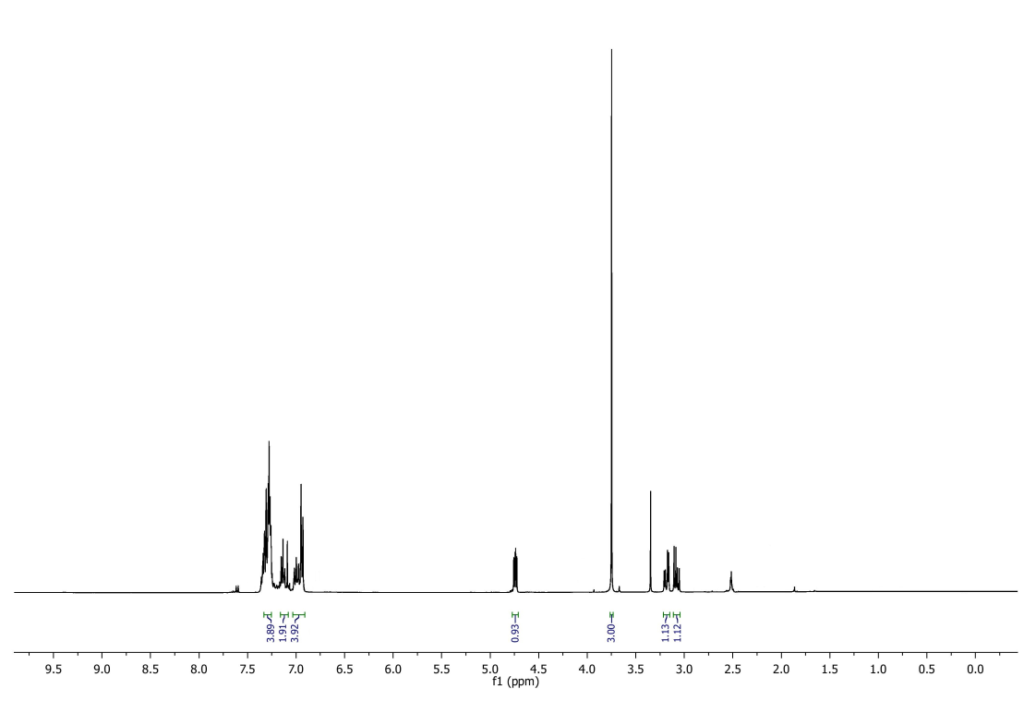
¹H NMR spectrum of compound 3a

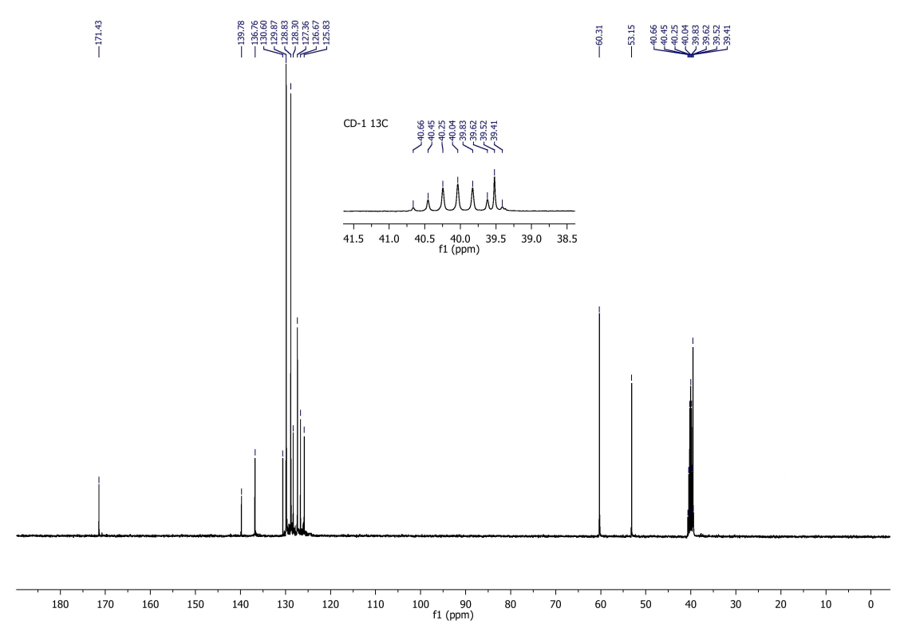
¹³C NMR spectrum of compound 3a

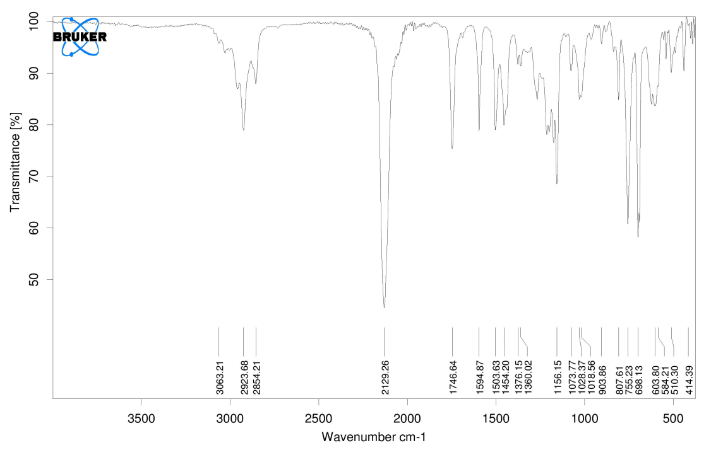
IR Spectrum of compound 3a
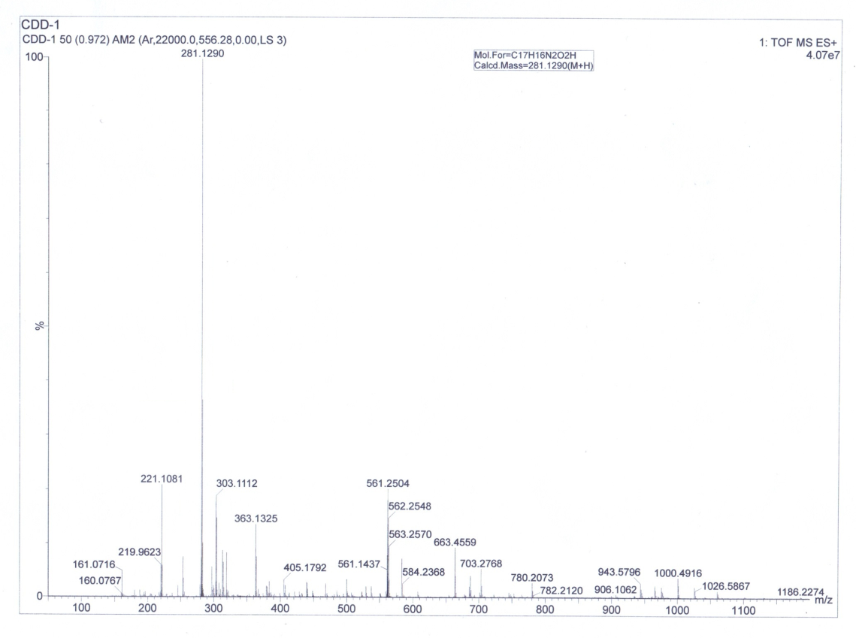
HRMS spectrum of compound 3a*

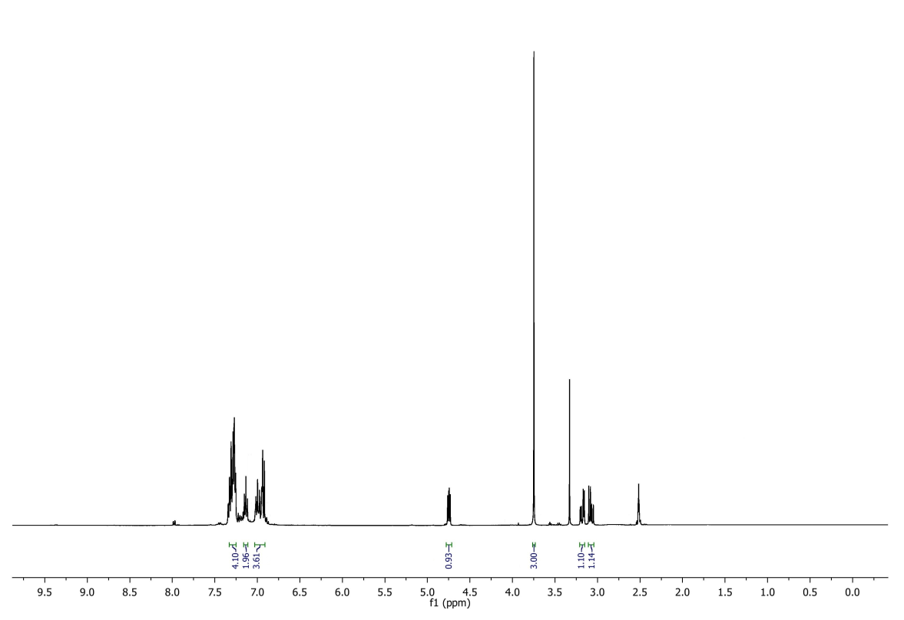
¹H NMR spectrum of compound 3a*

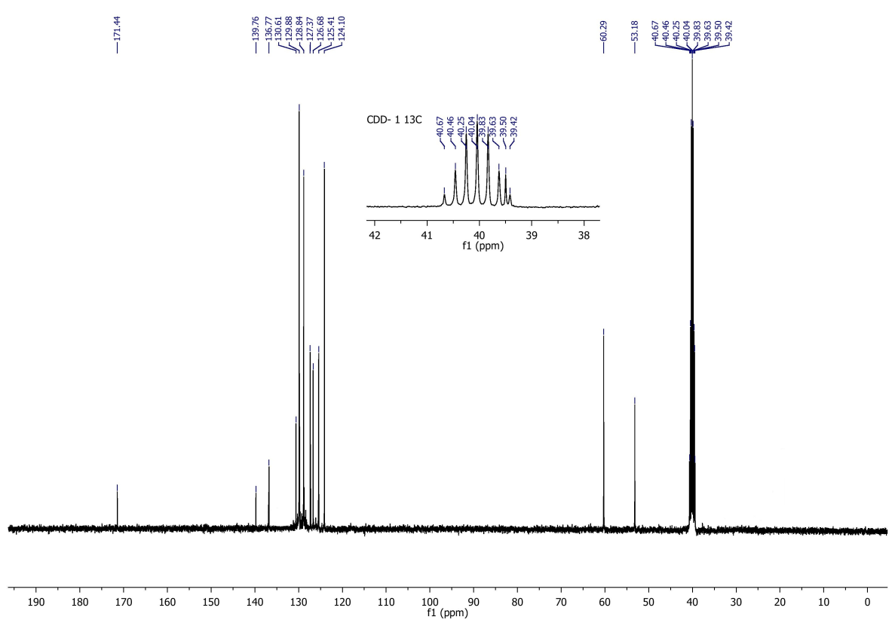
¹³C NMR spectrum of compound 3a*

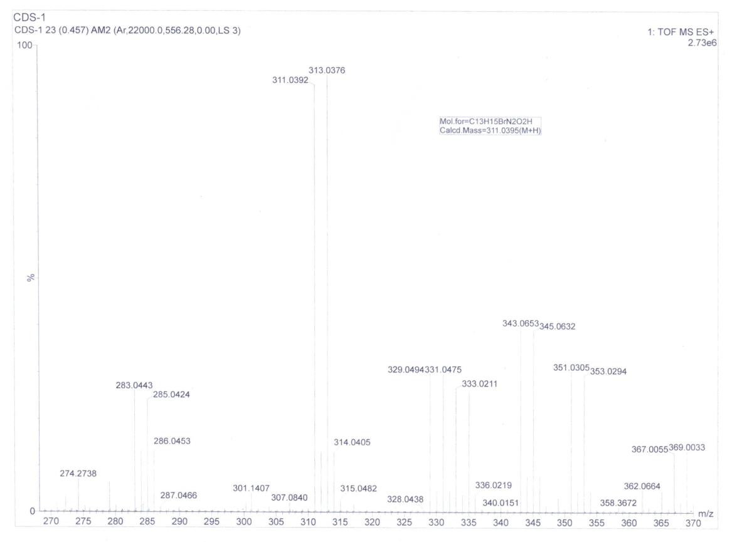
HRMS spectrum of compound 3b

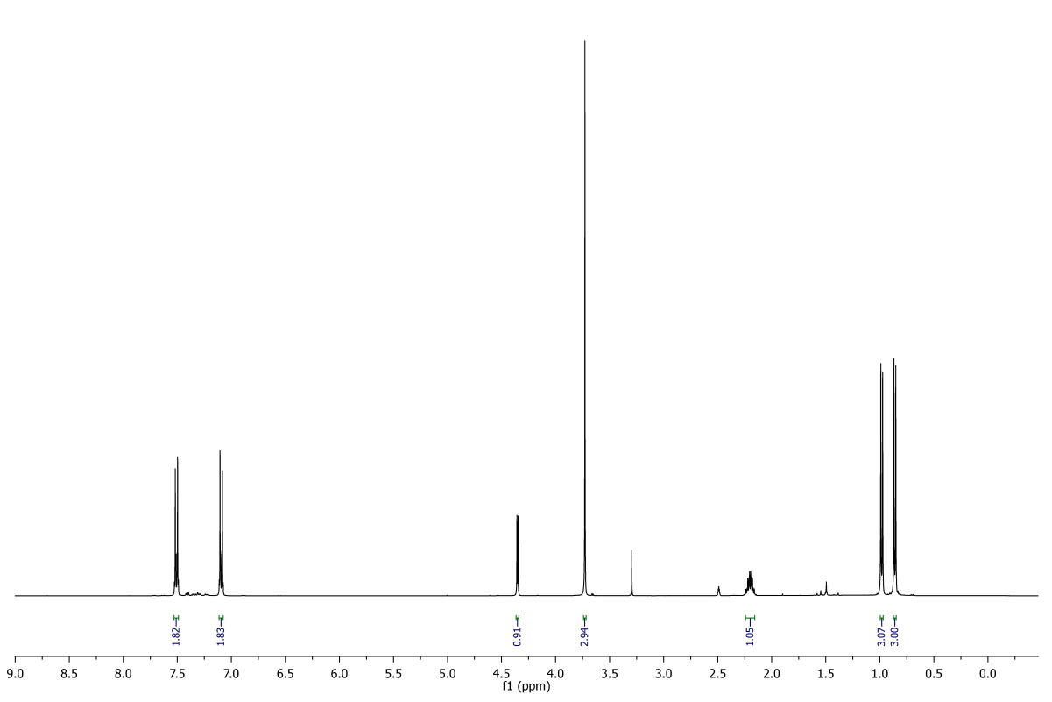
¹H NMR spectrum of compound 3b

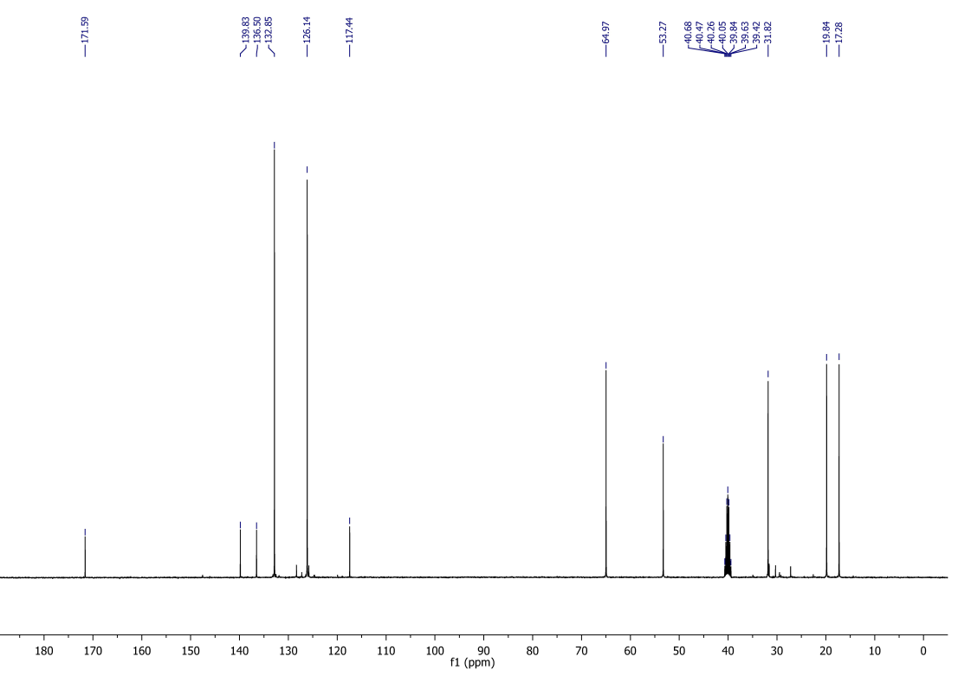
¹³C NMR spectrum of compound 3b

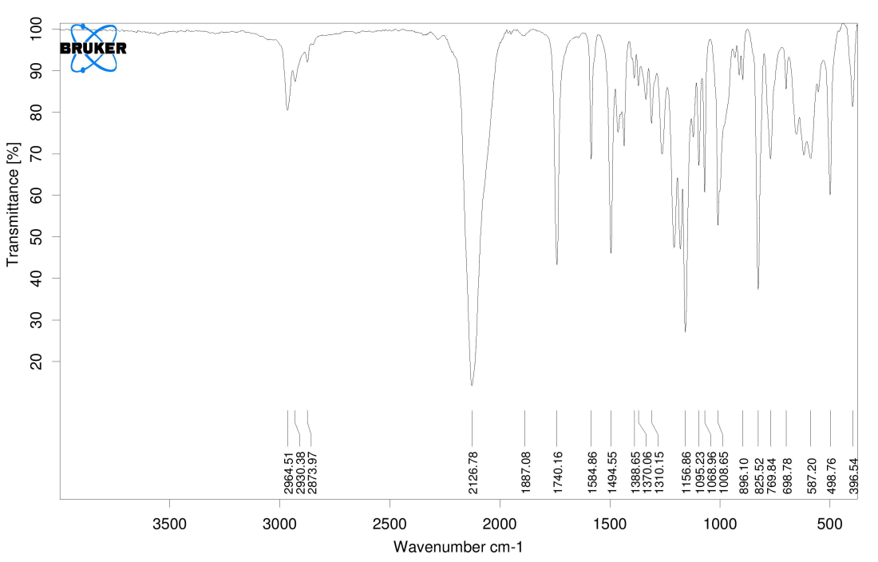
IR Spectrum of compound 3b

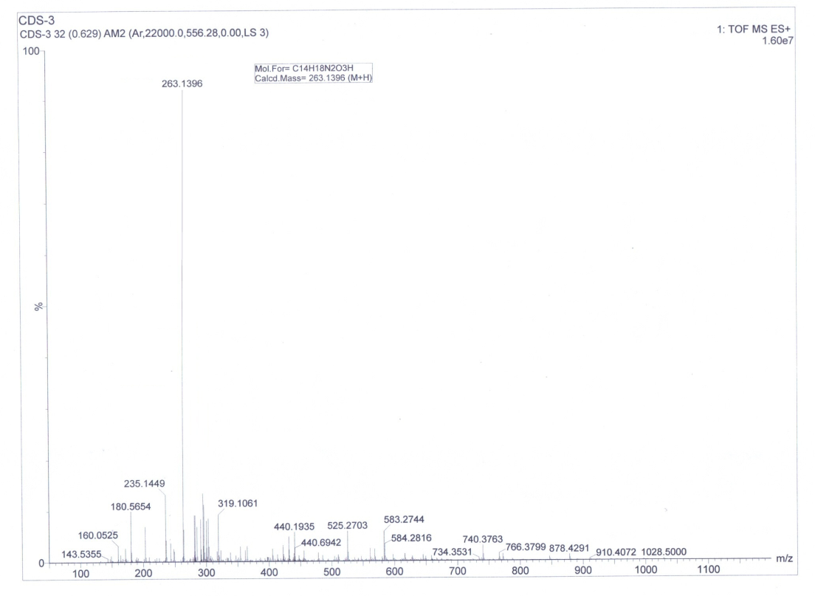
HRMS spectrum of compound 3c

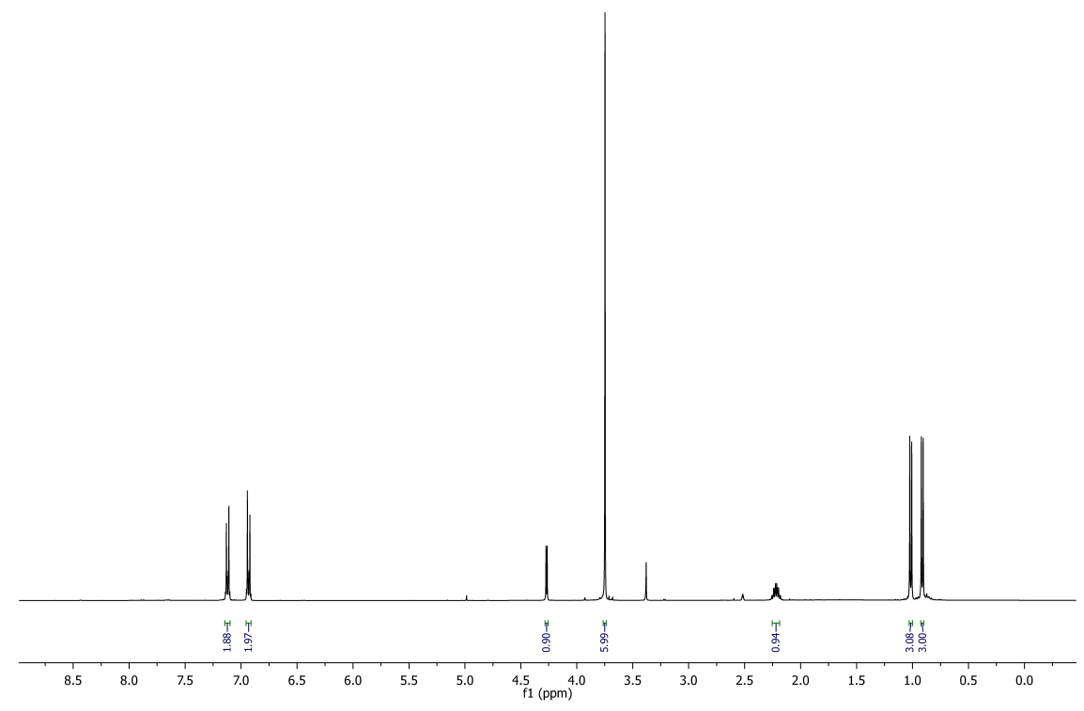
¹H NMR spectrum of compound 3c

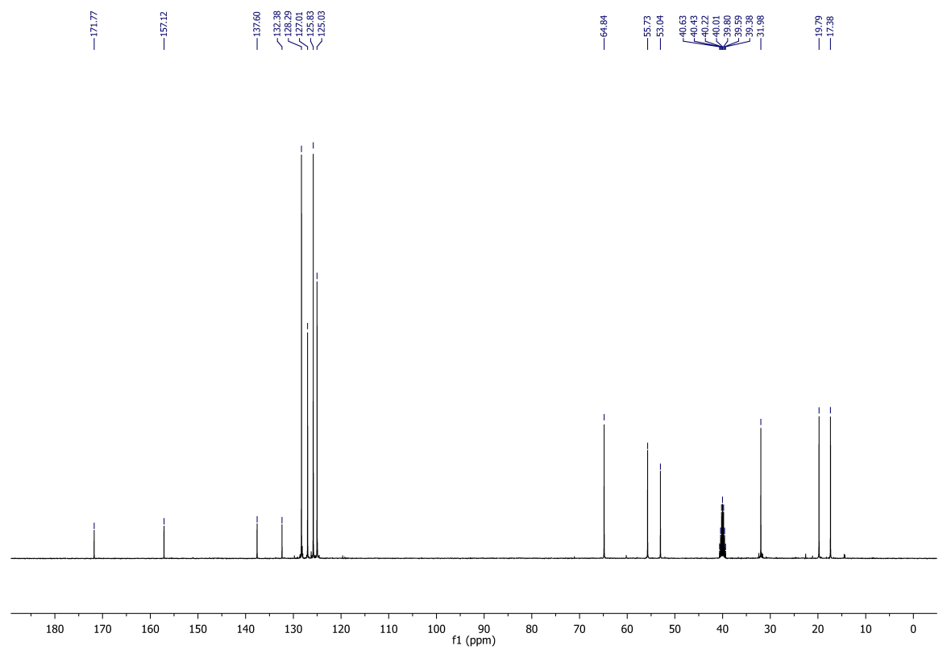
¹³C NMR spectrum of compound 3c

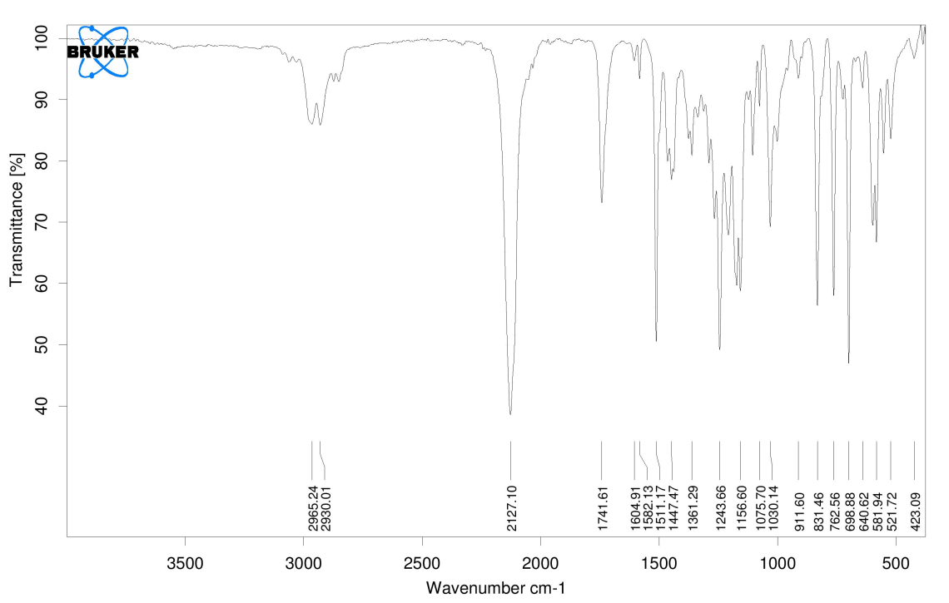
IR Spectrum of compound 3c

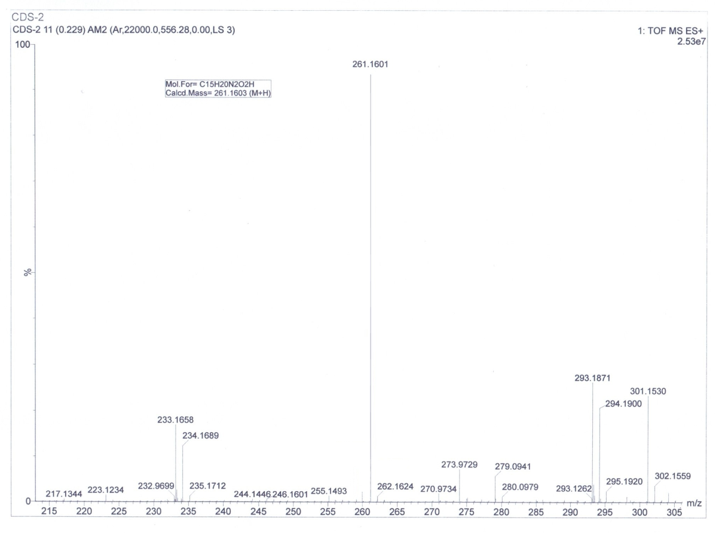
HRMS spectrum of compound 3d

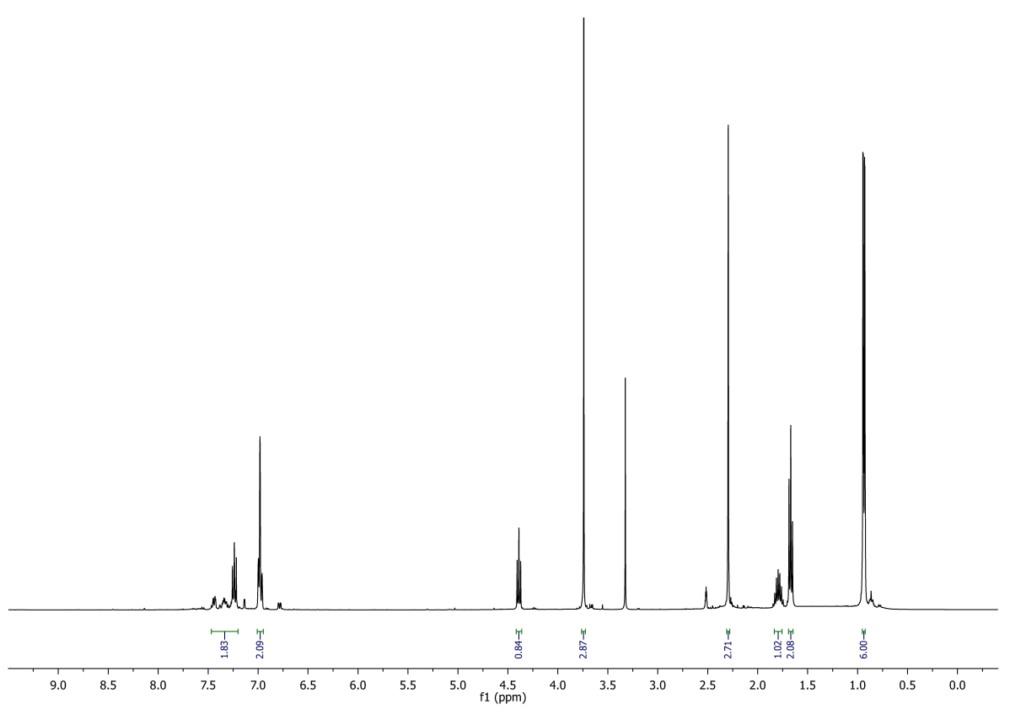
¹H NMR spectrum of compound 3d

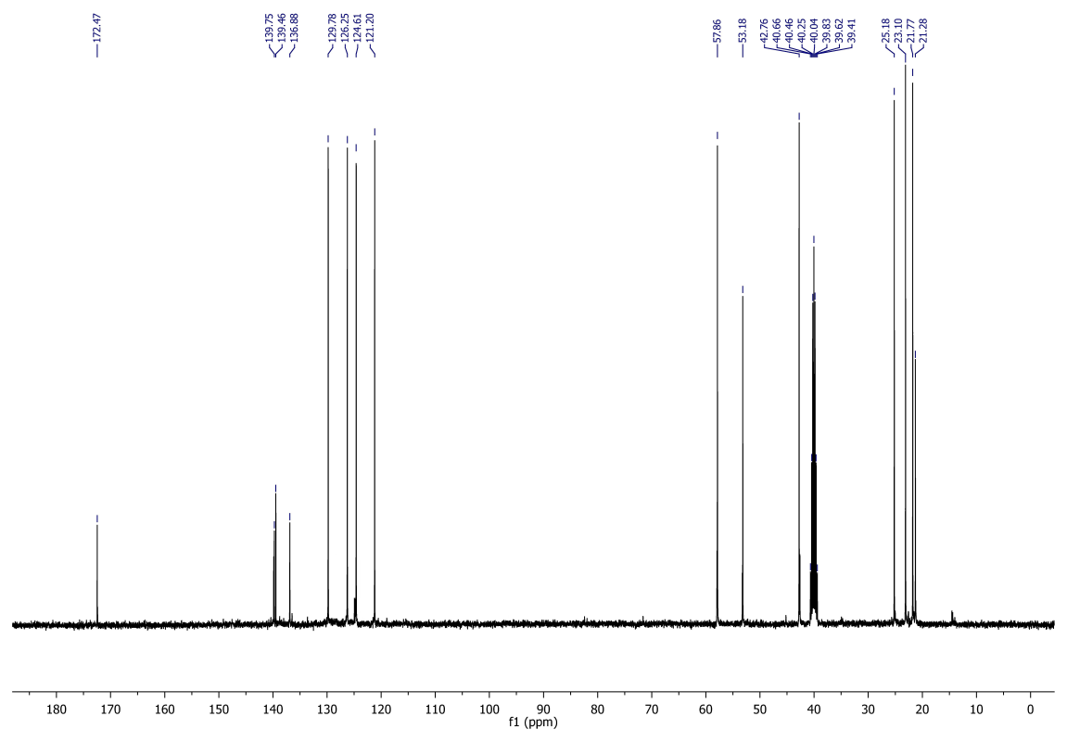
¹³C NMR spectrum of compound 3d

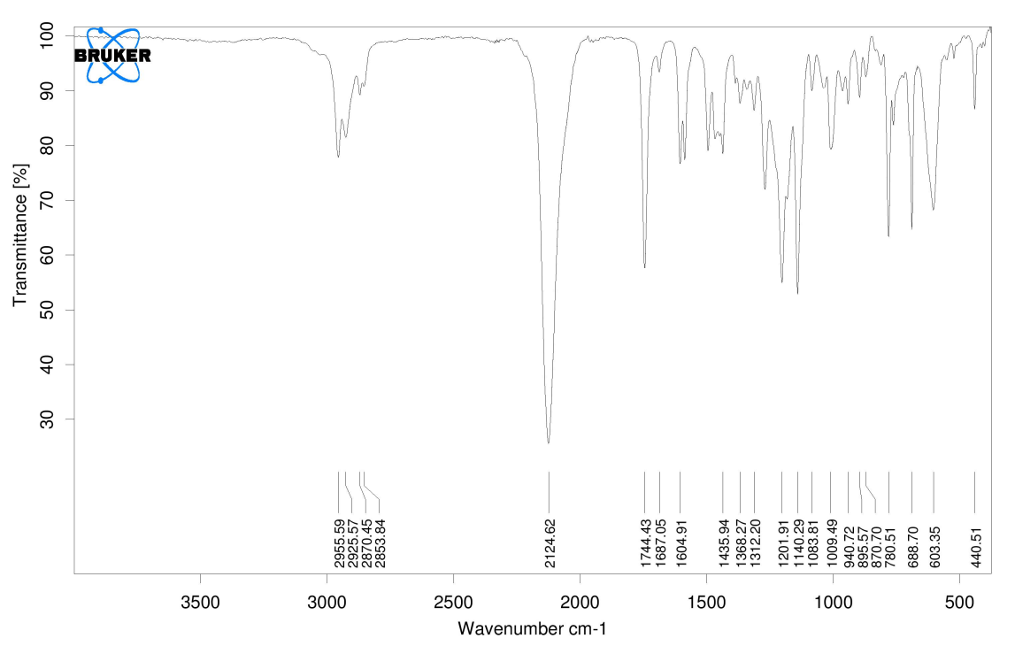
IR Spectrum of compound 3d

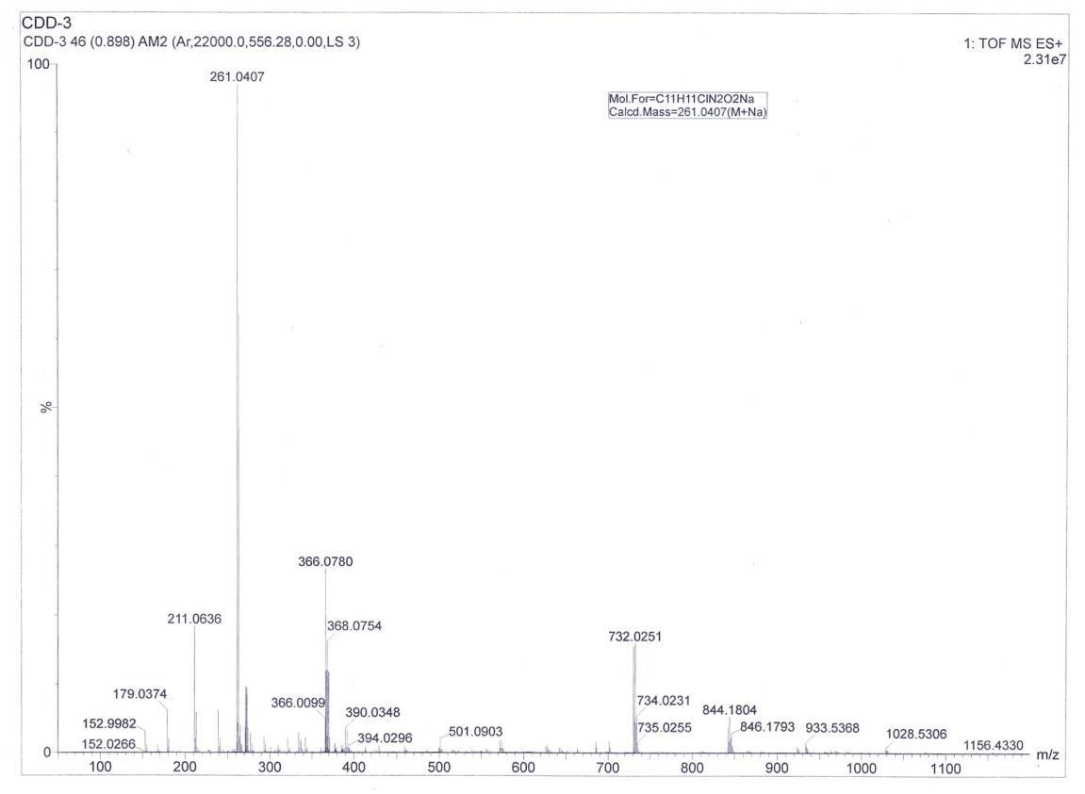
HRMS spectrum of compound 3e

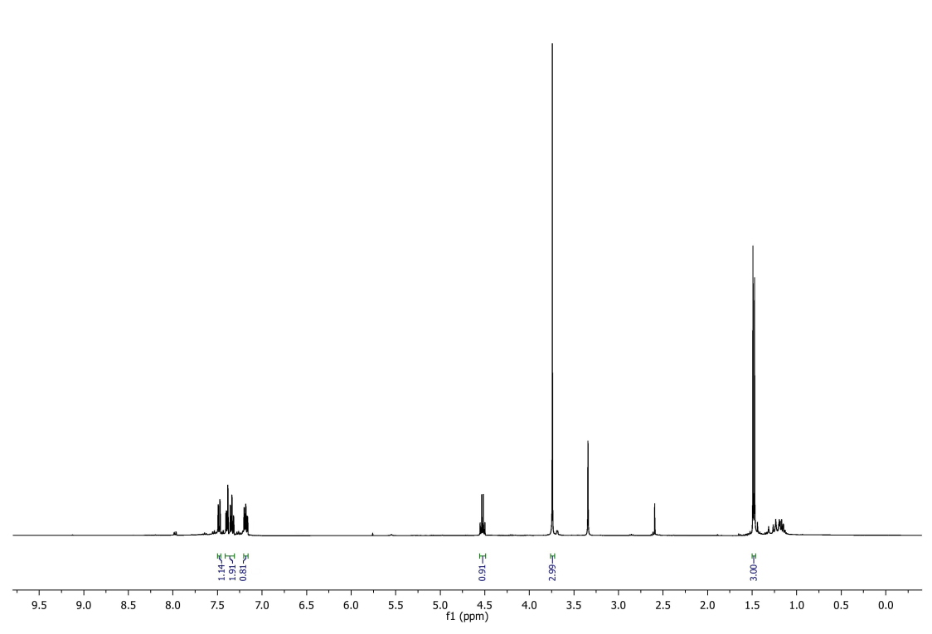
¹H NMR spectrum of compound 3e

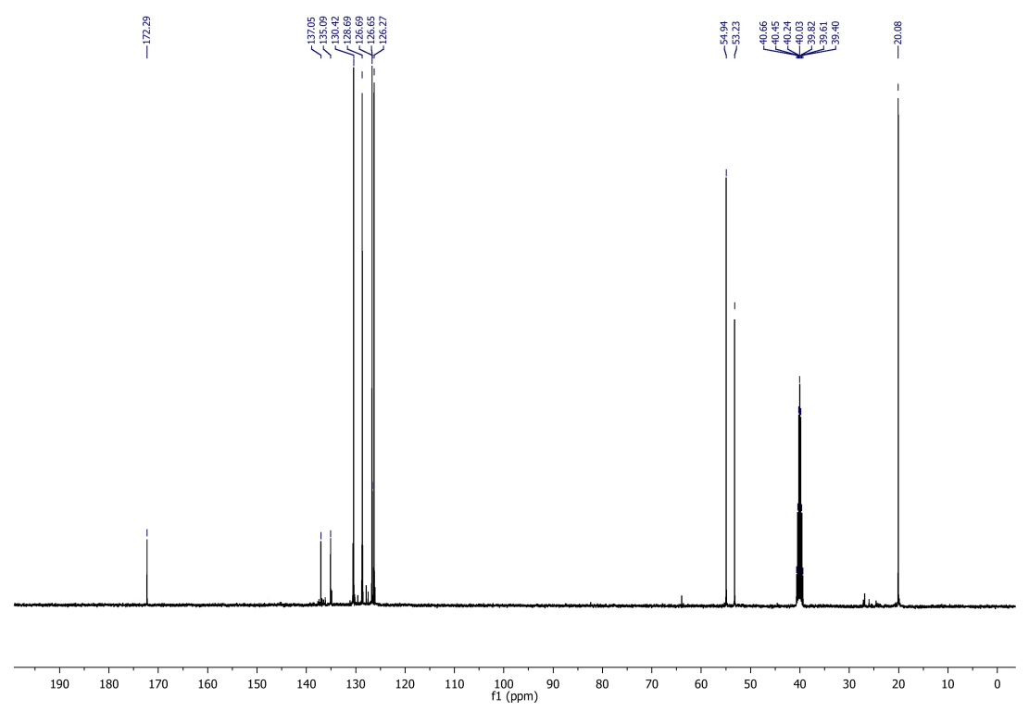
¹³C NMR spectrum of compound 3e

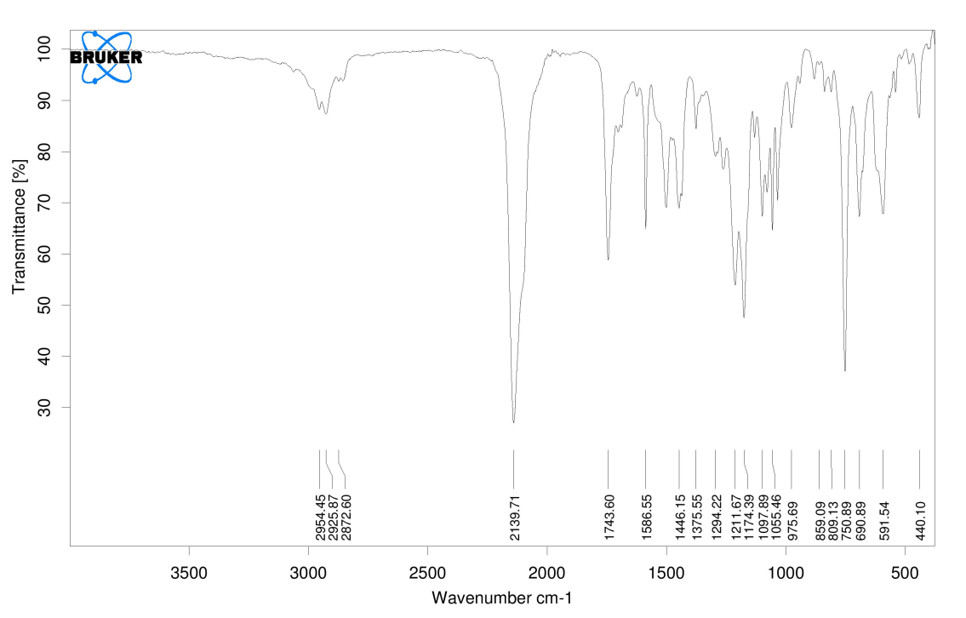
IR Spectrum of compound 3e

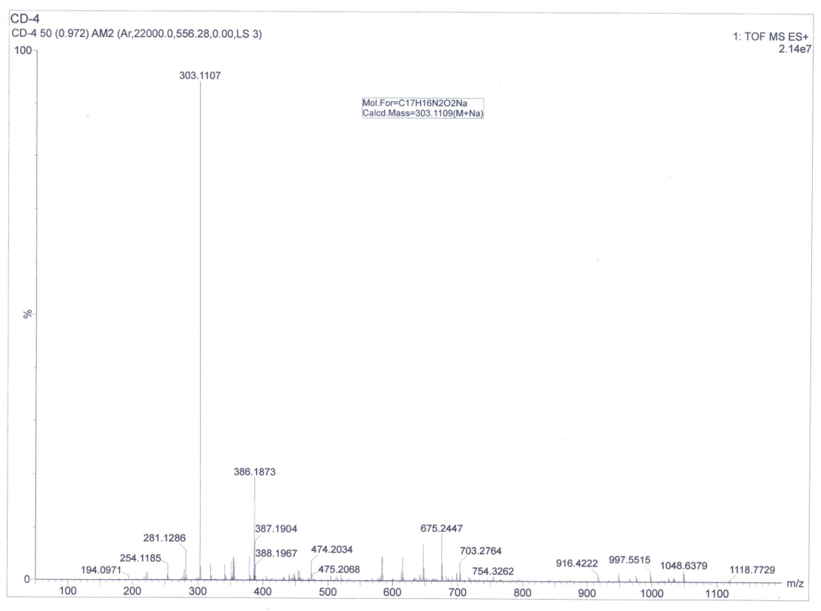
HRMS spectrum of compound 3f

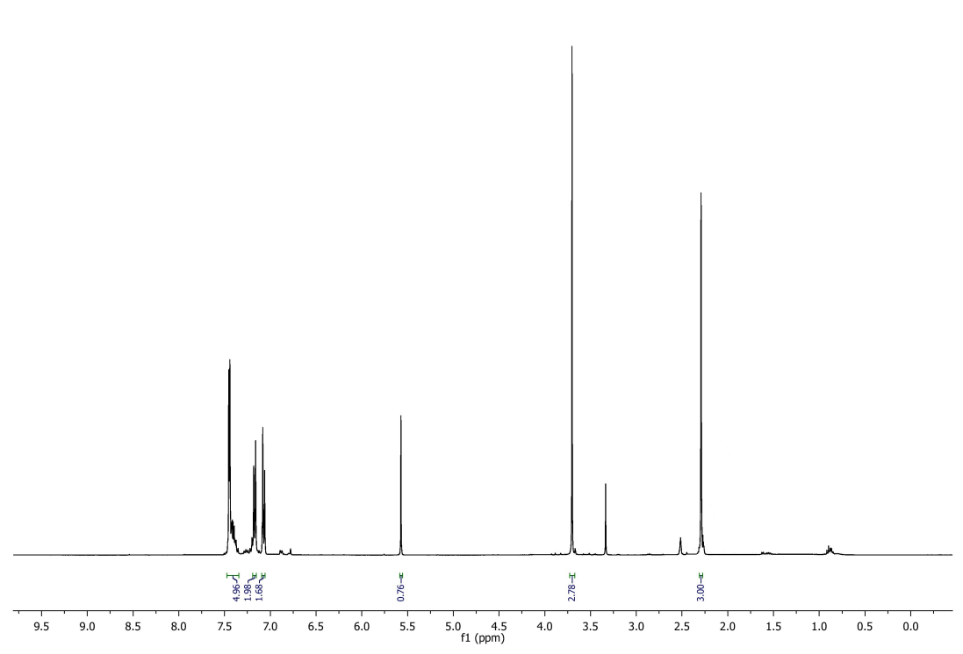
¹H NMR spectrum of compound 3f

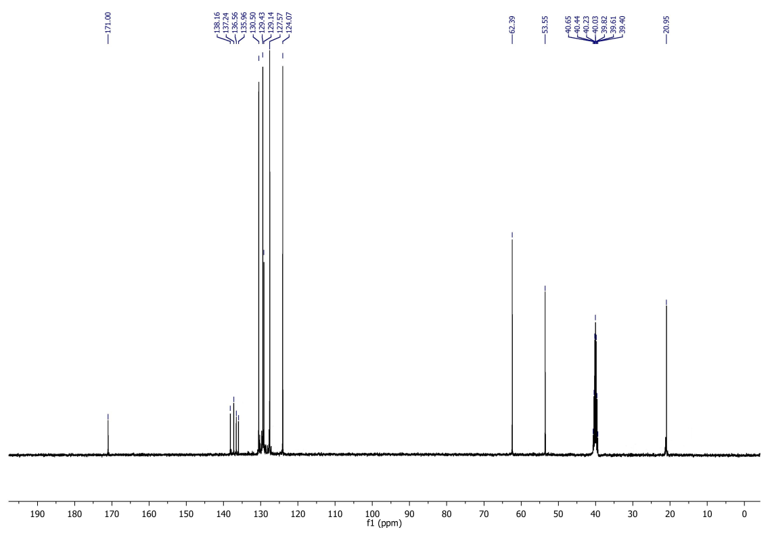
¹³C NMR spectrum of compound 3f

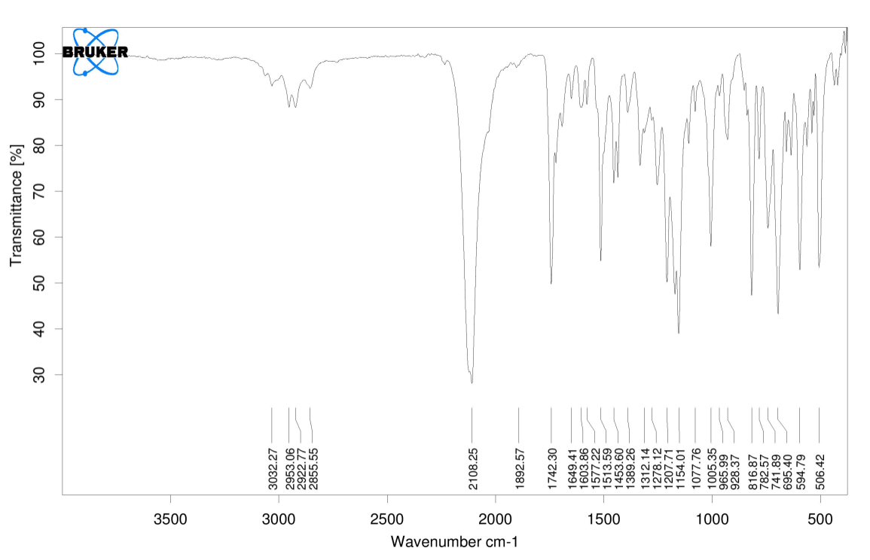
IR Spectrum of compound 3f

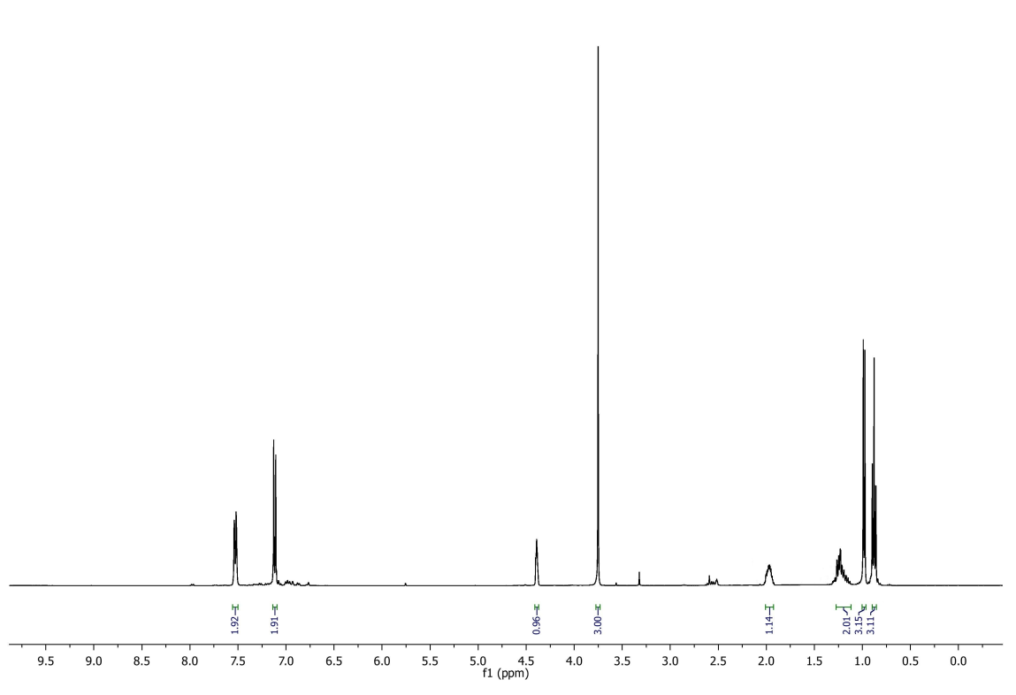
¹H NMR spectrum of compound 3g

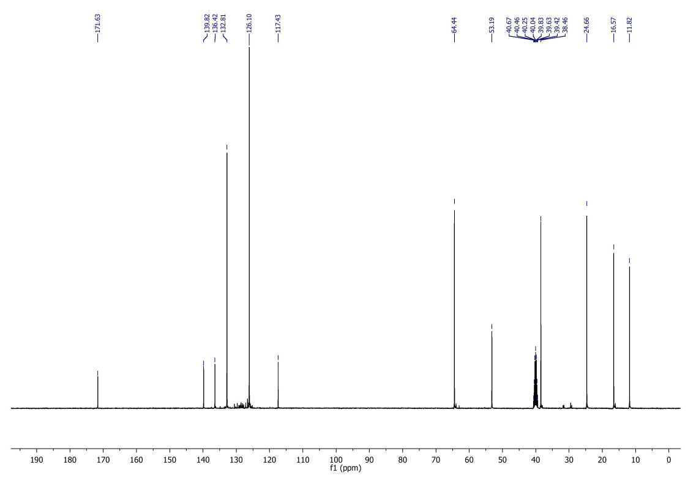
¹³C NMR spectrum of compound 3g

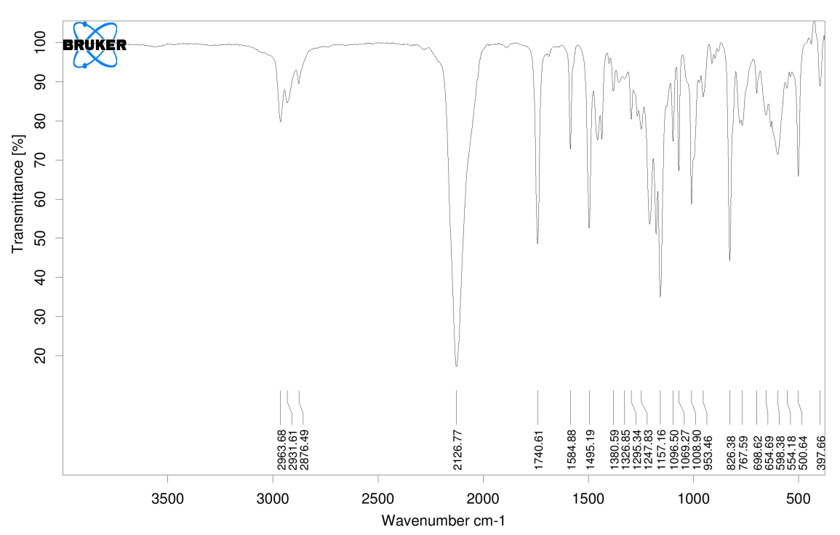
IR Spectrum of compound 3g

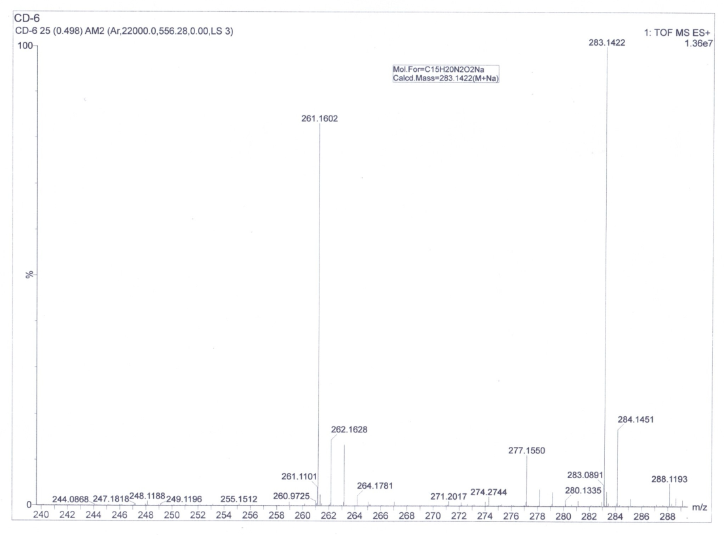
HRMS spectrum of compound 3h

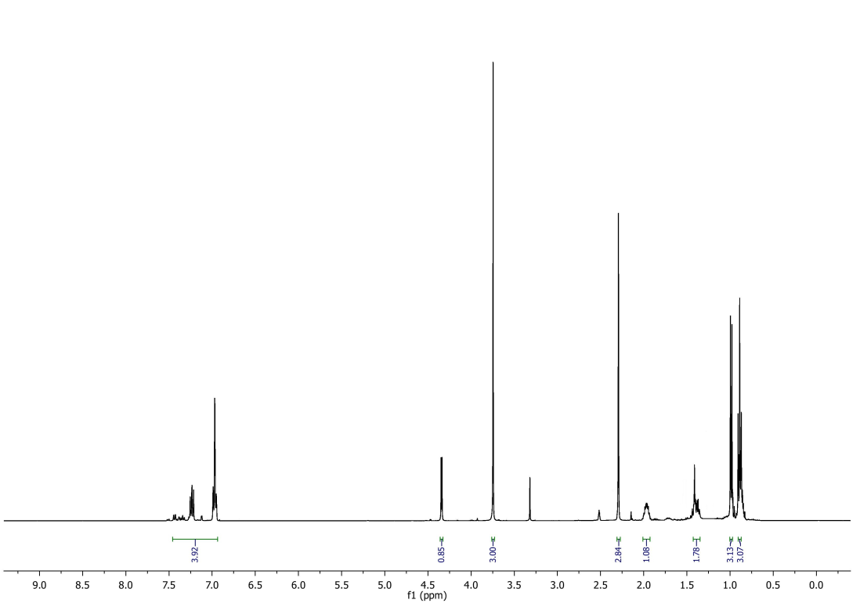
¹H NMR spectrum of compound 3h
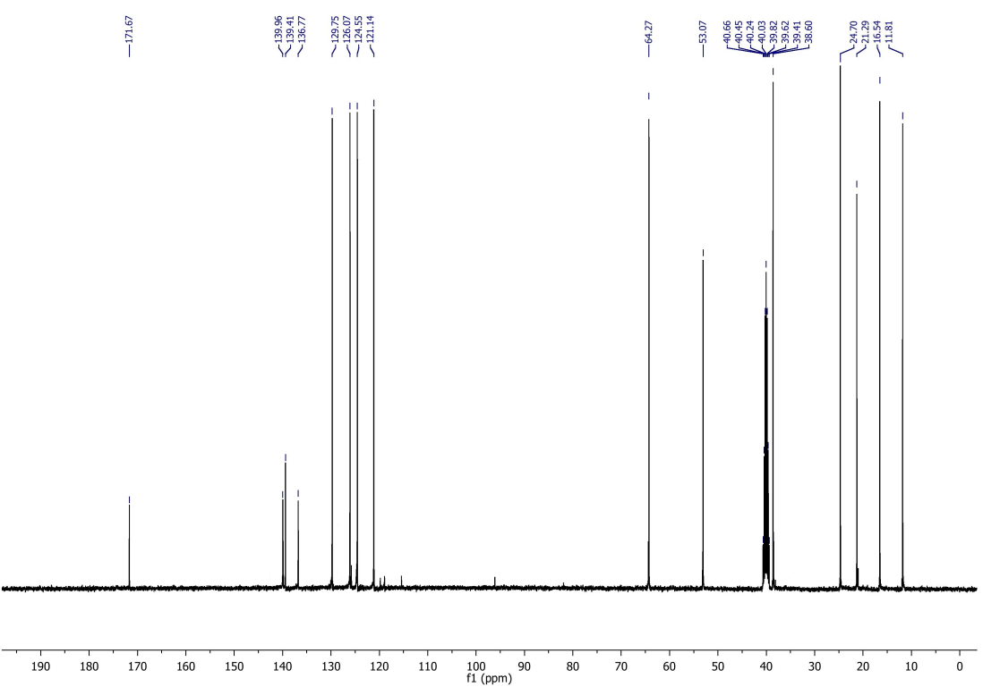
¹³C NMR spectrum of compound 3h

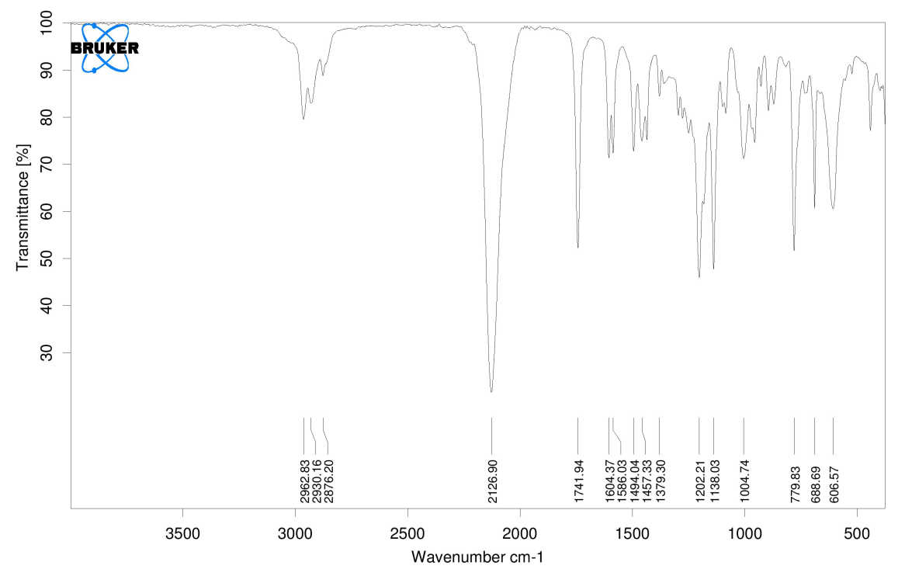
IR Spectrum of compound 3h
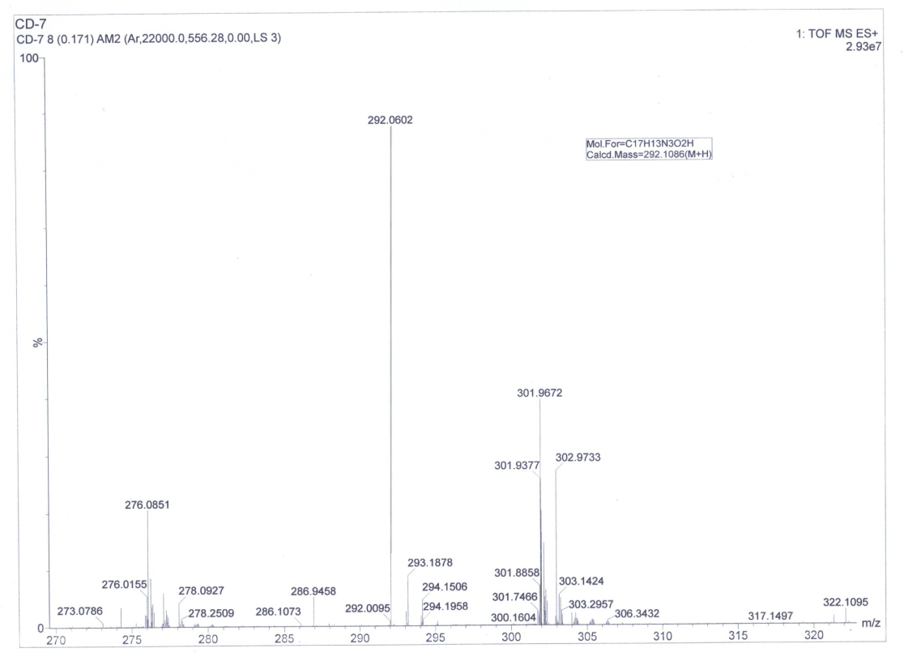
HRMS spectrum of compound 3i

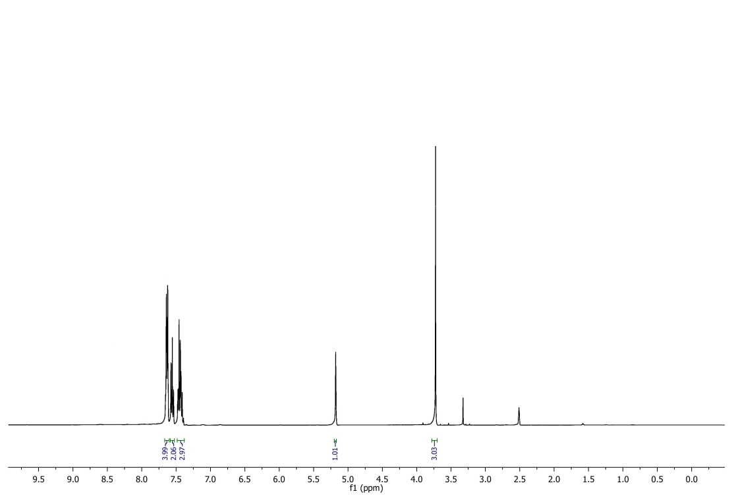
¹H NMR spectrum of compound 3i

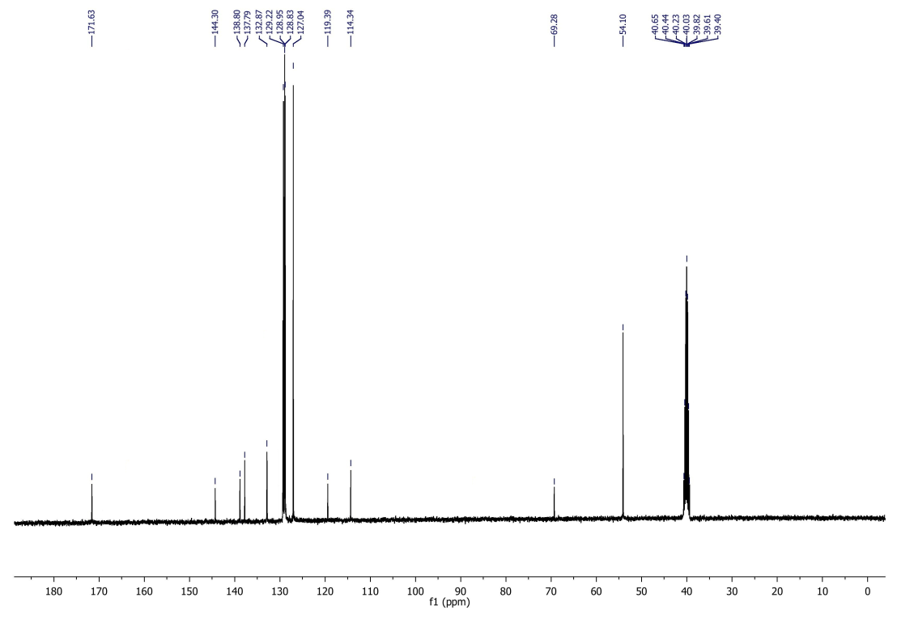
¹³C NMR spectrum of compound 3i

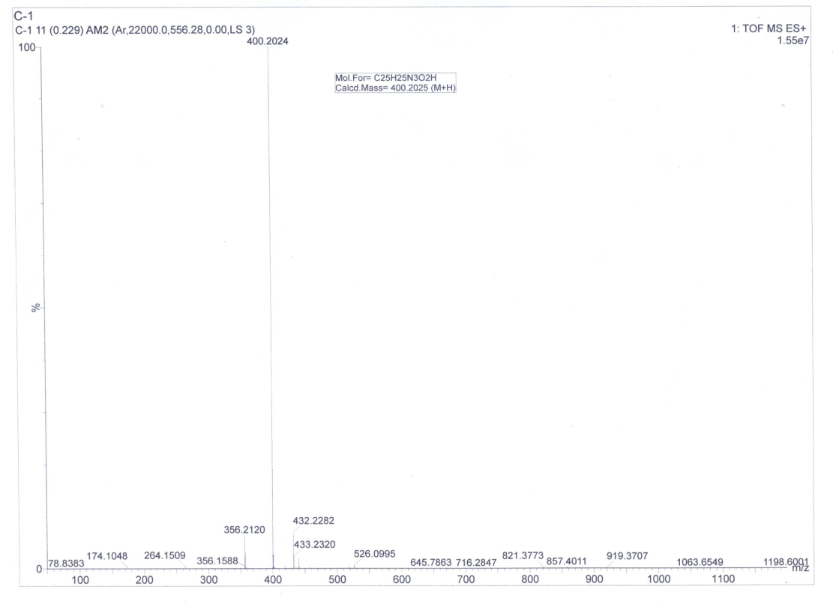
HRMS spectrum of compound 6a
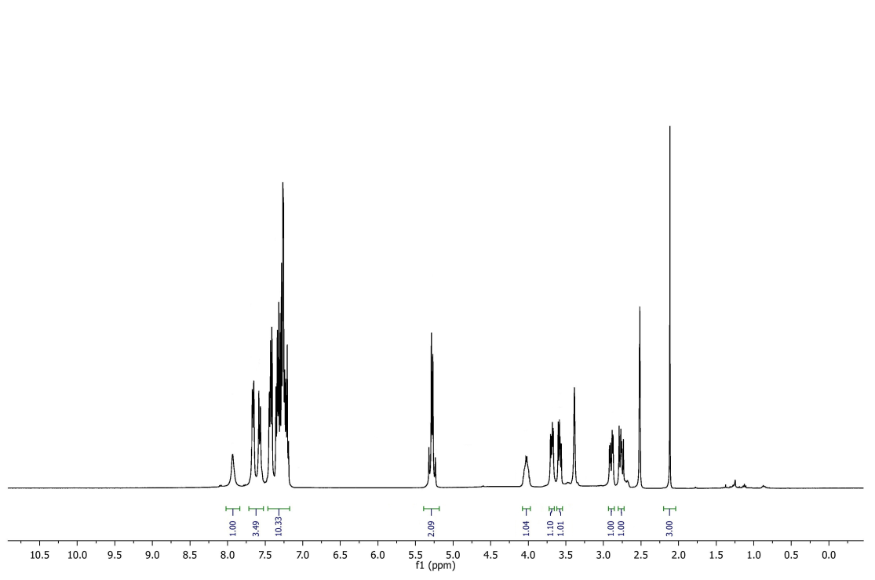
¹H NMR spectrum of compound 6a

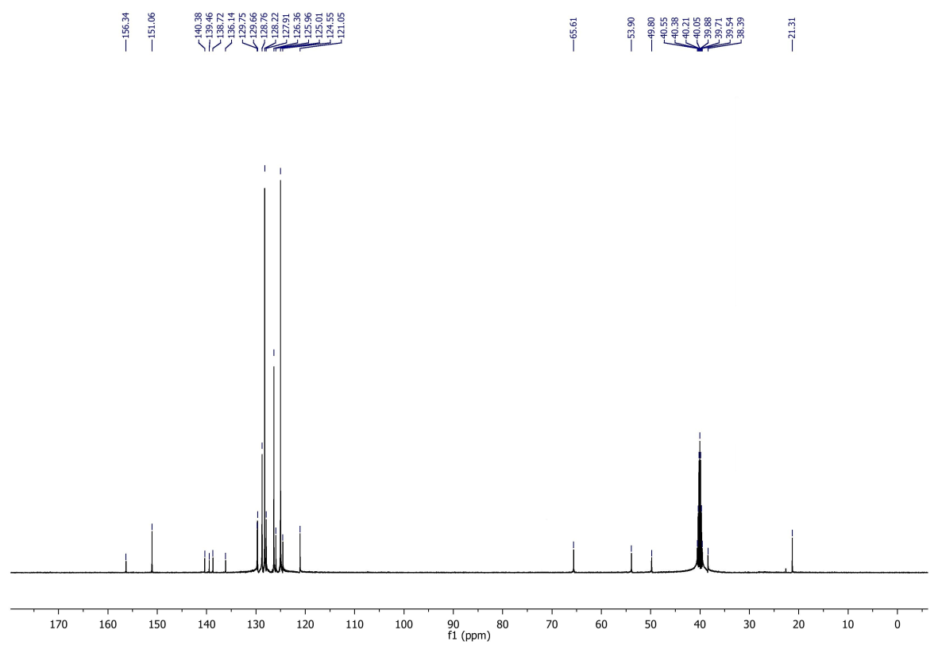
¹³C NMR spectrum of compound 6a
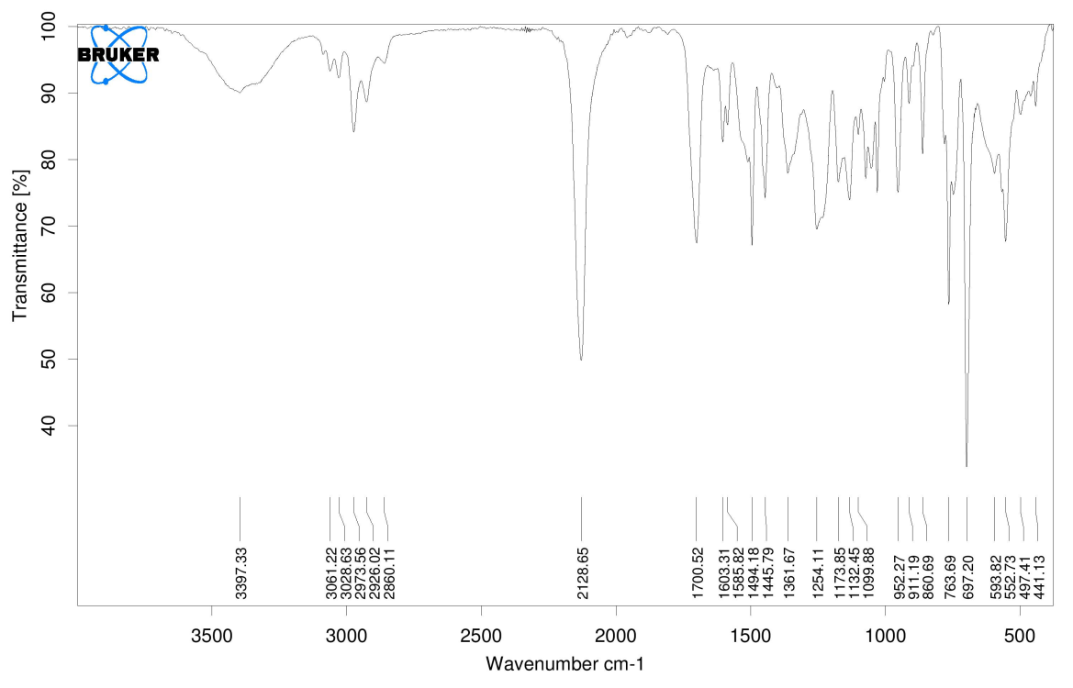
IR Spectrum of compound 6a

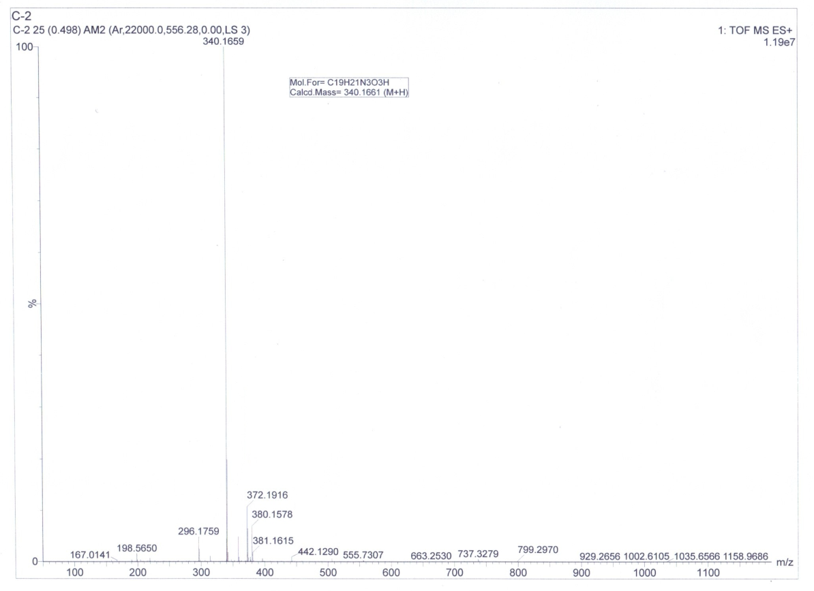
HRMS spectrum of compound 6b
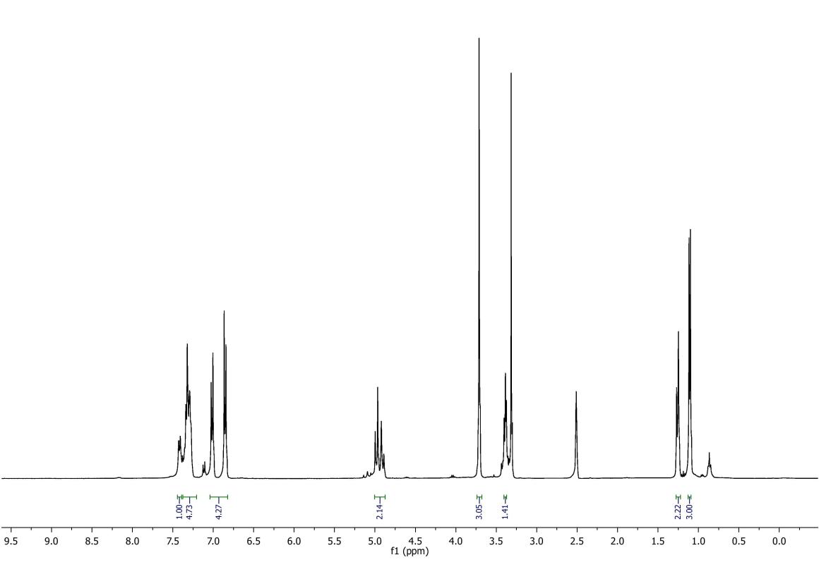
¹H NMR spectrum of compound 6b

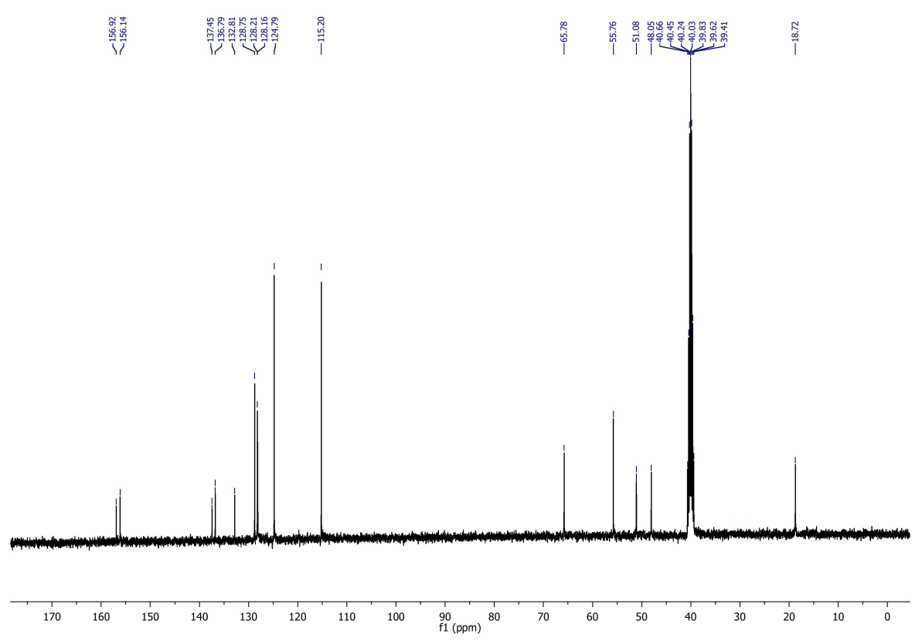
¹³C NMR spectrum of compound 6b

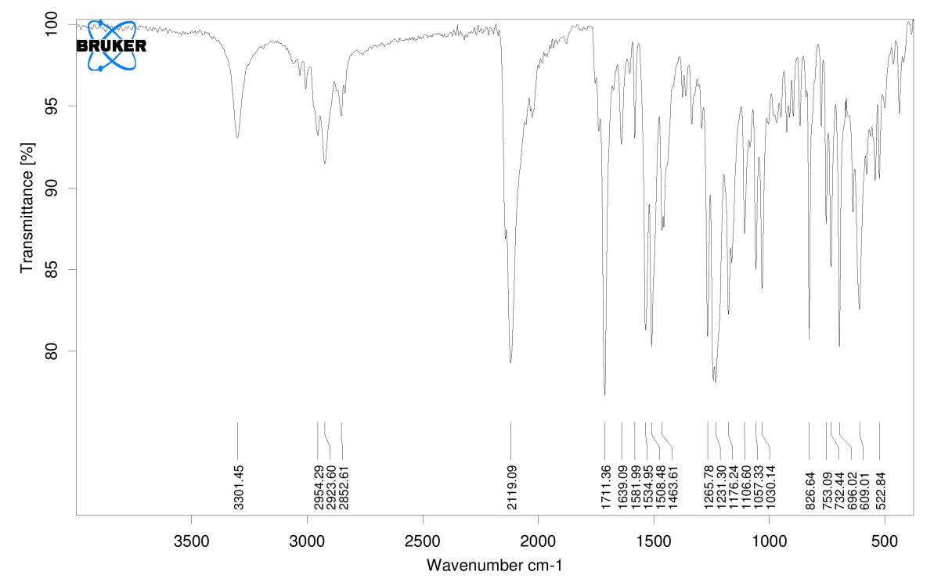
IR Spectrum of compound 6b

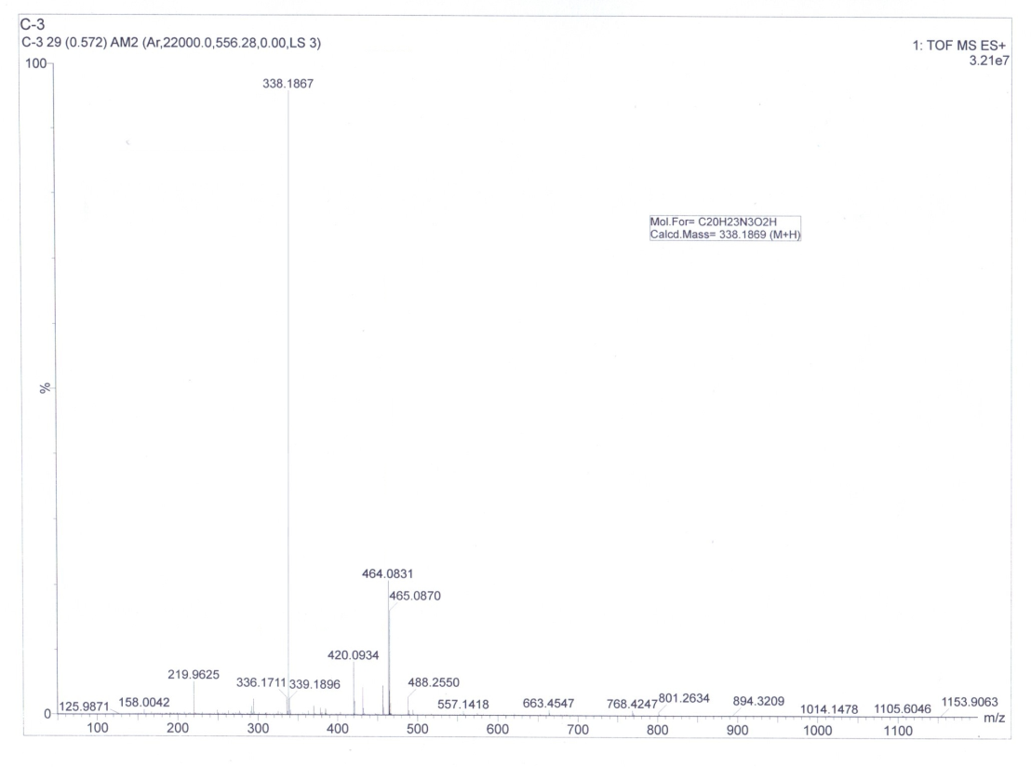
HRMS spectrum of compound 6c

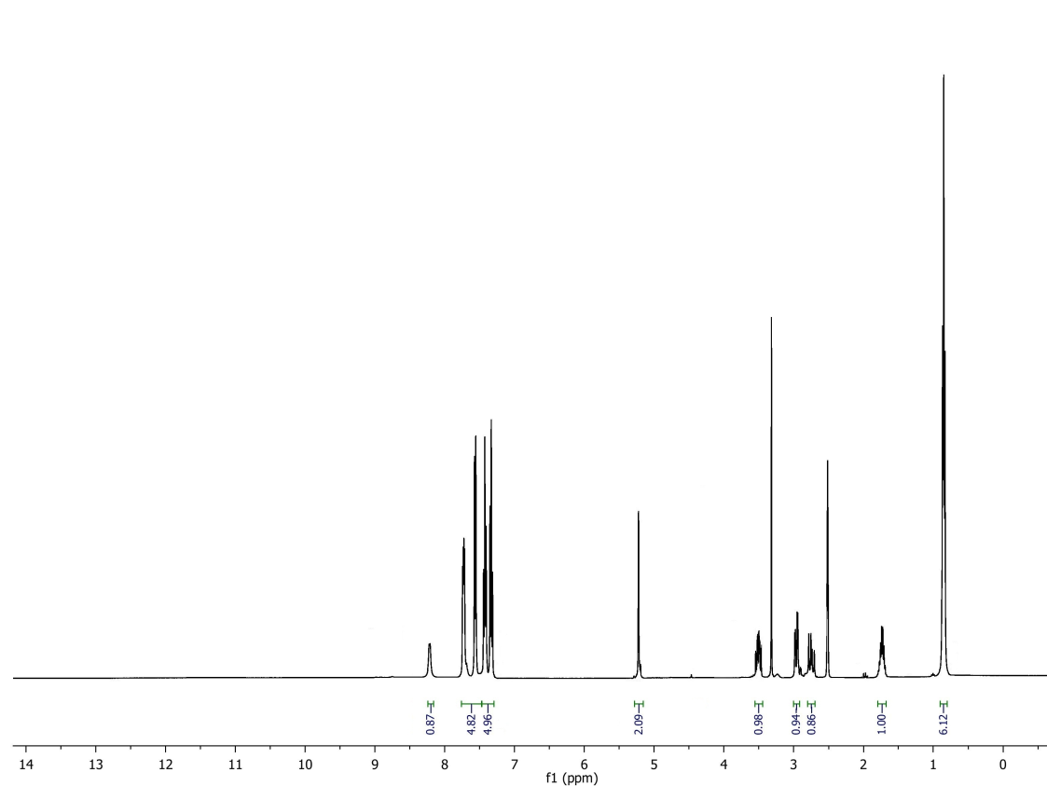
¹H NMR spectrum of compound 6c

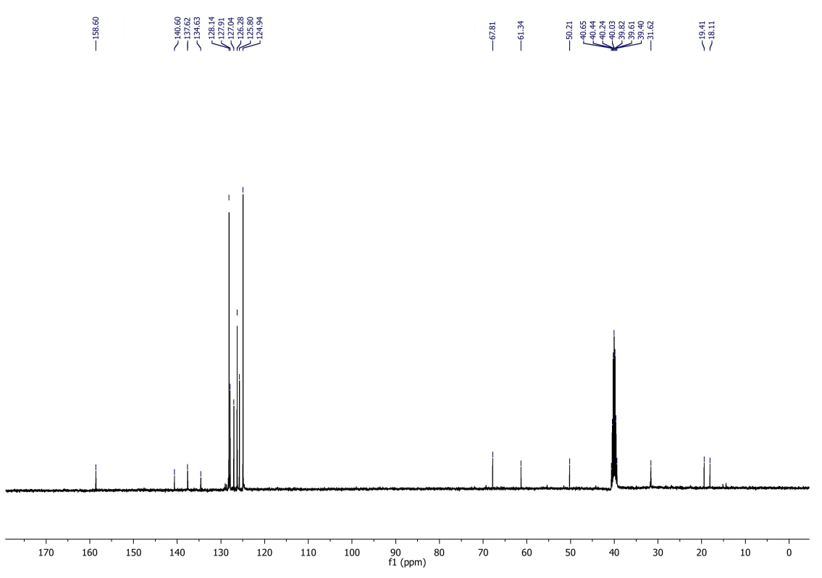
¹³C NMR spectrum of compound 6c
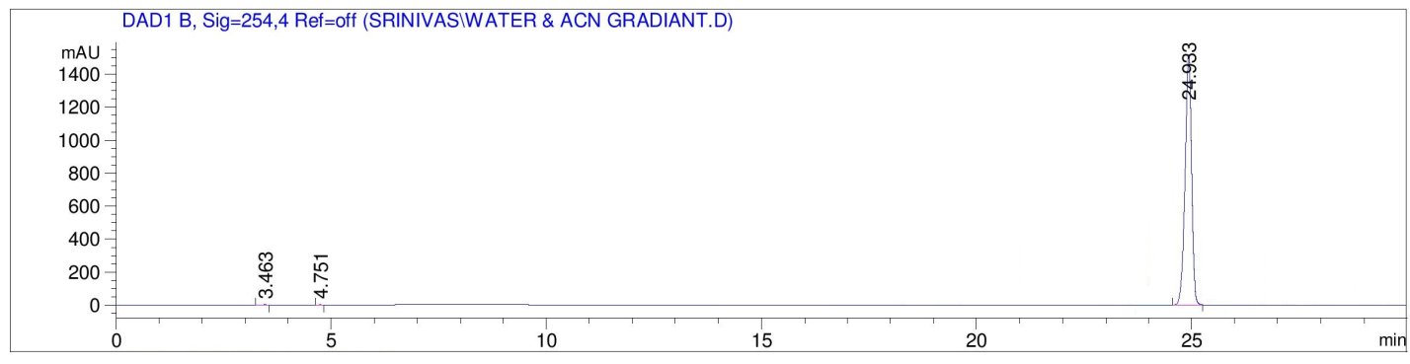
RP-HPLC Chromatogram of 3a

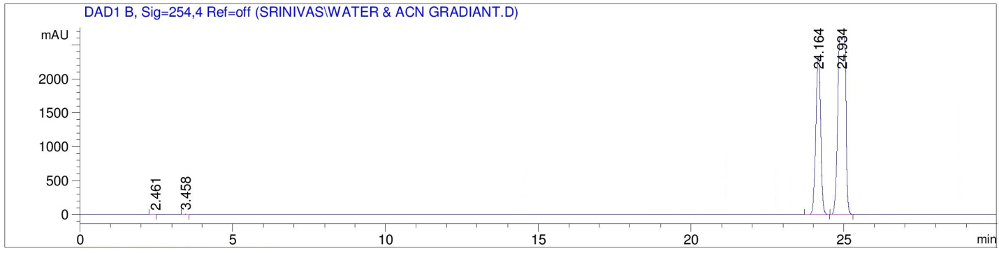
RP-HPLC Chromatogram of 3a & 3a*

RP-HPLC profiles of 3a and 3a* (method: gradient 0.1% TFA, water-acetonitrile (0-100%) in 30 min; VWD at λ = 254 nm; flow rate: 1.0 mL/min; column: phenominex made Lux, pore size-5μ, Amylose-2, diameter x length = 250 x 4.6 mm).
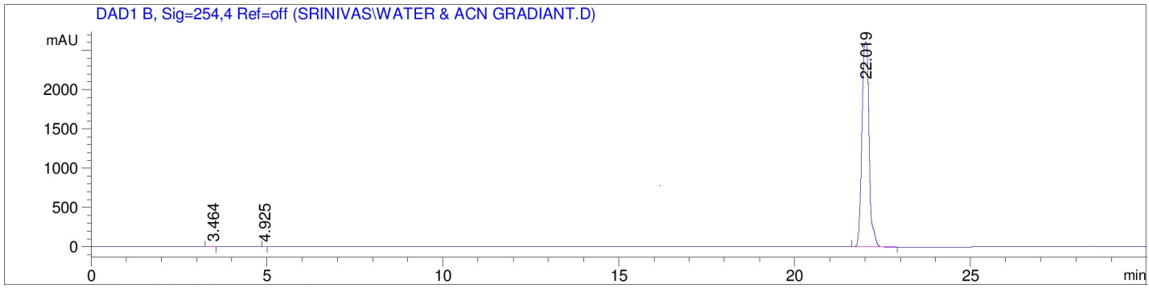
RP-HPLC Chromatogram of 3e

RP-HPLC profiles of 3e, (method: gradient 0.1% TFA, water-acetonitrile (0-100%) in 30 min; VWD at λ = 254 nm; flow rate: 1.0 mL/min; column: phenominex made Lux, pore size-5μ, Amylose-2, diameter x length = 250 x 4.6 mm).
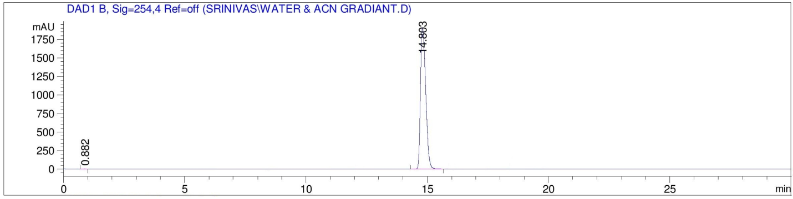
RP-HPLC Chromatogram of 6b

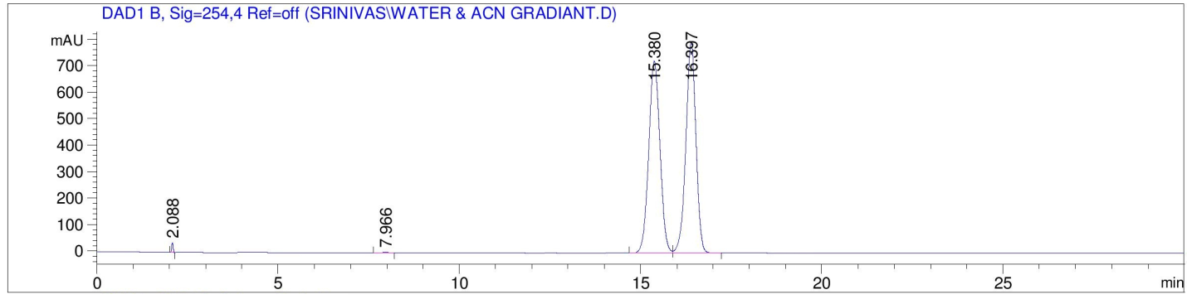
RP-HPLC Chromatogram of 6b &6b*

RP-HPLC profiles of 6b and6b* (method: gradient 0.1% TFA, water-acetonitrile (0-100%) in 30 min; VWD at λ = 254 nm; flow rate: 1.0 mL/min; column: phenominex made Lux, pore size-5μ, Cellulose-1, diameter x length = 250 x 4.6 mm).
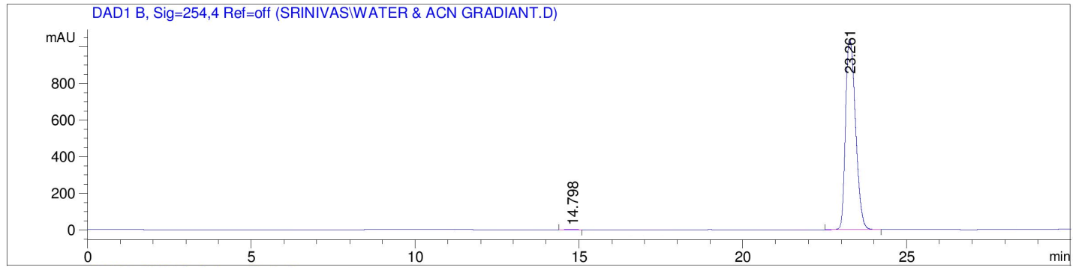
RP-HPLC Chromatogram of 6a

RP-HPLC profiles of 6a (method: gradient 0.1% TFA, water-acetonitrile (0-100%) in 30 min; VWD at λ = 254 nm; flow rate: 1.0 mL/min; column: phenominex made Lux, pore size-5μ, Cellulose-1, diameter x length = 250 x 4.6 mm).
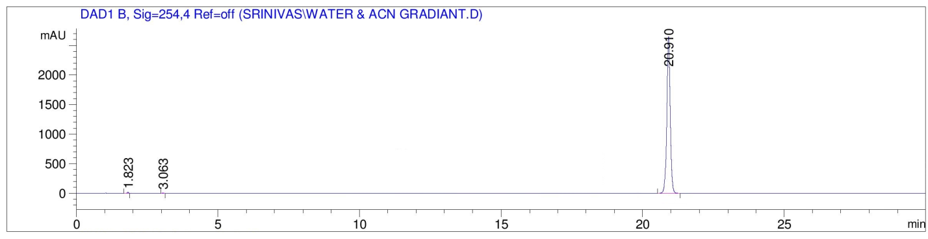
RP-HPLC Chromatogram of 3a

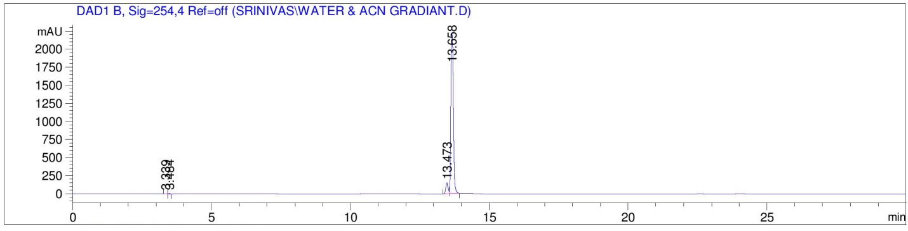
RP-HPLC Chromatogram of 3e

RP-HPLC profiles of 3a and 3e (method: gradient 0.1% TFA water-acetonitrile (0-100%) in 30 min; VWD at λ = 254 nm; flow rate: 1.0 mL/min; column: Agilent Eclipse, XDB-C18, pore size-5 μm, diameter x length = 4.6 x 150 nm).

