Investigation of particle deposition on a micropatterned surface as an energy-efficient air cleaning technique in ventilation ducting systems
Haolun Xu ª, Sau Chung Fu ^{b}, Ka Chung Chan ^{b} and Christopher Y.H. Chao ^{b}
ª Department of Mechanical and Aerospace Engineering, The Hong Kong University of Science and Technology, Clear Water Bay, Hong Kong
^{b} Department of Mechanical Engineering, The University of Hong Kong, Pok Fu Lam, Hong Kong

S1. EXPERIMENTAL METHOGOLOGY TO CALCULATE PARTICLE DEPOSITION VELOCITY
Figure S1 showed the contact angle of DEHS liquid particle on patterned surface. The contact angle measured from Figure S1 is nearly 23º - 25º. The aerosol droplet forms a cap that can be viewed as part of a larger sphere with a radius of R_{S}. This cap can be viewed as a cut-off from the larger sphere by a plane. The radius of larger sphere in Figure S1 is AO and CO, which is perpendicular to the red arrow (liquid-vapor interface) at the three-line contact angle. The contact radius in Figure S1 is r_{s}. The total volume of this spherical cap is similar to the volume of original aerosols deposited and coalesced on the surface. Based on the geometry, the total volume of this spherical cap can be found as Equation (S1).
$$V_{cap}=\frac{1}{3}πR_{s}^{3}\left(2-3cosα+\cos^{3}α\right)$$ | (S1)
where V_{cap} is the volume of spherical cap, R_{s} is the contact radius of aerosol and α is the aerosol contact angle. The contact area of the circle can be expressed by Equation (S2).
$$A_{s-l}=πr_{s}^{2}=π{(R_{s}sinα)}^{2}$$ | (S2)
Combining Equation (S2) with Equation (S1), the contact area of the planar surface can be found as Equation (S3).
$$A_{s-l}=πV_{cap}^{2/3}{\left[\frac{π}{3}\left(2-3cosα+\cos^{3}α\right)\right]}^{-2/3}\sin^{2}α$$ | (S3)
The contact area of planar surface can be measured from the microscope. Based on Equation (S3), the volume of aerosol deposited in each picture can be determined.
$$V_{cap}={(\frac{A_{s-l}}{π{\left[\frac{π}{3}\left(2-3cosα+\cos^{3}α\right)\right]}^{-\frac{2}{3}}\sin^{2}α})}^{\frac{3}{2}}$$ | (S4)
The particle deposition number is calculated by using the total volume of each aerosol droplet divided by the volume of monodispersed spherical aerosol in Equation (S5).
$$N_{d}=\frac{V_{cap}}{\frac{4}{3}π{(\frac{d_{p}}{2})}^{3}}$$ | (S5)
Substituting Equation (S4) into Equation (S5), we can obtain the particle deposition number as a function of contact radius, contact angle as well as released particle size.
$$N_{d}=\frac{2{r_{s}}^{3}\left(2-3cosα+\cos^{3}α\right)}{{d_{p}}^{3}\sin^{3}α}$$ | (S6)
Equation (S6) can be applied to calculate monodispersed particle number in a coalesced larger particle on the surface. For solid particles, attention must be paid to reduce the formation of agglomerates because multi-layers are hard to count (Hinds 2012). However, coagulation or coalescence may occur for liquid particles. There are two kinds of mechanism for liquid aerosol coagulation, either by Brownian motion or by turbulent eddies. For simple monodisperse coagulation, the particle size increases with time according to Equation (S7).
$$d\left(t\right)=d_{0}{(1+N_{0}Kt)}^{1/3}$$ | (S7)
where d₀ is the initial particle size, d(t) is the particle size after deposition duration t, N₀ is the particle number concentration for undisturbed flow, and K is the corrected coagulation coefficient which can be checked from (Hinds 2012). The particle size after a long time of duration for the 0.5 µm particle is still 0.523 µm, which did not change with the particle size. Therefore, the larger particles are due to the coalescence of liquid aerosols on the surface. The resolution of the microscope can barely visualize the particle size smaller than 1 µm, thus a longer particle deposition time allows smaller particles to coalesce together. In order to increase the accuracy of submicron particle deposition, the deposition time in our experiment is almost 2 hours. Therefore, in our experimental methodology, the coalesced aerosol is recognized as a spherical cap that combines numbers of simple monodispersed particles.
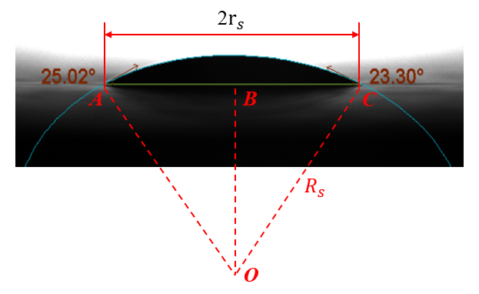
Figure S1 Schematic of DEHS aerosol droplet placed on a flat surface with uniform meniscus radius
Figure S2 displayed a 790 μm×790 μm image from a Nikon eclipse Ni-E Microscope under an object of 20x. The visualized area in each photo is $6.24×{10}^{-7}$ m². Each blue circle represents a coalesced particle for 0.5-µm monodispersed particle. Take Figure S2 for example, the calculation procedure for the deposition velocity in this figure is shown in Table S1. The contact particle diameter was identified by the Nikon microscope software. Then the volume of each aerosol was determined by using Equation S4. Our experiment has been running for a duration of 5400s, therefore, the released particles will coalesce on the surface. Each identified aerosol consists of several numbers of 0.5-µm particles, and the particle concentration above the patterned surface is 4.67$×{10}^{9}$ #/m³. A summation of differently located aerosol will be the total deposition number. The deposition velocity is calculated by Equation (S8). It should be noted that the deposition velocity in Table S1 is only calculated based on one figure. However, different figures are calculated according to a similar procedure in Table S1 and these values are averaged or area-weighted to gain an overall deposition velocity.
$$V_{d}^{+}=\frac{J}{n_{0}×u^{*}}=\frac{particle number deposited/(area∙deposition duration)}{particle number /volume×friction velocity}$$ | (S8)
Table S1 Calculation of deposition velocity in Figure S2
Contact diameter (µm) | Contact area (µm²) | Volume (µm³) | Particle number in each droplet (#) | Total deposition number (#) | Deposition velocity (m/s)
4.14 | 53.82 | 23.62 | 361 | 929 | $$5.9×{10}^{-5}$$
4.12 | 53.38 | 23.33 | 356
1.98 | 12.31 | 2.59 | 40
3.23 | 32.82 | 11.25 | 172

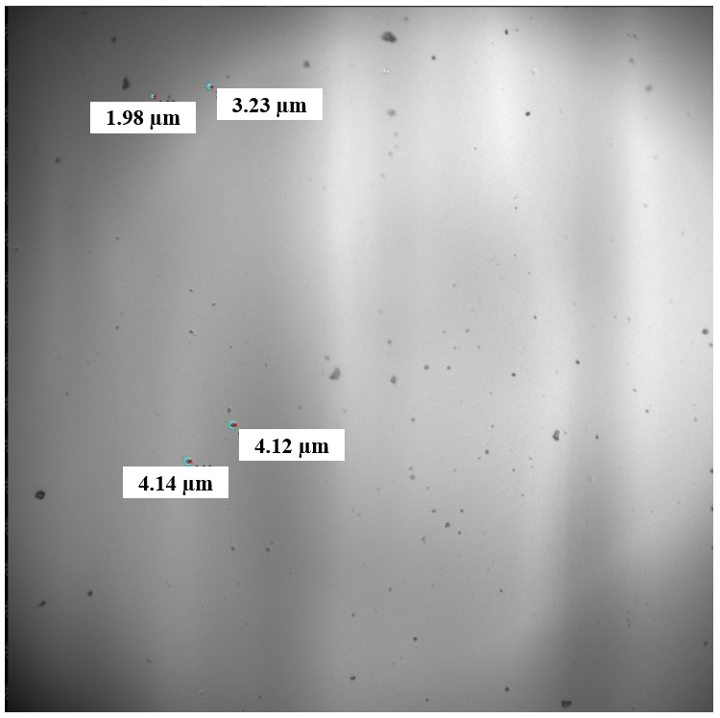
Figure S2 Calculation of deposition velocity
Figure S3 illustrated the surface roughness profile for the 3d printed smooth surface in our experiment. The surface roughness was measured by a Veeco 3300 profiler. The top minor photo in Figure S3 represented a measurement area of 0.627 mm × 0.471 mm. The height between the green arrow and red arrow in the upper minor photo in Figure S3 was 7.513 µm. The bottom photo in Figure S3 showed the surface roughness profile through the horizontal line. It can be seen that the surface roughness oscillates like a sine wave. The averaged surface roughness on our experimental smooth surface was 2.2 µm, but the surface was assumed ideally perfect in our numerical simulation cases. Our current mesh size cannot resolve the surface roughness directly. This may lead to a difference between experimental and numerical results because the surface roughness will also enhance particle deposition.
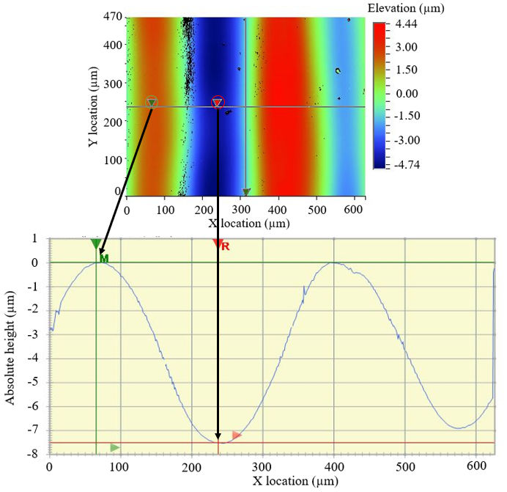
Figure S3 Illustration of surface roughness contour (top) and surface roughness profile (bottom) for a smooth surface
S2. PARTICLE DEPOSITION LOCATION IN THE CAVITY BETWEEN SEMI-CIRCULAR RIBS
The particle deposition location is influenced by the flow patterns within the cavity, and because the flow field for different heights of semi-circular patterned surface is similar, the particle deposition location follows a similar trend for different heights of semi-circular patterned surface. We first discuss the 0.5-μm particle deposition location and deposition velocity on the semi-circular height of 500 μm at the p/e value of 3, 4, 5 and 6. Subsequently, the 2.5-μm particle deposition velocity on the semi-circular height of 2000 μm at the p/e value of 3, 4, 5 and 6 are demonstrated. The 0.5-µm particle deposition photos for each p/e at the height of 2000 µm are shown in Figure S4. Figure S4(a) and (b) shows the particle deposition at the semi-circular ribs where p/e=3 and p/e=4. Figure S4(c) and (d) shows the particle deposition at the upstream and downstream locations for a p/e value of 5. Figure S4(e) and (f) shows particle deposition at the upstream and downstream locations where p/e=6. The green circle in the figure represents a clearly visualized particle (the white arrow in Figure S4(a) and (b) identify the particles), and the other black spots are defects on the surface. At the semi-circular patterns where p/e=3 and p/e=4 as shown in Figures S4(a) and (b), the non-dimensional deposition velocity is 9.3×10⁻⁵ and 6.86×10⁻⁴, respectively. At the p/e=5 and p/e=6, the downstream location has more particles deposited compared with the upstream location. The larger particles in Figure S4(d) is formed by the coalescence of liquid aerosols on the solid surface. In order to increase the accuracy of submicron particle deposition, the deposition time in our experiment is three hours to allow smaller particles coalesced on the surface. As discussed in the experimental methodology, the coalesced aerosol is recognized as a spherical cap that combines numbers of simple monodispersed particles. In Figure S4(c) and (d), the non-dimensional deposition velocity at the upstream and downstream is 6.77×10⁻⁴ and 1.17×10⁻³. In Figure S4(e) and (f), the non-dimensional deposition velocity at the upstream and downstream is 9.0×10⁻⁴ and 1.95×10⁻³. In the case of p/e=5, 6 and 10, the deposition velocity can be evaluated from the deposition velocity on different surface areas and can be expressed as Equation (S9).
$$V_{d}=V_{d,u}×l_{u}\%+V_{d,c}×l_{c}\%+V_{d,d}×l_{d}\%$$ | (S9)
where V_{d,u} , V_{d,c} and V_{d,d} are deposition velocity at upstream, center and downstream for a patterned surface. l_{u}, l_{c} and l_{d} are area-weighted ratio at upstream, center and downstream region discussed in Table S4. The deposition of 0.5-µm particles for the semi-circular height of 500 µm where p/e value is 10 are shown in Figure S5. The non-dimensional deposition velocities in Figure S5 (a), (b) and (c) are 3.43×10⁻⁴, 4.74×10⁻⁴ and 8.88×${10}^{-4}$.
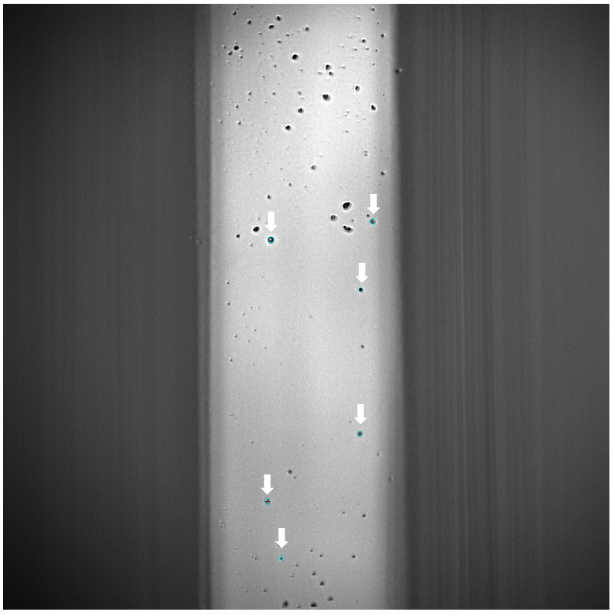 |  | 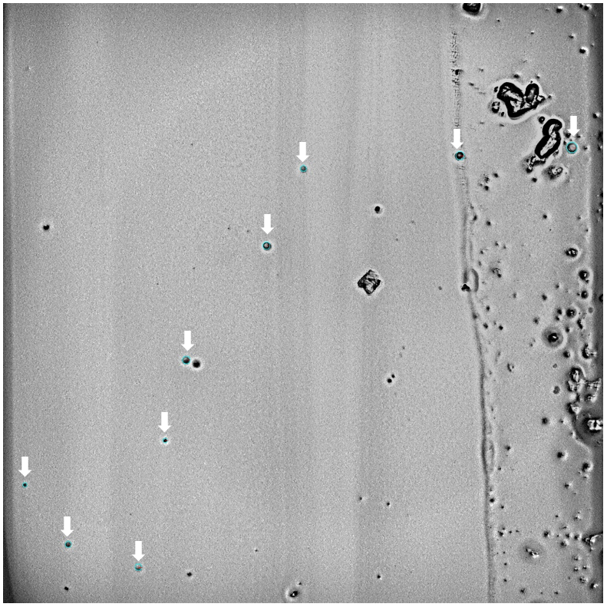
(a) |  | (b)
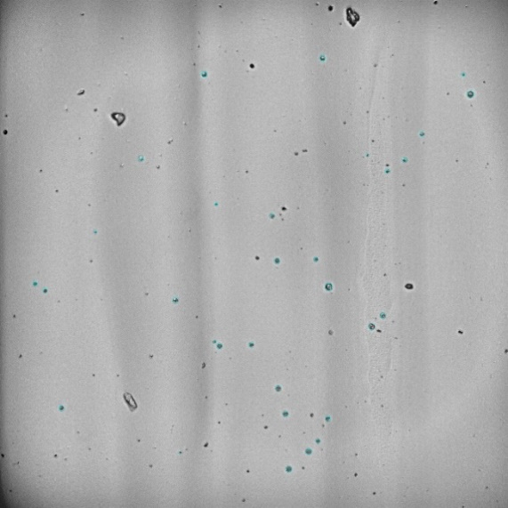 |  | 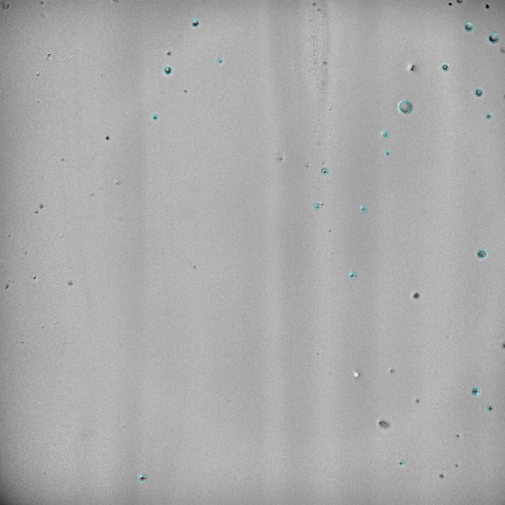
(c) |  | (d)
(e) |  | (f)
Figure S4 Photos after 0.5 µm particle deposition for the semi-circular height of 500 µm: (a) p/e=3 (b) p/e=4 (c) p/e=5, upstream (d) p/e=5, downstream (e) p/e=6, upstream (f) p/e=6, downstream
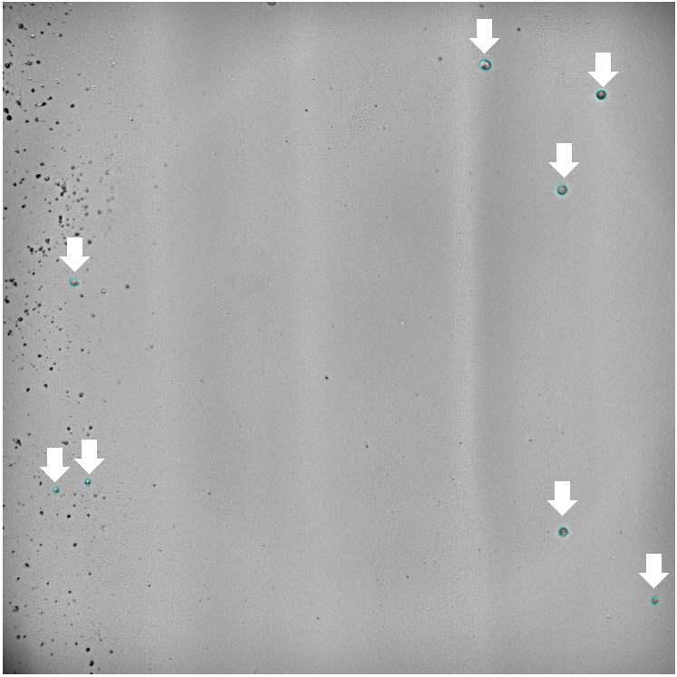 | 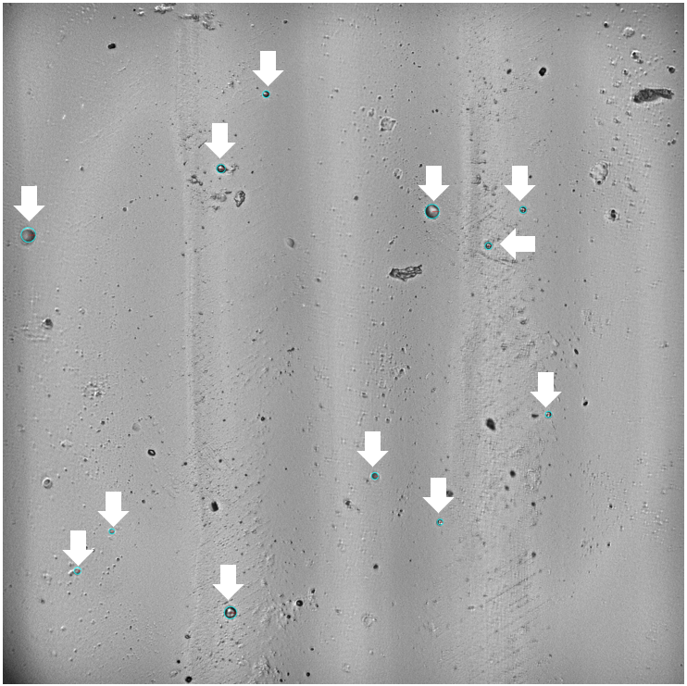 |  | 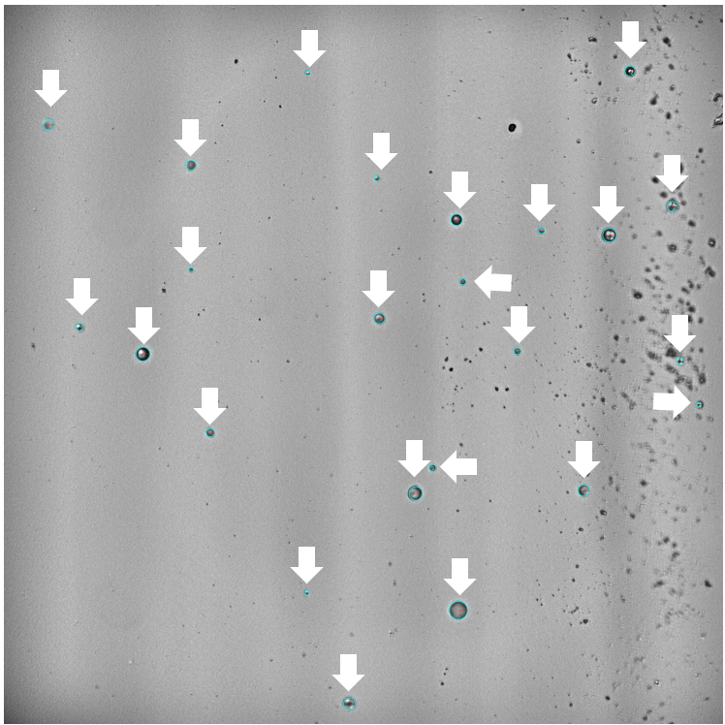
Figure S5 Photos after 0.5 µm particle deposition for the semi-circular height of 500 µm: (a) p/e=10, upstream (b) p/e=10, center (c) p/e=10, downstream
Figure S6 displays 2.5-µm particle deposition for the semi-circular height of 2000 µm at different p/e value. Figure S6(a) and (b) shows the particle deposition at the p/e=3 and p/e=4. Figure S6(c) and (d) shows the particle deposition at the upstream and downstream of the cavity at the p/e=5. Figure S6(e) and (f) show the particle deposition at the upstream and downstream of the cavity at the p/e=6. Observed from Figure S6(b), the p/e=4 has more aerosol particles deposited on the surface compared with other figures. At the p/e=5 (Figure S6(c) and (d)) and p/e=6 (Figure S6(e) and (f)), the deposition at the downstream location of the cavity has more particles deposited compared with the upstream and center of the cavity. The trend of the deposition enhancement at the upstream and downstream is similar to the discussion in Lai, Byrne and Goddard (2000). In their experiment on enhanced particle deposition by a ribbed surface in a ventilation duct, the presence of a downstream rib formed a vortex, thus the highest deposition enhancement appears at the downstream. From our illustration of the streamline (Figure S7(a) and (b)), a small upward swirl flow appears at the downstream location and the direction of flow is opposite to the direction of separation flow at the center region. As the two streams of the flow collide with each other, larger particles deposit due to the effect of inertia impaction, and it is even harder for the particles to change their direction rapidly as the flow moves upward outside the cavity. The deposition at the downstream cavity has a more significant effect than the deposition at the upstream cavity at the p/e value of 5 and 6. Based on the above analysis of deposition velocity at different locations, the ratio of deposition velocity at different locations can be concluded in Table S2 and Table S3 for the particle size of 0.5 μm and 2.5 μm. It can be observed as the p/e value increases, the downstream of the cavity has more particles deposited compared with the upstream of the cavity. The overall deposition velocity for larger p/e value decreases, and therefore, the optimized p/e appears in the middle values of p/e.
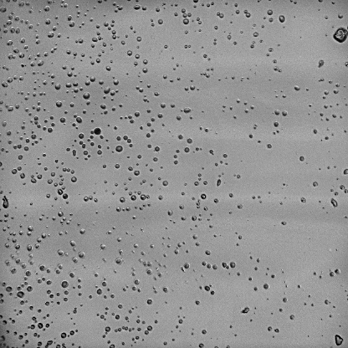 | 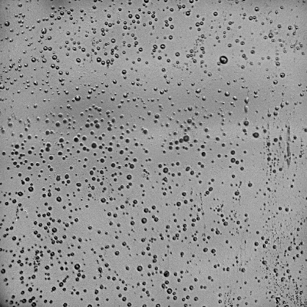
(a) | (b)
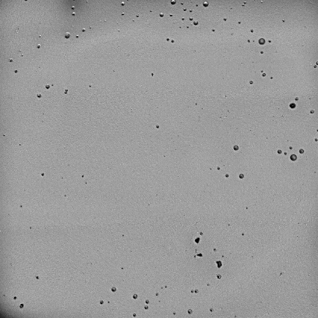 | 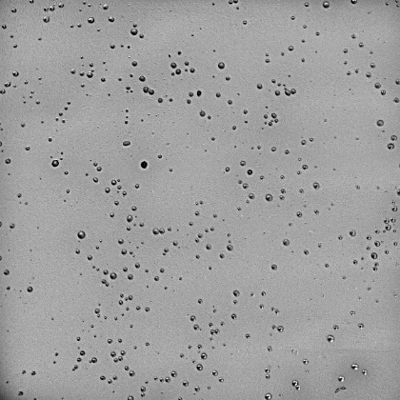
(c) | (d)
 | 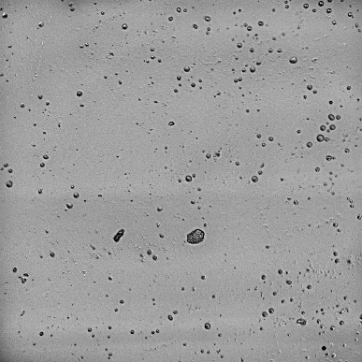
(e) | (f)
Figure S6 Photos after 2.5 µm particle deposition for the semi-circular height of 2000 µm: (a) p/e=3 (b) p/e=4 (c) p/e=5, upstream (d) p/e=5, downstream (e) p/e=6, upstream (f) p/e=6, downstream
Table S2. Non-dimensional deposition velocity at different locations in the cavity for the particle size of 0.5 μm
Height (µm) | p/e=3 | p/e=4 | p/e=5 | p/e=6 | p/e=10
2000 | 1.35×10⁻⁴ | 2.89×10⁻⁴ | Upstream (6.79×10⁻⁴): Downstream (1.67×10⁻³) =1:2.46 | Upstream (3.04×10⁻⁴): Downstream (1.42×10⁻³) =1:4.67
500 | 9.3×10⁻⁵ | 6.86×10⁻⁴ | Upstream (6.77×10⁻⁴): Downstream (1.17×10⁻³) =1:1.73 | Upstream (9.0×10⁻⁴): Downstream (1.95×10⁻³) =1:2.16 | Upstream (3.43×10⁻⁴): Center (4.74×10⁻⁴): Downstream (8.88×10⁻⁴) =1:1.38:2.59

Table S3. Non-dimensional deposition velocity at different locations in the cavity for the particle size of 2.5 μm
Height (µm) | p/e=3 | p/e=4 | p/e=5 | p/e=6
2000 | 3.46×10⁻² | 3.79×10⁻² | Upstream (5.63×10⁻³): Downstream (1.53×10⁻²) =1:2.72 | Upstream (4.74×10⁻³): Downstream (1.69×10⁻²) =1:3.57
500 | 6.49×10⁻⁴ | 6.59×10⁻³ | Upstream (4.70×10⁻³): Downstream (1.97×10⁻²) =1:4.19 | Upstream (3.50×10⁻³): Downstream (1.56×10⁻²) =1:4.46
S3. FLOW PATTERNS AT THE LEEWARD AND WINDWARD SIDES OF THE CAVITY
The flow field for different heights of semi-circular patterned surface is similar. In this section the p/e value of 5, 6 and 10 with the semi-circular height of 2000 µm is discussed. At the p/e value of 3 and 4, a recirculation flow exists for different heights of semi-circular patterned surface. Based on the flow fields at the p/e value of 5 and 6 (Figure S7), the recirculation flow is found at the leeward side of the upward semi-circular rib and the separation region appears at the windward side of the downward semi-circular rib. For the case of p/e=10 at the semi-circular height of 2000 µm, three different locations can be defined from Figure S8 (a). X-direction wall shear stress was used to find out the area-weighted percentage of upstream, center and downstream locations in Figure S8(b). The area percentage of upstream, center and downstream was indicated by the changing of the shear stress symbol (from negative to positive or from positive to negative). In Figure S8(b), the upstream region (negative values of shear stress) represents the reattachment length in Figure S8(a). The center region (positive values) represents the separation length, and the downstream region (negative values) represents a spiral flow which has the same direction as the recirculation flow. The variation of x-direction wall shear stress can also be used to calculate the area-weighted percentage for different heights of a semi-circular patterned surface. Table S4 concluded the area-weighted ratio under each p/e value for the semi-circular height of 2000 µm. The area-weighted percentage for different locations in Table S4 is applicable to all heights of semi-circular patterned surface. l_{u}, l_{c} and l_{d} represent the length of upstream, center and downstream regions. It can be observed that the percentage of recirculation length gradually decreases as the p/e value increases. However, the area percentage of the center region increases.
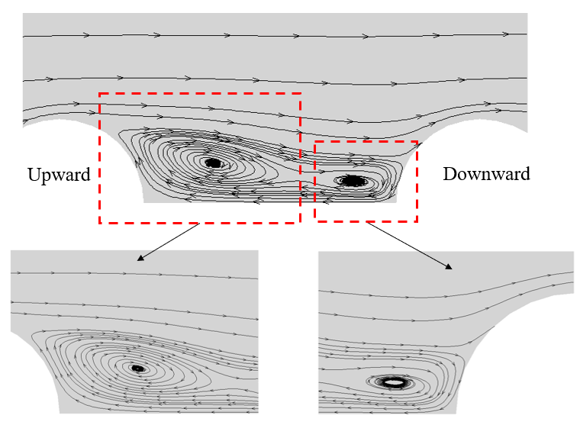
(a)
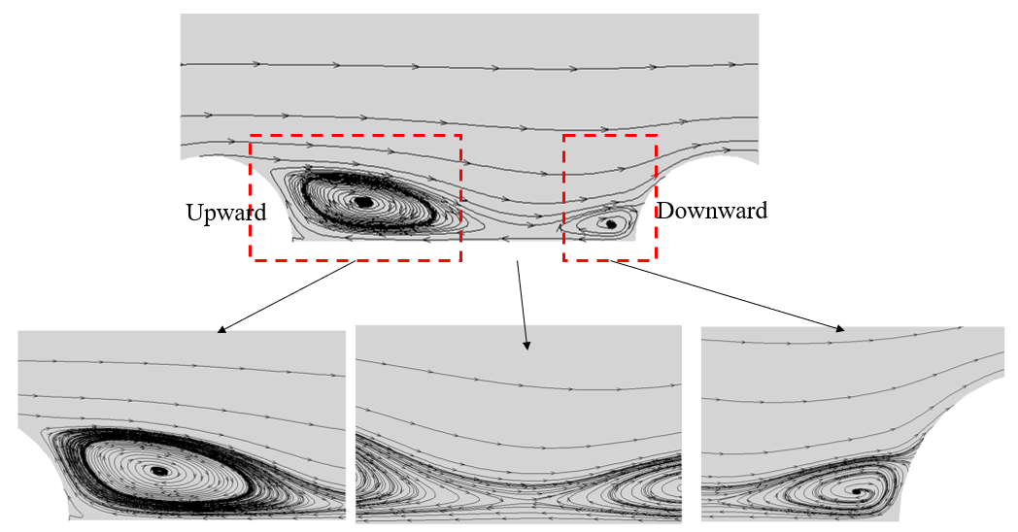
(b)
Figure S7. Flow pattern for 2000 µm semi-circular at (a) p/e of 5 (b) p/e of 6
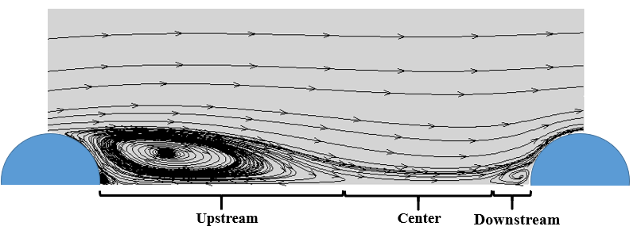
(a)
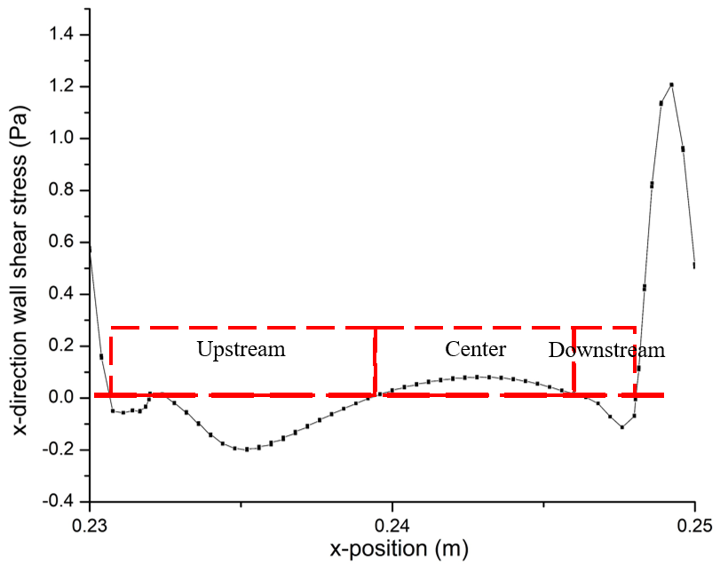
(b)
Figure S8 Illustration of different deposition locations for the semi-circular height of 2000 µm at a p/e of 10: (a) velocity vector field between the cavity (b) x-direction wall shear stress (Pa) between the cavity

Table S4 Area-weighted ratio for all heights of semi-circular patterned surface under each p/e
p/e=3 | p/e=4 | p/e=5 | p/e=6 | p/e=10
l_{u}=e | l_{u}=2e | l_{u}: l_{d}=2.1e:0.9e | l_{u}: l_{d} =2.4e:1.6e | l_{u}: l_{c}: l_{d} =4e:3.2e:0.8e
Figure S9 displays the pressure drop (Pa) along the channel for different heights of semi-circular patterns. The pressure drop increases from p/e value of 3 to 6 at the semi-circular heights of 2000 µm, 1500 µm and 800 µm. With a p/e value of 3, the flow was not easily separated into the cavity and the pressure drop is mainly due to the obstructions by the semi-circular ribs. The smaller the semi-circular height decreases, the more the pressure drop suffers along the channel. At the p/e value of 6, the flow separates after it encounters the semi-circular ribs. The flow resistance increased as the path of flow becomes more complicated compared with the straightforward flow field in a smooth channel. With the p/e value at 10 and 15, the pressure drop decreased because there are not many flow separations for the fluid to turn around. Understanding the pressure drop at different p/e value will help to decrease the energy consumption, as well as enhance the efficiency of the current ventilation ducting system.
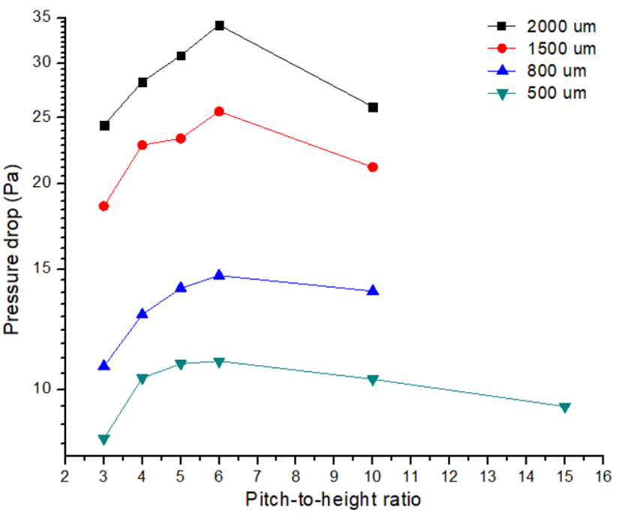
Figure S9 Pressure drop (Pa) for different heights of semi-circular patterns

References
Hinds, W. C. 2012. Aerosol technology: Properties, behavior, and measurement of airborne particles. 2nd ed. US: John Wiley & Sons.
Lai, A. C., Byrne, M. A. and Goddard, A. J. 2000. Enhanced particle loss in ventilation duct with ribbed surface. Building and Environment 35:425-432.

