**Supporting Information**

Design of oxoperoxovanadium(V) complexes and their DNA interaction studies

SARASWATHI KOTHANDAN and A. SHEELA*

**Supporting Information for single crystal data of complex 1**

Table S1. Atomic coordinates ( x 104) and equivalent isotropic displacement parameters (Å2x 103)

for fdk2. U(eq) is defined as one third of the trace of the orthogonalized Uij tensor.

________________________________________________________________________________

x y z U(eq)

________________________________________________________________________________

C(1) 5405(3) 4898(3) 8178(2) 75(1)

C(2) 5465(4) 3847(3) 8109(3) 89(1)

C(3) 6407(4) 3400(3) 7743(3) 88(1)

C(4) 7291(4) 3996(3) 7440(3) 90(1)

C(5) 7236(3) 5047(3) 7498(2) 74(1)

C(6) 6305(2) 5508(2) 7882(2) 56(1)

C(7) 6305(2) 6636(2) 7960(2) 52(1)

C(8) 4733(3) 8737(2) 6714(2) 58(1)

C(9) 4117(3) 8799(3) 6000(2) 69(1)

C(10) 4734(3) 8868(3) 5287(2) 74(1)

C(11) 5943(3) 8851(3) 5309(2) 64(1)

C(12) 6513(3) 8764(2) 6051(2) 48(1)

C(13) 7807(2) 8726(2) 6142(2) 49(1)

C(14) 8575(3) 8687(3) 5493(2) 66(1)

C(15) 9763(3) 8646(3) 5636(3) 78(1)

C(16) 10177(3) 8671(3) 6414(3) 74(1)

C(17) 9367(3) 8712(2) 7044(2) 59(1)

C(18) 8984(3) 4033(4) 5450(2) 85(1)

C(19) 9610(4) 4832(5) 5820(3) 114(2)

C(20) 9178(6) 5810(5) 5773(4) 135(2)

C(21) 8176(6) 6020(4) 5362(4) 129(2)

C(22) 7542(4) 5240(3) 5002(3) 95(1)

C(23) 7951(3) 4246(3) 5053(2) 64(1)

C(24) 7243(3) 3439(2) 4657(2) 60(1)

N(1) 5909(2) 8719(2) 6745(1) 47(1)

N(2) 8213(2) 8726(2) 6911(2) 47(1)

N(3) 5558(2) 7099(2) 8430(2) 60(1)

O(6) 7708(2) 2531(2) 4675(2) 82(1)

O(1) 7047(2) 7182(2) 7587(1) 56(1)

O(2) 5604(2) 8154(2) 8463(1) 58(1)

O(3) 8019(2) 8559(2) 8552(1) 69(1)

O(4) 7122(2) 10148(2) 7701(1) 62(1)

O(5) 6211(2) 9895(2) 8262(1) 65(1)

O(7) 6305(2) 3611(2) 4346(2) 87(1)

O(8) 6570(2) 1106(2) 3949(2) 68(1)

V(1) 6994(1) 8721(1) 7902(1) 48(1)

________________________________________________________________________________

Table S2. Bond lengths [Å] and angles [°] for fdk2.

_____________________________________________________

C(1)-C(2) 1.381(5)

C(1)-C(6) 1.386(4)

C(1)-H(1) 0.9300

C(2)-C(3) 1.361(6)

C(2)-H(2) 0.9300

C(3)-C(4) 1.366(6)

C(3)-H(3) 0.9300

C(4)-C(5) 1.380(5)

C(4)-H(4) 0.9300

C(5)-C(6) 1.373(4)

C(5)-H(5) 0.9300

C(6)-C(7) 1.480(4)

C(7)-O(1) 1.264(3)

C(7)-N(3) 1.301(4)

C(8)-N(1) 1.336(4)

C(8)-C(9) 1.375(4)

C(8)-H(8) 0.9300

C(9)-C(10) 1.374(5)

C(9)-H(9) 0.9300

C(10)-C(11) 1.373(5)

C(10)-H(10) 0.9300

C(11)-C(12) 1.392(4)

C(11)-H(11) 0.9300

C(12)-N(1) 1.338(4)

C(12)-C(13) 1.477(4)

C(13)-N(2) 1.354(4)

C(13)-C(14) 1.384(4)

C(14)-C(15) 1.370(5)

C(14)-H(14) 0.9300

C(15)-C(16) 1.369(6)

C(15)-H(15) 0.9300

C(16)-C(17) 1.392(5)

C(16)-H(16) 0.9300

C(17)-N(2) 1.327(4)

C(17)-H(17) 0.9300

C(18)-C(23) 1.372(5)

C(18)-C(19) 1.405(6)

C(18)-H(18) 0.9300

C(19)-C(20) 1.373(8)

C(19)-H(19) 0.9300

C(20)-C(21) 1.353(9)

C(20)-H(20) 0.9300

C(21)-C(22) 1.384(7)

C(21)-H(21) 0.9300

C(22)-C(23) 1.383(5)

C(22)-H(22) 0.9300

C(23)-C(24) 1.481(4)

C(24)-O(7) 1.204(4)

C(24)-O(6) 1.300(4)

N(1)-V(1) 2.276(2)

N(2)-V(1) 2.145(2)

N(3)-O(2) 1.382(3)

N(3)-H(3A) 0.83(2)

O(6)-H(6A) 0.8200

O(1)-V(1) 2.081(2)

O(2)-V(1) 1.9752(19)

O(3)-V(1) 1.599(2)

O(4)-O(5) 1.428(3)

O(4)-V(1) 1.901(2)

O(5)-V(1) 1.871(2)

O(8)-H(8B) 0.85(2)

O(8)-H(8A) 0.83(2)

C(2)-C(1)-C(6) 120.5(3)

C(2)-C(1)-H(1) 119.8

C(6)-C(1)-H(1) 119.8

C(3)-C(2)-C(1) 120.3(3)

C(3)-C(2)-H(2) 119.9

C(1)-C(2)-H(2) 119.9

C(2)-C(3)-C(4) 119.7(4)

C(2)-C(3)-H(3) 120.2

C(4)-C(3)-H(3) 120.2

C(3)-C(4)-C(5) 120.6(4)

C(3)-C(4)-H(4) 119.7

C(5)-C(4)-H(4) 119.7

C(6)-C(5)-C(4) 120.3(3)

C(6)-C(5)-H(5) 119.8

C(4)-C(5)-H(5) 119.8

C(5)-C(6)-C(1) 118.6(3)

C(5)-C(6)-C(7) 118.6(3)

C(1)-C(6)-C(7) 122.9(3)

O(1)-C(7)-N(3) 117.6(3)

O(1)-C(7)-C(6) 121.3(2)

N(3)-C(7)-C(6) 121.0(2)

N(1)-C(8)-C(9) 122.8(3)

N(1)-C(8)-H(8) 118.6

C(9)-C(8)-H(8) 118.6

C(10)-C(9)-C(8) 118.8(3)

C(10)-C(9)-H(9) 120.6

C(8)-C(9)-H(9) 120.6

C(11)-C(10)-C(9) 119.1(3)

C(11)-C(10)-H(10) 120.5

C(9)-C(10)-H(10) 120.5

C(10)-C(11)-C(12) 119.3(3)

C(10)-C(11)-H(11) 120.4

C(12)-C(11)-H(11) 120.4

N(1)-C(12)-C(11) 121.5(3)

N(1)-C(12)-C(13) 114.9(2)

C(11)-C(12)-C(13) 123.7(3)

N(2)-C(13)-C(14) 120.9(3)

N(2)-C(13)-C(12) 115.7(2)

C(14)-C(13)-C(12) 123.3(3)

C(15)-C(14)-C(13) 119.2(3)

C(15)-C(14)-H(14) 120.4

C(13)-C(14)-H(14) 120.4

C(16)-C(15)-C(14) 119.9(3)

C(16)-C(15)-H(15) 120.0

C(14)-C(15)-H(15) 120.0

C(15)-C(16)-C(17) 118.5(3)

C(15)-C(16)-H(16) 120.7

C(17)-C(16)-H(16) 120.7

N(2)-C(17)-C(16) 121.9(3)

N(2)-C(17)-H(17) 119.1

C(16)-C(17)-H(17) 119.1

C(23)-C(18)-C(19) 119.3(5)

C(23)-C(18)-H(18) 120.4

C(19)-C(18)-H(18) 120.4

C(20)-C(19)-C(18) 119.2(5)

C(20)-C(19)-H(19) 120.4

C(18)-C(19)-H(19) 120.4

C(21)-C(20)-C(19) 121.2(5)

C(21)-C(20)-H(20) 119.4

C(19)-C(20)-H(20) 119.4

C(20)-C(21)-C(22) 120.3(6)

C(20)-C(21)-H(21) 119.9

C(22)-C(21)-H(21) 119.9

C(23)-C(22)-C(21) 119.4(5)

C(23)-C(22)-H(22) 120.3

C(21)-C(22)-H(22) 120.3

C(18)-C(23)-C(22) 120.5(4)

C(18)-C(23)-C(24) 122.1(3)

C(22)-C(23)-C(24) 117.4(3)

O(7)-C(24)-O(6) 122.7(3)

O(7)-C(24)-C(23) 122.4(3)

O(6)-C(24)-C(23) 114.9(3)

C(8)-N(1)-C(12) 118.6(3)

C(8)-N(1)-V(1) 124.90(19)

C(12)-N(1)-V(1) 116.37(18)

C(17)-N(2)-C(13) 119.5(3)

C(17)-N(2)-V(1) 120.6(2)

C(13)-N(2)-V(1) 119.89(18)

C(7)-N(3)-O(2) 117.6(2)

C(7)-N(3)-H(3A) 120(2)

O(2)-N(3)-H(3A) 122(2)

C(24)-O(6)-H(6A) 109.5

C(7)-O(1)-V(1) 113.88(18)

N(3)-O(2)-V(1) 112.79(16)

O(5)-O(4)-V(1) 66.64(12)

O(4)-O(5)-V(1) 68.88(12)

H(8B)-O(8)-H(8A) 111(3)

O(3)-V(1)-O(5) 103.91(12)

O(3)-V(1)-O(4) 101.09(11)

O(5)-V(1)-O(4) 44.48(9)

O(3)-V(1)-O(2) 102.42(10)

O(5)-V(1)-O(2) 77.27(9)

O(4)-V(1)-O(2) 120.81(9)

O(3)-V(1)-O(1) 91.06(11)

O(5)-V(1)-O(1) 152.57(9)

O(4)-V(1)-O(1) 154.69(8)

O(2)-V(1)-O(1) 77.12(8)

O(3)-V(1)-N(2) 92.57(11)

O(5)-V(1)-N(2) 123.15(9)

O(4)-V(1)-N(2) 79.28(8)

O(2)-V(1)-N(2) 151.11(9)

O(1)-V(1)-N(2) 78.06(8)

O(3)-V(1)-N(1) 163.61(10)

O(5)-V(1)-N(1) 90.69(9)

O(4)-V(1)-N(1) 84.03(8)

O(2)-V(1)-N(1) 87.86(8)

O(1)-V(1)-N(1) 78.68(8)

N(2)-V(1)-N(1) 72.93(9)

_____________________________________________________________

Symmetry transformations used to generate equivalent atoms:

Table S3. Anisotropic displacement parameters (Å2x 103) for fdk2. The anisotropic

displacement factor exponent takes the form: -22[ h2 a*2U11 + ... + 2 h k a* b* U12 ]

______________________________________________________________________________

U11 U22 U33 U23 U13 U12

______________________________________________________________________________

C(1) 68(2) 73(2) 85(2) -2(2) 10(2) -7(2)

C(2) 88(2) 74(2) 107(4) -2(2) 6(2) -21(2)

C(3) 101(3) 67(2) 96(3) -10(2) -12(2) -4(2)

C(4) 85(2) 76(2) 107(3) -16(2) 1(2) 14(2)

C(5) 66(2) 77(2) 78(2) -2(2) 4(2) -2(2)

C(6) 58(1) 64(2) 44(1) 2(2) -5(2) -2(1)

C(7) 53(1) 64(2) 39(1) 10(2) 1(2) 1(1)

C(8) 53(2) 66(2) 53(2) -6(1) -1(1) -9(1)

C(9) 57(2) 84(2) 65(2) -10(2) -13(2) -11(2)

C(10) 78(2) 92(2) 53(2) -7(2) -25(2) -15(2)

C(11) 82(2) 77(2) 34(2) -6(1) -1(2) -11(2)

C(12) 60(2) 48(1) 36(1) -6(1) 2(1) -8(1)

C(13) 62(2) 48(2) 37(1) 1(1) 7(1) -4(1)

C(14) 74(2) 76(2) 46(2) -2(1) 18(2) -4(2)

C(15) 76(2) 91(3) 67(2) 6(2) 32(2) 10(2)

C(16) 51(2) 82(2) 88(3) 14(2) 18(2) 6(2)

C(17) 56(2) 65(2) 58(2) 7(1) 2(1) -1(1)

C(18) 75(2) 102(3) 78(2) -12(2) -14(2) -19(2)

C(19) 88(3) 172(5) 83(3) -28(3) -4(2) -52(3)

C(20) 149(5) 134(5) 123(4) -56(4) 25(4) -75(4)

C(21) 143(5) 91(3) 153(6) -48(3) 12(4) -35(3)

C(22) 97(3) 81(3) 106(3) -19(2) 1(2) -8(2)

C(23) 62(2) 73(2) 57(2) -12(2) 1(1) -12(2)

C(24) 60(2) 68(2) 53(2) -4(1) -6(1) 1(1)

N(1) 51(1) 52(1) 38(1) -4(1) -1(1) -7(1)

N(2) 48(1) 52(1) 42(2) 2(1) 5(1) -3(1)

N(3) 61(2) 67(2) 52(1) 6(1) 14(1) -5(1)

O(6) 82(2) 66(1) 98(2) -6(1) -40(1) 5(1)

O(1) 58(1) 63(1) 47(1) 5(1) 12(1) -2(1)

O(2) 62(1) 66(1) 46(1) 2(1) 16(1) -1(1)

O(3) 67(1) 100(2) 39(1) 0(1) -8(1) 1(1)

O(4) 63(1) 63(1) 58(1) -8(1) 1(1) -7(1)

O(5) 66(1) 73(1) 57(1) -15(1) 9(1) -1(1)

O(7) 69(2) 85(2) 107(2) -28(1) -36(2) 14(1)

O(8) 66(1) 73(2) 65(1) -20(1) -2(1) 11(1)

V(1) 51(1) 64(1) 30(1) -3(1) 1(1) -3(1)

______________________________________________________________________________

Table S4. Hydrogen coordinates ( x 104) and isotropic displacement parameters (Å2x 10 3)

for fdk2.

________________________________________________________________________________

x y z U(eq)

________________________________________________________________________________

H(1) 4755 5199 8425 90

H(2) 4860 3443 8313 107

H(3) 6449 2692 7700 105

H(4) 7936 3690 7192 107

H(5) 7833 5445 7276 88

H(8) 4313 8707 7196 69

H(9) 3298 8795 5999 82

H(10) 4338 8925 4797 89

H(11) 6376 8897 4833 77

H(14) 8289 8690 4966 79

H(15) 10288 8601 5206 93

H(16) 10982 8660 6518 88

H(17) 9641 8730 7574 71

H(18) 9266 3366 5473 102

H(19) 10310 4700 6093 137

H(20) 9581 6338 6029 162

H(21) 7913 6692 5321 155

H(22) 6846 5383 4727 114

H(6A) 7245 2117 4480 123

H(8B) 5900(20) 1220(30) 3750(30) 107(17)

H(8A) 7000(20) 780(30) 3630(20) 76(11)

H(3A) 5070(20) 6760(20) 8695(18) 66(9)

________________________________________________________________________________

Table S5. Torsion angles [°] for fdk2.

________________________________________________________________

C(6)-C(1)-C(2)-C(3) -0.5(6)

C(1)-C(2)-C(3)-C(4) -0.4(7)

C(2)-C(3)-C(4)-C(5) -0.2(7)

C(3)-C(4)-C(5)-C(6) 1.8(6)

C(4)-C(5)-C(6)-C(1) -2.6(5)

C(4)-C(5)-C(6)-C(7) 177.6(3)

C(2)-C(1)-C(6)-C(5) 2.0(5)

C(2)-C(1)-C(6)-C(7) -178.2(3)

C(5)-C(6)-C(7)-O(1) 10.0(4)

C(1)-C(6)-C(7)-O(1) -169.8(3)

C(5)-C(6)-C(7)-N(3) -168.4(3)

C(1)-C(6)-C(7)-N(3) 11.8(4)

N(1)-C(8)-C(9)-C(10) -1.5(5)

C(8)-C(9)-C(10)-C(11) 1.3(5)

C(9)-C(10)-C(11)-C(12) 0.0(5)

C(10)-C(11)-C(12)-N(1) -1.4(5)

C(10)-C(11)-C(12)-C(13) 179.3(3)

N(1)-C(12)-C(13)-N(2) -4.6(3)

C(11)-C(12)-C(13)-N(2) 174.7(3)

N(1)-C(12)-C(13)-C(14) 175.1(3)

C(11)-C(12)-C(13)-C(14) -5.6(4)

N(2)-C(13)-C(14)-C(15) 0.2(5)

C(12)-C(13)-C(14)-C(15) -179.5(3)

C(13)-C(14)-C(15)-C(16) -1.7(5)

C(14)-C(15)-C(16)-C(17) 1.6(5)

C(15)-C(16)-C(17)-N(2) 0.1(5)

C(23)-C(18)-C(19)-C(20) -0.4(7)

C(18)-C(19)-C(20)-C(21) -1.5(8)

C(19)-C(20)-C(21)-C(22) 2.3(10)

C(20)-C(21)-C(22)-C(23) -1.1(9)

C(19)-C(18)-C(23)-C(22) 1.5(6)

C(19)-C(18)-C(23)-C(24) -179.5(4)

C(21)-C(22)-C(23)-C(18) -0.7(7)

C(21)-C(22)-C(23)-C(24) -179.8(4)

C(18)-C(23)-C(24)-O(7) 175.9(4)

C(22)-C(23)-C(24)-O(7) -5.0(5)

C(18)-C(23)-C(24)-O(6) -3.7(5)

C(22)-C(23)-C(24)-O(6) 175.4(3)

C(9)-C(8)-N(1)-C(12) 0.1(5)

C(9)-C(8)-N(1)-V(1) 175.8(2)

C(11)-C(12)-N(1)-C(8) 1.4(4)

C(13)-C(12)-N(1)-C(8) -179.3(2)

C(11)-C(12)-N(1)-V(1) -174.7(2)

C(13)-C(12)-N(1)-V(1) 4.7(3)

C(16)-C(17)-N(2)-C(13) -1.6(4)

C(16)-C(17)-N(2)-V(1) 177.2(2)

C(14)-C(13)-N(2)-C(17) 1.5(4)

C(12)-C(13)-N(2)-C(17) -178.8(2)

C(14)-C(13)-N(2)-V(1) -177.4(2)

C(12)-C(13)-N(2)-V(1) 2.4(3)

O(1)-C(7)-N(3)-O(2) 2.3(4)

C(6)-C(7)-N(3)-O(2) -179.3(2)

N(3)-C(7)-O(1)-V(1) 5.4(3)

C(6)-C(7)-O(1)-V(1) -173.1(2)

C(7)-N(3)-O(2)-V(1) -9.1(3)

O(4)-O(5)-V(1)-O(3) 91.75(14)

O(4)-O(5)-V(1)-O(2) -168.39(13)

O(4)-O(5)-V(1)-O(1) -147.00(18)

O(4)-O(5)-V(1)-N(2) -10.78(15)

O(4)-O(5)-V(1)-N(1) -80.74(12)

________________________________________________________________

Symmetry transformations used to generate equivalent atoms:

Table S6. Hydrogen bonds for fdk2 [Å and °].

____________________________________________________________________________

D-H...A d(D-H) d(H...A) d(D...A) <(DHA)

____________________________________________________________________________

C(8)-H(8)...O(2) 0.93 2.66 3.151(4) 113.9

C(11)-H(11)...O(3)#1 0.93 2.27 3.159(4) 159.6

C(17)-H(17)...O(3) 0.93 2.46 2.933(4) 111.5

O(6)-H(6A)...O(8) 0.82 1.76 2.566(3) 165.7

O(8)-H(8B)...O(2)#2 0.85(2) 1.95(2) 2.770(3) 163(4)

O(8)-H(8A)...O(4)#3 0.83(2) 2.01(3) 2.835(3) 170(3)

O(8)-H(8A)...O(5)#3 0.83(2) 2.42(2) 3.185(3) 153(3)

N(3)-H(3A)...O(7)#4 0.83(2) 1.96(2) 2.762(3) 162(3)

____________________________________________________________________________

Symmetry transformations used to generate equivalent atoms:

#1 -x+3/2,y,z-1/2 #2 -x+1,-y+1,z-1/2 #3 -x+3/2,y-1,z-1/2

#4 -x+1,-y+1,z+1/2

**Supporting Information for single crystal data of complex 2**

Table S7. Atomic coordinates ( x 104) and equivalent isotropic displacement parameters (Å2x 103)

for pv01. U(eq) is defined as one third of the trace of the orthogonalized Uij tensor.

________________________________________________________________________________

x y z U(eq)

________________________________________________________________________________

C(1) 4443(14) 1217(17) 1680(30) 87(7)

C(2) 4403(19) 170(20) 1320(30) 127(11)

C(3) 4920(20) -520(20) 2150(30) 123(11)

C(4) 5492(17) -176(13) 3370(30) 108(9)

C(5) 6140(30) -780(20) 4410(40) 148(15)

C(6) 6650(30) -330(30) 5550(50) 172(18)

C(7) 6678(17) 740(20) 5760(30) 99(8)

C(8) 7200(20) 1250(30) 6780(30) 136(12)

C(9) 7186(18) 2310(30) 6890(30) 113(9)

C(10) 6594(15) 2925(18) 6000(20) 89(7)

C(11) 6081(12) 1398(14) 4810(20) 72(6)

C(12) 5520(13) 970(13) 3630(20) 72(5)

C(13) 3797(12) 3201(12) 6510(20) 67(5)

C(14) 3860(12) 3734(14) 7760(20) 69(5)

C(15) 3399(15) 3410(16) 8650(20) 91(7)

C(16) 2825(15) 2625(18) 8380(20) 87(6)

C(17) 2774(12) 2063(15) 7140(20) 78(6)

C(18) 3241(12) 2354(13) 6187(19) 68(5)

C(19) 4309(10) 3429(11) 5500(20) 57(4)

N(1) 4966(9) 1638(10) 2751(15) 65(4)

N(2) 6058(10) 2508(10) 4970(18) 67(4)

N(3) 4692(10) 4355(10) 5556(17) 69(4)

O(1) 5184(8) 4493(8) 4616(12) 73(4)

O(2) 4389(7) 2760(8) 4551(12) 62(3)

O(3) 4290(8) 3639(9) 2092(14) 81(4)

O(4) 5841(7) 3152(10) 2161(13) 66(4)

O(5) 5855(9) 4181(9) 2802(15) 87(4)

V(1) 5076(2) 3311(2) 3252(3) 56(1)

O(6) 6050(13) 6395(12) 4410(20) 132(7)

________________________________________________________________________________

Table S8. Bond lengths [Å] and angles [°] for pv01.

_____________________________________________________

C(1)-N(1) 1.31(2)

C(1)-C(2) 1.35(3)

C(1)-H(1) 0.9300

C(2)-C(3) 1.34(4)

C(2)-H(2) 0.9300

C(3)-C(4) 1.41(4)

C(3)-H(3) 0.9300

C(4)-C(12) 1.45(2)

C(4)-C(5) 1.49(4)

C(5)-C(6) 1.36(5)

C(5)-H(5) 0.9300

C(6)-C(7) 1.35(4)

C(6)-H(6) 0.9300

C(7)-C(8) 1.32(4)

C(7)-C(11) 1.45(3)

C(8)-C(9) 1.33(4)

C(8)-H(8) 0.9300

C(9)-C(10) 1.39(3)

C(9)-H(9) 0.9300

C(10)-N(2) 1.29(2)

C(10)-H(10) 0.9300

C(11)-N(2) 1.39(2)

C(11)-C(12) 1.40(3)

C(12)-N(1) 1.39(2)

C(13)-C(14) 1.37(3)

C(13)-C(18) 1.39(2)

C(13)-C(19) 1.49(3)

C(14)-C(15) 1.36(3)

C(14)-H(14) 0.9300

C(15)-C(16) 1.35(3)

C(15)-H(15) 0.9300

C(16)-C(17) 1.38(3)

C(16)-H(16) 0.9300

C(17)-C(18) 1.41(3)

C(17)-H(17) 0.9300

C(18)-H(18) 0.9300

C(19)-O(2) 1.28(2)

C(19)-N(3) 1.314(19)

N(1)-V(1) 2.134(13)

N(2)-V(1) 2.282(16)

N(3)-O(1) 1.386(19)

N(3)-H(3A) 0.8600

O(1)-V(1) 1.964(12)

O(2)-V(1) 2.029(12)

O(3)-V(1) 1.574(12)

O(4)-O(5) 1.424(17)

O(4)-V(1) 1.867(12)

O(5)-V(1) 1.831(13)

N(1)-C(1)-C(2) 125(2)

N(1)-C(1)-H(1) 117.3

C(2)-C(1)-H(1) 117.3

C(3)-C(2)-C(1) 118(3)

C(3)-C(2)-H(2) 120.9

C(1)-C(2)-H(2) 120.9

C(2)-C(3)-C(4) 122(2)

C(2)-C(3)-H(3) 118.8

C(4)-C(3)-H(3) 118.8

C(3)-C(4)-C(12) 116(2)

C(3)-C(4)-C(5) 132(2)

C(12)-C(4)-C(5) 112(3)

C(6)-C(5)-C(4) 125(3)

C(6)-C(5)-H(5) 117.5

C(4)-C(5)-H(5) 117.5

C(7)-C(6)-C(5) 121(3)

C(7)-C(6)-H(6) 119.5

C(5)-C(6)-H(6) 119.5

C(8)-C(7)-C(6) 125(3)

C(8)-C(7)-C(11) 117(2)

C(6)-C(7)-C(11) 118(3)

C(7)-C(8)-C(9) 121(3)

C(7)-C(8)-H(8) 119.7

C(9)-C(8)-H(8) 119.7

C(8)-C(9)-C(10) 122(3)

C(8)-C(9)-H(9) 119.2

C(10)-C(9)-H(9) 119.2

N(2)-C(10)-C(9) 122(2)

N(2)-C(10)-H(10) 118.9

C(9)-C(10)-H(10) 118.9

N(2)-C(11)-C(12) 116.0(16)

N(2)-C(11)-C(7) 121(2)

C(12)-C(11)-C(7) 123(2)

N(1)-C(12)-C(11) 120.1(15)

N(1)-C(12)-C(4) 119(2)

C(11)-C(12)-C(4) 120(2)

C(14)-C(13)-C(18) 118.3(19)

C(14)-C(13)-C(19) 124.5(17)

C(18)-C(13)-C(19) 117.1(17)

C(15)-C(14)-C(13) 119.6(18)

C(15)-C(14)-H(14) 120.2

C(13)-C(14)-H(14) 120.2

C(16)-C(15)-C(14) 125(2)

C(16)-C(15)-H(15) 117.5

C(14)-C(15)-H(15) 117.5

C(15)-C(16)-C(17) 116(2)

C(15)-C(16)-H(16) 122.2

C(17)-C(16)-H(16) 122.2

C(16)-C(17)-C(18) 121.7(19)

C(16)-C(17)-H(17) 119.2

C(18)-C(17)-H(17) 119.2

C(13)-C(18)-C(17) 119.5(17)

C(13)-C(18)-H(18) 120.2

C(17)-C(18)-H(18) 120.2

O(2)-C(19)-N(3) 117.7(17)

O(2)-C(19)-C(13) 122.6(14)

N(3)-C(19)-C(13) 119.7(16)

C(1)-N(1)-C(12) 118.9(17)

C(1)-N(1)-V(1) 125.4(14)

C(12)-N(1)-V(1) 115.6(11)

C(10)-N(2)-C(11) 117.1(16)

C(10)-N(2)-V(1) 130.2(13)

C(11)-N(2)-V(1) 112.6(13)

C(19)-N(3)-O(1) 116.4(15)

C(19)-N(3)-H(3A) 121.8

O(1)-N(3)-H(3A) 121.8

N(3)-O(1)-V(1) 112.7(8)

C(19)-O(2)-V(1) 114.2(10)

O(5)-O(4)-V(1) 66.0(8)

O(4)-O(5)-V(1) 68.7(7)

O(3)-V(1)-O(5) 101.4(7)

O(3)-V(1)-O(4) 100.8(7)

O(5)-V(1)-O(4) 45.3(6)

O(3)-V(1)-O(1) 102.8(6)

O(5)-V(1)-O(1) 76.4(6)

O(4)-V(1)-O(1) 120.2(5)

O(3)-V(1)-O(2) 92.0(7)

O(5)-V(1)-O(2) 153.6(5)

O(4)-V(1)-O(2) 153.5(5)

O(1)-V(1)-O(2) 78.5(5)

O(3)-V(1)-N(1) 94.3(6)

O(5)-V(1)-N(1) 123.2(6)

O(4)-V(1)-N(1) 78.4(6)

O(1)-V(1)-N(1) 150.9(5)

O(2)-V(1)-N(1) 77.6(5)

O(3)-V(1)-N(2) 167.7(6)

O(5)-V(1)-N(2) 90.2(6)

O(4)-V(1)-N(2) 84.3(6)

O(1)-V(1)-N(2) 83.9(5)

O(2)-V(1)-N(2) 79.0(5)

N(1)-V(1)-N(2) 75.6(5)

_____________________________________________________________

Symmetry transformations used to generate equivalent atoms:

Table S9. Anisotropic displacement parameters (Å2x 103) for pv01. The anisotropic

displacement factor exponent takes the form: -22[ h2 a*2U11 + ... + 2 h k a* b* U12 ]

______________________________________________________________________________

U11 U22 U33 U23 U13 U12

______________________________________________________________________________

C(1) 73(15) 93(14) 80(16) -23(12) -10(13) -25(11)

C(2) 120(20) 130(20) 140(30) -80(20) 50(20) -36(18)

C(3) 170(30) 80(16) 150(30) -73(18) 100(20) -46(17)

C(4) 140(20) 38(8) 170(30) -6(13) 90(20) 5(11)

C(5) 230(40) 61(14) 190(40) 46(18) 110(30) 80(20)

C(6) 190(40) 140(30) 210(50) 110(30) 120(40) 100(30)

C(7) 110(20) 90(15) 110(20) 49(14) 47(17) 55(14)

C(8) 110(30) 190(30) 90(20) 30(20) 0(20) 50(20)

C(9) 100(20) 160(20) 62(16) -4(16) -5(15) -24(18)

C(10) 107(18) 86(12) 61(14) 14(10) -5(14) 0(12)

C(11) 66(13) 66(10) 82(15) 26(9) 14(12) 14(9)

C(12) 76(12) 55(9) 92(16) 5(9) 36(12) 9(9)

C(13) 75(13) 44(8) 80(14) 8(8) 16(11) 16(8)

C(14) 76(14) 68(10) 68(13) -12(9) 30(12) -12(9)

C(15) 116(19) 90(13) 55(13) -14(10) -1(13) -11(13)

C(16) 98(18) 110(16) 59(15) 1(12) 26(14) 18(13)

C(17) 64(13) 79(11) 96(18) 15(11) 29(13) -2(9)

C(18) 75(13) 81(11) 41(11) -8(8) 0(10) 0(10)

C(19) 56(11) 46(8) 65(11) 6(7) 6(9) -5(7)

N(1) 58(9) 66(8) 71(12) -14(7) 19(9) -2(7)

N(2) 68(10) 69(8) 65(10) 4(7) 20(9) 5(7)

N(3) 100(13) 41(6) 63(10) -3(6) 16(9) -1(6)

O(1) 103(10) 61(6) 61(8) 5(5) 31(8) -16(6)

O(2) 73(8) 44(6) 72(9) -16(5) 22(7) -7(5)

O(3) 71(8) 79(8) 79(10) 7(6) -10(7) 23(6)

O(4) 70(9) 66(7) 74(9) 1(6) 39(7) 1(6)

O(5) 132(13) 60(6) 83(9) -2(6) 50(9) -29(7)

V(1) 70(2) 43(1) 53(2) -1(2) 10(1) 1(2)

O(6) 175(19) 97(11) 134(16) -19(10) 59(14) -61(11)

______________________________________________________________________________

Table S10. Hydrogen coordinates ( x 104) and isotropic displacement parameters (Å2x 10 3)

for pv01.

________________________________________________________________________________

x y z U(eq)

________________________________________________________________________________

H(1) 4069 1679 1110 104

H(2) 4026 -76 523 153

H(3) 4902 -1241 1910 148

H(5) 6193 -1507 4254 177

H(6) 6995 -776 6206 206

H(8) 7592 853 7424 163

H(9) 7578 2651 7590 135

H(10) 6584 3664 6141 107

H(14) 4216 4315 7989 83

H(15) 3486 3754 9516 109

H(16) 2487 2475 8978 105

H(17) 2421 1477 6941 93

H(18) 3180 1983 5343 82

H(3A) 4641 4849 6144 82

________________________________________________________________________________

Table S11. Torsion angles [°] for pv01.

________________________________________________________________

N(1)-C(1)-C(2)-C(3) 2(5)

C(1)-C(2)-C(3)-C(4) 1(5)

C(2)-C(3)-C(4)-C(12) -4(4)

C(2)-C(3)-C(4)-C(5) -177(3)

C(3)-C(4)-C(5)-C(6) 180(4)

C(12)-C(4)-C(5)-C(6) 6(5)

C(4)-C(5)-C(6)-C(7) -8(7)

C(5)-C(6)-C(7)-C(8) -174(4)

C(5)-C(6)-C(7)-C(11) 7(5)

C(6)-C(7)-C(8)-C(9) 180(3)

C(11)-C(7)-C(8)-C(9) -1(5)

C(7)-C(8)-C(9)-C(10) 3(5)

C(8)-C(9)-C(10)-N(2) -3(4)

C(8)-C(7)-C(11)-N(2) -1(4)

C(6)-C(7)-C(11)-N(2) 179(3)

C(8)-C(7)-C(11)-C(12) 176(2)

C(6)-C(7)-C(11)-C(12) -5(4)

N(2)-C(11)-C(12)-N(1) -3(3)

C(7)-C(11)-C(12)-N(1) -179(2)

N(2)-C(11)-C(12)-C(4) -179.8(19)

C(7)-C(11)-C(12)-C(4) 3(3)

C(3)-C(4)-C(12)-N(1) 4(3)

C(5)-C(4)-C(12)-N(1) 179(2)

C(3)-C(4)-C(12)-C(11) -179(2)

C(5)-C(4)-C(12)-C(11) -4(3)

C(18)-C(13)-C(14)-C(15) 2(3)

C(19)-C(13)-C(14)-C(15) -175.4(16)

C(13)-C(14)-C(15)-C(16) -5(3)

C(14)-C(15)-C(16)-C(17) 6(3)

C(15)-C(16)-C(17)-C(18) -5(3)

C(14)-C(13)-C(18)-C(17) -1(3)

C(19)-C(13)-C(18)-C(17) 176.4(15)

C(16)-C(17)-C(18)-C(13) 3(3)

C(14)-C(13)-C(19)-O(2) 161.4(16)

C(18)-C(13)-C(19)-O(2) -16(2)

C(14)-C(13)-C(19)-N(3) -19(3)

C(18)-C(13)-C(19)-N(3) 163.6(15)

C(2)-C(1)-N(1)-C(12) -1(4)

C(2)-C(1)-N(1)-V(1) 176(2)

C(11)-C(12)-N(1)-C(1) -179(2)

C(4)-C(12)-N(1)-C(1) -2(3)

C(11)-C(12)-N(1)-V(1) 3(2)

C(4)-C(12)-N(1)-V(1) -179.9(15)

C(9)-C(10)-N(2)-C(11) 1(3)

C(9)-C(10)-N(2)-V(1) -175.5(17)

C(12)-C(11)-N(2)-C(10) -176.5(19)

C(7)-C(11)-N(2)-C(10) 0(3)

C(12)-C(11)-N(2)-V(1) 1(2)

C(7)-C(11)-N(2)-V(1) 177.8(17)

O(2)-C(19)-N(3)-O(1) -3(2)

C(13)-C(19)-N(3)-O(1) 177.5(14)

C(19)-N(3)-O(1)-V(1) 7.2(17)

N(3)-C(19)-O(2)-V(1) -2.3(19)

C(13)-C(19)-O(2)-V(1) 177.0(12)

O(4)-O(5)-V(1)-O(3) -94.0(9)

O(4)-O(5)-V(1)-O(1) 165.4(9)

O(4)-O(5)-V(1)-O(2) 146.8(12)

O(4)-O(5)-V(1)-N(1) 8.9(11)

O(4)-O(5)-V(1)-N(2) 81.7(9)

O(5)-O(4)-V(1)-O(3) 95.3(9)

O(5)-O(4)-V(1)-O(1) -16.5(10)

O(5)-O(4)-V(1)-O(2) -147.1(12)

O(5)-O(4)-V(1)-N(1) -172.4(9)

O(5)-O(4)-V(1)-N(2) -96.0(9)

________________________________________________________________

Symmetry transformations used to generate equivalent atoms:

Table S12. Hydrogen bonds for pv01 [Å and °].

____________________________________________________________________________

D-H...A d(D-H) d(H...A) d(D...A) <(DHA)

____________________________________________________________________________

C:\Users\Elcot\Downloads\research work\scheme 1\Tip images of the pv11 and pv22\uv data pv22.tif

Figure S1. UV spectrum of complex **1** (1.8×10-5 M) in acetonitrile.

**C:\Users\saraswathi\Desktop\5.2.2020 JCC\Revision\UV data of PV22 400-800.tif**

Figure S2. Visible spectrum of complex **1** (1.8×10-5 M) in acetonitrile.

**C:\Users\Elcot\Downloads\research work\scheme 1\Tip images of the pv11 and pv22\uv data pv11.tif**

Figure S3. UV spectrum of complex **2** (2.3×10-5 M) in acetonitrile.

**C:\Users\saraswathi\Desktop\5.2.2020 JCC\Revision\UV data of pv11 400-800.tif**

Figure S4. Visible spectrum of complex **2** (2.3×10-5 M) in acetonitrile.

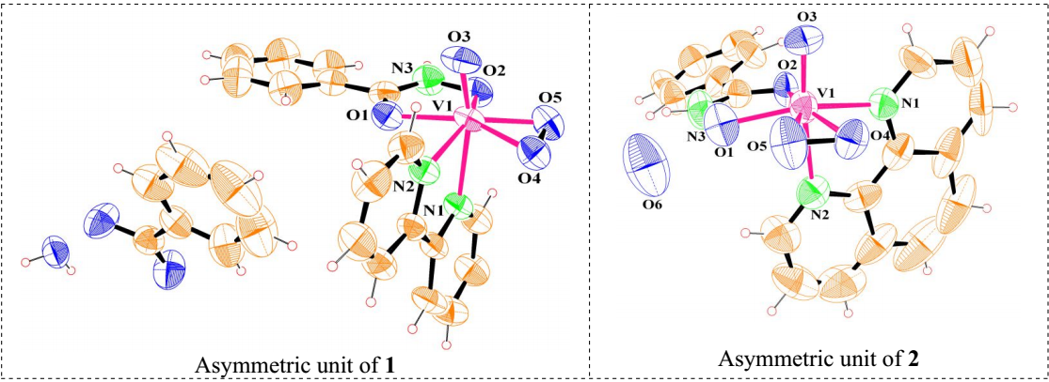

Figure S5. Supporting information for comparison of asymmetric units in **1** and **2**.

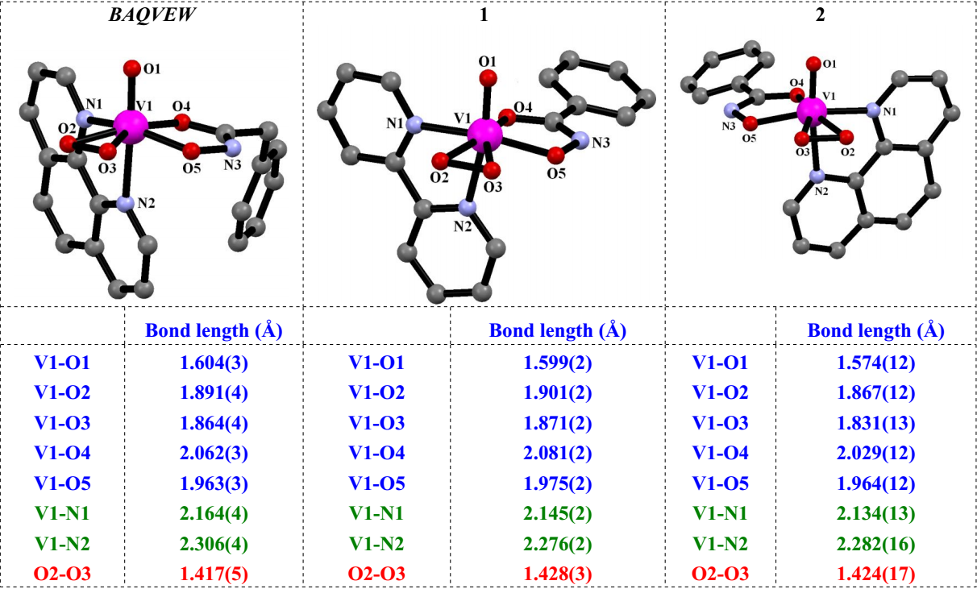

Figure S6. Supporting information for comparison of structures of the [VO(O2)(L1)(L2)] complex units in **1** and **2** (L = bidentate ligand) with that found in *BAQVEW*.

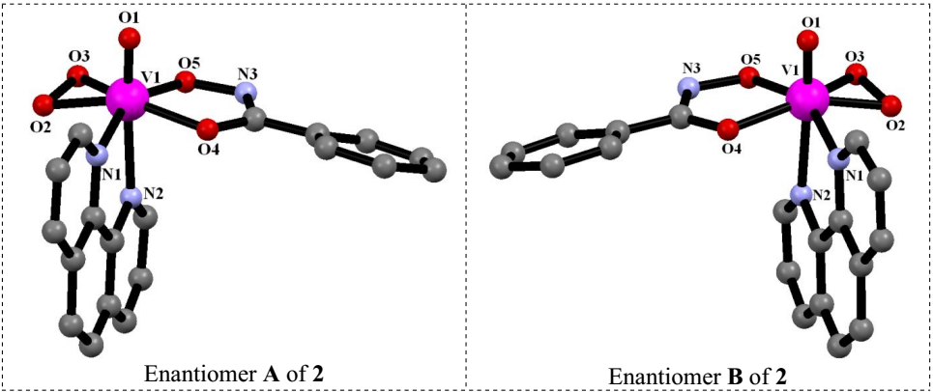

Figure S7. Supporting information for comparison of the partners in the pair of enantiomers present in the structure of **2**.



Figure S8. Supporting information for FT-IR data of complex **1**.



Figure S9. Supporting information for FT-IR data of complex **2**.

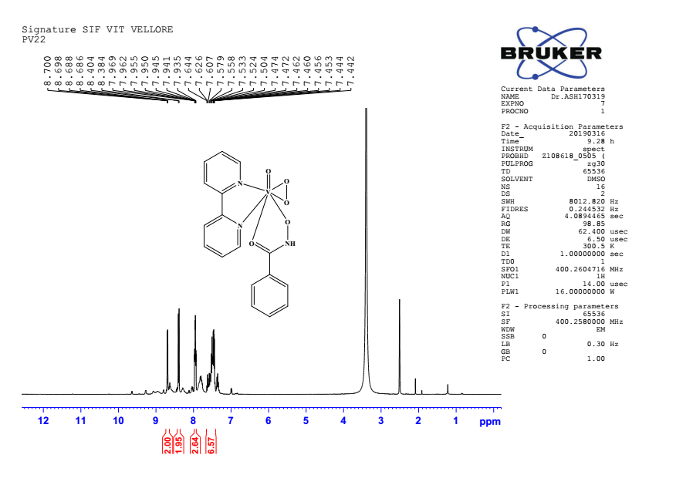

Figure S10. Supporting information for 1H NMR spectra of complex **1**.

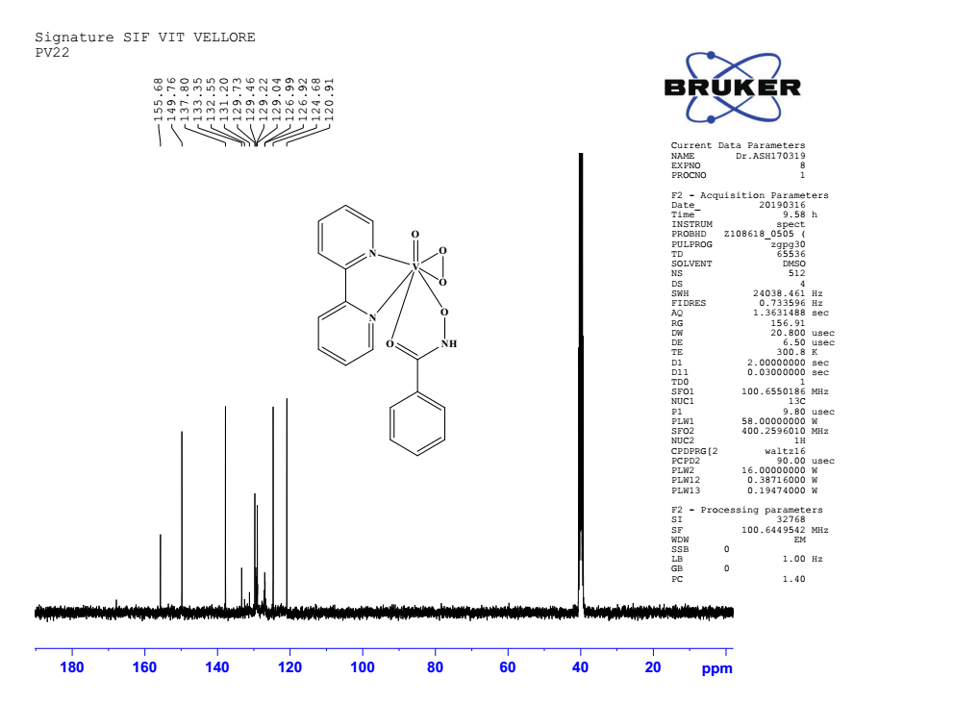

Figure S11. Supporting information for 13C NMR spectra of complex **1**.

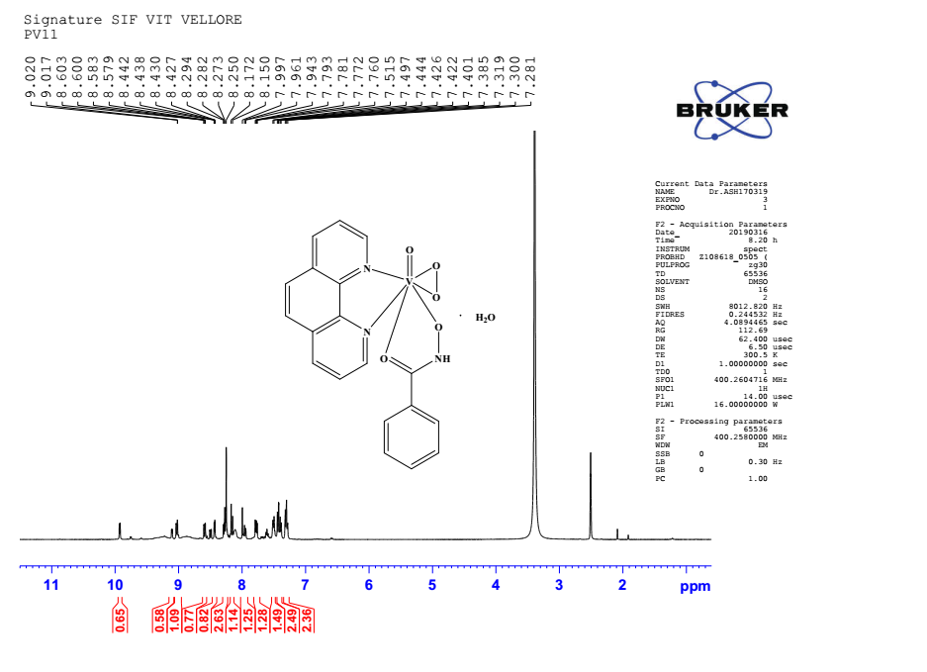

Figure S12. Supporting information for 1H NMR spectra of complex **2**.

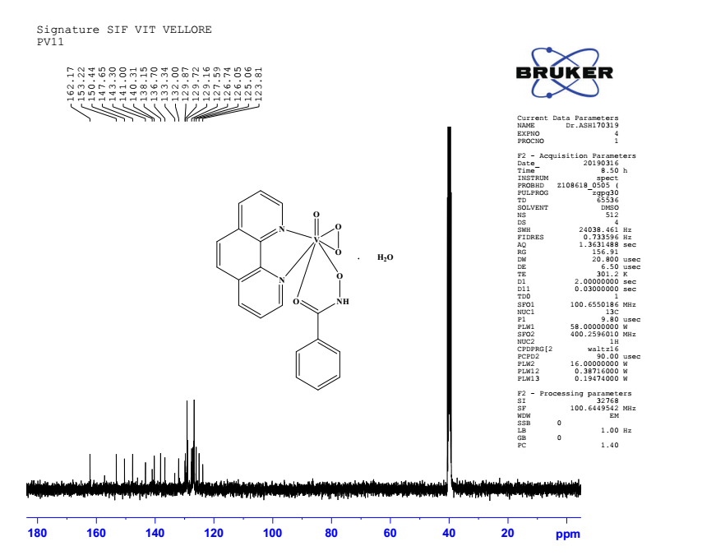

Figure S13. Supporting information for 13C NMR spectra of complex **2**.

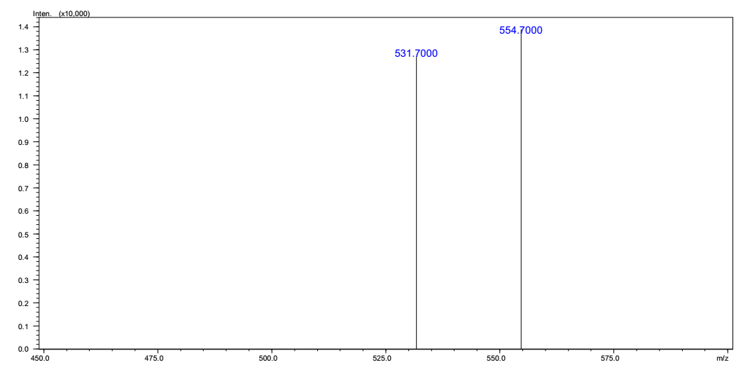

Figure S14. Supporting information for ESI mass of complex **1**.

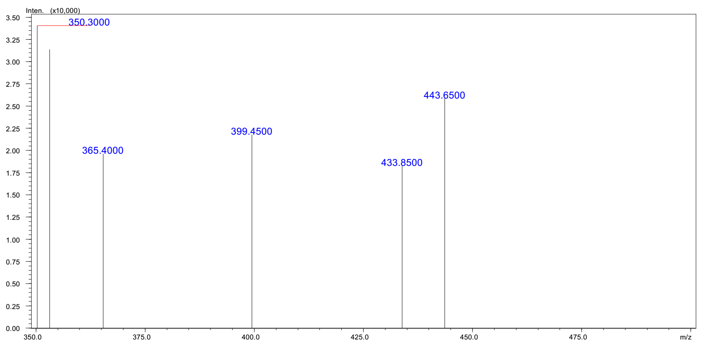

Figure S15. Supporting information for ESI mass of complex **2**.

**C:\Users\Elcot\Downloads\research work\scheme 1\Tip images of the pv11 and pv22\pv22 40mm 1.tif**

Figure S16. Absorption spectral titrations of complex **1** (40 µM) in the presence of 0.2 mM DNA in 10 mM Tris HCl buffer (pH 7.2).

**C:\Users\Elcot\Downloads\research work\scheme 1\Tip images of the pv11 and pv22\pv22 60mm 1.tif**

Figure S17. Absorption spectral titrations of complex **1** (60 µM) in the presence of 0.2 mM DNA in 10 mM Tris HCl buffer (pH 7.2).

**C:\Users\Elcot\Downloads\research work\scheme 1\Tip images of the pv11 and pv22\pv22 80mm 1.tif**

Figure S18. Absorption spectral titrations of complex **1** (80 µM) in the presence of 0.2 mM DNA in 10 mM Tris HCl buffer (pH 7.2).

**C:\Users\Elcot\Downloads\research work\scheme 1\Tip images of the pv11 and pv22\PV11 40 MM 1.tif**

Figure S19. Absorption spectral titrations of complex **2** (40 µM) in the presence of 0.2 mM DNA in 10 mM Tris HCl buffer (pH 7.2).

**C:\Users\Elcot\Downloads\research work\scheme 1\Tip images of the pv11 and pv22\PV11 60 MM 1.tif**

Figure S20. Absorption spectral titrations of complex **2** (60 µM) in the presence of 0.2 mM DNA in 10 mM Tris HCl buffer (pH 7.2).

**C:\Users\Elcot\Downloads\research work\scheme 1\Tip images of the pv11 and pv22\PV22 20MM GRAPH 1.tif**

Figure S21. Supporting information for complex **1** (20 µM) plot of [DNA] / [εa − εf] vs. DNA.

**C:\Users\Elcot\Downloads\research work\scheme 1\Tip images of the pv11 and pv22\PV22 40MM GRAPH 1.tif**

Figure S22. Supporting information for complex **1** (40 µM) plot of [DNA] / [εa − εf] vs. DNA.

**C:\Users\Elcot\Downloads\research work\scheme 1\Tip images of the pv11 and pv22\PV22 60MM GRAPH 1.tif**

Figure S23. Supporting information for complex **1** (60 µM) plot of [DNA] / [εa − εf] vs. DNA.

**C:\Users\Elcot\Downloads\research work\scheme 1\Tip images of the pv11 and pv22\PV22 80MM GRAPH 1.tif**

Figure S24. Supporting information for complex **1** (80 µM) plot of [DNA] / [εa − εf] vs. DNA.

**C:\Users\Elcot\Downloads\research work\scheme 1\Tip images of the pv11 and pv22\PV11 20 MM GRAPH 1.tif**

Figure S25. Supporting information for complex **2** (20 µM) plot of [DNA] / [εa − εf] vs. DNA.

**C:\Users\Elcot\Downloads\research work\scheme 1\Tip images of the pv11 and pv22\PV11 40 MM GRAPH 1.tif**

Figure S26. Supporting information for complex **2** (40 µM) plot of [DNA] / [εa − εf] vs. DNA.

**C:\Users\Elcot\Downloads\research work\scheme 1\Tip images of the pv11 and pv22\PV11 60 MM GRAPH 1.tif**

Figure S27. Supporting information for complex **2** (60 µM) plot of [DNA] / [εa − εf] vs. DNA.