Synthesis of highly functionalized selenophenes via a three-component condensation
Zahra Siroosª, Alireza Hassanabadi^{b*} , Mohammad H. Mossleminª
ªDepartment of Chemistry, Yazd Branch, Islamic Azad University, Yazd, Iran
^{b}Department of Chemistry, Zahedan Branch, Islamic Azad University, Zahedan, Iran
E-mail: ar_hasanabadi@yahoo.com

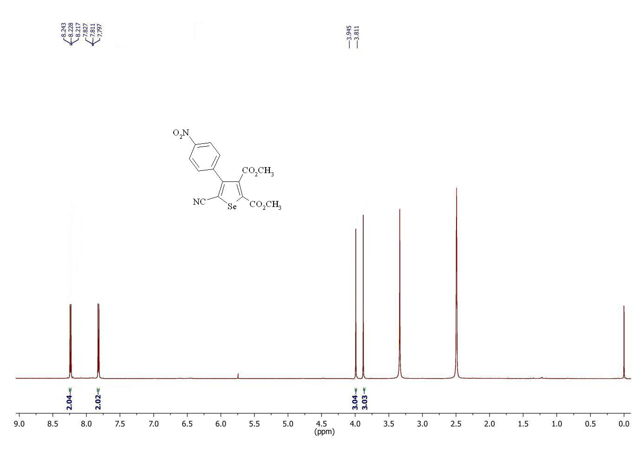
Figure S 1: ¹H NMR spectrum of 3a

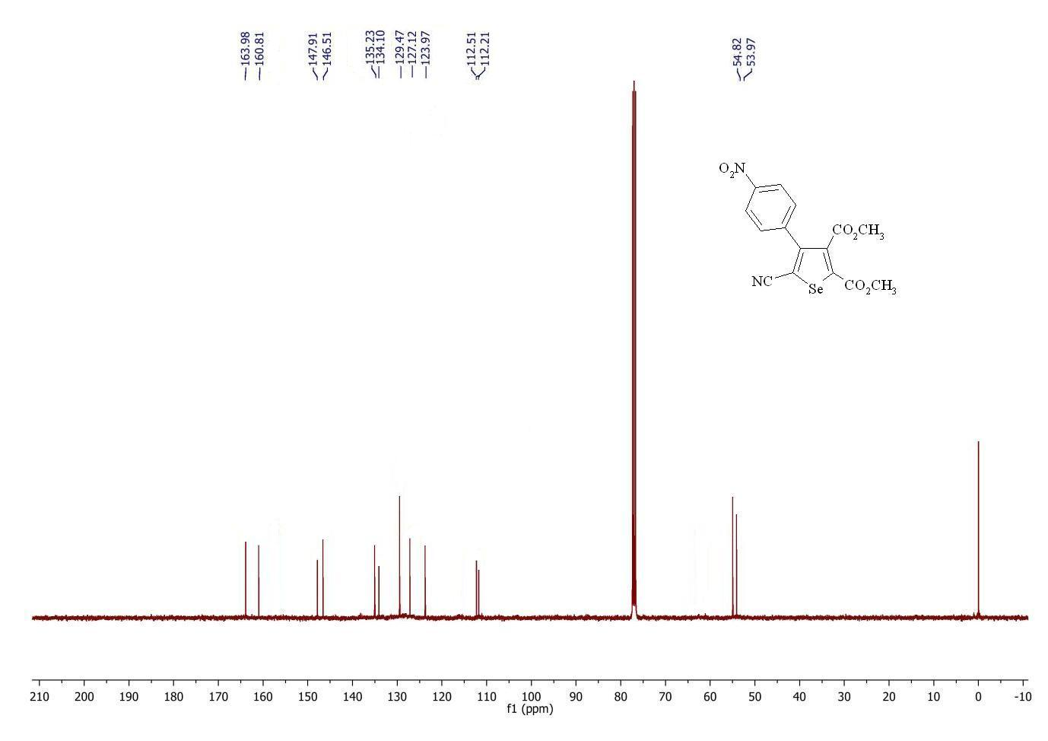
Figure S 2: ¹³C NMR spectrum of 3a

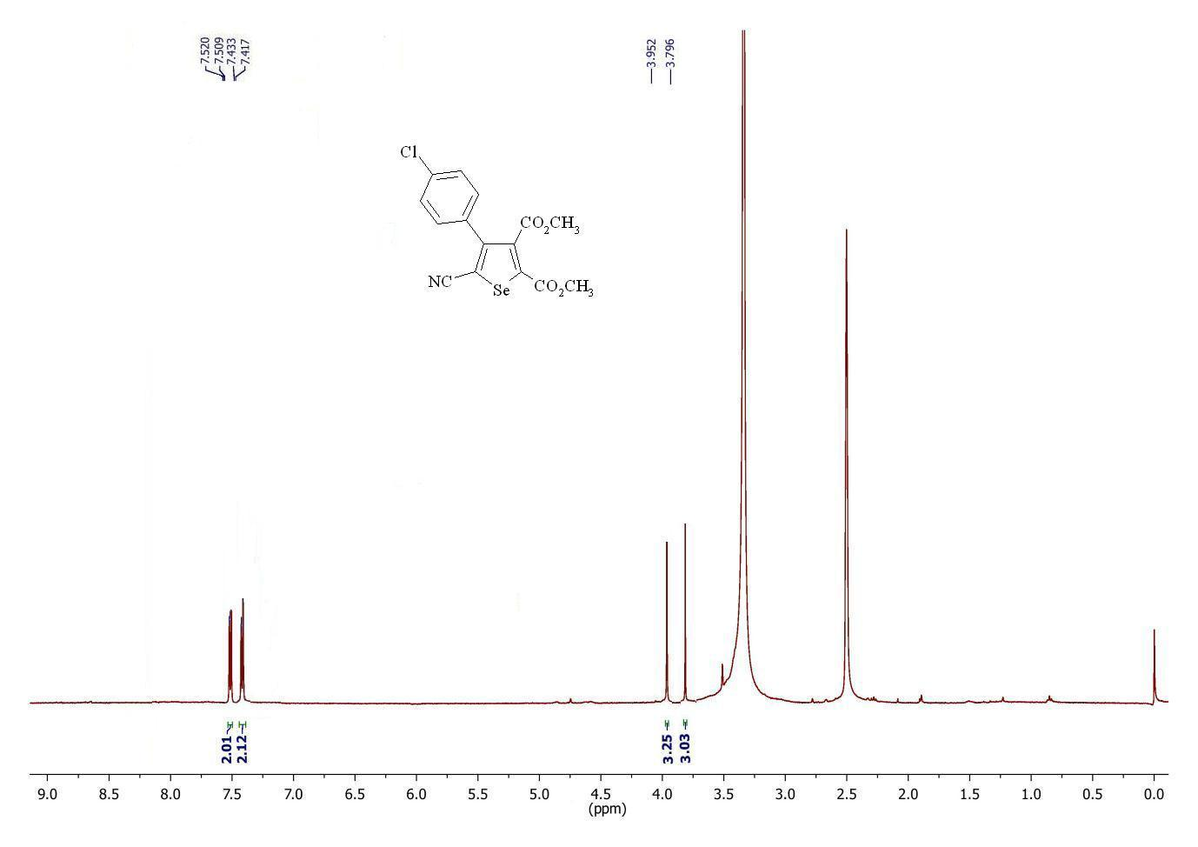
Figure S 3: ¹H NMR spectrum of 3b
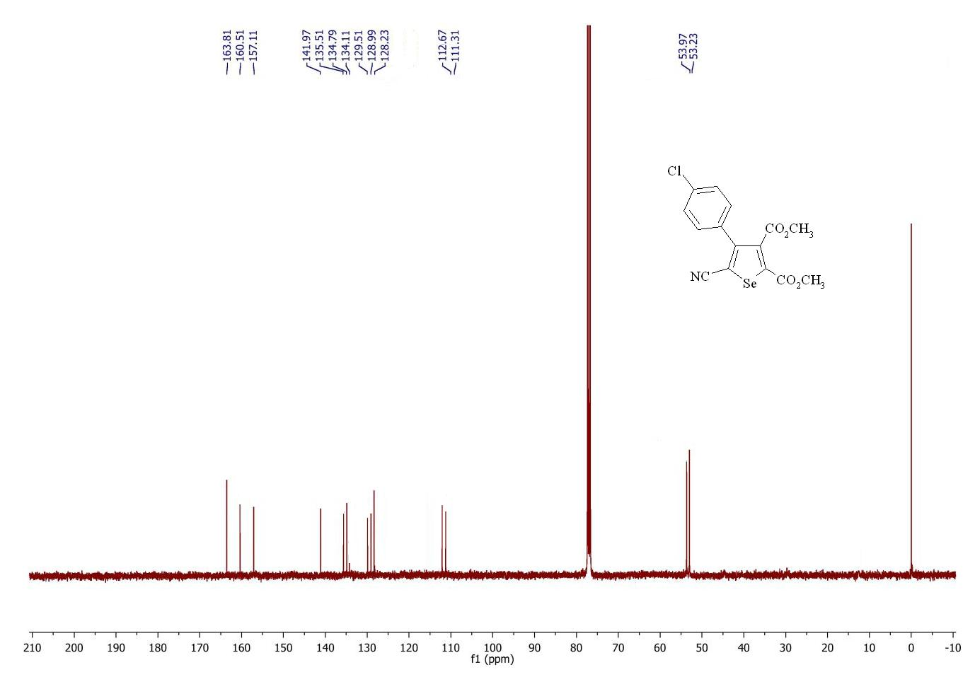
Figure S 4: ¹³C NMR spectrum of 3b

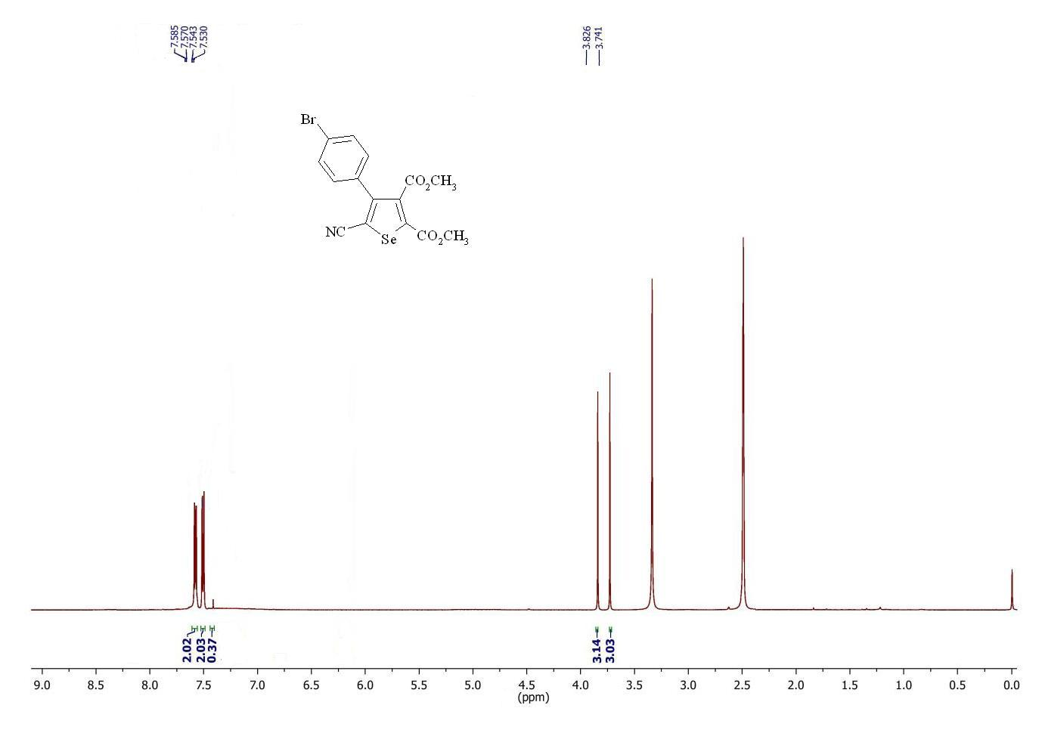
Figure S 5: ¹H NMR spectrum of 3c
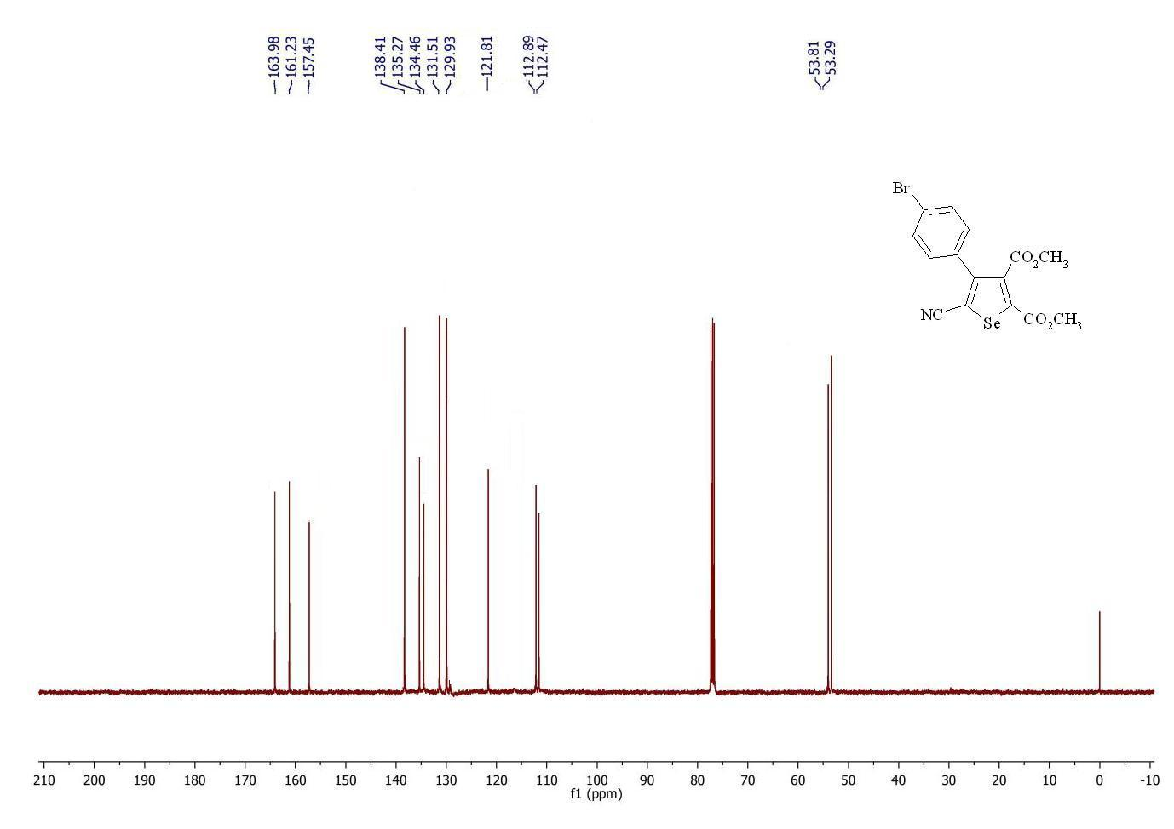
Figure S 6: ¹³C NMR spectrum of 3c

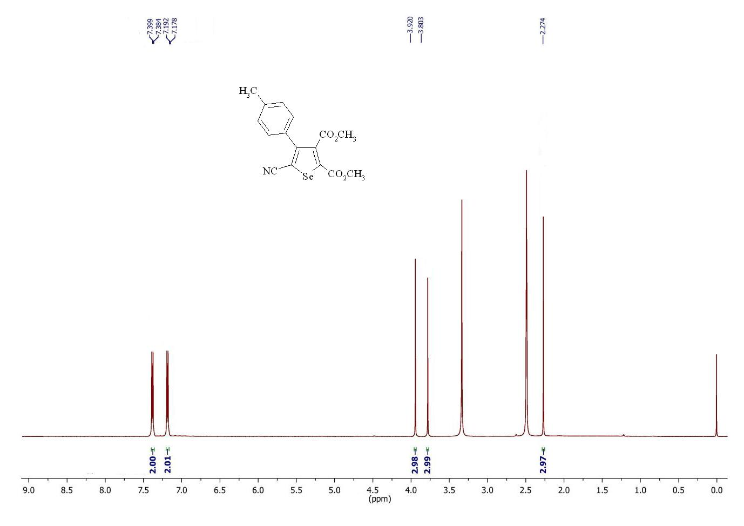
Figure S 7: ¹H NMR spectrum of 3d
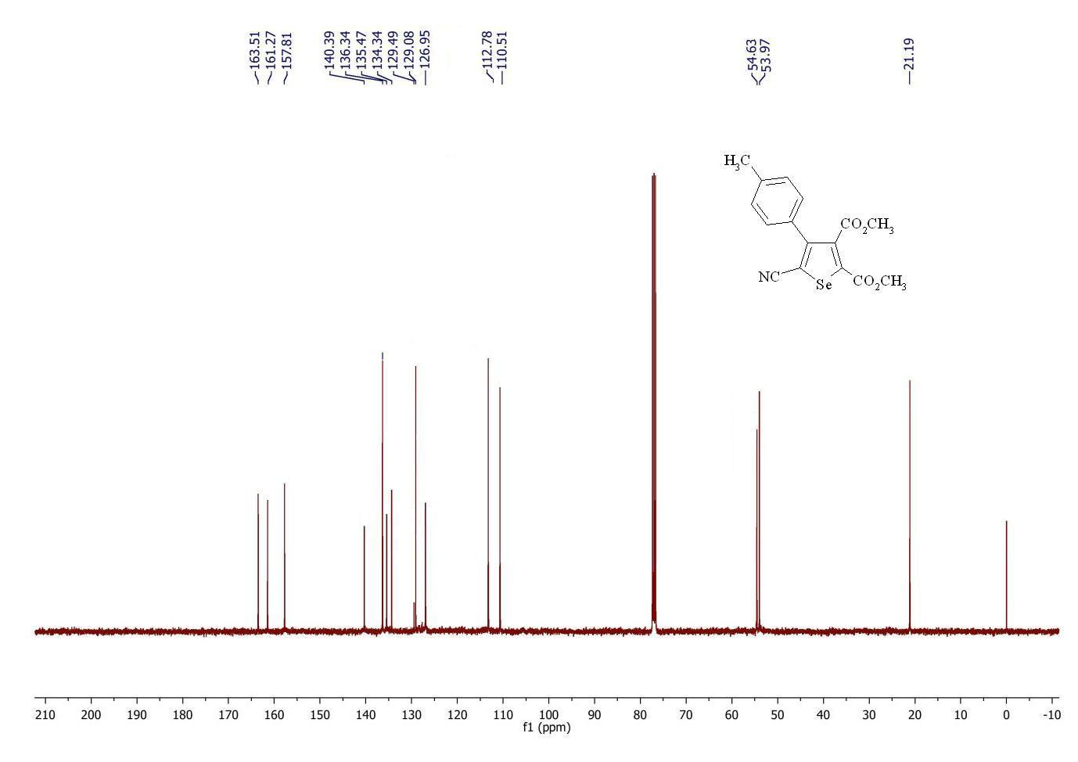
Figure S 8: ¹³C NMR spectrum of 3d

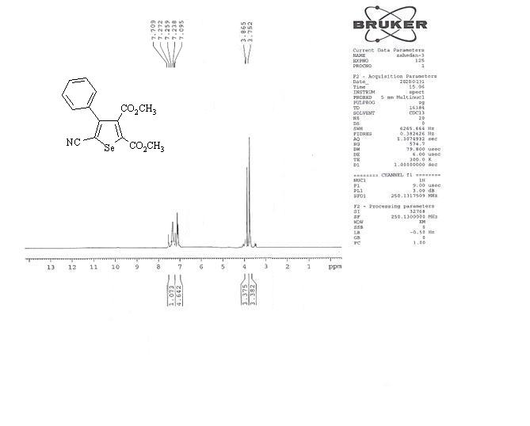
Figure S 9: ¹H NMR spectrum of 3e

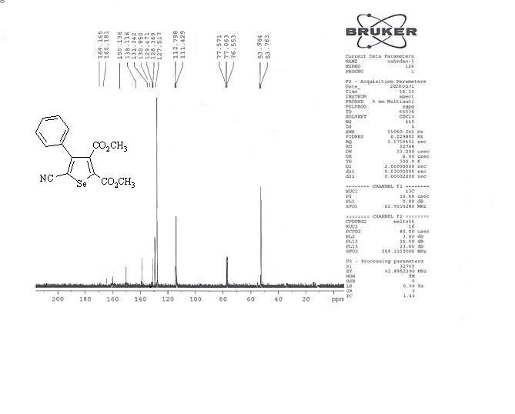
Figure S 10: ¹³C NMR spectrum of 3e

