SUPPORTING INFORMATION
For

A ligand free approach to substituted (Z)-3-methyleneisoindolin-1-ones via Cu (I) catalyzed regio - and stereo selective assembly of 2-iodobenzamide and terminal alkyne

Rimpa De, Mrinal K. Bera*

Department of Chemistry, Indian Institute of Engineering Science and Technology (IIEST), Shibpur
PO- Botanic Garden, Howrah- 711 103 (WB), India

mrinalkbera26@gmail.com

TABLE OF CONTENT

Genaral consideration
Characterisation data
¹H and ¹³C NMR spectra of sample 3a to 3x respectively
Crystal data of 3a

General consideration
All the chemicals including CuI and all substituted acetylene compounds were purchased from Sigma Aldrich. Potassium carbonate was purchased from Spectrochem, India. Thin layer chromatography was done by precoated silica gel on glass plate. All the ¹H and ¹³C NMR spectra were recorded at 400MHz and 100MHz, 150MHz. Chemical shifts value are given in δ (parts per million) related to CDCl₃ [ ¹H NMR(7.26 ppm) and ¹³C NMR(77.26 ppm) ]. Coupling constant (J) and spin multiplicity are given in Hz and singlet (s), doublet (d), triplet (t), quartet (q), multiplate (m). All commercially available solvents were used after distillation for purity. Inert atmosphere created by nitrogen gas. All the glassware was oven-dried. All the HRMS spectra recorded in Q-TOF mass spectrometer.

Characterisation data
(Z)-3-Benzylidene 2-phenyl isoindolin -1-one (3a)
Yield: 85%, white solid.

¹HNMR(400MHz,CDCl₃):δ= 7.95(d,7.6Hz,1H), 7.87(d,7.6Hz,1H), 7.68(t,7.2 Hz,1H), 7.55(t,7.4 Hz,1H), 7.08(brs,5H), 6.97-6.90(m,3H), 6.8(brs, 1H), 6.84(d,3.2Hz,2H).
¹³CNMR(150MHz,CDCl₃):δ=167.89,138.89,136.10,134.58,133.79,132.67,129.44,129.33,128.40,128.04,127.45,126.95,126.80,124.13,119.61,107.87.
HRMS: m/z [M+H]⁺calcd for C₂₁H₁₅NO:298.1234; found: 298.1207.

(Z)-3-benzylidene-2-(4-bromophenyl) isoindolin-1-one (3b)
Yield: 80%, white solid
¹HNMR(400MHz,CDCl₃):δ=7.94(d,7.6Hz,1H),7.86(d,7.6Hz,1H),7.68(t,7.4Hz,1H),7.56(t,7.4Hz,1H),7.19(d,8.4Hz,2H),7.05(d,6.8Hz,1H),6.95(m,4H),6.86(d,7.6Hz,3H)
¹³CNMR(150MHz,CDCl₃):δ=167.97,138.71,135.10,134.32,133.54,132.89,131.43,129.58,129.35,128.90, 127.77, 127.14, 124.19, 120.56, 119.67, 108.04.
HRMS:m/z[M+H]⁺calcdforC₂₁H₁₄BrNO:376.0339;found:376.0304,378.0270.
(Z)-3-benzylidene-2-(4-chlorophenyl) isoindolin-1-one (3c)
Yield: 85%, light yellow solid.
¹HNMR(400MHz,CDCl₃):δ=7.94(d,7.2Hz,1H),7.86(d,7.6Hz,1H),7.68(m,1H),7.56(t,7.4Hz,1H),7.04(m,3H),6.98(m,4H),6.86(d,8.4Hz,3H).
¹³CNMR(150MHz,CDCl₃):δ=168.05,138.71,134.60,134.39,133.56,132.88,132.59,129.58,129.37,128.56,128.47,127.78,127.61,127.14,124.19,119.67,108.01.
HRMS: m/z [M+H]⁺calcd for C₂₁H₁₄ClNO:332.0844 ; found:332.0843.

(Z)-3-benzylidene-2-(m-tolyl) isoindolin-1-one (3d)
Yield: 95%, white solid.
¹HNMR(400MHz,CDCl₃):δ=7.95(d,7.6Hz,1H),7.85(d,7.6Hz,1H),7.67(t,7.4Hz,1H),7.55(t,7.4Hz,1H),7.01(t,7.8Hz,1H), 6.97-6.90(m,4H),6.86(d,7.2Hz,3H),6.82(s,1H),6.79(brs,1H),2.07(s,3H).
¹³CNMR(150MHz,CDCl₃):δ=168.17,138.77,138.27,135.73,134.62,133.92,132.58,129.38,129.06,128.28,128.23,128.05,127.68,127.30,126.77,124.57,124.05,119.56,107.82,
21.16.
HRMS: m/z [M+H]⁺calcd for C₂₂H₁₇NO:312.139;found:312.1353.

(Z)-2-(4-bromophenyl)-3-(4-methylbenzyliden) isoindolin-1-one (3e)
Yield: 88%, light yellow solid.
¹HNMR(400MHz,CDCl₃):δ=7.93(dd,7.2Hz,3.4Hz,1H),7.84(dd,7.6Hz,3.8Hz,1H),7.67(dt,8Hz,3.2Hz,1H),7.54(dt,8Hz,3.8Hz,1H),7.25(d,1.6Hz,3H),7.20(m,2H),6.93(m,2H),6.82(d,4Hz,1H),6.80(m,2H),6.73(m,2H),2.25(s,3H).
¹³CNMR(150MHz,CDCl₃):δ=167.99,138.81,137.31,135.18,133.87,132.83,131.39,130.57,129.42,129.27,128.92,128.33,127.72
HRMS: m/z [M+H]⁺calcd for C₂₂H₁₆BrNO: 390.0495; found: 390.0463,392.0408.

(Z)-2-(4-chlorophenyl)-3-(4-methylbenzylidene) isoindolin-1-one (3f)
Yield: 92%, light yellow solid.
¹H NMR (400MHz,CDCl₃): δ= 7.86(d,7.6Hz,1H),7.77(d,7.6 Hz,1H),7.60(t,7.6 Hz,1H),7.47(t,7.2Hz,1H),6.98(d,8.4Hz,1H),6.92(d,8.8Hz,2H),6.75(s,1H),6.71(d,8.0 Hz,2H),6.67(d,8.0 Hz,2H),2.17(s,3H).
¹³CNMR(150MHz,CDCl₃):δ=168.07,138.83,137.28,134.70,133.90,132.82,132.53,130.59,129.41,129.31,128.56,128.43,128.32,127.73,124.17,119.60,108.29,21.38.
HRMS: m/z [M+H]⁺calcd for C₂₂H₁₆ClNO: 346.10 ; found: 346.1001.

(Z)-3-(4-methylbenzylidene)-2-(m-tolyl) isoindolin-1-one (3g)
Yield: 92%, white solid.
¹HNMR(400MHz,CDCl₃):δ=7.94(d,7.2Hz,1H),7.84(d,8.0Hz,1H),7.66(t,7.4Hz,1H),7.53(t,7.4Hz,1H),7.03(t,7.6Hz,1H),6.97(d,7.6Hz,1H),6.80(s,1H),6.78(brs,1H),6.73(brs,4H),2.19(s,3H),2.08(s,3H).
¹³CNMR(150MHz,CDCl₃):δ=168.16,138.89,138.19,136.64,135.84,134.06,132.51,130.94129.20,129.02,128.27,128.23,128.00,127.53,124.57,124.03,119.49,108.08,21.34,21.16.HRMS: m/z [M+H]⁺calcd for C₂₃H₁₉NO:326.1547; found: 326.1543.

(Z)-3-(4-methylbenzylidene)-2-phenylisoindolin-1-one (3h)
Yield: 80%, white solid.
¹HNMR(400MHz,CDCl₃):δ=7.88(d,7.6Hz,1H),7.78(d,7.6Hz,1H),7.60(t,7.2Hz,1H),7.47(t,7.6Hz,1H),7.02(m,5H),6.74(s,1H),6.66.(m,4H),2.12(s,3H).
¹³CNMR(100MHz,CDCl₃):δ=168.24,139.04,136.76,136.25,133.98,132.60,130.81,129.31,129.24,128.39,128.17,127.96,127.44,126.81,124.10,
119.53,108.19, 21.37.
HRMS: m/z [M+H]⁺calcd for C₂₂H₁₇NO: 312.1310; found: 312.8719

(Z)-3-(4-tert-butyl)benzylidene)2-phenylisoindolin-1-one (3i)
Yield: 87%, light yellowish white.
¹H NMR (400MHz,CDCl₃):δ=7.88(d,7.6Hz,1H), 7.79(d,7.6Hz,1H) , 7.60(t,7.4Hz,1H), 7.47(t,7.4Hz,1H), 6.97(m,5H), 6.84(d,8.4Hz,2H) ,6.77(s,1H), 6.68(d,8.0Hz,2H), 1.13(s,9H).
¹³CNMR (150MHz, CDCl₃): δ=168.32, 150.01, 138.88, 132.58, 129.28, 128.89, 128.25, 127.54, 126.76, 124.32, 124.08, 119.56, 108.01, 34.59, 31.40.
HRMS: m/z [M+H]⁺ calcd for C₂₅H₂₃NO: 354.186; found: 354.1812.

(Z)-3-(4-pentylbenzyllidene)-2-phenylisoindolin-1-one (3j)
Yield: 87%, light yellowish solid.
¹HNMR(400MHz,CDCl₃):δ=7.97(d,7.6Hz,1H),7.87(d,8.0Hz,1H),7.69(t,7.4Hz,1H),7.56(t,7.2Hz,1H),7.06(m,5H),6.85(s,1H),6.75(q,8.0Hz,4H),2.45(t,7.4Hz,2H),1.50(p,7.6Hz,2H),1.33(p,7.2Hz,2H),1.23(m,62H),0.92(t,7.2 Hz,3H).
¹³CNMR(150MHz,CDCl₃):δ=168.19,141.82,138.92,136.14,134.03,132.59,131.01,129.24,129.18,128.33,127.95,127.56,127.44,126.81,124.08,119.53,108.19,35.71,31.39,31.31,22.79,14.32.
HRMS: m/z [M+H]⁺ calcd for C₂₆H₂₅NO: 368.1936;found:368.1984
(Z)-3-(4-butylbenzylidene)-2-(m-tolyl) isoindolin-1-one (3k)

Yield: 87%, light yellow solid.

¹HNMR(400MHz,CDCl₃):δ=7.94(d,7.6Hz,1H),7.84(d,7.6Hz,1H),7.66(t,7.4Hz,1H),7.54(t,7.4Hz,1H),7.00(m,2H),6.84-6.81(m,2H),6.77-6.71(m,5H),2.44(t,7.4Hz,2H),2.07(s,3H),1.49
1.43(m,2H),1.29-1.24(m,2H),0.92(t,7.4Hz,3H).
¹³CNMR(150MHz,CDCl₃):δ=168.19,141.69,138.84,138.14,135.82,134.19,132.52,131.19,129.22,128.99,128.29,128.19,128.02,127.56,127.44,124.62,124.02,119.50,108.15,35.45,33.78,22.29,21.19,14.19.
HRMS: m/z [M+H]⁺ calcd for C₂₆H₂₅NO: 368.2016; found:368.1976

(Z)-3-4-(4-butylbenzylidene)-2-(4-chlorophenyl) isoindolin-1-one (3l)
Yield: 88%, white solid.
¹HNMR(400MHz,CDCl₃):δ=7.94(d,7.6Hz,1H),7.85(d,8Hz,1H),7.68(t,7.2Hz,1H),7.55(t,7.4Hz,1H),7.01(m,4H),6.85(s,1H),6.77(m,4H),2.48(t,7.6Hz,2H),1.50(m,2H),1.29(m,2H),0.94(t,7.4Hz,3H).
¹³CNMR(150MHz,CDCl₃):δ=168.02,142.41,138.75,134.66,133.95,132.80,132.50,130.81,129.40,129.22,128.59,128.38,127.75,127.69,124.14,119.60,108.28,35.55, 34.08,22.43,14.23.
HRMS: m/z [M+H]⁺calcd for C₂₅H₂₂ClNO: 388.147; found: 388.1468.

(Z)-2-(4-bromophenyl)-3-(4-butylbenzylidene) isoindolin-1-one (3m)
Yield: 87%, yellowish solid.
¹HNMR(400MHz,CDCl₃):δ=7.94(d,7.6Hz,1H),7.85(d,7.6Hz,1H),7.67(t,7.4Hz,1H),7.54(t,7.6Hz,1H),7.18(m,2H),6.92(m,2H),6.84(s,1H),6.77(dd,16Hz,8Hz,4H),2.48(t,7.6Hz,2H),
1.52(q,7.6Hz,2H),1.32(q,7.2Hz,2H),0.94(t,7.2Hz,3H).
¹³CNMR(150MHz,CDCl₃):δ=167.95,142.45,138.75,135.16,133.86,132.81,131.13,130.78,129.40,129.20,128.92,127.73,127.69,124.15,120.46,119.60,35.56,34.12,22.49,14.27.
HRMS: m/z [M+H]⁺ calcd for C₂₅H₂₂BrNO:432.0965; found :432.0911

(Z)-2-(4-bromophenyl)-3-(4-pentylbenzylidene) isoindolin-1-one (3n)
Yield: 86%, light yellow solid.
¹HNMR(400MHz,CDCl₃):δ=7.94(d,7.6Hz,1H),7.85(d,8Hz,1H),7.67(m,1H),7.54(t,7.6Hz,1H),7.18(m,2H),6.92(m,2H),6.8(s,1H),6.77(m,4H),2.47(t,7.6Hz,2H),1.51(m,2H),1.32(m,4H),
0.92(m,3H).
¹³CNMR(150MHz,CDCl₃):δ=167.96,142.53,138.76,135.16,133.86,132.81,131.34,130.78,129.41,129.21,128.93,127.74,127.67,124.15,120.45,119.61,108.32,35.88,31.70,31.69,22.77,14.35.

HRMS:m/z[M+H]⁺calcdforC₂₆H₂₄BrNO:446.1121;found:446.1084,448.1034.

(Z)-2-(4-chlorophenyl)-3-(4-pentylbenzylidene) isoindolin-1-one (3o)
Yield: 95%, white solid.
¹HNMR(400MHz,CDCl₃):δ=7.94(d,7.6Hz,1H),7.85(d,8.0Hz,1H),7.68(t,7.4Hz,1H),7.55(t,7.6Hz,1H),7.01(q,8.4Hz,3H),6.84(s,1H),6.76(m,4H),2.47(t,7.6Hz,2H),1.52(m,2H),1.32(m,4H),0.91(t,7.2Hz,3H).
¹³CNMR(150MHz,CDCl₃):δ=168.03,142.49,138.77,134.67,133.95,132.81,132.50,130.81,129.41,129.24,128.59,128.38,127.76,127.67,124.15,119.61,108.29,35.87,31.66,31.64,22.77,14.32.
HRMS: m/z [M+H]⁺calcd for C₂₆H₂₄ClNO: 402.1626; found : 402.1593.

(Z)-3-(4-pentylbenzylidene)-2-(m-tolyl) isoindolin-1-one (3p)
Yield: 89%, white solid.

¹H NMR (400MHz,CDCl₃): δ= 7.87(d,7.6Hz,1H), 7.77(d,7.6Hz,1H), 7.58(t,7.4Hz,1H), 7.46(t,7.4Hz,1H), 6.92(m,2H), 6.75(m,2H), 6.67(m,5H), 2.36(t,7.6Hz,2H), 1.99(s,3H), 1.41(m,2H), 1.27(m,2H), 1.16(m,2H), 0.84(t,7.2 Hz,3H).
¹³CNMR(150MHz,CDCl₃):δ=168.16,141.74,138.86,138.13,135.82,134.17,132.51,131.19,129.21,129.00,128.29,128.19,128.03,127.56,127.43,124.61,124.03,119.50,108.12,35.74,31.46,31.36,22.79,21.22,14.29.
HRMS: m/z [M+H]⁺ calcd for C₂₇H₂₇NO :382.2173; found:382.2169.

(Z)-3-(4-butylbenzylidene-2-phenylisoindolin-1-one (3q)
Yield: 88%, light yellow solid.
¹HNMR (400MHz,CDCl₃):δ= 7.88(d,7.2 Hz,1H),7.78(d, 7.6Hz, 1H), 7.59 (t,7.4Hz,1H),7.47(t,7.4Hz,1H),6.98(m,5H),6.75(s,1H),6.66(q,8.0Hz,4H),2.36(t,7.6Hz,2H),1.39(p,7.4Hz,2H),1.19(m,2H),0.84(t,7.2 Hz,3H)
¹³CNMR(150MHz,CDCl₃):δ=168.20,141.78,138.92,136.14,134.06,132.59,131.01,129.25,129.17,128.33,127.96,127.57,127.45,126.81,124.08,119.54,108.19,35.43,33.77,22.25,14.19.
HRMS: m/z [M+H]⁺ calcd for C₂₅H₂₃NO:354.186; found: 354.1827

(Z)-3-butylidene-2-phenylisoindolin-1-one (3r)
Yield: 90%, white solid.
¹HNMR(400MHz,CDCl₃): δ= 7.82(d,7.6 Hz,1H),7.62(d,8.0Hz,1H),7.53(t,7.6 Hz,1H),7.4-7.3(m,4H),7.28(d,7.2Hz,2H),5.57(t,7.8Hz,1H),1.57(m,2H),1.21(h,7.6Hz,2H),
0.64(t,7.2Hz, 3H).
¹³CNMR(150MHz,CDCl₃):δ=168.18,138.33,137.37,135.00,132.21,129.37,128.90,128.68,128.54,128.02,123.75,119.12,110.41,28.49,23.23,13.86.
HRMS: m/z [M+H]⁺calcd for C₁₈H₁₇NO: 264.1390;foumd: 264.1523
Z)-2-(4-bromophenyl)-3-butylideneisoindolin-1-one (3s)
Yield: 85%, yellowish solid.
¹HNMR(400MHz,CDCl₃):δ=7.81(d,7.6Hz,1H),7.62(d,8Hz,1H),7.54(m,3H),7.42(t,7.6Hz,1H),7.18(m,3H),1.63(q,7.6Hz,2H),1.26(h,2Hz,2H),0.69(m,3H).
¹³CNMR(100MHz,CDCl₃):δ=167.17,138.35,137.53,134.83,132.57,132.52,132.49,132.29,131.83,130.43,128.86,128.36,128.17,124.11,123.85,122.31,119.20,110.61,93.30,28.81,23.17,13.85.
HRMS: m/z [M+H]⁺ calcd for C₁₈H₁₆BrNO: 342.0495 ;found:342.6997.

(Z)-3-butylidene-2-(4-chlorophenyl) isoindolin-1-one (3t)
Yield: 82%, yellowish solid.
¹H NMR (400MHz, CDCl3): δ = 7.88(d,7.6Hz, 1H), 7.69(d,7.6Hz,1H), 7.61(m,1H),7.50-7.44(m,3H), 7.32-7.28(m,2H), 5.65(t,7.8Hz,1H), 1.69(q,7.6Hz,2H), 1.35-1.28(m,2H), 0.76(t,7.2Hz,3H).
HRMS: m/z [M+H]⁺ calcd for C₁₈H₁₆ClNO: 298.10 ;found:298.1049.

(Z)-3-butylidene-2-(4-methoxyphenyl) isoindolin-1-one (3u)
Yield: 86%, colorless solid.
¹H NMR (400MHZ, CDCl₃): δ = 7.87(d,7.6Hz,1H), 7.67(d,7.6Hz, 1H), 7.57(m,1H), 7.46(t,7.8Hz, 1H), 7.25-7.22(m,2H), 7.00-6.96(m,2H), 5.61(t,8.0Hz,1H), 3.85(s,3H), 1.66(m,2H), 1.32-1.07(m,2H), 0.73(t,7.2Hz,3H).
HRMS: m/z [M+Na]⁺ calcd for C₁₉H₁₉NO₂: 316.1313 ;found:316.0911.
(Z)-3-benzylidene-2(2, 4-dimethylphenyl) isoindolin-1-one (3v)
Yield: 87%, yellow solid.
¹H NMR (400MHZ, CDCl₃): δ = 7.94(d,7.2Hz,1H),7.83(d,8Hz,1H), 7.66(m,1H),7.54(t,7.4Hz,1H),6.97-6.93(m,1H), 6.90-6.86(m,2H),6.82-6.78(m,5H), 6.71(d,8Hz,1H), 2.19(s,3H), 2.06(s,3H).
HRMS: m/z [M+H]⁺ calcd for C₂₃H₁₉NO: 326.1547; found:326.1493.
(Z)-3-benzylidene-2-(3-chlorophenyl) isoindolin-1-one (3w)
Yield: 84%, yellow solid.
¹H NMR (400MHZ, CDCl₃): δ = 7.94(d,7.6Hz,1H), 7.85(d,7.6Hz,1H), 7.68(t,7.4Hz,1H), 7.55(t,7.4Hz,1H), 7.02-6.95(m,7H), 6.87(t,6.6Hz,3H).
HRMS: m/z [M+H]⁺ calcd for C₂₁H₁₄ClNO: 332.0764; found:332.0384.

(Z)-3-benzylidene-2-(4-methoxyphenyl) isoindolin-1-one (3x)
Yield: 84%, colorless solid.
¹H NMR (400MHZ, CDCl₃): δ = 7.94(d,7.6Hz,1H), 7.85(d,7.6Hz,1H), 7.67(td,8.0Hz,0.8Hz,1H), 7.56-7.52(m,1H), 7.01-6.92(m,5H), 6.86(d,7.2Hz,2H), 6.82(s,1H), 6.62(m,2H), 3.71(s,3H).
HRMS: m/z [M+H]⁺ calcd for C₂₂H₁₇NO₂: 328.1293; found:328.0916.

Characterisation of data
1_{H} NMR of (Z)-3-benzylidene-2-phenylisoindolin-1-one (3a):
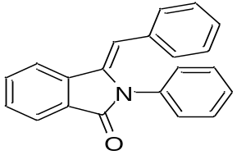

¹³C NMR of (Z)-3-benzylidene-2-phenylisoindolin-1-one (3a):

1_{H} NMR of (Z)-3-benzylidene-2-(4-bromophenyl) isoindolin-1-one (3b):
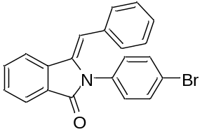

¹³C NMR of (Z)-3-benzylidene-2-(4-bromophenyl) isoindolin-1-one (3b):

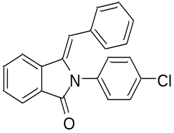
1_{H} NMR of (Z)-3-benzylidene-2-(4-chlorophenyl) isoindolin-1-one (3c):

¹³C NMR of (Z)-3-benzylidene-2-(4-chlorophenyl) isoindolin-1-one (3c):

1_{H} NMR of (Z)-3-benzylidene-2-(m-tolyl) isoindolin-1-one (3d):
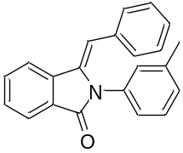

¹³C NMR of (Z)-3-benzylidene-2-(m-tolyl) isoindolin-1-one (3d):

1_{H} NMR of (Z)-2-(4-bromophenyl)-3-(4-methylbenzylidene) isoindolin-1-one (3e):
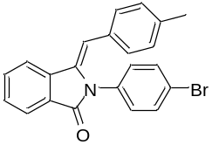

¹³C NMR of (Z)-2-(4-bromophenyl)-3-(4-methylbenzylidene) isoindolin-1-one (3e):

1_{H} NMR of (Z)-2-(4-chlorophenyl)-3-(4-methylbenzylidene) isoindolin-1-one (3f):
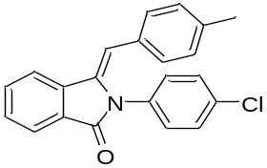

¹³C NMR of (Z)-2-(4-chlorophenyl)-3-(4-methylbenzylidene) isoindolin-1-one (3f):

1_{H} NMR of (Z)-3-(4-methylbenzylidene)-2-(m-tolyl) isoindolin-1-one (3g):
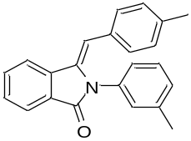

¹³C NMR of (Z)-3-(4-methylbenzylidene)-2-(m-tolyl) isoindolin-1-one (3g):

1_{H} NMR of (Z)-3-(4-methylbenzylidene)-2-phenylisoindolin-1-one (3h):
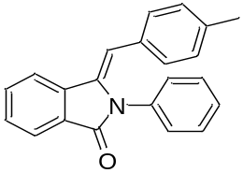

¹³C NMR of (Z)-3-(4-methylbenzylidene)-2-phenylisoindolin-1-one (3h):

1_{H} NMR of (Z)-3-(4-tert-butylbenzylidene)-2-phenylisoindolin-1-one (3i):
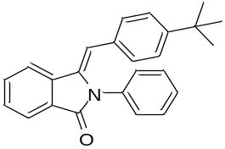

¹³C NMR of (Z)-3-(4-tert-butylbenzylidene)-2-phenylisoindolin-1-one (3i):

1_{H} NMR of (Z)-3-(4-butylbenzylidene)-2-phenylisoindolin-1-one (3j):
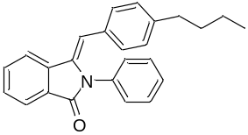

¹³C NMR of (Z)-3-(4-butylbenzylidene)-2-phenylisoindolin-1-one (3j):

1_{H} NMR of (Z)-3-(4-butylbenzylidene)-2-(m-tolyl) isoindolin-1-one (3k):
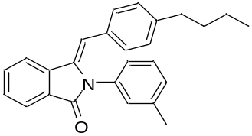

¹³C NMR of (Z)-3-(4-butylbenzylidene)-2-(m-tolyl) isoindolin-1-one (3k):

1_{H} NMR of (Z)-3-(4-butylbenzylidene)-2-(4-chlorophenyl) isoindolin-1-one (3l):
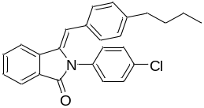

¹³C NMR of (Z)-3-(4-butylbenzylidene)-2-(4-chlorophenyl) isoindolin-1-one (3l):

1_{H} NMR of (Z)-(4-bromophenyl)-3-(4-butylbenzylidene) isoindolin-1-one (3m):
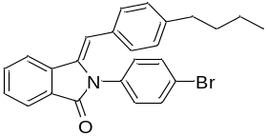

¹³C NMR of (Z)-(4-bromophenyl)-3-(4-butylbenzylidene) isoindolin-1-one (3m):

1_{H} NMR of (Z)-2-(4-bromophenyl)-3-(4-pentylbenzylidene) isoindolin-1-one (3n):
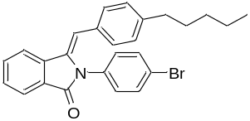

¹³C NMR of (Z)-2-(4-bromophenyl)-3-(4-pentylbenzylidene) isoindolin-1-one (3n):

1_{H} NMR of (Z)-2-(4-chlorophenyl)-3-(4-pentylbenzylidene) isoindolin-1-one (3o):
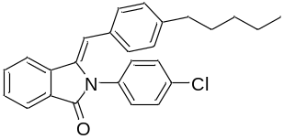

¹³C NMR of (Z)-2-(4-chlorophenyl)-3-(4-pentylbenzylidene) isoindolin-1-one (3o):

1_{H} NMR of (Z)-3-(4-pentylbenzylidene)-2-(m-tolyl) isoindolin-1-one (3p):

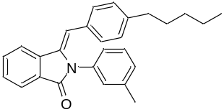

¹³C NMR of (Z)-3-(4-pentylbenzylidene)-2-(m-tolyl) isoindolin-1-one (3p):

1_{H} NMR of (Z)-3-(4-pentylbenzylidene)-2-phenylisoindolin-1-one (3q):
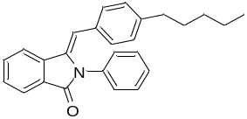

¹³C NMR of (Z)-3-(4-pentylbenzylidene)-2-phenylisoindolin-1-one (3q):

1_{H} NMR of (Z)-3-butylidene-2-phenylisoindolin-1-one (3r):
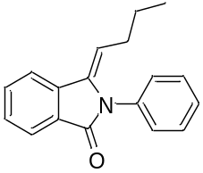

¹³C NMR of (Z)-3-butylidene-2-phenylisoindolin-1-one (3r):

1_{H} NMR of (Z)-2-(4-bromophenyl)-3-butylidene isoindolin-1-one (3s):
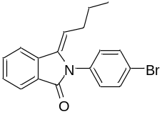

¹³C NMR of (Z)-2-(4-bromophenyl)-3-butylidene isoindolin-1-one (3s):

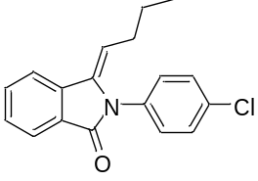1_{H} NMR of (Z)-3-butylidene-2-(4-chlorophenyl) isoindolin-1-one (3t):
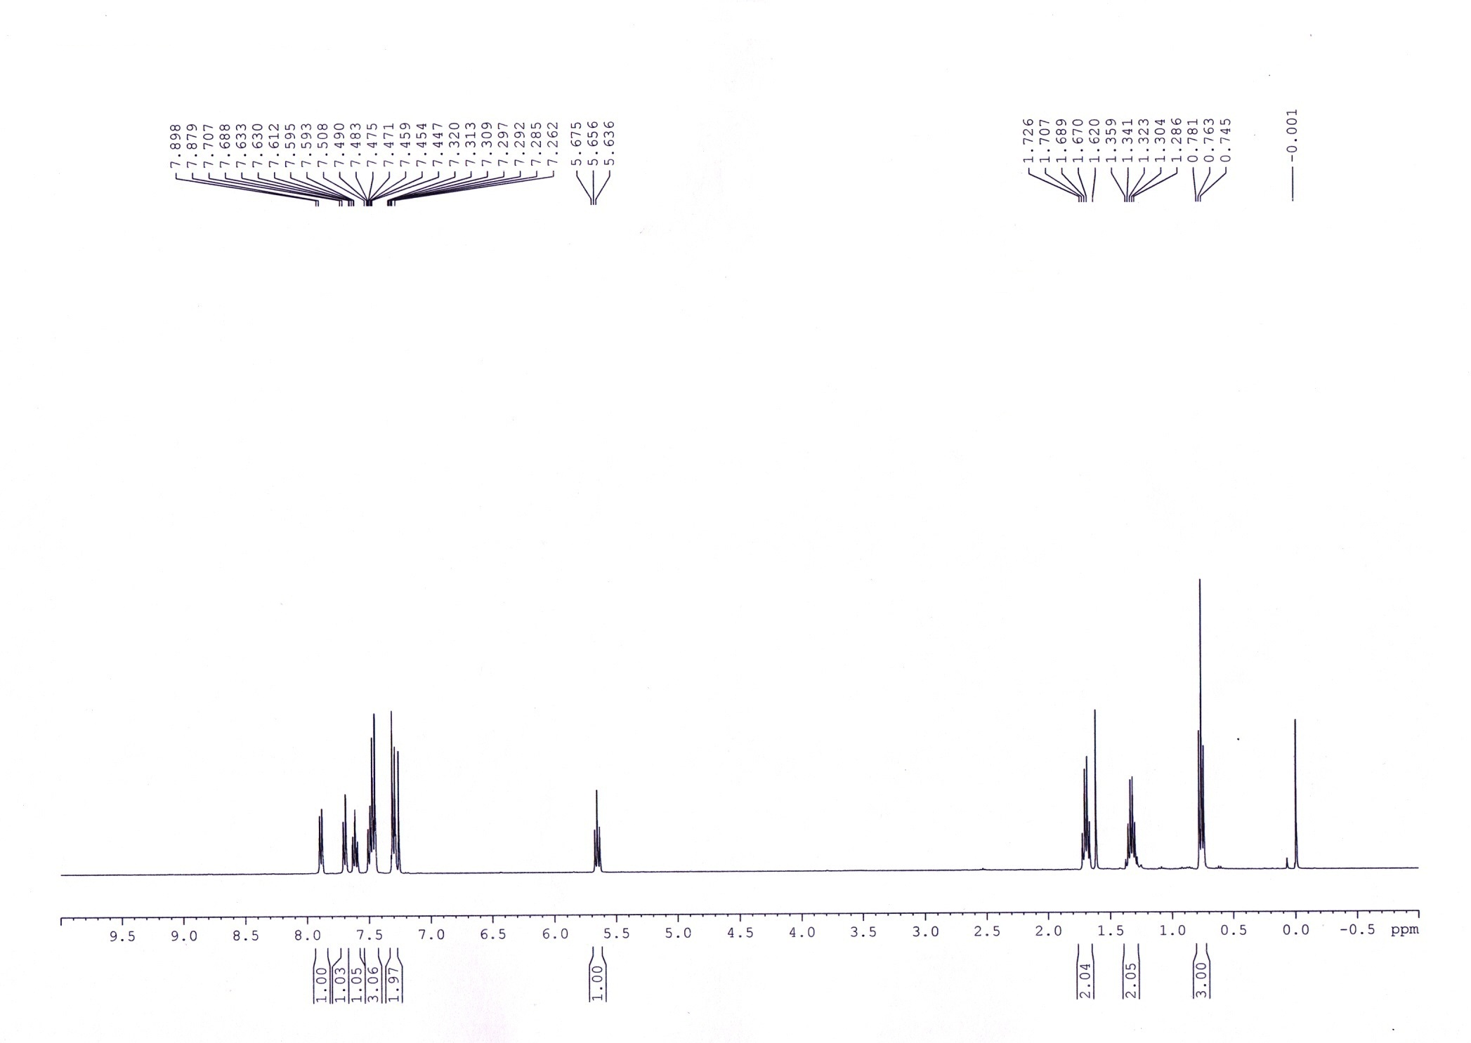

1_{H} NMR of (Z)-3-butylidene-2-(4-methoxyphenyl) isoindolin-1-one (3u):
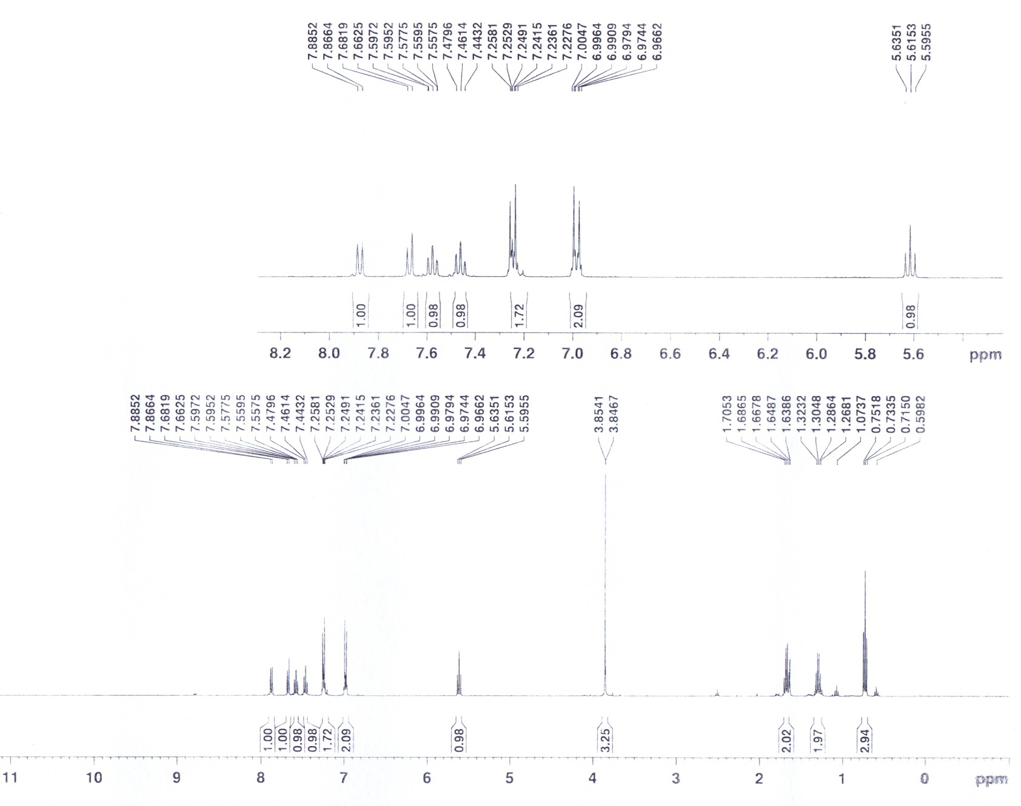
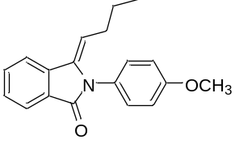

1_{H} NMR of (Z)-3-benzylidene-2-(2, 4-dimethylphenyl) isoindolin-1-one (3v):

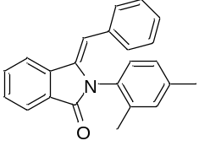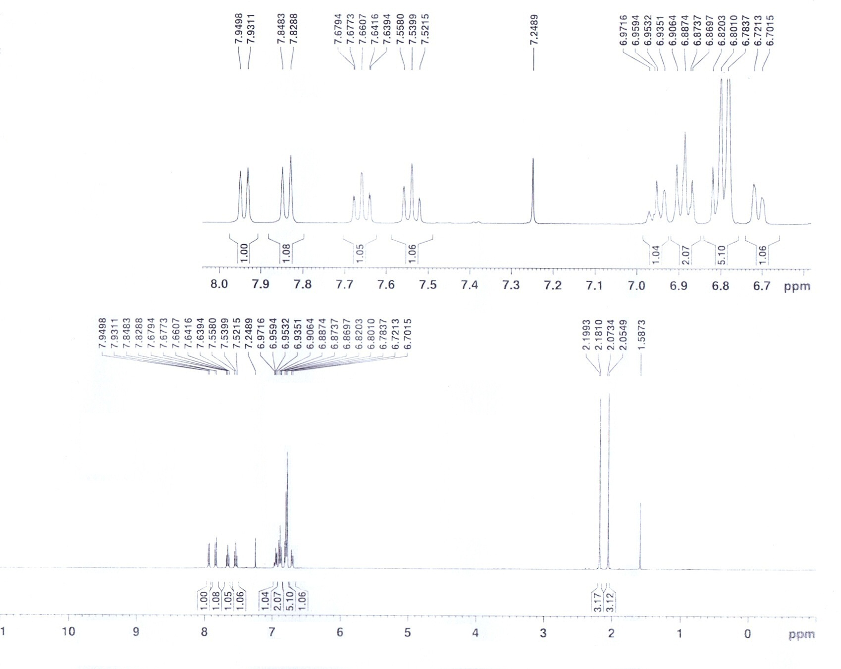

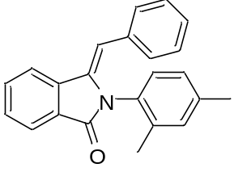
1_{H} NMR of (Z)-3-benzylidene-2-(3-chlorophenyl) isoindolin-1-one (3w):
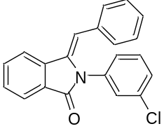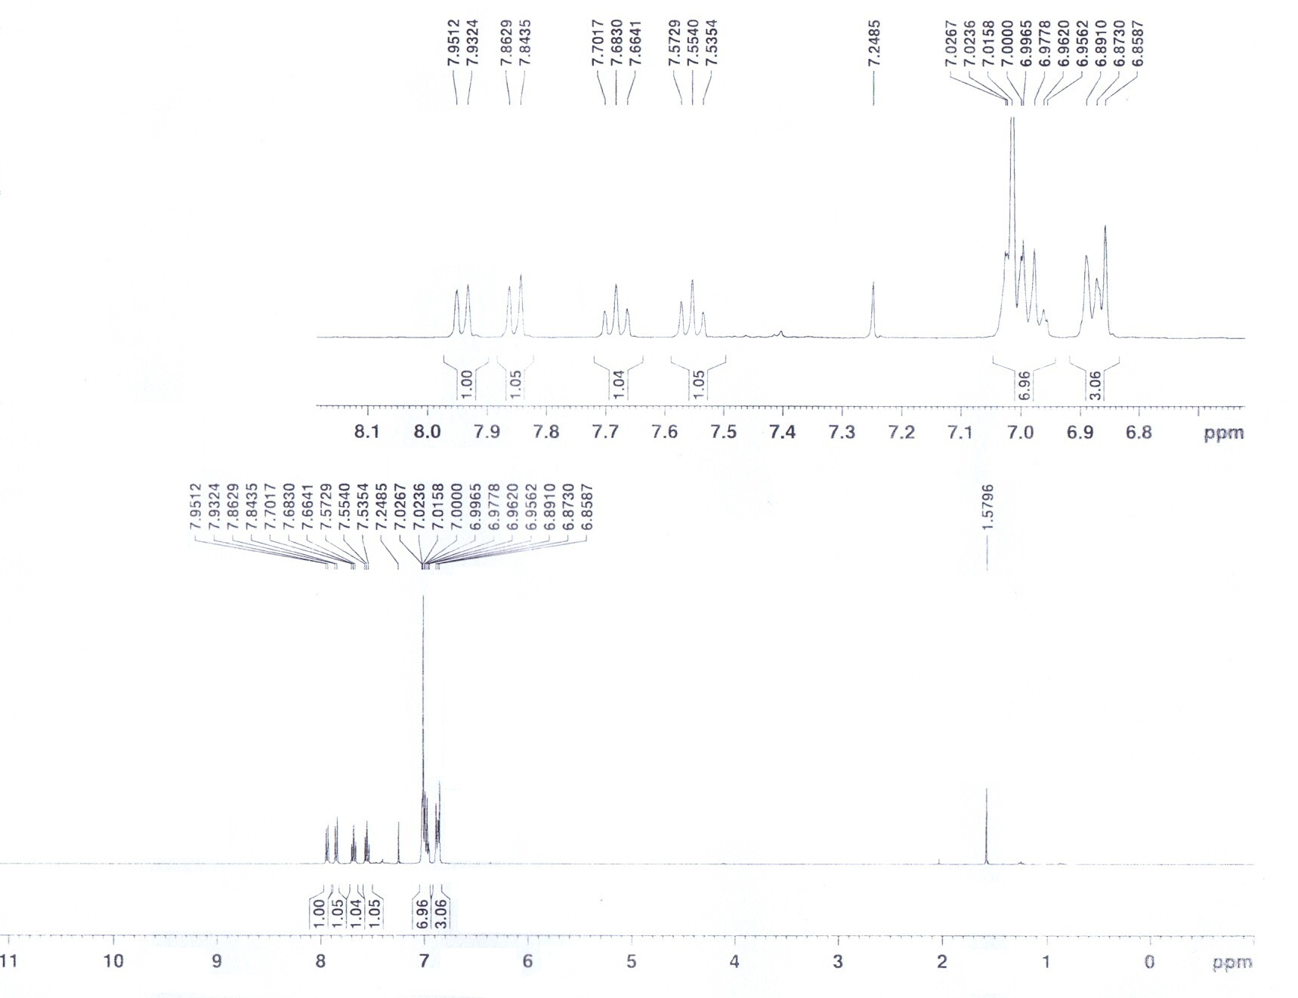

1_{H} NMR of (Z)-3-benzylidene-2-(4-methoxyphenyl) isoindolin-1-one (3x):
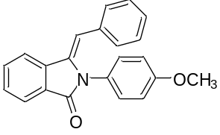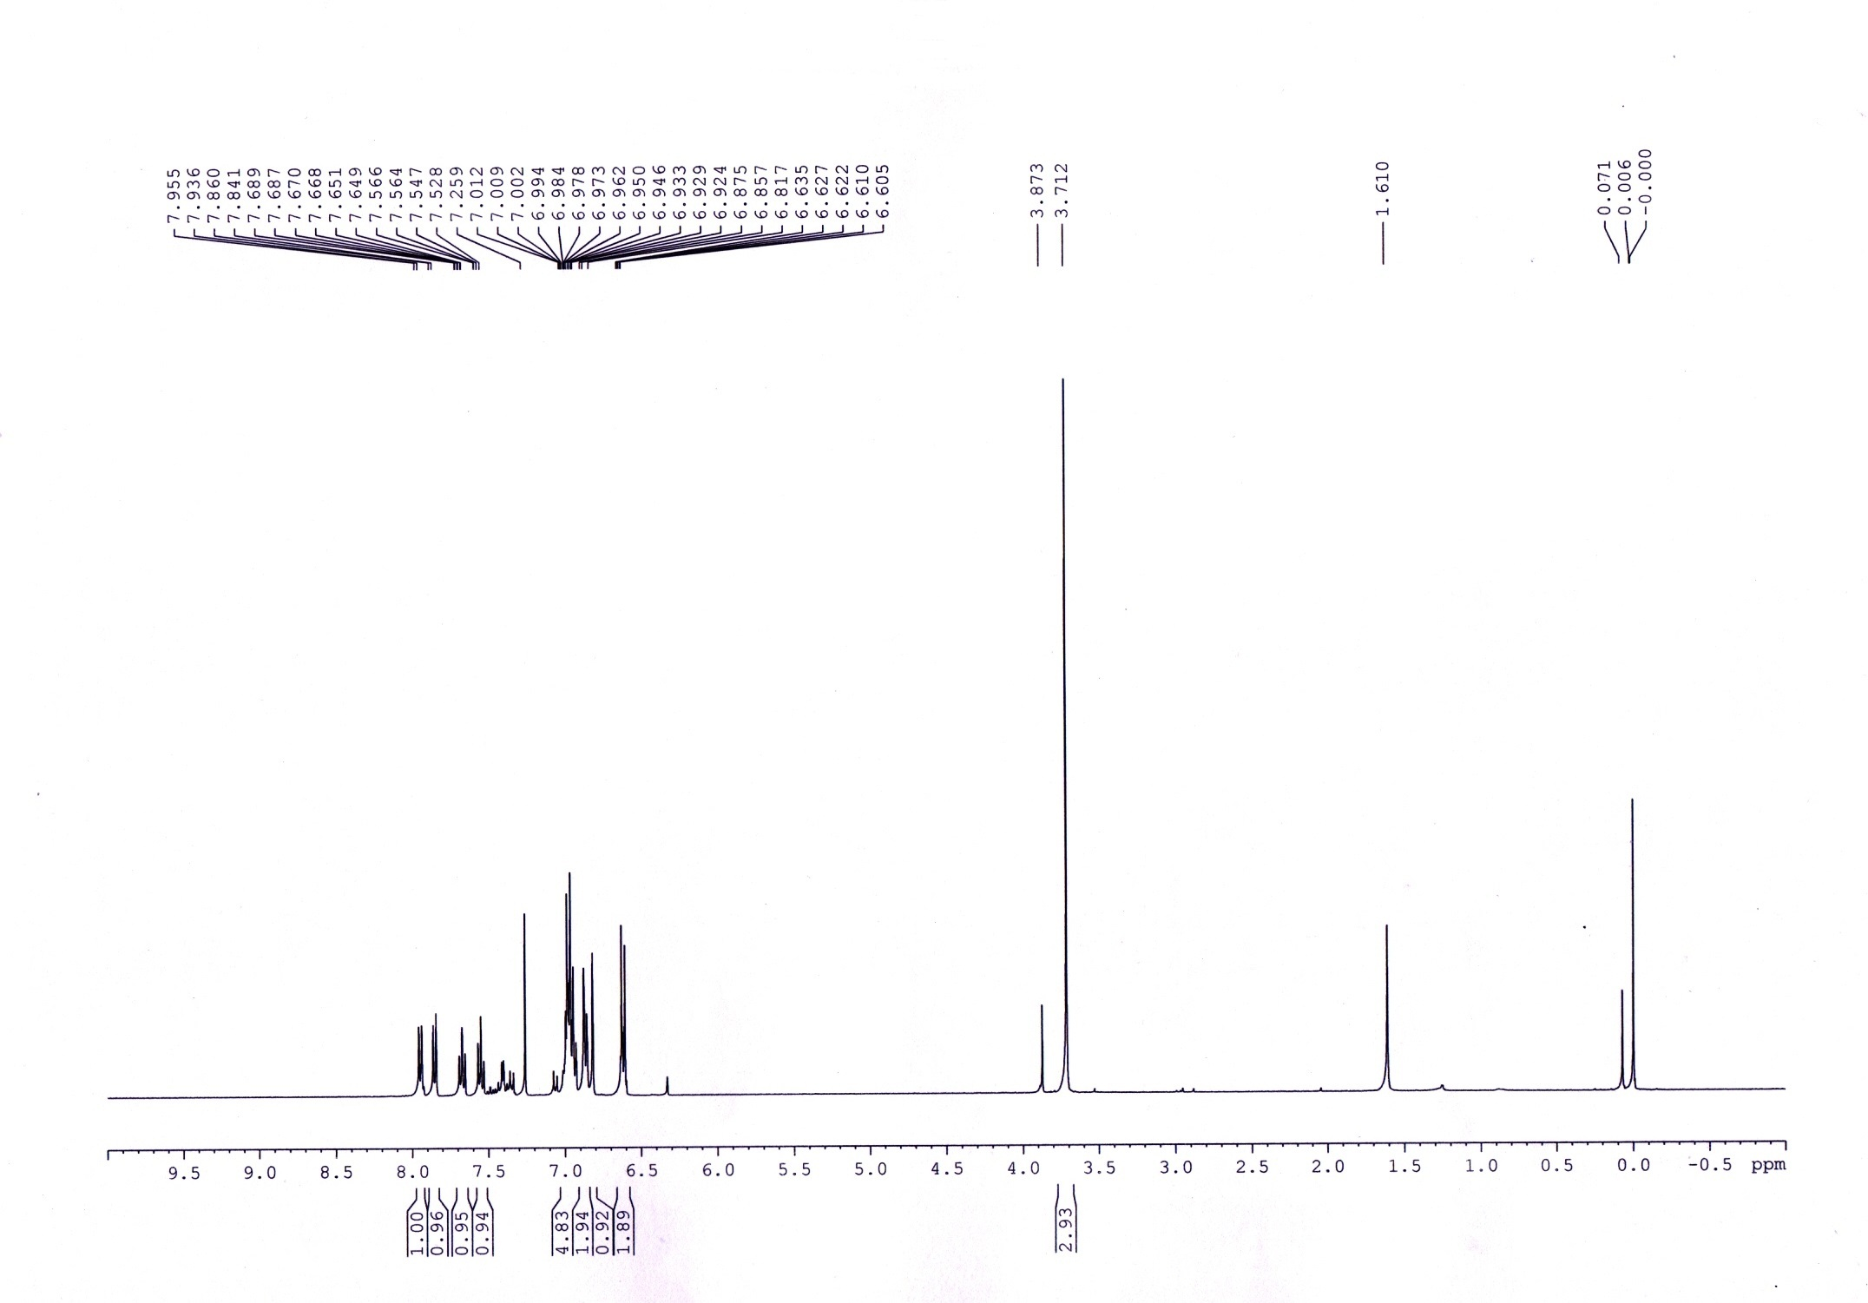

Crystal data of 3a

Bond precision: | C-C = 0.0031 A | Wavelength=0.71073

Cell: | a=8.1980(7) | b=9.3605(8) | c=19.8777(15)
 | alpha=90 | beta=90 | gamma=90
Temperature: | 297 K

 | Calculated | Reported
Volume | 1525.4(2) | 1525.4(2)
Space group | P 21 21 21 | P 21 21 21
Hall group | P 2ac 2ab | P 2ac 2ab
Moiety formula | C21 H15 N O | ?
Sum formula | C21 H15 N O | C21 H15 N O
Mr | 297.34 | 297.00
Dx,g cm-3 | 1.295 | 1.295
Z | 4 | 4
Mu (mm-1) | 0.079 | 0.079
F000 | 624.0 | 682.0
F000' | 624.25
h,k,lmax | 10,11,24 | 10,11,24
Nref | 2997[ 1743] | 2998
Tmin,Tmax
Tmin'

Correction method= Not given

Data completeness= 1.72/1.00 | Theta(max)= 25.999

R(reflections)= 0.0332( 2613) | wR2(reflections)= 0.0813( 2998)

S = 1.104 | Npar= 209

