Synthesis and chemical reactivity of novel pyrano[3,2-*c*]quinoline-3-carbonitriles

Magdy A. Ibrahim and Al-Shimaa Badran*

Department of Chemistry, Faculty of Education, Ain Shams University, Roxy,   
11711 Cairo, Egypt

E-mail: [badran.shimaa@yahoo.com](mailto:badran.shimaa@yahoo.com)

**(A) Spectroscopic and characterization of the synthesized compounds:**

***6-Methyl-4,5-dioxo-5,6-dihydro-4H-pyrano[3,2-c]quinoline-3-carbonitrile (2).***

A mixture of aldehyde **1** (0.51 g, 2 mmol) and hydroxylamine hydrochloride (0.14 g, 2 mmol) in glacial acetic acid (10 mL) was heated under reflux for 1 h. After cooling, the precipitate so formed was filtered and crystallized from ethanol to give compound **2** as pale yellow needle crystals, yield (0.32 g, 63%), m.p. 275–276 oC. IR (KBr, cm-1): *ṽ*max 3011 (CHarom), 2980, 2935 (CHaliph), 2213 (C≡N), 1660 (C=Opyran-4-one), 1643 (C=Oquinolone), 1571 (C=C).1H NMR (DMSO-*d*6*,* δ, 300MHz): 3.74 (s, 3H, CH3), 7.43 (t, 1H, *J* =7.5 Hz, H-9), 7.66 (d, 1H, *J =* 8.1 Hz, H-7), 7.82 (t, 1H, H-8), 8.14 (d, 1H, *J* =8.4 Hz, H-10), 8.46 (s, 1H, H-2). 13C NMR (DMSO-*d*6, δ, 75MHz): 29.7, 96.3, 107.9, 115.1, 118.9, 122.0, 125.2 127.9, 128.9, 137.3, 160.6, 172.5, 175.6, 187.6. Mass spectrum, m/z (*I*r %): 252 (M+., 66), 224 (89), 202 (10), 174 (14), 156 (16), 140 (17), 128 (45), 118 (100), 101 (50), 80 (42), 77 (20), 64 (20). Anal. Calcd for C14H8N2O3 (252.22): C, 66.67; H, 3.20; N, 11.11%. Found: C, 66.56; H, 3.03; N, 10.98%.

***4-Hydroxy-6-methyl-2,5-dioxo-5,6-dihydro-2H-pyrano[3,2-c]quinoline-3-carbonitrile (3).***

A mixture of aldehyde **1** (0.51 g, 2 mmol) and hydroxylamine hydrochloride (0.28 g, 4 mmol), in glacial acetic acid (10 mL), was heated under reflux for 1 h. The solid so obtained after cooling was filtered and crystallized from ethanol to give compound **3** as yellow needle crystals, yield (0.31 g, 58%), m.p. >300oC.IR (KBr, cm-1): *ṽ*max 3147 (br, OH), 3077 (CHarom), 2229 (C≡N), 1716 (C=Opyran-2-one), 1652 (C=Oquinolone), 1617 (C=C). 1H NMR (DMSO-*d*6*,* δ, 300MHz): 3.59 (s, 3H,CH3), 7.34 (t, 1H, *J* =7.8 Hz, H-9), 7.58 (d, 1H, *J* = 8.7 Hz, H-7), 7.80 (t, 1H, *J* = 7.2 Hz, H-8), 8.12 (d, 1H, *J* = 8.4 Hz, H-10). 13C NMR (DMSO-*d*6*,* δ, 75 MHz): 29.2, 85.0, 111.9, 115.7, 119.1, 123.3, 124.8, 126.1, 129.2, 133.9, 145.5, 149.0, 162.4, 180.0. Mass spectrum, m/z (*I*r %): 268 (M+., 60), 240 (61),215 (13), 202 (40), 184 (44), 159 (10), 155 (12), 134 (49), 117 (16), 106 (39), 104 (59), 91 (29), 77 (100), 64 (25). Anal. Calcd for C14H8N2O4 (268.22): C, 62.69; H, 3.01; N, 10.44%. Found: C, 62.53; H, 2.87; N, 10.24%.

***4-Hydroxy-6-methyl-2,5-dioxo-5,6-dihydro-2H-pyrano[3,2-c]quinoline-3-carboxamide (4).***

A mixture of aldehyde **1** (0.51 g, 2 mmol) and hydroxylamine hydrochloride (0.28 g, 4 mmol), in glacial acetic acid (10 mL), was heated under reflux for 4 h. The solid so obtained after cooling was filtered and crystallized from DMF/H2O to give compound **4** as pale yellow needle crystals, yield (0.34 g, 59%), m.p. > 300 oC. IR (KBr, cm-1): *ṽ*max 3400 (br, OH), 3303, 3154 (NH2), 3047 (CHarom), 2930 (CHaliph), 1706 (C=Opyran-2-one), 1660 (C=Oamide), 1647 (C=Oquinolone), 1590 (C=C). 1H NMR (DMSO-*d*6, *,* δ, 300 MHz): 3.69 (s, 3H, CH3), 7.34 (t, 1H, *J* =7.5 Hz, H-9), 7.56 (d, 1H, *J* = 8.1 Hz, H-7), 7.73 (t, 1H, *J* = 7.5 Hz, H-8), 8.07 (d, 1H, *J* =8.4 Hz, H-10), 8.33 (bs, 2H, NH2 exchangeable with D2O). 13C NMR (DMSO-*d*6*,* δ, 75 MHz), δ: 29.2, 98.8, 112.7, 117.3, 123.9, 125.2, 127.4, 130.4, 132.7, 143.9, 161.8, 164.9, 171.5, 182.8. Mass spectrum, m/z (*I*r %): 286 (M+.,18), 285 (100), 283 (7), 268 (40), 240 (53), 202 (9), 184 (17), 134 (9), 116 (5), 104 (26), 91 (7), 84 (28), 77 (33), 69 (11). Anal. Calcd for C14H10N2O5 (286.25): C, 58.75; H, 3.52; N, 9.79%. Found: C, 58.64; H, 3.34; N, 9.45%.

***1-Amino-5-methylisoxazolo[5',4':4,5]pyrano[3,2-c]quinoline-4,11(5H)-dione (5)***

***Procedure A****.*A mixture of aldehyde **1** (0.51 g, 2 mmol) and hydroxylamine hydrochloride (0.28 g, 4 mmol), in absolute EtOH (15 mL), containing aqueous potassium hydroxide solution (1%, 5 mL) was heated under reflux for 0.5 h. The solid that obtained during heating, was filtered and crystallized from dioxane to give compound **5** as pale yellow needle crystals, yield (0.35 g, 62%), m.p. 215-216oC.

***Procedur B****.*A mixture of compound **3** (0.54 g, 2 mmol) and hydroxylamine hydrochloride (0.14 g, 2 mmol), in absolute EtOH (15 mL), was heated under reflux for 0.5 h. The solid that obtained after cooling was filtered and crystallized from dioxane to give compound **5** as pale yellow needle crystals, yield (0.31 g, 55%), m.p. 215-216 oC. IR (KBr, cm-1): *ṽ*max 3305, 3157 (NH2), 2949 (CHaliph), 1727 (C=Opyran-2-one), 1640 (C=Oquinolone), 1612 (C=N), 1586 (C=C). 1H NMR (DMSO-*d*6, δ*,* 300 MHz): 3.67 (s, 3H,CH3), 7.55 (t, 1H, *J =* 7.5 Hz, H-8), 7.83 (d, 1H, *J =* 8.4 Hz, H-6), 7.92 (t, 1H, *J =* 8.1 Hz, H-7), 8.16 (d, 1H, *J =* 7.8 Hz, H-9), 9.17 (s, 1H, NH, exchangeable with D2O), 11.32 (bs, 1H, NH, exchangeable with D2O). 13C NMR (DMSO-*d*6, 75 MHz), δ: 29.9, 91.3, 106.4, 115.1, 121.0, 124.2, 126.4, 129.3, 136.5, 146.5, 161.8, 163.7, 165.3, 191.9. Mass spectrum, m/z (*I*r %): 283 (M+., 6), 268 (44), 240 (44), 215 (32), 202 (61), 184 (39), 159 (23), 134 (64), 117 (15), 106 (46), 91 (30), 77(100). Anal. Calcd forC14H9N3O4 (283.25); C, 59.37; H, 3.20; N, 14.84 %. Found: C, 59.16; H, 3.01; N, 14.76 %.

***3-[(5-Amino-1-phenyl-1H-pyrazol-4-yl)carbonyl]-4-hydroxy-1-methylquinolin-2(1H)-one (6).***

A mixture of carbonitrile **2** (0.50 g, 2 mmol) and phenylhydrazine (0.21 g, 2 mmol) in absolute EtOH (15 mL) was heated under reflux for 10 min. The red-orange needle crystals obtained during heating were filtered and recrystallized from DMF/EtOH to give compound **6**, m.p. 278-279 ºC, yield (0.51 g, 71%). IR (KBr, cm-1): *ṽ*max 3443 (OH), 3221, 3208 (NH2), 3009 (CHarom), 2930 (CHaliph), 1678 (C=Oquinolone and C=Oketone), 1616 (C=N) and 1602 (C=C).1H NMR (DMSO-*d*6, δ*,* 400 MHz) : 3.62 (s, 3H, CH3), 6.02 (bs, 2H, NH2 exchangeable with D2O), 6.96 (d,1H, *J =* 7.6 Hz, Ar-H), 7.23 (t, 1H, *J =* 7.6 Hz, Ar-H), 7.29 (t, 1H, *J =* 7.6 Hz, Ar-H), 7.36-7.44 (m, 3H, Ar-H), 7.72 (t, 1H, *J =* 8.4 Hz, Ar-H), 8.02 (t, 1H, *J =* 8.4 Hz, Ar-H), 8.26 (d, 1H, *J =* 8.4 Hz, Ar-H), 8.38 (s, 1H, H-3pyrazole). 13C NMR (DMSO-*d*6, 100 MHz), δ: 29.9, 93.7, 107.3, 114.9, 120.1, 122.9, 124.3, 126.7, 127.4, 128.8, 129.5, 135.1, 138.9, 140.9, 149.6, 161.8, 167.4, 190.3. Mass spectrum, m/z (*I*r %): 360 (M+.,100), 345 (9) 332(15), 269 (8) 215 (85), 202 (25), 159 (60), 131 (89), 77 (52). Anal. Calcd for C20H16N4O3 (360.37): C, 66.66; H, 4.48; N, 15.55%. Found: C, 66.48; H, 4.23; N, 15.30%.

***Benzyl 5-amino-4-[(4-hydroxy-1-methyl-2-oxo-1,2-dihydroquinolin-3-yl) carbonyl]-1H-pyrazole-1-carbodithioate (7)***

A mixture of carbonitrile **2** (0.50 g, 2 mmol) and *S*-benzyl dithiocarbazate (0.39 g, 2 mmol) in absolute EtOH (15 mL) was heated under reflux for 0.5 h. The pale yellow needle crystals obtained during heating were filtered and recrystallized from DMF/H2O to give compound **7**, m.p. 299-300 ºC, yield (0.63 g, 70%). IR (KBr, cm-1): *ṽ*max 3322 (OH), 3123 (NH2), 3059 (CHarom), 2985 (CHaliph), 1662 (C=Oketone), 1647 (C=Oquinolone), 1617 (C=N) and 1595(C=C). 1H NMR (DMSO-*d*6, δ,400 MHz): 3.60 (s, 3H, CH3), 4.44 (s, 2H, CH2), 7.39-7.46 (m, 5H, Ar-H and NH2 exchangeable with D2O), 7.26-7.34 (m, 3H, Ar-H), 7.64 (d, 1H, *J =* 8.8 Hz, H-8), 7.81 (t, 1H, *J =* 8 Hz, H-7), 8.11 (d, 1H, *J =* 7.2 Hz, H-5), 8.64 (s, 1H, H-3pyrazole). 13C NMR (DMSO-*d*6, δ, 100 MHz): 29.6, 38.1, 94.2, 112.5, 115.9, 122.2, 123.2, 123.5, 124.5, 128.3, 129.2, 129.5, 134.5, 137.0, 140.5, 154.0, 161.6, 165.7, 186.8, 193.1. Mass spectrum, m/z (*I*r %): 450(M+.,3), 267 (5), 242 (15), 215 (11), 208 (14), 202 (21), 175 (5), 148 (18), 134 (13), 106 (9), 91 (100), 77 (23). Anal. Calcd for C22H18N4O3S2 (450.53): C, 58.65; H, 4.03; N, 12.44, S, 14.23%. Found: C, 58.46; H, 3.90; N, 12.30, S, 14.13%.

***3-{[5-Amino-1-(7-chloroquinolin-4-yl)-1H-pyrazol-4-yl]carbonyl}-4-hydroxy-1-methylquinolin-2(1H)-one (10)***

A mixture of carbonitrile **2** (0.50 g, 2 mmol) and 7-chloro-4-hydrazinoquinoline (**8**) (0.38 g, 2 mmol) in absolute ethanol (15 mL) was heated under reflux for 0.5 h. The orange red needle crystals obtained during heating were filtered and recrystallized from DMF/EtOH to give compound **10**, m.p.> 300 ºC, yield (0.68 g, 77%). IR (KBr, cm-1): *ṽ*max 3382, 3235, 3191 (OH, NH2), 3099 (CHarom), 2985 (CHaliph), 1678 (C=Oketone), 1663 (C=Oquinolone), 1620 (C=N), 1608 (C=C). 1H NMR (DMSO-*d*6, δ*,* 400 MHz): 3.61 (s, 3H,CH3), 7.28 (bs, 2H, NH2, exchangeable with D2O), 7.31 (t, 1H, *J =* 7.6 Hz, Ar-H), 7.55 (d, 1H, *J =* 7.2 Hz, Ar-H), 7.69-7.78 (m, 4H, Ar-H), 7.97 (s, H, H-8quinoline), 8.05 (d, 1H, *J =* 8.0 Hz, Ar-H), 8.23 (s, 1H, H-3pyrazole), 9.11 (d, 1H, J= 8.2 Hz, H-2quinoline), 12.01 (bs, 1H, OH exchangeable with D2O). 13C NMR (DMSO-*d*6, δ, 100 MHz): 29.6, 95.4, 111.8, 115.3, 118.4, 199.9, 122.2, 122.8, 125.1, 126.4, 127.6, 128.4, 129.5, 133.5, 133.9, 135.1, 141.5, 144.3, 149.9, 153.1, 163.2, 172.9, 187.4. Mass spectrum, m/z (*I*r %): 445 (M+., 50), 428 (87), 400(12), 313 (2), 271 (8), 268 (13), 202 (25), 243 (100), 202 (33), 175 (12), 134 (23), 104 (24), 91 (12), 77 (36). Anal. Calcd for C23H16ClN5O3 (445.86): C, 61.96; H, 3.62; N, 15.71%. Found: C, 61.68; H, 3.51; N, 15.50%.

***3-{[5-Amino-1-(5,6-diphenyl-1,2,4-triazin-3-yl)-1H-pyrazol-4-yl]carbonyl}-4-hydroxy-1-methylquinolin-2(1H)-one (11)***

A mixture of carbonitrile **2** (0.50 g, 2 mmol) and 3-hydrazino-5,6-diphenyl-1,2,4-triazine (**9**) (0.52 g, 2 mmol) in absolute ethanol (15 mL) was heated under reflux for 0.5 h. The pale yellow needle crystals obtained during heating were filtered and crystallized from DMF/MeOH to give compound **11**, m.p.> 300 ºC, yield (0.71 g, 68%). IR (KBr, cm-1): *ṽ*max 3411 (OH), 3275, 3117 (NH2), 3059 (CHarom), 2911 (CHaliph), 1676 (C=Oketone), 1652 (C=Oquinolone), 1621 (C=N) and 1602 (C=C).1H NMR (DMSO-*d*6, δ*,* 300 MHz): 3.59 (s, 3H, CH3), 7.07 (bs, 2H, NH2, exchangeable with D2O), 7.28-7.44 (m, 6H, Ar-H), 7.51-7.59 (m, 2H, Ar-H), 7.72-7.79 (m, 3H, Ar-H), 7.91 (d, H, *J =* 8.4 Hz, H-8quinoline), 8.02-8.13 (m, 2H, Ar-H), 8.41 (s, 1H, H-3 pyrazole). Mass spectrum, m/z (*I*r %): 515 (M+., 10), 477 (13), 263 (15), 335 (2), 317 (4), 284 (20), 266 (7), 203 (15), 218 (10), 201 (22), 178 (4), 159 (11), 146 (10), 134 (32), 117 (13), 104 (64), 91 (22), 83 (100), 77 (83). Anal. Calcd for C29H21N7O3 (515.52): C, 67.56; H, 4.11; N, 19.02%. Found: C, 67.35; H, 3.87; N, 18.80%.

***3-Amino-6-methyl-5H,12H-pyrimido[4`,5`:4,5]pyrano[3,2-c]quinoline-5,12-dione(12)***

To a solution of carbonitrile **2** (0.50 g, 3 mmol) in absolute ethanol (15 mL), guanidine hydrochloride (0.20 g, 2 mmol) in aqueous potassium hydroxide solution (5%, 15 mL) was added. The reaction mixture was heated under reflux for 3 h. After cooling, the reaction mixture was poured onto crushed ice (~ 20 g) and neutralized with conc. HCl. The solid so formed was filtered and crystallized from AcOH/H2O to give compound **12** as dark yellow needle crystals, mp > 300 ºC, yield (0.30 g, 51%). IR (KBr, cm-1): *ṽ*max 3296, 3215 (NH2), 3075 (CHarom), 2930 (CHaliph), 1721 (C=Opyran-2-one), 1663 (C=Oquinolone), 1619 (C=N) and 1572 (C=C).1H NMR (DMSO-*d*6, δ*,* 300 MHz) :3.77 (s, 3H, CH3), 7.32 (t, 1H, *J =* 8.4 Hz, H-9), 7.54-7.63 (m, 2H, H-7 and H-8), 8.06 (bs, 2H, NH2, exchangeable with D2O), 8.18 (d, 1H, H-10), 8.53 (s, 1H, H-1). 13C NMR (DMSO-*d*6, δ, 75 MHz): 29.8, 105.9, 112.8, 115.9, 122.3, 125.1, 126.9, 129.2, 136.0, 153.3, 158.6, 160.8, 162.1, 163.0, 167.7. Mass spectrum, m/z (*I*r ); 294(M+.,65), 293 (100), 279(65), 270 (42), 251 (61), 224 (42), 195 (40), 140 (38), 135 (43), 105 (35), 91 (20), 89 (40), 77 (53). Anal. Calcd for C15H10N4O3 (294.26): C, 61.22; H, 3.43; N, 19.04%. Found: C, 61.01; H, 3.25; N, 18.86%.

***(6-Methyl-5,12-dioxo-5H,12H-pyrimido[4`,5`:4,5]pyrano[3,2-c]quinolin-3-yl) cyanamide (13)***

To a solution of carbonitrile **2** (0.50 g, 2 mmol) in absolute ethanol (15 mL), cyanoguanidine (0.17 g, 2 mmol) in aqueous potassium hydroxide solution (5%, 15 mL) was added. The reaction mixture was heated under reflux for 3 h. After cooling, the reaction mixture was poured onto crushed ice (~ 20 g) and neutralized with conc. HCl. The solid so formed was filtered and crystallized from AcOH to give compound **13** as yellow needle crystals, mp > 300 ºC, yield (0.35 g, 54%). IR (KBr, cm-1): *ṽ*max 3258 (N–H), 3059 (CHarom.), 2905 (CHaliph), 2231 (C≡N), 1725 (C=Opyran-2-one), 1657 (C=Oquinolone), 1630 (C=N) and 1575 (C=C). 1H NMR (DMSO-*d*6, *δ,* 300MHz) : 3.71 (s, 3H,CH3), 7.52 (t, 1H, *J =* 7.2 Hz, H-9), 7.80 (d, *J =* 8.4 Hz, 1H, H-7), 7.86 (t, 1H, *J =* 7.2 Hz, H-8), 8.18 (d, 1H, *J =* 8.1 Hz, H-10), 8.69 (s, 1H, H-1), 10.72 (s,1H, NH exchangeable with D2O). 13C NMR (DMSO-*d*6, δ, 75 MHz): 29.2, 106.4, 112.0, 116.1, 118.6, 121.7, 123.9, 125.8, 129.2, 135.2, 150.5, 155.3, 160.5, 161.2, 162.8, 170.3. Mass spectrum, m/z (*I*r ): 319 (M+.,12), 291 (8), 216 (24), 190 (22), 160 (42), 132 (100), 120 (30), 104 (17), 90 (13), 77 (15), 64 (16). Anal. Calcd for C16H9N5O3 (319.27): C, 60.19; H, 2.84; N, 21.94%. Found: C, 60.00; H, 2.77; N, 21.79%.

***1-Amino-5-methyl-3-phenyl-5H,11H-pyrazolo[3`,4`:4,5]pyrano[3,2-c]quinoline-4,11-dione (14)***

A mixture of carbonitrile **3** (0.54 g, 2 mmol) and phenylhydarzine (0.22 g, 2 mmol), in ethanolic sodium ethoxide solution (0.5 g in 30 mL absolute EtOH), was heated under reflux for 0.5 h. The red needle crystals obtained during heating were filtered and recrystallized from DMF to give compound **14**, mp > 300 ºC, yield (0.52 g, 73%). IR (KBr, cm-1):  *ṽ*max 3332, 3267 (NH2), 3096 (CHarom), 2911 (CHaliph), 1663 (C=Opyran-2-one), 1651 (C=Oquinolone), 1622 (C=N) and 1591 (C=C). 1H NMR (DMSO-*d*6, *δ,* 300 MHz): 3.59 (s, 3H,CH3), 6.72(t, 1H, *J =* 7.5 Hz, Ar-H), 6.91(d, 1H, *J =* 7.5 Hz, Ar-H), 7.22 (t, 1H,*J =* 8.1 Hz, Ar-H), 7.42 (t, 1H,*J =* 7.5 Hz, Ar-H), 7.59(d, 1H, *J =* 8.4 Hz, Ar-H), 7.74-7.85 (m, 2H, Ar-H), 8.16(d, 1H, *J =* 8.1 Hz, Ar-H), 8.24(d, 1H, *J =* 7.8 Hz, Ar-H), 9.45 (bs, 1H, NH, exchangeable with D2O), 9.55 (bs, 1H, NH, exchangeable with D2O). 13C NMR (DMSO-*d*6, δ, 75 MHz): 29.2, 95.4, 105.1, 114.2, 117.3, 120.4, 122.0, 123.9, 125.2, 127.4, 129.9, 132.7, 138.9, 143.9, 153.0, 157.2, 161.8, 163.1.Mass spectrum, m/z (*I*r %): 358 (M+.,8), 343 (23), 325 (29), 268 (5), 242 (3), 202 (11), 186 (3), 159 (18), 134 (24), 116 (10), 104 (38), 91 (23), 77 (100), 65 (28). Anal. Calcd for C20H14N4O3 (358.35): C, 67.03; H, 3.94; N, 15.63%. Found: C, 66.88; H, 3.81; N, 15.59%.

***1-Amino-5-methyl-3-(7-chloroquinolin-4-yl)-5H,11H-pyrazolo[3`,4`:4,5] pyrano[3,2-c]quinoline-4,11-dione (15)***

A mixture of carbonitrile **3** (0.54 g, 2 mmol) and 7-chloro-4-hydrazinoquinoline (0.39 g, 2 mmol), in ethanolic sodium ethoxide solution (0.5 g in 30 mL absolute EtOH), was heated under reflux for 0.5 h. The dark red needle crystals obtained during heating were filtered and recrystallized from DMF/EtOH to give compound **15**, mp > 300 ºC, yield (0.52 g, 58%). IR (KBr, cm-1): *ṽ*max 3393(br, NH2), 3083 (CHarom), 2924, 2853 (CHaliph), 1669 (C=Opyran-2-one), 1643 (C=Oquinolone), 1619 (C=N) and 1597 (C=C).1H NMR (DMSO-*d*6, *δ,* 300MHz) :3.64 (s, 3H,CH3), 7.02(t, 1H, *J =* 8.1Hz, H-8), 7.50(d, 1H, *J =* 6.9Hz, Ar-H), 7.76-7.81 (m, 2H, Ar-H), 7.92 (s, 1H, H-8quinoline), 8.26-8.36 (m, 3H, Ar-H), 9.04(d, 1H, *J =* 8.4 Hz, H-2quinoline),9.51 (bs, 1H, NH, exchangeable with D2O), 9.63 (bs, 1H, NH, exchangeable with D2O).13C NMR (DMSO-*d*6*,* δ, 75 MHz): 29.5, 93.5, 106.0, 111.8, 114.8, 117.3, 122.0, 123.9, 127.4, 128.3, 128.9, 129.2, 129.9, 132.7, 135.2, 136.8, 143.9, 148.7, 150.8, 152.4, 155.3, 156.8, 161.8.Mass spectrum, m/z (*I*r ): 443(M+.,17), 419 (32), 400 (23), 387 (25), 358(24), 334 (28), 302 (21), 288 (22), 268 (29), 228 (25), 214 (26), 187 (51), 167 (23), 80 (100), 64 (70). Anal. Calcd for C23H14ClN5O3 (443.84): C, 62.24; H, 3.18; N, 15.78%. Found: C, 62.02; H, 2.98; N, 15.51%.

***1-Amino-5-methyl-3--(5,6-diphenyl-1,2,4-triazin-3-yl)-5H,11H-pyrazolo[3`,4`:4,5] pyrano[3,2-c]quinoline-4,11-dione (16)***

A mixture of carbonitrile **3** (0.54 g, 2 mmol) and 3-hydrazino-5,6-diphenyl-1,2,4-triazine (0.51 g, 2 mmol), in ethanolic sodium ethoxide solution (0.5 g in 30 mL absolute EtOH), was heated under reflux for 0.5 h. The orange needle crystals obtained during heating were filtered and crystallized from DMF to give compound **16**, mp > 300 ºC, yield (0.61 g, 59%). IR (KBr, cm-1): *ṽ*max 3396 (br, NH2), 3085 (CHarom), 2942 (CHaliph), 1662 (C=Opyran-2-one and C=Oquinolone), 1619 (C=N), 1590 (C=C). 1H NMR (DMSO-*d*6, δ*,* 300MHz): 3.66 (s, 3H, CH3), 6.91-7.34 (m, 8H, Ar-H), 7.69-7.77 (m, 2H, Ar-H), 7.93-8.07 (m, 4H, Ar-H), 9.31 (bs, 1H, NH, exchangeable with D2O), 9.57 (bs, 1H, NH, exchangeable with D2O). Mass spectrum, m/z (*I*r ): 513 (M+.,8), 493 (8), 465 (9), 415 (9), 375 (66), 347 (22), 317 (15), 216 (6), 160 (10), 132 (21), 80 (32), 64 (100). Anal. Calcd for C29H19N7O3 (513.51): C, 67.83; H, 3.73; N, 19.09%. Found: C, 67.67; H, 3.54; N, 18.93%.

***1-Amino-5-methyl-3H,5H,11H-pyrazolo[3`,4`:4,5]pyrano[3,2-c]quinoline-4,11-dione (17)***

A mixture of carbonitrile **3** (0.54 g, 2 mmol) and *S*-benzyl dithiocarbazate (0.40 g, 2 mmol), in ethanolic sodium ethoxide solution (0.5 g in 30 mL absolute EtOH), was heated under reflux for 0.5 h. The pale orange crystals obtained during heating were filtered and crystallized from DMF/MeOH to give compound **17** as orange needle crystals, mp > 300 ºC, yield (0.37 g, 66%). IR (KBr, cm-1): *ṽ*max: 3423(br, NH2, NH), 3076 (CHarom), 2937 (CHaliph), 1673 (C=Opyran-2-one), 1640 (C=Oquinolone), 1614 (C=N), 1587 (C=C). 1H NMR (DMSO-*d*6, δ*,* 300 MHz): 3.73 (s, 3H, CH3), 7.37 (t, 1H, *J =* 7.2 Hz, H-8), 7.57(d, 1H, *J =* 8.7 Hz, H-6), 7.76 (t, 1H, *J =* 7.5 Hz, H-7), 8.14 (d, 1H, *J =* 8.1 Hz, H-9), 9.07 (bs, 1H, NH, exchangeable with D2O), 9.21 (bs, 1H, NH, exchangeable with D2O), 11.69 (bs, 1H, NH, exchangeable with D2O). 13C NMR (DMSO-*d*6, δ, 75 MHz): 29.8, 93.5, 106.3, 116.1, 121.4, 123.6, 126.4, 128.2, 132.3, 134.9, 150.5, 152.4, 157.1, 161.8. Mass spectrum, m/z (*I*r ): 282 (M+.,11), 251 (18), 238 (25), 175 (14), 132 (18), 104 (42), 91 (27), 77 (82), 63 (38), 55 (100). Anal. Calcd for C14H10N4O3 (282.25): C, 59.57; H, 3.57; N, 19.85%. Found: C, 59.39; H, 3.31; N, 19.68%.

***1,3-Diamino-6-methyl-5H,12H-pyrimido[4`,5`:4,5]pyrano[3,2-c]quinoline-5,12-dione(18)***

A mixture of carbonitrile **3** (0.54 g, 2 mmol) and guanidine hydrochloride (0.20 g, 2 mmol), in ethanolic sodium ethoxide solution (0.5 g in 30 mL absolute EtOH), was heated under reflux for 4 h. After cooling, the reaction mixture was poured onto crushed ice (~ 20 g) and neutralized with conc. HCl. The solid so formed was filtered and crystallized from AcOH to give compound **18** as pale brown needle crystals, mp > 300 ºC, yield (0.38 g, 61%). IR (KBr, cm-1): *ṽ*max 3386 (br, 2NH2), 3086 (CHarom), 2923 (CHaliph), 1680 (C=Opyran-2-one), 1640 (C=Oquinolone), 1620 (C=N) and 1580 (C=C). 1H NMR (DMSO-*d*6, δ,300 MHz): 3.61 (s, 3H, CH3), 7.36 (t, 1H, *J =* 8.4Hz, H-9), 7.58(d, 1H,*J =* 8.4Hz, H-7), 7.77 (t, 1H, *J =* 7.5 Hz, H-8),7.99 (bs, 2H, NH2, exchangeable with D2O), 8.15 (d, 1H, *J =* 8.1 Hz, H-10), 9.11 (bs, 1H, NH, exchangeable with D2O), 9.23 (bs, 1H, NH, exchangeable with D2O).13C NMR (DMSO-*d*6, δ, 75 MHz): 29.6, 96.9, 106.0, 115.8, 121.4, 123.6, 127.1, 128.9, 134.9, 150.8, 154.9, 158.1, 162.4, 164.7, 166.9. Mass spectrum, m/z (*I*r ): 309 (M+.,18), 298 (25), 285 (28), 273 (26), 261 (22), 241 (23), 216 (32), 182 (34), 155 (33), 139 (43), 126 (38), 101 (34), 80 (92), 64 (100). Anal. Calcd for C15H11N5O3 (309.28): C, 58.25; H, 3.58; N, 22.64%. Found: C, 58.16; H, 3.37; N, 22.43%.

***(1-Amino-6-methyl-5,12-dioxo-5H,12H-pyrimido[4`,5`:4,5]pyrano[3,2-c]quinolin-3-yl)cyanamide (19).***

A mixture of carbonitrile **3** (0.54 g, 2 mmol) and cyanoguanidine (0.16 g, 2 mmol), in ethanolic sodium ethoxide solution (0.5 g in 30 mL absolute EtOH), was heated under reflux for 4h. After cooling, the reaction mixture was poured onto crushed ice (~ 20 g) and neutralized with conc. HCl. The solid so formed was filtered and crystallized from AcOH to give compound **19** as dark yellow needle crystals, mp > 300 ºC, yield (0.40 g, 60%).IR (KBr, cm-1): *ṽ*max 3370 (br, NH2, NH) 3071 (CHarom), 2942 (CHaliph), 2228 (C≡N), 1682 (C=Opyran-2-one), 1643 (C=Oquinolone), 1621 (C=N) and 1560 (C=C).1H NMR (DMSO-*d*6, *δ,* 300MHz): 3.78 (s, 3H,CH3), 7.60 (t, 1H, , *J =* 7.8 Hz, H-9), 7.88 (d, 1H, *J =* 8.7 Hz, H-7), 8.00 (t, 1H, *J =* 8.4 Hz, H-8), 8.22 (d, 1H, *J =* 8.1 Hz, H-10), 9.23 (bs, 1H, NH, exchangeable with D2O), 9.41 (bs, 1H, NH, exchangeable with D2O), 10.50 (bs, 1H, NH, exchangeable with D2O). 13C NMR (DMSO-*d*6, δ, 75 MHz): 28.9, 96.0, 105.1, 115.1, 118.9, 121.7, 124.2, 126.4, 128.2, 132.0, 150.2, 155.9, 160.2, 162.1, 163.1, 170.9. Mass spectrum, m/z (*I*r %): 334 (M+., 14), 311 (42), 296 (22), 273 (20) 257 (38), 245 (36), 229 (58), 217 (23), 188(36), 146 (59), 132 (79), 119 (34), 91 (40), 77 (100). Anal. Calcd for C16H10N6O3 (334.29): C, 57.49; H, 3.02; N, 25.15%. Found: C, 57.26; H, 2.99; N, 24.89%.

**(B) Copies of 1H-NMR and 13C-NMR spectral data for the synthesized compounds:**

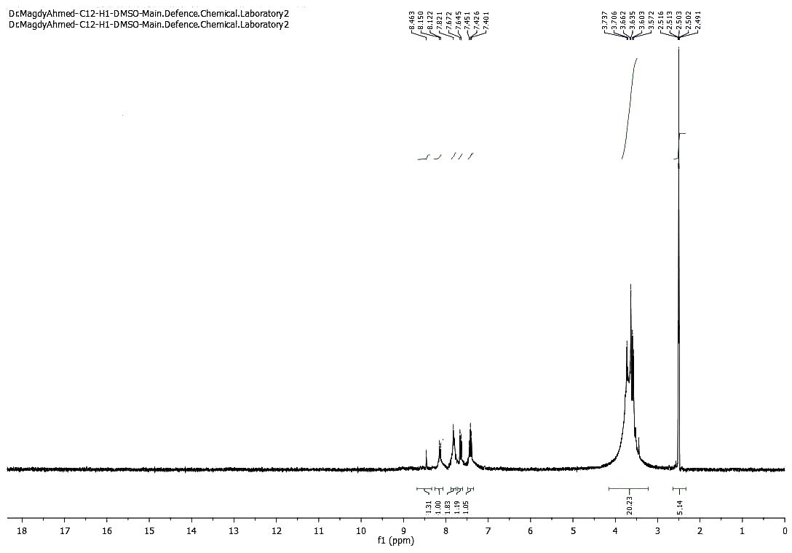

**Figure 1. 1H NMR spectrum of compound 2**

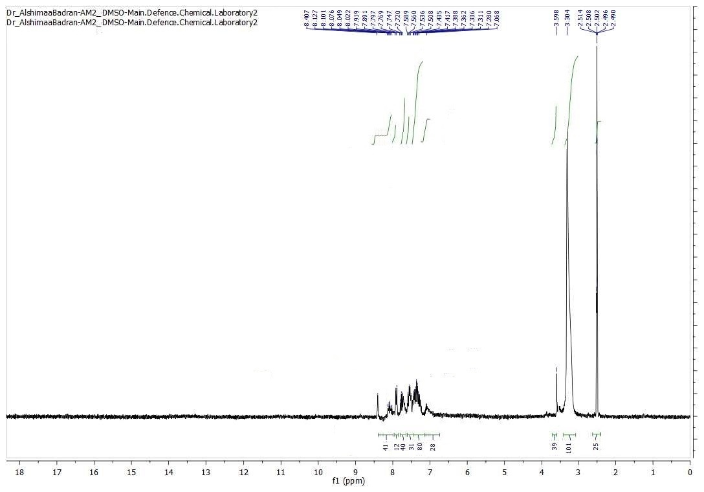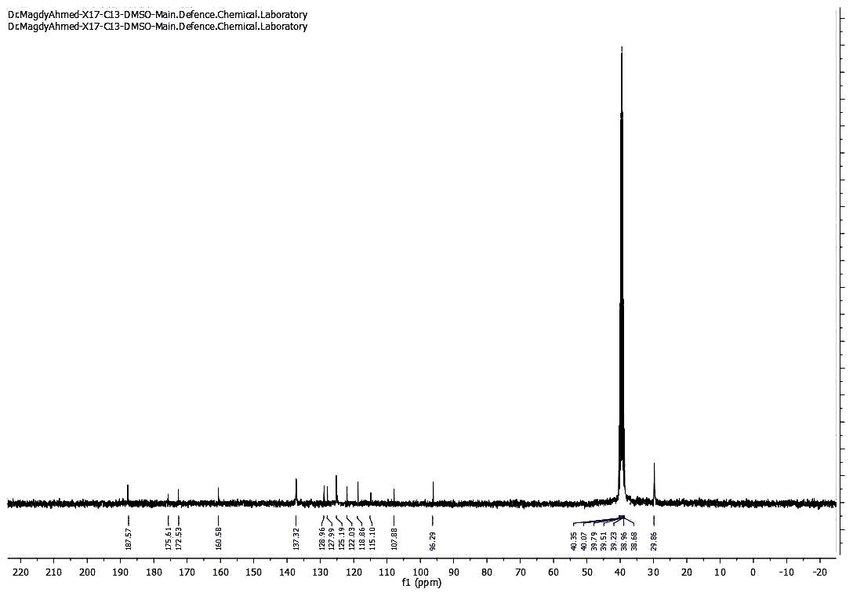

**Figure 2. 13C NMR spectrum of compound 2**

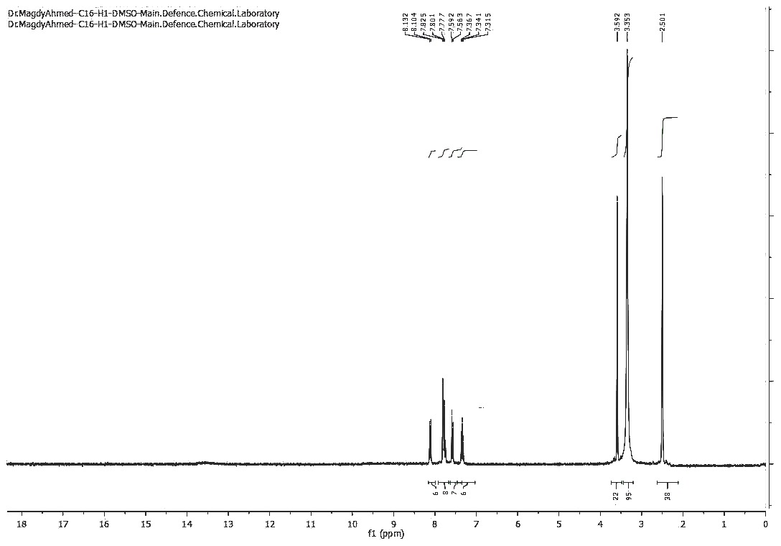

**Figure 3. 1H NMR spectrum of compound 3**

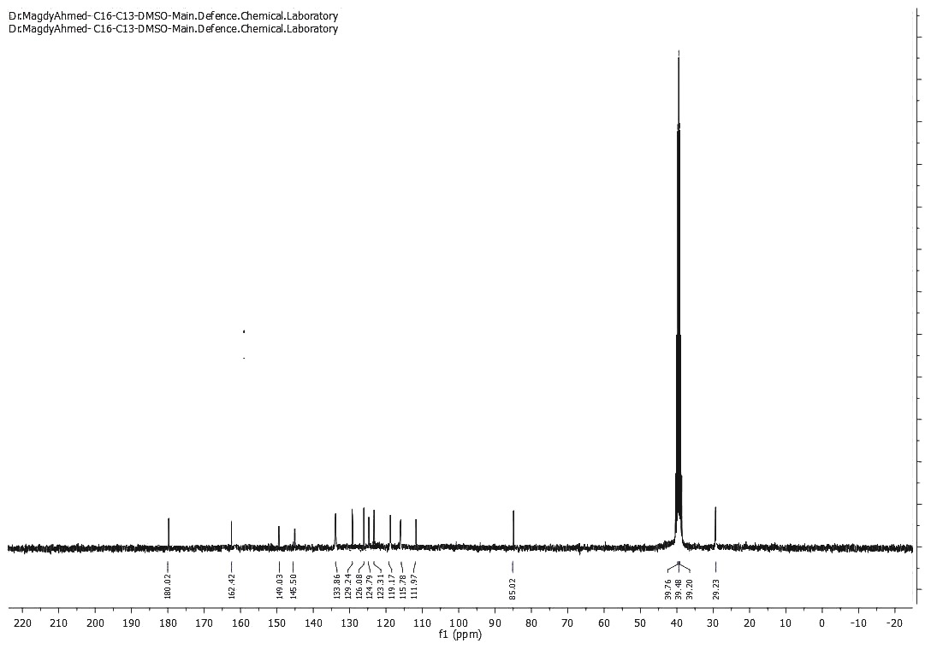

**Figure 4. 13C NMR spectrum of compound 3**

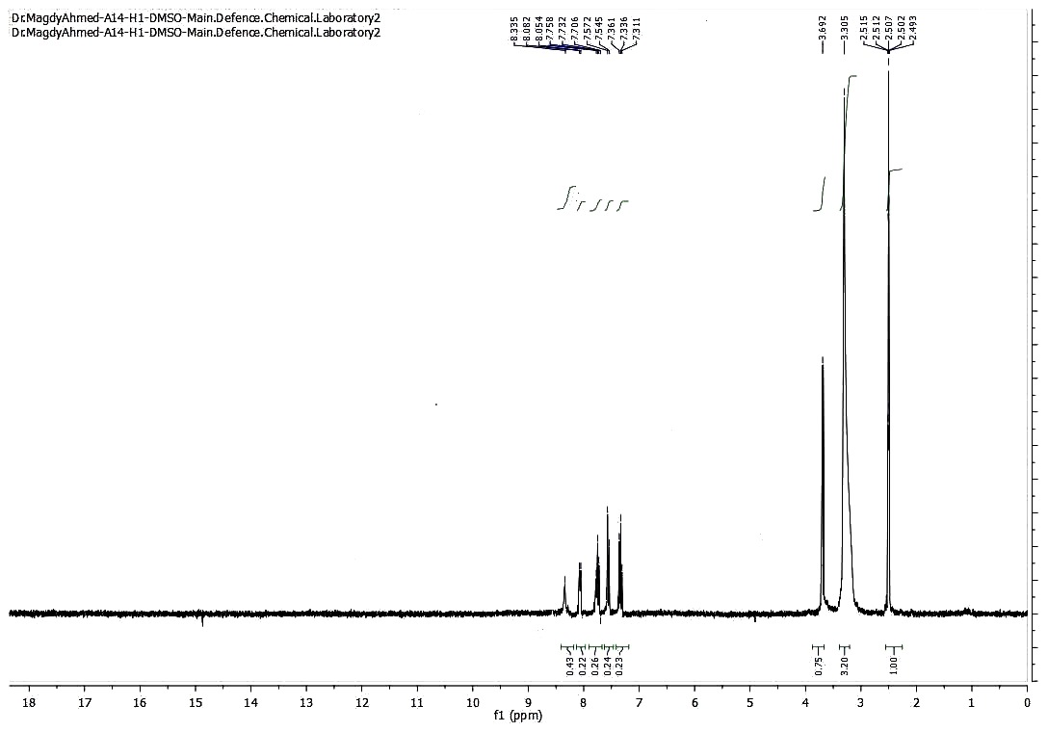

**Figure 5. 1H NMR spectrum of compound 4**

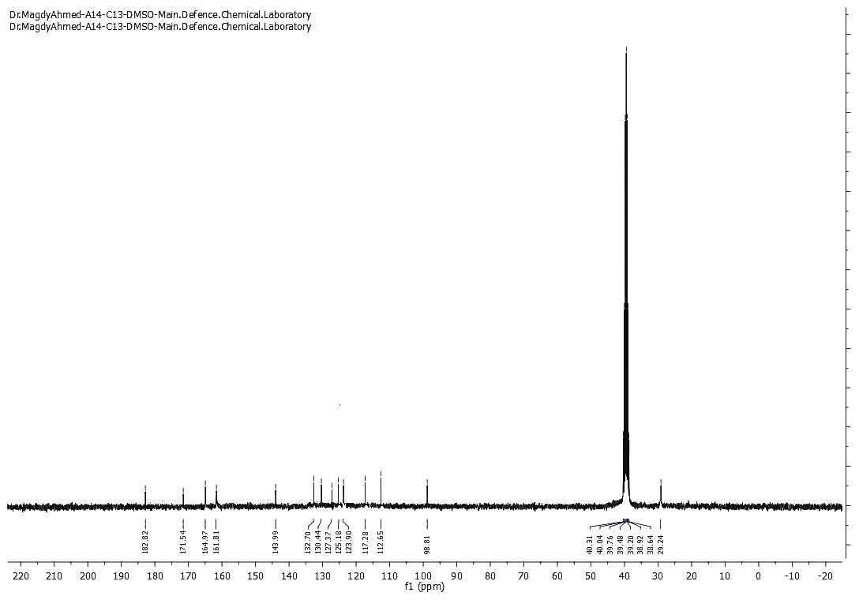

**Figure 6. 13C NMR spectrum of compound 4**

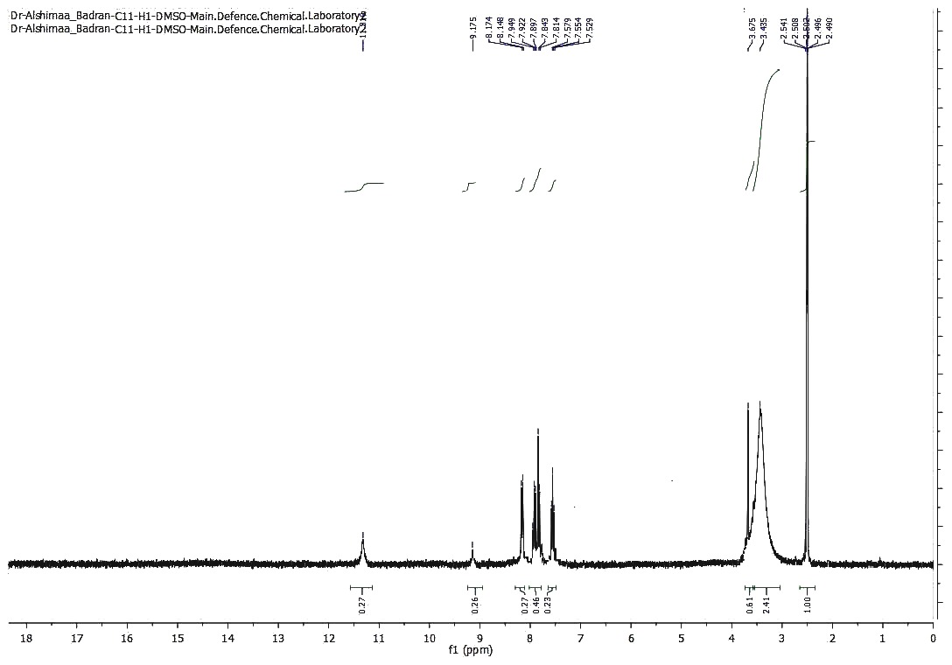

**Figure 7. 1H NMR spectrum of compound 5**

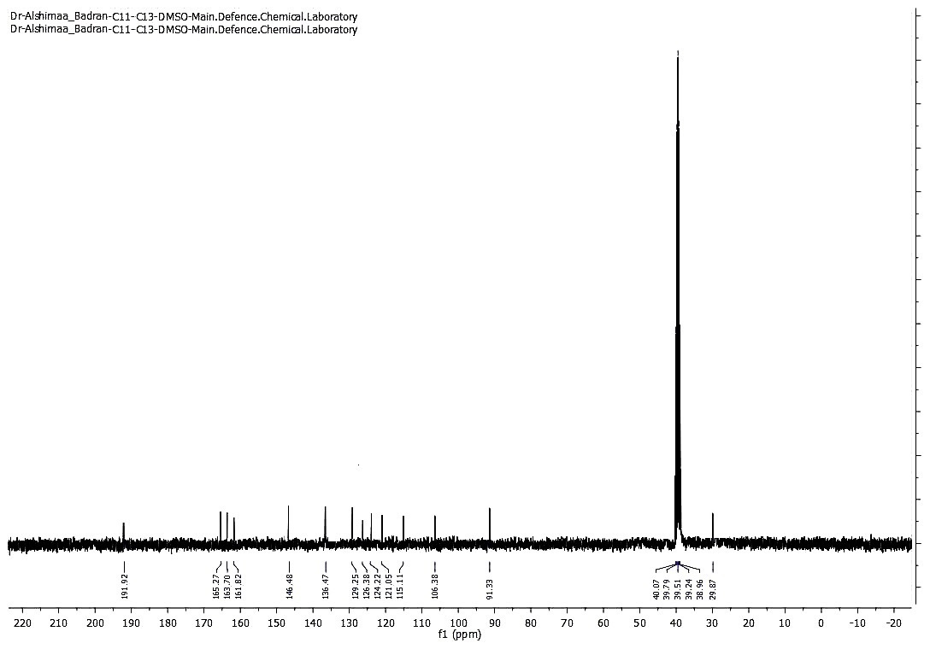

**Figure 8. 13C NMR spectrum of compound 5**

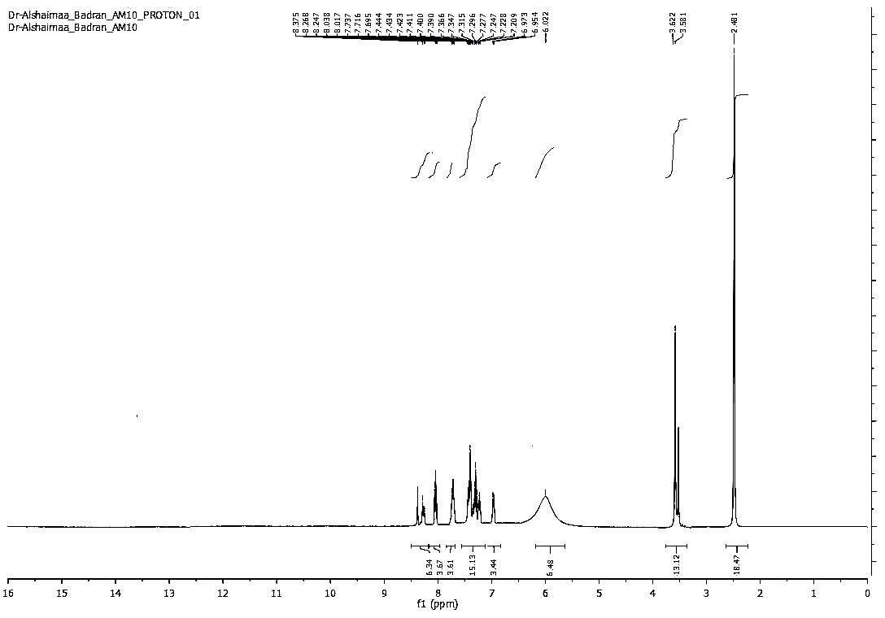

**Figure 9. 1H NMR spectrum of compound 6**

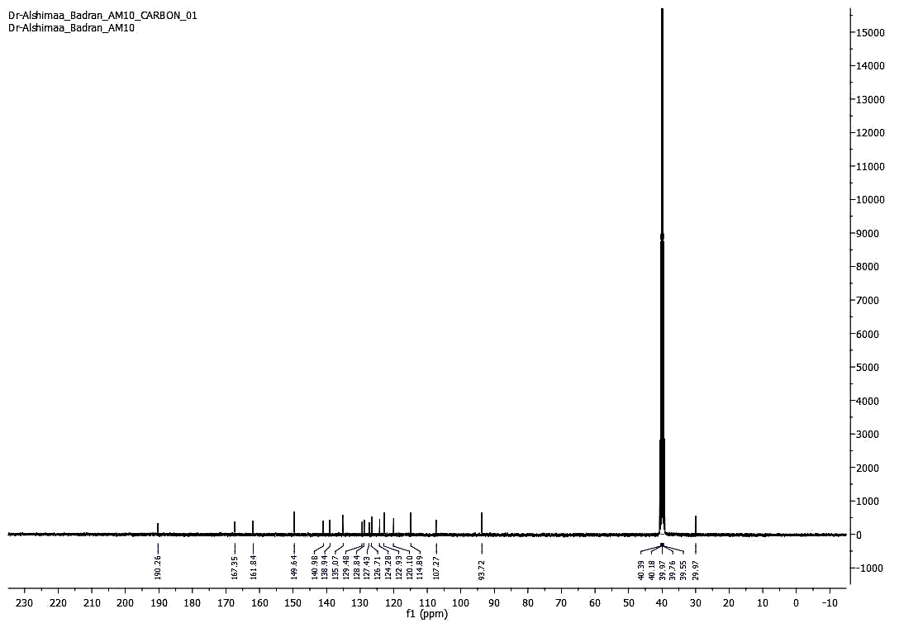

**Figure 10. 13C NMR spectrum of compound 6**

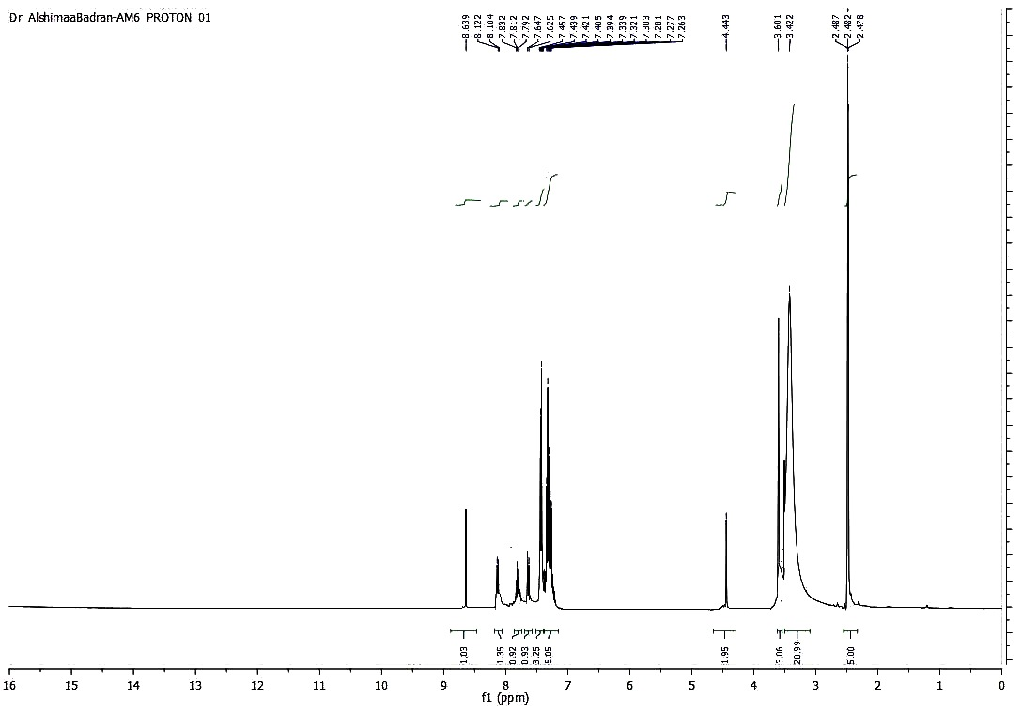

**Figure 11. 1H NMR spectrum of compound 7**

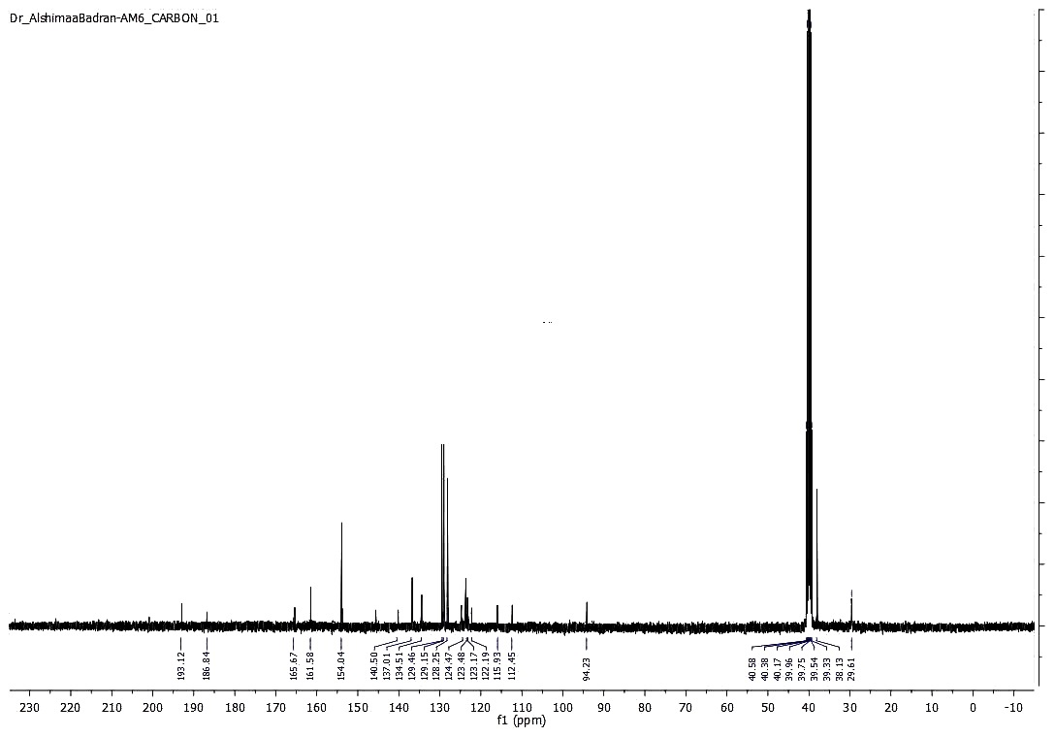

**Figure 12. 13C NMR spectrum of compound 7**

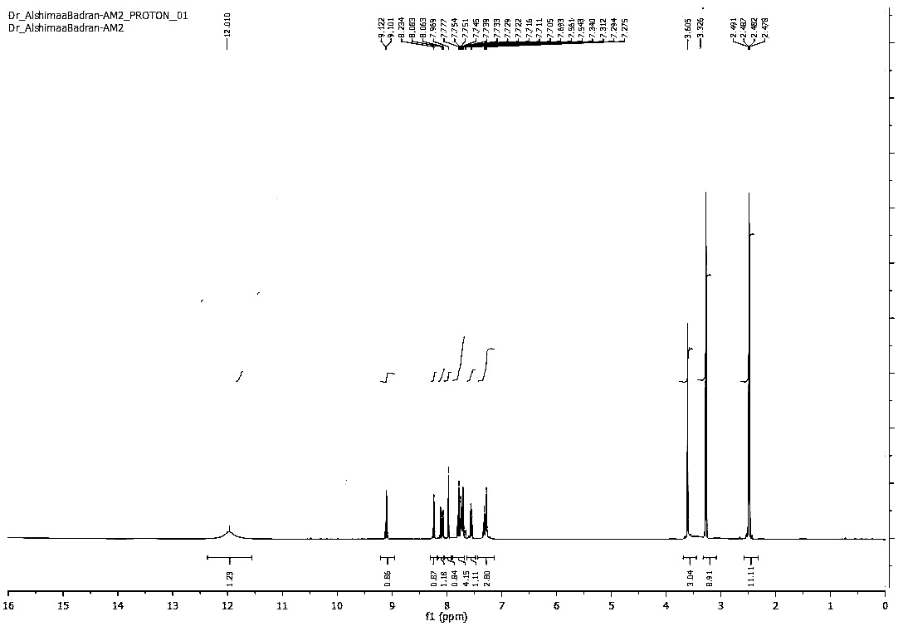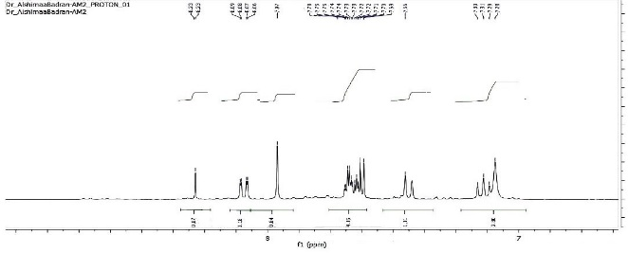

**Figure 13. 1H NMR spectrum of compound 10**

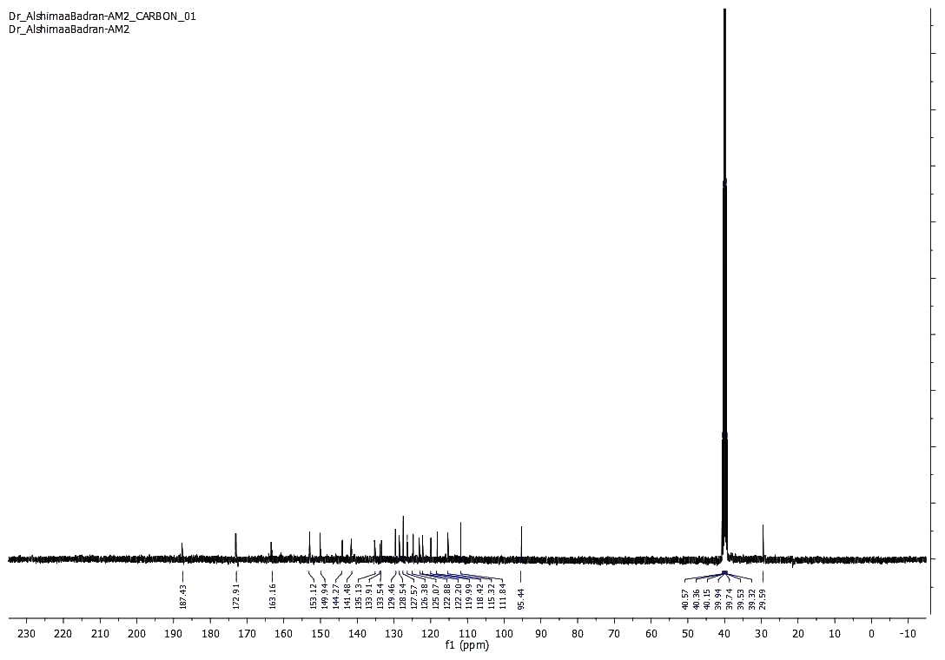

**Figure 14. 13C NMR spectrum of compound 10**

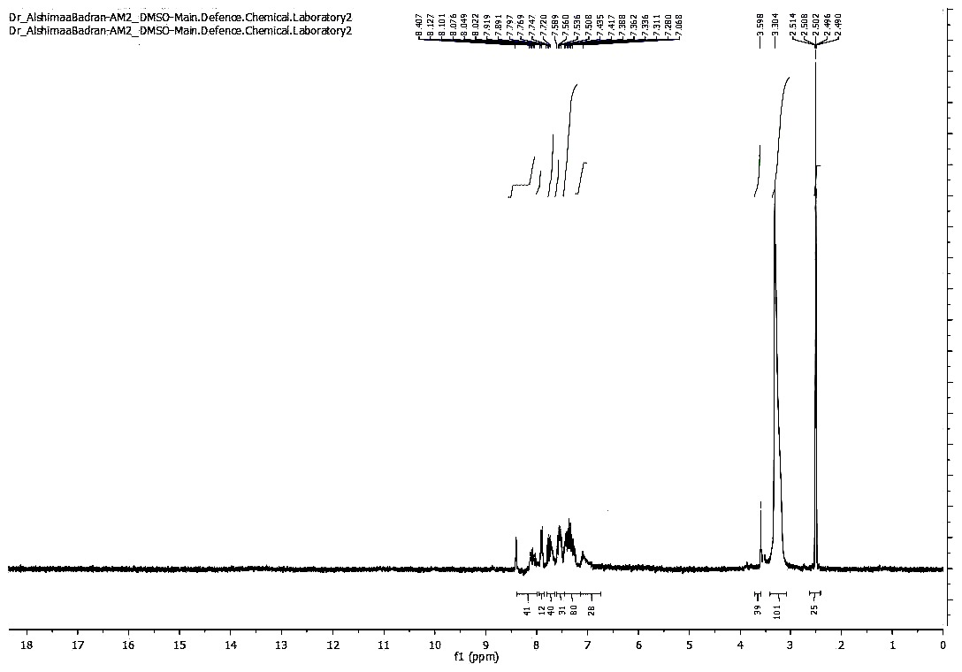

**Figure 15. 1H NMR spectrum of compound 11**

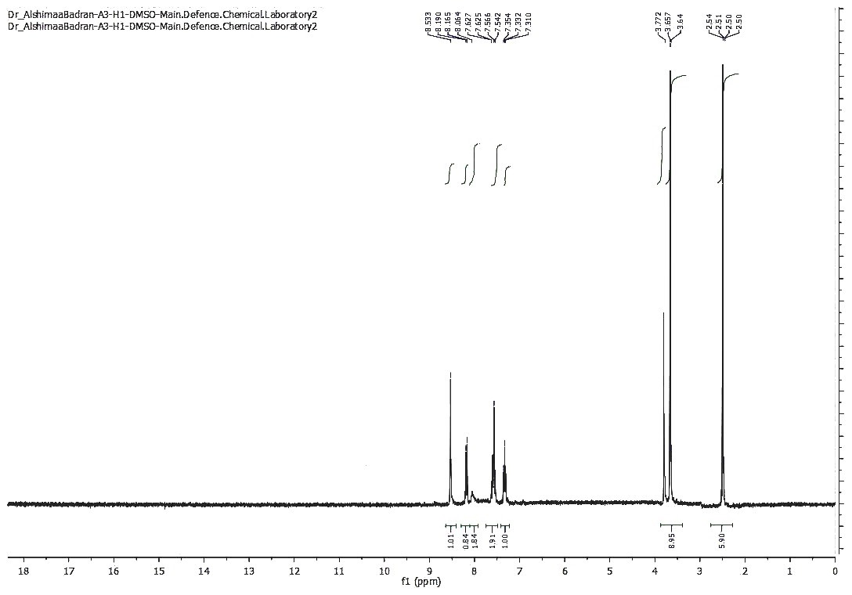

**Figure 16. 1H NMR spectrum of compound 12**

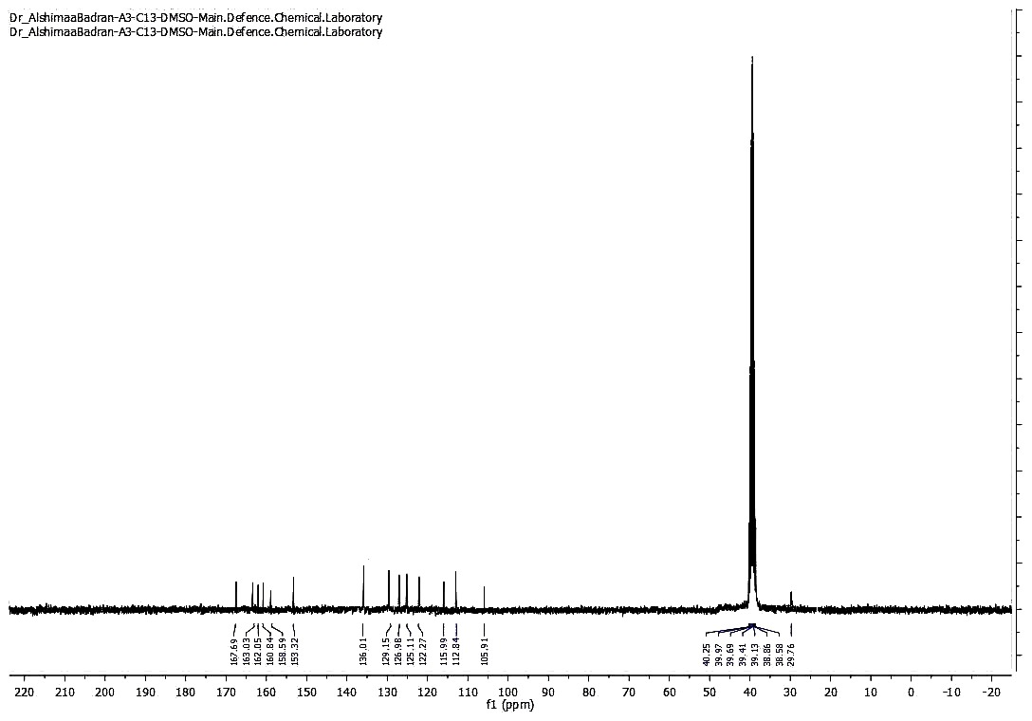

**Figure 17. 13C NMR spectrum of compound 12**

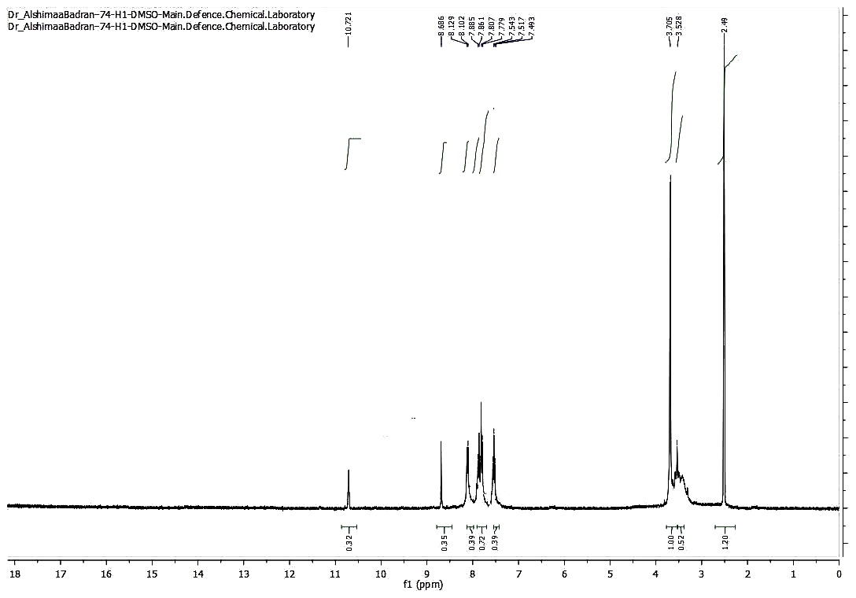

**Figure 18. 1H NMR spectrum of compound 13**

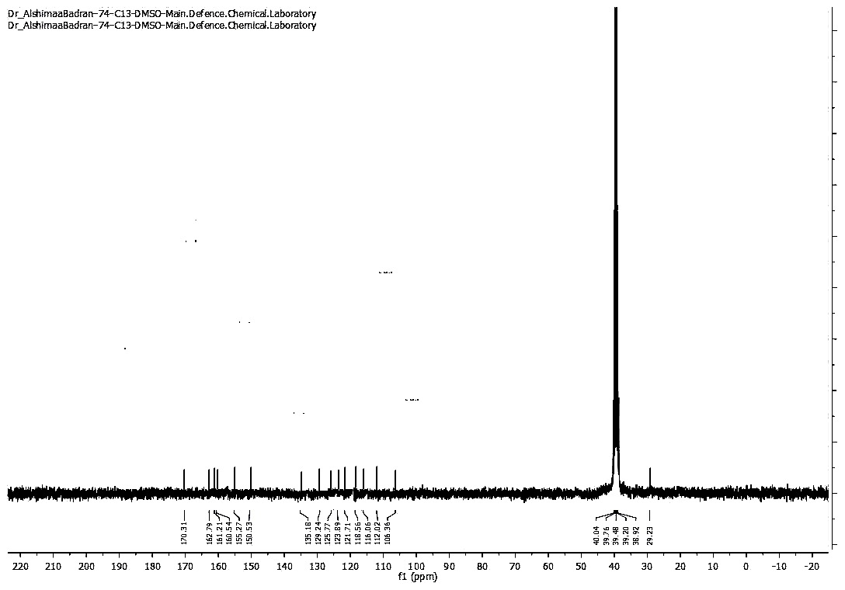

**Figure 19. 13C NMR spectrum of compound 13**

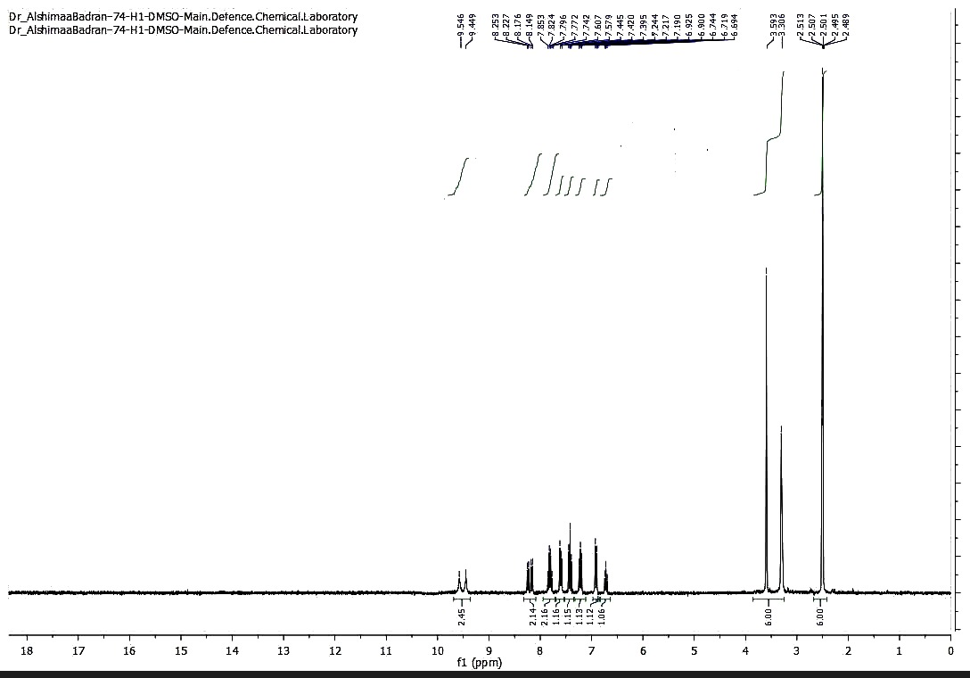

**Figure 20. 1H NMR spectrum of compound 14**

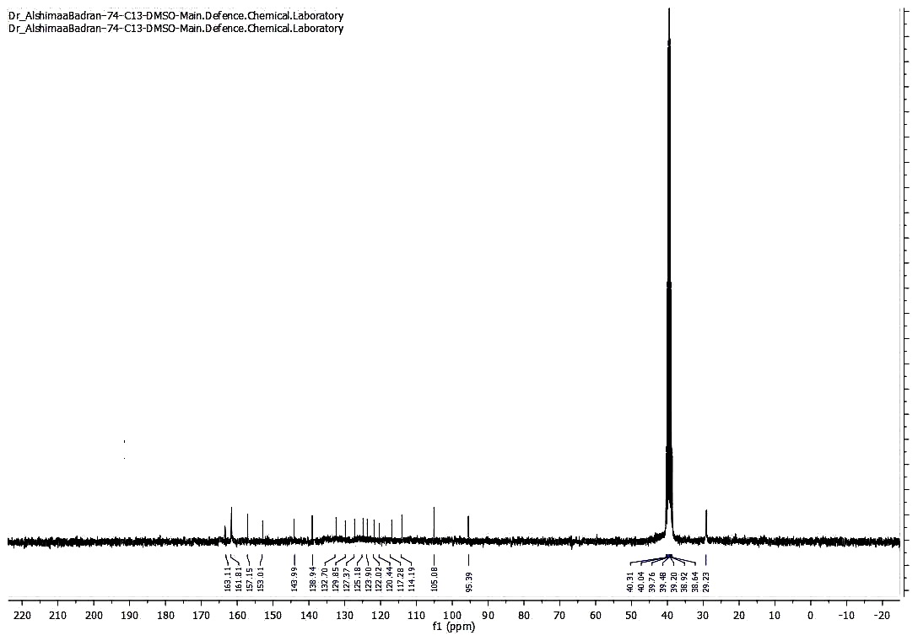

**Figure 21. 13C NMR spectrum of compound 14**

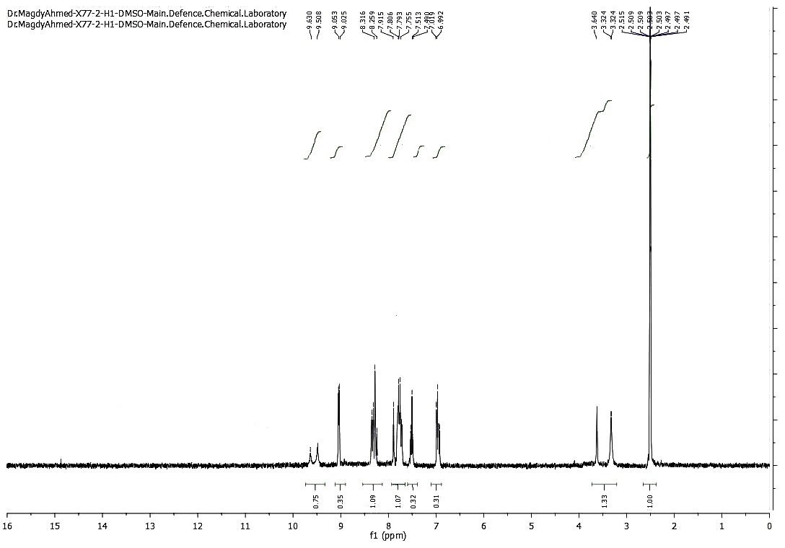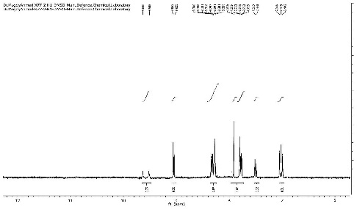

**Figure 22. 1H NMR spectrum of compound 15**

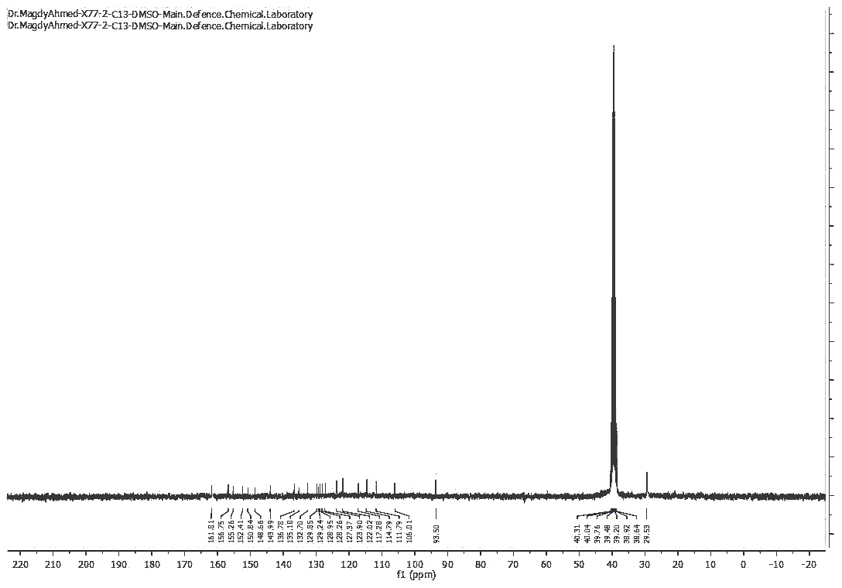

**Figure 23. 13C NMR spectrum of compound 15**

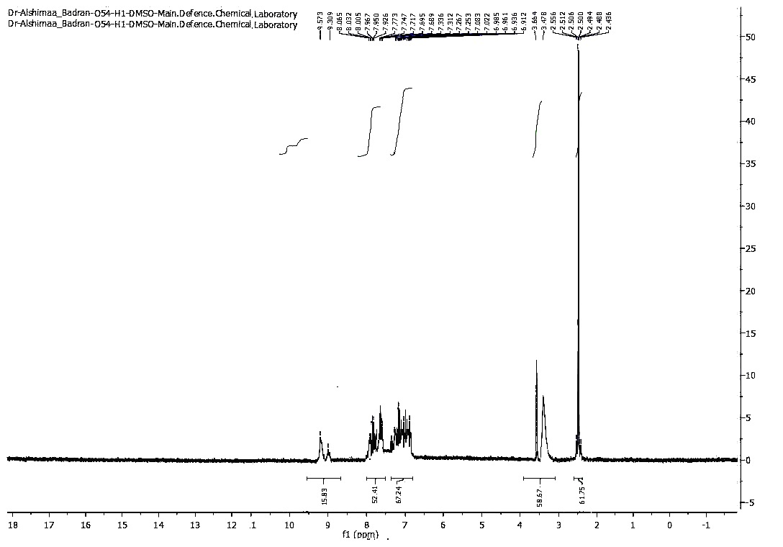

**Figure 24. 1H NMR spectrum of compound 16**

©

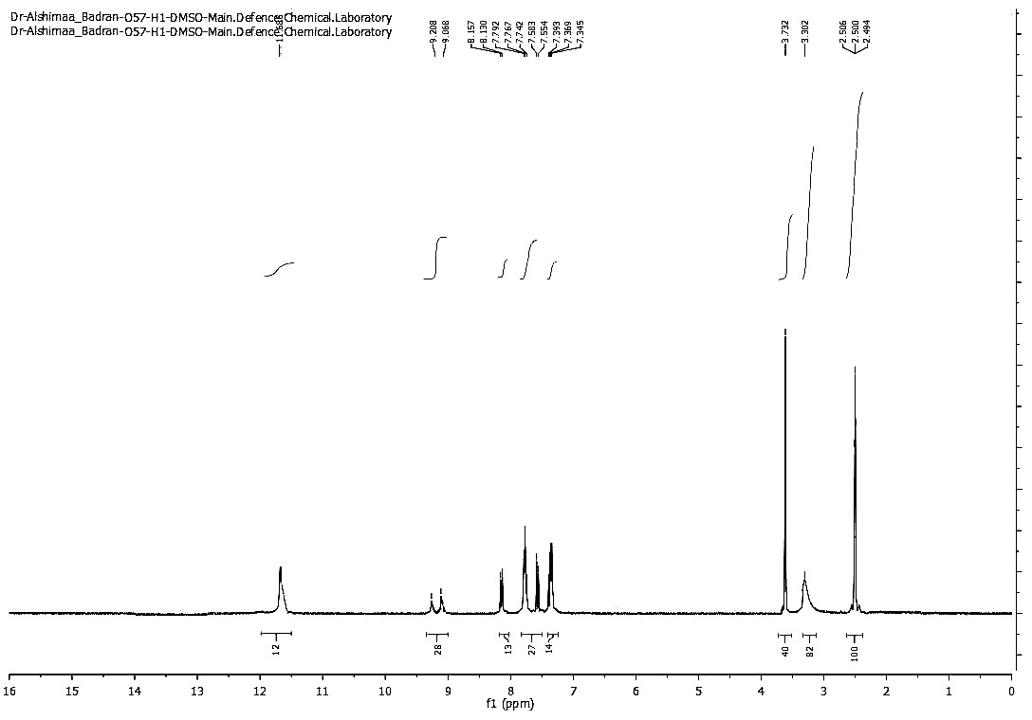

**Figure 25. 1H NMR spectrum of compound 17**

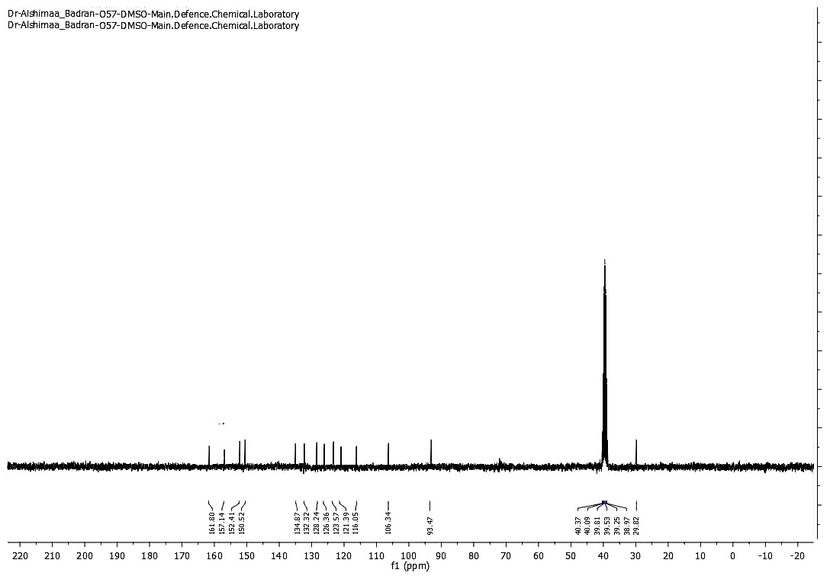

**Figure 26. 13C NMR spectrum of compound 17**

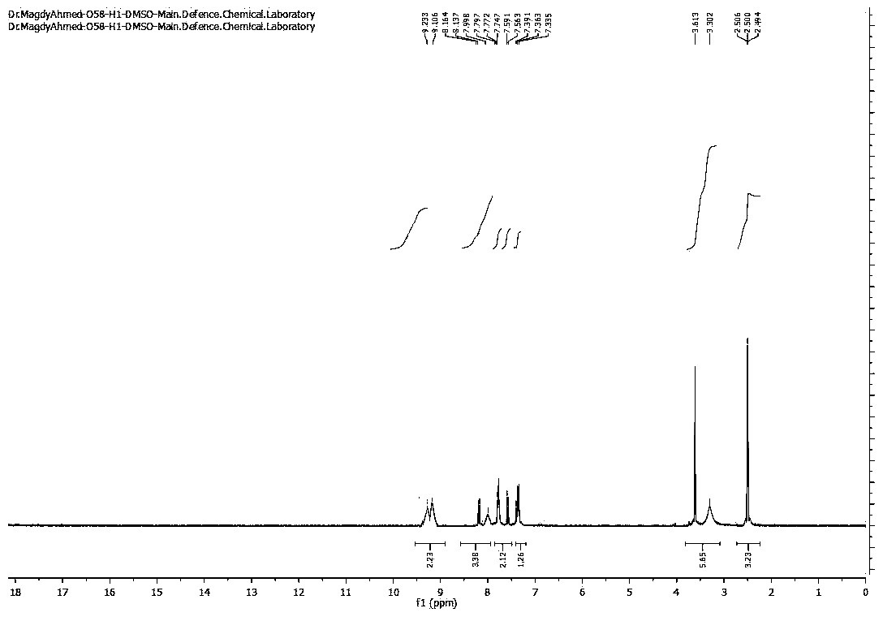

**Figure 27. 1H NMR spectrum of compound 18**

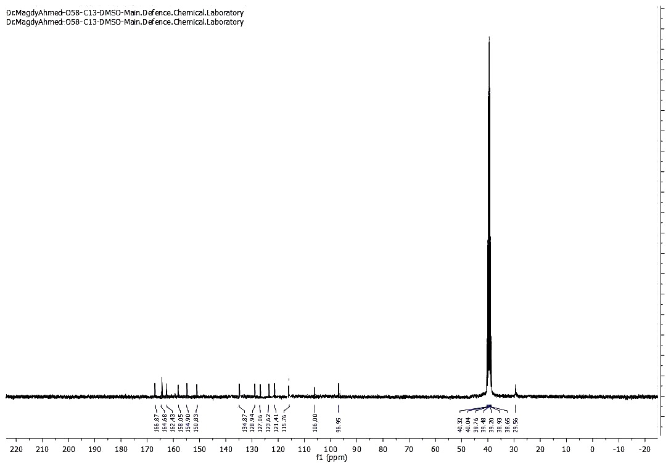

**Figure 28. 13C NMR spectrum of compound 18**

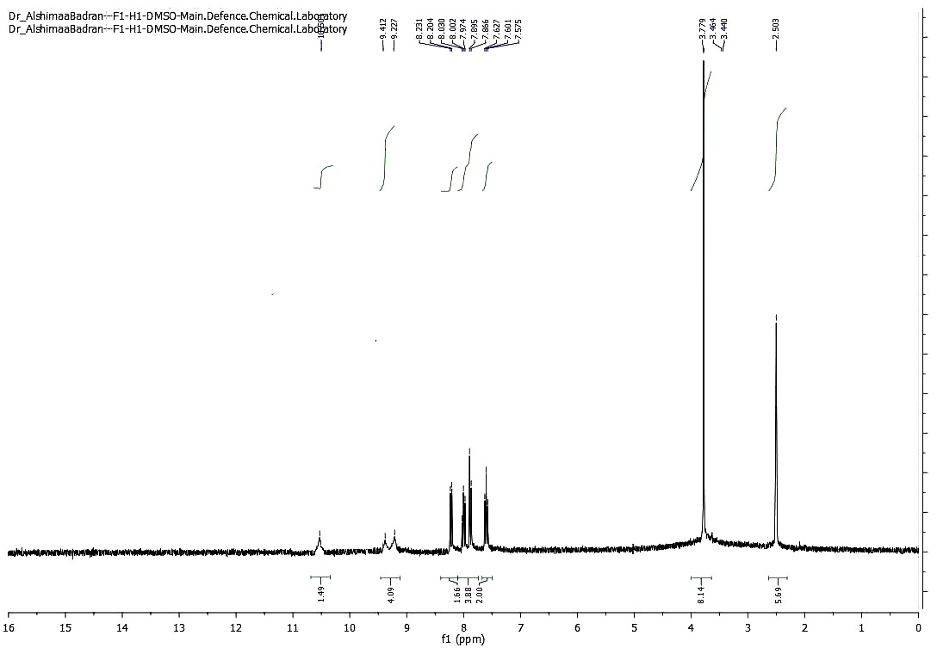

**Figure 29. 1H NMR spectrum of compound 19**

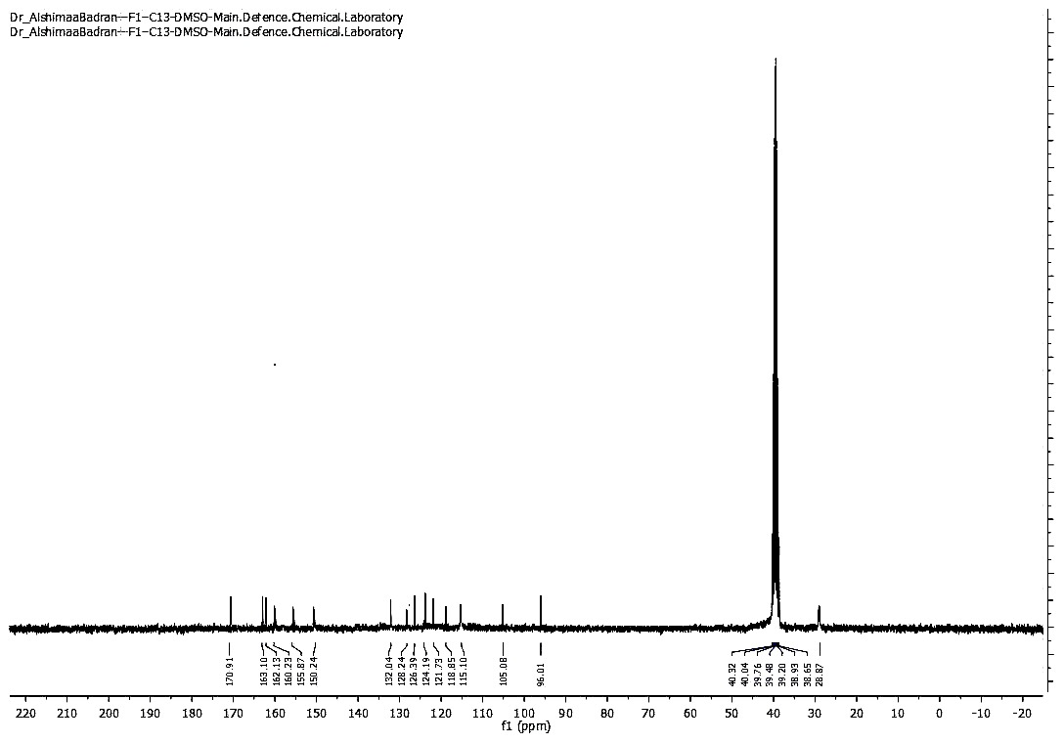

**Figure 30. 13C NMR spectrum of compound 19**