Supplementary Materials
Experimental, quantum computational study and in-vitro antidiabetic activity of oxidovanadium(IV) complexes incorporating 2,2'-bis(pyridylmethyl)amine and polypyridyl ligands

NEETU PATEL, A.K. PRAJAPATI, R.N. JADEJA*, I.P. TRIPATHI and N. DWIVEDI

(a) +ve
(b) -ve
Figure S1. ESI mass spectra of complex 1.

(a) +ve
(b) –ve
Figure S2. ESI mass spectra of complex 2.

(a) +ve
(b) –ve
Figure S3. ESI mass spectra of complex 3.

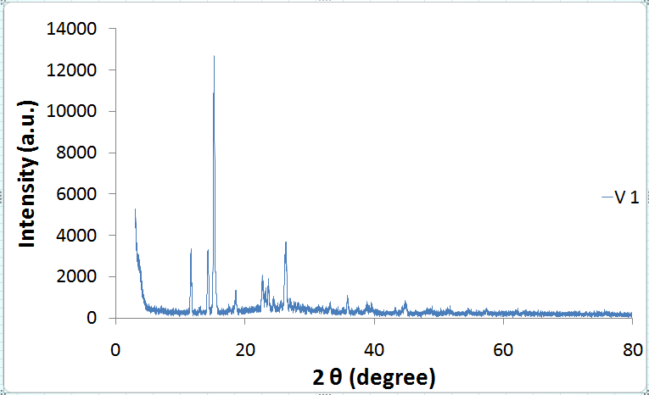

Figure S4. Powder XRD data of complex 1.

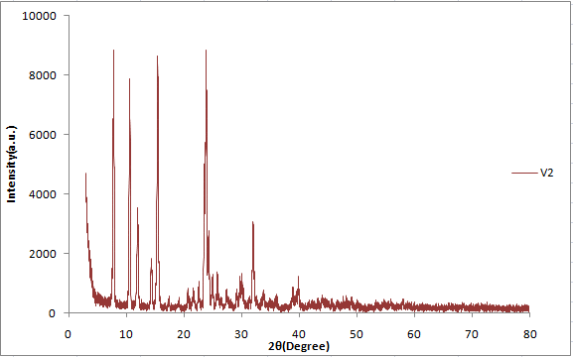

Figure S5. Powder XRD data of complex 2.

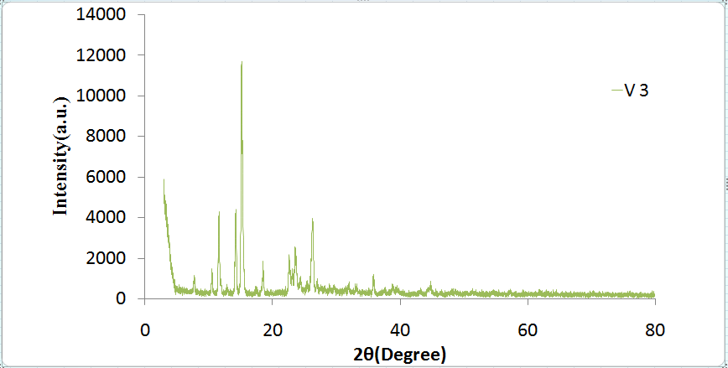

Figure S6. Powder XRD data of complex 3.

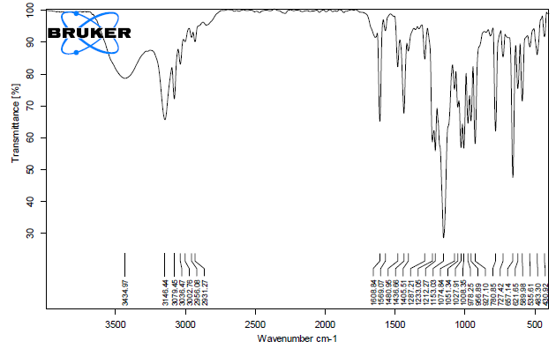
Figure S7. FT-IR data of complex 1.

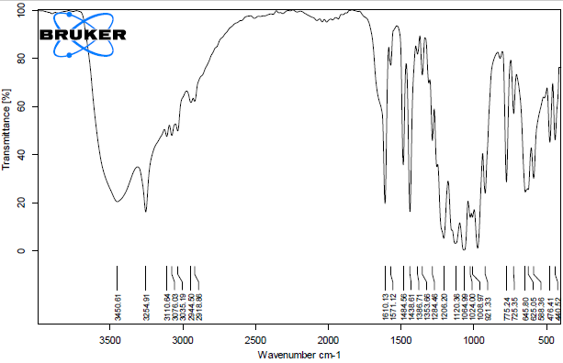
Figure S8. FT-IR data of complex 2.

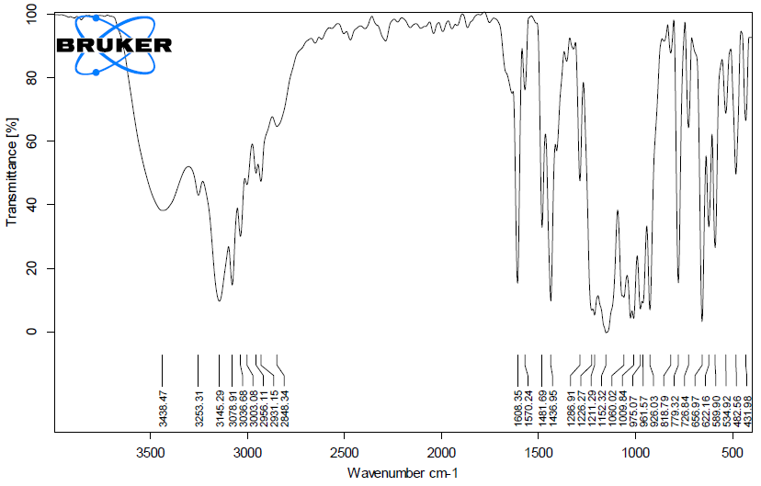
Figure S9. FT-IR data of complex 3.

