Microwave-assisted and Catalyst-free Sulfenylation of Imidazo[2,1-b]thiazoles with Sulfonyl Hydrazides in Water
Shaohua Wang, ^{a,b} * Run Luo,ª Lina Guo, ª Tianxi Zhu,ª Xu Chenª and Wenjie Liu^{a,b} *
ªSchool of Chemistry and Chemical Engineering, Guangdong Pharmaceutical University, Guangzhou 510006, P.R. of China;
^{b} Guangdong Cosmetics Engineering & Technology Research Center, Guangzhou, 510006, P.R. of China.
Email: wangshaohua108@163.com, wjliu1113@126.com
Supplemental Materials
1. Typical procedure for the synthesis of 3a
A 5-mL glass pressure vial was charged with 3-methyl-6-phenylimidazo[2,1-b]thiazole 1a (0.2 mmol), p-toluenesulfonyl hydrazide 2a (0.24 mmol) and water (2 mL). The vial was sealed with a PTFE/silicone septum and heated to 120 °C for 20 min under microwave irradiation (300 W). The reaction mixture was allowed to cool to room and diluted with ethyl acetate (20 mL). The resulting solution was washed with brine (2×8 mL), dried over anhydrous MgSO₄. The solvent was removed and the crude product was separated by column chromatography (eluted with petroleum ether : ethyl acetate=6 : 1) to afford target arylation product 3a.
2. Analytical data for 3a-3r and 5a-5f
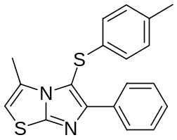5-(p-tolylthio)-3-methyl-6-phenylimidazo[2,1-b]thiazole(3a)
White solid, m. p. 158-159 °C. ¹H NMR (400 MHz, CDCl₃) δ 8.05 (d, J = 8.0 Hz, 2H), 7.39 (t, J = 7.4 Hz, 2H), 7.34-7.30 (m, 1H), 7.07 (d, J = 8.0 Hz, 2H), 6.96 (d, J = 8.0 Hz, 2H), 6.34 (s, 1H), 2.53 (s, 3H), 2.29 (s, 3H). ¹³C NMR (100 MHz, CDCl₃) δ 153.6, 153.1, 135.6, 135.2, 133.7, 131.3, 130.3, 128.3, 128.1, 127.9, 125.2, 108.8, 107.6, 20.9, 14.4. ESI-MS (m/z) 337 [M+H]⁺. Anal. calcd. C, 67.82; H, 4.79; N, 8.33; Found: C, 67.71 H, 4.74; N, 8.24.
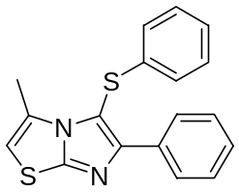3-methyl-6-phenyl-5-(phenylthio)imidazo[2,1-b]thiazole(3b)
White solid, m. p. 110-112 °C. ¹H NMR (400 MHz, CDCl₃) δ 8.02 (d, J = 7.6 Hz, 2H), 7.35 (t, J = 7.4 Hz, 2H), 7.30-7.28 (m, 1H), 7.23-7.19 (m, 2H), 7.11-7.08 (m, 1H), 7.04-7.02 (m, 2H), 6.29 (s, 1H), 2.46 (s, 3H). ¹³C NMR (100 MHz, CDCl₃) δ 153.8, 153.3, 138.8, 133.6, 131.3, 129.5, 128.3, 128.1, 127.9, 125.8, 125.1, 107.8, 14.3. ESI-MS (m/z) 323 [M+H]⁺. Anal. calcd. C, 67.05; H, 4.38; N, 8.69; Found: C, 66.94; H, 4.34; N, 8.58.
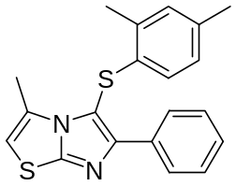5-(2,4-dimethylphenylthio)-3-methyl-6-phenylimidazo[2,1-b]thiazole(3c)
White solid, m. p. 167-169 °C. ¹H NMR (400 MHz, CDCl₃) δ 7.98 (d, J = 6.8 Hz, 2H), 7.40-7.33 (m, 3H), 7.02 (s, 1H), 6.86 (d, J = 8.0 Hz, 1H), 6.58 (d, J = 8.0 Hz, 1H), 6.42 (s, 1H), 2.48 (s, 3H), 2.39 (s, 3H), 2.26 (s, 3H). ¹³C NMR (100 MHz, CDCl₃) δ 153.9, 153.2, 135.1, 134.3, 133.7, 133.5, 131.5, 131.3, 128.3, 128.1, 127.91, 127.88, 124.8, 108.0, 107.6, 20.8, 19.6, 14.0. ESI-MS (m/z) 351 [M+H]⁺. Anal. calcd. C, 68.53; H, 5.18; N, 7.99; Found: C, 68.42; H, 5.14; N, 7.88.
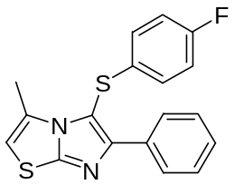5-(4-fluorophenylthio)-3-methyl-6-phenylimidazo[2,1-b]thiazole(3d)
White solid, m. p. 118-120 °C. ¹H NMR (400 MHz, CDCl₃) δ 8.04 (d, J = 7.2 Hz, 2H), 7.39-7.30 (m, 3H), 7.03-6.93 (m, 4H), 6.34 (s, 1H), 2.51 (s, 3H). ¹³C NMR (100 MHz, CDCl₃) δ 161.3 (d, J = 244.1 Hz), 153.8, 153.3, 133.7 (d, J = 3.1 Hz), 133.5, 131.1, 128.4, 128.2, 127.9, 126.9 (d, J = 7.8 Hz), 116.7 (d, J = 22.1 Hz), 107.9, 14.4. ESI-MS (m/z) 341 [M+H]⁺. Anal. calcd. C, 63.50; H, 3.85; N, 8.23; Found: C, 63.41; H, 3.80; N, 8.15.
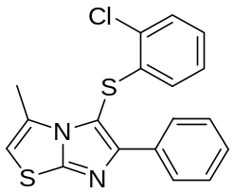5-(2-chlorophenylthio)-3-methyl-6-phenylimidazo[2,1-b]thiazole(3e)
White solid, m. p. 152-153 °C. ¹H NMR (400 MHz, CDCl₃) δ 7.98 (d, J = 7.6 Hz, 2H), 7.40-7.30 (m, 4H), 7.08 (t, J = 3.2 Hz, 2H), 6.70 (t, J = 3.4 Hz, 1H), 6.38 (s, 1H), 2.47 (s, 3H). ¹³C NMR (100 MHz, CDCl₃) δ 154.5, 153.7, 137.7, 133.4, 131.2, 130.0, 129.8, 128.4, 128.3, 127.8, 127.8, 126.6, 126.3, 108.0, 106.8, 14.1. ESI-MS (m/z) 357 [M+H]⁺. Anal. calcd. C, 60.58; H, 3.67; N, 7.85; Found: C, 60.47; H, 3.63; N, 7.75.
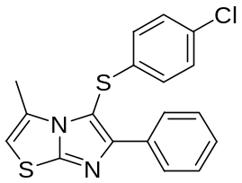5-(4-chlorophenylthio)-3-methyl-6-phenylimidazo[2,1-b]thiazole(3f)
White solid, m. p. 138-140 °C. ¹H NMR (400 MHz, CDCl₃) δ 7.99 (d, J = 8.0 Hz, 2H), 7.37 (t, J = 7.4 Hz, 2H), 7.33-7.29 (m, 1H), 7.21 (d, J = 8.0 Hz, 2H), 6.97 (d, J = 8.0 Hz, 2H), 6.36 (s, 1H), 2.49 (s, 3H). ¹³C NMR (100 MHz, CDCl₃) δ 154.0, 153.5, 137.3, 133.4, 131.7, 131.1, 129.6, 129.3, 129.1, 128.3, 127.8, 126.3, 108.0, 14.3. ESI-MS (m/z) 357 [M+H]⁺. Anal. calcd. C, 60.58; H, 3.67; N, 7.85; Found: C, 60.48; H, 3.63; N, 7.74.
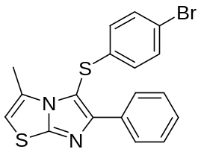5-(4-bromophenylthio)-3-methyl-6-phenylimidazo[2,1-b]thiazole(3g)
White solid, m. p. 137-139 °C. ¹H NMR (400 MHz, CDCl₃) δ 7.96 (d, J = 7.2 Hz, 2H), 7.36-7.28 (m, 5H), 6.87 (d, J = 8.4 Hz, 2H), 6.31 (s, 1H), 2.44 (s, 3H). ¹³C NMR (100 MHz, CDCl₃) δ 154.1, 153.5, 138.0, 133.4, 132.6, 131.1, 128.4, 128.3, 127.9, 126.9, 126.6, 119.5, 108.0, 14.4. ESI-MS (m/z) 401 [M+H]⁺. Anal. calcd. C, 53.87; H, 3.26; N, 6.98; Found: C, 53.79; H, 3.22; N, 6.87.
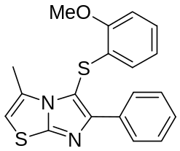5-(2-methoxyphenylthio)-3-methyl-6-phenylimidazo[2,1-b]thiazole(3h)
White solid, m. p. 155-156 °C. ¹H NMR (400 MHz, CDCl₃) δ 7.98 (d, J = 7.6 Hz, 2H), 7.39-7.27 (m, 3H), 7.12 (t, J = 7.6 Hz, 1H), 6.89 (d, J = 8.0 Hz, 1H), 6.81 (t, J = 7.6 Hz, 1H), 6.63(d, J = 7.6 Hz, 1H), 6.35 (s, 1H), 3.92 (s, 3H), 2.50 (s, 3H). ¹³C NMR (100 MHz, CDCl₃) δ 155.0, 154.0, 153.3, 133.7, 131.4, 128.3, 128.0, 127.9, 127.2, 126.5, 125.7, 121.8, 110.8, 107.6, 55.9, 14.1. ESI-MS (m/z) 353 [M+H]⁺. Anal. calcd. C, 64.74; H, 4.58; N, 7.95; Found: C, 64.65; H, 4.53; N, 7.82.
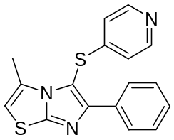3-methyl-6-phenyl-5-(pyridin-4-ylthio)imidazo[2,1-b]thiazole(3i)
Yellow oil. ¹H NMR (400 MHz, CDCl₃) δ 8.41 (d, J = 4.4 Hz, 2H), 7.91 (d, J = 7.2 Hz, 2H), 7.39-7.34 (m, 3H), 6.96 (d, J = 4.8Hz, 2H), 6.42 (s, 1H), 2.47 (s, 3H). ¹³C NMR (100 MHz, CDCl₃) δ 154.8, 154.0, 150.3, 150.0, 133.1, 130.9, 128.5, 128.4, 127.9, 119.6, 108.4, 104.9, 14.2. ESI-MS (m/z) 324 [M+H]⁺. Anal. calcd. C, 63.13; H, 4.05; N, 12.99; Found: C, 62.97; H, 3.98; N, 12.85.
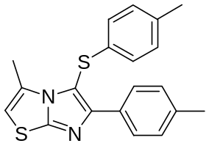5-(p-tolylthio)-3-methyl-6-p-tolylimidazo[2,1-b]thiazole(3j)
White solid, m. p. 179-180 °C. ¹H NMR (400 MHz, CDCl₃) δ 7.92 (d, J = 8.4 Hz, 2H), 7.19 (d, J = 7.6 Hz, 2H), 7.06 (d, J = 8.0 Hz, 2H), 6.95 (d, J = 8.4 Hz, 2H), 6.34 (s, 1H), 2.52 (s, 3H), 2.35 (s, 3H), 2.28 (s, 3H). ¹³C NMR (100 MHz, CDCl₃) δ 153.8, 153.0, 137.9, 135.6, 135.3, 131.3, 130.8, 130.2, 129.0, 127.8, 125.2, 108.4, 107.4, 21.3, 20.9, 14.4. ESI-MS (m/z) 351 [M+H]⁺. Anal. calcd. C, 68.53; H, 5.18; N, 7.99; Found: C, 68.44; H, 5.14; N, 7.89.
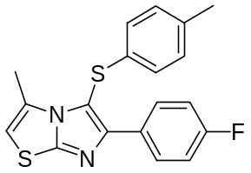5-(p-tolylthio)-6-(4-fluorophenyl)-3-methylimidazo[2,1-b]thiazole(3k)
White solid, m. p. 114-116 °C. ¹H NMR (400 MHz, CDCl₃) δ 8.04 (dd, J = 8.8 Hz, J = 5.6 Hz, 2H), 7.08-7.03 (m, 4H), 6.94 (dd, J = 6.4 Hz, J = 2.0 Hz, 2H), 6.32 (s, 1H), 2.50 (s, 3H), 2.27 (s, 3H). ¹³C NMR (100 MHz, CDCl₃) δ 162.7 (d, J = 246.1 Hz), 153.1, 152.7, 135.8, 135.0, 131.3, 130.4 129.9 (d, J = 3.1 Hz), 129.7 (d, J = 8.0 Hz), 125.2, 115.2 (d, J = 21.3 Hz), 108.6, 107.7, 20.9, 14.4. ESI-MS (m/z) 355 [M+H]⁺. Anal. calcd. C, 64.38; H, 4.27; N, 7.90; Found: C, 64.30; H, 4.22; N, 7.78.
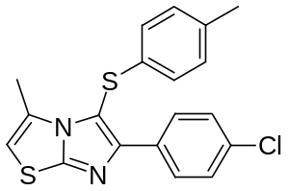5-(p-tolylthio)-6-(4-chlorophenyl)-3-methylimidazo[2,1-b]thiazole(3l)
White solid, m. p. 169-171 °C. ¹H NMR (400 MHz, CDCl₃) δ 8.00 (d, J = 7.6 Hz, 2H), 7.34 (d, J = 8.0 Hz, 2H), 7.06 (d, J = 7.6 Hz, 2H), 6.93 (d, J = 7.6 Hz, 2H), 6.36 (s, 1H), 2.53 (s, 3H), 2.28 (s, 3H). ¹³C NMR (100 MHz, CDCl₃) δ 153.2, 152.4, 135.8, 134.8, 134.0, 132.2, 131.3, 130.3, 129.1, 128.5, 125.2, 109.1, 107.8, 20.9, 14.4. ESI-MS (m/z) 371 [M+H]⁺. Anal. calcd. C, 61.52; H, 4.08; N, 7.55; Found: C, 61.43; H, 4.03; N, 7.44.
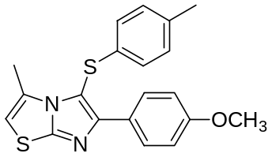5-(p-tolylthio)-6-(4-methoxyphenyl)-3-methylimidazo[2,1-b]thiazole(3m)
White solid, m. p. 218-220 °C. ¹H NMR (400 MHz, CDCl₃) δ 7.98 (d, J = 8.8 Hz, 2H), 7.06 (d, J = 8.4 Hz, 2H), 6.95 (d, J = 8.4 Hz, 2H), 6.91 (d, J = 8.8 Hz, 2H), 6.31 (s, 1H), 3.81 (s, 3H), 2.51 (s, 3H), 2.28 (s, 3H). ¹³C NMR (100 MHz, CDCl₃) δ 159.6, 153.6, 153.0, 135.6, 135.4, 131.3, 130.3, 129.2, 126.4, 125.2, 107.8, 107.2, 55.3, 20.9, 14.4. ESI-MS (m/z) 367 [M+H]⁺. Anal. calcd. C, 65.54; H, 4.95; N, 7.64; Found: C, 65.44; H, 4.91; N, 7.55.
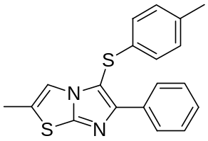5-(p-tolylthio)-2-methyl-6-phenylimidazo[2,1-b]thiazole(3n)
White solid, m. p. 158-160 °C. ¹H NMR (400 MHz, CDCl₃) δ 8.10 (d, J = 7.6 Hz, 2H), 7.38 (t, J = 7.4 Hz, 2H), 7.30 (t, J = 7.4 Hz, 1H), 7.13 (s, 1H), 7.05 (d, J = 8.4 Hz, 2H), 6.98 (d, J = 8.0 Hz, 2H), 2.39 (s, 3H), 2.28 (s, 3H). ¹³C NMR (100 MHz, CDCl₃) δ 151.1, 150.7, 136.0, 133.7, 132.4, 130.2, 128.4, 127.9, 127.3, 127.1, 126.0, 114.6, 107.8, 20.9, 14.2. ESI-MS (m/z) 337 [M+H]⁺. Anal. calcd. C, 67.82; H, 4.79; N, 8.33; Found: C, 67.71; H, 4.75; N, 8.24.
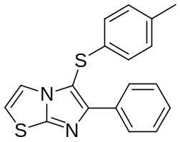5-(p-tolylthio)-6-phenylimidazo[2,1-b]thiazole(3o)
Pale yellow oil. ¹H NMR (400 MHz, CDCl₃) δ 8.16 (d, J = 7.6 Hz, 2H), 7.43-7.31 (m, 4H), 7.04 (d, J = 7.6 Hz, 2H), 6.99 (d, J = 8.0 Hz, 2H), 6.76 (d, J = 4.0 Hz, 1H), 2.27 (s, 3H). ¹³C NMR (100 MHz, CDCl₃) δ 152.3, 151.3, 136.2, 133.7, 132.2, 130.2, 128.4, 128.1, 127.5, 126.2, 118.1, 113.0, 108.4, 21.0. ESI-MS (m/z) 323 [M+H]⁺. Anal. calcd. C, 67.05; H, 4.38; N, 8.69; Found: C, 66.95; H, 4.33; N, 8.60.
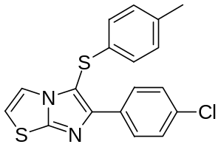5-(p-tolylthio)-6-(4-chlorophenyl)imidazo[2,1-b]thiazole(3p)
White solid, m. p. 163-165 °C.¹H NMR (400 MHz, CDCl₃) δ 8.10 (d, J = 8.8 Hz, 2H), 7.38-7.34 (m, 3H), 7.04 (d, J = 8.0 Hz, 2H), 6.96 (d, J = 8.4 Hz, 2H), 6.79 (d, J = 4.8 Hz, 1H), 2.26 (s, 3H). ¹³C NMR (100 MHz, CDCl₃) δ 151.3, 151.0, 136.4, 133.9, 132.2, 131.8, 130.3, 128.7, 128.6, 126.3, 118.0, 113.2, 108.7, 21.0, ESI-MS (m/z) 357 [M+H]⁺. Anal. calcd. C, 60.58; H, 3.67; N, 7.85; Found: C, 60.49; H, 3.62; N, 7.73.
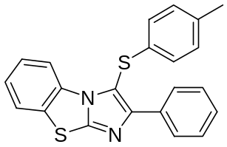2-phenyl-3-(p-tolylthio)benzo[d]imidazo[2,1-b]thiazole(3q)
White solid, m. p. 116-118 °C. ¹H NMR (400 MHz, CDCl₃) δ 8.33 (d, J = 7.6 Hz, 1H), 8.11 (d, J = 7.2 Hz, 2H), 7.63 (d, J = 7.6 Hz, 1H), 7.39 (t, J = 7.4 Hz, 2H), 7.34-7.23 (m, 3H), 7.07-7.01 (m, 4H), 2.23 (s, 3H). ¹³C NMR (100 MHz, CDCl₃) δ 153.4, 150.6, 136.1, 133.5, 133.3, 132.9, 130.4, 130.2, 128.4, 128.3, 127.8, 126.4, 125.8, 124.9, 124.0, 114.5, 110.6, 21.0. ESI-MS (m/z) 373 [M+H]⁺. Anal. calcd. C, 70.93; H, 4.33; N, 7.52; Found: C, 70.82; H, 4.28; N, 7.41.
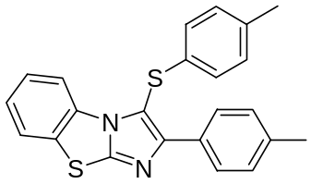2-p-tolyl-3-(p-tolylthio)benzo[d]imidazo[2,1-b]thiazole(3r)
White solid, m. p. 161-163 °C. ¹H NMR (400 MHz, CDCl₃) δ 8.33 (m, 1H), 8.00 (d, J = 8.4 Hz, 2H), 7.65 (m, 1H), 7.33-7.24 (m, 2H), 7.21 (d, J = 8.0 Hz, 2H), 7.07-7.02 (m, 4H), 2.36 (s, 3H), 2.24 (s, 3H). ¹³C NMR (100 MHz, CDCl₃) δ 153.6, 150.5, 138.2, 136.0, 133.5, 133.0, 130.3, 130.1, 129.1, 127.7, 126.3, 125.8, 124.8, 123.9, 114.4, 110.1, 21.4, 20.9. ESI-MS (m/z) 387 [M+H]⁺. Anal. calcd. C, 71.47; H, 4.69; N, 7.25; Found: C, 71.36; H, 4.63; N, 7.17.
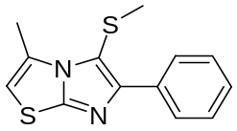3-methyl-5-(methylthio)-6-phenylimidazo[2,1-b]thiazole(5a)
Pale yellow oil. ¹H NMR (400 MHz, CDCl₃) δ 8.13 (d, J = 7.6 Hz, 2H), 7.44 (t, J = 7.6 Hz, 2H), 7.34-7.31 (m, 1H), 6.35 (s, 1H), 2.74 (s, 3H), 2.29 (s, 3H). ¹³C NMR (100 MHz, CDCl₃) δ 151.8, 151.1, 134.2, 131.0, 128.3, 127.8, 127.7, 114.2, 107.5, 22.3, 14.7. ESI-MS (m/z) 261 [M+H]⁺. Anal. calcd. C, 59.97; H, 4.65; N, 10.76; Found: C, 59.88; H, 4.61; N, 10.64.
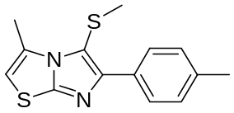3-methyl-5-(methylthio)-6-p-tolylimidazo[2,1-b]thiazole(5b)
White solid, m. p. 131-133 °C. ¹H NMR (400 MHz, CDCl₃) δ 8.03 (d, J = 7.2 Hz, 2H), 7.25 (d, J = 7.6 Hz, 2H), 6.36 (s, 1H), 2.76 (s, 3H), 2.40 (s, 3H), 2.30 (s, 3H). ¹³C NMR (100 MHz, CDCl₃) δ 151.7, 151.3, 137.5, 131.4, 131.0, 129.0, 127.7, 113.7, 107.3, 22.3, 21.3, 14.7. ESI-MS (m/z) 275 [M+H]⁺. Anal. calcd. C, 61.28; H, 5.14; N, 10.21; Found: C, 61.17; H, 5.09; N, 10.28.
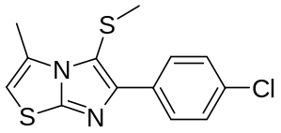6-(4-chlorophenyl)-3-methyl-5-(methylthio)imidazo[2,1-b]thiazole(5c)
White solid, m. p. 125-127 °C. ¹H NMR (400 MHz, CDCl₃) δ 8.10 (d, J = 7.6 Hz, 2H), 7.39 (d, J = 8.0 Hz, 2H), 6.39 (s, 1H), 2.76 (s, 3H), 2.29 (s, 3H). ¹³C NMR (100 MHz, CDCl₃) δ 151.9, 149.8, 133.5, 132.7, 131.0, 129.0, 128.4, 114.3, 107.7, 22.2, 14.7. ESI-MS (m/z) 295 [M+H]⁺. Anal. calcd. C, 52.96; H, 3.76; N, 9.50; Found: C, 52.85; H, 3.71; N, 9.36.
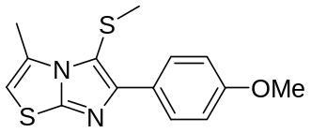6-(4-methoxyphenyl)-3-methyl-5-(methylthio)imidazo[2,1-b]thiazole(5d)
White solid, m. p. 138-140 °C. ¹H NMR (400 MHz, CDCl₃) δ 8.08 (d, J = 7.6 Hz, 2H), 6.97 (d, J = 8.0 Hz, 2H), 6.36 (s, 1H), 3.85 (s, 3H), 2.76 (s, 3H), 2.30 (s, 3H). ¹³C NMR (100 MHz, CDCl₃) δ 159.3, 151.7, 151.1, 131.0, 129.1, 126.9, 113.7, 113.2, 107.1, 55.3, 22.3, 14.7. ESI-MS (m/z) 291 [M+H]⁺. Anal. calcd. C, 57.90; H, 4.86; N, 9.65; Found: C, 57.80; H, 4.82; N, 9.53.
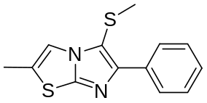2-methyl-5-(methylthio)-6-phenylimidazo[2,1-b]thiazole(5e)
White solid, m. p. 97-99 °C. ¹H NMR (400 MHz, CDCl₃) δ 8.16 (d, J = 7.6 Hz, 2H), 7.42 (t, J = 7.4 Hz, 2H), 7.33-7.28 (m, 2H), 2.44 (s, 3H), 2.28 (s, 3H). ¹³C NMR (100 MHz, CDCl₃) δ 149.5, 148.7, 134.2, 128.3, 127.6, 127.2, 126.8, 114.5, 112.3, 19.4, 14.2. ESI-MS (m/z) 261 [M+H]⁺. Anal. calcd. C, 59.97; H, 4.65; N, 10.76; Found: C, 59.86; H, 4.61; N, 10.65.
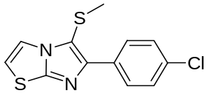6-(4-chlorophenyl)-5-(methylthio)imidazo[2,1-b]thiazole(5f)
Yellow oil. ¹H NMR (400 MHz, CDCl₃) δ 8.14 (d, J = 7.6 Hz, 2H), 7.57 (d, J = 3.2 Hz, 1H), 7.40 (d, J = 7.6 Hz, 2H), 6.90 (d, J = 3.2 Hz, 1H), 2.29 (s, 3H). ¹³C NMR (100 MHz, CDCl₃) δ 150.3, 148.9, 133.6, 132.5, 128.6, 128.5, 117.8, 113.0, 19.3. ESI-MS (m/z) 281 [M+H]⁺. Anal. calcd. C, 51.33; H, 3.23; N, 9.98; Found: C, 51.23; H, 3.18; N, 9.86.
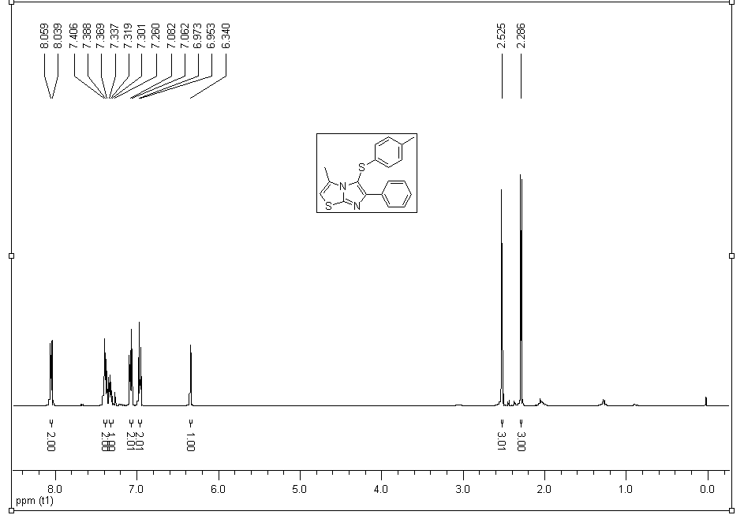
Figure S 1: ¹H NMR of 3a
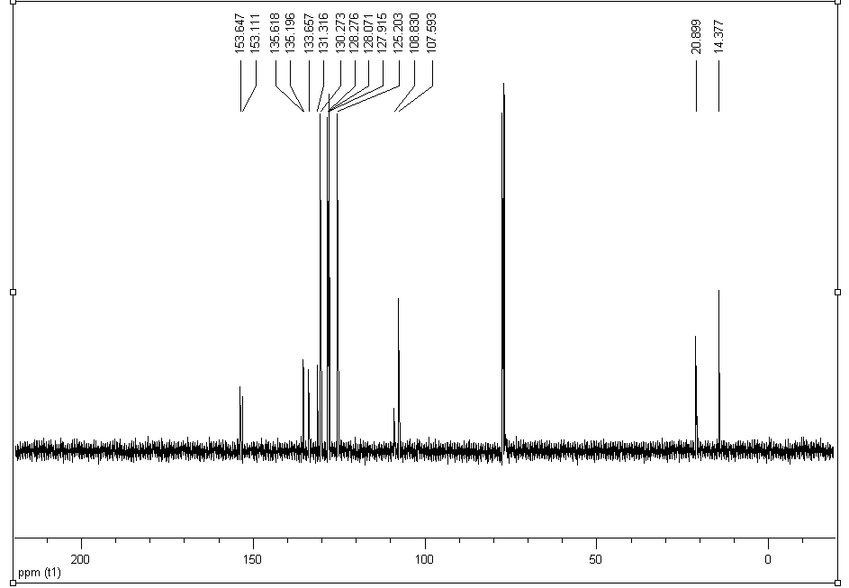
Figure S 2: ¹³C NMR of 3a

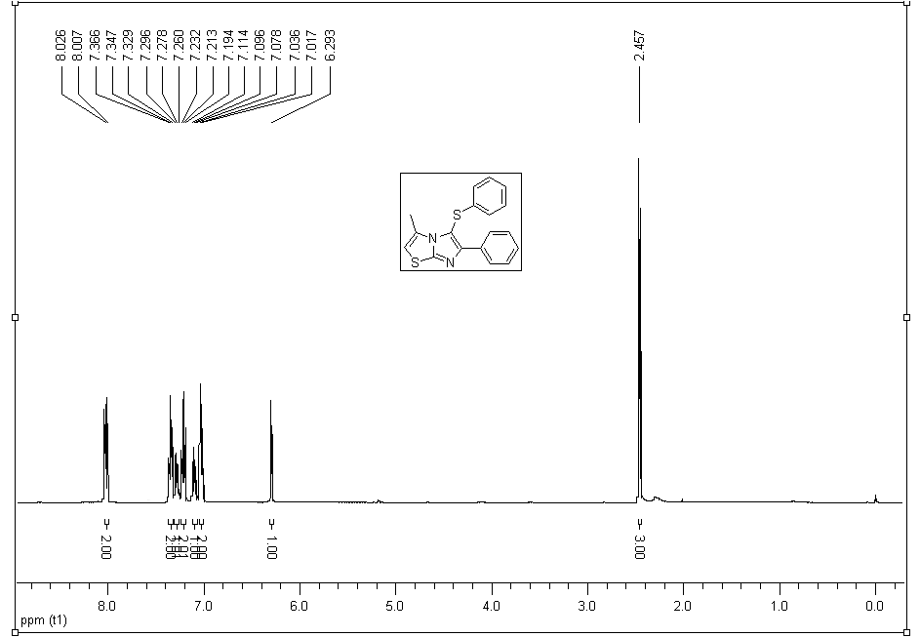
Figure S 3: ¹H NMR of 3b
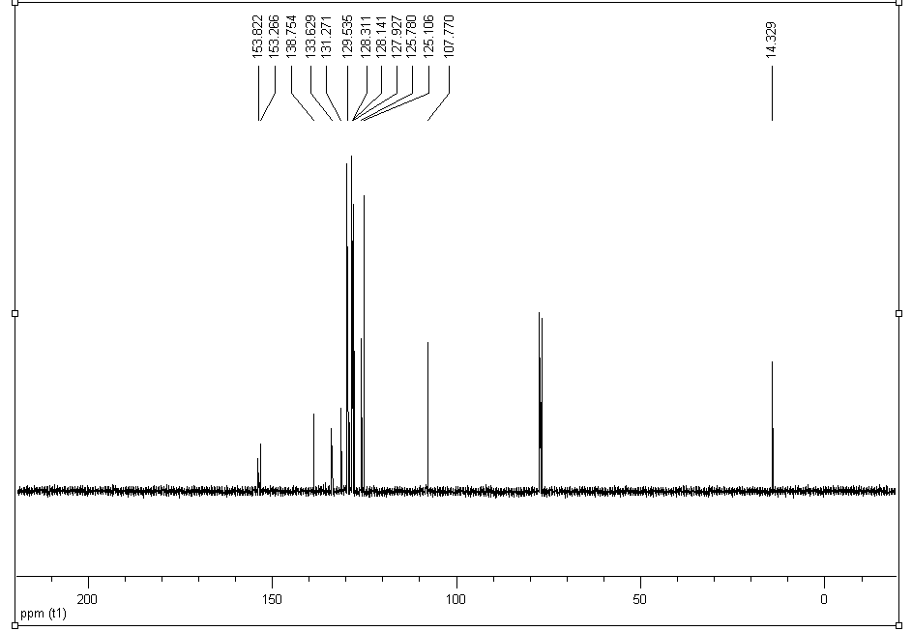
Figure S 4: ¹³C NMR of 3b

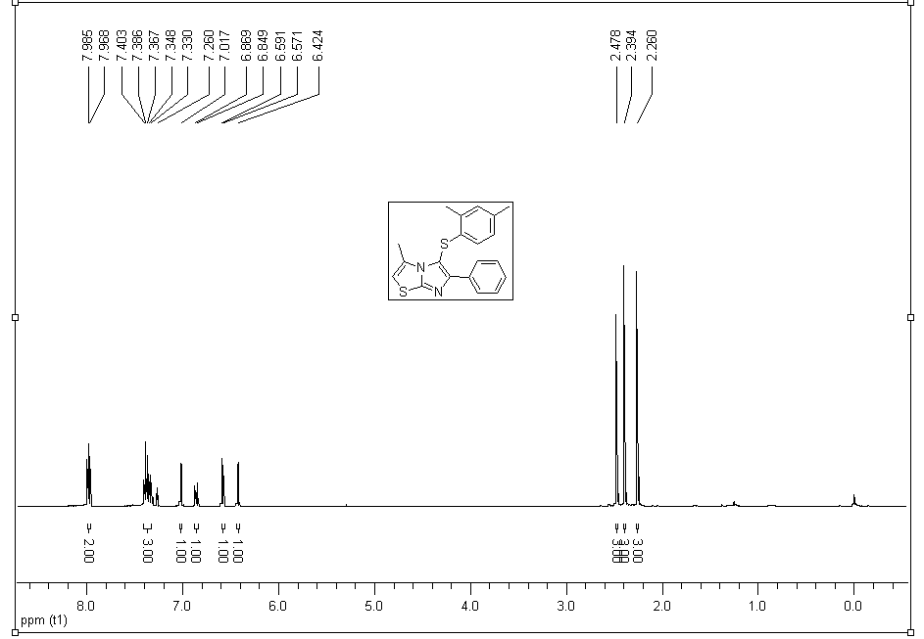
Figure S 5: ¹H NMR of 3c
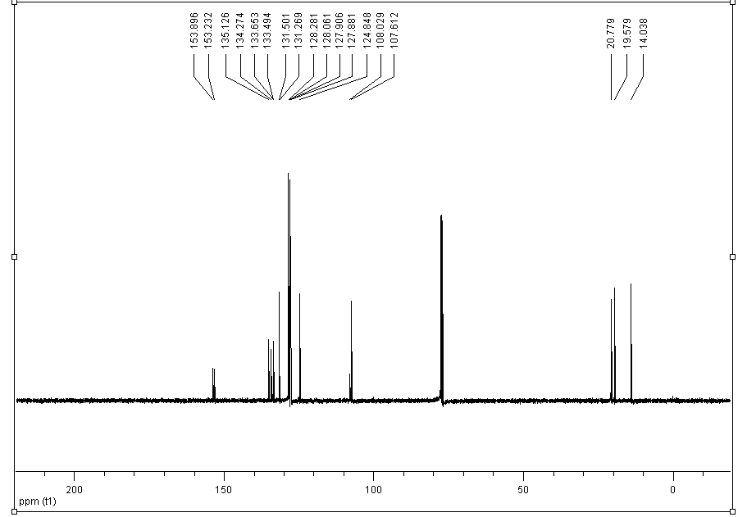
Figure S 6: ¹³C NMR of 3c

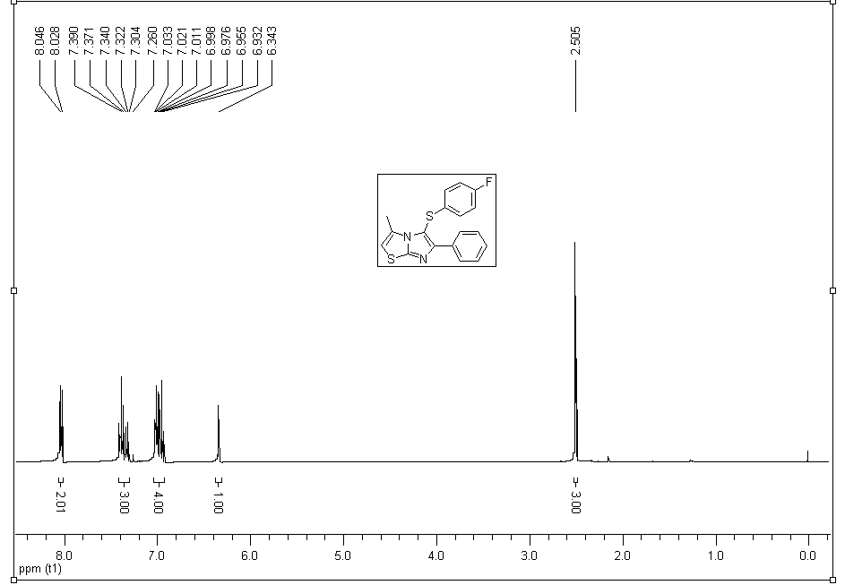
Figure S 7: ¹H NMR of 3d
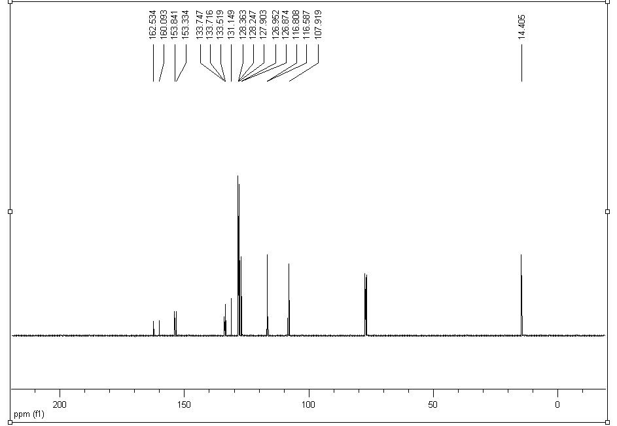
Figure S 8: ¹³C NMR of 3d

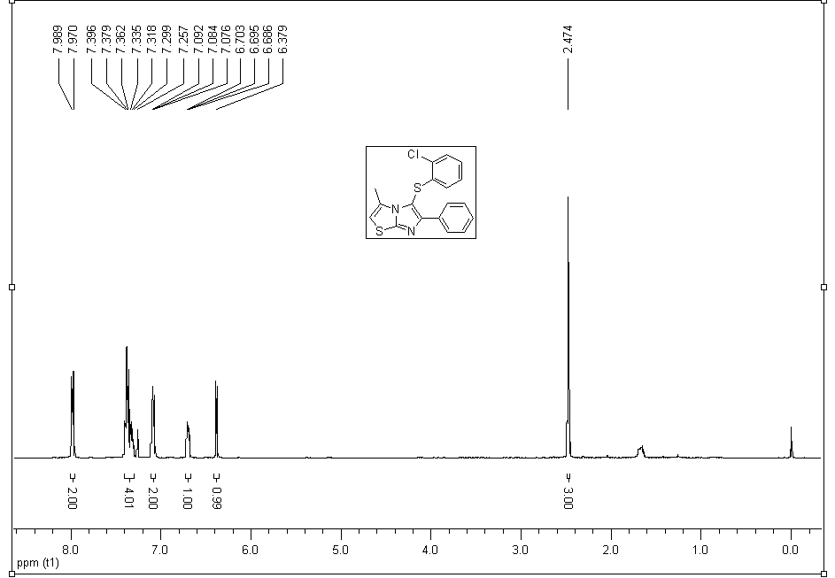
Figure S 9: ¹H NMR of 3e
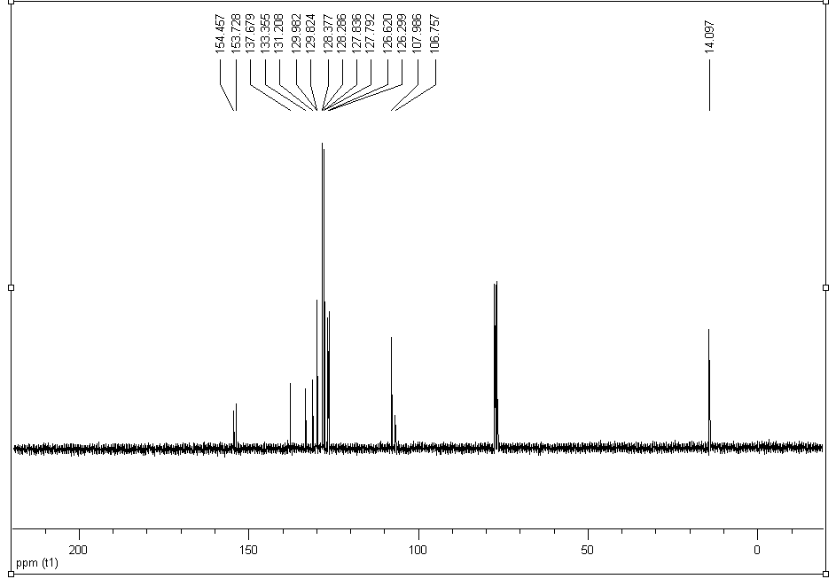
Figure S 10: ¹³C NMR of 3e

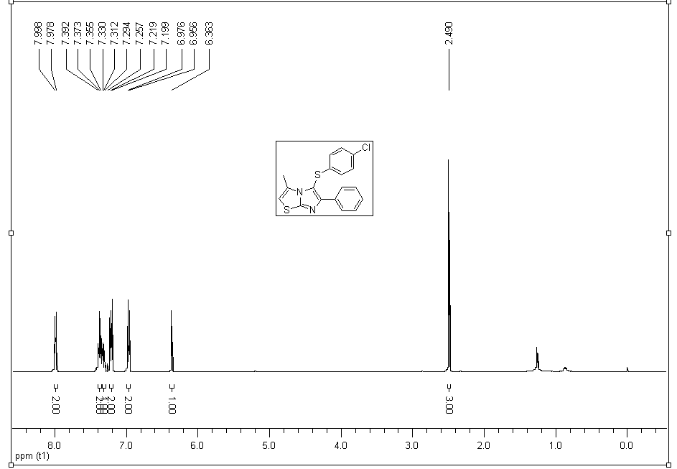
Figure S 11: ¹H NMR of 3f
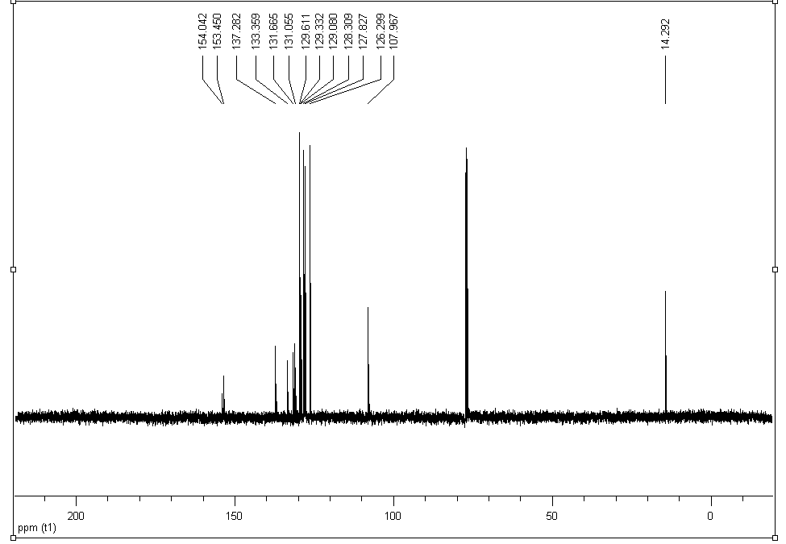
Figure S 12: ¹³C NMR of 3f

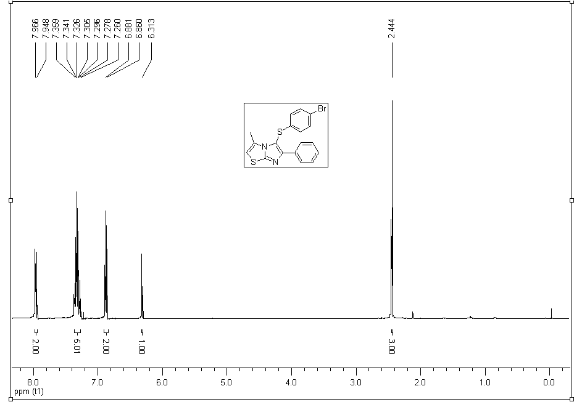
Figure S 13: ¹H NMR of 3g
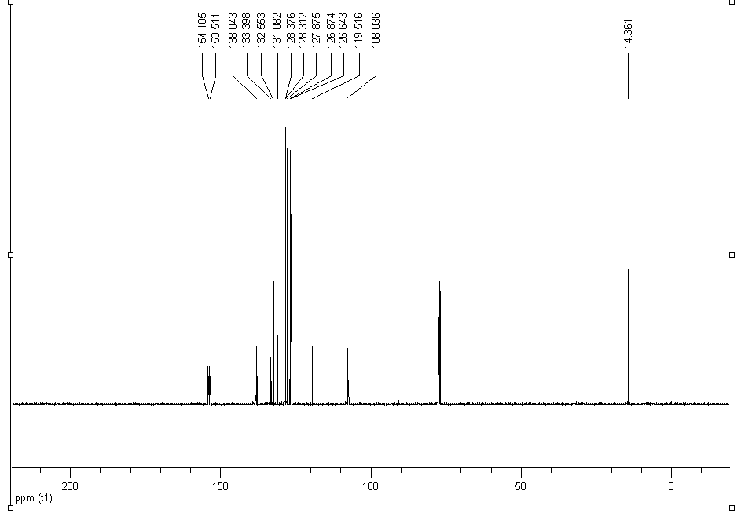
Figure S 14: ¹³C NMR of 3g

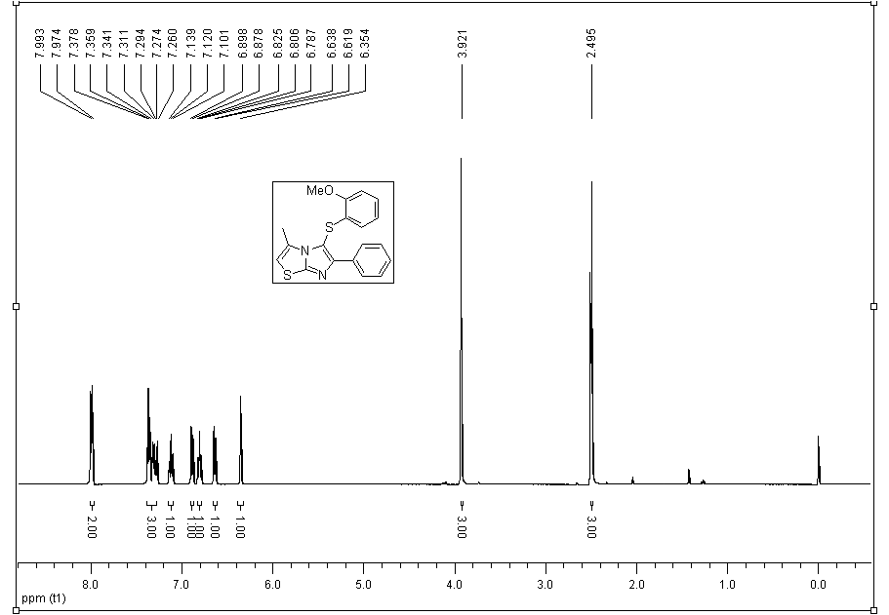
Figure S 15: ¹H NMR of 3h
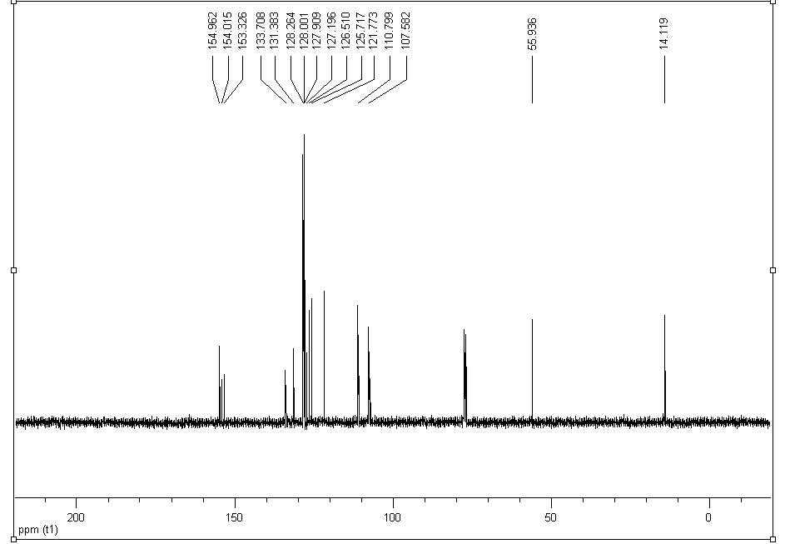
Figure S 16: ¹³C NMR of 3h

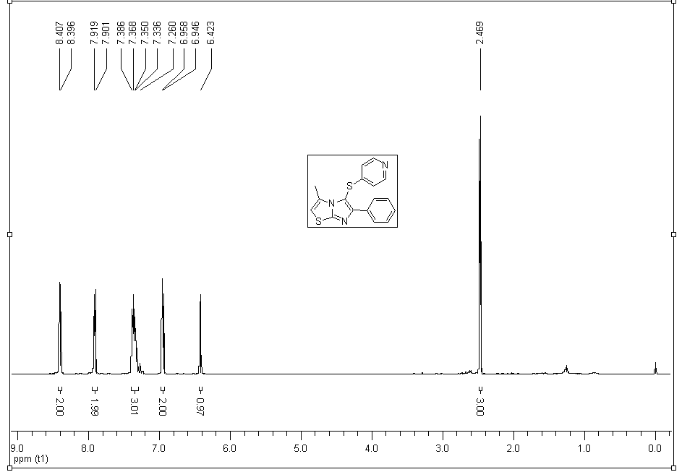
Figure S 17: ¹H NMR of 3i
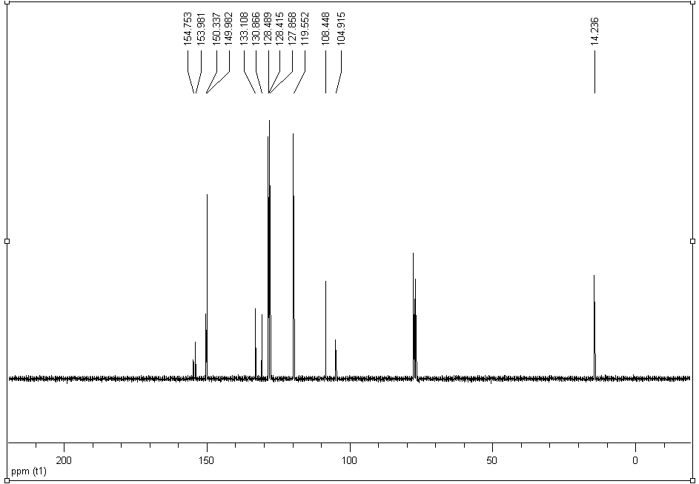
Figure S 18: ¹³C NMR of 3i

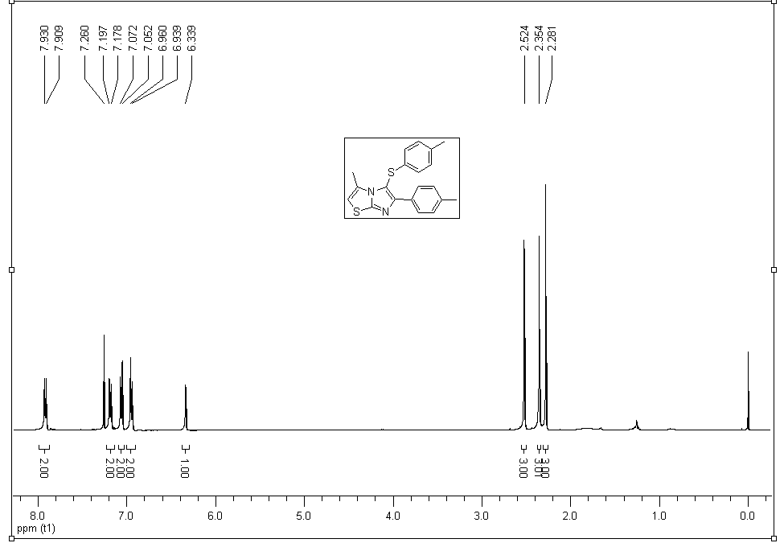
Figure S 19: ¹H NMR of 3j
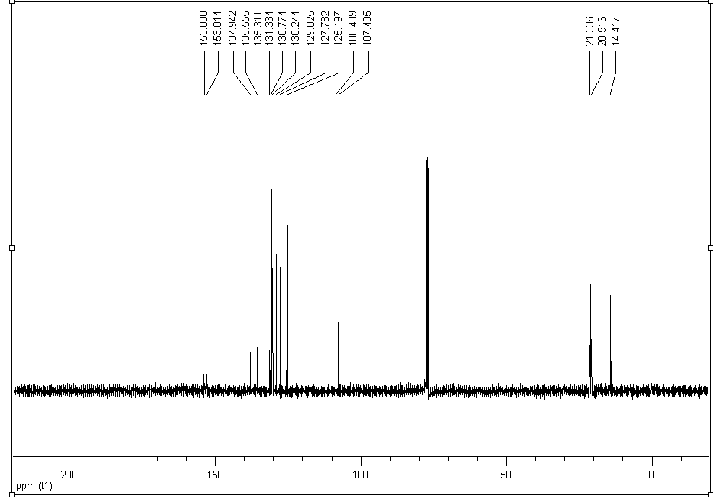
Figure S 20: ¹³C NMR of 3j

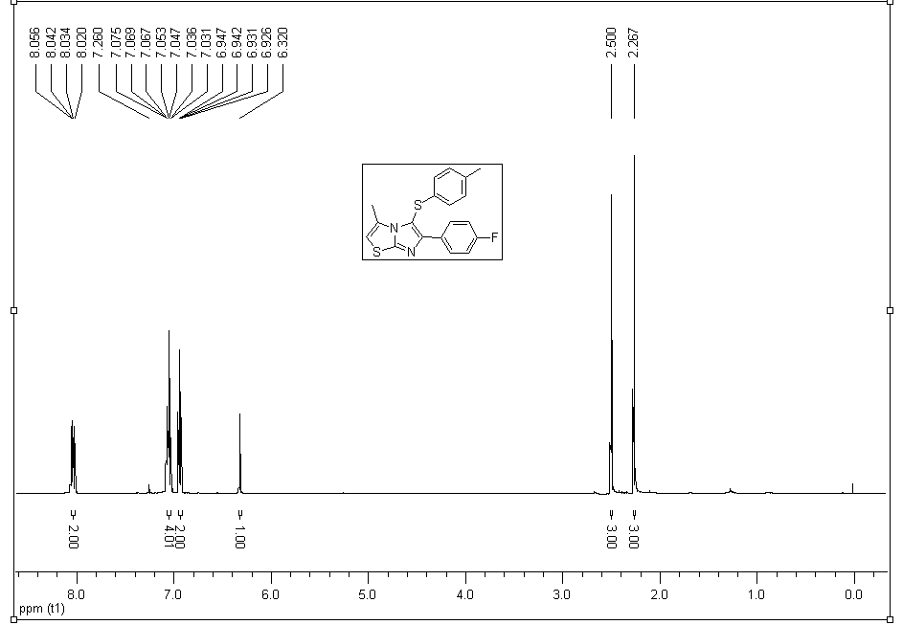
Figure S 21: ¹H NMR of 3k
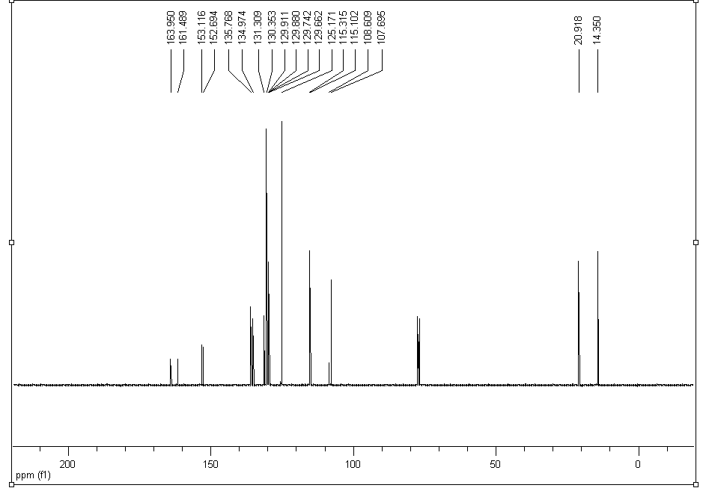
Figure S 22: ¹³C NMR of 3k

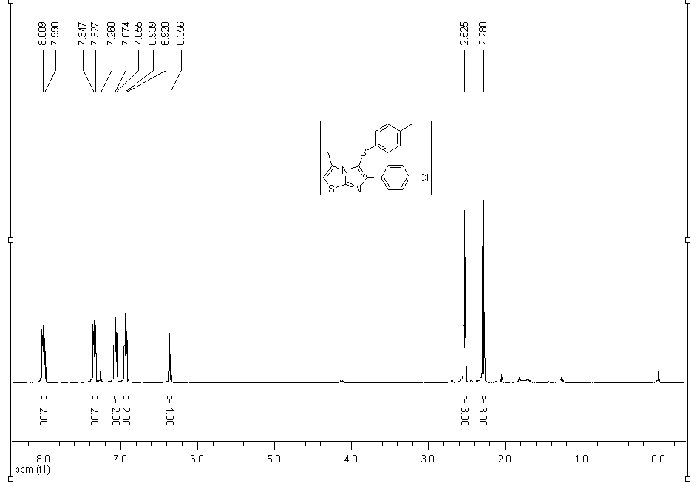
Figure S 23: ¹H NMR of 3l
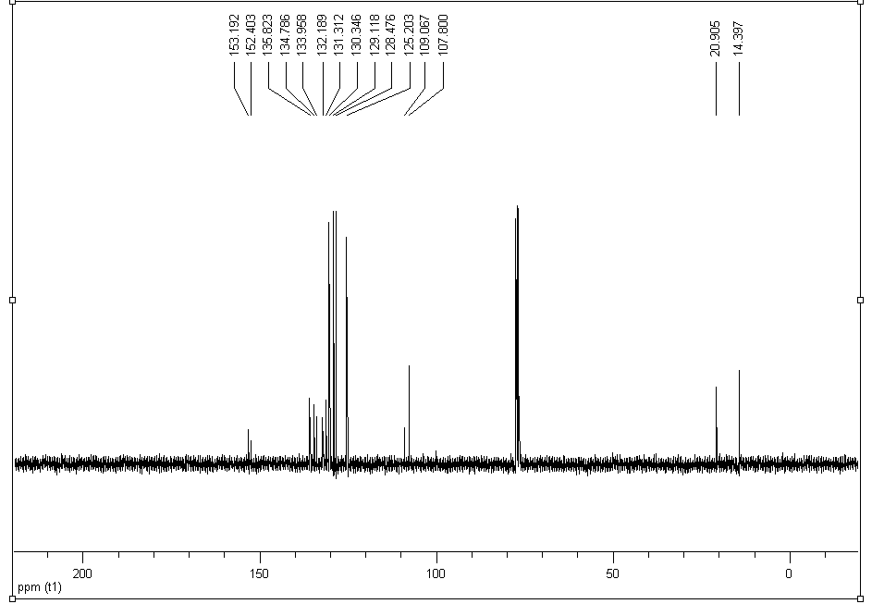
Figure S 24: ¹³C NMR of 3l

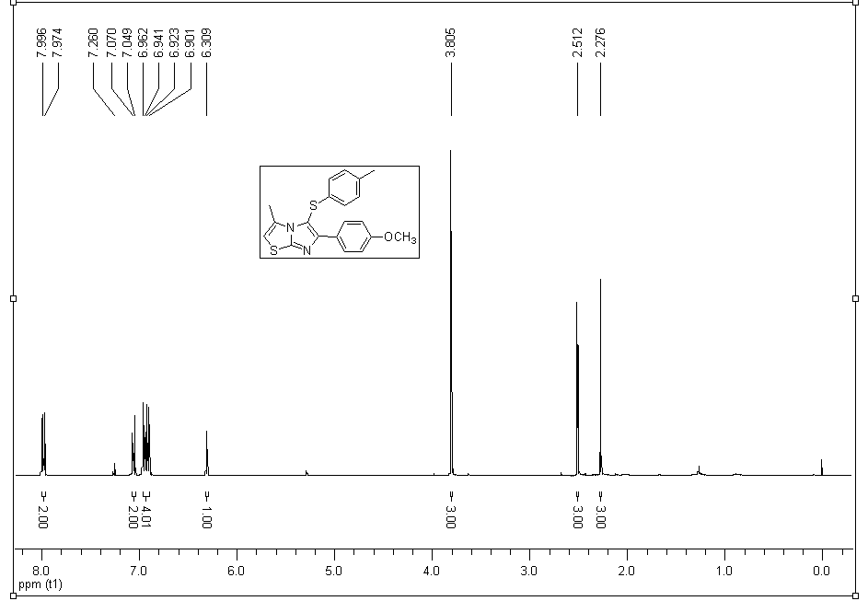
Figure S 25: ¹H NMR of 3m
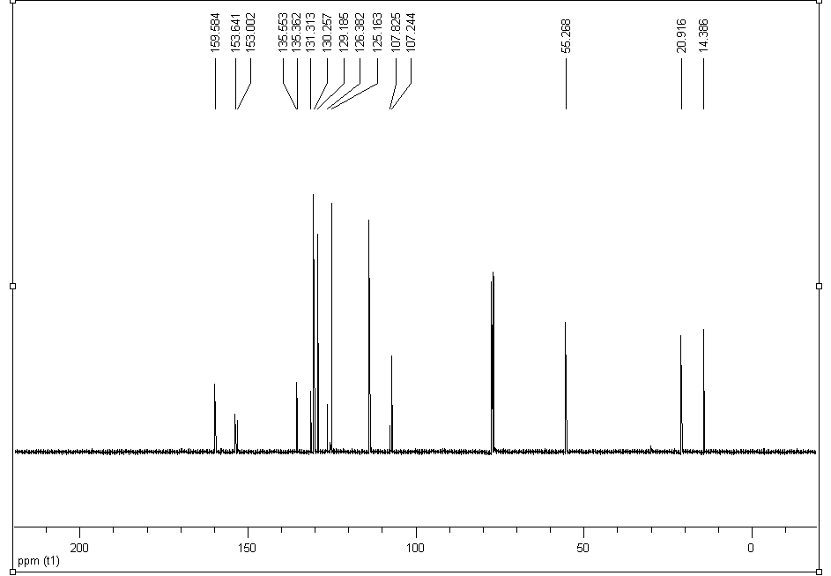
Figure S 26: ¹³C NMR of 3m

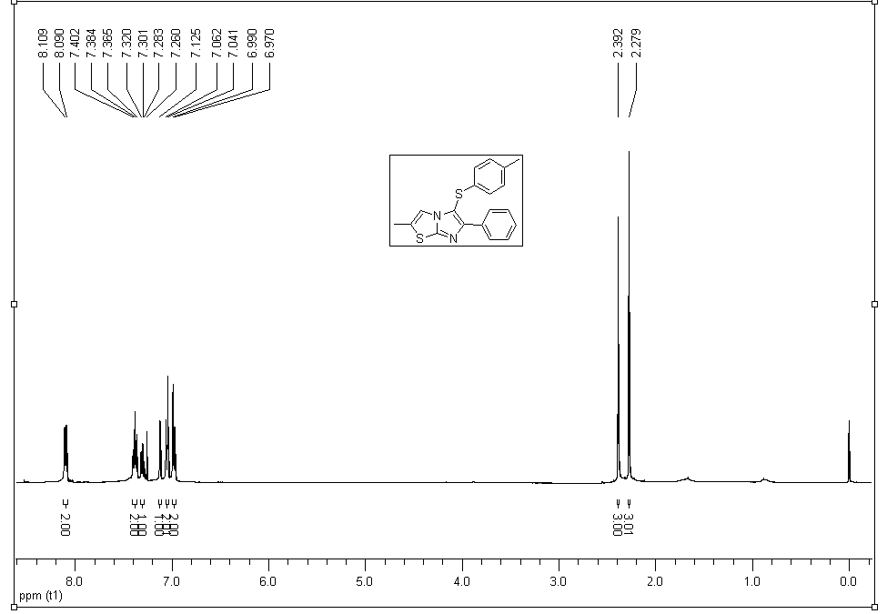
Figure S 27: ¹H NMR of 3n
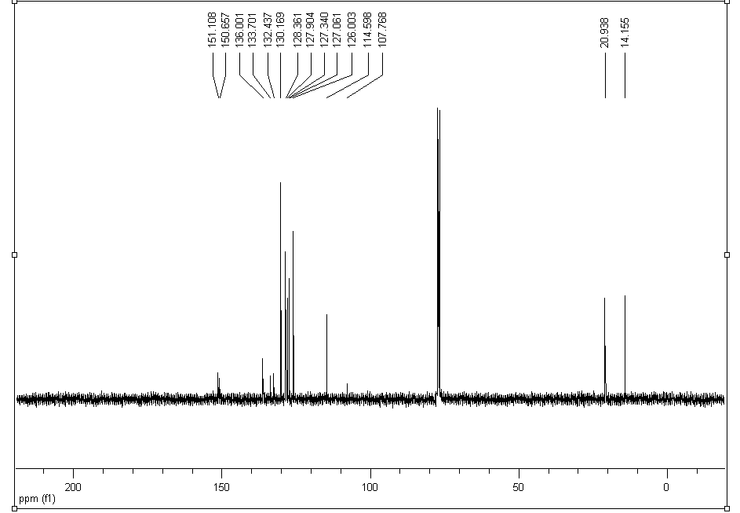
Figure S 28: ¹³C NMR of 3n

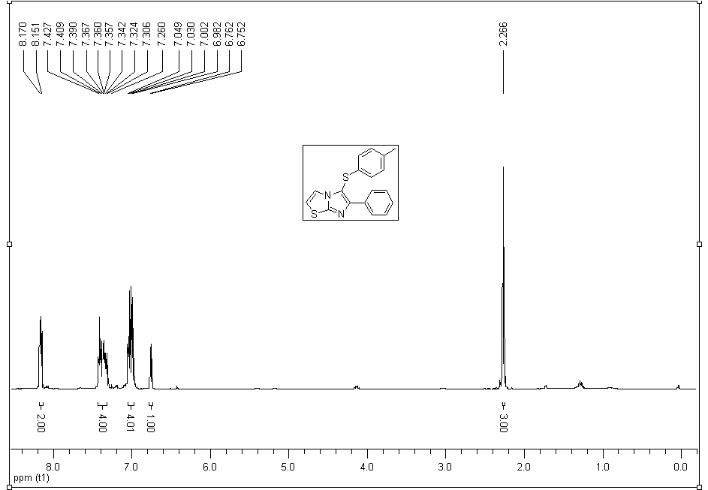
Figure S 29: ¹H NMR of 3o
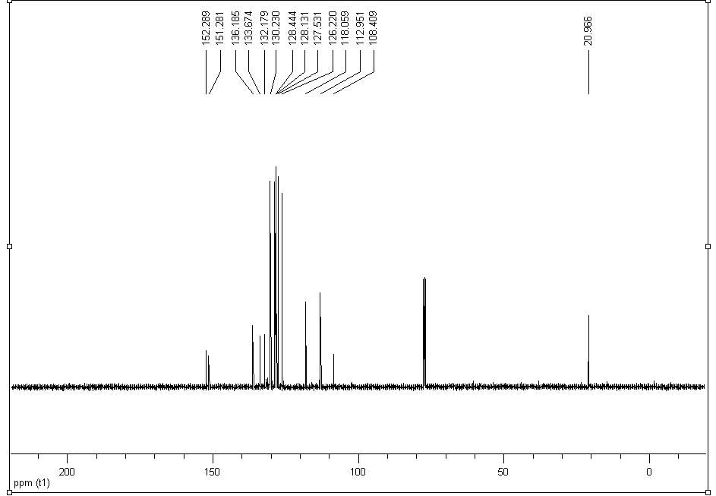
Figure S 30: ¹³C NMR of 3o

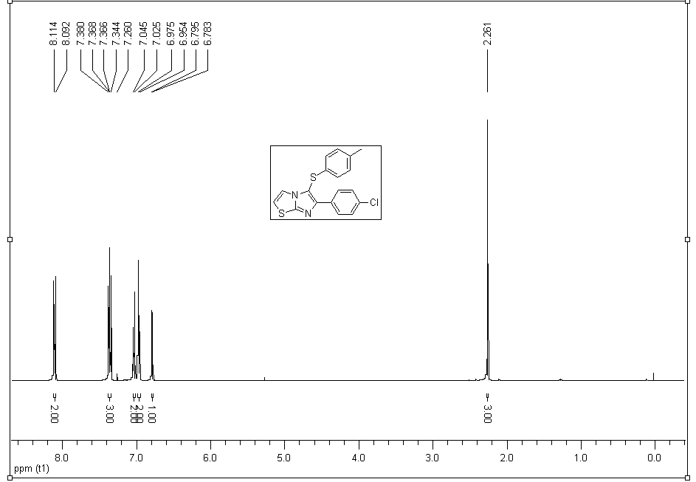
Figure S 31: ¹H NMR of 3p
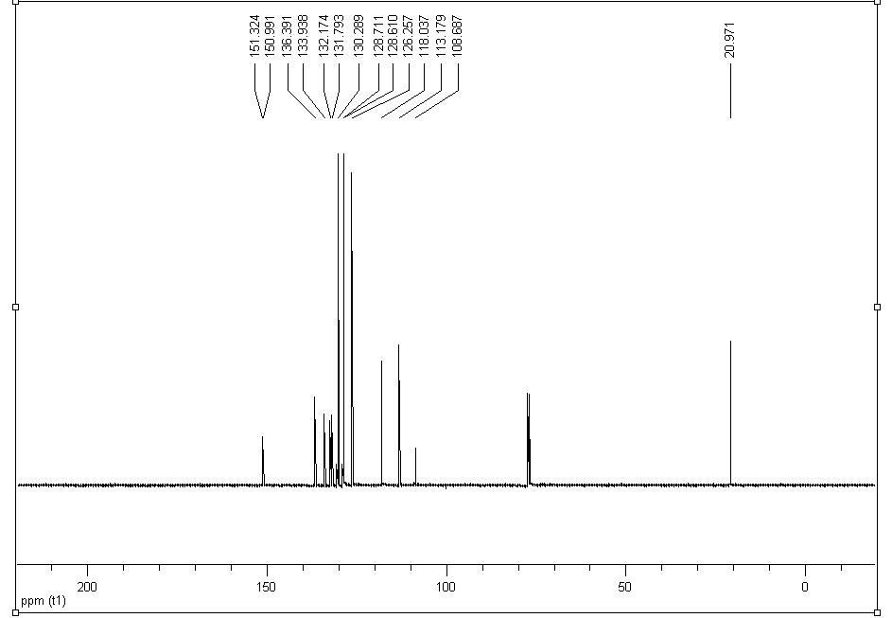
Figure S 32: ¹³C NMR of 3p

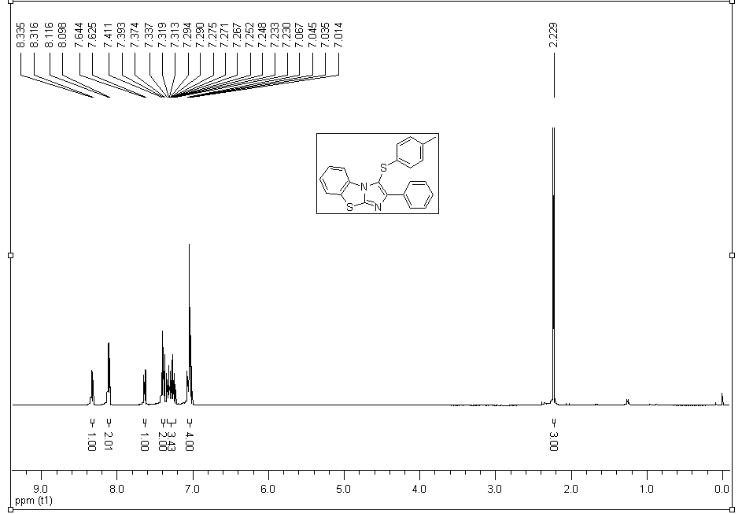
Figure S 33: ¹H NMR of 3q
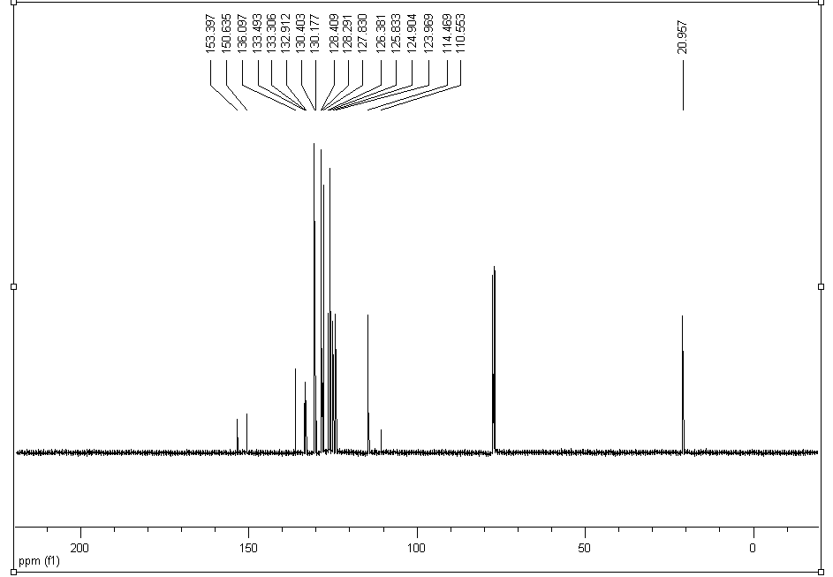
Figure S 34: ¹³C NMR of 3q

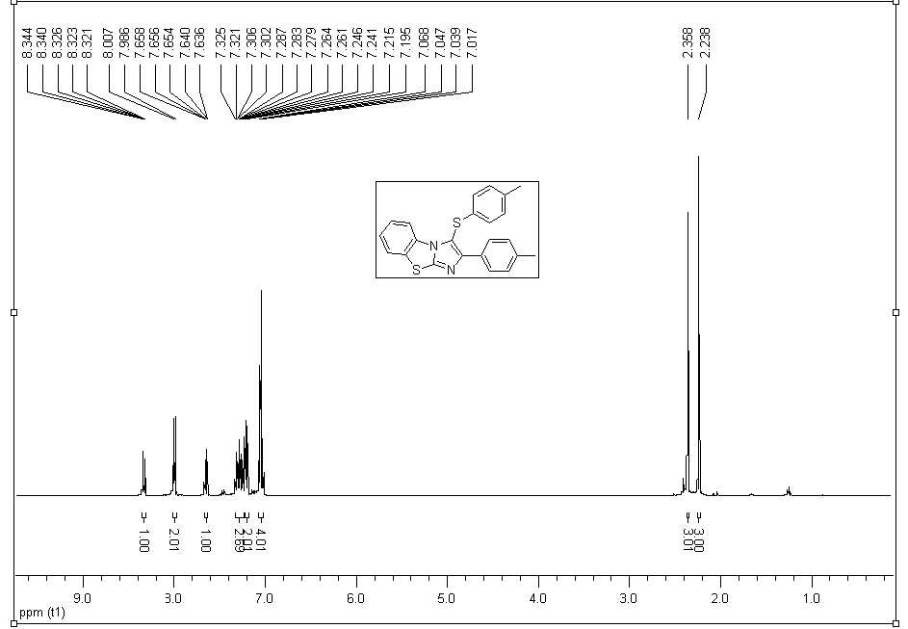
Figure S 35: ¹H NMR of 3r
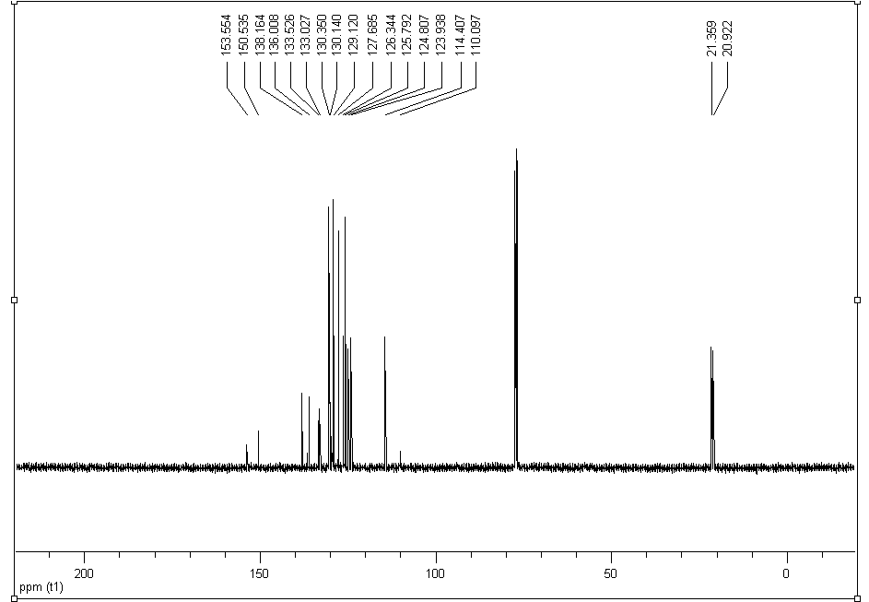
Figure S 36: ¹³C NMR of 3r

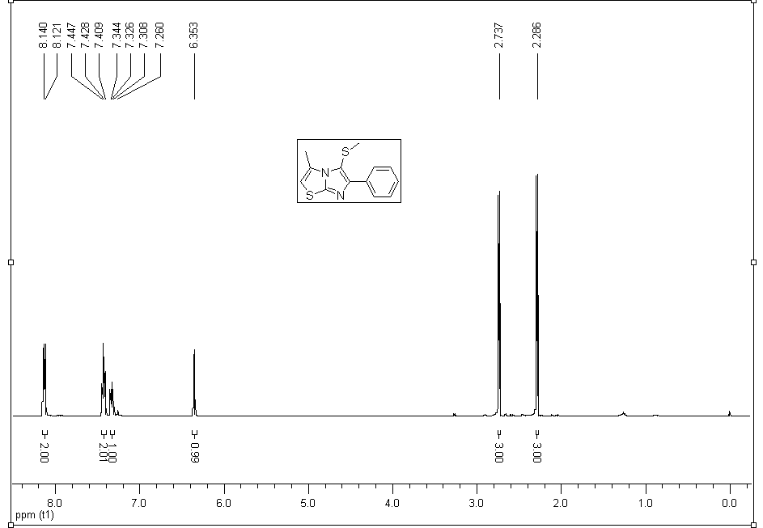
Figure S 37: ¹H NMR of 5a
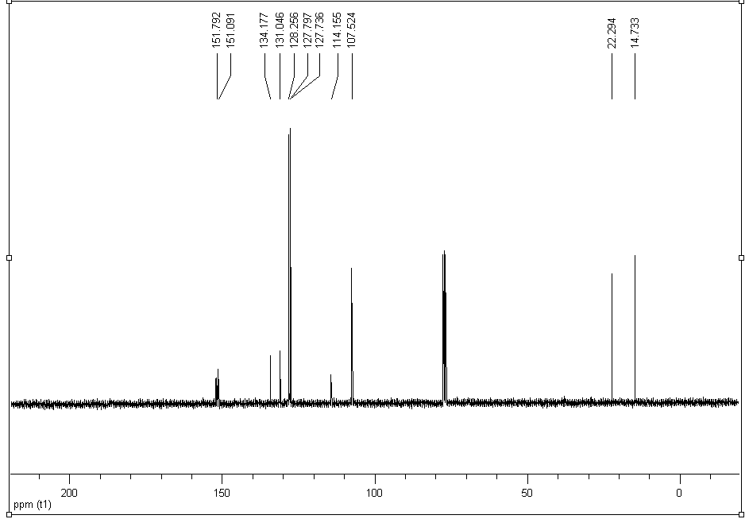
Figure S 38: ¹³C NMR of 5a

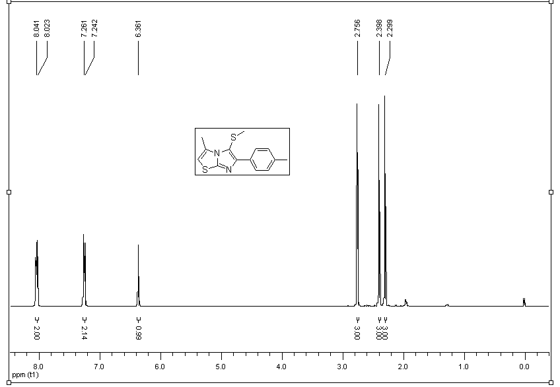
Figure S 39: ¹H NMR of 5b
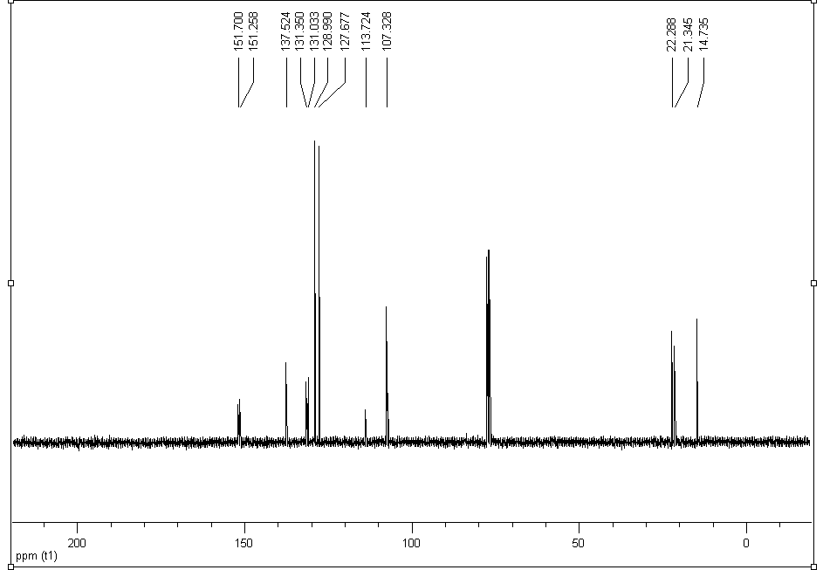
Figure S 40: ¹³C NMR of 5b

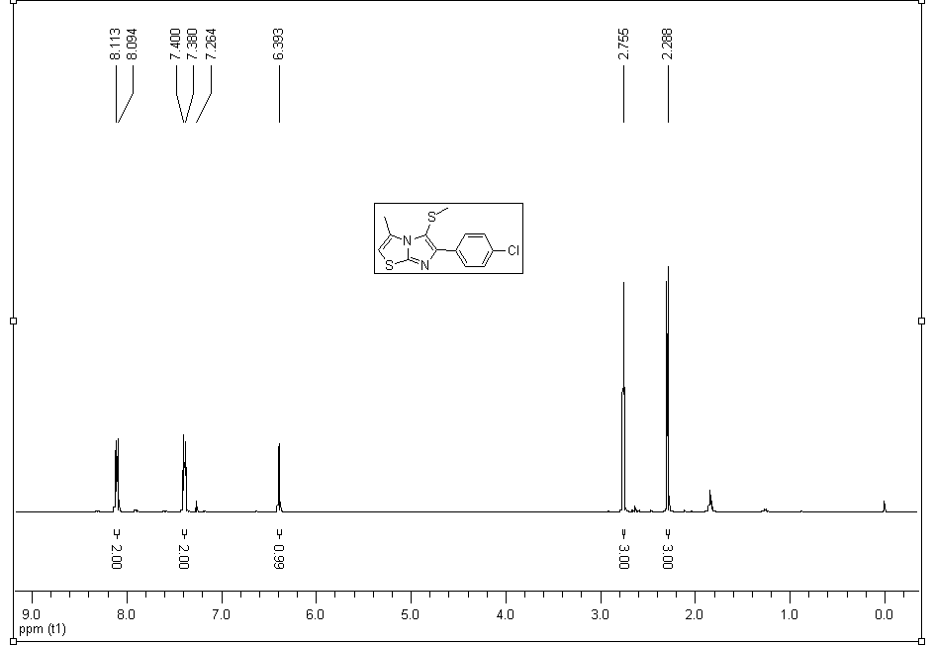
Figure S 41: ¹H NMR of 5c
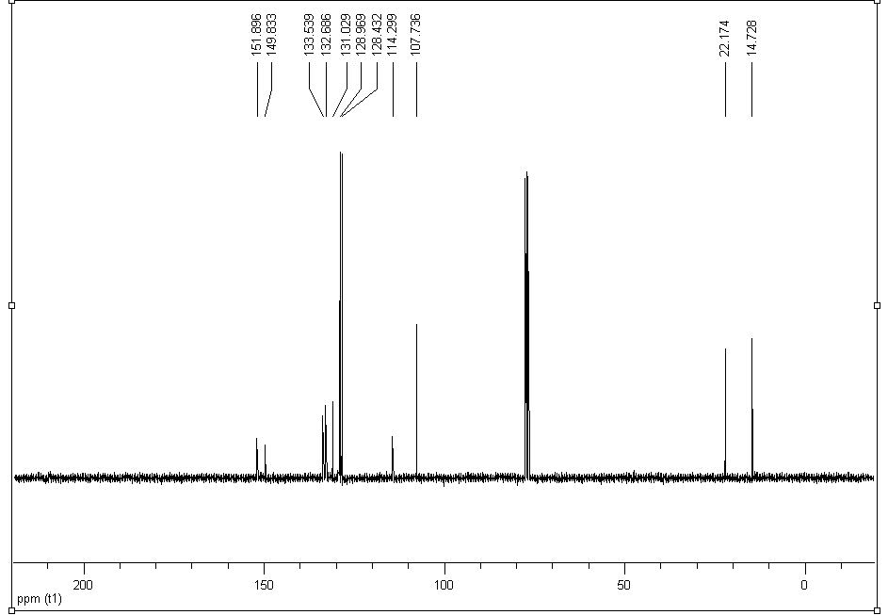
Figure S 42: ¹³C NMR of 5c

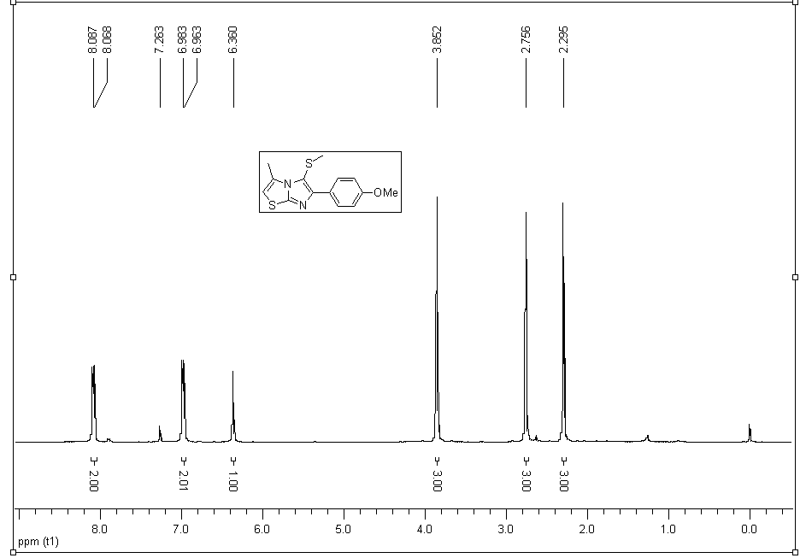
Figure S 43: ¹H NMR of 5d
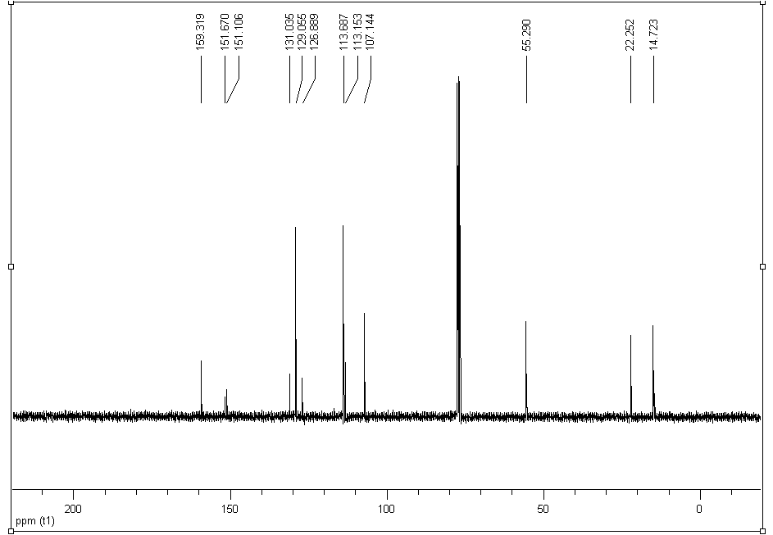
Figure S 44: ¹³C NMR of 5d

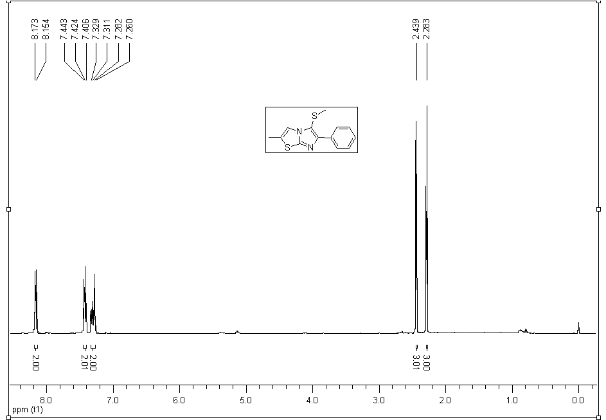
Figure S 45: ¹H NMR of 5e
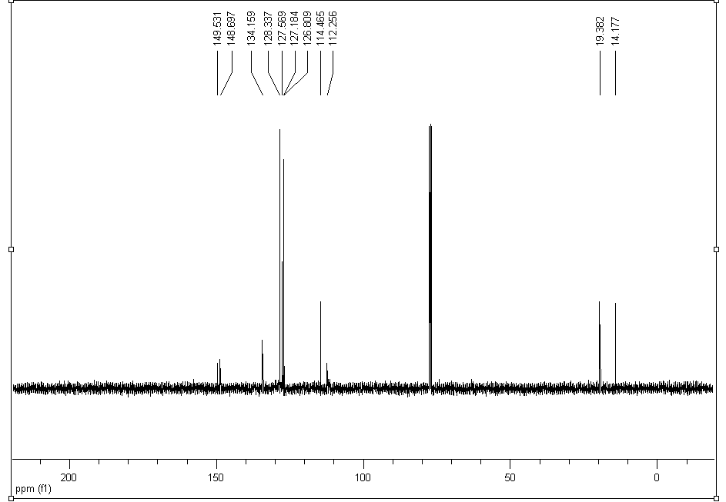
Figure S 46: ¹³C NMR of 5e

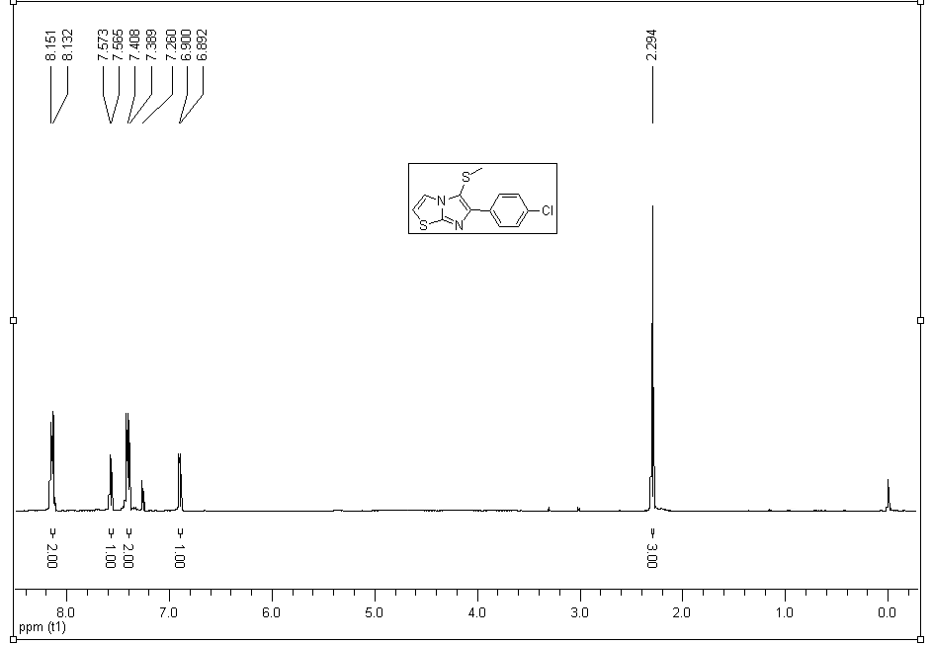
Figure S 47: ¹H NMR of 5f
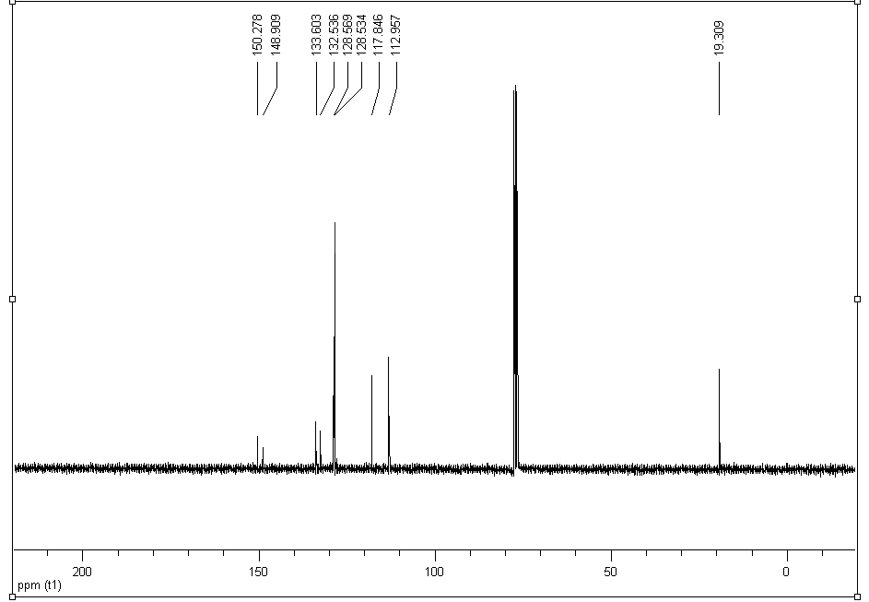
Figure S 48: ¹³C NMR of 5f

