Co-assembled ZnO-Fe₂O_{3x}-CuO_{x} nano-oxide materials for antibacterial protection
S. J. Owonubi¹, Collins N. Ateba² and Neerish Revaprasadu¹
¹ Department of Chemistry, University of Zululand, KwaDlangezwa, KwaZulu-Natal, South Africa
²Department of Microbiology, Faculty of Natural and Agricultural Sciences, North-West University, Mafikeng Campus, Private Bag X2046, Mmabatho, 2735, South Africa
Email: oshesan@gmail.com
Supplemental Materials

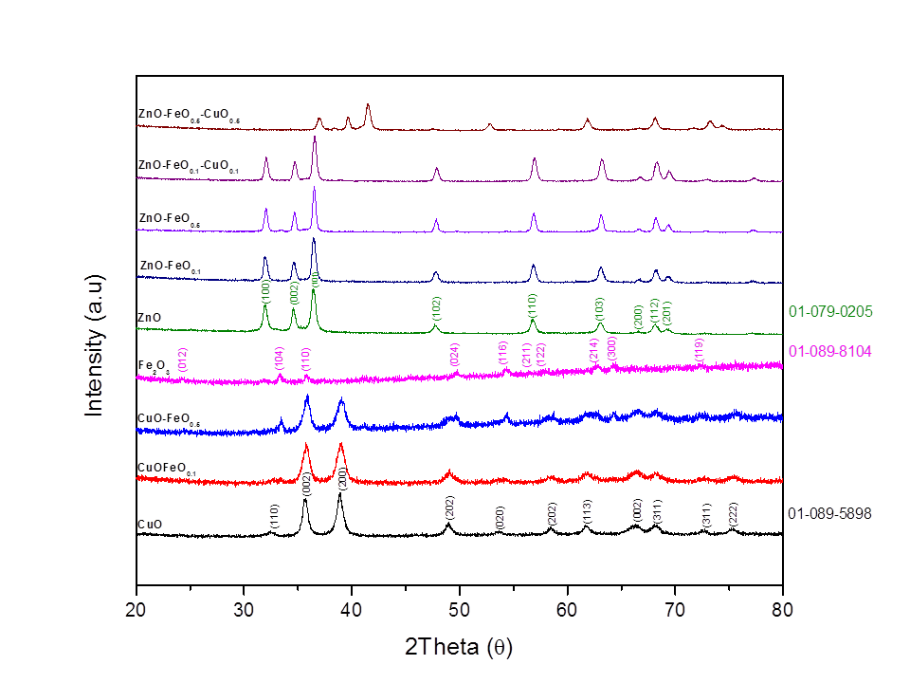
Figure S 1: XRD spectra for MONPs
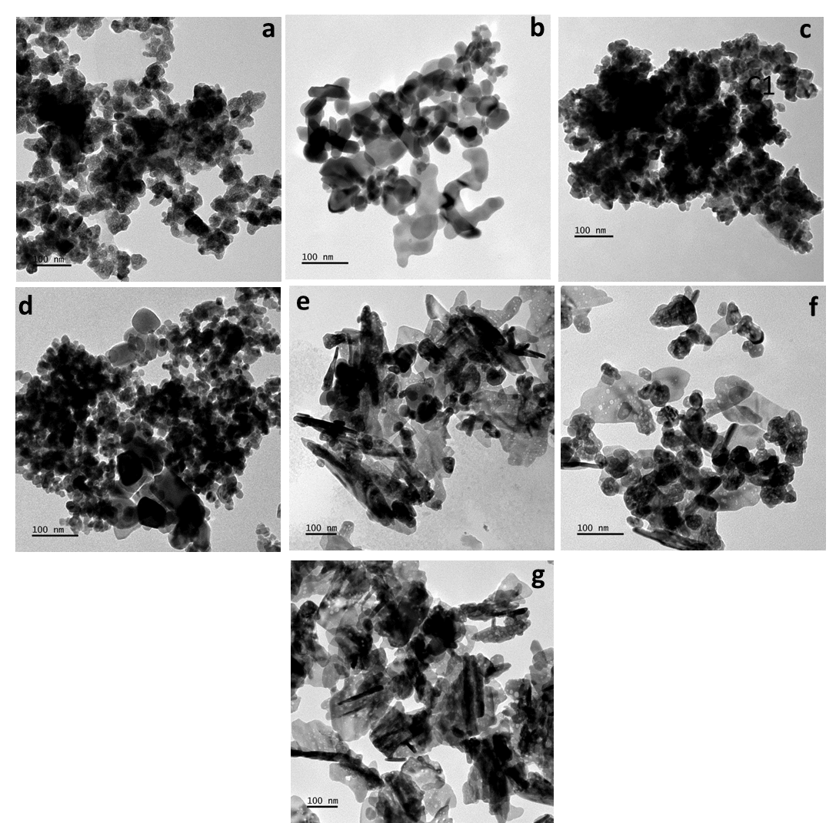Figure S 2: TEM Micrographs of (a) ZnO (b) FeO (c) CuO (d) CuOFeO_{0.5}
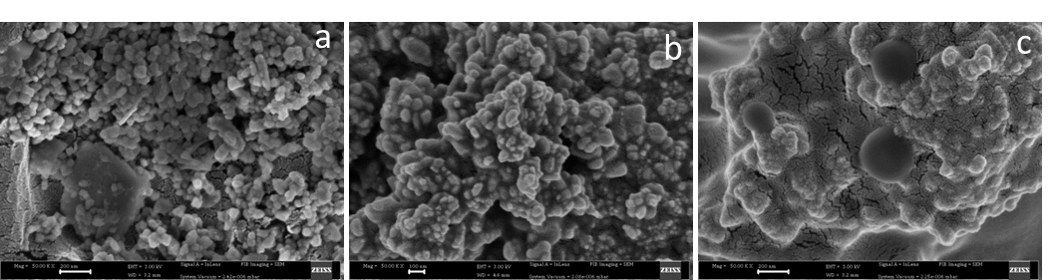
Figure S 3: SEM micrographs of (a) ZnO (b) FeO (c) CuO

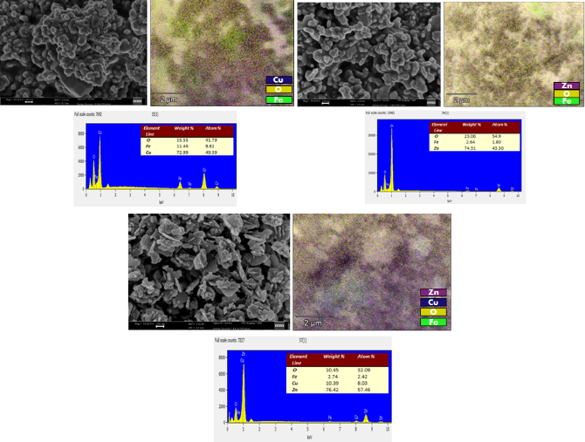
Figure S 4: SEM micrographs, EDX pattern and mappings of (a) ZnOFeO_{0.5} CuO_{0.5} (b) ZnOFeO_{0.5} (c) CuOFeO_{0.5}

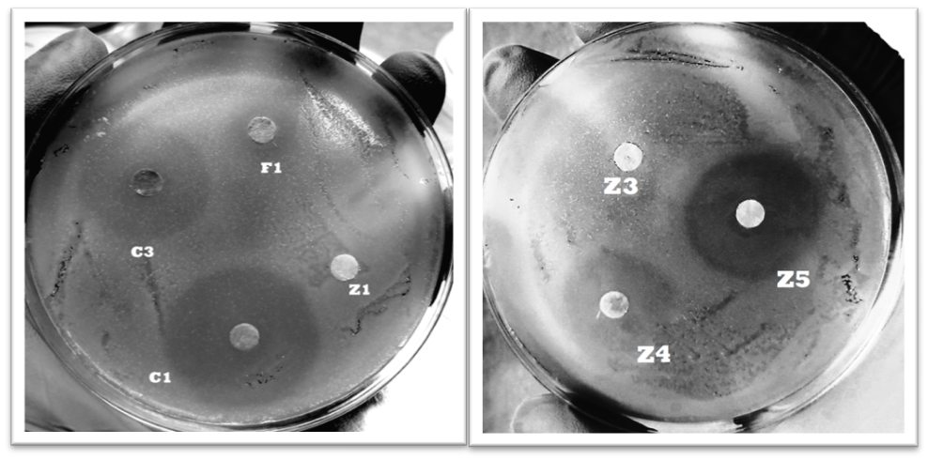
Figure S 5: Antibacterial activity of synthesized MONPs treatments (1mg/mL) on S.pneumoniae

Table S 1: Antibacterial activity of synthesized MONPs treatments (1 mg/mL) on S.pneumoniae
Zone of Inhibition Diameter (mm) ± SD
 | ZnO | Fe₂O₃ | CuO | CuOFeO_{0.5} | ZnOFeO_{0.5} | ZnOFeO_{0.1}CuO_{0.1} | ZnOFeO_{0.5}CuO_{0.5}
B.cereus | - | - | 16 ± 0.3 | 26 ± 0.2 | - | 20 ± 1.4 | 24 ± 0.8
S.pneumoniae | - | 8 ± 0.67 | 31 ± 0.5 | 25 ± 0.8 | - | 20 ± 0.5 | 28 ± 1.1
S.aureus | - | - | 27 ± 0.7 | 28 ± 0.6 | - | - | 29 ± 0.5

