THERMAL AND ELECTROCHEMICAL BEHAVIOR OF ACIDIC PYROPHOSPHATE (NH₄)₂Zn(H₂P₂O₇)₂.2H₂O
F. Z. Elhafiane^{a*}, R. Khaoulaf^{b}, M. Harcharras^{c}, M. Ouakki^{d} and K. Brouziª
ªEnergy, Materials and Sustainable Development , EMDD-CERNE2D, Mohammed V University in Rabat, Salé Morocco
^{b}Laboratory of Spectroscopy, Molecular Modeling, Materials, Nanomaterials, Water and Environment, LS3MN2E-CERNE2D, Faculty of Sciences Av Ibn Battouta, Mohammed V University in Rabat, Morocco
^{c}Material and Environmental Engineering Laboratory, Modeling and Application, Department of Chemistry, Faculty of Science, Ibn Tofail University, Kenitra, Morocco
^{d}Laboratory of Materials, Electrochemistry and Environment, Faculty of Science, Ibn Tofail University, PB 133-14050 Kénitra, Morocco
Email: fz.elhafiane@gmail.com
Supplemental Materials
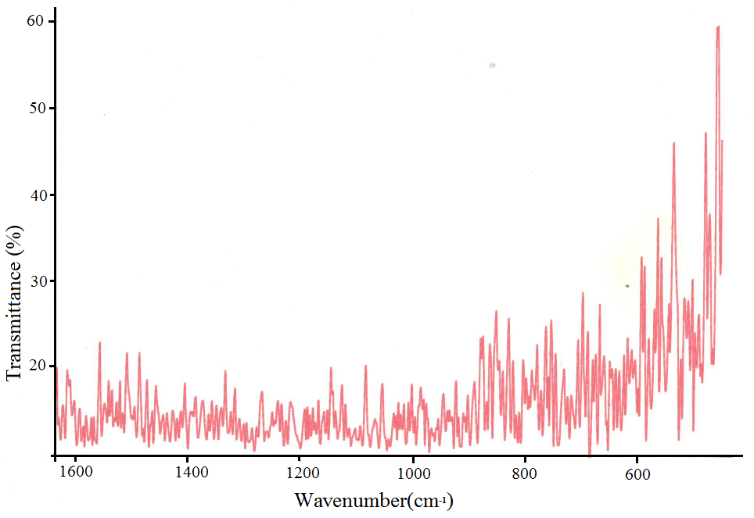
Figure S 1: Infrared Spectrum of (NH₄)₂Zn(H₂P₂O₇)₂.2H₂O at 460°C, amorphous phase.

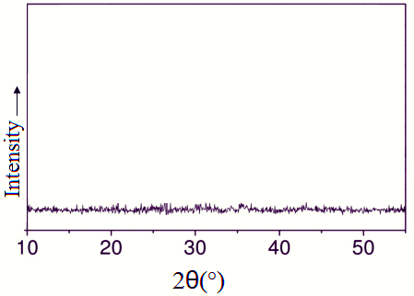
Figure S 2: X-ray powder diffractogram of the (NH₄)₂Zn(H₂P₂O₇)₂.2H₂O at 460°C, amorphous.

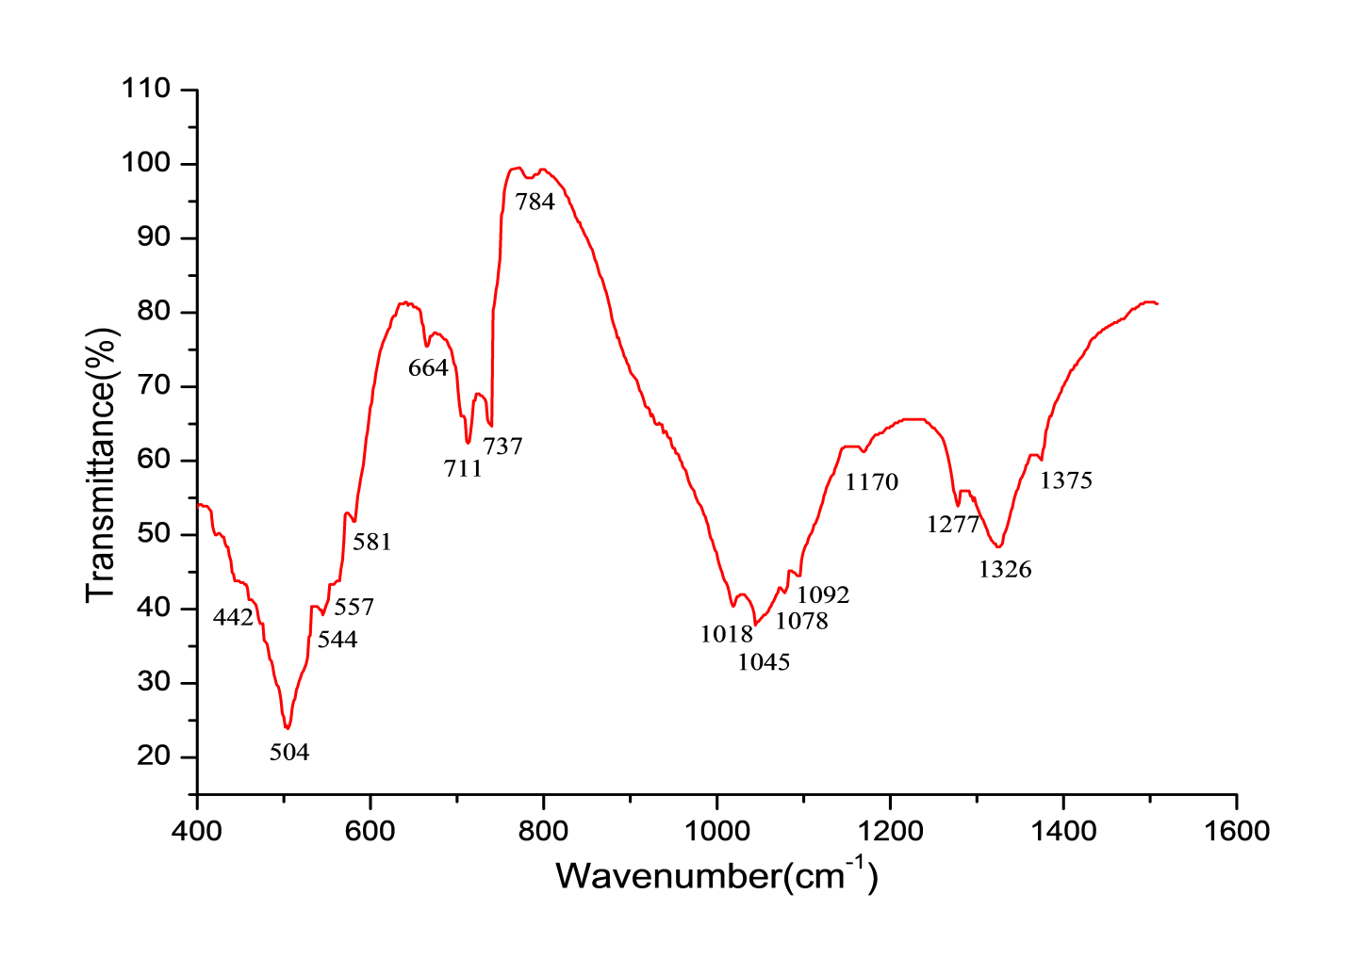
Figure S 3: Infrared spectrum of Zn₂P₄O₁₂ after heating the (NH₄)₂Zn(H₂P₂O₇)₂.2H₂O at 910°

Figure S 4: Nyquist diagram for mild steel with selected concentrations of (NH₄)₂Zn(H₂P₂O₇)₂.2H₂O

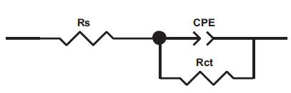

Figure S 5: Equivalent circuit model used to fit the impedance spectra

Figure S 6: Langmuir adsorption isotherm in 1.0M HCl solution containing different concentrations of (NH₄)₂Zn(H₂P₂O₇)₂.2H₂O

Figure S 7: Arrhenius plots for mild steel corrosion in 1.0 M HCl in the absence and in presence of (NH₄)₂Zn(H₂P₂O₇)₂.2H₂O

Table S 1: Potentiodynamic polarization parameters for mild steel in 1.0 M HCl with and without different concentrations of (NH₄)₂Zn (H₂P₂O₇)₂.2H₂O at 298K.

Medium | Conc.  M | -E_{corr} mV/SCE | i_{corr}  µA cm⁻² | -β_{c}  mV dec⁻¹ | β_{a}  mV dec⁻¹ | η_{PP}  %
HCl 1.0M | -- | 470 | 714 | 145 | 121 | -
Inh | 10⁻³ | 595 | 50 | 97 | 90 | 93.0
 | 10⁻⁴ | 596 | 80 | 91 | 86 | 88.7
 | 10⁻⁵ | 598 | 102 | 102 | 85 | 85.7
 | 10⁻⁶ | 575 | 109 | 98 | 83 | 84.7

Table S 2: AC impedance parameters for mild steel in 1.0 M HCl solution with respect to the concentration of (NH₄)₂Zn (H₂P₂O₇)₂.2H₂O
 | Conc.  (M) | R_{s}  (Ω cm²) | R_{ct}  (Ω cm²) | C_{dl}  (µF.cm⁻² ) | n_{dl} | Q  (µF.S^{n-1}) | Ɵ | ƞ_{imp}  %
HCl 1.0M | -- | 1.9 | 23.4 | 190 | 0.897 | 470 | - | -
Inh | 10⁻³ | 1.6 | 305.5 | 73.7 | 0.853 | 128 | 0.923 | 92.3
 | 10⁻⁴ | 1.4 | 202.8 | 90.8 | 0.854 | 162 | 0.884 | 88.4
 | 10⁻⁵ | 0.9 | 157.9 | 93.9 | 0.827 | 194 | 0.851 | 85.1
 | 10⁻⁶ | 1.3 | 147.1 | 101.2 | 0.865 | 178 | 0.841 | 84.1

Table S 3: Polarization parameters for mild steel in 1 M HCl with 10⁻³ M of (NH₄)₂Zn(H₂P₂O₇)₂.2H₂O at various temperatures
Compounds | Temperature  K | -E_{corr}  mV/SCE | i_{corr}  µA cm⁻² | -β_{c}  mV dec⁻¹ | β_{a}  mV dec⁻¹ | η_{PP}  %
Blank | 298 | 470 | 714 | 145 | 121 | -
 | 308 | 491 | 950 | 154 | 112 | -
 | 318 | 475 | 1340 | 151 | 126 | -
 | 328 | 465 | 2080 | 159 | 108 | -
inh | 298 | 595 | 50 | 97 | 90 | 93.0
 | 308 | 497 | 92 | 115 | 96 | 90.3
 | 318 | 495 | 175 | 107 | 112 | 86.9
 | 328 | 499 | 332 | 100 | 105 | 84.0

Table S 4: Corrosion kinetic parameters of mild steel dissolution in 1M HCl in the absence and in the presence of 10⁻³M of (NH₄)₂Zn (H₂P₂O₇)_{2.}2H₂O
Conc | Ea (kJ/mol) | ΔHa(kJ/mol) | ΔSa(kJ/mol.K)
Blank | 28.7 | 26.1 | -102.8
inh | 51.3 | 48.7 | -49.0

Table S 5: Crystal Structure and Data Refinement Parameters
Compound | This work | Literature [10]
Empirical Formula | (NH₄)₂Zn(H₂P₂O₇)₂.2H₂O
Formula Weight | 489.4 | 489.4
Crystal System / Space Group | Triclinic, Pī | Triclinic, Pī
a / Å | 7.0144 (3) | 7.0026(2)
b / Å | 7.2891 (3) | 7.3297(2)
c / Å | 7.7721 (4) | 7.7885(3
α / ° | 80.436 (4) | 81.229(1)
β / ° | 70.594 (4) | 71.064(1)
γ / ° | 88.654 (4) | 88.172(1)
V / Å³ | 369.38 (3) | 373.64(2)
Z | 1 | 1
D _{calc} (g/cm³) | 2.2001 | 2.175
μ (mm⁻¹) | 2.19 | 2.160
Crystal size (mm) | 0.64 × 0.54 × 0.38 | 0.19×0.31×0.40
Color / Shape | Colourless /Prism | Colourless/Prism
Temp (K) | 120 | 293
Theta range for collection | 3.41° to 29.49° | 2.81° to 30.00°
Reflections collected | 5646 | 5328
Independent reflections | 1839 | 2055
Data/restraints/parameters | 1839/8/130 | 2055/6/135
Goodness of fit on F² | 1.48 | 1.240
Final R indices [I > 2σ(I)] | R₁=0.0228, wR₂=0.0784 | R₁ =0.0447, wR₂ =0.1336
R indices (all data) | R₁= 0.0245, wR₂= 0.0794 | R₁ = 0.0480, wR₂=0.1360
Largest difference peak/hole | 0.43 and -0.39 e Å⁻³ | 1.295 and -1.168 e Å⁻³

