Supplemental Material

SUPPLEMENTAL MATERIALS AND IMPLEMENTATION

Climate-related video resources provided to instructors
The following resources were provided to instructors for use in introducing polar research and climate change topics to students.

General climate change videos, optional for all modules:
- Climate Change: Lines of Evidence, from the National Academies of Science, Engineering and Medicine. http://nas-sites.org/americasclimatechoices/videos-multimedia/climate-change-lines-of-evidence-videos/. Options include a 26 minute video or any of 7 videos of about 4 minutes each. To allow for varying levels of available class time, video content was ranked as follows, from most to least relevant. Chapter 1: From the 18 second mark to the 1 minute mark; Chapter 3; and Chapter 5 (8 minutes total). Chapters 1-5 (about 20 minutes).
- A one-minute video about climate change from The Royal Society:
http://nas-sites.org/americasclimatechoices/.
- Causes and Effects of Climate Change (National Geographic; 3 minutes):
https://youtu.be/G4H1N_yXBiA.
- Effect of climate change on hurricanes, by Vox. https://youtu.be/_0TCrGtTEQM.

Local sea level rise and polar ice melt, Rovibrational Spectra of the polar atmospheres, and Processing of Images of Arctic Ice
- Antarctica Is Melting at a Dangerous Pace—Here's Why, National Geographic, https://video.nationalgeographic.com/video/magazine/0000015c-d022-d1cb-a7fd-d4ffc11f0000.
- How is world sea level rise driven by melting Arctic ice, Scientific American, https://www.scientificamerican.com/article/how-is-worldwide-sea-level-rise-driven-by-melting-arctic-ice/.
- Modeling the Future of the Greenland Ice Sheet, NASA Goddard, https://www.youtube.com/watch?v=LtpD-bAFQoc
- Greenland's ice sheet just lost 11 billion tons of ice -- in one day, CNN: https://www.cnn.com/2019/08/02/world/greenland-ice-sheet-11-billion-intl/index.html.
Sea ice loss
- 2018 Arctic Sea Ice Ties for Sixth Lowest Minimum Extent on NASA Record. NASA Goddard: https://www.youtube.com/watch?v=pyIdwDbtcGs.

Heat diffusion through Permafrost
- Animation: Permafrost – what is it? Alfred Wegener Institute. https://www.awi.de/en/focus/permafrost.html. Scroll down to see the video.

Ice Cores and Climate Change
- Ice Core Secrets Could Reveal Answers to Global Warming from Science Nation: https://www.youtube.com/watch?v=NENZ6TSc1fo.
- Ice Core Record of Climate, from NOVA: https://kcts9.pbslearningmedia.org/resource/nvei.sci.earth.climate/ice-core-record-of-climate/#.WvssFK3MxPM .

Supplemental CGI Modules
In 2017/2018, a computer science module, described below, was included among the modules taught.

Computer Science: Processing images of polar ice (Ice Images)
Students apply image processing algorithms to an image of Arctic ice taken from satellite. First, students watch a series of climate change videos as a transition into this topic. Following this, students learn about the ice-albedo effect, how climate change is causing Arctic sea ice decline, and effects on humans and other life. They then view images of Arctic sea ice taken by a satellite instrument and select one to download. Through a website, they examine annual and long-term trends in Arctic and Antarctic sea ice. Students then download the selected ice image and plot it. Using this image, they learn about image storage and representation in Python, including loading, re-sizing, cropping, and applying colormaps to an image of Arctic ice. They extract the red, green, and blue components from a color image and learn how to convert it to a black and white image. Finally, they apply different types of median filtering for removing noise from an image of sea ice extent and learn how to use Edge Detection to detect the sea ice edge. The image processing CGI module is described in detail by Rowe, Cheng, Fortmann, Wright, & Neshyba (2018).

SUPPLEMENTAL EVALUATION

Student surveys
In the academic year prior to 2018/2019, pre- and post-intervention surveys were administered for similar modules taught in many of the same classes. However, for three of four questions there were no statistically significant changes in the medians for most modules (see Table S1). The lack of effect on the medians is consistent with response-shift bias, in which the respondent’s internal frame of reference changes as a result of the educational program (Howard et al., 1979; Klatt and Taylor-Powell, 2005; Drennan and Hyde 2008). As further evidence of response-shift bias, for questions regarding comfort with the computational tool and the importance of polar research for climate change, 13% and 11% of students reported a decrease after taking the module. Even for the question about previous exposure to polar research, for which a significant increase in the overall median was found (from 2 to 3; p<0.01) 5% of students reported less exposure after the module (e.g. from “little” to “none”). Moreover, physical chemistry students who had never completed a CGI module before overall ranked their comfort with Python higher before the module than computer science students did (3 vs 2). A reasonable interpretation is that the computer science students were better able to rank their knowledge of a computer programming language than other students.
In addition to response-shift bias, there were a number of challenges associated with administering pre/post surveys in the first year of the project. There was large attrition in the number of students who took the post survey, likely to due to survey response fatigue (Porter et al 2004), especially given that the module took typically only one to three class or lab periods. Because the surveys were anonymous, it was difficult to align pre and post surveys (this was based on student’s reported initials, mother’s initials, and birth months, which sometimes showed variability between pre and post).
In the student surveys from year 1, only 3 students ranked the degree to which human activities are contributing to climate change lower on the post survey. The open answer responses of all three of these students indicate a lack of complete English fluency (e.g. “What do dot black line through graph stand for?” “How the water waves changes?” and “…after a few explanations, I started to understand and could done another one in the future with no problem.” Thus is it possible that their change in ranking from “Significantly” to “Moderately” was due to a language barrier rather than a shift in perception. Having pre- and post-survey questions side by side may help students who are not native English speakers and who therefore might not understand nuances between words used in the Likert scale.
Despite these challenges, the prior-year results provide useful context for comparison, given in the Supplemental Evaluation and Results sections below.
Following are the student survey used in 2018/2019 and the script of the faculty interview. The student survey was made available online. Survey response possibilities for institution, instructor, course, and module were selected from drop-down tables and are not shown here. (The student survey from the prior year differs from the survey shown below in that it asks students to self-assess exposure to polar data and research before as well as after taking the module, asks about how much humans have contributed to climate change, and does not include questions 11- 13.)

2018-2019 CGI Polar Student Retrospective Pre-Post Survey
This survey asks for your feedback about the modules in your course that involved studying polar data. Your responses will be used to improve future courses and will also contribute to the evaluation of these modules that will be provided to the National Science Foundation. Your participation is voluntary. Your responses are anonymous and will NOT affect your grades so please be candid. Thank you!

- Are you at least 18 years of age? Y/N
(If no: This survey is for students who are at least 18 years of age. Thank you. [Survey terminates])
- What is the current school year and term?
  - Fall 2018
  - Winter/Spring 2019
- Please select your semester, college, instructor, course, and module below.
- Institution Name
- Instructor Name
- Course Name
- Module Name
- How comfortable were you with the Python Programming Language BEFORE this module, and how comfortable are you NOW? (If you did not use Python, please select "NA".)
 | Very Uncomfortable | Somewhat Uncomfortable | Neutral | Somewhat Comfortable | Very Comfortable | Don’t Know | N/A
BEFORE this Module
NOW (After the Module)

- How comfortable were you with Excel BEFORE this module, and how comfortable are you NOW? (If you did not use Excel, please select "NA".)
 | Very Uncomfortable | Somewhat Uncomfortable | Neutral | Somewhat Comfortable | Very Comfortable | Don’t Know | N/A
BEFORE this Module
NOW (After the Module)

- BEFORE this module, how much exposure did you have to polar research?
None/ A little / Some / A fair amount / A great deal / Don’t know

- Describe what you learned in this module about polar regions, data, or research.
(Open-ended)

- Describe what you learned in this module about climate or climate change.
(Open-ended)

- Describe what you learned in this module relating to your course topic.
(Open-ended)
- BEFORE this module, how important did you think polar research was in the context of climate change? How important do you think it is NOW?
 | Not Important  at All | Slightly Important | Moderately Important | Very Important | Extremely Important | Don’t Know
BEFORE this Module
NOW (After the Module)

- How would you rate your climate knowledge BEFORE this module and NOW?
 | Very Poor | Poor | Fair | Good | Excellent
BEFORE this Module
NOW (After the Module)

- How would you rate your knowledge on the course topic BEFORE this module and NOW?
 | Very Poor | Poor | Fair | Good | Excellent
BEFORE this Module
NOW (After the Module)

- Doing this module was a ________ way to learn about a topic in your course. Choose from the list below to fill in the blank. (Check all that apply)
Fun Exciting Engaging Useful Motivating Helpful Challenging Boring
Not Useful Unhelpful Confusing Too Easy Too Hard Not Relevant Other ___

- Was this the first computational guided inquiry (CGI) you have ever done?
Yes / No / Don’t know

- Overall, how would you rate the polar data module you just completed?
Very poor / Poor / Fair / Good / Excellent / Don’t know
- Why did you give the polar data module this rating?
(Open-ended)
- Do you have any suggestions for improving this polar data module?
(Open-ended)
- Would you like to learn more about polar data?
Yes / Maybe / No
- Are you a science, technology, engineering or math major?
Yes / No
- Are you considering a science, technology, engineering, or math major?
Yes / Maybe / No
- What is your gender identity?
Male / Female / Other / Prefer not to say
- What is your race/ethnicity? (Check all that apply)
- White
- African American/Black
- Hispanic/Latino/a
- Asian
- Filipino/a
- Pacific Islander
- American Indian or Alaska Native
- Multiple Ethnicities
- Other, please describe _____
- Prefer not to say

- Do you have any other comments about the polar data module? (Open-ended)

2018-2019 CGI-Polar Faculty Telephone Interview Script

Hello,

First, let me give you a bit of background about our interview. The purpose of this interview is to learn about your opinions and experiences with the CGI-Polar project. These interviews will contribute to the CGI-Polar evaluation, which will be submitted to the National Science Foundation, and may also contribute to a publication in a peer-reviewed educational journal.

Before we start, I need to tell you about the confidentiality safeguards we have taken. This is a confidential process: No one other than the evaluation team at Washington State University will have access to information about participants, notes, tapes or other work products. This means that no one at your institution or within the CGI-Polar management team will have access to information about our conversation. No information will be identified by individual participant. At the conclusion of the project, all working documents and identified data will be destroyed. You are welcome to skip any question or excuse yourself at any time.

Do you have any questions? Yes___ [Answer questions and repeat]
No___ [Continue]

I would like to record our conversation to make sure I don’t miss anything you want to share. Is that ok? Yes___ [Turn on recorder and continue]
No___ [Do not turn on recorder]

Do you agree to participate in this interview?
Yes____[Go to Question 1]
No____[Terminate Interview]

- Did the modules you implemented substitute for pre-existing course objectives?
- [If yes, modules substitute for pre-existing course objectives] How effective were the modules in helping your students meet the course’s learning objectives?
  - Would you say that your students learned the course content better, the same, or worse with the modules than with the original classroom pedagogy?
- Did providing the context of climate change motivate students to learn?
- To what extent were the modules fun and engaging for the students?
- Did the students gain anything else from the modules?

Now we have some questions about your experience implementing the modules.
- How was your experience implementing the modules in your course?
- What were the principal hurdles to implementing the modules?
- How did you transition from the course topic to the module?
  - What was effective and how could the transition be more effective?
- What have you taken away from your participation in the project?
  - Has your involvement in the project changed how you think about teaching? If so, how?
- If you will be teaching the same class in the future, do you plan to continue to use the modules?
  - If not, why not?
- Is there anything else you’d like to share about your experience in this project?

Supplemental Results
Comparisons to Prior-year results
A comparison of the survey results from 2018/2019 to those of the prior academic year (Table S1 and Figures S1-S6) further supports the idea that the first year surveys suffered from response-shift bias. In both surveys, students were asked about their before-module and after-module comfort with the computational tool and to rank the importance of polar research in the context of climate change. For the modules overall, statistically significant increases in medians were found for both questions in year 2 (p < 0.05) but not in year 1. (This was also true when considering only the 5 of 6 modules that were taught in both years). This lack of effect is consistent with response-shift bias. In particular, in year 1 the median response for computational-tool comfort was 4 both before and after the module (vs. shifting from 3 to 4 in year 2), consistent with overrating prior to the program (Howard et al., 1979). For the importance of polar research to climate change, medians were lower after the module for students in year 1 vs year 2 (4 vs 5). The lack of shift seen in year 1 was not correlated with other responses: students in year 1 gave the module equally favorable overall module rankings (median of 4), were equally likely to say they wanted to learn more polar research (60%) and had similar demographics (except that there was a higher percentage of STEM majors in the first year, 70% vs 58%, but this was not found to be correlated with shift).
The only response in the first-year survey that shifted significantly for the modules overall was exposure to polar research and data, for which the median shifted from 2 to 3 (some to a little; p < 0.01), indicating that students felt their exposure to polar research and data had increased through the module.
Comparison to prior-year results also revious year results suggest that there was year-to-year variability in results for various modules. For Economics: Arctic EV and Sea Level Rise, in the previous year (2017/2018), when there were more respondents (42 vs. 26), the median ranking was 4, in line with the other modules in both years (see Fig. S5a and Table S1), and only 13% of students mentioned that the modules were confusing in the open-ended responses. Similarly, while the percentages of students who indicated they want to learn more about polar research were slightly lower for the Economics modules in year 2, the differences were not statistically significant and in year 1 the percentages for Economics were among the highest for the modules. The instructor was the same and the classes were similar in both years, suggesting that these differences may be due to year-to-year variability. Thus, additional data is needed.
In comparing STEM vs non-STEM majors, there were no statistically significant differences found in prior-year results, suggesting that differences found in 2018/2019 may be due to student variation.
The Computer Science: Ice images module was taught in the prior year (2017/2018) only. There are some interesting differences in the ice module relative to other modules taught in 2017/2018. The computer science module was the only module in year 1 for which there was a significant shift in student-reported comfort with the computational tool. Student-reported comfort increased from 2 to 4 (somewhat uncomfortable to somewhat comfortable). This module was specifically directed at improving Python fluency while students learn about image processing. Thus, this question indicates that students believed they improved their knowledge on the topic. The median module ranking was 4 (good), in line with other modules. However, this module had the lowest percentage of students reporting that they would like to learn more polar research (31% of respondents compared to 50% or more for other courses), indicating that the connection to polar research should be made more explicit.

Table S1. Student survey results for courses taught in 2017/2018. Medians and modes of student survey responses (see text), where n refers to the number of students who answered the survey item, U is the Mann-Whitney U with associated P, N indicates no, M male, F female, Ex excel, and Py python. Other abbreviations and the Likert scale to rank conversion are described in the text.
 | Overall | Econ:  Arctic  EV | Econ:  Sea level rise | Quant:  Polar Spectra | Thermo:  Ice  Melt | Physics:Perma-frost | Comp Sci: Ice  Images
Py/Ex comfort:  Before median  After median  n  U  P | 4  4  151  10167  0.09 | 4  4  46  998  0.6 | 4  4  44  967  0.997 | 4  4  6  16  0.7 | 3.5  4  28  335  0.3 | 3  3  10  40  0.5 | 2  4  17  53  <0.01
Importance polar:  Before median  After median  n  U  P | 4  4  144  9229  0.07 | 4  5  44  802  0.12 | 4  4  38  662  0.5 | 4.5  5.0  6  12  0.3 | 4  4  25  275  0.4 | 4  4  15  120  0.7 | 4  4  16  120  0.7
Human climate chng:  Before median  After median  n  U  P | 3  3  156  12301  0.7 | 3  3  45  990  0.6 | 3  3  44  946  0.7 | 3  3  6  18  1 | 3  3  29  434  0.6 | 3  3  15  131  0.3 | 3  3  -  -  -
Polar before:  Before median  After median  n  U  P | 2  3  153  6830  <0.01 | 2  3  44  580  <0.01 | 2  3  43  561  <0.01 | 3  3  6  18  0.93 | 2  2.5  28  222  <0.01 | 1  3  15  69  0.06 | 1  3  17  35  <0.01
Learn more polar (%) | 60 | 74 | 59 | 100 | 50 | 50 | 31
Module rank median | 4 | 4 | 4 | 5 | 4 | 4 | 4
First CGI (%) | 51 | 35 | 59 | 0 | 29 | 88 | 94
STEM major (%) | 70 | 48 | 42 | 100 | 100 | 100 | 100
Female (%) | 52 | 52 | 68 | 67 | 54 | 38 | 24
Computational Tool | - | Ex | Ex | Py | Py | Py | Py
Total Students | 261 | 63 | 84 | 24 | 45 | 19 | 26

Table S2. Course descriptions for Computational Guided Inquiry (CGI) Modules, including course names, educational setting (CC, PLA, and State indicate community college, private liberal arts, and state schools, respectively, and Econ stands for economics), course level, time taken to complete the modules, number of students in the class and number of students who completed the survey (N and n), as well as the numbers for the prior year (N_{p} and n_{p}). Long names for modules are given in the main text. Dashes indicate that the course or survey did not occur in the given year.
Module | Course | Setting | Level | Time  (h) | N_{p} | n_{p} | N | n
Arctic EV | Sci & Econ of Clim Chngª Environmental Econ  Climate Change Econ | PLA  PLA  PLA | Upper  Lower  Upper | 1.5  2  2 | 42  21  - | 30  16  - | -  24  19 | -  19  12
Sea level  rise | Sci & Econ of Clim Chng  Climate Change Econ Regional & Urban Econ  Urban Economics | PLA  PLA  PLA  State | Upper  Upper  Upper  Upper | 1.5  2  1.5  1.5 | 42  -  15  27 | 24  -  12  8 | 44  19  35  - | 19  17  0  -
Polar  Spectra | Physical Chemistry  Physical Chemistry  Physical Chemistry Quantum Chemistry  Engineering Physics^{b,c} | PLA  PLA  PLA  PLA  CC | Upper  Upper  Upper  Upper  Lower | 5  4  3  3.5  3 | 10  -  -  14  - | 6  -  -  0  - | 11  5  4  10  8 | 9  2  4  7  -
Ice Melt | Physical Chemistry  Physical Chemistry  Physical Chemistry Chemical Thermodynamics  Engineering Physics^{b} | PLA PLA  PLA  PLA  CC | UpperUpper  Upper  Upper Lower | 5  4  5  5  3 | 25  2  -  20  - | 15  1  -  13  - | 20  11  5  10  20 | 15  0  0  5  -
Permafrost | Engineering Physics | CC | Lower | 3 | 19 | 16 | 20 | 21
Ice Images | Computer Sci. Sem.^{d} | PLA | Upper | 9 | 26 | 17 | - | -
Ice Cores | Tools in Env. Sci.^{e} | PLA | Lower | 4.5 | - | - | 10 | 6
Total |  |  |  | - | 263 | 158 | 275 | 136
Total Unique^{f} |  |  |  |  | 196 |  | 198
ªScience and Economics of Climate Change. ^{b}These modules were simplified for the lower-level class. Student surveys for these modules are only counted once, under Permafrost. ^{c}This module was given as extra credit. ^{d}Computer Science Seminar. ^{e}Tools in Environmental Science. ^{f}Estimated total number of (unique) students who completed one or more modules.

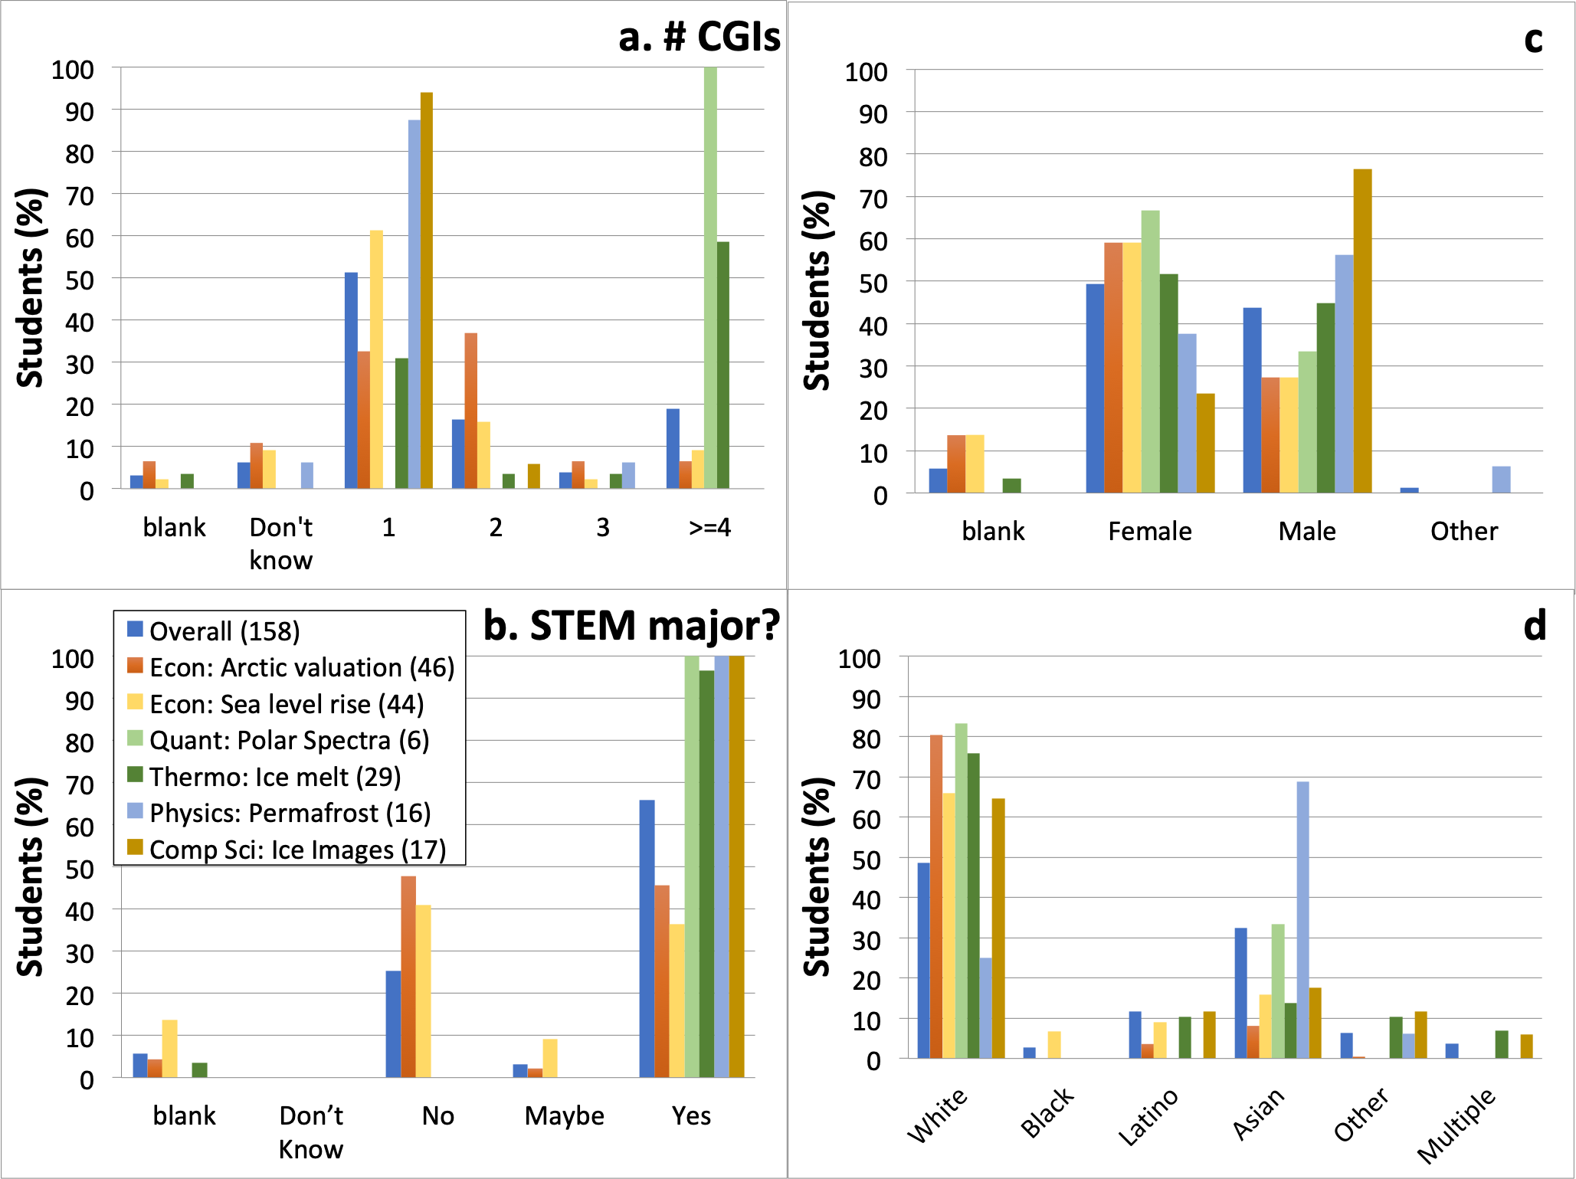
Figure S1. Student demographics for 2017/2018, including student-reported answers to the questions (a) “Is this the first CGI you have done?” and (b) “Are you a STEM major?” Also shown are (c) gender identity and (d) race/ethnic identity; where other is comprised of Filipino, Pacific Islander, American Indian / Alaska Native, Turkish, and Black Middle Eastern.

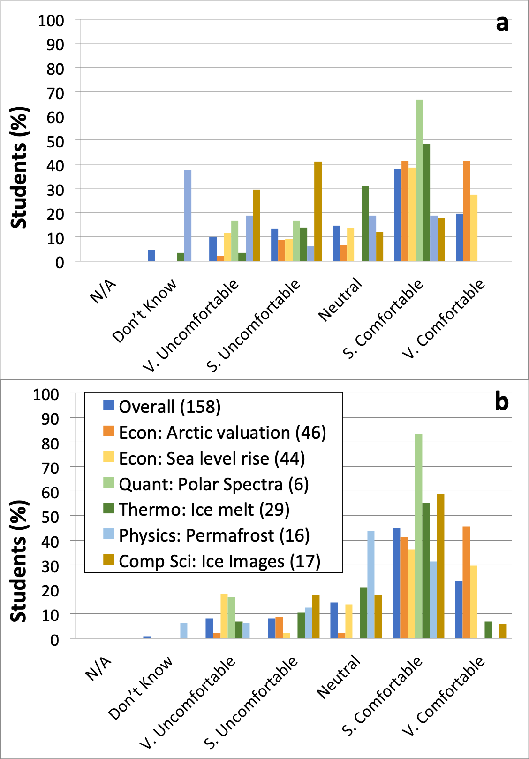
Figure S2. Comfort with computational tool reported in retrospective pre-post survey for courses taught in 2017/2018, (a) before the module and (b) after the module. Economics (Econ) modules use Excel; other modules use Python. The legend in panel (b) refers to both panels and shows the modules and the number of survey respondents.

In the first year of the project, students were asked before and after taking the module how much they believe humans have contributed to climate change. However, students came in with 80 to 100% responding with the highest possible ranking (Significantly) and there was no significant change in this response after taking the module (see Fig. S3). We therefore concluded that this belief is already very high and, while it could be used to motivate the use of the modules, is not a belief we can reasonably expect to increase. Thus this question was removed from the survey in the second year.

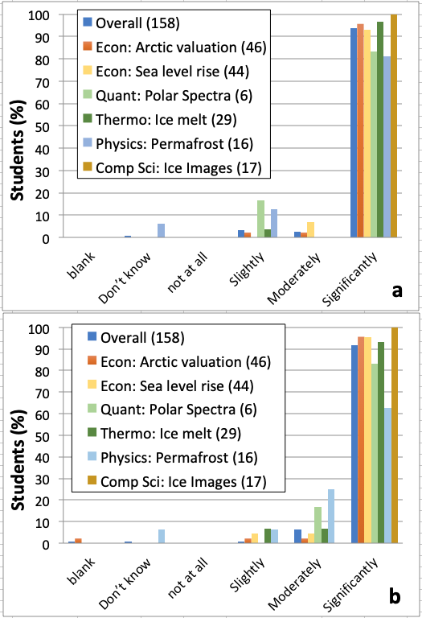
Figure S3. Student survey responses regarding how much they believe humans have contributed to climate change (a) before taking the module, reported on a pre-module survey and (b) after taking the module, reported on a post-module survey. Modules are shown in the legend; numbers in legend indicate number of survey respondents.

Course disciplinary content
Additional examples of free-form responses written by students that point to learning of specific course content:

I learned about phase diagrams and how to construct them using Thomson and Clausius-Clapeyron equations. I also learned about salt and its effect on freezing/boiling point temperature using Raoult's law.

I learned that there is a relationship between blackbody radiation spectra and rot-vib spectra.

I learned how to calculate the value of things seemingly immeasurable.

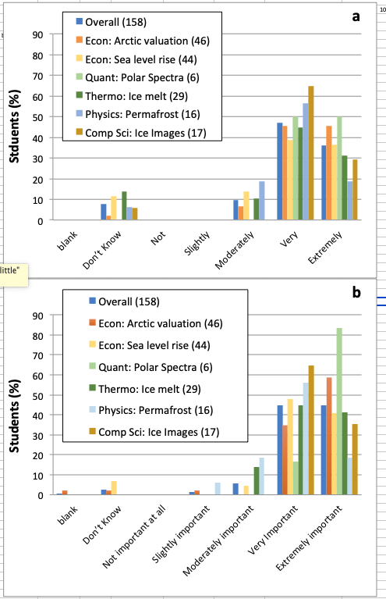
Figure S4. Student retrospective pre-post survey responses for classes taught in 2017/2018 regarding how important they felt polar research is for climate change: (top) before taking the module and (bottom) after taking the module. Modules are shown in the legend; numbers in legend indicate number of survey respondents.

Climate literacy and importance of the role of polar regions
Linkages between emergent themes and climate literacy principles are given in Table S2.
Additional examples of student free-form responses consistent with increases in climate literacy, understanding of the role of polar regions, and value placed on the importance of polar regions for climate change, including:

I learned that most of the greenhouse gases is comprised of water.

I learned that polar regions play a large role in stabilizing the earth's atmosphere and that ice shelves are becoming increasingly unstable.

I learned about the pattern of glacial and interglacial periods that correspond with Milankovitch cycles. I also learned about the role of carbon dioxide in preventing ice ages.

Table S2. Links between emergent themes and climate literacy principles.
Emergent Themes | Climate Literacy Principles
CC impacts | Climate affects life,  Climate change has consequences
CC urgency, Actions | Humans affect climate and  Climate change has consequences.
Polar regions | Climate is variable.
Assumptions, Data, | Our understanding of climate
CC complex | Climate is complex.

Active learning with real-world data
Student responses that are consistent with the idea that using real-world data can provide a powerful motivation for engaging disciplinary content follow.

The connection to polar data was extremely well integrated into the course material and helped expand upon practical uses for Physical Chemistry.

It connected real climate data to the economic models we learn about in class.

It was incredibly engaging and applied much of our quantum knowledge to a real-life situation.

It not only helps me to understand more about polar research and its impacts in studying about climate change, but also provides a wonderful learning opportunity in coding which is outside the scope of a conventional physics classroom.

I have only ever been told this data, so actually working with and calculating parts of it was very cool—Makes me want to do research in the following!

I found it really interesting how we were using the same devices in lab (IR) but on gases in the atmosphere, I hadn't previously known how research was conducted on that.

Ro-vibrational studies ... aren't in fact merely mathematical torture.

This program has really been helping me to solidify the concepts. This is because it makes the equations physically tangible (they make sense) beyond mathematical memorization.

After this module, I taught myself many new polar concepts like the greenhouse effect, permafrost, thermal diffusivity, etc; and how they relate to each other. The activity also helped correct my misconceptions about polar physics.

Following are examples of student responses indicating that students learned that real-world data and relationships are complex, and that this complexity presents a challenge that can lead to skill-building, and responses that indicate that incorrect care in choosing assumptions and conducting studies can skew results.

I learned that you have to make many assumptions in order to collect predictive data.

These surveys seem fully willing to produce results that are wrong due to data limitations or necessity for assumption.

Climate modeling is actually a lot more difficult than expected because there are so many circumstances and variables that need to be taken into consideration. This module taught me that small scale modeling is very useful for big picture analysis.

It was comprehensive and insightful, but also I feel like it did not cover every value possible to the Arctic, like I only saw existence values of polar bears and whales but I feel like there are more Arctic animals. Also, the same course taught me the drawbacks that come with things like Total Economic Valuation and Travel Cost Method, so the resulting number for the Arctic is questionable.

We can drive environmental policy using economic valuation.

I learned that you have to make many assumptions in order to collect predictive data.
I felt like I learned a lot about how these studies were conducted and what items needed to be looked at when reading these studies and how they may skew data in different ways.

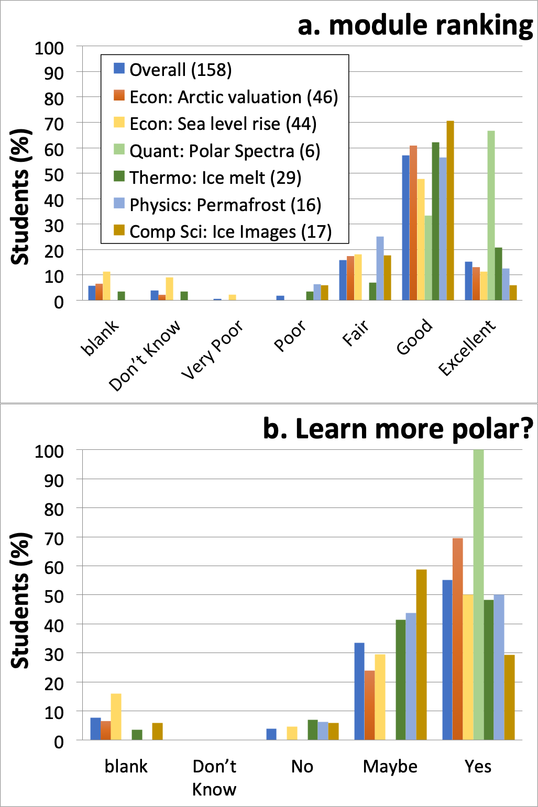
Figure S5. Survey results from 2017/2018 for (a) Student ranking of module. (b) Student response to question, “Would you like to learn more about polar research?”

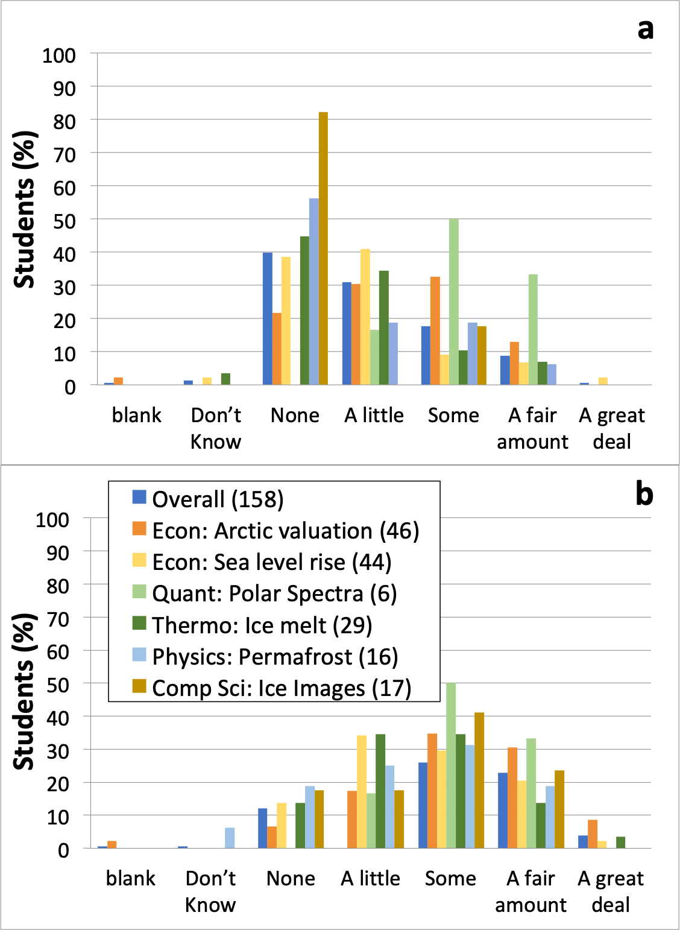
Figure S6. Student self-assessments of exposure to polar data and research (a) before taking the module during 2017/2018, and (b) after taking the module during 2017/2018. Modules are shown in the legend; numbers in the legend indicate the number of survey respondents.

The method for ranking the Likert scales is given in Table S3. Responses that could not be ranked, such as “Don’t know” were omitted

Table S3. Number ranking for Likert scales for student survey questions.
Question | 1 | 2 | 3 | 4 | 5
Comfort with Python / Excel before/after | Very  Uncom-fortable | Somewhat  Uncom-fortable | Neutral | Somewhat  Comfort-able | Very Comfort-able
Importance of polar research in context of climate change before/after | Not imp-ortant at all | Slightly  important | Moderately important | Very important | Extremely important
Climate / course knowledge rating before/after | Very poor | Poor | Fair | Good | Excellent
Exposure to polar research before | None | A little | Some | A fair amount | A great deal

Instructor Interview Responses
There were nine interviewees. The following is a partial summary of responses prepared by the external evaluator. The external evaluator selected a single quote that summarized each response in all cases, except where it wasn’t possible to summarize succinctly. Instructor responses are numbered.
- [If yes, modules substitute for pre-existing course objectives] How effective were the modules in helping your students meet the course’s learning objectives?
1 – “very good”
2 – “pretty effective”
3 – “very effective”
4 – “hard to evaluate, but students were very engaged”
5 – “Pretty effective”
6 – “I would say – I think that the modules that are specifically designed to meet course learning objectives are, in many cases, like the best way that I could imagine meeting course learning objectives. That said, I do think that there was at times some tension between the desire to put the polar data in, pit students about climate change with course content. And so there were some cases where I felt like I was deliberately not teaching course content, and instead, choosing to make the tradeoff, where I spent more time teaching students about polar science, or polar data, or climate change.”
7 – “Very successful and very useful.”
8 – “So the ones that covered the same material that I would cover, did an effective job.”
9 – “I think that they were quite helpful.”

Additional quotes:
- “a more sophisticated understanding of the concepts.”
- “So, it was kind of a small sample – just one class before, and two after. But, my sense was that the process really helped the students grasp the concepts better than they had before the module.”
- “But it also really reinforced a lot of the topics that we had been discussing in class”

- Would you say that your students learned the course content better, the same, or worse with the modules than with the original classroom pedagogy?
1 – “Better”
2 – “Better”
3 – “Better”
4 – “At least the same, if not better. But it’s still a little bit hard to say.”
5 – “I would say, the first time I taught this class, I included the module in it. So I don’t have another situation without the module to compare it to. However, I do think that being able to not just learn about [topic redacted], and [topic redacted], but to also be able to apply it in the context of their city – I think that was a useful benefit for them. So I would expect that they learned it better, by being able to do the module.”
6 – “I think probably better, still.”
7 –“ Better”
8 – “I would say similar.”
9 – “I think better.”

Supplemental References
Rowe, P. M., Cheng, H., Fortmann, L., Wright, A., & Neshyba, S. (2018). Teaching image processing in an upper level CS undergraduate class using computational guided inquiry and polar data. Journal of Computing Sciences in Colleges, 34(1), 171-179.

