Design, synthesis and bioactivity evaluation of novel thioether derivatives containing a sulfonohydrazide moiety
Pei Li ^{1,#}, Junliang Zhou ^{2,#}, Yan Liu ³, Xiang Wang ¹
¹ Qiandongnan Engineering and Technology Research Center for Comprehensive Utilization of National Medicine/Key Laboratory for Modernization of Qiandongnan Miao & Dong Medicine, Kaili University, Kaili 556011, P.R. China
² Guizhou Fruit Institute, Guizhou Academy of Agricultural Sciences, Guiyang, 550025 P.R. China
³ National Chemical Low Carbon Technology and Engineering Center, Kunshan, 215300 P.R. China
Email: pl19890627@126.com (P.L.), gzhwx0828@126.com (X.W.)

Supplemental Materials
Table S 1: In vitro antibacterial activity of the target compounds against Xoo and Xac.
Compounds | Inhibition rate (%)
 | Xoo |  | Xac
 | 200 (μg/mL) | 100 (μg/mL) | 200 (μg/mL) | 100 (μg/mL)
4a | 71±1.06 | 54±2.64 | 60±2.39 | 48±3.06
4b | 60±1.25 | 50±4.62 | 56±2.62 | 45±1.65
4c | 40±0.98 | 32±0.95 | 35±1.62 | 30±1.65
4d | 48±2.49 | 41±1.32 | 42±2.97 | 35±2.46
4e | 77±3.62 | 61±1.52 | 70±2.62 | 53±1.65
4f | 74±3.51 | 57±2.19 | 62±1.56 | 50±0.98
4g | 88±1.49 | 75±2.65 | 83±1.13 | 70±3.21
4h | 57±2.09 | 48±2.94 | 54±2.13 | 40±1.65
4i | 66±1.62 | 50±3.01 | 63±2.62 | 51±2.19
4j | 38±3.01 | 30±2.01 | 35±1.60 | 25±2.65
4k | 32±1.32 | 25±0.98 | 20±2.65 | 18±1.65
4l | 18±1.16 | 10±2.19 | 10±1.65 | 8±2.59
4m | 25±0.46 | 19±2.26 | 21±1.89 | 16±2.45
4n | 47±2.68 | 40±3.10 | 41±2.62 | 34±2.23
4o | 42±1.18 | 35±2.65 | 40±2.56 | 30±2.46
4p | 95±0.59 | 85±1.65 | 88±4.01 | 76±1.35
Bismerthiazol | 70±0.89 | 52±1.62 | 55±2.43 | 32±3.26
Thiodiazole copper | 63±2.71 | 45±2.65 | 36±1.56 | 16±2.19

Table S 2: The EC₅₀ values of some of the target compounds against Xoo and Xac.
Compounds | EC₅₀ (μg/mL)
 | Xoo | Xac
4a | 52.12±2.62 | 76.12±3.56
4b | 105.62±1.56 | 86.26±2.94
4e | 41.88±1.65 | 54.26±1.65
4f | 32.99±2.98 | 85.65±5.65
4g | 21.87±2.65 | 26.32±2.10
4i | 67.59±3.49 | 68.54±2.59
4p | 13.75±0.95 | 18.56±2.14
Bismerthiazol | 84.48±2.89 | 145.62±2.65
Thiodiazole copper | 109.65±3.01 | 230.26±2.46

N'-(2-((4-chlorophenyl)thio)acetyl)-4-fluorobenzenesulfonohydrazide (4a). White solid; mp 185−186 ºC; yield 85%; ¹H NMR (400 MHz, DMSO-d₆, ppm) δ: 10.34 (s, 1H, −NH−), 10.07 (s, 1H, −NH−), 7.80−7.77 (m, 2H, Ph-H), 7.37−7.26 (m, 6H, Ph-H), 3.56 (s, 2H, −SCH₂−); ¹³C NMR (100 MHz, DMSO-d₆, ppm) δ: 167.3, 135.6, 135.1, 131.2, 131.2, 130.1, 129.3, 116.4 (d, J = 22.0 Hz, F−C), 116.3, 34.4; HRMS (ESI) [M+Na]⁺ calcd for C₁₄H₁₂ClFN₂O₃S₂: 396.9854, found: 396.9859; Anal. calcd for C₁₄H₁₂ClFN₂O₃S₂: C 44.86, H 3.23, N 7.47, found: C 44.85, H 3.21, N 7.45.
N'-(2-((4-chlorophenyl)thio)acetyl)-4-chlorobenzenesulfonohydrazide (4b). White solid; mp 186−187 ºC; yield 80%; ¹H NMR (400 MHz, DMSO-d₆, ppm) δ: 10.35 (s, 1H, −NH−), 10.16 (s, 1H, −NH−), 7.73 (d, J = 8.4 Hz, 2H, Ph-H), 7.52 (d, J = 8.4 Hz, 2H, Ph-H), 7.35 (d, J = 8.4 Hz, 2H, Ph-H), 7.27 (q, J = 2.0 Hz, 2H, Ph-H), 3.56 (s, 2H, −SCH₂−); ¹³C NMR (100 MHz, DMSO-d₆, ppm) δ: 167.4, 138.4, 138.2, 135.0, 131.2, 130.0, 130.0, 129.4, 129.3, 34.3; HRMS (ESI) [M+Na]⁺ calcd for C₁₄H₁₂Cl₂N₂O₃S₂: 390.9739, found: 390.9736; Anal. calcd for C₁₄H₁₂Cl₂N₂O₃S₂: C 42.98, H 3.09, N 7.16, found: C 42.99, H 3.11, N 7.15.
N'-(2-((4-chlorophenyl)thio)acetyl)-4-methylbenzenesulfonohydrazide (4c). White solid; mp 159−160 ºC; yield 89%; ¹H NMR (400 MHz, DMSO-d₆, ppm) δ: 10.25 (s, 1H, −NH−), 9.90 (s, 1H, −NH−), 7.62 (d, J = 8.0 Hz, 2H, Ph-H), 7.37−7.33 (m, 2H, Ph-H), 7.30−7.24 (m, 4H, Ph-H), 3.55 (s, 2H, −SCH₂−), 2.34 (s, 3H, −CH₃); ¹³C NMR (100 MHz, DMSO-d₆, ppm) δ: 167.2, 143.6, 136.4, 131.1, 130.1, 129.7, 129.2, 128.1, 34.4, 21.5; HRMS (ESI) [M+Na]⁺ calcd for C₁₅H₁₅ClN₂O₃S₂: 393.0110, found: 393.0149; Anal. calcd for C₁₅H₁₅ClN₂O₃S₂: C 48.58, H 4.08, N 7.55, found: C 48.56, H 4.09, N 7.53.
N'-(2-((4-chlorophenyl)thio)acetyl)benzenesulfonohydrazide (4d). White solid; mp 177−178 ºC; yield 79%; ¹H NMR (400 MHz, DMSO-d₆, ppm) δ: 10.20 (s, 2H, 2 × −NH−), 7.74 (dd, J₁ = J₂ = 1.2 Hz, 2H, Ph-H), 7.64−7.60 (m, 1H, Ph-H), 7.51−7.47 (m, 2H, Ph-H), 7.36−7.33 (m, 2H, Ph-H), 7.30−7.26 (m, 2H, Ph-H), 3.56 (s, 2H, −SCH₂−); ¹³C NMR (100 MHz, DMSO-d₆, ppm) δ: 167.3, 139.3, 135.1, 133.4, 131.2, 130.2, 129.3, 128.2, 128.0, 34.6; HRMS (ESI) [M+Na]⁺ calcd for C₁₄H₁₃ClN₂O₃S₂: 378.9948, found: 378.9951; Anal. calcd for C₁₄H₁₃ClN₂O₃S₂: C 47.12, H 3.67, N 7.85, found: C 47.14, H 3.69, N 7.83.
N'-(2-((4-chlorophenyl)thio)acetyl)propane-1-sulfonohydrazide (4e). White solid; mp 115−116 ºC; yield 72%; ¹H NMR (400 MHz, DMSO-d₆, ppm) δ: 9.90 (s, 2H, 2 × −NH−), 7.42−7.36 (m, 4H, Ph-H), 3.71 (s, 2H, −SCH₂−), 2.83−2.79 (m, 2H, −CH₂−), 1.75−1.65 (m, 2H, −CH₂−), 0.88 (t, J = 7.2 Hz, 3H, −CH₃); ¹³C NMR (100 MHz, DMSO-d₆, ppm) δ: 168.0, 134.9, 131.4, 130.6, 129.4, 53.2, 34.7, 17.0, 13.2; HRMS (ESI) [M+Na]⁺ calcd for C₁₁H₁₅ClN₂O₃S₂: 345.0110, found: 345.0158; Anal. calcd for C₁₁H₁₅ClN₂O₃S₂: C 40.93, H 4.68, N 8.68, found: C 40.94, H 4.69, N 8.67.
N'-(2-((4-chlorophenyl)thio)acetyl)butane-1-sulfonohydrazide (4f). White solid; mp 125−126 ºC; yield 70%; ¹H NMR (400 MHz, DMSO-d₆, ppm) δ: 10.02 (s, 2H, 2 × −NH−), 7.42−7.35 (m, 4H, Ph-H), 3.71 (s, 2H, −SCH₂−), 2.82 (t, J = 8.0 Hz, 2H, −CH₂−), 1.67−1.63 (m, 2H, −CH₂−), 1.30−1.25 (m, 2H, −CH₂−), 0.83 (t, J = 7.2 Hz, 3H, −CH₃); ¹³C NMR (100 MHz, DMSO-d₆, ppm) δ: 168.0, 134.9, 131.3, 130.5, 129.3, 51.3, 34.6, 25.2, 21.4, 13.9; HRMS (ESI) [M+Na]⁺ calcd for C₁₂H₁₇ClN₂O₃S₂: 359.0267, found: 359.0310; Anal. calcd for C₁₂H₁₇ClN₂O₃S₂: C 42.79, H 5.09, N 8.32, found: C 42.78, H 5.09, N 8.34.
N'-(2-((4-fluorophenyl)thio)acetyl)-4-chlorobenzenesulfonohydrazide (4g). White solid; mp 165−166 ºC; yield 79%; ¹H NMR (400 MHz, DMSO-d₆, ppm) δ: 10.31 (s, 1H, −NH−), 10.14 (s, 1H, −NH−), 7.74 (d, J = 8.8 Hz, 2H, Ph-H), 7.55 (d, J = 8.4 Hz, 2H, Ph-H), 7.34−7.14 (m, 2H, Ph-H), 3.50 (s, 2H, −SCH₂−); ¹³C NMR (100 MHz, DMSO-d₆, ppm) δ: 167.6, 138.4, 138.2, 138.2, 131.6, 131.5, 131.2, 130.0, 129.4, 116.4 (d, J = 22. Hz, F−C), 35.3; HRMS (ESI) [M+Na]⁺ calcd for C₁₄H₁₂ClFN₂O₃S₂: 396.9854, found: 396.9851; Anal. calcd for C₁₄H₁₂ClFN₂O₃S₂: C 44.86, H 3.23, N 7.47, found: C 44.88, H 3.22, N 7.46.
N'-(2-((4-fluorophenyl)thio)acetyl)-4-methylbenzenesulfonohydrazide (4h). White solid; mp 136−137 ºC; yield 84%; ¹H NMR (400 MHz, DMSO-d₆, ppm) δ: 10.21 (s, 1H, −NH−), 9.88 (s, 1H, −NH−), 7.63 (d, J = 8.0 Hz, 2H, Ph-H), 7.33−7.28 (m, 4H, Ph-H), 7.16 (d, J = 9.2 Hz, 2H, Ph-H), 3.50 (s, 2H, −SCH₂−), 2.35 (s, 3H, −CH₃); ¹³C NMR (100 MHz, DMSO-d₆, ppm) δ: 167.4, 143.7, 136.4, 131.7, 131.6, 131.3, 129.7, 128.1, 116.5 (d, J = 22.0 Hz, F−C), 116.3, 35.5, 21.5; HRMS (ESI) [M+Na]⁺ calcd for C₁₅H₁₅FN₂O₃S₂: 377.0406, found: 377.0447; Anal. calcd for C₁₅H₁₅FN₂O₃S₂: C 50.83, H 4.27, N 7.90, found: C 50.82, H 4.26, N 7.88.
N'-(2-((4-fluorophenyl)thio)acetyl)benzenesulfonohydrazide (4i). White solid; mp 180−181 ºC; yield 81%; ¹H NMR (400 MHz, DMSO-d₆, ppm) δ: 10.24 (s, 1H, −NH−), 9.99 (s, 1H, −NH−), 7.75 (d, J = 7.2 Hz, 2H, Ph-H), 7.63 (t, J = 7.2 Hz, 1H, Ph-H), 7.51 (t, J = 8.0 Hz, 2H, Ph-H), 7.34−7.31 (m, 2H, Ph-H), 7.18−7.13 (m, 2H, Ph-H), 3.50 (s, 2H, −SCH₂−); ¹³C NMR (100 MHz, DMSO-d₆, ppm) δ: 167.5, 139.4, 133.4, 131.8, 131.7, 131.3, 129.3, 128.0, 116.4 (d, J = 22.0 Hz, F−C), 35.6; HRMS (ESI) [M+Na]⁺ calcd for C₁₄H₁₃FN₂O₃S₂: 363.0244, found: 363.0248; Anal. calcd for C₁₄H₁₃FN₂O₃S₂: C 49.40, H 3.85, N 8.23, found: C 49.42, H 3.86, N 8.25.
N'-(2-(p-tolylthio)acetyl)-4-fluorobenzenesulfonohydrazide (4j). White solid; mp 161−162 ºC; yield 80%; ¹H NMR (400 MHz, DMSO-d₆, ppm) δ: 10.29 (s, 1H, −NH−), 10.05 (s, 1H, −NH−), 7.80−7.77 (m, 2H, Ph-H), 7.30 (t, J = 8.8 Hz, 2H, Ph-H), 7.14 (dd, J₁ = 8.8 Hz, J₂ = 8.0 Hz, 4H, Ph-H), 3.48 (s, 2H, −SCH₂−), 2.28 (s, 3H, −CH₃); ¹³C NMR (100 MHz, DMSO-d₆, ppm) δ: 167.6, 136.2, 135.6, 132.2, 131.2, 131.1, 130.0, 129.1, 116.4 (d, J = 22.0 Hz, F−C), 35.1, 21.0; HRMS (ESI) [M+Na]⁺ calcd for C₁₅H₁₅FN₂O₃S₂: 377.0400, found: 377.0405; Anal. calcd for C₁₅H₁₅FN₂O₃S₂: C 50.83, H 4.27, N 7.90, found: C 50.82, H 4.26, N 7.92.
N'-(2-(p-tolylthio)acetyl)- 4-chlorobenzenesulfonohydrazide (4k). White solid; mp 164−165 ºC; yield 83%; ¹H NMR (400 MHz, DMSO-d₆, ppm) δ: 10.31 (s, 1H, −NH−), 10.13 (s, 1H, −NH−), 7.73−7.71 (m, 2H, Ph-H), 7.54−7.50 (m, 2H, Ph-H), 7.17−7.11 (m, 4H, Ph-H), 3.48 (s, 2H, −SCH₂−), 2.28 (s, 3H, −CH₃); ¹³C NMR (100 MHz, DMSO-d₆, ppm) δ: 167.7, 138.3, 138.2, 136.2, 132.2, 130.0, 130.0, 129.4, 129.1, 35.0, 21.0; HRMS (ESI) [M+Na]⁺ calcd for C₁₅H₁₅ClN₂O₃S₂: 393.0105, found: 393.0101; Anal. calcd for C₁₅H₁₅ClN₂O₃S₂: C 48.58, H 4.08, N 7.55, found: C 48.55, H 4.06, N 7.56.
N'-(2-(p-tolylthio)acetyl)-4-methylbenzenesulfonohydrazide (4l). White solid; mp 138−139 ºC; yield 80%; ¹H NMR (400 MHz, DMSO-d₆, ppm) δ: 10.19 (s, 1H, −NH−), 9.88 (s, 1H, −NH−), 7.62 (d, J = 8.0 Hz, 2H, Ph-H), 7.27 (d, J = 8.4 Hz, 2H, Ph-H), 7.17 (d, J = 8.8 Hz, 2H, Ph-H), 7.11 (d, J = 8.0 Hz, 2H, Ph-H), 3.47 (s, 2H, −SCH₂−), 2.35 (s, 3H, −CH₃), 2.28 (s, 3H, −CH₃); ¹³C NMR (100 MHz, DMSO-d₆, ppm) δ: 167.5, 143.6, 136.5, 136.1, 132.3, 130.0, 129.7, 129.2, 128.1, 35.1, 21.5, 21.0; HRMS (ESI) [M+Na]⁺ calcd for C₁₆H₁₈N₂O₃S₂: 373.0657, found: 373.0699; Anal. calcd for C₁₆H₁₈N₂O₃S₂: C 54.84, H 5.18, N 7.99, found: C 54.85, H 5.16, N 7.96.
N'-(2-(p-tolylthio)acetyl)benzenesulfonohydrazide (4m). White solid; mp 139−140 ºC; yield 83%; ¹H NMR (400 MHz, DMSO-d₆, ppm) δ: 10.23 (s, 1H, −NH−), 9.98 (s, 1H, −NH−), 7.76−7.73 (m, 2H, Ph-H), 7.65−7.61 (m, 1H, Ph-H), 7.52−7.48 (q, 2H, Ph-H), 7.18−7.10 (m, 4H, Ph-H), 3.48 (s, 2H, −SCH₂−), 2.28 (s, 3H, −CH₃); ¹³C NMR (100 MHz, DMSO-d₆, ppm) δ: 167.6, 139.4, 136.2, 133.4, 132.3, 130.0, 129.9, 129.3, 128.0, 35.3, 21.0; HRMS (ESI) [M+Na]⁺ calcd for C₁₅H₁₆N₂O₃S₂: 359.0495, found: 359.0498; Anal. calcd for C₁₅H₁₆N₂O₃S₂: C 53.55, H 4.79, N 8.33, found: C 53.57, H 4.77, N 8.36.
N'-(2-(p-tolylthio)acetyl)propane-1-sulfonohydrazide (4n). White solid; mp 99−100 ºC; yield 81%; ¹H NMR (400 MHz, DMSO-d₆, ppm) δ: 10.30 (s, 1H, −NH−), 9.51 (s, 1H, −NH−), 7.30−7.28 (m, 2H, Ph-H), 7.13 (d, J = 8.0 Hz, Ph-H), 3.64 (s, 2H, −SCH₂−), 2.82−2.78 (m, 2H, −CH₂−), 2.27 (s, 3H, −CH₃), 1.73−1.69 (m, 2H, −CH₂−), 0.88 (t, J = 7.2 Hz, 3H, −CH₃); ¹³C NMR (100 MHz, DMSO-d₆, ppm) δ: 168.3, 136.4, 132.0, 130.1, 129.6, 53.1, 35.3, 21.0, 17.0, 13.2; HRMS (ESI) [M+Na]⁺ calcd for C₁₂H₁₈N₂O₃S₂: 325.0656, found: 325.0711; Anal. calcd for C₁₂H₁₈N₂O₃S₂: C 47.66, H 6.00, N 9.26, found: C 47.67, H 5.97, N 9.26.
N'-(2-(p-tolylthio)acetyl)butane-1-sulfonohydrazide (4o). White solid; mp 105−106 ºC; yield 85%; ¹H NMR (400 MHz, DMSO-d₆, ppm) δ: 10.27 (s, 1H, −NH−), 9.61 (s, 1H, −NH−), 7.82 (d, J = 8.0 Hz, 2H, Ph-H), 7.27 (d, J = 8.0 Hz, 2H, Ph-H), 3.63 (s, 2H, −SCH₂−), 2.82 (t, J = 8.0 Hz, 2H, −CH₂−), 2.27 (s, 3H, −CH₃), 1.70−1.64 (m, 2H, −CH₂−), 1.33−1.23 (m, 2H, −CH₂−), 0.40 (t, J = 7.6 Hz, 3H, −CH₃); ¹³C NMR (100 MHz, DMSO-d₆, ppm) δ: 168.3, 136.3, 132.0, 130.1, 129.5, 51.2, 35.3, 25.3, 21.4, 21.0, 13.9; HRMS (ESI) [M+Na]⁺ calcd for C₁₃H₂₀N₂O₃S₂: 339.0813, found: 339.0867; Anal. calcd for C₁₃H₂₀N₂O₃S₂: C 49.34, H 6.37, N 8.85, found: C 49.36, H 6.36, N 8.87.
N'-(2-(ethylthio)acetyl)-4-fluorobenzenesulfonohydrazide (4p). White solid; mp 118−119 ºC; yield 80%; ¹H NMR (400 MHz, DMSO-d₆, ppm) δ: 10.18 (s, 1H, −NH−), 10.02 (s, 1H, −NH−), 7.89−7.86 (m, 2H, Ph-H), 7.42−7.38 (m, 2H, Ph-H), 2.97 (s, 2H, −SCH₂−), 2.38 (q, J = 7.6 Hz, 2H, −CH₂−), 1.10 (t, J = 7.2 Hz, 3H, −CH₃); ¹³C NMR (100 MHz, DMSO-d₆, ppm) δ: 168.4, 135.7, 131.3, 131.2, 116.4 (d, J = 22.0 Hz, F−C), 31.9, 25.8, 14.6; HRMS (ESI) [M+Na]⁺ calcd for C₁₀H₁₃FN₂O₃S₂: 315.0249, found: 315.0305; Anal. calcd for C₁₀H₁₃FN₂O₃S₂: C 41.09, H 4.48, N 9.58, found: C 41.06, H 4.46, N 9.57.

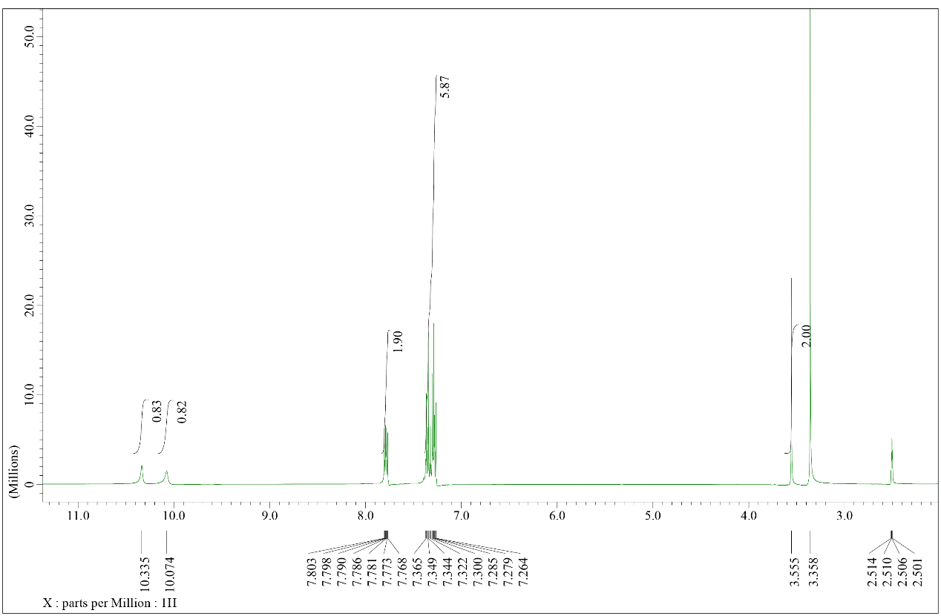
Figure S 1. ¹H NMR of compound 4a
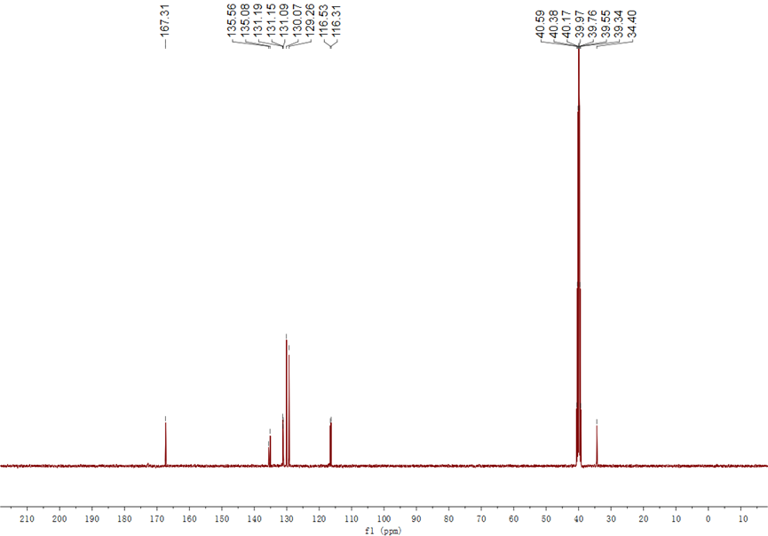
Figure S 2. ¹³C NMR of compound 4a
Figure S 3. HRMS (ESI) of compound 4a

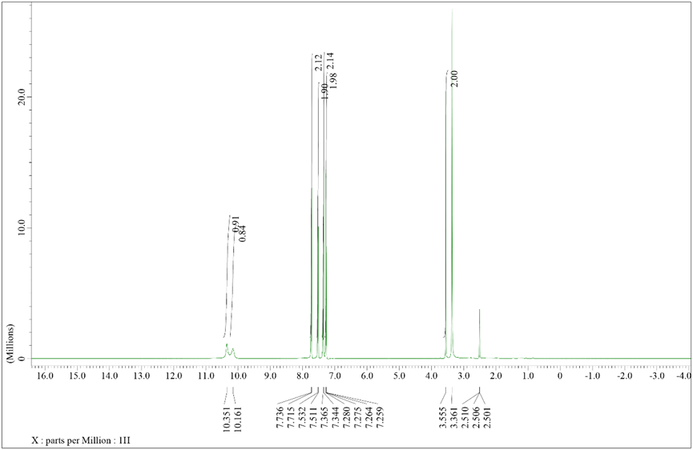
Figure S 4. ¹H NMR of compound 4b
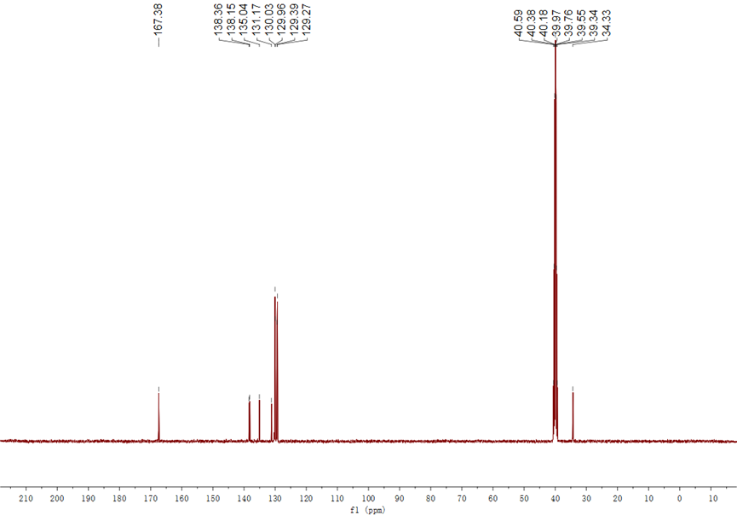
Figure S 5. ¹³C NMR of compound 4b
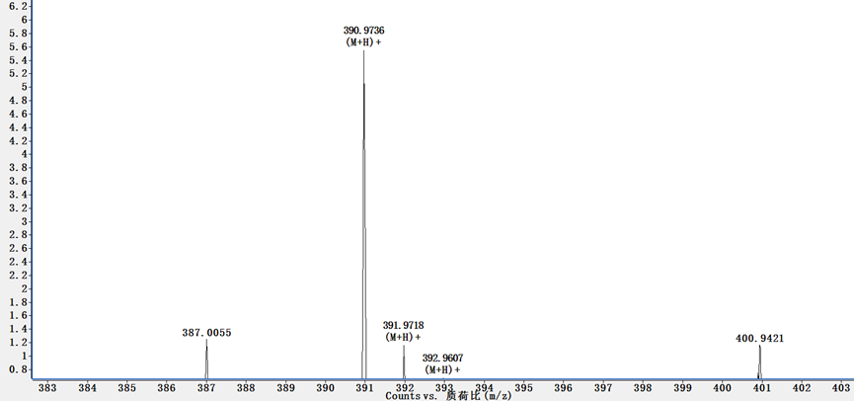
Figure S 6. HRMS (ESI) of compound 4b

Figure S 7. ¹H NMR of compound 4c
Figure S 8. ¹³C NMR of compound 4c
Figure S 9. HRMS (ESI) of compound 4c

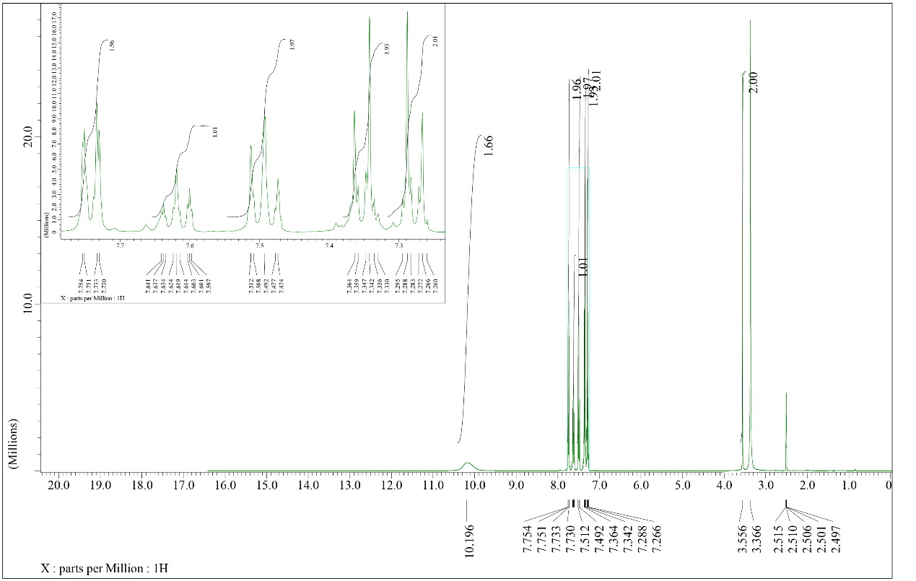
Figure S 10. ¹H NMR of compound 4d
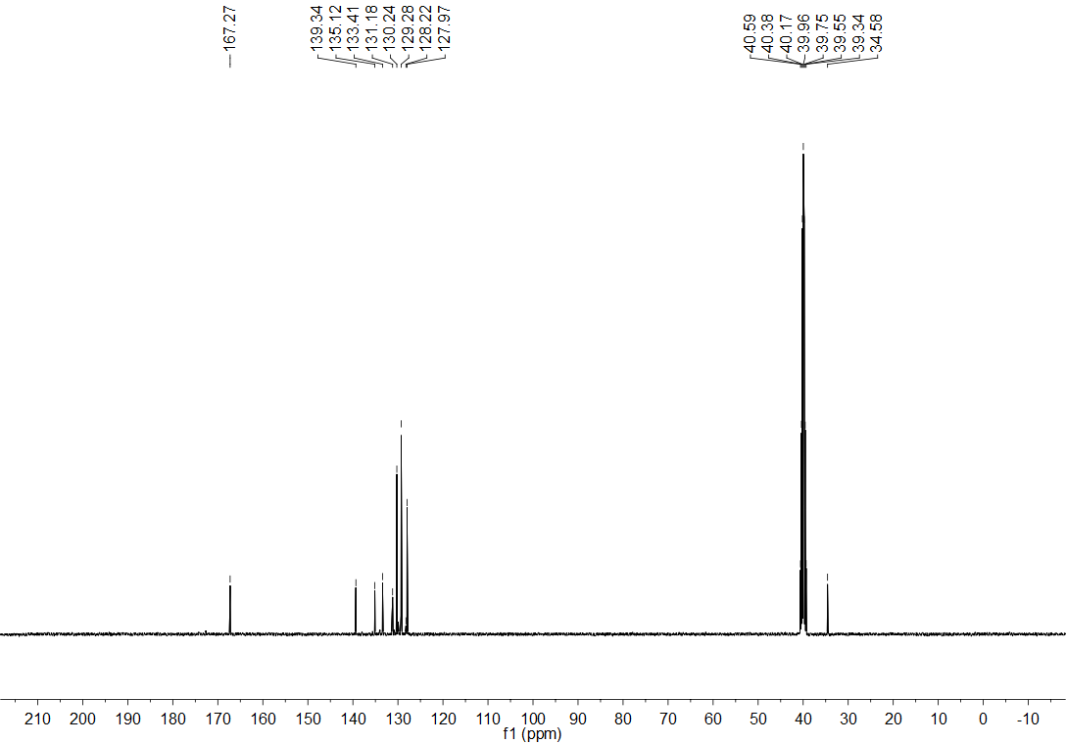
Figure S 11. ¹³C NMR of compound 4d
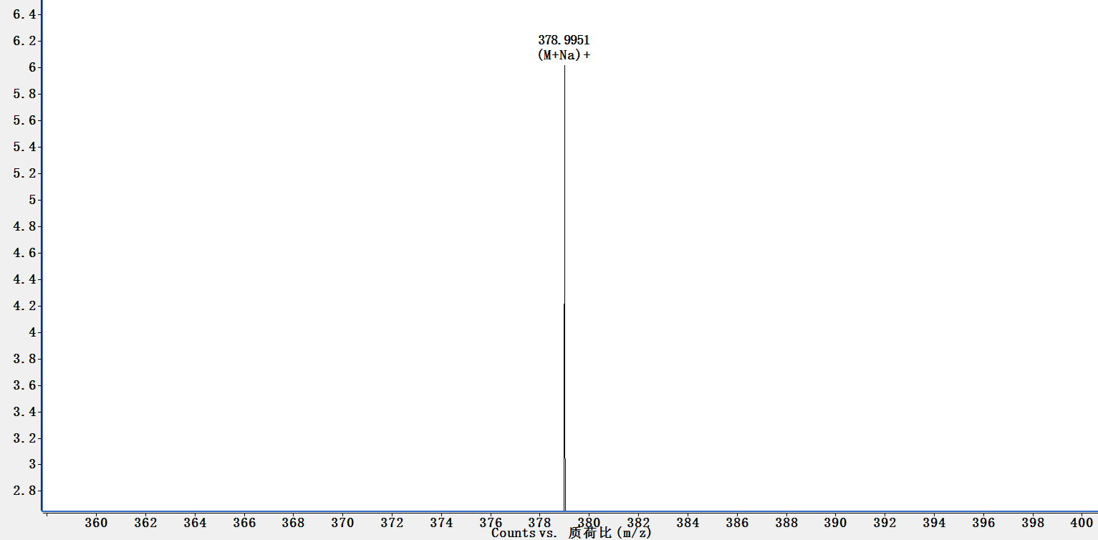
Figure S 12. HRMS (ESI) of compound 4d

Figure S 13. ¹H NMR of compound 4e
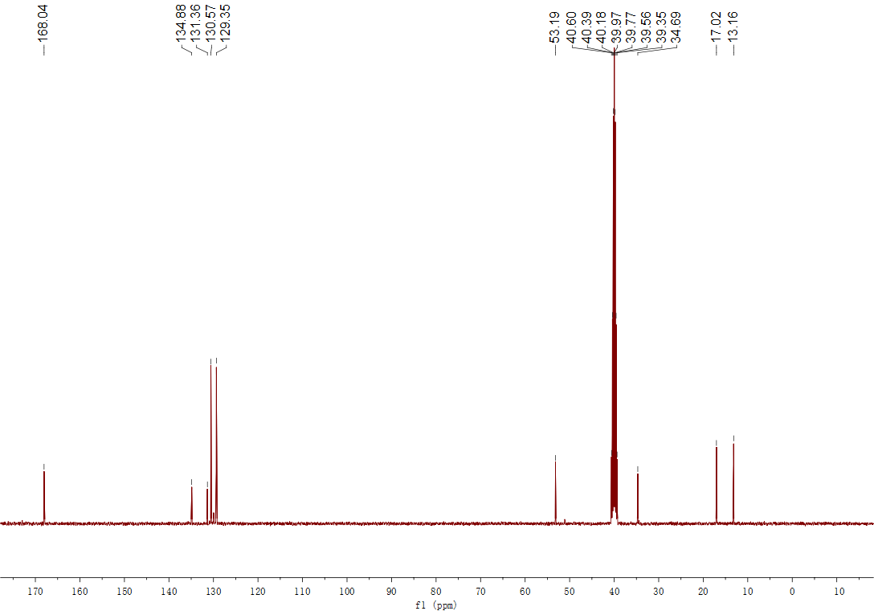
Figure S 14. ¹³C NMR of compound 4e
Figure S 15. HRMS (ESI) of compound 4e

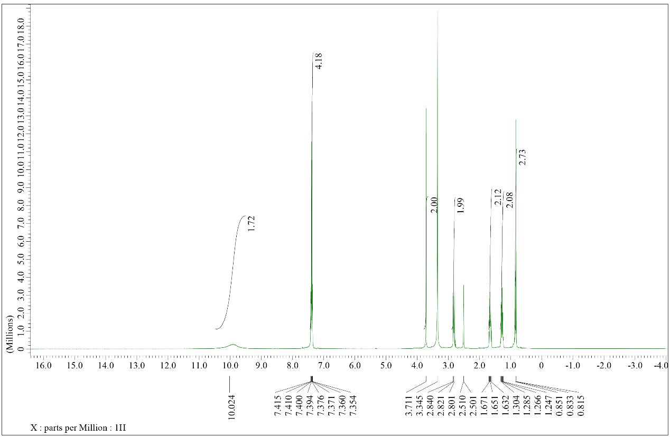
Figure S 16. ¹H NMR of compound 4f
Figure S 17. ¹³C NMR of compound 4f
Figure S 18. HRMS (ESI) of compound 4f

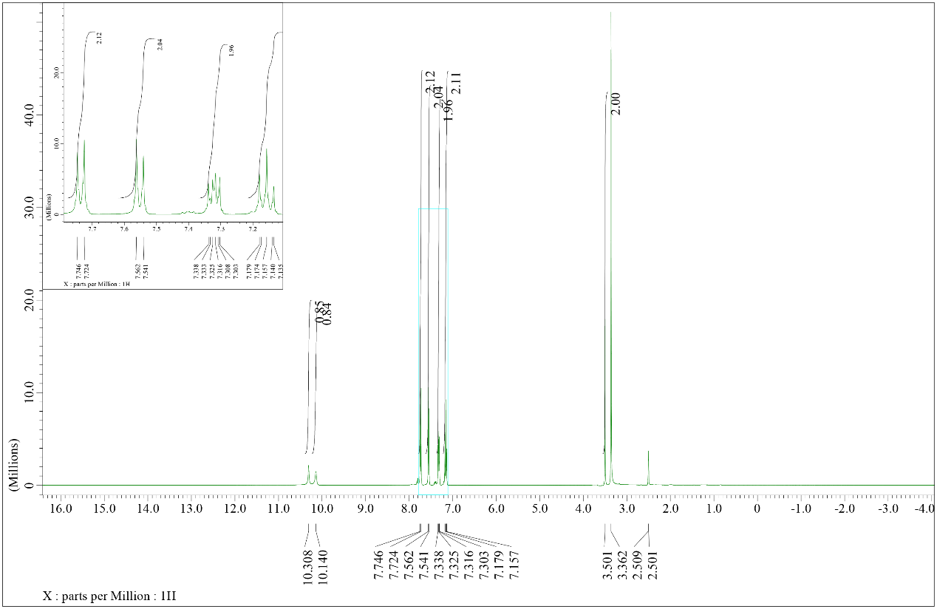
Figure S 19. ¹H NMR of compound 4g
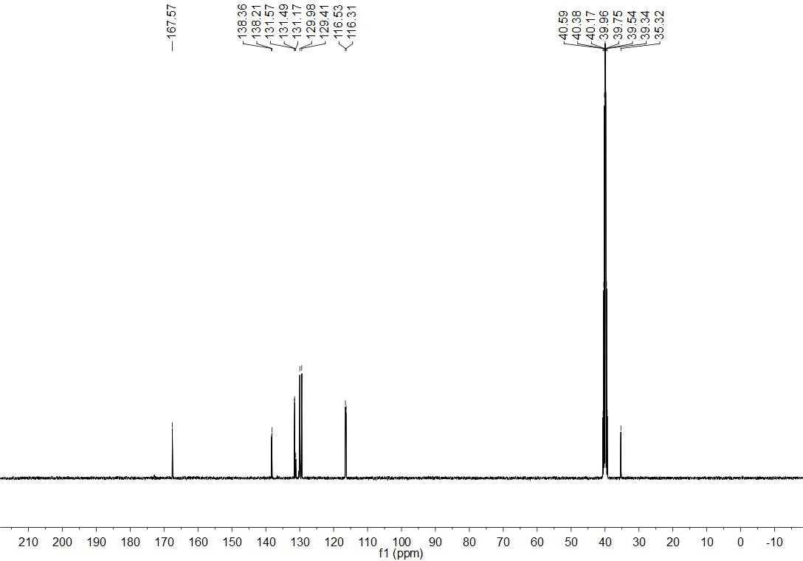
Figure S 20. ¹³C NMR of compound 4g
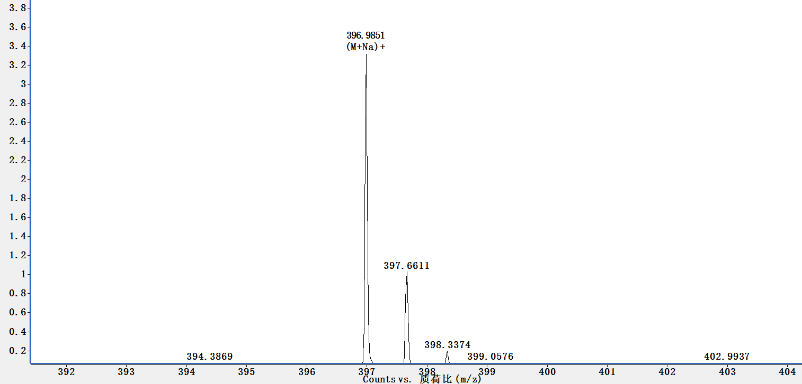
Figure S 21. HRMS (ESI) of compound 4g

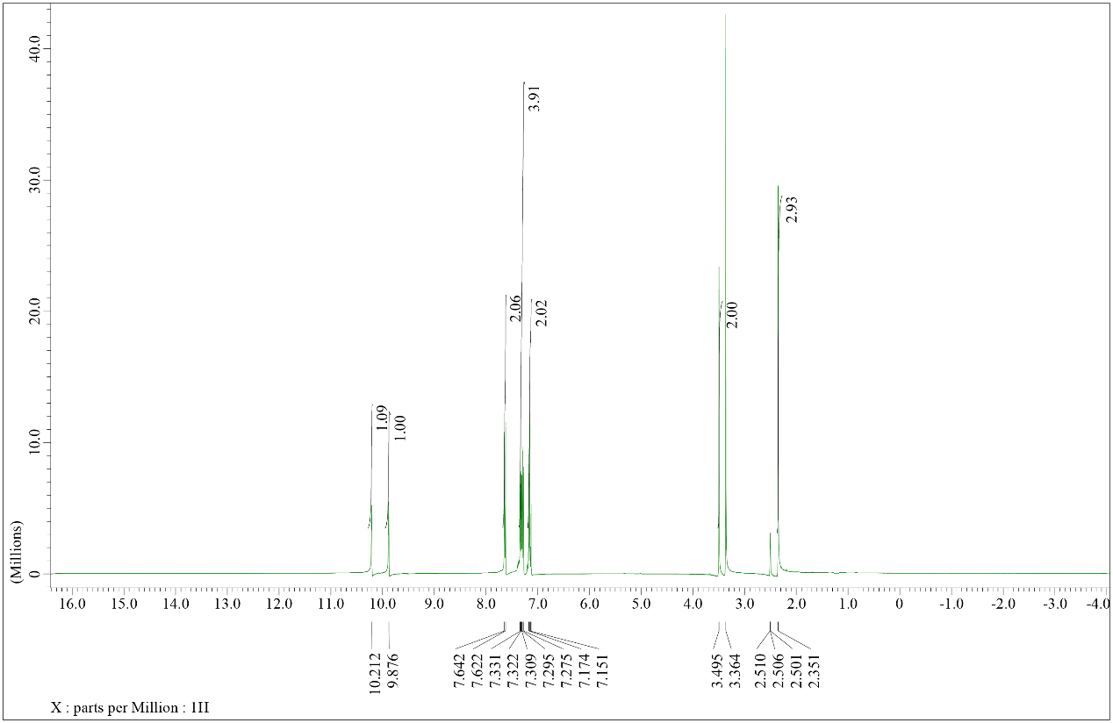
Figure S 22. ¹H NMR of compound 4h
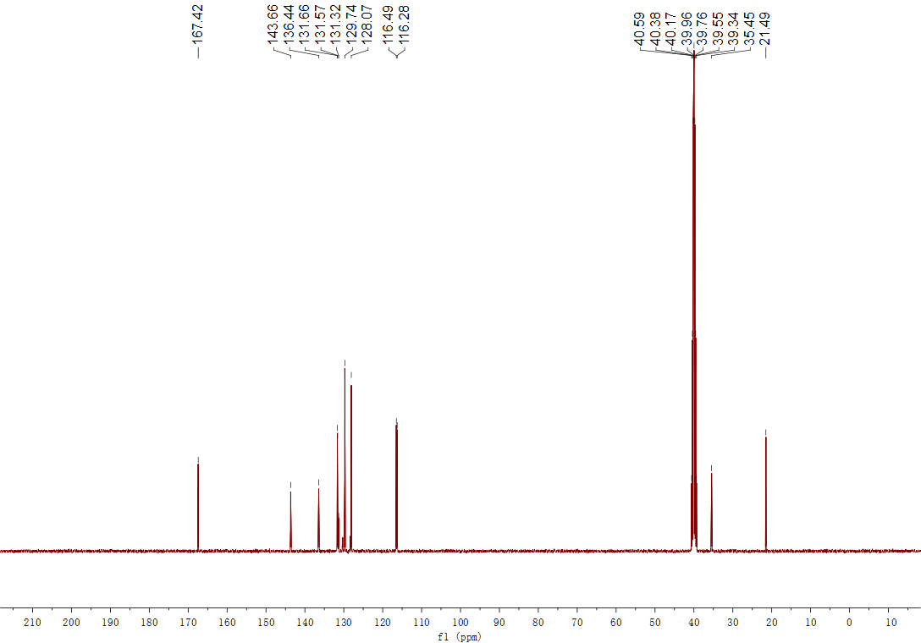
Figure S 23. ¹³C NMR of compound 4h
Figure S 24. HRMS (ESI) of compound 4h

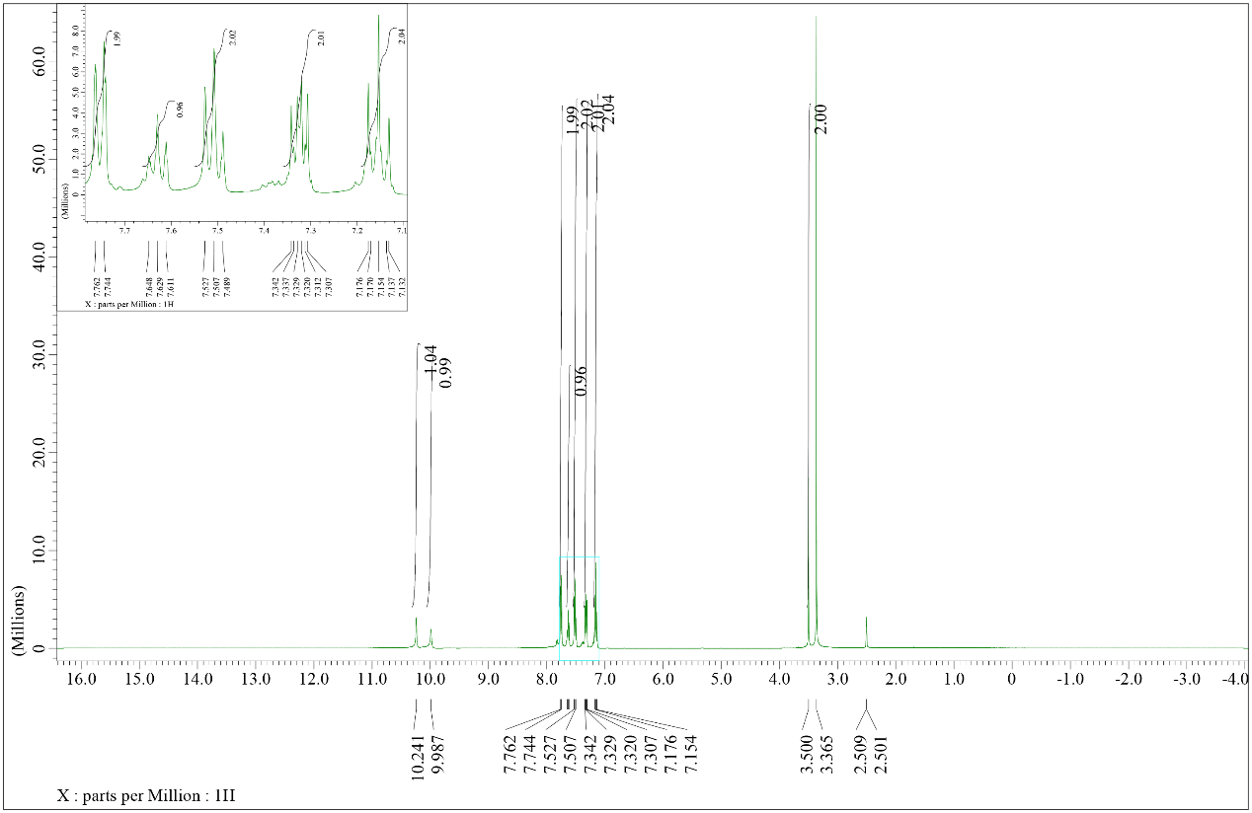
Figure S 25. ¹H NMR of compound 4i
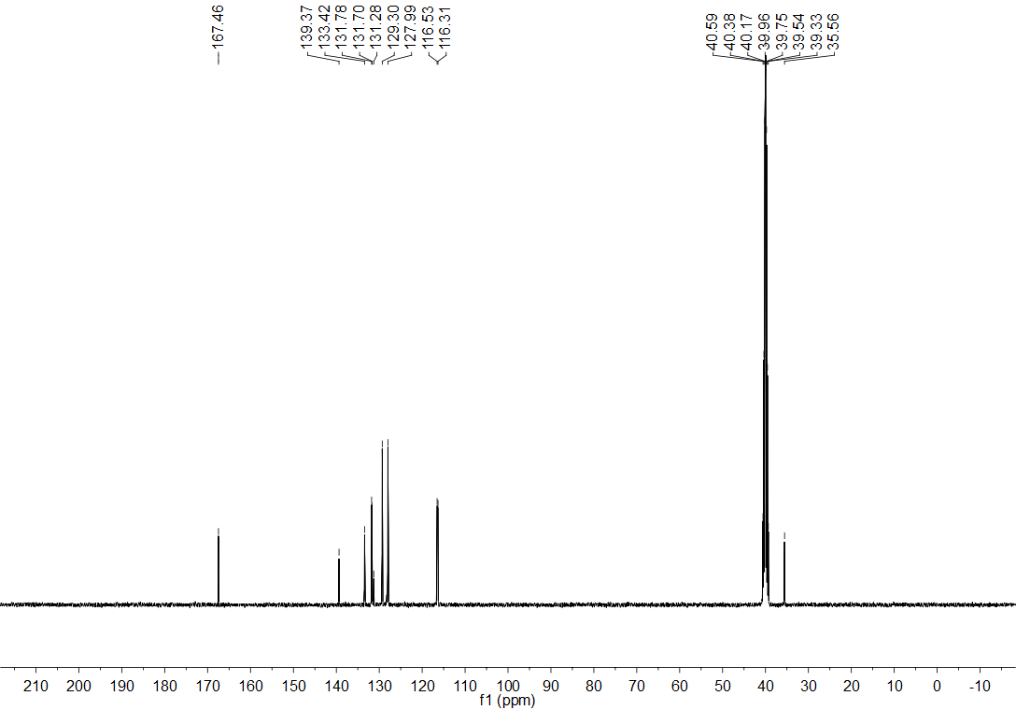
Figure S 26. ¹³C NMR of compound 4i
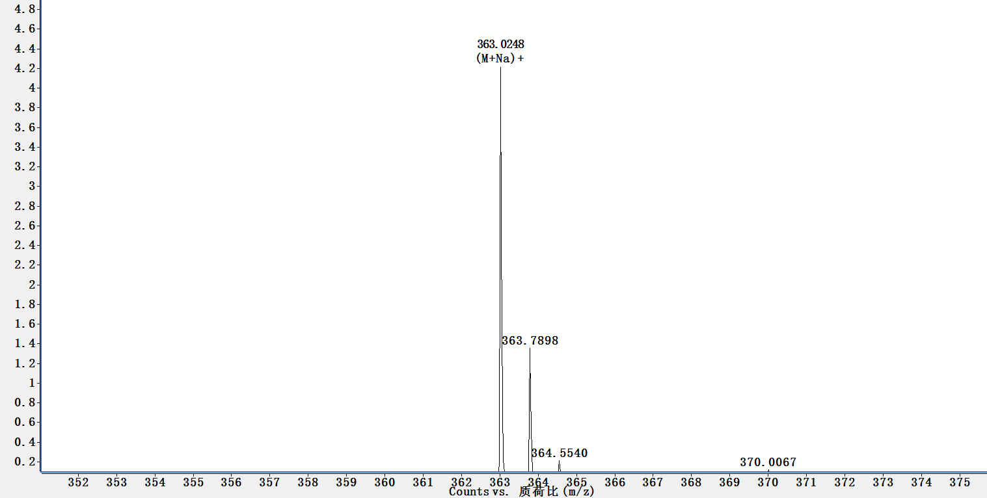
Figure S 27. HRMS (ESI) of compound 4i

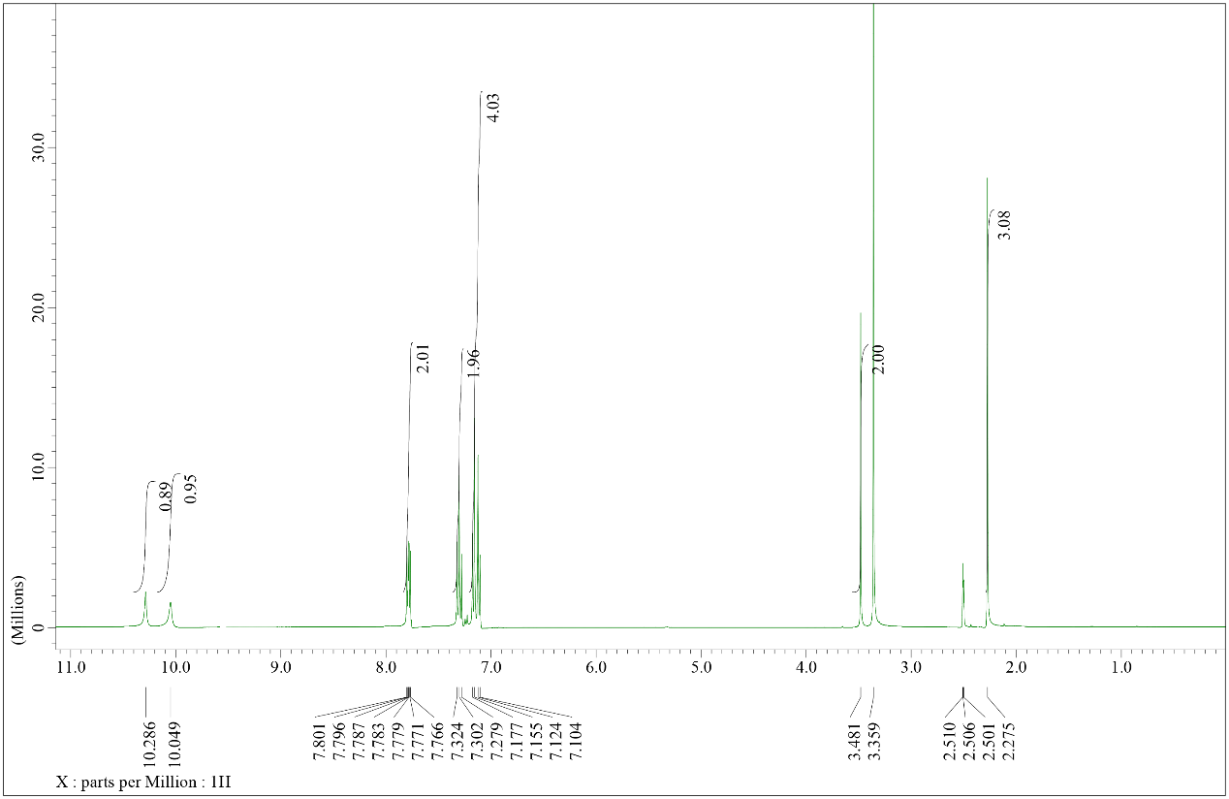
Figure S 28. ¹H NMR of compound 4j
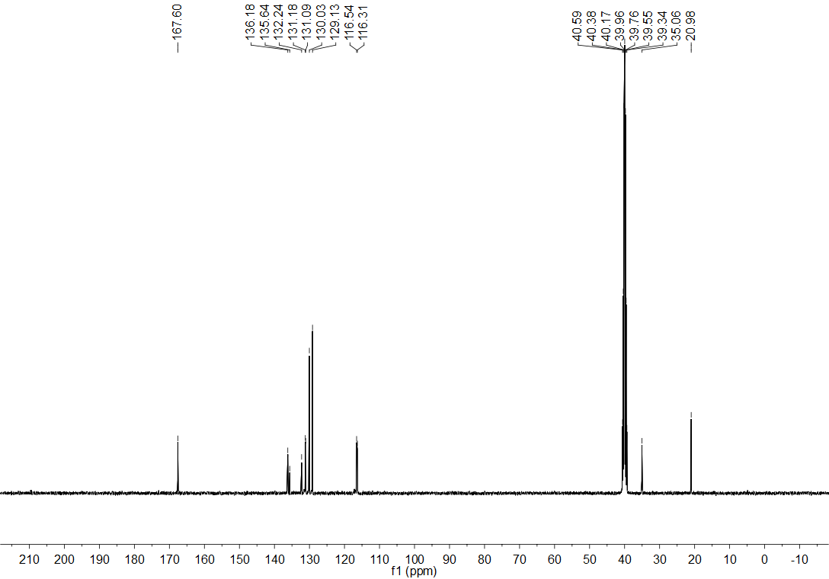
Figure S 29. ¹³C NMR of compound 4j
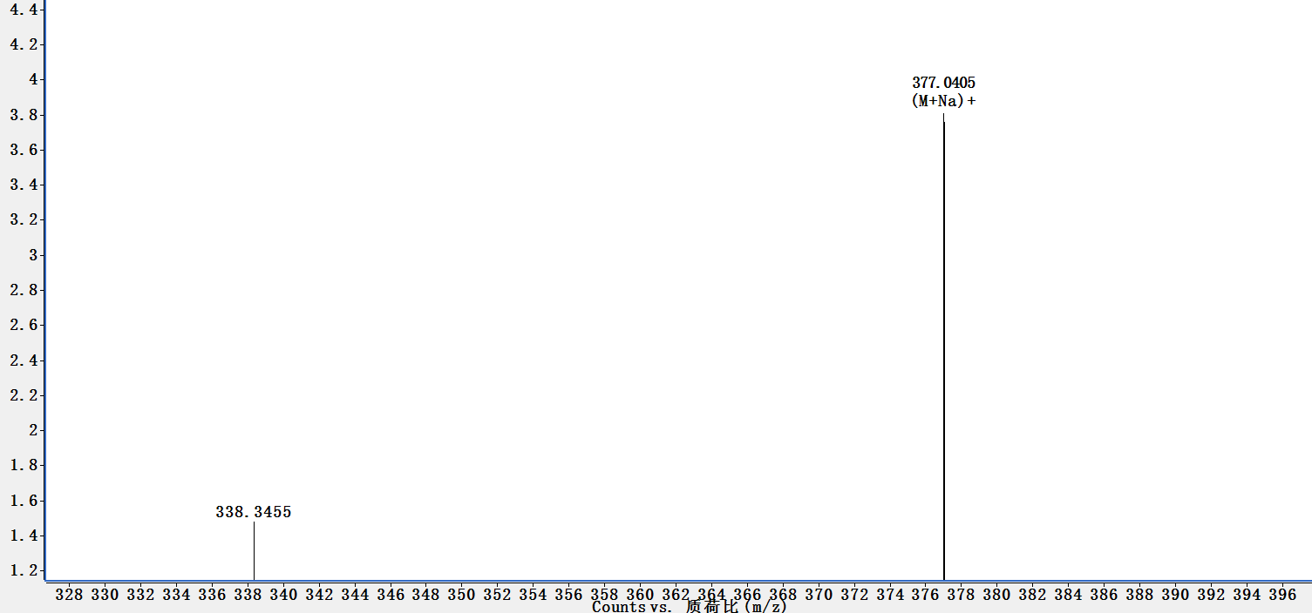
Figure S 30. HRMS (ESI) of compound 4j

Figure S 31. ¹H NMR of compound 4k
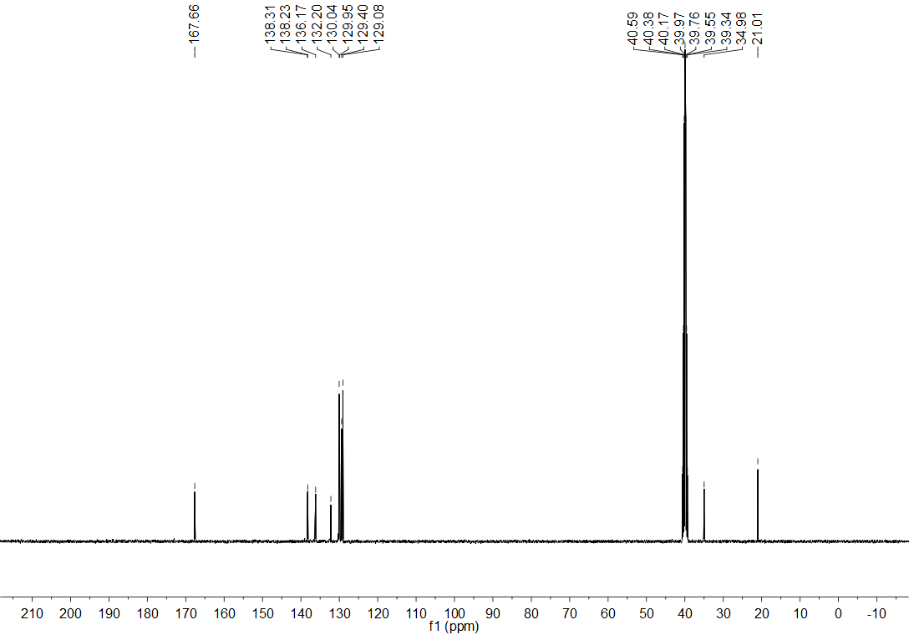
Figure S 32. ¹³C NMR of compound 4k
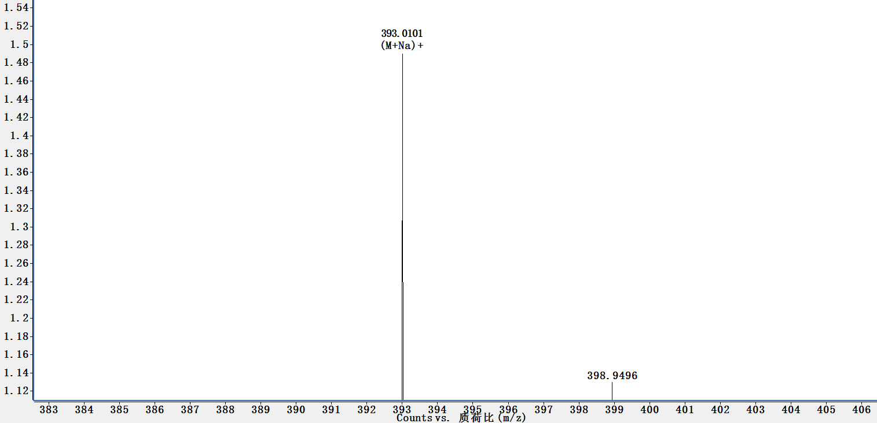
Figure S 33. HRMS (ESI) of compound 4k

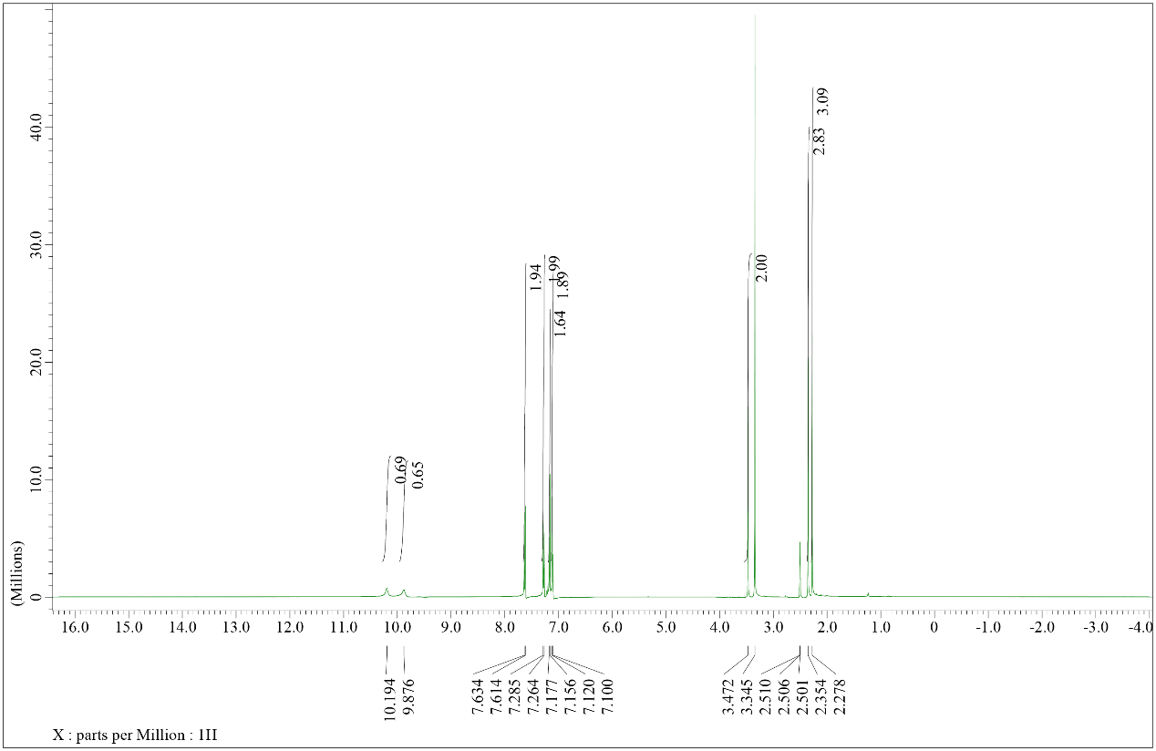
Figure S 34. ¹H NMR of compound 4l
Figure S 35. ¹³C NMR of compound 4l
Figure S 36. HRMS (ESI) of compound 4l

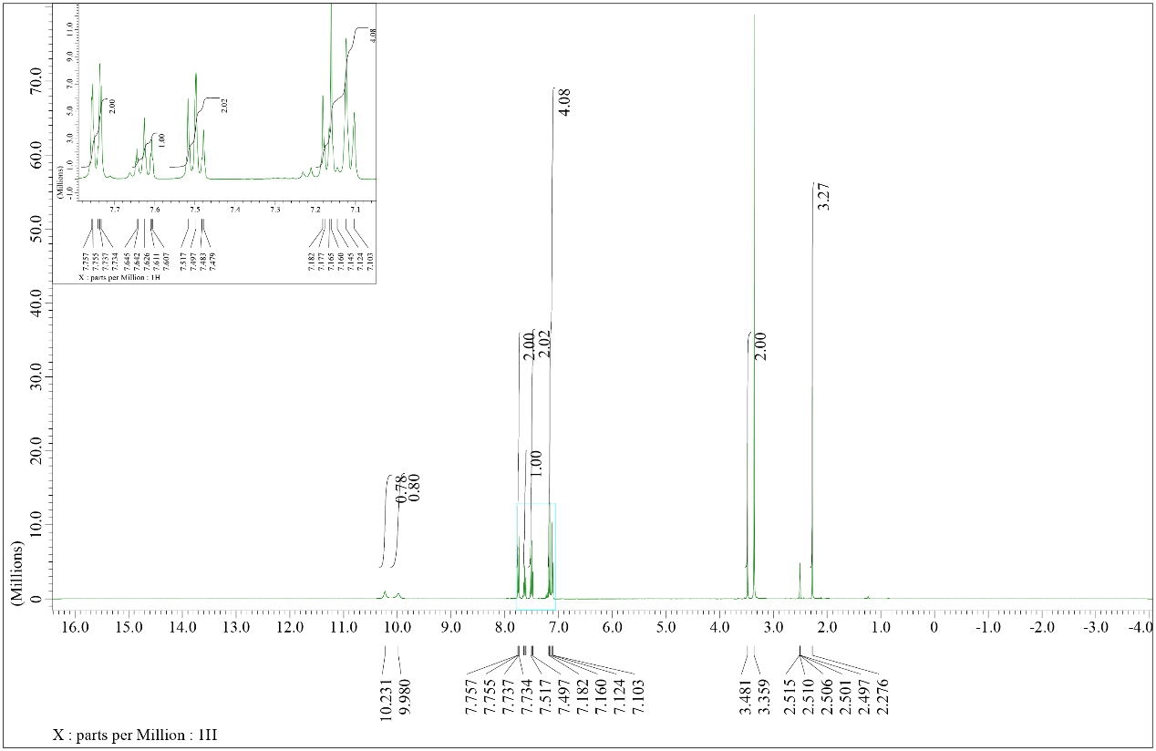
Figure S 37. ¹H NMR of compound 4m
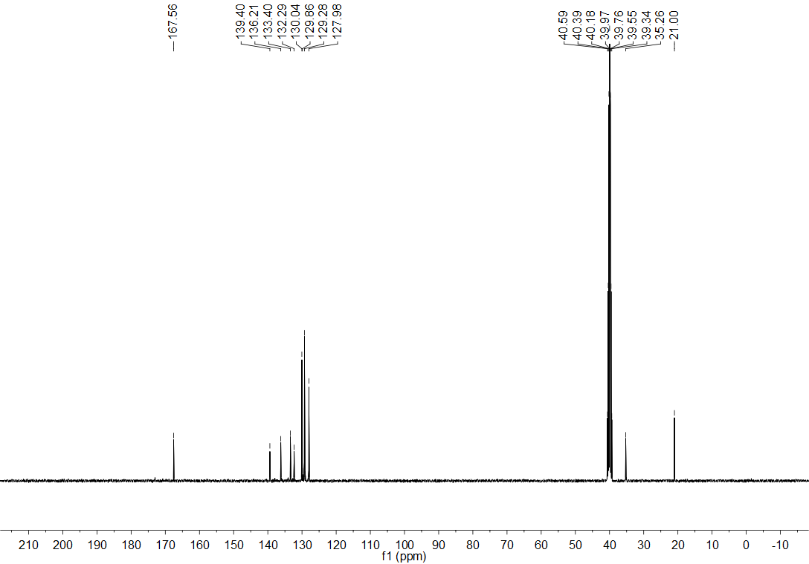
Figure S 38. ¹³C NMR of compound 4m
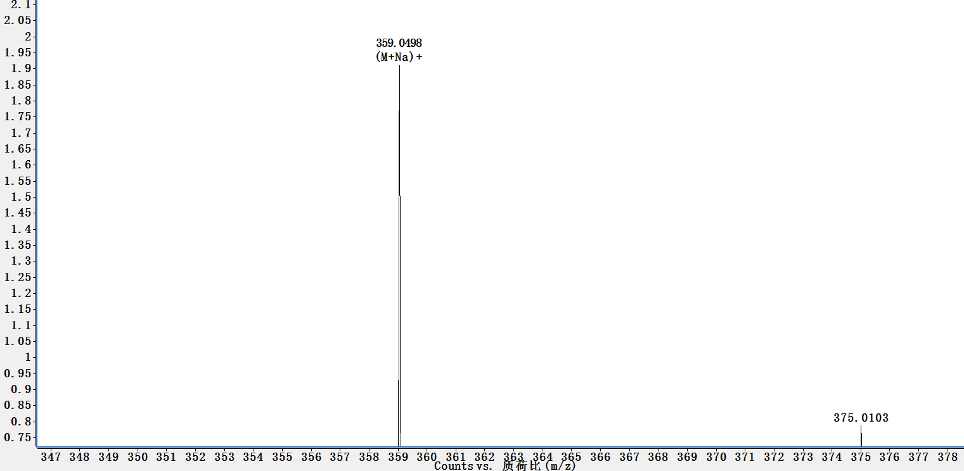
Figure S 39. HRMS (ESI) of compound 4m

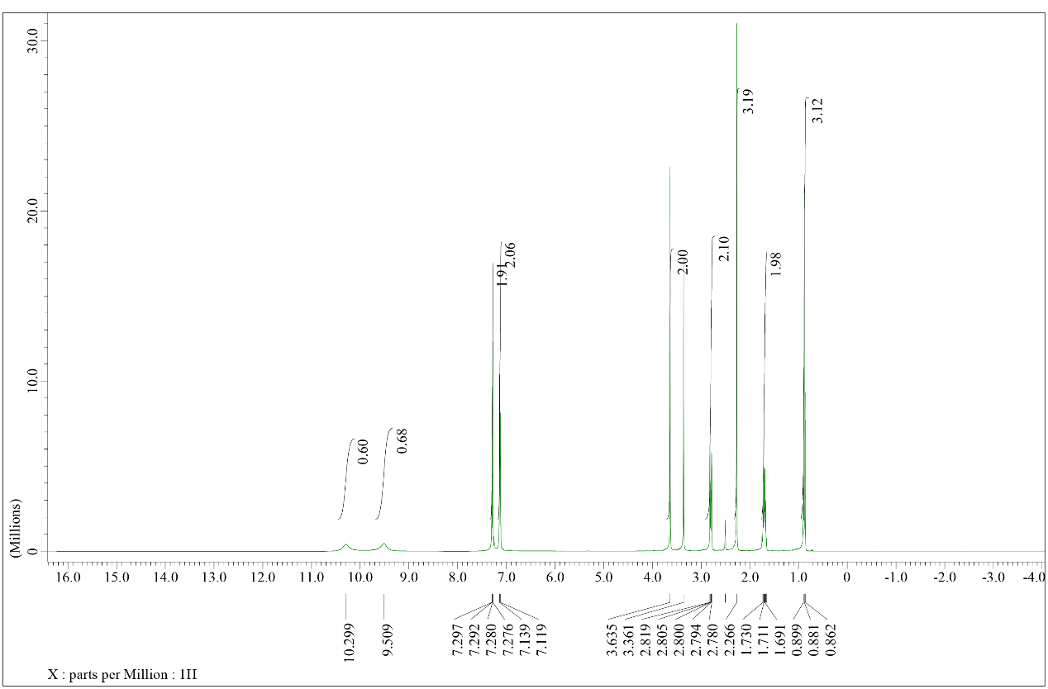
Figure S 40. ¹H NMR of compound 4n
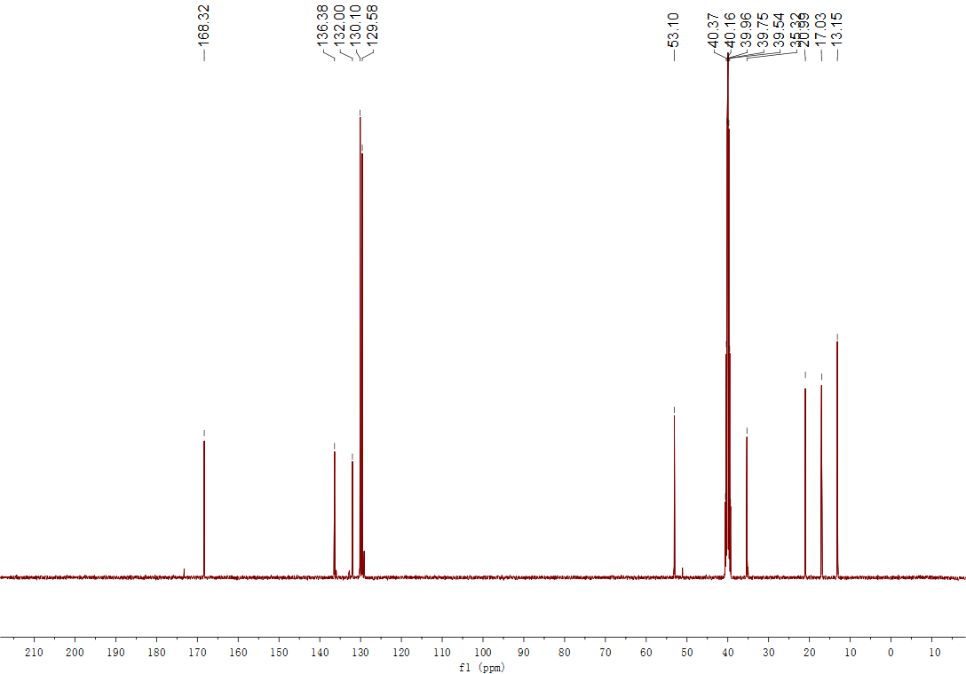
Figure S 41. ¹³C NMR of compound 4n
Figure S 42. HRMS (ESI) of compound 4n

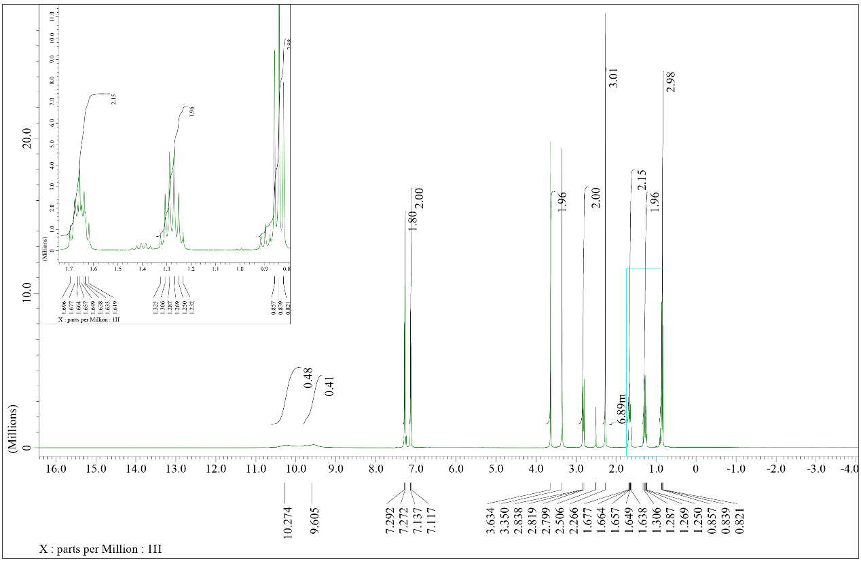
Figure S 43. ¹H NMR of compound 4o
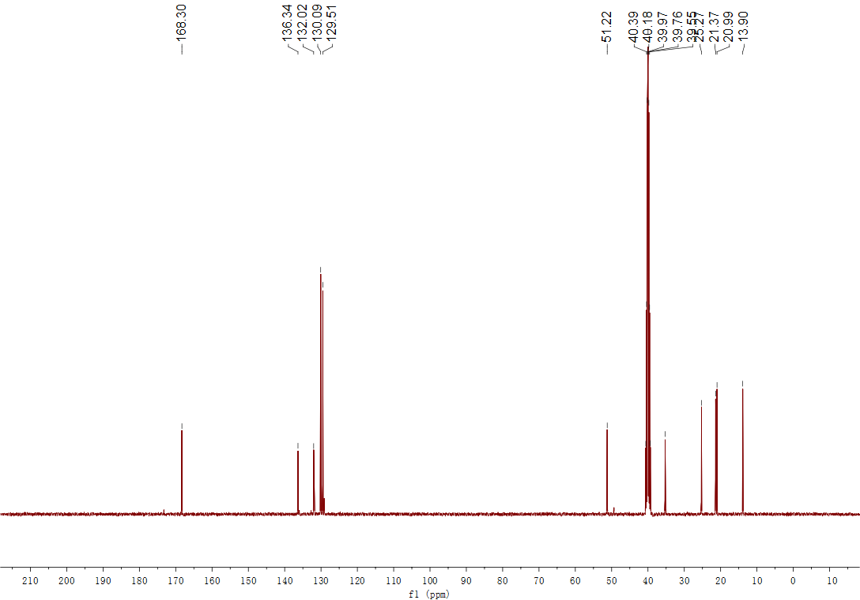
Figure S 44. ¹³C NMR of compound 4o
Figure S 45. HRMS (ESI) of compound 4o

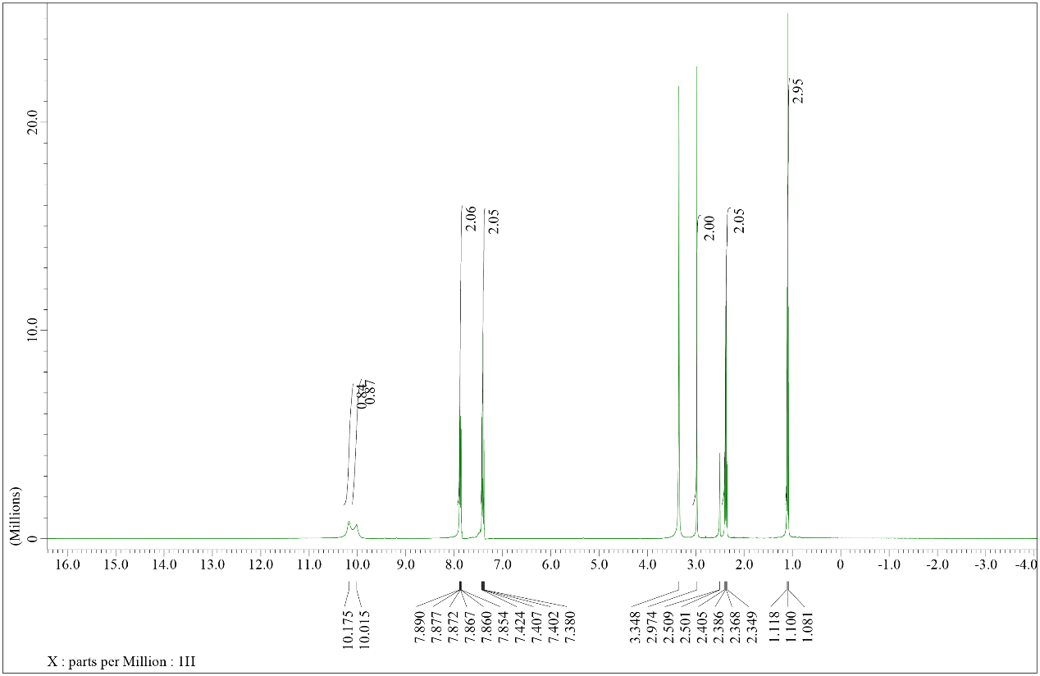
Figure S 46. ¹H NMR of compound 4p
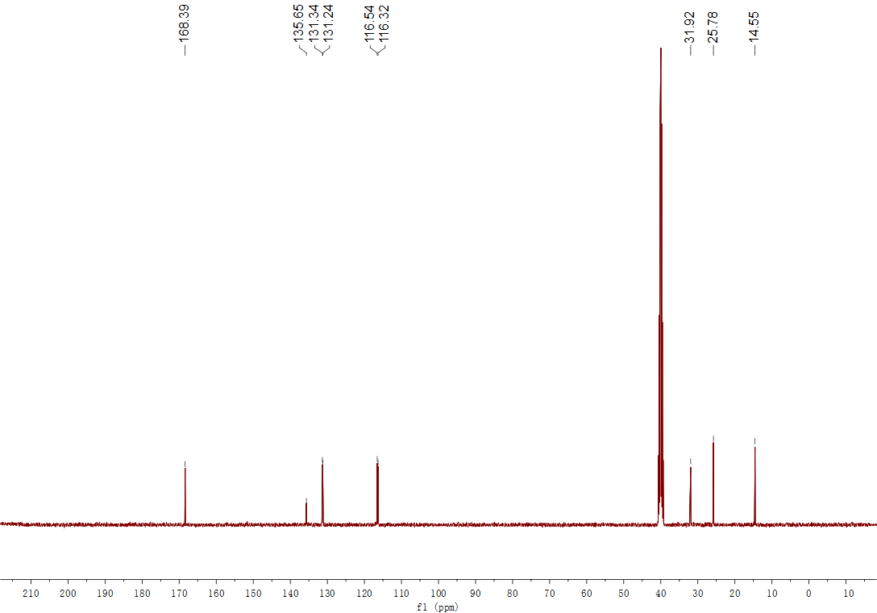
Figure S 47. ¹³C NMR of compound 4p
Figure S 48. HRMS (ESI) of compound 4p

