Supplementary Information

Competitive cascade cyclization of 2'-tosyloxychalcones: An easy access to Thioflavones and Thioaurones
Somepalli Venkateswarlu^{a,}*, Gandrotu Narasimha Murtyª, Meka Satyanarayanaª and
Vidavalur Siddaiah^{b}
ªDrug Discovery, Laila Impex Research Centre, No. 1, Phase III, Jawahar Autonagar,
Vijayawada-520 007, India
^{b}Department of Organic Chemistry, School of Chemistry, Andhra University,
Visakhapatnam 530 003, India
* Corresponding author. Tel.: +91-866-2545689; Fax: +91-866-2543484;
E-mail: drvsomepalli@gmail.com; somepalli01@rediffmail.com

Index:
- General information S2
- Characterization data of thioflavones and thioaurones. S2-S11
- Procedure for cyclization in presence of metal catalyst S11
- References S12
- ¹H-NMR and ¹³C-NMR spectrums of thioflavones and
Thioaurones. S13-S32

General information: Reagents and solvents were analytical grade and were used without further purification. Melting points were recorded on a Mel-Temp melting point apparatus, in open capillaries and are uncorrected. ¹H NMR (400 MHz), ¹³C NMR-DEPT (100 MHz) spectra were recorded on a Bruker AMX 400 MHz NMR spectrometer. The chemical shifts (δ ppm) and coupling constants (Hz) are reported in the standard fashion. In the ¹³C NMR spectra, the nature of the carbons (C, CH, CH₂ or CH₃) was determined by DEPT-135 spectra. Mass spectra were recorded on Agilent 1100 LC/MSD and HRMS were recorded on Micromass Q-TOF spectrometer using electro-spray ionization mode. 2'-Tosyloxychalcones (1) were prepared from the corresponding 2'-hydroxychalcones according to the literature procedure.¹
The following compounds were prepared as per the general procedure described in the main text.

2-Phenyl-4H-thiochromen-4-one (2a):
Pale yellow color solid (160 mg, 67%), mp 120–122 ºC (lit.² mp 121–122 ºC). ¹H NMR (400 MHz, CDCl₃): δ 8.56 (1H, dd, J = 8.0, 0.8 Hz), 7.66–7.72 (3H, m), 7.63 (1H, td, J = 7.5, 1.2 Hz), 7.56 (1H, td, J = 7.4, 1.2 Hz), 7.48–7.53 (3H, m), 7.25 (1H, s); ¹³C NMR (100 MHz, CDCl₃): δ 180.8, 152.9, 137.7, 136.6, 131.6, 131.0, 130.8, 129.3, 128.6, 127.7, 127.0, 126.5, 123.5; LC-MS (positive ion mode): m/z 239 (M+H)⁺.

(Z)-2-Benzylidenebenzo[b]thiophen-3(2H)-one (3a):
Yellow color solid (35 mg, 15%), mp 124–126 ºC (lit.³ mp 128–130 ºC). ¹H NMR (400 MHz, CDCl₃): δ 7.97 (1H, s), 7.95 (1H, d, J = 8.0 Hz), 7.72 (2H, d, J = 7.6 Hz), 7.58 (1H, td, J = 7.4, 0.8 Hz), 7.47–7.52 (3H, m), 7.40–7.44 (1H, m), 7.30 (1H, t, J = 7.4 Hz); ¹³C NMR (100 MHz, CDCl₃): δ 188.6, 146.2, 135.3, 134.4, 133.6, 131.0, 130.5, 130.3, 130.1, 129.0, 127.1, 125.6, 123.9; LC-MS (positive ion mode): m/z 239 (M+H)⁺.

2-(4-Methoxyphenyl)-4H-thiochromen-4-one (2b):
Pale yellow color solid (165 mg, 62%), mp 118–120 ºC (lit.⁴ mp 124–125 ºC). ¹H NMR (400 MHz, CDCl₃): δ 8.54 (1H, dd, J = 8.0, 0.8 Hz), 7.64–7.68 (3H, m), 7.62 (1H, td, J = 7.5, 1.6 Hz), 7.54 (1H, td, J = 7.5, 1.2 Hz), 7.21 (1H, s), 7.02 (2H, d, J = 8.8 Hz), 3.88 (3H, s); ¹³C NMR (100 MHz, CDCl₃): δ 180.9, 161.9, 152.7, 137.6, 131.5, 131.0, 128.9, 128.6, 128.3, 127.6, 126.4, 122.2, 114.7, 55.5; LC-MS (negative ion mode): m/z 267 (M–H)–.

(Z)-2-(4-Methoxybenzylidene)benzo[b]thiophen-3(2H)-one (3b):
Yellow color solid (32 mg, 12%), mp 148–152 ºC (lit.³ mp 153–154 ºC). ¹H NMR (400 MHz, CDCl₃): δ 7.95 (1H, s), 7.94 (1H, d, J = 6.0 Hz), 7.69 (2H, d, J = 8.8 Hz), 7.57 (1H, td, J = 7.5, 0.8 Hz), 7.51 (1H, d, J = 7.6 Hz), 7.30 (1H, td, J = 7.5, 0.8 Hz), 7.01 (2H, d, J = 8.4 Hz), 3.88 (3H, s); ¹³C NMR (100 MHz, CDCl₃): δ 188.6, 161.3, 146.0, 134.9, 133.7, 133.0, 130.8, 127.9, 127.1, 127.0, 125.5, 123.9, 114.7, 55.4; LC-MS (positive ion mode): m/z 269 (M+H)⁺.

2-(4-Chlorophenyl)-4H-thiochromen-4-one (2c):
Pale yellow color solid (170 mg, 63%), mp 162–164 ºC (lit.⁴ mp 161–165 ºC). ¹H NMR (400 MHz, CDCl₃): δ 8.55 (1H, d, J = 8.0 Hz), 7.62–7.67 (4H, m), 7.56 (1H, td, J = 7.5, 1.8 Hz), 7.48 (2H, d, J = 8.4 Hz), 7.20 (1H, s); ¹³C NMR (100 MHz, CDCl₃): δ 180.7, 151.5, 137.4, 137.1, 135.0, 131.7, 130.9, 129.6, 128.7, 128.2, 127.9, 126.5, 123.6; LC-MS (positive ion mode): m/z 273, 275 (M+H)⁺.

(Z)-2-(4-Chlorobenzylidene)benzo[b]thiophen-3(2H)-one (3c):
Yellow color solid (35 mg, 13%), mp 160–162 ºC (lit.⁵ mp 162–165 ºC). ¹H NMR (400 MHz, CDCl₃): δ 7.95 (1H, d, J = 7.6 Hz), 7.90 (1H, s), 7.64 (2H, d, J = 8.4 Hz), 7.60 (1H, td, J = 8.0, 1.2 Hz), 7.51 (1H, d, J = 8.0 Hz), 7.46 (2H, d, J = 8.4 Hz), 7.32 (1H, t, J = 7.4 Hz); ¹³C NMR (100 MHz, CDCl₃): δ 188.5, 145.8, 136.2, 135.4, 132.9, 132.0, 131.9, 130.9, 130.3, 129.4, 127.2, 125.8, 124.0; LC-MS (positive ion mode): m/z 273, 275 (M+H)⁺.

2-(p-Tolyl)-4H-thiochromen-4-one (2d):
Pale yellow color solid (165 mg, 66%), mp 110–112 ºC (lit.⁴ 118–119 ºC). ¹H NMR (400 MHz, CDCl₃): δ 8.55 (1H, d, J = 8.0 Hz), 7.59–7.67 (4H, m), 7.55 (1H, t, J = 7.4 Hz), 7.31 (2H, d, J = 8.0 Hz), 7.24 (1H, s), 2.43 (3H, s); ¹³C NMR (100 MHz, CDCl₃): δ 180.9, 153.1, 141.3, 137.7, 133.8, 131.5, 131.0, 130.0, 128.6, 127.7, 126.8, 126.4, 122.9, 21.4; LC-MS (positive ion mode): m/z 253 (M+H)⁺.

(Z)-2-(4-Methylbenzylidene)benzo[b]thiophen-3(2H)-one (3d):
Yellow color solid (42 mg, 17%), mp 126–128 ºC (lit.³ mp 134–136 ºC). ¹H NMR (400 MHz, CDCl₃): δ 7.95 (1H, s), 7.94 (1H, d, J = 8.8 Hz), 7.62 (2H, d, J = 8.0 Hz), 7.57 (1H, td, J = 7.5, 1.2 Hz), 7.51 (1H, d, J = 8.0 Hz), 7.28–7.31 (3H, m), 2.41 (3H, s); ¹³C NMR (100 MHz, CDCl₃): δ 188.7, 146.1, 140.9, 135.1, 133.8, 131.6, 131.1, 130.7, 129.8, 129.3, 127.0, 125.5, 123.9, 21.6; LC-MS (positive ion mode): m/z 253 (M+H)⁺.

2-(3-Nitrophenyl)-4H-thiochromen-4-one (2e):
Pale yellow color solid (180 mg, 64%), mp 178–180 ºC (lit.⁶ mp 176 ºC). ¹H NMR (400 MHz, CDCl₃): δ 8.55–8.58 (2H, m), 8.39 (1H, dd, J = 8.4, 2.0 Hz), 8.03 (1H, d, J = 8.0 Hz), 7.73 (1H, t, J = 8.0 Hz), 7.66–7.70 (2H, m), 7.58–7.63 (1H, m), 7.28 (1H, s); ¹³C NMR (100 MHz, CDCl₃): δ 180.5, 149.8, 148.8, 138.3, 136.9, 132.7, 132.0, 130.8, 130.5, 128.8, 128.3, 126.6, 125.2, 124.7, 122.1; LC-MS (positive ion mode): m/z 284 (M+H)⁺.

(Z)-2-(3-Nitrobenzylidene)benzo[b]thiophen-3(2H)-one (3e):
Yellow color solid (32 mg, 11%), mp 238–240 ºC (lit.⁷ mp 229 ºC). ¹H NMR (400 MHz, DMSO-d₆): δ 8.63 (1H, s), 8.33 (1H, dd, J = 7.8, 1.0 Hz), 8.23 (1H, d, J = 8.0 Hz), 8.08 (1H, s), 7.92 (1H, d, J = 7.6 Hz), 7.84–7.89 (2H, m), 7.78 (1H, t, J = 7.4 Hz), 7.45 (1H, t, J =7.4 Hz); ¹³C NMR (100 MHz, DMSO-d₆): δ 187.5, 148.3, 144.7, 136.7, 136.5, 135.4, 132.3, 130.8, 130.4, 129.2, 126.8, 126.6, 124.8, 124.5, 124.4; LC-MS (positive ion mode): m/z 284 (M+H)⁺.

2-(4-(Dimethylamino)phenyl)-4H-thiochromen-4-one (2f):
Yellow color solid (191 mg, 68%), mp 168–170 ºC. ¹H NMR (400 MHz, CDCl₃): δ 8.52 (1H, d, J = 8.0 Hz), 7.55–7.63 (4H, m), 7.50 (1H, t, J = 7.4 Hz), 7.20 (1H, s), 6.74 (2H, d, J = 8.8 Hz), 3.04 (6H, s); ¹³C NMR (100 MHz, CDCl₃): δ 180.9, 153.3, 152.2, 137.7, 131.2, 131.1, 128.4, 127.8, 127.3, 126.3, 123.3, 120.1, 112.0, 40.1; LC-MS (positive ion mode): m/z 282 (M+H)⁺; HRMS-(EI) (m/z): (M+Na)⁺ calcd for C₁₇H₁₅NOSNa 304.0772, found 304.0769.

(Z)-2-(4-(Dimethylamino)benzylidene)benzo[b]thiophen-3(2H)-one (3f):
Red color solid (64 mg, 23%), mp 158–160 ºC (lit.⁸ mp 170 ºC). ¹H NMR (400 MHz, CDCl₃): δ 7.96 (1H, s), 7.94 (1H, d, J = 8.8 Hz), 7.64 (2H, d, J = 8.8 Hz), 7.50–7.56 (2H, m), 7.28–7.30 (1H, m), 6.76 (2H, d, J = 8.8 Hz), 3.08 (6H, s); ¹³C NMR (100 MHz, CDCl₃): δ 188.3, 151.6, 145.9, 135.2, 134.0, 133.4, 131.4, 126.7, 125.1, 124.8, 123.8, 122.1, 112.0, 40.0; LC-MS (positive ion mode): m/z 282 (M+H)⁺.

7-Methoxy-2-(4-methoxyphenyl)-4H-thiochromen-4-one (2g):
Pale yellow color solid (200 mg, 67%), mp 126–128 ºC (lit.⁹ mp 136-138 ºC). ¹H NMR (400 MHz, CDCl₃): δ 8.46 (1H, d, J = 8.8 Hz), 7.64 (2H, d, J = 8.8 Hz), 7.13 (1H, s), 7.09 (1H, dd, J = 8.8, 2.4 Hz), 7.04 (1H, d, J = 2.4 Hz), 7.00 (2H, d, J = 8.8 Hz), 3.92 (3H, s), 3.87 (3H, s); ¹³C NMR (100 MHz, CDCl₃): δ 180.4, 161.9, 161.8, 151.6, 139.8, 130.5, 128.9, 128.3, 124.8, 122.3, 116.3, 114.7, 108.6, 55.7, 55.5; LC-MS (positive ion mode): m/z 299 (M+H)⁺.

(Z)-6-Methoxy-2-(4-methoxybenzylidene)benzo[b]thiophen-3(2H)-one (3g):
Yellow color solid (48 mg, 16%), mp 122–124 ºC. ¹H NMR (400 MHz, CDCl₃): δ 7.88 (1H, s), 7.87 (1H, d, J = 8.8 Hz), 7.66 (2H, d, J = 8.8 Hz), 7.00 (2H, d, J = 8.8 Hz), 6.96 (1H, d, J = 2.0 Hz), 6.82 (1H, dd, J = 8.4, 2.0 Hz), 3.91 (3H, s), 3.88 (3H, s); ¹³C NMR (100 MHz, CDCl₃): δ 187.1, 165.5, 161.1, 148.8, 132.8, 132.6, 128.5, 128.4, 127.2, 124.3, 114.6, 113.3, 107.6, 55.8, 55.4; LC-MS (positive ion mode): m/z 299 (M+H)⁺; HRMS-(EI) (m/z): (M+Na)⁺ calcd for C₁₇H₁₄O₃SNa 321.0561, found 321.0566.

2-(4-Bromophenyl)-7-methoxy-4H-thiochromen-4-one (2h):
Pale yellow color solid (200 mg, 58%), mp 144–146 ºC. ¹H NMR (400 MHz, CDCl₃): δ 8.45 (1H, d, J = 8.8 Hz), 7.63 (2H, d, J = 8.4 Hz), 7.53 (2H, d, J = 8.8 Hz), 7.12 (1H, s), 7.10 (1H, dd, J = 8.8, 2.4 Hz), 7.04 (1H, d, J = 2.4 Hz), 3.92 (3H, s); ¹³C NMR (100 MHz, CDCl₃): δ 180.1, 162.1, 150.5, 139.5, 135.5, 132.5, 130.6, 128.4, 125.2, 124.7, 123.6, 116.6, 108.6, 55.7; LC-MS (positive ion mode): m/z 347, 349 (M+H)⁺; HRMS-(EI) (m/z): (M+Na)⁺ calcd for C₁₆H₁₁BrO₂SNa 368.9561, 370.9541 found 368.9559, 370.9533.

(Z)-2-(4-Bromobenzylidene)-6-methoxybenzo[b]thiophen-3(2H)-one (3h):
Yellow color solid (45 mg, 13%), mp 196–198 ºC. ¹H NMR (400 MHz, CDCl₃): δ 7.87 (1H, d, J = 8.8 Hz), 7.81 (1H, s), 7.60 (2H, d, J = 8.8 Hz), 7.53 (2H, d, J = 8.4 Hz), 6.94 (1H, d, J = 2.0 Hz), 6.83 (1H, dd, J = 8.6, 2.0 Hz), 3.92 (3H, s); ¹³C NMR (100 MHz, CDCl₃): δ 186.8, 165.9, 148.6, 133.4, 132.3, 132.0, 131.6, 130.9, 128.7, 124.2, 123.8, 113.5, 107.8, 55.9; LC-MS (positive ion mode): m/z 347, 349 (M+H)⁺; HRMS-(EI) (m/z): (M+H)⁺ calcd for C₁₆H₁₂BrO₂S 346.9741, 348.9721 found 346.9738, 348.9715.

6-Chloro-2-(4-methoxyphenyl)-4H-thiochromen-4-one (2i):
Pale yellow color solid (200 mg, 66%), mp 182–184 ºC (lit.⁹ mp 190-192 ºC). ¹H NMR (400 MHz, CDCl₃): δ 8.50 (1H, s), 7.64 (2H, d, J = 8.4 Hz), 7.54–7.59 (2H, m), 7.19 (1H, s), 7.01 (2H, d, J = 8.8 Hz), 3.88 (3H, s); ¹³C NMR (100 MHz, CDCl₃): δ 179.6, 162.1, 152.8, 135.7, 134.2, 132.1, 131.8, 128.5, 128.3, 128.2, 127.8, 122.0, 114.8, 55.5; LC-MS (positive ion mode): m/z 303, 305 (M+H)⁺.

(Z)-5-Chloro-2-(4-methoxybenzylidene)benzo[b]thiophen-3(2H)-one (3i):
Yellow color solid (40 mg, 13%), mp 188–190 ºC. ¹H NMR (400 MHz, CDCl₃): δ 7.95 (1H, s), 7.90 (1H, d, J = 2.4 Hz), 7.66 (2H, d, J = 8.4 Hz), 7.52 (1H, dd, J = 8.4, 2.0 Hz), 7.44 (1H, d, J = 8.4 Hz), 7.01 (2H, d, J = 8.8 Hz), 3.88 (3H, s); ¹³C NMR (100 MHz, CDCl₃): δ 187.3, 161.6, 144.1, 134.8, 134.7, 133.1, 132.3, 131.9, 127.8, 126.8, 126.7, 124.8, 114.8, 55.5; LC-MS (positive ion mode): m/z 303, 305 (M+H)⁺; HRMS-(EI) (m/z): (M+Na)⁺ calcd for C₁₆H₁₁ClO₂SNa 325.0066, 327.0036 found 325.0068, 327.0040.

Procedure for cyclization in presence of metal catalyst: To a solution of 2'-tosyloxychalcone (1, 1 mmol) in dry DMSO (5 mL) was added sulphur powder (160 mg, 5 mmol), Cu(OAc)₂ (181.6 mg 1 mmol), and triethylamine (0.69 mL, 5 mmol) successively at rt. The mixture was stirred at 80ºC for 2 h and poured into ice cold water (40 mL). The mixture was stirred for 15 min and extracted with ethyl acetate (3 × 50 mL). The combined EtOAc layer was washed with water (50 mL), brine (50 mL), and dried over sodium sulfate. The solution was filtered and evaporated the solvent. The residue was chromatographed over silica gel column using hexane: ethyl acetate mixture as eluents to give thioaurone (3a), as a yellow color solid (24 mg, 10%), mp 126–128 ºC (lit.³ mp 128–130ºC). Further elution of the column with the same solvent system gave thioflavone (2a), as a pale yellow color solid (167 mg, 70%), mp 120–122 ºC (lit.² mp 121–122 ºC).
References
- Gormley, T. R.; O’Sullivan, W. I. Tetrahedron 1973, 29, 369–373.
- Wang, H. -K.; Bastow, K. F.; Cosentino, L. M.; Lee, K. -H. J. Med. Chem. 1996, 39, 1975–1980.
- Cabiddu, M. G.; Cabiddu, S.; Cadoni, E.; Montis, S. D.; Fattuoni, C.; Melis, S.; Usai, M. Synthesis 2002, 875–878.
- Lee, J. I. Bull Korean Chem. Soc. 2009, 30, 710–712.
- Kamila, S.; Mukherjee, C.; Pradhan, T. K.; De, A. Arkivoc 2006, part ii, 45–60.
- Bossert, F. J. Liebigs Ann. Chem. 1965, 680, 40-51.
- Mohamed, B., Ghali A. H., Maria D., Abdelali, K., Mohamed, E. Y. Mediterr. J. Chem. 2015, 4, 9-17.
- Maerz, B.; Wiedbrauk, S.; Oesterling, S.; Samoylova, E.; Nenov, A.; Mayer, P.; Regina, V. -R.; Zinth, W.; Dube, H. Chem. Eur. J. 2014, 20, 13984–13992.
- Yang, X.; Li, S.; Liu, H.; Jiang, Y.; Fu, H. RSC Adv. 2012, 2, 6549-6554.

¹H-spectrum of 2-Phenyl-4H-thiochromen-4-one.
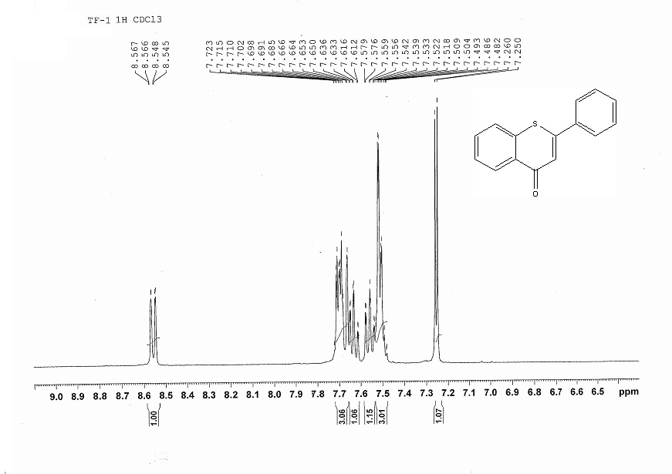
¹³C-spectrum of 2-Phenyl-4H-thiochromen-4-one.
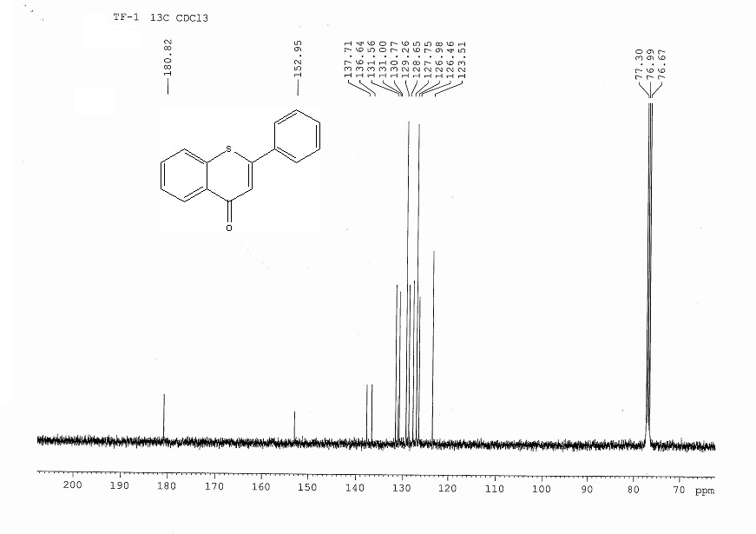
¹H-spectrum (Z)-2-Benzylidenebenzo[b]thiophen-3(2H)-one.
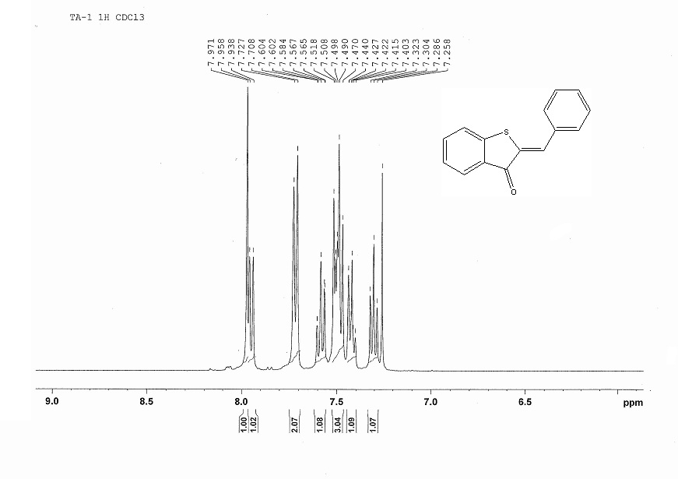
¹³C-spectrum (Z)-2-Benzylidenebenzo[b]thiophen-3(2H)-one.
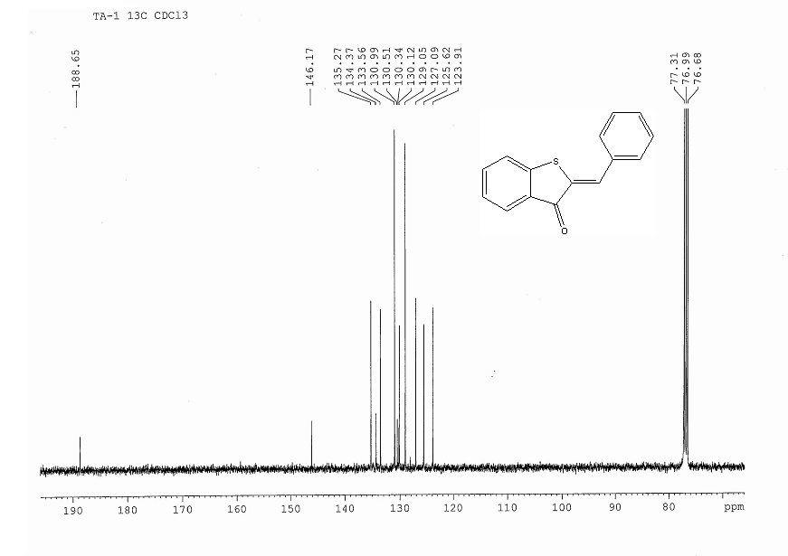
¹H-NMR spectrum of 2-(4-Methoxyphenyl)-4H-thiochromen-4-one.
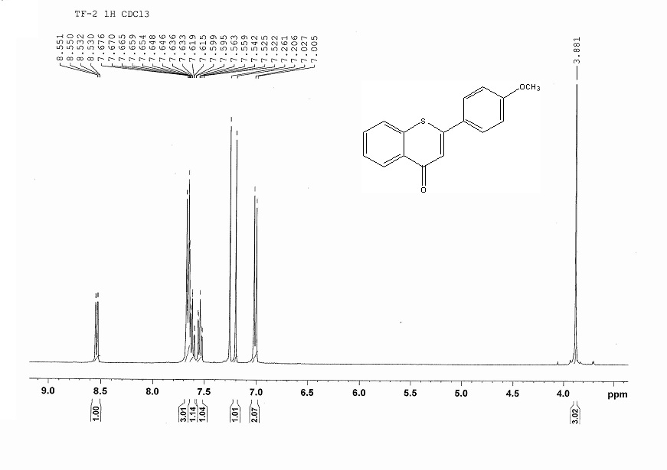
¹³C-NMR spectrum of 2-(4-Methoxyphenyl)-4H-thiochromen-4-one.
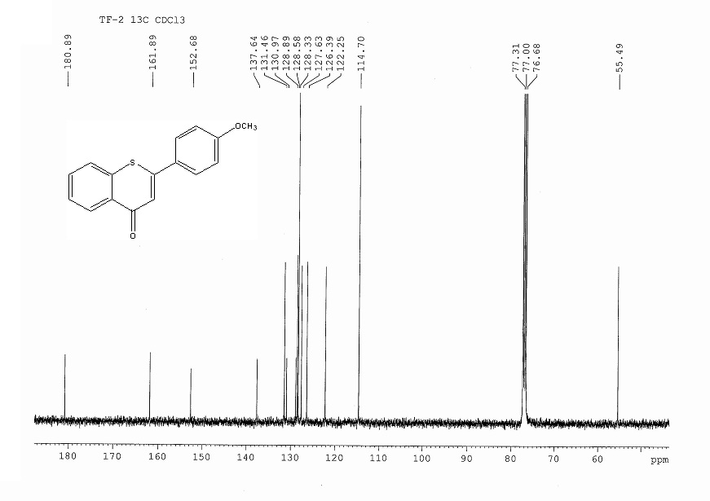
¹H-NMR spectrum (Z)-2-(4-Methoxybenzylidene)benzo[b]thiophen-3(2H)-one.
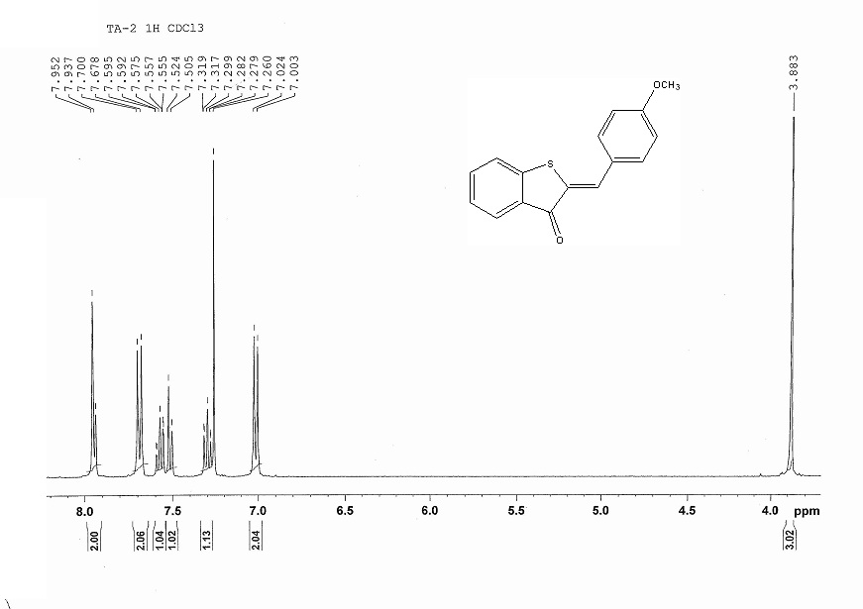
¹³C-NMR spectrum (Z)-2-(4-Methoxybenzylidene)benzo[b]thiophen-3(2H)-one.
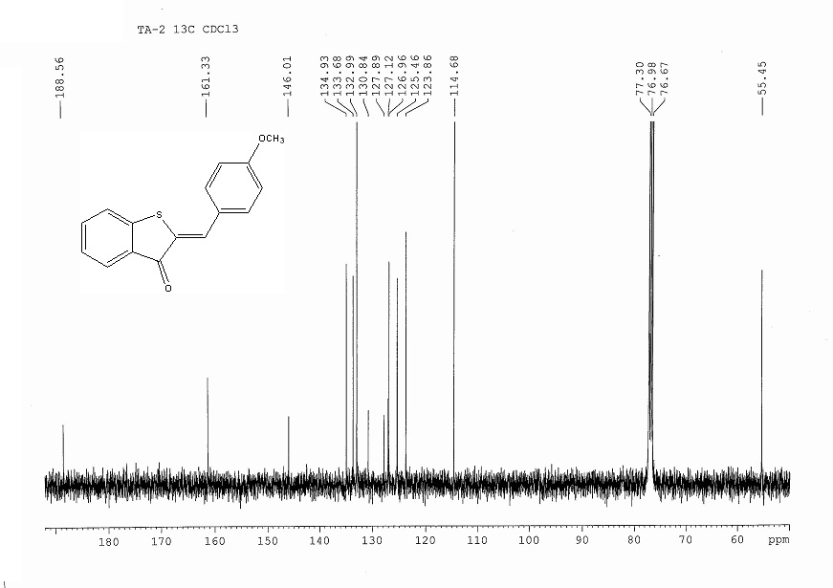
¹H-NMR spectrum 2-(4-Chlorophenyl)-4H-thiochromen-4-one.
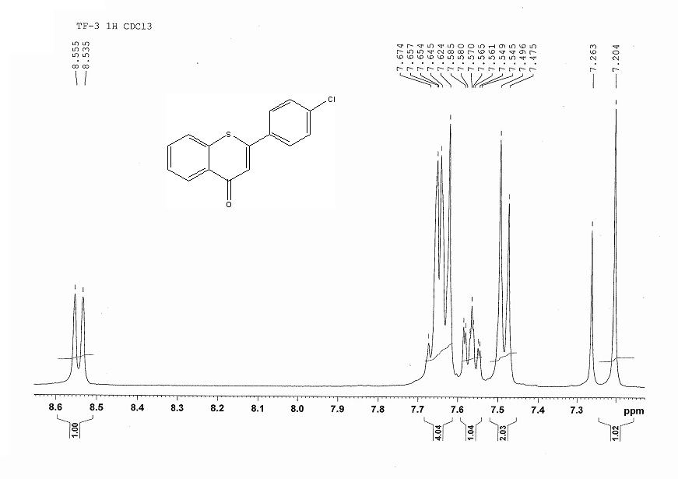
¹³C-NMR spectrum 2-(4-Chlorophenyl)-4H-thiochromen-4-one.
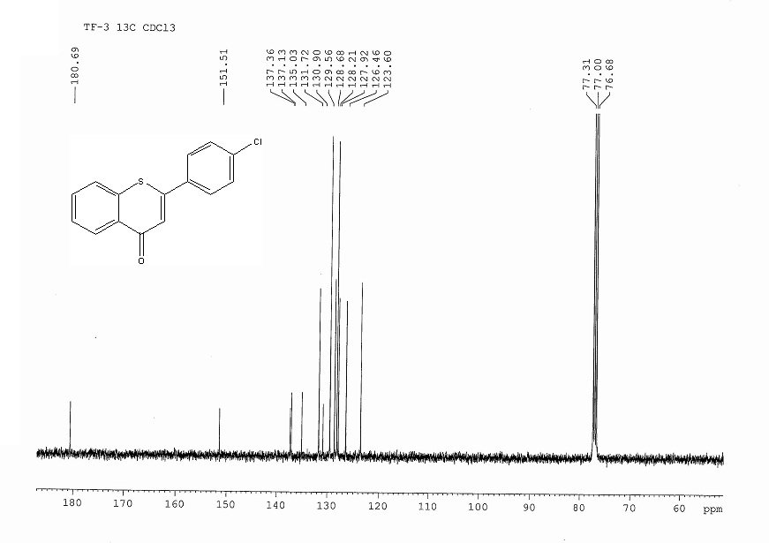
¹H-NMR spectrum (Z)-2-(4-Chlorobenzylidene)benzo[b]thiophen-3(2H)-one.
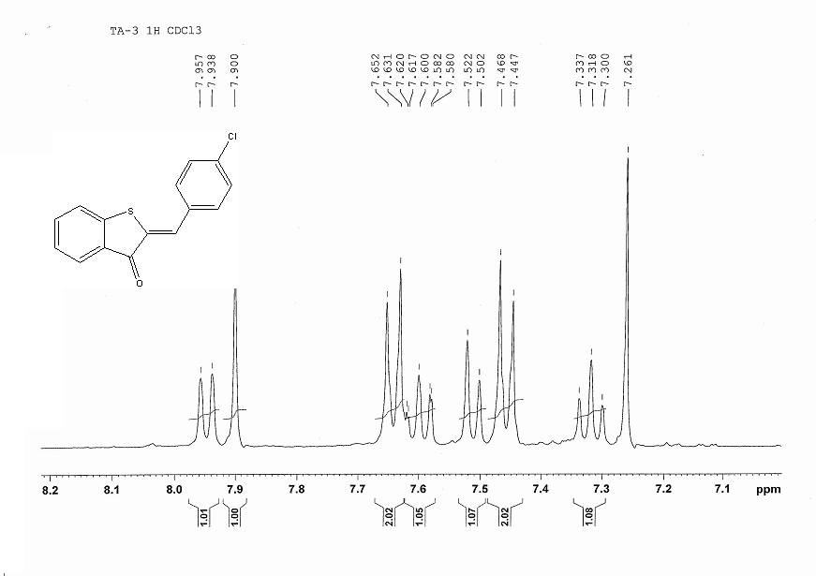
¹³C-NMR spectrum (Z)-2-(4-Chlorobenzylidene)benzo[b]thiophen-3(2H)-one.
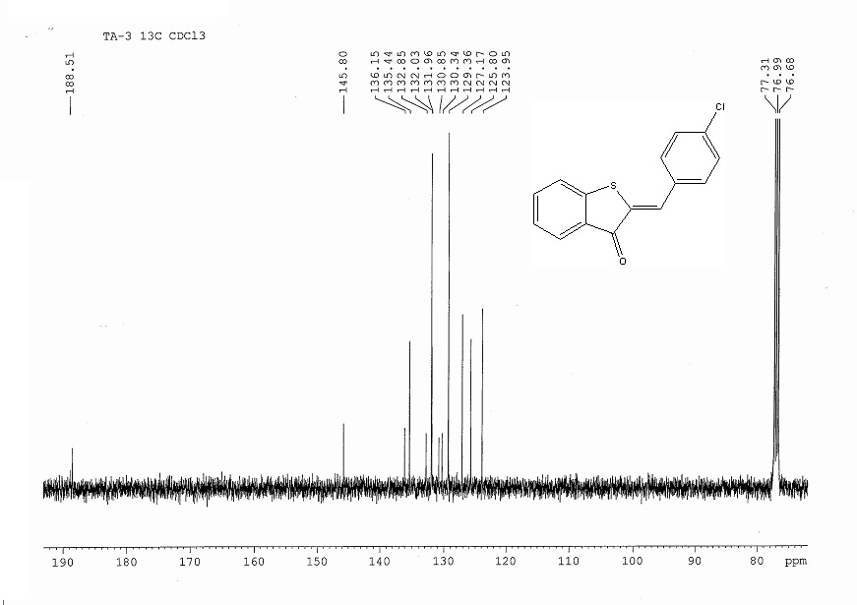
¹H-NMR spectrum of 2-(p-Tolyl)-4H-thiochromen-4-one.
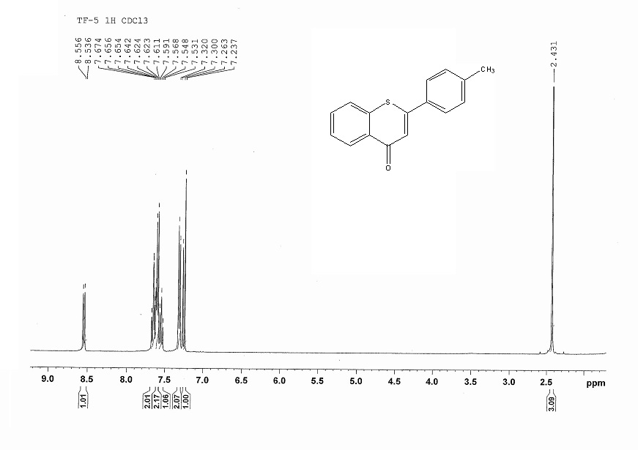
¹³C-NMR spectrum of 2-(p-Tolyl)-4H-thiochromen-4-one.
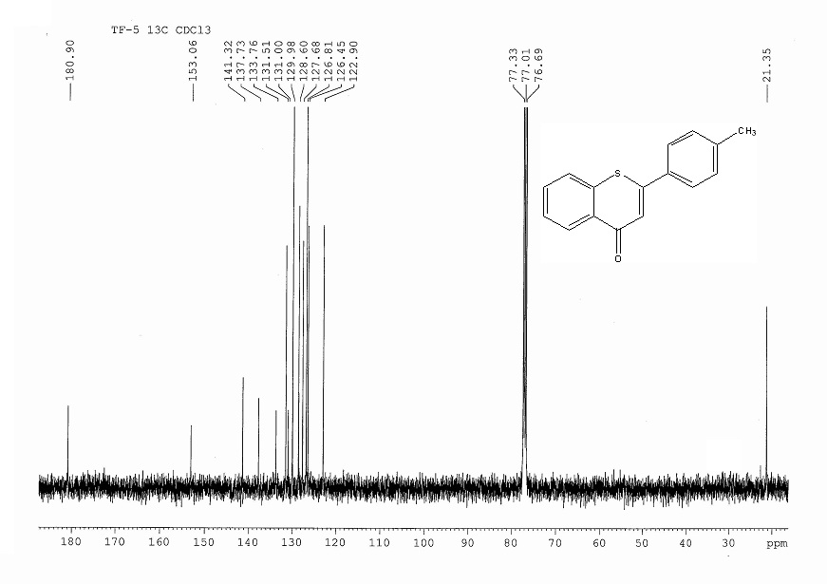
¹H-NMR spectrum of (Z)-2-(4-Methylbenzylidene)benzo[b]thiophen-3(2H)-one.
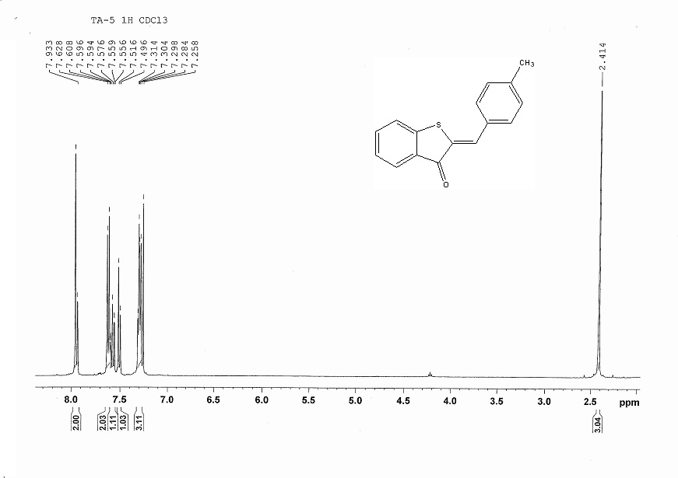
¹³C-NMR spectrum of (Z)-2-(4-Methylbenzylidene)benzo[b]thiophen-3(2H)-one.
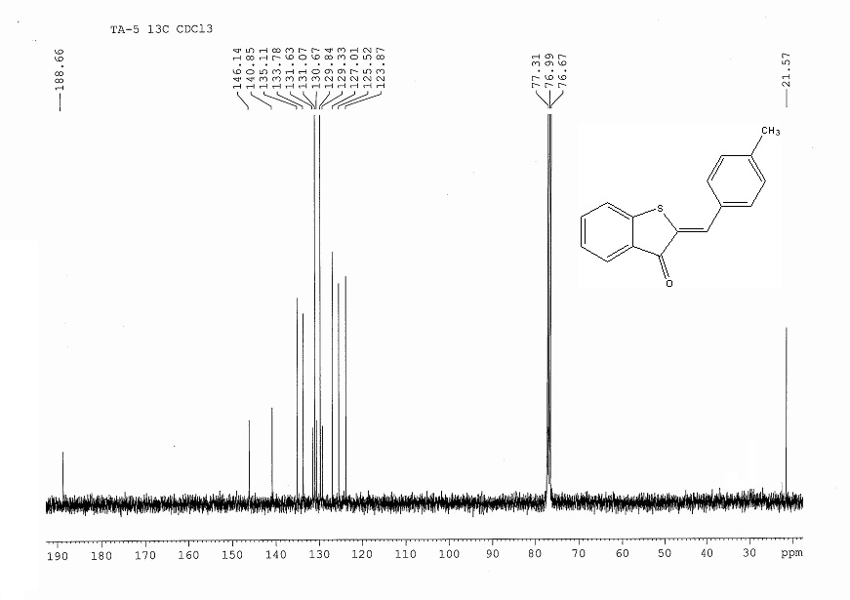
¹H-NMR spectrum of 2-(3-Nitrophenyl)-4H-thiochromen-4-one.
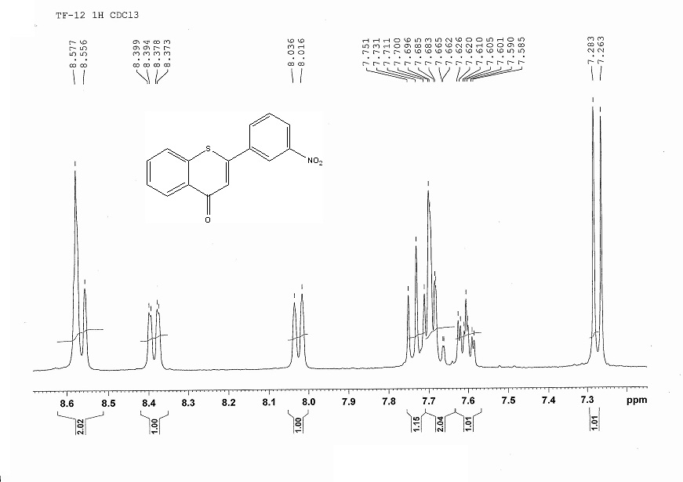
¹³C-NMR spectrum of 2-(3-Nitrophenyl)-4H-thiochromen-4-one.
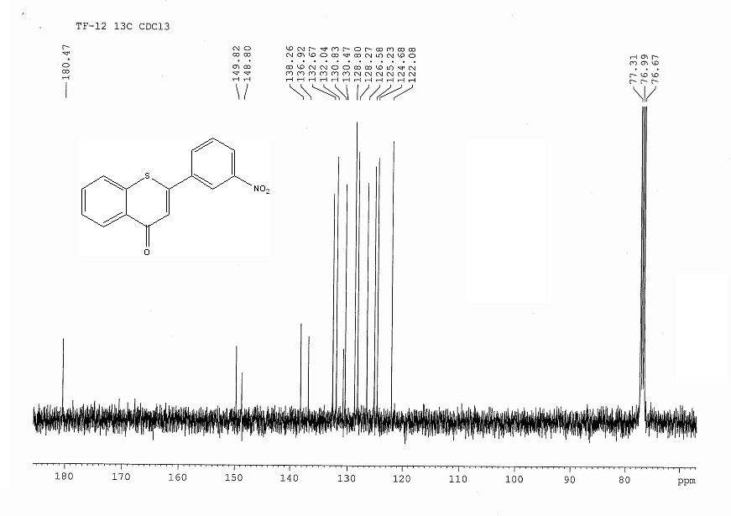
¹H-NMR spectrum of (Z)-2-(3-Nitrobenzylidene)benzo[b]thiophen-3(2H)-one.
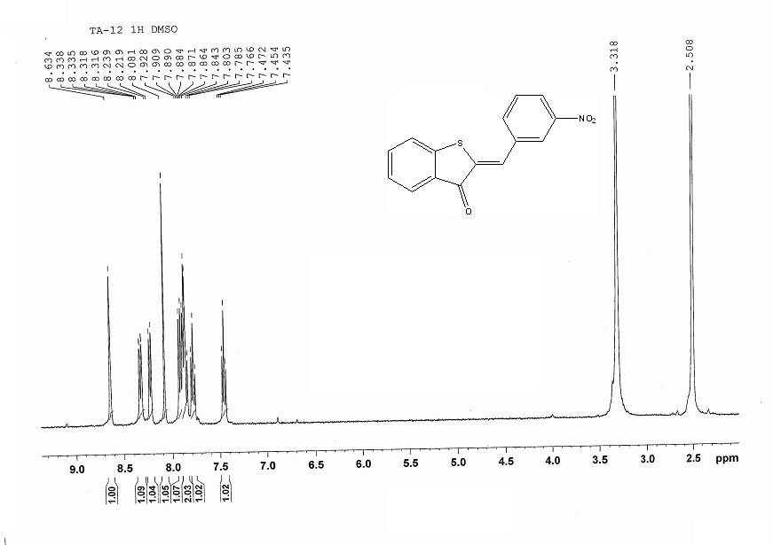
¹³C-NMR spectrum of (Z)-2-(3-Nitrobenzylidene)benzo[b]thiophen-3(2H)-one.
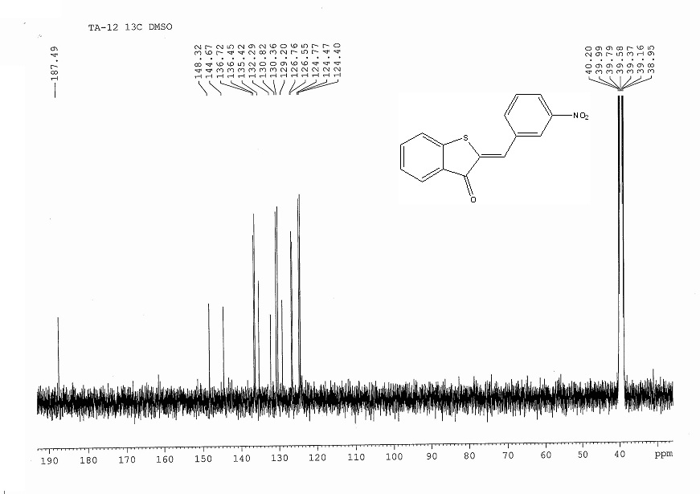
¹H-NMR spectrum of 2-(4-(Dimethylamino)phenyl-4H-thiochromen-4-one.
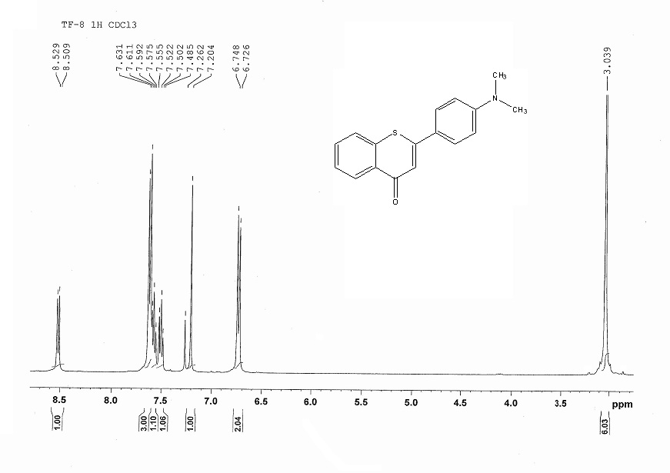
¹³C-NMR spectrum of 2-(4-(Dimethylamino)phenyl-4H-thiochromen-4-one.
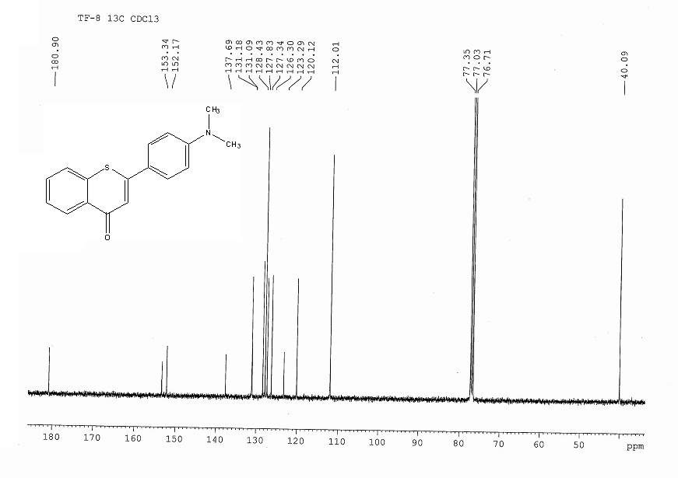
¹H-NMR spectrum of (Z)-2-(4-Dimethylamino)benzylidene)benzo[b]thiophen-3(2H)-one
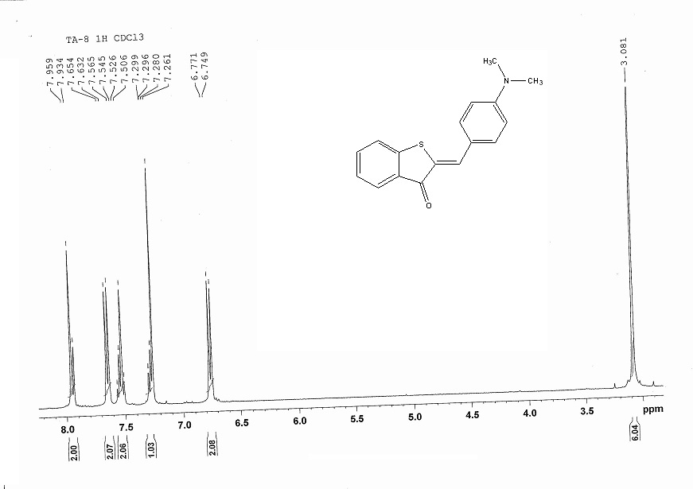
¹³C-NMR spectrum of (Z)-2-(4-Dimethylamino)benzylidene)benzo[b]thiophen-3(2H)-one.
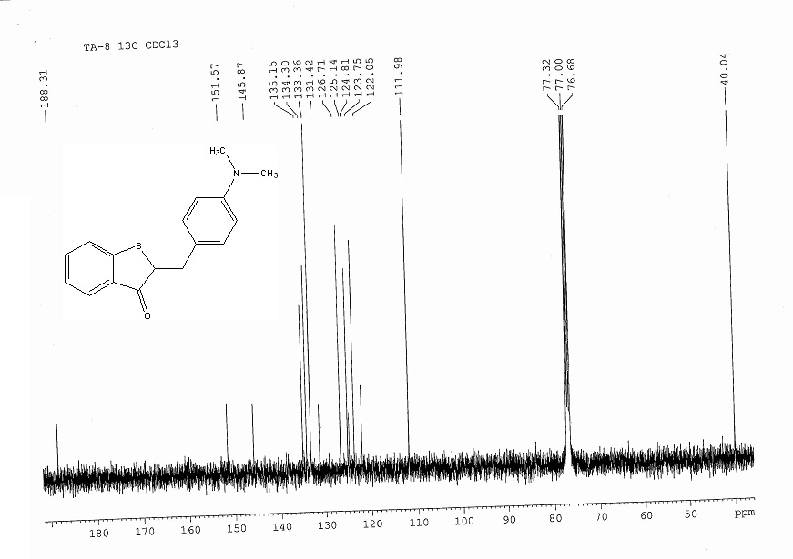
¹H-NMR spectrum of 7-Methoxy-2-(4-methoxyphenyl)-4H-thiochromen-4-one.
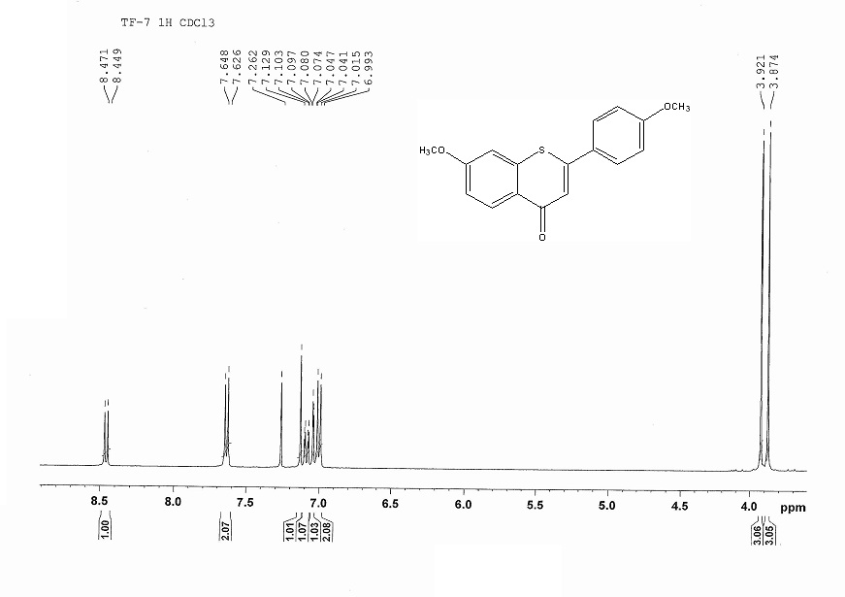
¹³C-NMR spectrum of 7-Methoxy-2-(4-methoxyphenyl)-4H-thiochromen-4-one.
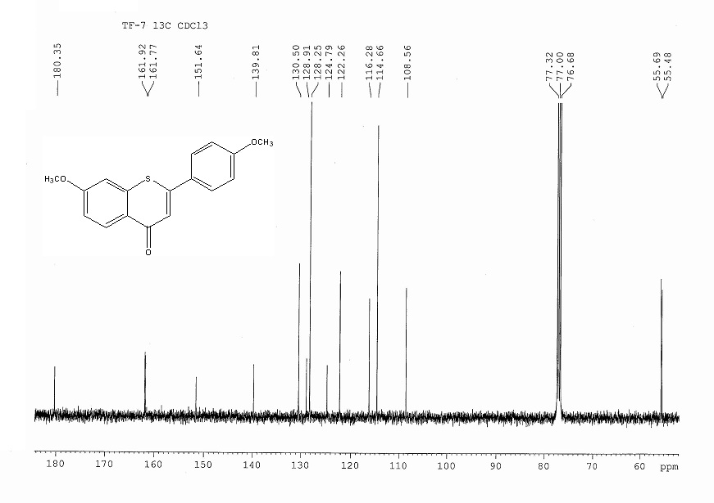
¹H-NMR spectrum of (Z)-6-Methoxy-2-(4-methoxybenzylidene)benzo[b]thiophen-3(2H)-one.
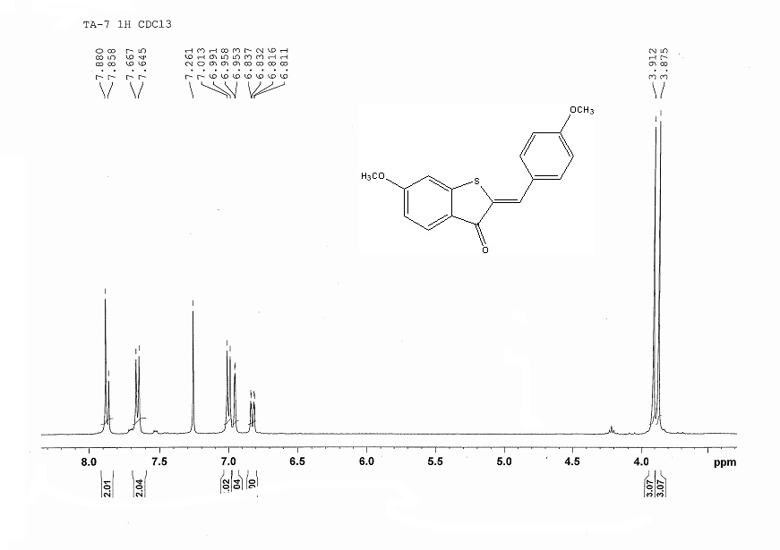
¹³C-NMR spectrum of (Z)-6-Methoxy-2-(4-methoxybenzylidene)benzo[b]thiophen-3(2H)-one.
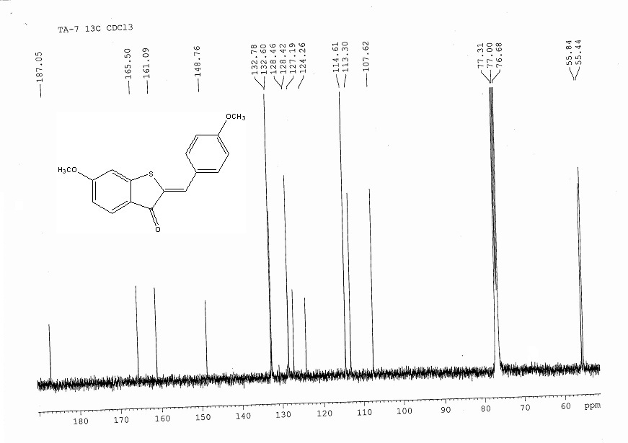
¹H-NMR spectrum of 2-(4-Bromophenyl)-7-methoxy-4H-thiochromen-4-one.
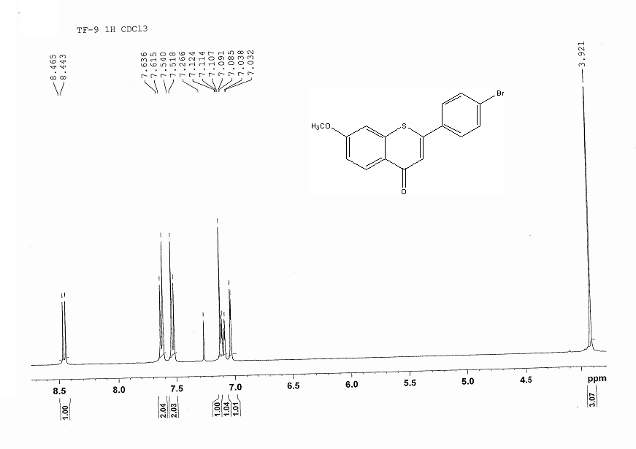
¹³C-NMR spectrum of 2-(4-Bromophenyl)-7-methoxy-4H-thiochromen-4-one.
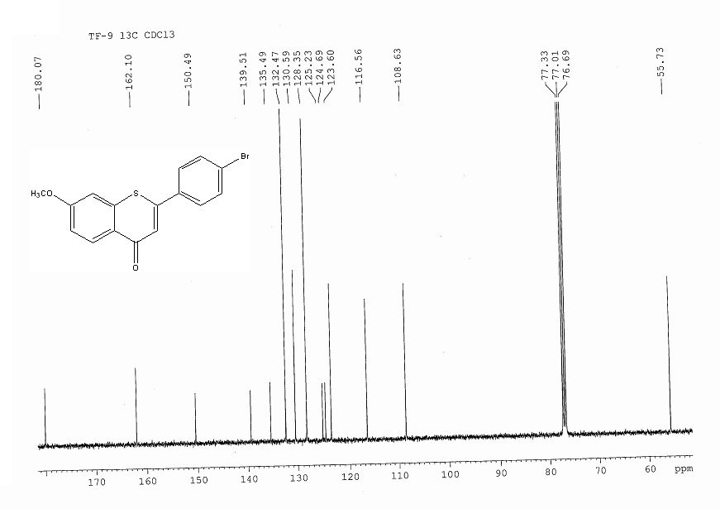
¹H-NMR spectrum of (Z)-2-(4-Bromobenzylidene)-6-methoxybenzo[b]thiophen-3(2H)-one.
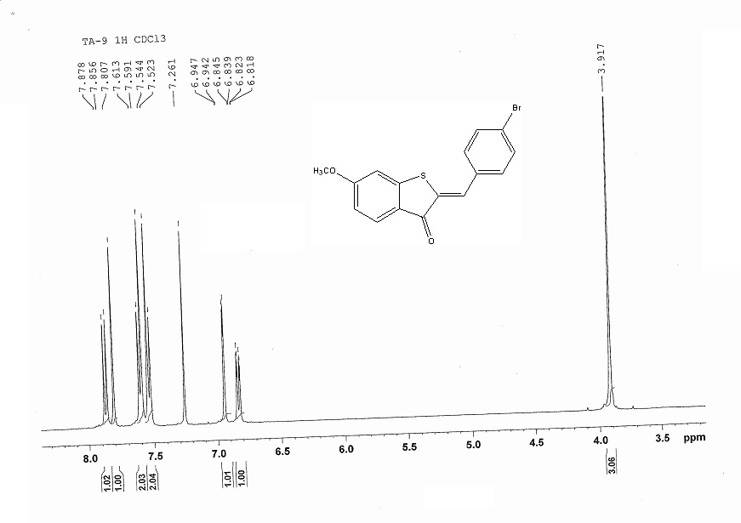
¹³C-NMR spectrum of (Z)-2-(4-Bromobenzylidene)-6-methoxybenzo[b]thiophen-3(2H)-one.
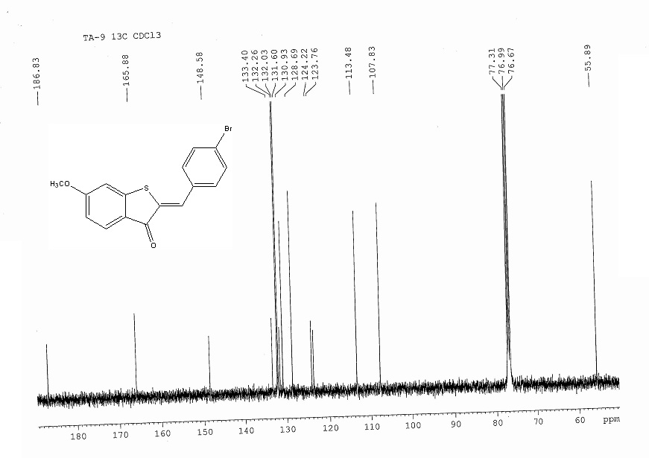

¹H-NMR spectrum of 6-Chloro-2-(4-methoxyphenyl)-4H-thiochromen-4-one.
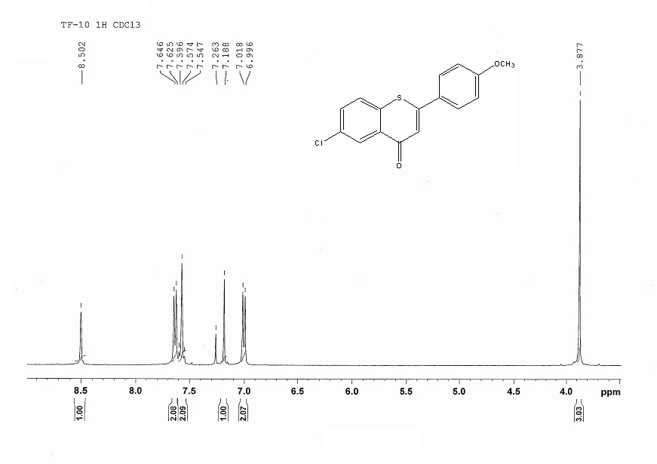
¹³C-NMR spectrum of 6-Chloro-2-(4-methoxyphenyl)-4H-thiochromen-4-one.
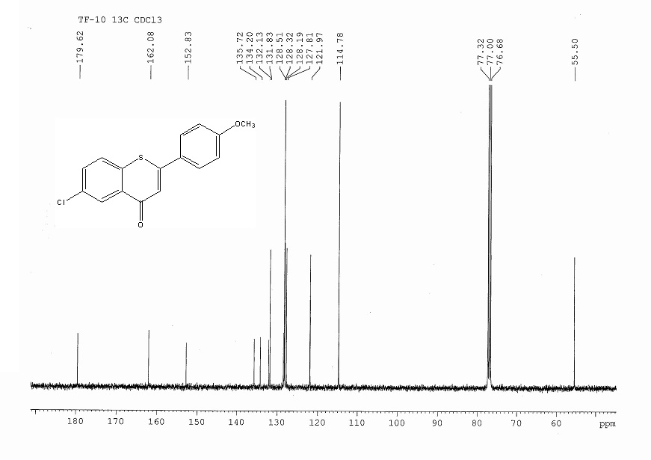
¹H-NMR spectrum of (Z)-5-Chloro-2-(4-methoxybenzylidene)benzo[b]thiophen-3(2H)-one.
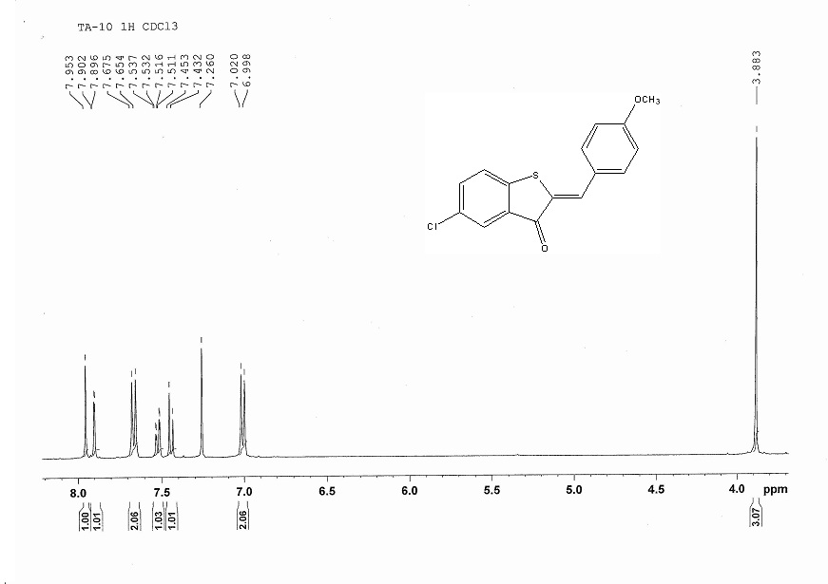
¹³C-NMR spectrum of (Z)-5-Chloro-2-(4-methoxybenzylidene)benzo[b]thiophen-3(2H)-one.
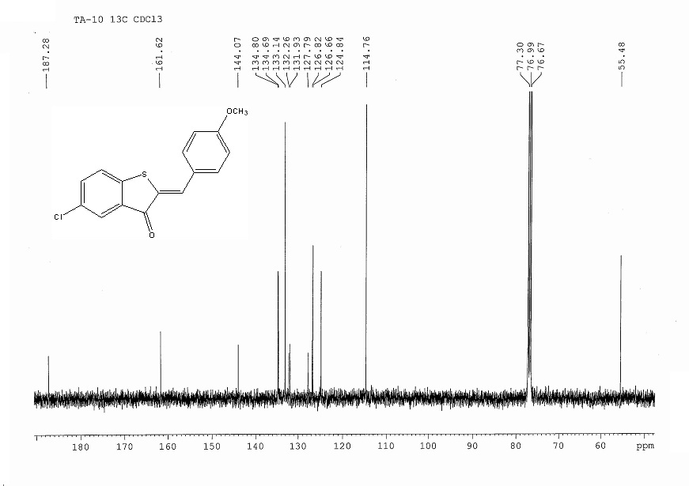

¹H-NMR spectrum of 6-Chloro-2-(3,4-dimethoxyphenyl)-4H-thiochromen-4-one.
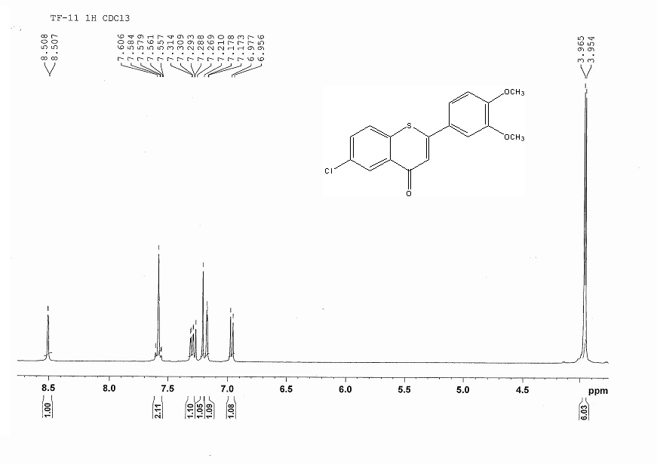
¹³C-NMR spectrum of 6-Chloro-2-(3,4-dimethoxyphenyl)-4H-thiochromen-4-one.
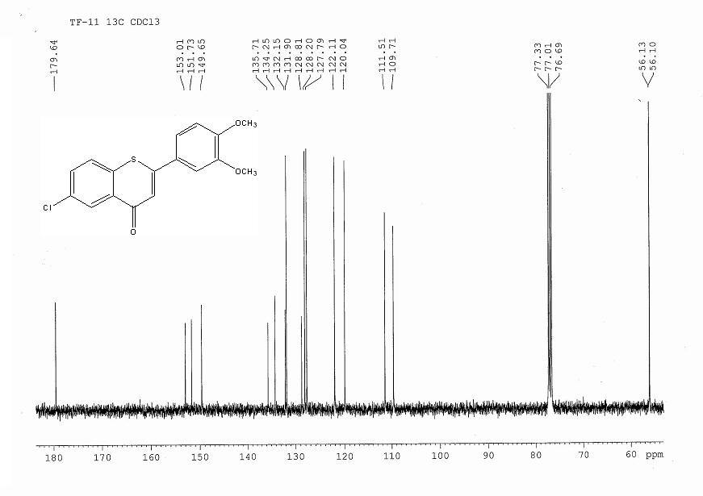
¹H-NMR spectrum of (Z)-5-Chloro-2-(3,4-dimethoxybenzylidene)benzo[b]thiophen-3(2H)-one.
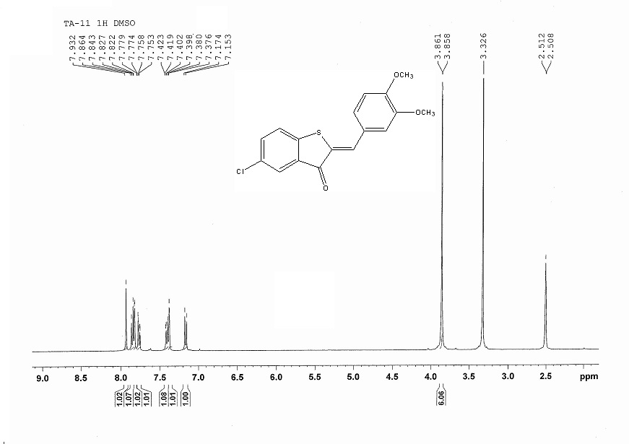
¹³C-NMR spectrum of (Z)-5-Chloro-2-(3,4-dimethoxybenzylidene)benzo[b]thiophen-3(2H)-one.
