**Supplemental material**



Fig 2c,2d: Kinetics of arsenic (V) adsorption on black tea iron oxide nanoparticles c) Concentration on adsorbent d) Kinetic model for Pseudo-first order model

 

Fig 3c,3d: Kinetics of arsenic (V) adsorption on Oak leaves iron oxide nanoparticles c) Concentration on adsorbent d) Kinetic model for Pseudo-first order

 

Fig 4c, 4d: Kinetics of arsenic (V) adsorption on Green tea leaves iron oxide nanoparticles c) Concentration on adsorbent d) Kinetic model for Pseudo-first order



Fig 5c, 5d: Kinetics of arsenic (V) adsorption on Pomegranate leaves iron oxide nanoparticles c) concentration on adsorbent d) Kinetic model for Pseudo-second order.

 

Fig 6: Kinetics of arsenic (V) adsorption on Eucalyptus leaves iron oxide nanoparticles c) Concentration on adsorbent d) Kinetic model for Pseudo-first order

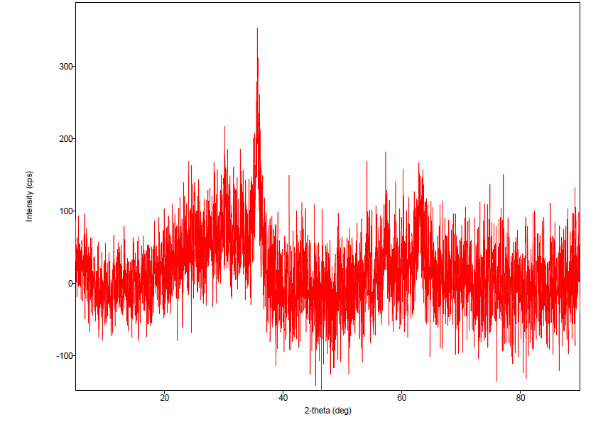

Fig 19b: XRD pattern of the pomegranate leaf FeNP (raw, not smoothened)