Appendix
Figure A1. Sled crash pulse
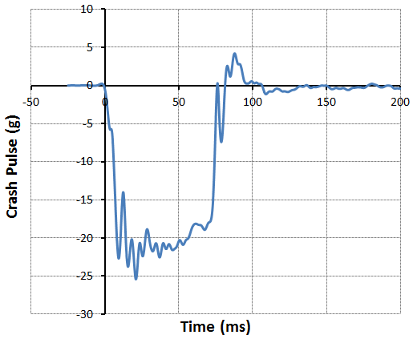

Figure A2. ATD kinematics in five sled tests
Test Condition and  Injury Measure | WC1022 | WC1023 | WC1106 | WC1107 | WC1109
ATD & Belt fit | 50M-Good | 50M-Poor | 50M-Poor | 50M-None | 5F-Poor
Airbag firing time | 12 ms | 12 ms | 42 ms | 42 ms | 42 ms
ATD kinematics at the maximal head/torsion excursions | 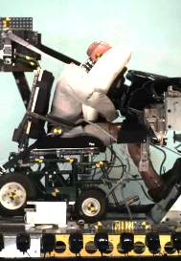 | 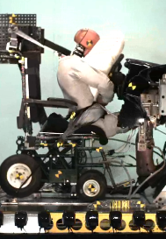 | 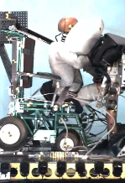 | 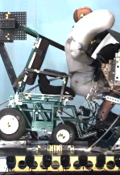 | 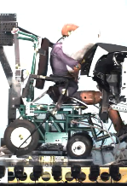

Figure A3. Comparison of occupant kinematics between sled tests and MADYMO simulations
 | WC1022  Midsize male with good belt fit |  | WC1023  Midsize male with poor belt fit |  | WC1109  Small female with poor belt fit
 | Test | Simulation | Test | Simulation | Test | Simulation
0 ms | 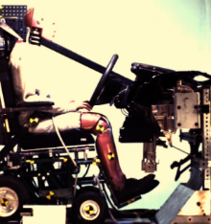 | 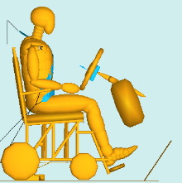 | 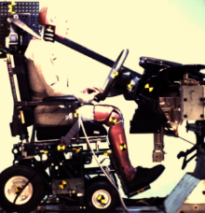 | 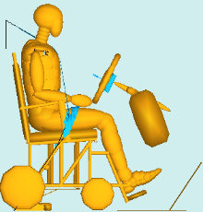 | 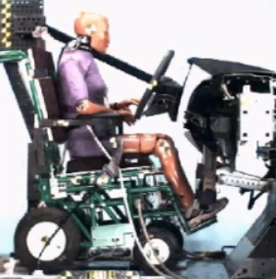 | 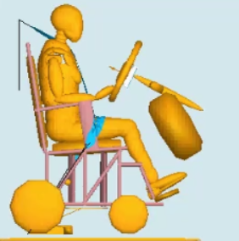
30 ms | 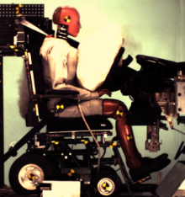 | 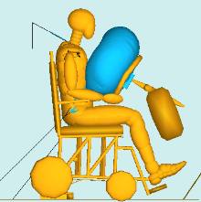 | 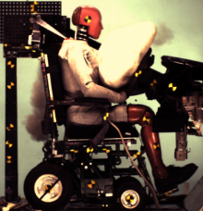 | 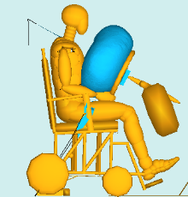 | 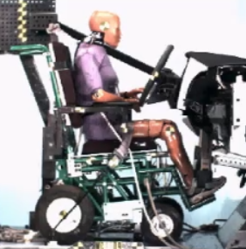 | 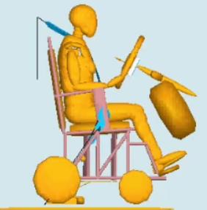
60 ms | 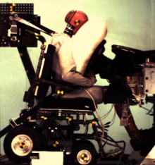 | 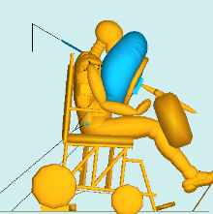 | 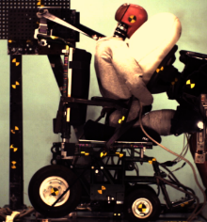 | 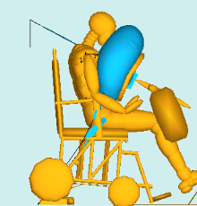 | 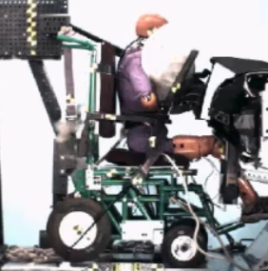 | 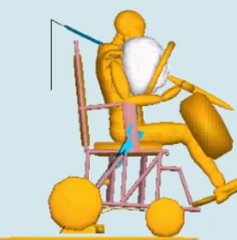
90 ms | 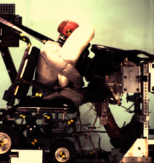 | 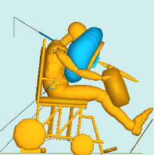 | 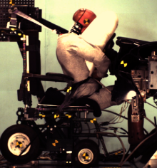 | 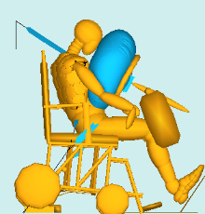 | 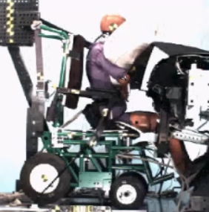 | 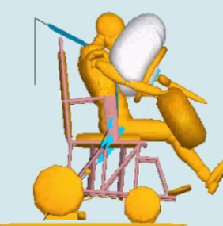
120 ms | 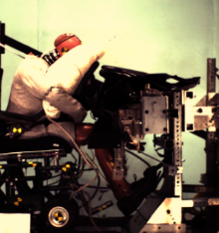 | 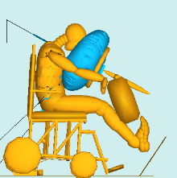 | 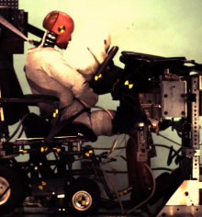 | 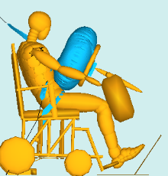 | 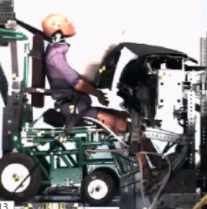 | 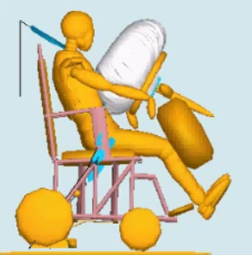

Table A1. Model-predicted injury measures in two parametric studies
 | ATD | Angle (degrees) | Belt fit | Airbag | HIC 15 | Nij | Chest D (mm) | Left Femur F (N) | Right Femur F (N)
Parametric Study #1 | 5F | 0 | Good | Yes | 124 | 0.37 | 43 | 1,892 | 1,893
 | 5F | 0 | Poor | Yes | 133 | 0.45 | 37.2 | 3,200 | 3,057
 | 5F | 0 | No belt | Yes | 29 | 0.26 | 37.9 | 4,225 | 4,210
 | 5F | 0 | Good | No | 381 | 0.41 | 33.5 | 1,634 | 2,693
 | 5F | 0 | Poor | No | 284 | 0.27 | 33.1 | 3,457 | 3,684
 | 5F | 0 | No belt | No | 240 | 1.40 | 56.3 | 4,148 | 4,090
 | 50M | 0 | Good | Yes | 98 | 0.18 | 36.2 | 1,043 | 762
 | 50M | 0 | Poor | Yes | 38 | 0.19 | 42.3 | 5,538 | 5,440
 | 50M | 0 | No belt | Yes | 38 | 0.14 | 68.2 | 5,214 | 4,742
 | 50M | 0 | Good | No | 373 | 0.37 | 33.2 | 1,353 | 1,109
 | 50M | 0 | Poor | No | 104 | 0.35 | 36.3 | 5,759 | 5,760
 | 50M | 0 | No belt | No | 281 | 0.64 | 81.5 | 5,122 | 5,147
Parametric Study #2 | 5F | 15 | Good | Yes | 143 | 0.44 | 43.4 | 2,256 | 1,140
 | 5F | 15 | Poor | Yes | 91 | 0.34 | 35.8 | 3,958 | 2,635
 | 5F | 15 | Good | No | 421 | 0.41 | 34.4 | 1,913 | 1,618
 | 5F | 15 | Poor | No | 205 | 0.43 | 34.7 | 4,041 | 2,894
 | 50M | 15 | Good | Yes | 92 | 0.22 | 44.3 | 2,761 | 344
 | 50M | 15 | Poor | Yes | 38 | 0.21 | 35.9 | 5,366 | 4,572
 | 50M | 15 | Good | No | 305 | 0.37 | 33.7 | 3,062 | 434
 | 50M | 15 | Poor | No | 113 | 0.45 | 28.9 | 5,220 | 4,793
 | 5F | 30 | Good | Yes | 104 | 0.38 | 41.6 | 1,277 | 402
 | 5F | 30 | Poor | Yes | 88 | 0.39 | 31.3 | 3,495 | 2,132
 | 5F | 30 | Good | No | 273 | 0.64 | 35.4 | 1,164 | 582
 | 5F | 30 | Poor | No | 111 | 0.45 | 21.0 | 3,382 | 2,331
 | 50M | 30 | Good | Yes | 222 | 0.70 | 40.0 | 1,870 | 156
 | 50M | 30 | Poor | Yes | 975 | 0.60 | 31.6 | 4,788 | 3,665
 | 50M | 30 | Good | No | 205 | 1.21 | 34.2 | 2,130 | 543
 | 50M | 30 | Poor | No | 1,336 | 0.68 | 19.6 | 4,545 | 4,094

Figure A4. Midsize male ATD kinematics at 100 ms in pure frontal crashes with different belt and airbag conditions
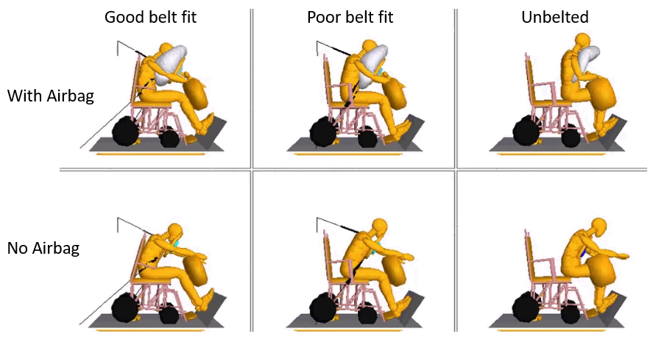

Figure A5. Small female ATD kinematics at 100 ms in pure frontal crashes with different belt and airbag conditions
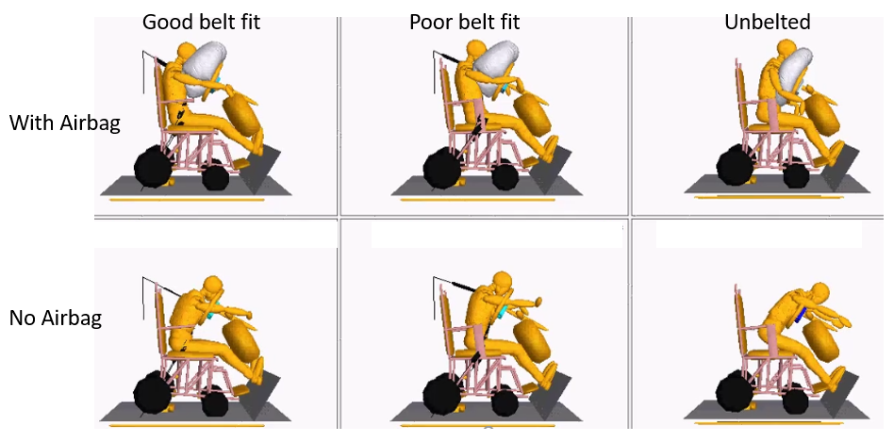

Figure A6. Midsize male ATD kinematics at 100 ms in oblique frontal crashes with different belt and airbag conditions
All oblique frontal crash simulations are with curtain airbag.
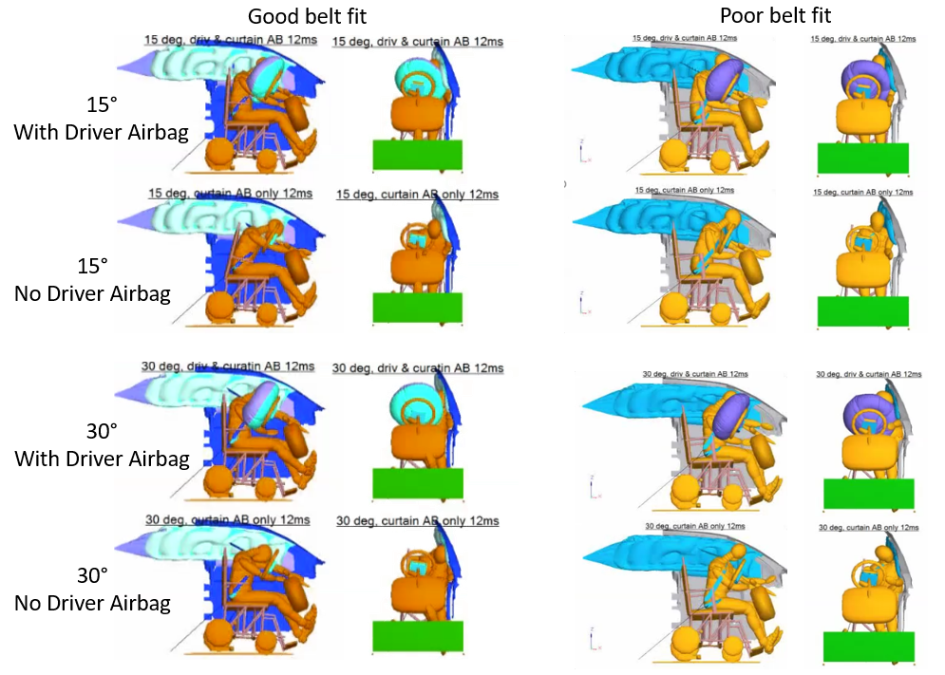

Figure A7. Small female ATD kinematics at 100 ms in oblique frontal crashes with different belt and airbag conditions
All oblique frontal crash simulations are with curtain airbag.
