Supplemental Material: Emissions and Radiative Impacts of Sub-10 nm Particles from Biofuel and Fossil Fuel Cookstoves

Shantanu H. Jathar1, Naman Sharma1, Kelsey R. Bilsback2, Jeffrey R. Pierce2, Joonas Vanhanen3, Timothy D. Gordon4, and John Volckens1

1Mechanical Engineering, Colorado State University, Fort Collins, CO, USA

2Atmospheric Science, Colorado State University, Fort Collins, CO, USA

3Airmodus Ltd., Helsinki, Finland

4Handix Scientific, Boulder, CO, USA

Correspondence to: Shantanu H. Jathar ([shantanu.jathar@colostate.edu](mailto:shantanu.jathar@colostate.edu))

*Table S1: Experiment details for the seven emissions tests performed for the five different cookstoves studied in this work along with historical emissions of PM and number emissions for the cookstoves based on the work of Bilsback et al. (2019).*

|  |  |  |  |  |
| --- | --- | --- | --- | --- |
| ***Expt. Date*** | ***Cookstove/Fuel*** | ***Test Time (mins)*** | ***PM2.5# (mg MJd-1)*** | ***N>10# (mg MJd-1)*** |
| Aug 31, 2018 | Three-stone fire / Douglas fir | 220 | 499 | 1.0×1015 |
| Aug 30, 2018 | Rocket elbow / Douglas fir | 260 | 104 | 5.2×1014 |
| Jan 25, 2020 | 123 |
| Sep 4, 2018 | Gasifier / Douglas fir | 150 | 78 | 1.1×1015 |
| Aug 31, 2018 | Charcoal / Hardwood lumps | 180 | 246 | 5.3×1014 |
| Aug 29, 2018 | LPG / LPG | 180 | 4 | 1.5×1014 |
| Jan 26, 2020 | 137 |

*#Based on Bilsback et al. (2019). MJd is a Megajoule of energy delivered to the pot.*

*Table S2: Mean±standard deviation for N1 and N11 emission factors expressed on a fuel burned and energy content basis.*

|  |  |  |  |  |
| --- | --- | --- | --- | --- |
| ***Cookstove*** | ***N1 (kg-fuel-1) ×1015*** | ***N1 (MJ-1) ×1015*** | ***N11 (kg-fuel-1) ×1015*** | ***N11 (MJ-1) ×1015*** |
| Three-stone fire | 10.9±4 | 0.62±0.2 | 6.1±1 | 0.35±0.1 |
| Rocket elbow | 11.6±9 | 0.66±0.5 | 6.2±3 | 0.35±0.2 |
| Gasifier | 12.7±8 | 0.73±0.4 | 4.2±2 | 0.24±0.1 |
| Charcoal | 39.4±12 | 1.40±0.4 | 6.4±2 | 0.23±0.1 |
| LPG | 19.7±13 | 0.42±0.3 | 0.8±0.5 | 0.02±0.01 |

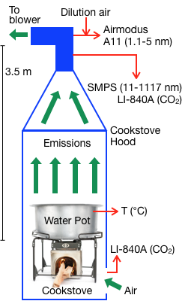

*Figure S1: Schematic for the cookstove tests performed in the emissions hood at the Colorado State University.*

**

*Figure S2: Particle number concentrations, N11 in cm-3, for the rocket elbow (a) and LPG (b) stoves during the experiments performed in 2018 (blue) and 2020 (mint green).*



*Figure S3: Particle number emission factors, N1 and N11 in # kg-fuel-1, for the (a) three-stone fire, (b) rocket elbow, (c) gasifier, (d) charcoal, and (e) LPG cookstoves during the experiments performed in 2018.*



*Figure S4: Averaged particle size distributions from the A11 (1.1-3.3 nm) and SMPS (11-1000 nm) for the five different cookstoves over the water boiling test. The data point for the A11 at a particle size of ~6 nm was based on estimates of N11-N3.*

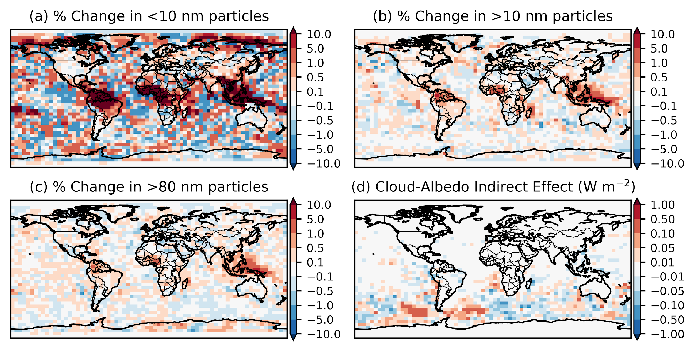

*Figure S5: Annually-averaged change in (a) <10 nm, (b) >10 nm, and (c) >80 nm particle number concentrations after a 10-fold addition of sub-10 nm particles from anthropogenic combustion sources to GEOS-Chem (SUB10_10×-BASE). (d) Annually-averaged cloud-albedo indirect effect associated with the addition of sub-10 nm particles from all anthropogenic combustion sources (i.e., excluding biomass burning).*

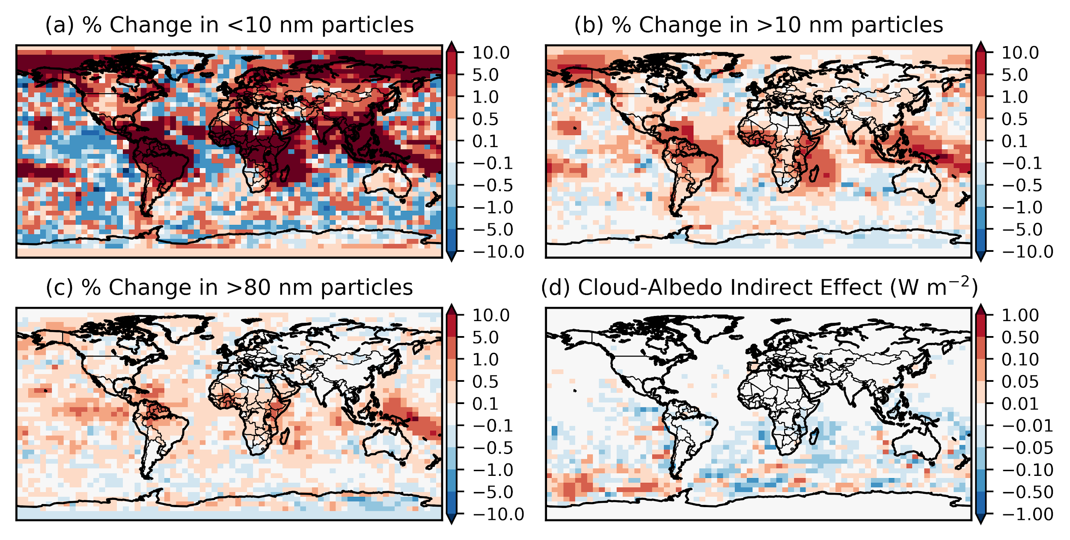

*Figure S6: Same as Figure 4 but for the ‘mod’ simulations, i.e., SUB10_1×mod-BASEmod*

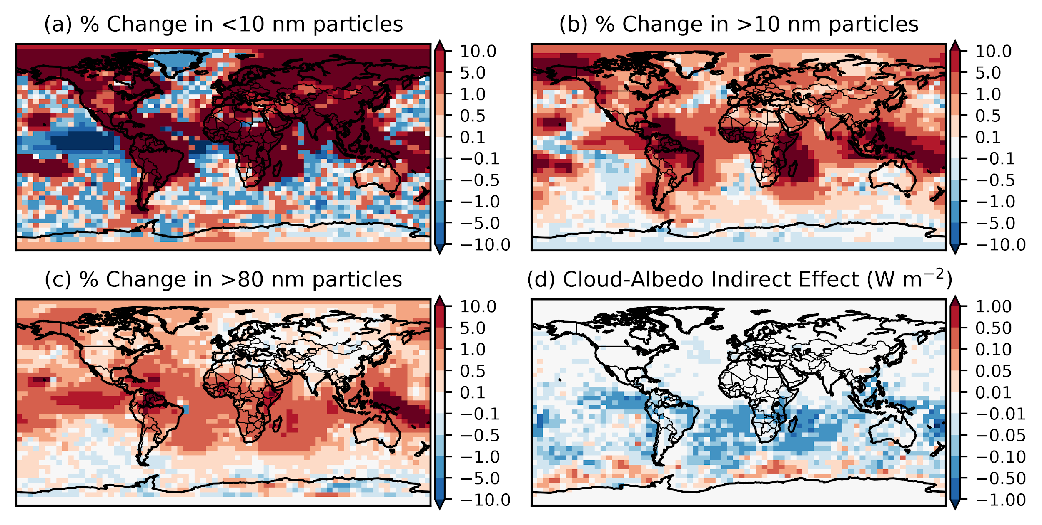

*Figure S7: Same as Figure S.5 but for the ‘mod’ simulations, i.e., SUB10_10×mod-BASEmod*