Supplementary Material

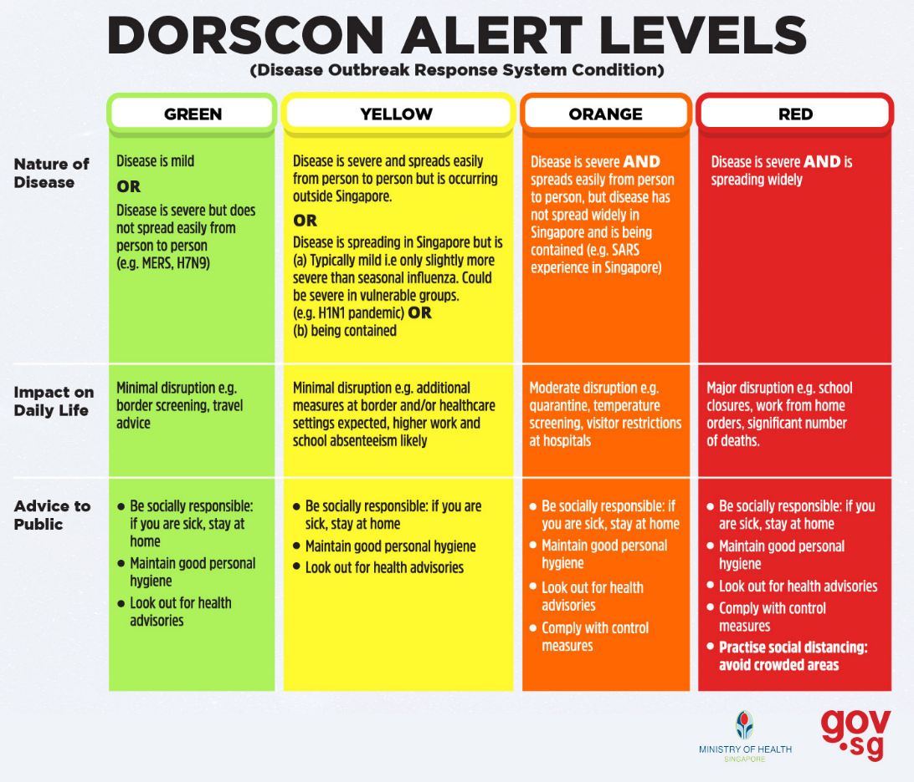

Supplementary Figure 1: Singapore Disease Outbreak Response System Condition⁸

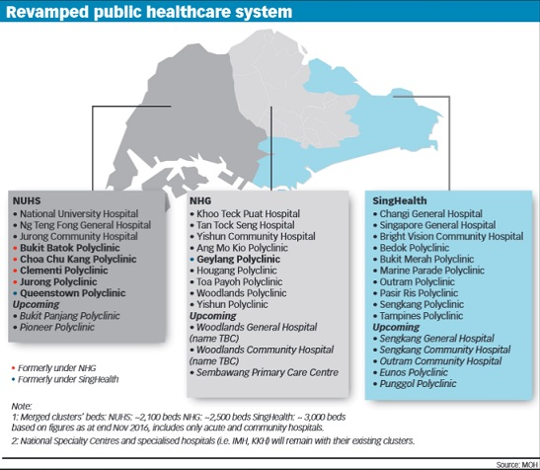

Supplementary Figure 2: – Singapore Public Health Care System Integrated Clusters⁷

