Supplement information
Synthesis and structure of pyrido[1,2-a]quinazoline condensed derivatives
O.Yu. Voskoboinikª, V.V. Stavytskyiª, O.M. Antypenkoª, M.S. Kazuninª, D.V. Kravtsovª, S.V. Shishkina^{b}, S.I. Kovalenkoª
ªDepartment of Organic and Bioorganic Chemistry, Zaporizhzhia State Medical University, 26 Maiakovski ave., Zaporizhzhia, 69035, Ukraine
^{b}SSI «Institute for Single Crystals», National Academy of Science of Ukraine

General part
Melting points were determined in open capillary tubes in a «Mettler Toledo МР 50» apparatus and were uncorrected. The elemental analyses (C, H, N) were performed using the ELEMENTAR vario EL cube analyzer (USA). IR spectra were recorded on a Shimadzu IR Prestige-21 Fourier spectrometer fitted with an attenuated total reflectance sampling accessory. Analyses were indicated by the symbols of the elements or functions within ±0.3% of the theoretical values. ¹H NMR spectra (400 MHz) and ¹³C NMR spectra (100 MHz) were recorded on a Varian-Mercury 400 (Varian Inc., Palo Alto, CA, USA) spectrometers with TMS as internal standard in DMSO-d₆ solution. LC-MS were recorded using chromatography/mass spectrometric system which consists of high performance liquid chromatography «Agilent 1100 Series» (Agilent, Palo Alto, CA, USA) equipped with diode-matrix and mass-selective detector «Agilent LC/MSD SL» (atmospheric pressure chemical ionization – APCI). Electron impact mass spectra (EI-MS) were recorded on a Varian 1200 L instrument at 70 eV (Varian, USA). The purity of all obtained compounds was checked by ¹H-NMR and LC-MS.
9a-Methyl-7,8,9,9a-tetrahydro-6H-benzo[4,5]imidazo[1,2-c]pyrido[1,2-a]quinazolin-6-one (2.1). Yield: 62%; mp = 121-123°С, IR (cm⁻¹): 3414, 2930, 1674, 1628, 1603, 1537, 1472, 1380, 1366, 1335, 1320, 1298, 1279, 1254, 1185, 1159, 1130, 1100, 1049, 1034, 981, 943, 842, 825, 760, 740, 702, 549, 527, 471; ¹H NMR (400 MHz, DMSO-d₆) δ 8.17 (d, J = 7.6 Hz, 1H, H-1), 8.02 – 6.73 (m, 7H, H-2,3,4,11,12,13,14), 3.16 – 2.91 (m, 2H, H-7,7`), 2.78 – 2.66 (m, 1H, H-9), 2.60 – 2.51 (m, 1H, H-9`), 2.22 – 1.84 (m, 2H, H-8,8`), 1.58 (s, 3H, 9a-CH₃). ¹³C NMR (126 MHz, DMSO) δ 169.8, 147.0, 144.3, 135.0, 132.6, 130.3, 128.1, 126.9, 125.1, 123.6, 122.8, 121.7, 120.2, 112.9, 77.3 (C-9a), 33.7, 26.9, 24.1, 17.0; EI-MS (m/z (I%_{rel}.): 304 (10.2), 303 (63.2), 302 (19.2), 288 (14.5), 275 (24.3), 274 (20.1), 261 (27.3), 260 (74.8), 248 (39.2), 247 (94.7), 246 (41.8), 234 (72.3), 233 (100.0), 231 (86.7), 219 (10.9), 207 (17.3), 206 (8.7), 205 (10.4), 194 (52.1), 192 (23.7), 164 (16.8), 143 (27.2), 131 (5.6), 130 (8.4), 129 (21.2), 116 (5.5), 115 (8.9), 103 (16.3), 102 (60.3), 90 (32.1), 77 (19.5), 76 (28.8), 75 (17.3), 64 (30.9), 63 (20.5), 62 (10.3), 55 (16.3), 52 (15.3), 51 (14.8), 45 (14.1), 44 (10.2), 42 (9.2), 39 (27.5); LC-MS: m/z = 304 [M+1]; Anal. Calcd. for C₁₉H₁₇N₃O: C, 75.23; H, 5.65; N, 13.85; found: C, 75.27; H, 5.69; N, 13.88.

2,4a-Dimethyl-4a,5,6,7-tetrahydro-8H-pyrido[1,2-a][1,2,4]triazolo[1,5-c]quinazolin-8-one (2.2). Yield: 59 %; mp = 203-205°С, ¹H NMR (400 MHz, DMSO-d₆) δ 7.86 (d, J = 7.6 Hz, 1H, H-13), 7.66 (d, J = 8.0 Hz, 1H, H-10), 7.48 (t, J = 7.5 Hz, 1H, H-11), 7.38 (t, J = 7.5 Hz, 1H, H-12), 3.06 – 2.96 (m, 1H, H-7), 2.73 – 2.59 (m, 1H, H-7`), 2.48 – 2.41 (m, 2H, H-5,5`), 2.36 (s, 3H, 2-CH₃), 2.06 – 1.83 (m, 2H, H-6,6`), 1.43 (s, 3H, 4a-CH₃). ¹³C NMR (126 MHz, DMSO) δ 169.4, 160.4, 148.5, 134.1, 130.4, 128.5, 127.1, 124.0, 119.6, 76.6 (C-4a), 33.5, 32.0, 26.9, 16.7, 14.4; LC-MS: m/z = 269 [M+1]; Anal. Calcd. for C₁₅H₁₆N₄O: C, 67.15; H, 6.01; N, 20.88; found: C, 67.19; H, 6.09; N, 20.93.

2-(2-Chlorophenyl)-4a-methyl-4a,5,6,7-tetrahydro-8H-pyrido[1,2-a][1,2,4]triazolo[1,5-c]quinazolin-8-one (2.3). Yield: 67 %; mp = 146-149°С, IR (cm⁻¹): 3434, 2926, 1682, 1632, 1610, 1597, 1581, 1545, 1507, 1479, 1464, 1444, 1424, 1383, 1372, 1360, 1335, 1319, 1278, 1255, 1208, 1197, 1172, 1140, 1120, 1098, 1053, 1035, 977, 958, 945, 914, 875, 856, 832, 785, 777, 759, 751, 718, 703, 664, 652, 559, 535, 517, 491, 466, 456;¹H NMR (400 MHz, DMSO-d₆) δ 8.00 (d, J = 7.7 Hz, 1H, H-13), 7.98 – 7.93 (m, 1H, 2-Ar H-6), 7.72 (d, J = 7.9 Hz, 1H, H-10), 7.61 – 7.32 (m, 5H, H-11,12, 2-Ar H-3,4,5), 3.27 – 3.07 (m, 1H, H-7), 2.78 – 2.64 (m, 1H, H-7`), 2.62 – 2.47 (m, 2H, H-5,5`), 2.14 – 1.83 (m, 2H, H-6.6`), 1.55 (s, 3H, 4a-CH₃); LC-MS: m/z = 365 [M+1]; Anal. Calcd. for C₂₀H₁₇ClN₄O: C, 65.84; H, 4.70; N, 15.36; found: C, 65.87; H, 4.75; N, 15.39.

2-(2-Bromophenyl)-4a-methyl-4a,5,6,7-tetrahydro-8H-pyrido[1,2-a][1,2,4]triazolo[1,5-c]quinazolin-8-one (2.4). Yield: 69%; mp = 146-149°С, IR (cm⁻¹): 3434, 2949, 1682, 1632, 1609, 1581, 1561, 1545, 1506, 1479, 1464, 1442, 1423, 1382, 1372, 1360, 1335, 1318, 1278, 1251, 1208, 1197, 1172, 1140, 1127, 1112, 1098, 1046, 1025, 976, 941, 913, 855, 832, 785, 777, 759, 748, 715, 661, 644, 558, 533, 515; ¹H NMR (400 MHz, DMSO-d₆) δ 8.00 (d, J = 7.7 Hz, 1H, H-13), 7.90 (d, J = 7.7 Hz, 1H, 2-Ar H-6), 7.78 – 7.66 (m, 2H, H-10, 2-Ar H-3), 7.54 (t, J = 8.4 Hz, 1H, H-11), 7.49 – 7.38 (m, 2H, 2-Ar H-4,5), 7.33 (t, J = 8.4 Hz, 1H, H-12), 3.25 – 3.06 (m, 1H, H-7), 2.80 – 2.61 (m, 1H, H-7`), 2.58 – 2.45 (m, 2H, H-5,5`), 2.07 – 1.83 (m, 2H, H-6,6`), 1.55 (s, 3H, 4a-CH₃). ¹³C NMR (126 MHz, DMSO) δ 169.5, 160.8, 148.6, 134.3, 134.2, 132.4, 132.2, 131.4, 130.8, 128.7, 128.2, 127.3, 124.3, 121.8, 119.4, 77.1 (C-4a), 33.5, 32.0, 27.0, 16.6; LC-MS: m/z = 409 [M+1]; Anal. Calcd. for C₂₀H₁₇BrN₄O: C, 58.69; H, 4.19; N, 13.69; found: C, 58.72; H, 4.23; N, 13.74.

2-(4-Fluorophenyl)-4a-methyl-4a,5,6,7-tetrahydro-8H-pyrido[1,2-a][1,2,4]triazolo[1,5-c]quinazolin-8-one (2.5). Yield: 52% (method A), 92% (method B), 73% (method C); mp = 156-158°С, IR (cm⁻¹): 3428, 2940, 1699, 1670, 1649, 1605, 1546, 1527, 1501, 1485, 1466, 1447, 1420, 1381, 1363, 1334, 1281, 1245, 1213, 1192, 1179, 1162, 1152, 1133, 1100, 1092, 1049, 1033, 1019, 1012, 981, 939, 915, 901, 853, 844, 814, 774, 757, 749, 713, 662, 616, 598, 570, 555, 530, 471; ¹H NMR (400 MHz, DMSO-d₆) δ 8.13 (dd, J = 8.6, 5.6 Hz, 2H, 2-Ar H-2,6), 8.00 (d, J = 7.6 Hz, 1H, H-13), 7.71 (d, J = 8.0 Hz, 1H, H-10), 7.54 (t, J = 8.3 Hz, 1H, H-11), 7.44 (t, J = 7.3 Hz, 1H, H-12), 7.18 (t, J = 8.7 Hz, 2H, 2-Ar H-3,5), 3.26 – 3.05 (m, 1H, H-7), 2.83 – 2.61 (m, 1H, H-7`), 2.62 – 2.52 (m, 2H, H-5,5`), 2.27 – 1.76 (m, 2H, H-6,6`), 1.52 (s, 3H, 4a-CH₃); LC-MS: m/z = 349 [M+1]+; Anal. Calcd. for C₂₀H₁₇FN₄O: C, 68.95; H, 4.92; N, 16.08; found: C, 68.91; H, 4.87; N, 16.02.

4a-Methyl-4a,5,6,7-tetrahydro-8H-pyrido[1,2-a]tetrazolo[1,5-c]quinazolin-8-one (2.6). Yield: 52% (method A), 89% (method B), 69% (method C); mp = 130-132°С, ¹H NMR (400 MHz, DMSO-d₆) δ 8.07 (d, J = 6.7 Hz, 1H, H-13), 7.76 (d, J = 7.6 Hz, 1H, H-10), 7.64 (t, J = 7.2 Hz, 1H, H-11), 7.50 (t, J = 6.7 Hz, 1H, H-12), 3.29 – 3.06 (m, 1H, H-7), 2.84 – 2.61 (m, 2H, H-5,7`), 2.58 – 2.51 (m, 1H, H-5`), 2.14 – 1.82 (m, 2H, H-5,5`), 1.56 (s, 3H, 4a-CH₃). ¹³C NMR (126 MHz, DMSO) δ 169.2, 148.4, 134.5, 132.1, 128.9, 127.6, 125.2, 116.2, 77.6 (C-4a), 33.4, 32.0, 27.3, 16.4; EI-MS (m/z (I%_{rel}.): 255 (9.9), 240 (91.3), 227 (37.3), 226 (65.8), 213 (10.6), 212 (100.0), 199 (10.3), 198 (17.1), 185 (22.6), 184 (47.5), 172 (44.2), 171 (19.7), 170 (22.5), 158 (56.3), 157 (32.6), 156 (37.2), 155 (20.7), 144 (65.5), 143 (37.5), 131 (20.7), 130 (31.7), 129 (54.3), 116 (22.9), 115 (19.2), 103 (52.3), 102 (73.8), 90 (28.7), 89 (19.4), 77 (29.6), 76 (37.8), 75 (21.3), 64 (20.9), 63 (24.5), 62 (20.3), 55 (77.3), 52 (15.3), 51 (37.8), 50 (29.2), 45 (9.8), 44 (10.2), 42 (31.2), 41 (30.4), 39 (42.3); LC-MS: m/z = 256 [M+1]; Anal. Calcd. for C₁₃H₁₃N₅O: C, 61.17; H, 5.13; N, 27.43; found: C, 61.22; H, 5.17; N, 27.48.

5a-Methyl-3-phenyl-5a,6,7,8-tetrahydro-2H,9H-pyrido[1,2-a][1,2,4]triazino[2,3-c]quinazoline-2,9-dione (2.7). Yield: 59%; mp = 244-246°С, IR (cm⁻¹): 3420, 3078, 3053, 2987, 2949, 1755, 1700, 1651, 1628, 1603, 1588, 1547, 1508, 1491, 1480, 1467, 1458, 1443, 1412, 1386, 1375, 1351, 1340, 1324, 1308, 1294, 1261, 1243, 1214, 1185, 1162, 1141, 1129, 1103, 1072, 1062, 1049, 1026, 976, 964, 949, 922, 913, 891, 879, 834, 815, 790, 783, 762, 704, 690, 670, 598, 580, 565, 531, 501, 475, 464; ¹H NMR (400 MHz, DMSO-d₆) δ 8.24 (d, J = 7.8 Hz, 1H, H-14), 8.19 (d, J = 7.9 Hz, 2H, 3-Ar H-2,6), 7.72 – 7.66 (m, 2H, H-11,12), 7.57 – 7.36 (m, 4H, H-13, 3-Ar H-3,4,5), 3.24 – 3.05 (m, 1H, H-8), 2.77 – 2.63 (m, 1H, H-8`), 2.58 – 2.23 (m, 2H, H-6,6`), 2.24 – 1.80 (m, 2H, H-7,7`), 1.60 (s, 3H, 5a-CH₃). ¹³C NMR (126 MHz, DMSO) δ 169.6, 161.5, 151.9, 147.2, 137.0, 133.4, 133.2, 130.8, 129.2, 127.8, 127.0, 126.9, 122.4, 81.0 (C-5a), 33.4, 31.8, 26.7, 16.4; EI-MS (m/z (I%_{rel}.): 255 (20.3), 241 (27.3), 240 (100.0), 212 (57.1), 186 (31.3), 185 (26.3), 169 (10.3), 143 (22.3), 129 (6.3), 116 (5.1), 115 (5.0), 103 (13.3), 102 (23.4), 90 (6.3), 89 (12.1), 77 (8.7), 76 (16.7), 75 (6.4), 63 (9.5), 55 (24.1), 51 (8.8), 42 (16.2), 41 (15.6), 40 (14.2), 39 (15.9); LC-MS: m/z = 359 [M+1]; Anal. Calcd. for C₂₁H₁₈N₄O₂: C, 70.38; H, 5.06; N, 15.63; found: C, 70.41; H, 5.09; N, 15.67.

5a-Methyl-3-(p-tolyl)-5a,6,7,8-tetrahydro-2H,9H-pyrido[1,2-a][1,2,4]triazino[2,3-c]quinazoline-2,9-dione (2.8). Yield: 63%; mp = 262-265°С, IR (cm⁻¹): 3436, 2980, 2943, 1699, 1648, 1603, 1589, 1544, 1516, 1501, 1481, 1469, 1442, 1416, 1402, 1374, 1352, 1343, 1324, 1311, 1261, 1245, 1212, 1187, 1142, 1128, 1102, 1062, 1049, 1034, 1020, 976, 967, 944, 913, 874, 831, 801, 788, 767, 717, 704, 683, 673, 660, 637, 603, 580, 561, 528, 501, 475, 464; ¹H NMR (400 MHz, DMSO-d₆) δ 8.23 (d, J = 7.8 Hz, 1H, H-14), 8.10 (d, J = 8.1 Hz, 2H, 3-Ar H-2,6), 7.74 – 7.60 (m, 2H, H-11,12), 7.58 – 7.40 (m, 1H, H-13), 7.25 (d, J = 8.0 Hz, 2H, 3-Ar H-3,5), 3.25 – 3.08 (m, 1H, H-8), 2.80 – 2.62 (m, 1H, H-8`), 2.58 – 2.51 (m, 2H, H-6,6`), 2.43 (s, 3H, 2-Ar-CH₃), 2.12 – 1.78 (m, 2H, H-7,7`), 1.59 (s, 3H, 5a-CH₃); LC-MS: m/z = 373 [M+1]; Anal. Calcd. for C₂₂H₂₀N₄O₂: C, 70.95; H, 5.41; N, 15.04; found: C, 70.99; H, 5.45; N, 15.07.

3-(4-Fluorophenyl)-5a-methyl-5a,6,7,8-tetrahydro-2H,9H-pyrido[1,2-a][1,2,4]triazino[2,3-c]quinazoline-2,9-dione (2.9). Yield: 56% (method A), 91% (method B); mp = 252-254°С, IR (cm⁻¹): 3429, 2924, 2853, 1699, 1646, 1602, 1589, 1548, 1501, 1481, 1443, 1417, 1403, 1376, 1343, 1325, 1296, 1262, 1246, 1223, 1185, 1158, 1143, 1129, 1103, 1061, 1048, 1015, 977, 944, 846, 834, 820, 790, 769, 719, 704, 690, 672, 660, 603, 585, 561, 533, 501, 478, 462; ¹H NMR (400 MHz, DMSO-d₆) δ 8.29 (dd, J = 8.7, 5.7 Hz, 2H, 3-Ar H-2,6), 8.23 (d, J = 7.8 Hz, 1H, H-14), 7.79 – 7.53 (m, 2H, H-11,12), 7.59 – 7.38 (m, 1H, H-13), 7.19 (t, J = 8.7 Hz, 2H, 3-Ar H-3,5), 3.29 – 3.05 (m, 1H, H-8), 2.86 – 2.61 (m, 1H, H-8`), 2.55 – 2.39 (m, 2H, H-6,6`), 2.13 – 1.85 (m, 2H, H-7,7`), 1.59 (s, 3H, 5a-CH₃). ¹³C NMR (126 MHz, DMSO-d₆) δ 169.6, 163.8 (d, J = 248.4 Hz), 161.5, 152.0, 146.2, 137.0, 133.4, 131.7 (d, J = 8.5 Hz), 129.7 (d, J = 3.0 Hz), 127.8, 127.0, 126.9, 122.3, 115.7 (d, J = 21.6 Hz), 81.0 (C-5 a), 33.4, 31.8, 26.6, 16.3; LC-MS: m/z = 377 [M+1]; Anal. Calcd. for C₂₁H₁₇FN₄O₂: C, 67.01; H, 4.55; N, 14.89; found: C, 67.05; H, 4.59; N, 14.93.

13-Bromo-5a-methyl-3-phenyl-5a,6,7,8-tetrahydro-2H,9H-pyrido[1,2-a][1,2,4]triazino[2,3-c]quinazoline-2,9-dione (2.10). Yield: 60 %; mp = 240-243°С, IR (cm⁻¹): 3434, 2924, 1686, 1649, 1600, 1582, 1546, 1506, 1477, 1446, 1420, 1401, 1380, 1361, 1334, 1291, 1247, 1214, 1186, 1171, 1149, 1127, 1102, 1078, 1048, 1034, 1019, 981, 959, 939, 892, 839, 815, 750, 714, 697, 688, 636, 617, 580, 564, 549, 531, 519, 505, 457; ¹H NMR (400 MHz, DMSO-d₆) δ 8.32 (d, J = 2.3 Hz, 1H, H-14), 8.25 – 8.11 (m, 2H, 3-Ar H-2,6), 7.81 (dd, J = 8.7, 2.3 Hz, 1H, H-12), 7.64 (d, J = 8.7 Hz, 1H, H-11), 7.53 – 7.30 (m, 3H, 3-Ar H-3,4,5), 3.18 – 3.06 (m, 1H, H-8,8`), 2.83 – 2.62 (m, 1H, H-6), 2.58 – 2.40 (m, 1H, H-6`), 2.11 – 1.86 (m, 2H, H-7,7`), 1.61 (s, 3H, 5a-CH₃). ¹³C NMR (126 MHz, DMSO) δ 169.6, 161.3, 150.8, 147.5, 136.3, 135.9, 133.1, 131.0, 130.0, 129.2, 129.0, 128.6, 124.3, 119.1, 81.2 (C-5 a), 33.4, 31.7, 26.7, 16.3; LC-MS: m/z = 437 [M+1]; Anal. Calcd. for C₂₁H₁₇BrN₄O₂: C, 57.68; H, 3.92; N, 12.81; found: C, 57.72; H, 3.95; N, 12.86.

4-(5-Methyl-5,6-dihydrotetrazolo[1,5-c]quinazolin-5-yl)butanoic acid (3.1). Yield: 62%; mp = 171-172°С, ¹H NMR (400 MHz, DMSO-d₆) δ 11.83 (s, 1H, COOH), 7.76 (d, J = 7.8 Hz, 1H, H-10), 7.28 (t, J = 7.9 Hz, 1H, H-8), 7.18 (s, 1H, 6-NH), 6.87 (d, J = 8.2 Hz, 1H, H-7), 6.81 (t, J = 7.5 Hz, 1H, H-9), 2.26 – 2.09 (m, 3H, CH₂CH₂CH₂COOH), 2.06 – 1.92 (m, 1H, CH₂CH₂CH₂COOH), 1.82 (s, 3H, 5-CH₃), 1.69 – 1.39 (m, 2H, CH₂CH₂CH₂COOH); ¹³C NMR (126 MHz, DMSO) δ 169.2, 148.4, 134.5, 132.1, 128.9, 127.6, 125.2, 116.2, 78.0 (C-5), 33.4, 32.0, 27.3, 16.4; LC-MS: m/z = 274 [M+1]; Anal. Calcd. for C₁₃H₁₅N₅O₂: C, 57.13; H, 5.53; N, 25.63; found: C, 57.17; H, 5.56; N, 25.67.

4-(2-(4-Fluorophenyl)-5-methyl-5,6-dihydro-[1,2,4]triazolo[1,5-c]quinazolin-5-yl)butanoic acid (3.2). Yield: 72%; mp = 208-211°С, IR (cm⁻¹): 3416 (COOH), 3234, 3208, 3114, 3042, 3008, 2960, 1901, 1704, 1626, 1606, 1598, 1529, 1486, 1470, 1451, 1438, 1415, 1371, 1337, 1272, 1248, 1220, 1170, 1154, 1132, 1106, 1092, 1048, 1037, 1010, 982, 939, 841, 813, 774, 751, 704, 636, 627, 567, 516, 491, 455; ¹H NMR (400 MHz, DMSO-d₆) δ 11.77 (s, 1H, COOH), 8.12 (dd, J = 8.3, 5.7 Hz, 2H, 2-Ar H-2,6), 7.70 (d, J = 7.6 Hz, 1H, H-10), 7.31 – 7.05 (m, 3H, H-8, 2-Ar H-3,5), 6.89 (s, 1H, 6-NH), 6.79 (d, J = 8.2 Hz, 1H, H-7), 6.73 (t, J = 7.5 Hz, 1H, H-9), 2.30 – 2.01 (m, 3H, CH₂CH₂CH₂COOH), 2.01 – 1.89 (m, 1H, CH₂CH₂CH₂COOH), 1.76 (s, 3H, 5-CH₃), 1.73 – 1.61 (m, 1H, CH₂CH₂CH₂COOH), 1.60 – 1.40 (m, 1H, CH₂CH₂CH₂COOH). ¹³C NMR (126 MHz, DMSO-d₆) δ 174.6, 163.2 (d, J = 245.8 Hz), 160.6, 150.1, 143.3, 132.4, 128.6 (d, J = 8.5 Hz), 128.1 – 127.9 (m), 124.4, 118.2, 116.1 (d, J = 21.7 Hz), 114.8, 109.6, 75.8 (C-5), 39.5, 33.8, 27.5, 19.4; LC-MS: m/z = 367 [M+1]; Anal. Calcd. for C₂₀H₁₉FN₄O₂: C, 65.56; H, 5.23; N, 15.29; found: C, 65.61; H, 5.27; N, 15.32.

4-(3-(4-Fluorophenyl)-6-methyl-2-oxo-6,7-dihydro-2H-[1,2,4]triazino[2,3-c]quinazolin-6-yl)butanoic acid (3.3). Yield: 67 %; mp = 217-219°С, IR (cm⁻¹): 3435 (COOH), 1732, 1637, 1616, 1547, 1519, 1480, 1404, 1333, 1273, 1228, 1178, 1158, 1030, 949, 845, 751, 721, 524; ¹H NMR (400 MHz, DMSO-d₆) δ 11.78 (s, 1H, COOH), 8.30 (dd, J = 8.6, 5.7 Hz, 2H, 3-Ar H-2,6), 7.97 (d, J = 7.5 Hz, 1H, H-11), 7.40 (s, 1H, 7-NH), 7.34 (t, J = 7.6 Hz, 1H, H-9), 7.17 (t, J = 8.7 Hz, 2H, 3-Ar H-3,5), 6.90 – 6.65 (m, 2H, H-8,10), 2.37 – 2.24 (m, 1H, CH₂CH₂CH₂COOH), 2.23 – 2.10 (m, 2H, CH₂CH₂CH₂COOH), 1.99 – 1.81 (m, 1H, CH₂CH₂CH₂COOH), 1.76 (s, 3H, 6-CH₃), 1.71 – 1.51 (m, 2H, CH₂CH₂CH₂COOH). ¹³C NMR (101 MHz, DMSO-d₆) δ 174.72, 163.8 (d, J = 248.6 Hz), 161.1, 152.5, 146.3, 145.7, 135.6, 131.6 (d, J = 8.5 Hz), 129.8 (d, J = 2.8 Hz), 127.3, 118.7, 115.9 – 115.3 (m, 3C), 112.0, 79.3 (C-6), 38.4, 33.9, 25.7, 19.4; LC-MS: m/z = 395 [M+1]; Anal. Calcd. for C₂₁H₁₉FN₄O₃: C, 63.95; H, 4.86; N, 14.21; found: C, 63.94; H, 4.88; N, 14.25.
X-ray structural study
The colourless crystals of 2.4 (C₂₀H₁₇N₄ОBr) are orthorhombic. At 293 K a = 11.810(1), b = 15.1368(9), c = 19.878(2) Å, V = 3553.5(5) Å³, M_{r} = 409.29, Z = 8, space group Pbca, d_{calc} = 1.530 g/сm³, m(MoK_{a}) = 2.330 mm⁻¹, F(000) = 1664. Intensities of 34413 reflections (5178 independent, R_{int} = 0.169) were measured on the «Xcalibur-3» diffractometer (graphite monochromated MoK_{α} radiation, CCD detector, ω-scaning, 2Θ_{max} = 60°). The structure was solved by direct method using SHELXTL package [17]. The absorption was considering using “multi-scan” semi-empiric method (T_{min} = 0.542, T_{max} = 0.800). Positions of the hydrogen atoms were located from electron density difference maps and refined by “riding” model with U_{iso} = nU_{eq} (n = 1.5 for methyl group and n = 1.2 for other hydrogen atoms) of the carrier atom. Full-matrix least-squares refinement against F² in anisotropic approximation for non-hydrogen atoms using 5125 reflections was converged to wR₂ = 0.185 (R₁ = 0.075 for 1791 reflections with F>4σ(F), S = 0.888). The final atomic coordinates, and crystallographic data for molecule 2.4 were deposited to with the Cambridge Crystallographic Data Centre, 12 Union Road, CB2 1EZ, UK (fax: +44-1223-336033; e-mail: deposit@ccdc.cam.ac.uk) and are available on request quoting the deposition numbers CCDC 1962433).

Compound 2.1 (9a-Methyl-7,8,9,9a-tetrahydro-6H-benzo[4,5]imidazo[1,2-c]pyrido[1,2-a]quinazolin-6-one)
IR spectrum of compound 2.1
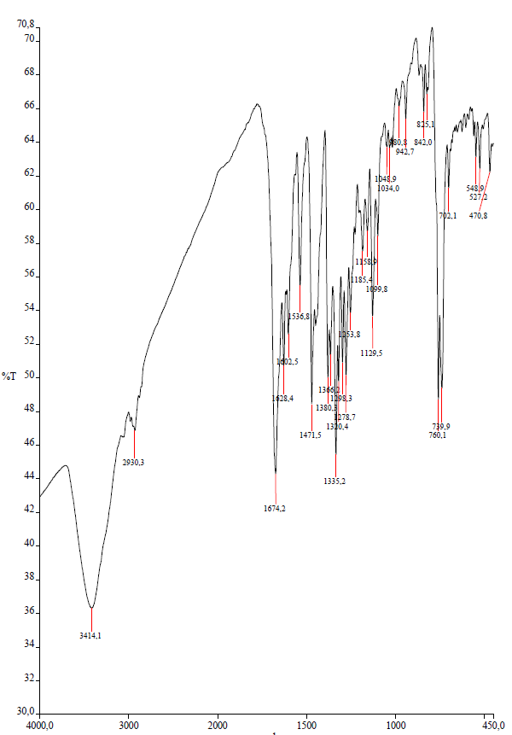
¹H NMR spectrum of compound 2.1

¹³C NMR spectrum of compound 2.1

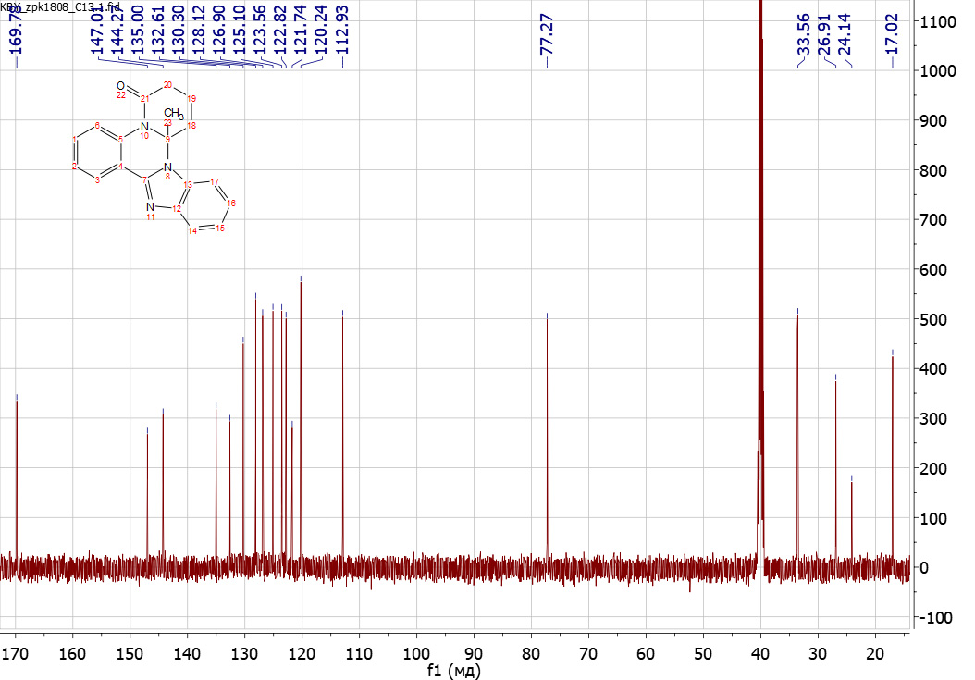

Compound 2.2 2,4a-Dimethyl-4a,5,6,7-tetrahydro-8H-pyrido[1,2-a][1,2,4]triazolo[1,5-
¹H NMR spectrum of compound 2.2

¹³C NMR spectra of compound 2.2

Compound 2.3 (2-(2-Chlorophenyl)-4a-methyl-4a,5,6,7-tetrahydro-8H-pyrido[1,2-a][1,2,4]triazolo[1,5-c]quinazolin-8-one)
IR spectrum of compound 2.3
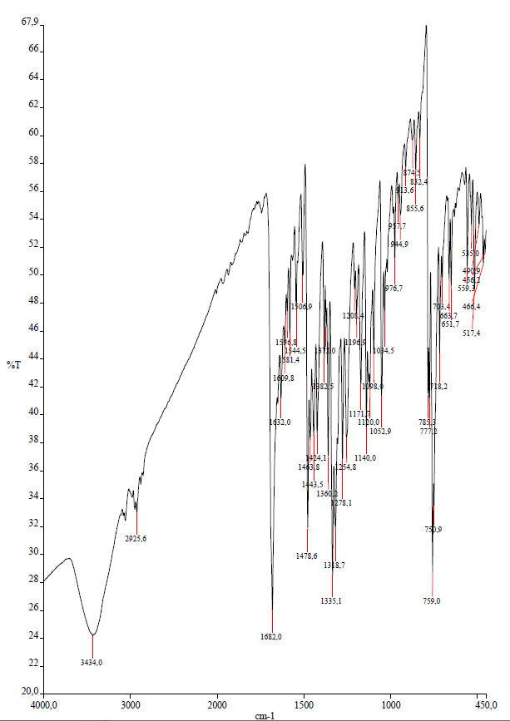

¹H NMR spectra of compound 2.3

Compound 2.4 (2-(2-Bromophenyl)-4a-methyl-4a,5,6,7-tetrahydro-8H-pyrido[1,2-a][1,2,4]triazolo[1,5-c]quinazolin-8-one)
IR spectrum of compound 2.4
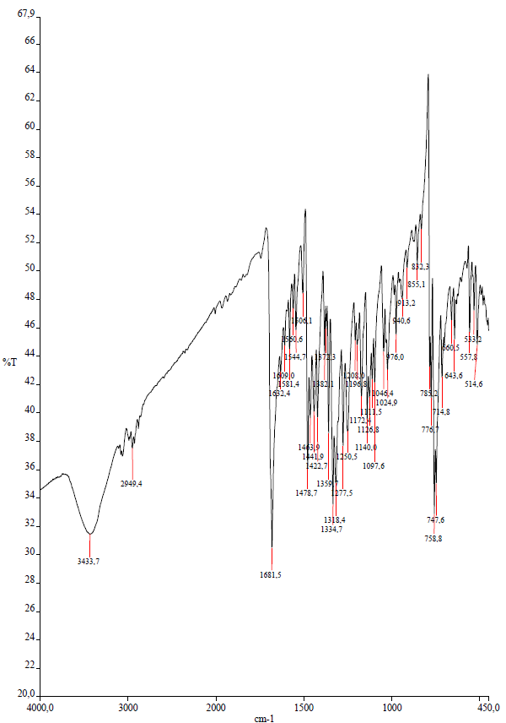

¹H NMR spectra of compound 2.4

¹³C NMR spectra of compound 2.4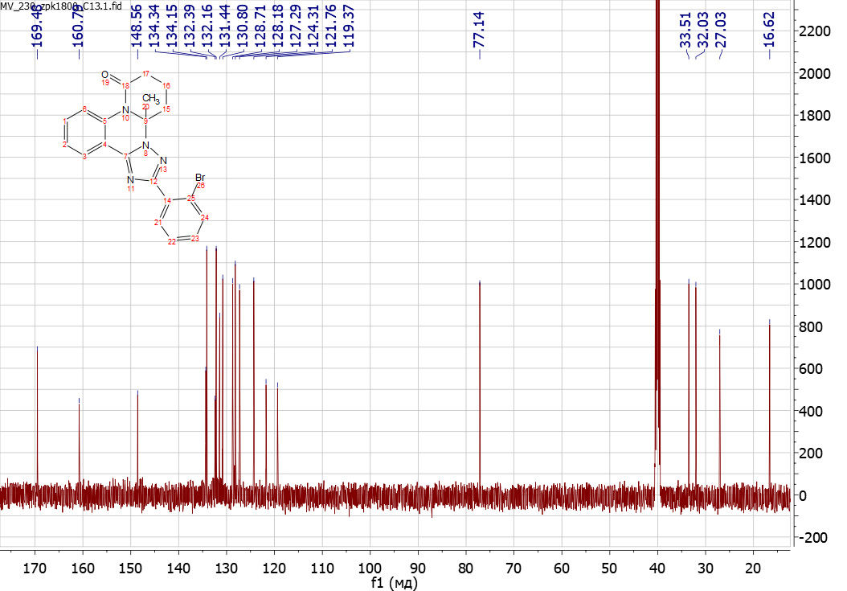

Structure of compound 2.4 according to the X-ray crystallographic data.

Compound 2.5 (2-(4-Fluorophenyl)-4a-methyl-4a,5,6,7-tetrahydro-8H-pyrido[1,2-a][1,2,4]triazolo[1,5-c]quinazolin-8-one)
IR spectrum of compound 2.5
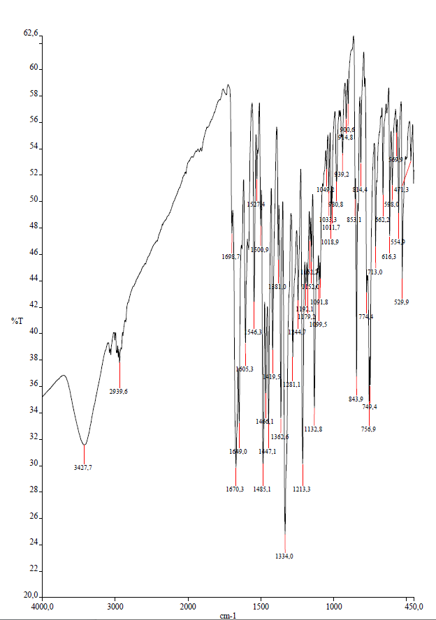

¹H NMR spectrum of compound 2.5

Compound 2.6 (4a-Methyl-4a,5,6,7-tetrahydro-8H-pyrido[1,2-a]tetrazolo[1,5-c]quinazolin-8-one)
¹H NMR spectrum of compound 2.6

¹³С NMR spectrum of compound 2.6

Compound 2.7 (5a-Methyl-3-phenyl-5a,6,7,8-tetrahydro-2H,9H-pyrido[1,2-a][1,2,4]triazino[2,3-c]quinazoline-2,9-dione)
IR spectrum of compound 2.7
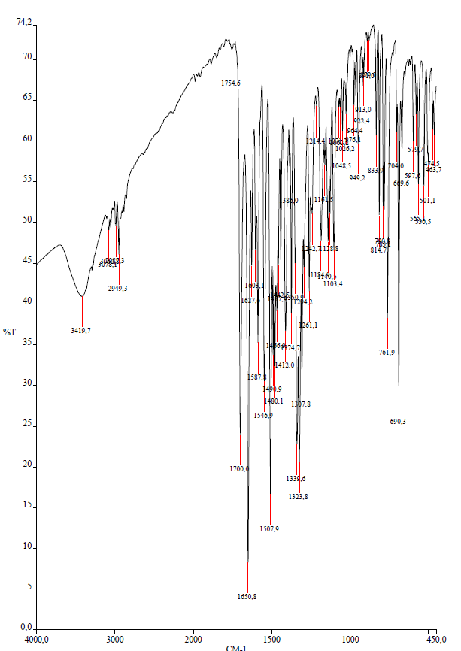

¹H NMR-specrum of compound 2.7

Compound 2.8 (5a-Methyl-3-(p-tolyl)-5a,6,7,8-tetrahydro-2H,9H-pyrido[1,2-a][1,2,4]triazino[2,3-c]quinazoline-2,9-dione)
IR spectrum of compound 2.8
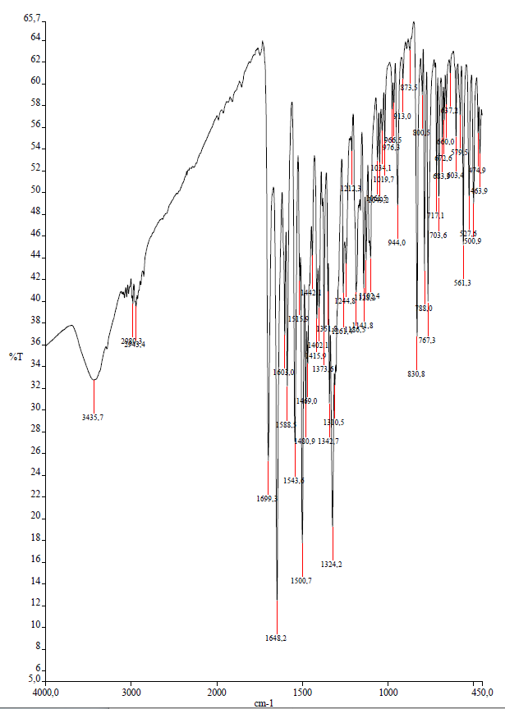

¹H NMR spectrum of compound 2.8

Compound 2.9 (3-(4-Fluorophenyl)-5a-methyl-5a,6,7,8-tetrahydro-2H,9H-pyrido[1,2-a][1,2,4]triazino[2,3-c]quinazoline-2,9-dione)
IR spectrum of compound 2.9
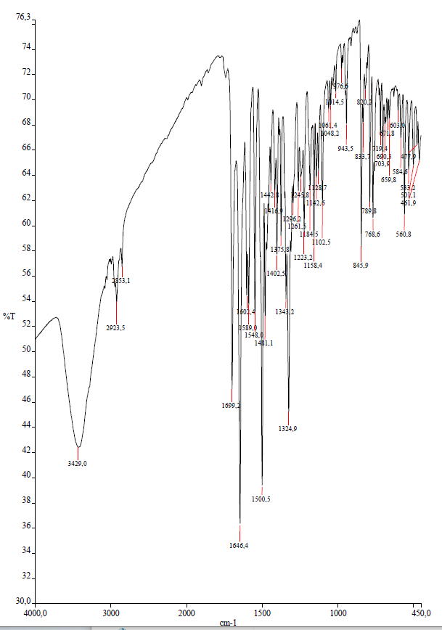
¹H NMR spectrum of compound 2.9

¹³C NMR spectrum of compound 2.9

Compound 2.10 (13-Bromo-5a-methyl-3-phenyl-5a,6,7,8-tetrahydro-2H,9H-pyrido[1,2-a][1,2,4]triazino[2,3-c]quinazoline-2,9-dione)
IR spectrum of compound 2.10
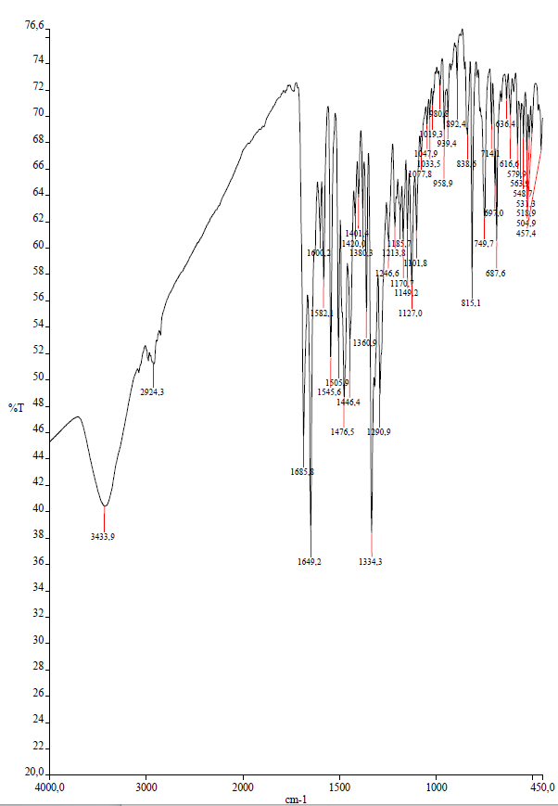

¹H NMR spectrum of compound 2.10

¹³C NMR spectrum of compound 2.10

Compound 3.1 (4-(5-Methyl-5,6-dihydrotetrazolo[1,5-c]quinazolin-5-yl)butanoic acid)

¹H NMR spectrum of compound 3.1

¹³C NMR spectrum of compound 3.1

Compound 3.2 (4-(2-(4-Fluorophenyl)-5-methyl-5,6-dihydro-[1,2,4]triazolo[1,5-c]quinazolin-5-yl)butanoic acid)
IR spectrum of compound 3.2
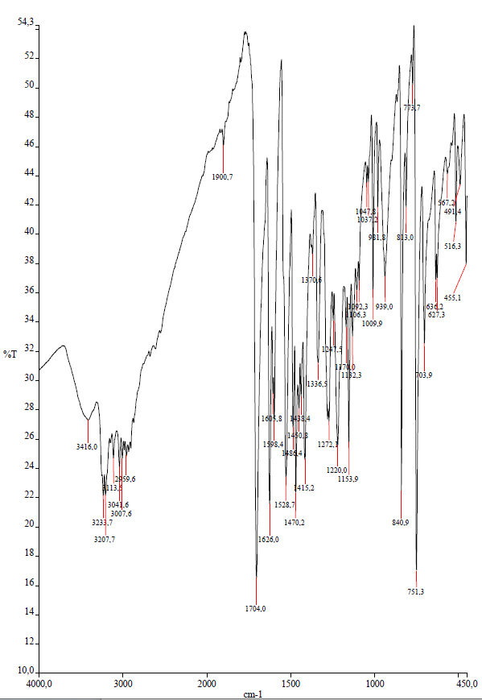

¹H NMR spectrum of compound 3.2

¹³C NMR spectrum of compound 3.2

Compound 3.3 (4-(3-(4-Fluorophenyl)-6-methyl-2-oxo-6,7-dihydro-2H-[1,2,4]triazino[2,3-c]quinazolin-6-yl)butanoic acid)
IR spectrum of compound 3.3
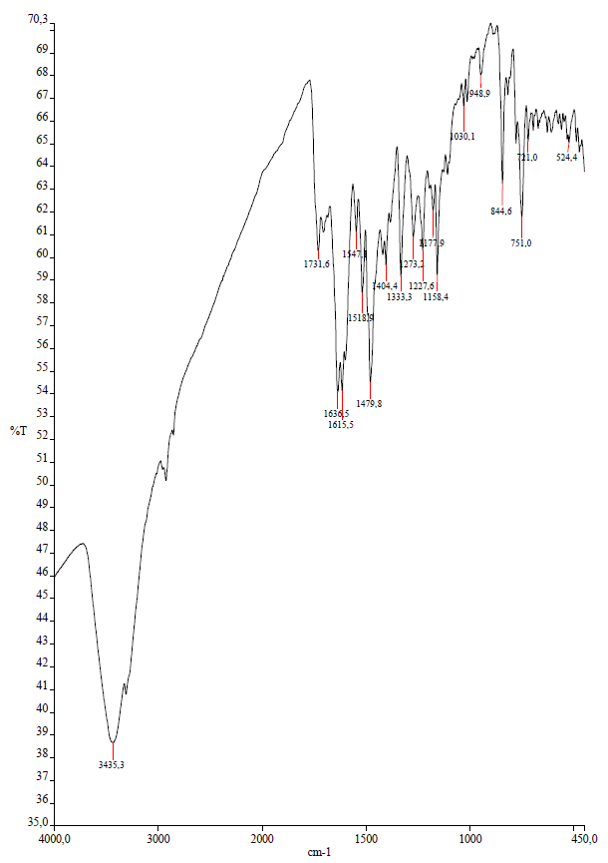

¹H NMR spectrum of compound 3.3

¹³C NMR spectrum of compound 3.3

