Biological and molecular modeling studies on some transition metal(II) complexes of a Quinoxaline based ONO donor bishydrazone ligand

Jijo Johnson ^{a*}, Chellaian Justin Dhanaraj ^{b*}

ª Department of Chemistry, Santhom Malankara Arts & Science College, Edanji, Thiruvananthapuram -695 503, Kerala, India
^{b} Department of Chemistry, University College of Engineering, Nagercoil, Konam,
Nagercoil - 629 004, Tamil Nadu, India

*Corresponding author. E-mail: jijo.n.johnson@gmail.com

SUPPLEMENTARY INFORMATION FILE
Biological studies
In vitro antimicrobial activity screening
In vitro antibacterial and antifungal activities of the ligand and its complexes were tested against the bacterial species S. aureus, E. coli and P. aeruginosa; also the fungal species, A. flavus, A. niger and C. albicans, by disc diffusion method. Chloramphenicol and Nystatin were used as standard antibacterial and antifungal agents. The test organisms were grown on nutrient agar (Muller Hinton agar for bacteria and antimytotic agar for fungi) medium in petri plates. The compounds were prepared in DMF and soaked in filter paper disc of 5 mm diameter and 1 mm thickness. The discs were placed on the previously seeded plates and incubated at 37 ºC. The diameter of inhibition zone around each disc was measured after 24 h for bacterial and 72 h for fungal species.

Electronic absorption titrations
A solution of CT DNA in the buffer (5 mmolL⁻¹ Tris-HCl/50 mmolL⁻¹ NaCl buffer (pH 7.2)) gave a UV absorbance ratio at 260 and 280 nm of about 1.89:1, indicating the CT DNA is free from protein contamination. The CT DNA concentration was determined by the UV absorption spectroscopy using the molar absorption coefficient of 6600 M⁻¹ cm⁻¹ at 260 nm. Stock solutions were kept at 4 °C and used within four days of preparation.
Electronic absorption titrations were performed in Tris-HCl/NaCl buffer (5 mmolL⁻¹ Tris-HCl/50 mmolL⁻¹ NaCl buffer pH 7.2) using DMF (10%) solution of metal complexes at room temperature. Absorption titration experiments were made using different concentrations of CT-DNA, without changing the concentration of complexes. Correction was made for absorbance of the CT-DNA itself. Metal complex-DNA solutions were allowed to incubate for 5 minutes before recording the spectra. For metal(II) complexes, the intrinsic binding constant (K_{b}) was determined by monitoring the changes of absorption in the MLCT band with increasing concentration of DNA using the following equation.
$[DNA]/(ε_{a}-ε_{f}$) $= [DNA]/(ε_{b}-ε_{f}$) +$1/K_{b}(ε_{b}-ε_{f}$)
Where, [DNA] is the concentration of DNA in base pairs. ε_{a}, ε_{f} and ε_{b} are the apparent, free and bound metal complex molar extinction coefficients respectively. A plot of [DNA]/(ε_{b}-ε_{f}) versus [DNA], gave a slope of 1/(ε_{b}-ε_{f}) and a y-intercept equal to K_{b}/(ε_{b}-ε_{f}), K_{b} is the ratio of the slope to the y-intercept.

Hydrodynamic method
In order to confirm the binding modes of the compounds with CT DNA, viscosity measurements were carried out using an Ostwald viscometer maintained at room temperature (27 ± 1 °C). Flow time was measured three times with a digital stopwatch for each sample measured three times and the average flow time was calculated. Data were presented as (η/η_{o})^{1/3} versus binding ratio. Relative viscosities of DNA were calculated using the relation,
η/η_{o}
Where,
η - Viscosity of CT DNA in the presence of complex
η_{o} - Viscosity of CT DNA alone

Cleavage of pUC18 DNA
The cleavage of supercoiled pUC18 DNA to its nicked circular form was studied by using agarose gel electrophoresis. pUC18 DNA (0.3 µg) dissolved in 5 mmolL⁻¹ Tris-HCl/50 mmolL⁻¹ NaCl buffer (pH 7.2), was treated with the complexes. The mixture was incubated at 37 °C for 1 h and then mixed with the loading buffer containing 25% bromophenol blue, 0.25% xylene cyanol and 30 % glycerol. Each sample (10⁻³ M, 0.5 µL) was loaded into 1% (w/v) agarose gel. Electrophoresis was undertaken for 2 h at 100 V in Tris-acetate-EDTA (TAE) buffer (pH 8.0). The gel was stained with ethidium bromide for 5 minutes after electrophoresis and then photographed under a UV transilluminator. To improve the DNA cleaving activity of the complexes, hydrogen peroxide (100 µmolL⁻¹) was added to each sample. The DNA cleavage efficiency of the complexes measured by determining the ability of the complexes to convert the super coiled DNA to nicked circular form and linear forms.

In vitro SOD activity
In vitro SOD activity was measured using alkaline DMSO as a source of superoxide radical (O₂^{.−}) and nitrobluetetrazolium (NBT) as O₂^{.−} scavenger. 400 μL sample added to a solution containing 2.1 mL of 0.2 M potassium phosphate buffer (pH 8.6) and 1mL of 56 μM NBT. The tubes kept on ice for 15 minutes and then 1.5 ml of alkaline DMSO solution added with stirring. The absorbance was recorded at 540 nm against a sample prepared under similar condition in DMSO. A unit of superoxide dismutase [SOD] activity is the concentration of complex or enzyme, which causes 50% inhibition of alkaline dimethylsulphoxide (DMSO) mediated reduction of nitroblue tetrazolium chloride (NBT).

Molecular docking
To find out the interaction between the synthesized metal complexes with DNA and SOD, rigid molecular docking studies were performed by using HEX 6.0 software, which is an interactive molecular graphics program for calculating and displaying feasible docking modes of a receptor and ligand molecule. HEX 6.0 performs docking using Spherical Polar Fourier Correlations. It necessitates the ligand and the receptor as input in PDB format.
The crystal structures of the B-DNA dodecamer d(CGCGAATTCGCG)₂ (PDB ID: 1BNA) and SOD (pdb ID: 1SXA) were downloaded from the protein data bank (http://www.rcsb.org./pdb). The amino acid chain was kept and the water molecules and co-crystallized ligand were removed. The structures of ligands in PDB file format were created by Avogadro software. The structures were optimized and used for molecular docking. The parameters used for docking include: correlation type – shape only, FFT mode – 3D, grid dimension – 0.6, receptor range – 180, ligand range – 180, twist range – 360, distance range – 40. PyMol software (http://pymol.sourceforge.net/) and Discovery Studio molecular graphics program were used for visualization of the docked pose.

DFT studies
The geometry optimization of the ligand and its metal complexes were carried out theoretically using Gaussian 09W program package (Frisch, et. al. 2013) by DFT/B3LYP method. 6-31G(d,p) and LANL2DZ are the basis sets chosen. All computational processes of ligand and metal complexes were made by using GaussView 5.0.8 software (Dennington et. al. 2009). Here The B3LYP stands for Becker's three - parameters exchange functional (B3) (Becke, 1988) in combination with the Lee-Yang-Parr correlation functional (LYP) (Lee et. al. 1988). 6-31G(d,p) is a popular polarized basis set which adds ‘p’ function to hydrogen atoms in addition to the ‘d’ functions on heavy atoms, while LANL2DZ is a basis set for post-third row atoms.

References
- M. J. Frisch, G. W. Trucks, H. B. Schlegel, G. E. Scuseria, M. A. Robb, J. R. Cheeseman, G. Scalmani, V. Barone, B. Mennucci, G. A. Petersson, H. Nakatsuji, M. Caricato, X. Li, H. P. Hratchian, A. F. Izmaylov, J. Bloino, G. Zheng, J. L. Sonnenberg, M. Hada, M. Ehara, K. Toyota, R. Fukuda, J. Hasegawa, M. Ishida, T. Nakajima, Y. Honda, O. Kitao, H. Nakai, T. Vreven, J.A. Montgomery, Jr., J. E. Peralta, F. Ogliaro, M. Bearpark, J. J. Heyd, E. Brothers, K. N. Kudin, V. N. Staroverov, T. Keith, R. Kobayashi, J. Normand, K. Raghavachari, A. Rendell, J. C. Burant, S. S. Iyengar, J. Tomasi, M. Cossi, N. Rega, J. M. Millam, M. Klene, J. E. Knox, J. B. Cross, V. Bakken, C. Adamo, J. Jaramillo, R. Gomperts, R. E. Stratmann, O. Yazyev, A. J. Austin, R. Cammi, C. Pomelli, J. W. Ochterski, R. L. Martin, K. Morokuma, V. G. Zakrzewski, G. A. Voth, P. Salvador, J. J. Dannenberg, S. Dapprich, A. D. Daniels, O. Farkas, J. B. Foresman, J. V. Ortiz, J. Cioslowski, D. J. Fox, Gaussian, Inc., Wallingford CT, 2013.
- GaussView, Version 5, Roy Dennington, Todd Keith and John Millam, Semichem Inc. Shawnee Mission KS, 2009.
- M.A.D. Becke, Phys. Rec. A. 1988; 38, 3098.
- C. Lee, W. Yang, R. G. Parr, Phys. Rev. B. 1988; 37, 785.

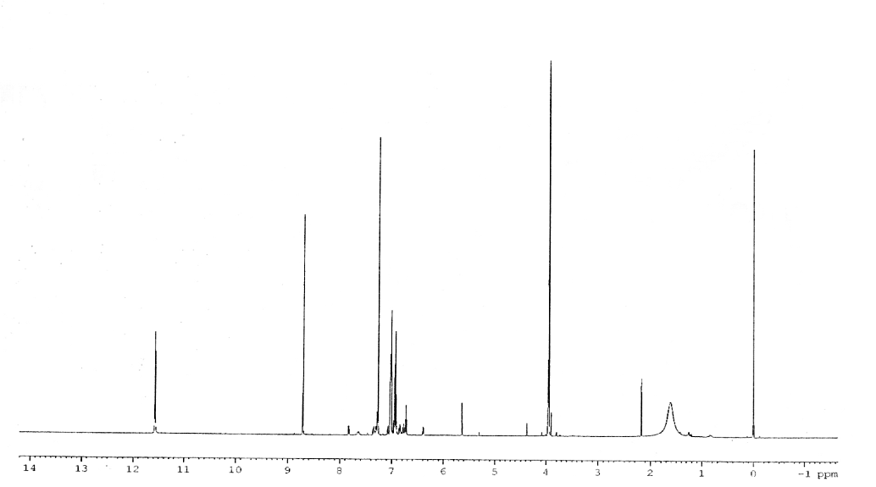
Fig. S1. ¹H NMR spectrum of HHQ.

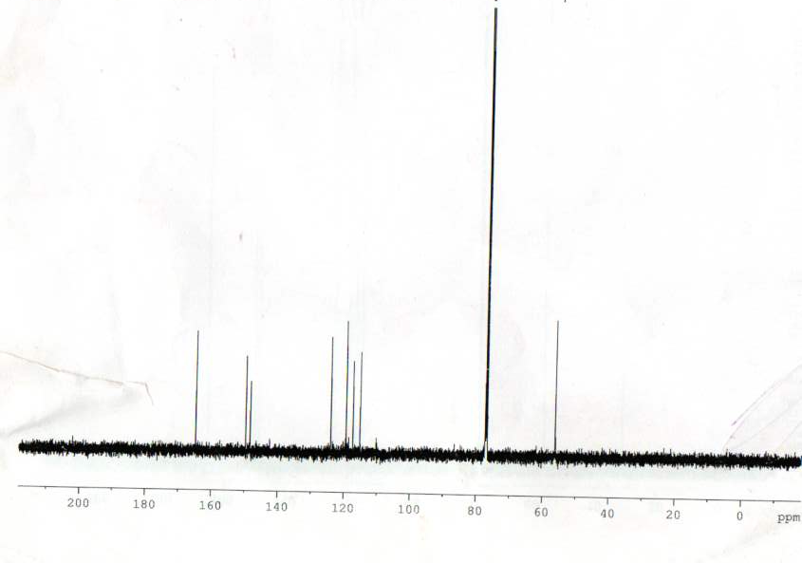
Fig. S2. ¹³C NMR spectrum of HHQ.

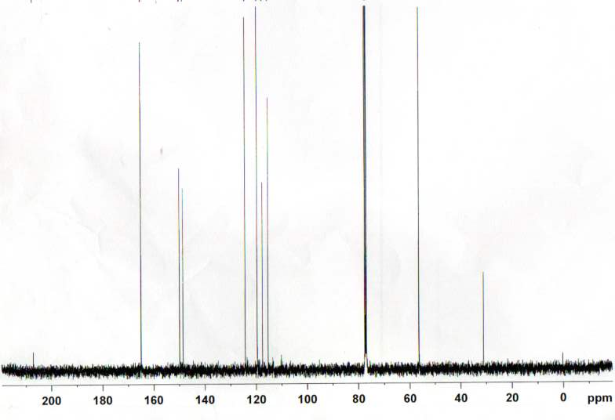
Fig. S3. ¹³C NMR spectrum of HHQ-4.

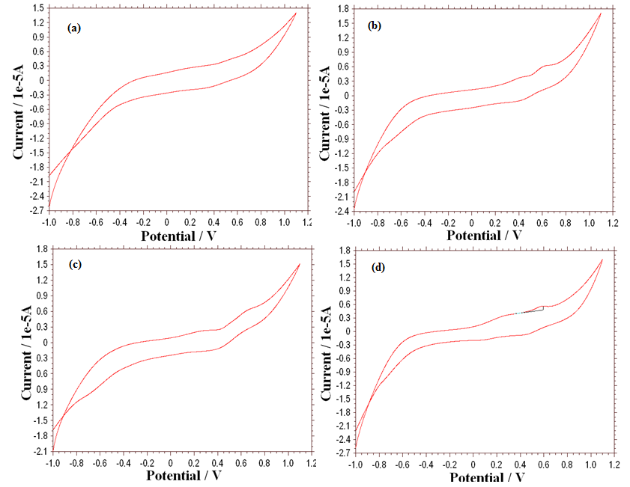
Fig. S4(a-d). Cyclic voltammogram of a) HHQ-1, b) HHQ-2, c) HHQ-3 and d) HHQ-4.

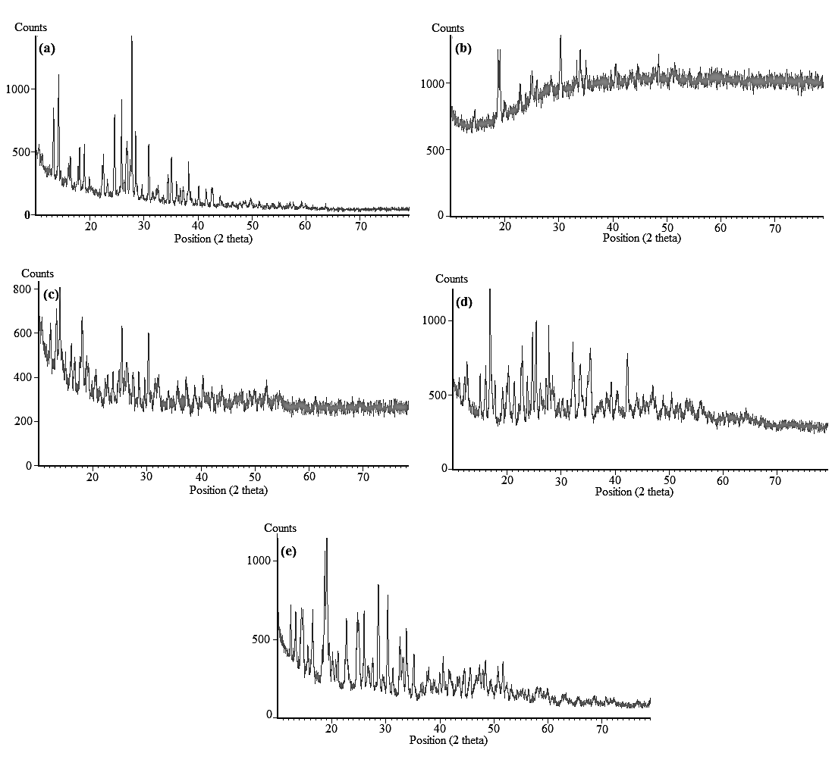
Fig. S5(a-e). Powder XRD pattern of a) HHQ, b) HHQ-1, c) HHQ-2, d) HHQ-3 and e) HHQ-4.

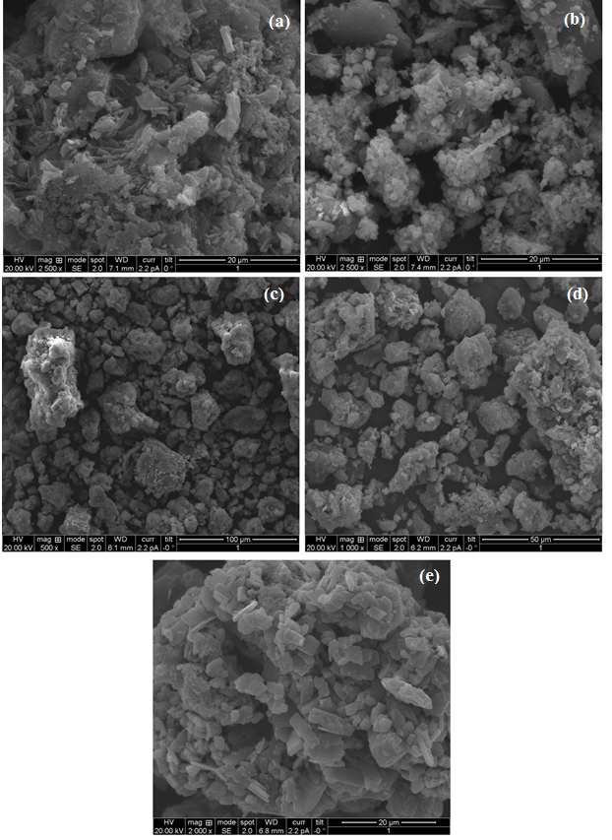
Fig. S6(a-e). SEM micrographs of a) HHQ, b) HHQ-1, c) HHQ-2, d) HHQ-3 and e) HHQ-4.

