Synthesis, Cytotoxicity, in-vitro Antibacterial Screening and in-silico Study of Novel Thieno[2,3-b]pyridines as Potential pim-1 Inhibitors
Ahmed E. M. Mekky, Sherif M. H. Sanad,* Ahmed Y. Said and Mohamed A. A. Elneairy
Chemistry Department, Faculty of Science, Cairo University, Giza 12613, Egypt
E-mail: sherif_hamed1980@yahoo.com
4. Experimental
4.1. Introduction
All organic solvents were acquired from commercial sources and used as received unless otherwise stated. All other chemicals were acquired from Merck and used without further purification. The melting points were measured on a Stuart melting point apparatus and are uncorrected. IR spectra were recorded on a Smart iTR, which is an ultra-high-performance, versatile Attenuated Total Reflectance (ATR) sampling accessory on the Nicolet iS10 FT-IR spectrometer. NMR spectra were recorded on Bruker Avance III 400 MHz spectrophotometer (400 MHz for ¹H and 100 MHz for ¹³C) using TMS as an internal standard and DMSO-d₆ as solvent and chemical shifts were expressed as δ ppm units. Elemental analyses were carried out on a EuroVector instrument C, H, N analyzer EA3000 Series.

4.2. General procedures and spectral data
General procedure for the synthesis of pyridine-2(1H)-thione derivatives 5.
A mixture of carbonyl derivatives 3a or 3b (5 mmol) and 2-cyanoethanethioamide 4 (5 mmol) in 30 mL dioxane was heated at reflux for 5 h. The reaction mixture was cooled, and the product was collected by filtration, washed with ethanol and recrystallized from the proper solvent.

4-(Thiophen-2-yl)-2-thioxo-6-(p-tolyl)-1,2-dihydropyridine-3-carbonitrile (5a).
Orange solid (ethanol, 72%); m.p. 220-222 ºC; IR (υ cm⁻¹): 3151 (NH), 2218 (CN), 1203 (C=S);¹H-NMR (DMSO-d₆): δ 2.40 (s, 3H, CH₃), 7.20 (s, 1H, pyridine-H5), 7.33-7.37 (m, 3H, 2 Ar-H’s and thiophene-H4), 7.77 (d, 2H, Ar-H’s), 8.05 (d, 1H, thiophene-H5), 8.10 (d, 1H, thiophene-H3), 14.03 (s, 1H, NH); ¹³C-NMR (DMSO-d₆): δ 21.4 (CH₃), 109.5 (pyridine-C3), 111.5 (pyridine-C5), 117.8 (CN), 128.7, 128.9 (thiophene-C4, C5), 129.2, 129.8, 132.7 (Ar-C), 133.1, 136.5 (thiophene-C3, C2), 142.2 (Ar-C), 148.0, 152.4, 180.3 (pyridine-C4, C6, C2); Anal. for C₁₇H₁₂N₂S₂ (308.4): C, 66.20; H, 3.92; N, 9.08; found: C, 65.99; H, 4.07; N, 9.19%.

6-(4-Methoxyphenyl)-4-(thiophen-2-yl)-2-thioxo-1,2-dihydropyridine-3-carbonitrile (5b).
Orange solid (ethanol, 78%); m.p. 214-216 ºC; IR (υ cm⁻¹): 3155 (NH), 2224 (CN), 1202 (C=S);¹H-NMR (DMSO-d₆): δ 3.85 (s, 3H, OCH₃), 7.04 (s, 1H, pyridine-H5), 7.08 (d, 2H, Ar-H’s), 7.44 (t, 1H, thiophene-H4), 7.70 (d, 2H, Ar-H’s), 7.95 (d, H, thiophene-H5), 8.10 (d, 1H, thiophene-H3), 14.16 (s, 1H, NH); Anal. for C₁₇H₁₂N₂OS₂ (324.4): C, 62.94; H, 3.73; N, 8.64; found: C, 62.78; H, 3.88; N, 8.79%.

General procedure for thieno[2,3-b]pyridine derivatives 7, 9, 11, 13, 15 and 17.
Method ‘A’.
A mixture of pyridine-2(1H)-thione 5 (5 mmol) and each of chloroacetone 6, ethyl chloroacetate 8, chloroacetamide 10 or chloroacetonitrile 12, 2-bromo-1-phenylethanone 14 or 2-bromo-1-(4-chlorophenyl)ethanone 16 (5 mmol) in absolute ethanol (20 mL) in the presence of sodium metal (10 mmol) was stirred at 80 ºC for 2-3 h. The product was collected by filtration, washed with ethanol, dried and then recrystallized from the appropriate solvent.

Method ‘B’.
A mixture of each of nicotinonitriles 18-22 (5 mmol) in absolute ethanol (20 mL) in the presence of sodium metal (5 mmol) was stirred at 80 ºC for 45 min to 1.5 h. The products that formed were collected by filtration, washed with ethanol, dried and then recrystallized from appropriate solvent.

2-Acetyl-3-amino-4-(thiophen-2-yl)-6-(p-tolyl)thieno[2,3-b]pyridine (7a).
Orange solid (dioxane); m.p. 180-181 ºC; IR (υ cm-1): 3464, 3290 (NH₂), 1624 (CO); ¹H-NMR (DMSO-d₆): δ 2.38 (s, 3H, p-CH₃), 2.39 (s, 3H, COCH₃), 6.82 (br s, 2H, NH₂), 7.32-7.34 (m, 3H, 2 Ar-H’s and thiophene-H4), 7.45 (d, 1H, thiophene-H3), 7.82 (s, 1H, pyridine-H5), 7.93 (d, 1H, thiophene-H5), 8.11 (d, 2H, Ar-H’s); ¹³C-NMR (DMSO-d₆): δ 21.3 (p-CH₃), 29.6 (CH₃CO), 105.5, 119.5, 120.5 (thienopyridine-C2, C5, C3a), 127.6 (Ar-C), 128.6, 129.9 (3 thiophene-C), 130.0, 134.6 (Ar-C), 136.5 (thiophene-C2), 140.5 (thienopyridine-C3), 141.7 (Ar-C), 147.9, 157.3, 161.5 (thienopyridine-C4, C6, C7a), 192.1 (CO); Anal. for C₂₀H₁₆N₂OS₂ (364.4): C, 65.91; H, 4.42; N, 7.69; found: C, 65.68; H, 4.20; N 7.54%.

2-Acetyl-3-amino-6-(4-methoxyphenyl)-4-(thiophen-2-yl)thieno[2,3-b]pyridine (7b).
Orange solid (dioxane); m.p. 156-157 ºC; IR (υ cm-1): 3464, 3288 (NH₂), 1629 (CO); ¹H-NMR (DMSO-d₆): δ 2.39 (s, 3H, CH₃), 3.85 (s, 3H, OCH₃), 6.82 (br s, 2H, NH₂), 7.08 (d, 2H, Ar-H’s), 7.32 (t,1H, thiophene-H4), 7.46 (d, 1H, thiophene-H3), 7.82 (s, 1H, pyridine-H5), 7.92 (d, 1H, thiophene-H5), 8.21 (d, 2H, Ar-H’s); ¹³C-NMR (DMSO-d₆): δ 29.5 (CH₃CO), 55.7 (OCH₃), 105.7 (thienopyridine-C2), 114.1 (Ar-C), 119.6, 120.5 (thienopyridine-C5, C3a), 128.5, 128.8 (Ar-C), 129.1, 129.4, 129.8 (thiophene-C4, C5, C3), 136.7 (thiophene-C2), 140.8 (thienopyridine-C3), 146.8, 156.8 (thienopyridine-C4, C6), 159.4 (Ar-C), 161.6 (thienopyridine-C7a), 192.2 (CO); Anal. for C₂₀H₁₆N₂O₂S₂ (380.4): C, 63.14; H, 4.24; N, 7.36; found: C, 63.40; H, 4.07; N 7.11%.

Ethyl 3-amino-4-(thiophen-2-yl)-6-(p-tolyl)thieno[2,3-b]pyridine-2-carboxylate (9a).
Yellow solid (ethanol/ dioxane mixture); m.p. 252 ºC; IR (υ cm⁻¹): 3464, 3332 (NH₂), 1666 (CO); ¹H-NMR (DMSO-d₆): δ 1.30 (t, 3H, CH₂CH₃), 2.38 (s, 3H, CH₃), 4.29 (q, 2H, CH₂CH₃), 6.12 (s, 2H, NH₂), 7.32-7.35 (m, 3H, 2 Ar-H’s and thiophene-H4), 7.45 (d, 1H, thiophene-H5), 7.70 (s, 1H, pyridine-H5), 7.92 (d, 1H, thiophene-H3), 8.15 (d, 2H, Ar-H’s); ¹³C-NMR (DMSO-d₆): δ 13.9 (CH₃), 21.3 (p-CH₃), 61.2 (OCH₂), 92.8 (thienopyridine-C2), 118.7 (thienopyridine-C5), 121.6 (thienopyridine-C3a), 127.6 (Ar-C), 128.6, 128.9, 129.9 (thiophene-C4, C5, C3), 130.0, 134.6 (Ar-C), 136.5 (thiophene-C2), 141.7 (Ar-C), 142.3 (thienopyridine-C3), 145.3, 145.8 (thienopyridine-C4, C6), 154.3 (thienopyridine-C7a), 166.4 (CO); Anal. for C₂₁H₁₈N₂O₂S₂ (394.5): C, 63.94; H, 4.60; N, 7.10; found: C, 63.70; H, 4.38; N, 7.23%.

Ethyl 3-amino-6-(4-methoxyphenyl)-4-(thiophen-2-yl)thieno[2,3-b]pyridine-2-carboxylate (9b).
Yellow crystals (ethanol/ dioxane mixture); m.p. 252-255 ºC; IR (υ cm-1): 3464, 3331 (NH₂), 1669 (CO); ¹H-NMR (DMSO-d₆): δ 1.30 (t, 3H, CH₂CH₃), 3.83 (s, 3H, OCH₃), 4.28 (q, 2H, CH₂CH₃), 6.11 (s, 2H, NH₂), 7.07 (d, 2H, Ar-H’s), 7.32 (t, 1H, thiophene H-4), 7.45 (d, 1H, thiophene-H5), 7.65 (s, 1H, pyridine-H5), 7.92 (d, 1H, thiophene-H3), 8.18 (d, 2H, Ar-H’s); ¹³C-NMR (DMSO-d₆): δ 13.8 (CH₃), 55.8 (OCH₃), 61.3 (OCH₂), 93.5 (thienopyridine-C2), 114.2 (Ar-C), 118.4 (thienopyridine-C5), 121.6 (thienopyridine-C3a), 128.5 (thiophene-C4), 128.6, 128.8 (Ar-C), 128.9, 129.7 (thiophene-C5, C3), 136.7 (thiophene-C2), 142.8 (thienopyridine-C3), 145.6, 146.3 (thienopyridine-C4, C6), 154.9 (thienopyridine-C7a), 158.9 (Ar-C), 166.3 (CO); Anal. for C₂₁H₁₈N₂O₃S₂ (410.5): C, 61.44; H, 4.42; N, 6.82; found: C, 61.22; H, 4.55; N, 7.01%.

3-Amino-4-(thiophen-2-yl)-6-(p-tolyl)thieno[2,3-b]pyridine-2-carboxamide (11a).
Yellow solid (dioxane); m.p. 266-267 ºC; IR (υ cm⁻¹): 3468, 3313, 3255 (2 NH₂), 1658 (CO); ¹H-NMR (DMSO-d₆): δ 2.37 (s, 3H, CH₃), 6.19 (s, 2H, NH₂), 7.22-7.32 (m, 5H, 2 Ar-H’s, thiophene-H4 and CONH₂), 7.43 (d, 1H, thiophene-H5), 7.83 (s, 1H, pyridine-H5), 7.88 (d, 1H, thiophene-H3), 8.09 (d, 2H, Ar-H’s); ¹³C-NMR (DMSO-d₆): δ 21.3 (CH₃), 99.0, 119.2, 121.4 (thienopyridine-C2, C5, C3a), 127.4 (Ar-C), 128.4, 129.4, 129.8 (thiophene-C5, C3, C4), 130.0, 134.9 (Ar-C), 137.0 (thiophene-C2), 140.1 (thienopyridine-C3), 140.3 (Ar-C), 145.9, 155.8, 160.4 (thienopyridine-C4, C6, C7a), 167.3 (CO); Anal. for C₁₉H₁₅N₃OS₂ (365.4): C, 62.44; H, 4.14; N, 11.50; found: C, 62.19; H, 4.03; N, 11.45%.

3-Amino-6-(4-methoxyphenyl)-4-(thiophen-2-yl)thieno[2,3-b]pyridine-2-carboxamide (11b).
Yellowish green crystals (dioxane); m.p. 262-265 ºC; IR (υ cm⁻¹): 3467, 3316, 3256 (2 NH₂), 1657 (CO); ¹H-NMR (DMSO-d₆): δ 3.84 (s, 3H, OCH₃), 6.18 (s, 2H, NH₂), 7.07 (d, 2H, Ar-H’s), 7.26 (br s, 2H, CONH₂), 7.29 (t, 1H, thiophene-H4), 7.42 (d, 1H, thiophene-H5), 7.78 (s, 1H, pyridine-H5), 7.88 (d, 1H, thiophene-H3), 8.18 (d, 2H, Ar-H’s); ¹³C-NMR (DMSO-d₆): δ 55.8 (OCH₃), 99.4 (thienopyridine-C2), 114.2 (Ar-C), 119.3, 120.8 (thienopyridine-C5, C3a), 128.4 (thiophene-C5), 128.6, 128.9 (Ar-C), 129.4, 129.8 (thiophene-C3, C4), 136.8 (thiophene-C2), 141.3 (thienopyridine-C3), 144.7, 154.9 (thienopyridine-C4, C6), 159.4 (Ar-C), 160.6 (thienopyridine-C7a), 167.6 (CO); Anal. for C₁₉H₁₅N₃O₂S₂ (381.4): C, 59.82; H, 3.96; N, 11.02; found: C, 59.67; H, 4.11; N, 11.13%.

3-Amino-4-(thiophen-2-yl)-6-(p-tolyl)thieno[2,3-b]pyridine-2-carbonitrile (13a).
Yellow crystals (ethanol/ dioxane mixture); m.p. 264-266 ºC; IR (υ cm⁻¹): 3466, 3224 (NH₂), 2197 (CN); ¹H-NMR (DMSO-d₆): δ 2.37 (s, 3H, CH₃), 5.95 (s, 2H, NH₂), 7.32-7.36 (m, 3H, 2 Ar-H’s and thiophene-H4), 7.44 (d, 1H, thiophene-H5), 7.84 (s, 1H, pyridine-H5), 7.88 (d, 1H, thiophene-H3), 8.09 (d, 2H, Ar-H’s); ¹³C-NMR (DMSO-d₆): 21.3 (CH₃), 74.3 (thienopyridine-C2), 115.9 (CN), 118.6, 119.1 (thienopyridine-C5, C3a), 127.4 (Ar-C), 128.6, 129.4 (thiophene-C4, C5), 129.8 (thiophene-C3), 130.1, 134.8 (Ar-C), 136.3 (thiophene-C2), 140.3 (Ar-C), 140.5, 140.7 (thienopyridine-C3, C4), 149.9, 156.4 (thienopyridine-C6, C7a); Anal. for C₁₉H₁₃N₃S₂ (347.4): C, 65.68; H, 3.77; N, 12.09; found: C, 65.81; H, 3.71; N, 12.27%.

3-Amino-6-(4-methoxyphenyl)-4-(thiophen-2-yl)thieno[2,3-b]pyridine-2-carbonitrile (13b).
Yellow crystals (ethanol/ dioxane mixture); m.p. 224-226 ºC; IR (υ cm⁻¹): 3464, 3224 (NH₂), 2198 (CN); ¹H-NMR (DMSO-d₆): δ 3.84 (s, 3H, OCH₃), 5.93 (s, 2H, NH₂), 7.07 (d, 2H, Ar-H’s), 7.32 (t, 1H, thiophene-H4), 7.45 (d, 1H, thiophene-H5), 7.88 (s, 1H, pyridine-H5), 7.94 (d, 1H, thiophene-H3), 8.19 (d, 2H, Ar-H’s); ¹³C-NMR (DMSO-d₆): 55.8 (OCH₃), 74.1 (thienopyridine-C2), 114.8 (Ar-C), 115.8 (CN), 118.9, 119.4 (thienopyridine-C5, C3a), 128.5, 129.3 (thiophene-C4, C5), 129.5 (Ar-C), 130.0 (thiophene-C3), 130.1 (Ar-C), 136.3 (thiophene-C2), 140.7 (thienopyridine-C3, C4), 150.4, 156.7 (thienopyridine-C6, C7a), 161.6 (Ar-C); Anal. for C₁₉H₁₃N₃OS₂ (363.4): C, 62.79; H, 3.61; N, 11.56; found: C, 63.00; H, 3.74; N, 11.40%.

3-Amino-2-benzoyl-4-(thiophen-2-yl)-6-(p-tolyl)thieno[2,3-b]pyridine (15a).
Yellow crystals (ethanol/ dioxane mixture); m.p. 224 ºC; IR (υ cm⁻¹): 3465, 3272 (NH₂); ¹H-NMR (DMSO-d₆): δ 2.34 (s, 3H, CH₃), 7.22-7.28 (m, 4H, NH₂ and 2 Ar-H’s), 7.33 (br s, 1H, thiophene-H4), 7.48 (br s, 1H, thiophene-H5), 7.53-7.62 (m, 3H, Ar-H’s), 7.77-7.79 (m, 3H, 2 Ar-H’s and pyridine-H5), 7.93 (d, 1H, thiophene-H3), 8.05 (d, 2H, Ar-H’s); ¹³C-NMR (DMSO-d₆): 21.3 (CH₃), 104.0, 119.4, 120.0 (thienopyridine-C2, C5, C3a), 127.5, 127.8, 128.7, 128.9, 129.9, 131.6, 134.5, 136.6 (Ar-C and thiophene-C), 140.6 (thienopyridine-C3), 141.2, 141.7 (Ar-C), 150.5, 157.5, 162.9 (thienopyridine-C4, C6, C7a), 189.4 (CO); Anal. for C₂₅H₁₈N₂OS₂ (426.5): C, 70.40; H, 4.25; N, 6.57; found: C, 70.64; H, 4.31; N, 6.69%.

3-Amino-2-benzoyl-6-(4-methoxyphenyl)-4-(thiophen-2-yl)thieno[2,3-b]pyridine (15b).
Orange crystals (dioxane); m.p. 178-179 ºC; IR (υ cm⁻¹): 3466, 3277 (NH₂); ¹H-NMR (DMSO-d₆): δ 3.84 (s, 3H, OCH₃), 7.07 (d, 2H, Ar-H’s), 7.24 (br s, 2H, NH₂), 7.34 (t, 1H, thiophene-H4), 7.52 (d, 1H, thiophene-H5), 7.54-7.63 (m, 3H, Ar-H’s), 7.79 (d, 2H, Ar-H’s), 7.84 (s, 1H, pyridine-H5), 7.95 (d, 1H, thiophene-H3), 8.20 (d, 2H, Ar-H’s); ¹³C-NMR (DMSO-d₆): 55.9 (OCH₃), 104.5 (thienopyridine-C2), 114.3 (Ar-C), 119.3, 120.4 (thienopyridine-C5, C3a), 127.8, 128.4, 128.5, 128.7, 128.9, 129.0, 130.6, 131.5, 136.8 (Ar-C and thiophene-C), 141.4 (thienopyridine-C3), 141.7 (Ar-C), 152.3, 156.8 (thienopyridine-C4, C6), 159.1 (Ar-C), 161.8 (thienopyridine-C7a), 189.2 (CO); Anal. for C₂₅H₁₈N₂O₂S₂ (442.5): C, 67.85; H, 4.10; N, 6.33; found: C, 67.54; H, 4.04; N, 6.11%.

3-Amino-2-(4-chlorobenzoyl)-4-(thiophen-2-yl)-6-(p-tolyl)thieno[2,3-b]pyridine (17a).
Yellow crystals (ethanol/ dioxane mixture); m.p. 198-199 ºC; IR (υ cm⁻¹): 3467, 3274 (NH₂); ¹H-NMR (DMSO-d₆): δ 2.38 (s, 3H, CH₃), 7.27 (br s, 2H, NH₂), 7.33-7.36 (m, 3H, 2 Ar-H’s and thiophene-H4), 7.51 (d, 1H, thiophene-H3), 7.63 (d, 2H, Ar-H’s), 7.83 (d, 2H, Ar-H’s), 7.88 (s, 1H, pyridine-H5), 7.96 (d, 1H, thiophene-H5), 8.13 (d, 2H, Ar-H’s); ¹³C-NMR (DMSO-d₆): δ 21.3 (CH₃), 103.8, 118.7, 119.8 (thienopyridine-C2, C5, C3a), 127.4, 129.3, 129.6, 129.8, 129.9, 130.2, 130.5, 134.5, 136.2, 136.5, 139.6, 140.3 (Ar-C and thiophene-C), 143.4 (thienopyridine-C3), 152.4, 155.6 (thienopyridine-C4, C6), 161.6 (thienopyridine-C7a), 187.5 (CO); Anal. for C₂₅H₁₇ClN₂OS₂ (460.9): C, 65.14; H, 3.72; N, 6.08; found: C, 64.97; H, 3.67; N, 5.93%

3-Amino-2-(4-chlorobenzoyl)-6-(4-methoxyphenyl)-4-(thiophen-2-yl)thieno[2,3-b]pyridine (17b).
Yellow crystals (ethanol/ dioxane mixture); m.p. 182-184 ºC; IR (υ cm⁻¹): 3464, 3271 (NH₂); ¹H-NMR (DMSO-d₆): δ 3.84 (s, 3H, OCH₃), 7.07 (d, 2H, Ar-H’s), 7.26 (br s, 2H, NH₂), 7.34 (t, 1H, thiophene-H4), 7.50 (d, 1H, thiophene-H5), 7.63 (d, 2H, Ar-H’s), 7.81 (s, 1H, pyridine-H5 ), 7.83 (d, 2H, Ar-H’s), 7.95 (d, 1H, thiophene-H3), 8.19 (d, 2H, Ar-H’s); ¹³C-NMR (DMSO-d₆): δ 55.8 (OCH₃), 103.4 (thienopyridine-C2), 114.8 (Ar-C), 119.2, 119.5 (thienopyridine-C5, C3a), 128.7, 129.1, 129.4, 129.6, 129.7, 129.9, 130.0, 136.4, 136.5, 139.8 (Ar-C and thiophene-C), 141.9 (thienopyridine-C3), 151.0, 157.6 (thienopyridine-C4, C6), 161.7 (Ar-C), 162.9 (thienopyridine-C7a), 187.9 (CO); Anal. for C₂₅H₁₇ClN₂O₂S₂ (476.9): C, 62.95; H, 3.59; N, 5.87; found: C, 62.99; H, 3.41; N, 5.62%.

General procedure for the synthesis of nicotinonitriles 18-22.
A mixture of pyridine-2(1H)-thione 5 (5 mmol) and each of chloroacetone 6, ethyl chloroacetate 8, chloroacetamide 10, chloroacetonitrile 12 or 2-bromo-1-(4-chlorophenyl)ethanone 16 (5 mmol) in ethanol (20 mL) in the presence of sodium metal (5 mmol) was stirred at rt for 1 h. The products so formed were collected by filtration, washed with cold ethanol, dried and then recrystallized from the appropriate solvent.

6-(4-Methoxyphenyl)-2-((2-oxopropyl)thio)-4-(thiophen-2-yl)nicotinonitrile (18).
Colorless solid (dioxane); m.p. 180-182 ºC; IR (υ cm-1): 2210 (CN), 1716 (CO); ¹H-NMR (DMSO-d₆): δ 2.38 (s, 3H, CH₃), 3.86 (s, 3H, OCH₃), 4.27 (s, 2H, CH₂), 7.06 (d, 2H, Ar-H’s), 7.33 (t, 1H, thiophene-H4), 7.46 (d, 1H, thiophene-H5), 7.86 (s, 1H, pyridine-H5), 7.94 (d, 1H, thiophene-H3), 8.21 (d, 2H, Ar-H’s); ¹³C-NMR (DMSO-d₆):δ 29.0 (CH₃), 41.1 (CH₂), 55.9 (OCH₃), 99.7 (pyridine-C3), 114.3 (Ar-C), 114.8 (pyridine-C5), 116.6 (CN), 129.0 (Ar-C), 129.2, 129.7 (thiophene-C4, C5), 130.8 (Ar-C), 131.4, 136.9 (thiophene-C3, C2), 146.2 (pyridine-C4), 158.3 (Ar-C), 162.0, 162.9 (pyridine-C6, C2), 202.3 (CO); Anal. for C₂₀H₁₆N₂O₂S₂ (380.4): C, 63.14; H, 4.24; N, 7.36; found: C, 63.39; H, 4.16; N, 7.17%.

Ethyl 2-((3-cyano-4-(thiophen-2-yl)-6-(p-tolyl)pyridin-2-yl)thio)acetate (19).
Colorless solid (ethanol/ dioxane mixture); m.p. 198-201 ºC; IR (υ cm⁻¹): 2214 (CN), 1728 (CO); ¹H-NMR (DMSO-d₆): δ 1.17 (t, 3H, CH₂CH₃), 2.37 (s, 3H, CH₃), 4.10 (q, 2H, CH₂CH₃), 4.22 (s, 2H, CH₂), 7.30-7.32 (m, 3H, 2 Ar-H’s and thiophene-H4), 7.88 (s, 1H, pyridine-H5), 7.97 (br s, 2H, thiophene-H5 and H3), 8.08 (d, 2H, Ar-H’s); ¹³C-NMR (DMSO-d₆): δ 14.4 (CH₃), 21.4 (p-CH₃), 33.1 (SCH₂), 61.6 (OCH₂), 100.1, 114.6 (pyridine-C3, C5), 116.4 (CN), 127.8 (thiophene-C5), 129.0 (Ar-C), 129.9, 130.9 (thiophene-C4, C3), 131.5, 133.8 (Ar-C), 136.7 (thiophene-C2), 141.5 (Ar-C), 146.3, 158.3, 162.8 (pyridine-C4, C6, C2), 169.0 (CO); Anal. for C₂₁H₁₈N₂O₂S₂ (394.5): C, 63.94; H, 4.60; N, 7.10; found: C, 63.88; H, 4.51; N, 7.21%.

2-((3-Cyano-6-(4-methoxyphenyl)-4-(thiophen-2-yl)pyridin-2-yl)thio)acetamide (20).
Colorless solid (dioxane); m.p. 276-277 ºC; IR (υ cm-1): 3464, 3332 (NH₂), 2198 (CN), 1635 (CO); ¹H-NMR (DMSO-d₆): δ 3.86 (s, 3H, OCH₃), 4.06 (s, 2H, CH₂), 7.07 (d, 2H, Ar-H’s), 7.24, 7.70 (2 br s, 2H, CONH₂), 7.34 (d, 1H, thiophene-H4), 7.89 (s, 1H, pyridine-H5), 7.96 (s, 2H, thiophene-H3 and H5), 8.29 (d, 2H, Ar-H’s); ¹³C-NMR (DMSO-d₆):δ 35.3 (CH₂), 55.8 (OCH₃), 99.6 (pyridine-C3), 114.3 (Ar-C), 114.5 (pyridine-C5), 116.2 (CN), 129.0 (Ar-C), 129.3, 129.8 (thiophene-C4, C5), 130.6 (Ar-C), 131.4, 136.7 (thiophene-C3, C2), 146.2 (pyridine-C4), 159.2 (Ar-C), 160.7, 161.8 (pyridine-C6, C2), 168.5 (CO); Anal. for C₁₉H₁₅N₃O₂S₂ (381.4): C, 59.82; H, 3.96; N, 11.02; found: C, 60.00; H, 4.04; N, 11.11%.

2-(Cyanomethyl)thio)-6-(4-methoxyphenyl)-4-(thiophen-2-yl)nicotinonitrile (21).
Colorless solid (ethanol/ dioxane mixture); m.p. 230-231 ºC; IR (υ cm⁻¹): 2245, 2210 (2 CN); ¹H-NMR (DMSO-d₆): δ 3.87 (s, 3H, OCH₃), 4.50 (s, 2H, CH₂), 7.11 (d, 2H, Ar-H’s), 7.35 (t, 1H, thiophene-H4), 7.99-8.02 (m, 3H, thiophene-H3, H5 and pyridine-H5), 8.34 (d, 2H, Ar-H’s); ¹³C-NMR (DMSO-d₆): 16.5 (CH₂), 55.9 (OCH₃), 99.9 (pyridine-C3), 114.8 (Ar-C), 114.9 (pyridine-C5), 116.2, 118.3 (CN), 129.0 (Ar-C), 129.1, 130.0 (thiophene-C4, C5), 131.7 (Ar-C), 131.8, 136.7 (thiophene-C3, C2), 146.5 (pyridine-C4), 158.6 (Ar-C), 160.8, 162.2 (pyridine-C6, C2); Anal. for C₁₉H₁₃N₃OS₂ (363.4): C, 62.79; H, 3.61; N, 11.56; found: C, 62.65; H, 3.87; N, 11.39%.

2-((2-(4-Chlorophenyl)-2-oxoethyl)thio)-4-(thiophen-2-yl)-6-(p-tolyl)nicotinonitrile (22).
Colorless solid (dioxane); m.p. 210-213 ºC; IR (υ cm⁻¹): 2214 (CN), 1693 (CO); ¹H-NMR (DMSO-d₆): δ 2.30 (s, 3H, CH₃), 5.01 (s, 2H, CH₂), 7.02 (d, 2H, Ar-H’s), 7.34 (t, 1H, thiophene-H4), 7.67 (d, 2H, Ar-H’s), 7.75 (d, 2H, Ar-H’s), 7.85 (s, 1H, pyridine-H5), 7.97-7.99 (m, 2H, thiophene-H3, H5), 8.12 (d, 2H, Ar-H’s); ¹³C-NMR (DMSO-d₆): 21.3 (CH₃), 38.3 (CH₂), 100.2, 114.7 (pyridine-C3, C5), 116.5 (CN), 127.7 (thiophene-C5), 129.1, 129.4 (Ar-C), 129.6, 130.7 (thiophene-C4, C3), 130.9, 131.5, 133.8, 135.2 (Ar-C), 136.7 (thiophene-C2), 139.0, 141.1 (Ar-C), 146.3, 158.4, 162.9 (pyridine-C4, C6, C2), 192.6 (CO); Anal. for C₂₅H₁₇ClN₂OS₂ (460.9): C, 65.14; H, 3.72; N, 6.08; found: C, 65.41; H, 3.60; N, 6.24%.

4.3. The in-vitro antibacterial assay
The assay was performed using the agar well diffusion method and nutrient agar medium [1-3]. The activity was estimated using each of Ciprofloxacin (100 µg susceptibility disc) and Gentamicin (120 µg susceptibility disc) as standard drugs and DMSO as a solvent and negative control. The antibacterial activity of new thienopyridines (15 mg/mL) were estimated using against the tested bacteria. Interpretation of results were done using of reference drugs breakpoint for each strain. Petri-dishes containing the sterilized media were prepared and allowed to solidify at rt. Microbial suspension in sterilized saline equivalent to McFarland 0.5 standard solution (1.5x 10⁵ CFU mL⁻¹) was prepared, whose turbidity modified to OD = 0.13 using spectrophotometer at 625 nm. In the solidified media, 6 mm diameter wells were made and 100 μL of each of the tested thienopyridines were added. The, the plates were left to stand for 24 h at 37 °C, then inhibition zones in mm were observed.

4.4. Minimum inhibitory concentration (MIC)
The two-fold serial dilution method was used to evaluate the MIC values [3, 4]. MIC value is the minimum thienopyridine concentration required to stop bacteria growth. For each strain of bacteria, 3-5 isolated colonies were transferred into 3-4 mL of sterile broth medium. The bacterial suspension was allowed to incubate for 2-6 h at 35-37 °C until its turbidity become equal to or greater than the turbidity of a McFarland Standard 0.5. Then, a stock solution of 1 mg/mL was prepared using DMSO as a solvent. The tested thienopyridines were subjected to further progressive dilutions with the broth medium. Addition of a fixed volume of the prepared bacterial inoculum to each concentration of the tested thienopyridines was done and then allowed to incubation for 16-20 h at 37 °C. The bacteria growth in the tested tubes was observed by comparing the resulted turbidity with the growth in the original inoculum without any of the tested thienopyridines. For comparison, Ciprofloxacin was tested in the same assay.

4.5. Minimum bactericidal concentration (MBC)
The thienopyridines showing potent antibacterial activity were evaluated for calculation of their MBC [5-7]. Both Staphylococcus aureus and Escherichia coli strains were cultured in sterile broth medium for overnight at 37 ºC. The assay was performed in 2 mL microcentrifuge tubes with concentrations ranging from 125 to 0.9 μg/mL of thienopyridines. Then, 0.1 mL of cultured bacteria was added to each concentration of thienopyridine and left to incubate for 24 h at 37 ºC. 10 μL sample was collected post incubation and seeded onto the agar plates and incubated for 24 h at 37 ºC. The MBC value is the lowest concentration of thienopyridine that killed a particular strain. All the experiments were carried out in duplicate and the average values were estimated.

4.6. The in-vitro antifungal activity
The antifungal activity was measured using agar well diffusion using sabouraud dextrose agar medium and Nystatin as a standard drug [2, 8]. “The activity was tested using the same assay for testing the antibacterial activity except the plates were incubated at 25 °C for 48 h after adding 100 μL of each tested solution of the tested molecules to each well.

4.7. Cytotoxicity against eukaryotic cells
4.7.1. Cell line, culture conditions and preparation of compounds
Cytotoxicity was screened against the human breast carcinoma cell line (MCF-7) and the human liver hepatocellular carcinoma cell line (HEPG2) which was obtained from Cairo University Research Park (CURP), Faculty of Agriculture. The cell lines were cultivated in Dulbecco’s Modified Eagle’s Medium (DMEM). All of the growth media were supplemented with 10% Foetal Bovine Serum (FBS) and antibiotics (100 U/mL penicillin and 100 mg/mL streptomycin) at 37°C in a humidified atmosphere containing 5% CO₂. The tested thienopyridines 9a, 9b, 11a, 11b, 15a and 17a as well as Doxorubicin, as a positive control, were dissolved in DMSO and final concentrations were diluted in culture medium.

4.7.2. Neutral red uptake assay (NRU assay)
The NRU assay relies on the ability of living cells to incorporate and bind neutral red, a weak cationic dye, in lysosomes [9]. Thienopyridines 9a, 9b, 11a, 11b, 15a and 17a were subjected to evaluation of their cytotoxicity against MCF-7 and HEPG2 cell lines in comparison to the reference Doxorubicin. 0.25% Trypsin-EDTA was used to collect exponentially growing. Hemocytometer was used to count the cell suspension and cell viability detected using trypan blue (100% viability). Then, an approximately 1.0 x 10⁵ cell/mL of cells suspension was made by dilution with complete medium. 200 µL of this suspension, about ≈20,000 cell/well, was dispensed by multichannel pipette into the inner 60 wells of the 96 well plate and the peripheral wells were filled with PBS. The plate was allowed to incubate for 24 h to allow cells attachment to the plate wall before the addition of the tested derivatives. Different concentrations of the tested derivatives (5, 25, 50 and 75 µg/mL) were made by using DMEM media. Then, 200 μL of treatment media was dispensed into four replicates for each concentration and other wells were filled with untreated cells only (as a negative control) and wells filled with media containing Doxorubicin HCL as a positive control. The 96 well plate allowed to incubate at 37° C for 48 h. Then, the medium and extracts were discarded and replaced with 100 µL of neutral red solution (50 mg/mL) and centrifuged at 1800 rpm for 10 min to eliminate any crystals of precipitated dye. After three hours of incubation at 37°C, the dye medium was removed and the microplate was washed twice with 150 µL PBS to eliminate the unabsorbed neutral red dye contained in the wells. Then, the cellular morphology of the treated cell lines with the tested derivatives were detected using Inverted Microscope Leica DMI3000B. Also, the absorbance of acidified ethanol solution containing extracted neutral red dye was calculated via microplate reader (BioTek, ELX808) at 540 nm to estimate the optical density and the cell viability% was determined.

4.8. The in-silico study: Molecular docking
The in-silico study was established by elucidation of molecular docking of some new thienopyridines with pim-1 kinase (PDB ID: 2OBJ). A rigid Molecular Operating Environment software (MOE) version 2015.10 software (https://www.chemcomp.com) was used in this study [10]. MOE is one of the facile interactive molecular graphics softwares. It is used to estimate the feasible docking modes of the set of ligands with the target enzyme. The input of the tested ligands as well as the enzyme must be in PDB format. The Gaussian 03 software was used to create the PDB files format of each ligand’s structure. On the other hand, the structure of pim-1 kinase (2OBJ) was obtained from protein data bank website (https://www.rcsb.org/). Only the amino-acid chain is kept, while other molecules such as co-crystallized ligands, water and other unsupported elements (e.g., Na, Mg, etc.,) are detached [11, 12].

References
[1] Sanad, S. M. H.; Ahmed, A. M. A.; Mekky, A. E. M. J Heterocyclic Chem 2020, 57(2), 590.
[2] Mekky, A. E. M.; Sanad, S. M. H. Polycycl Aromat Comp, Published Online Jun 20, 2019. DOI: 10.1080/10406638.2019.1631194.
[3] Albert, A. Selective Toxicity: Physico-chemical Basis of Therapy, 6th ed.; Wiley & Sons: New York, 1979.
[4] Sanad, S. M. H.; Hanna, D. H.; Mekky, A. E. M. J Mol Struct 2019, 1188, 214.
[5] Wiegand, I.; Hilpert, K.; Hancock, R. E. Nat Protoc 2008, 3, 163.
[6] Kamal, A.; Rahim, A.; Riyaz, S.; Poornachandra, Y.; Moku, B.; Kumar, C. G.; Hussaini, S. M.; Sridha, B.; Machiraju, P. K. Org Biomol Chem 2015, 13, 1347.
[7] CLSI (2006) Clinical and Laboratory Standards Institute. Methods for dilution antimicrobial susceptibility tests for bacteria that grow aerobically. CLSI documents M27-S3. Wayne, PA, USA.
[8] Pradeep, M. A.; Kumar, N. R.; Swaroop, D. K.; Reddy, N. S.; Sirisha, K.; Kumar, C. G.; Babu, N. J.; Ganapathi, T.; Narsaiah, B. ChemistrySelect 2019, 4(1), 138.
[9] Repetto G, Del Peso A, Zurita JL. Neutral red uptake assay for the estimation of cell viability/cytotoxicity. Nat Protoc 2008, 3(7), 1125.
[10] Molecular Operating Environment (MOE), 2019.01; Chemical Computing Group Inc., 1010 Sherbooke St. West, Suite #910, Montreal, QC, Canada, H3A 2R7, 2015.
[11] Mysinger, M. M.; Shoichet, B. K. J Chem Inf Model 2010, 50, 1561.
[12] Neudert, G.; Klebe, G. J Chem Inf Model 2011, 51, 2731.

¹H NMR Spectrum of Compound 7a
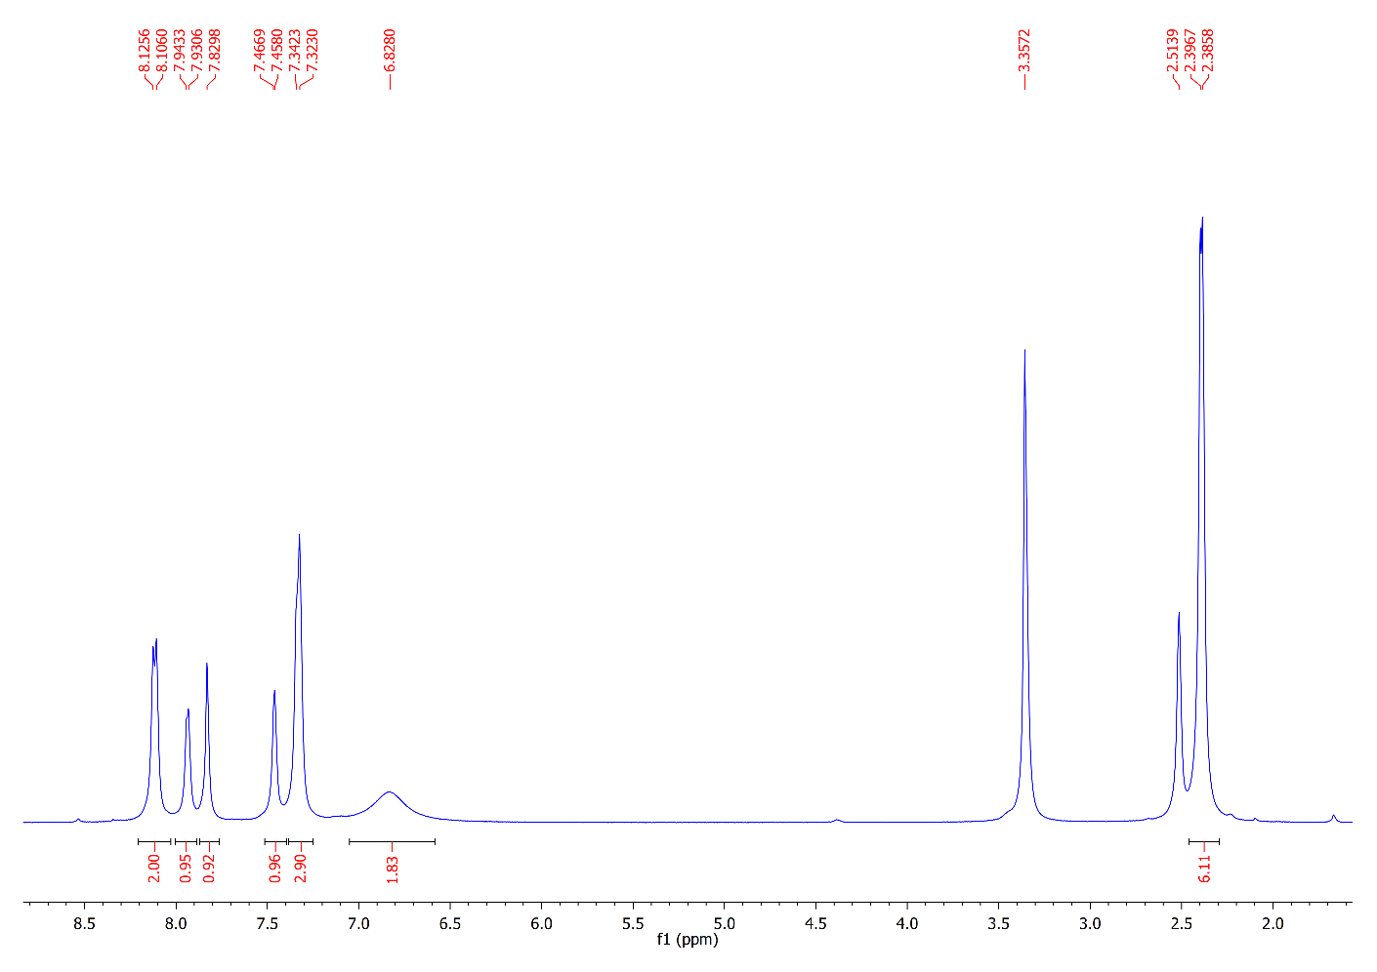
¹³C NMR Spectrum of Compound 7a
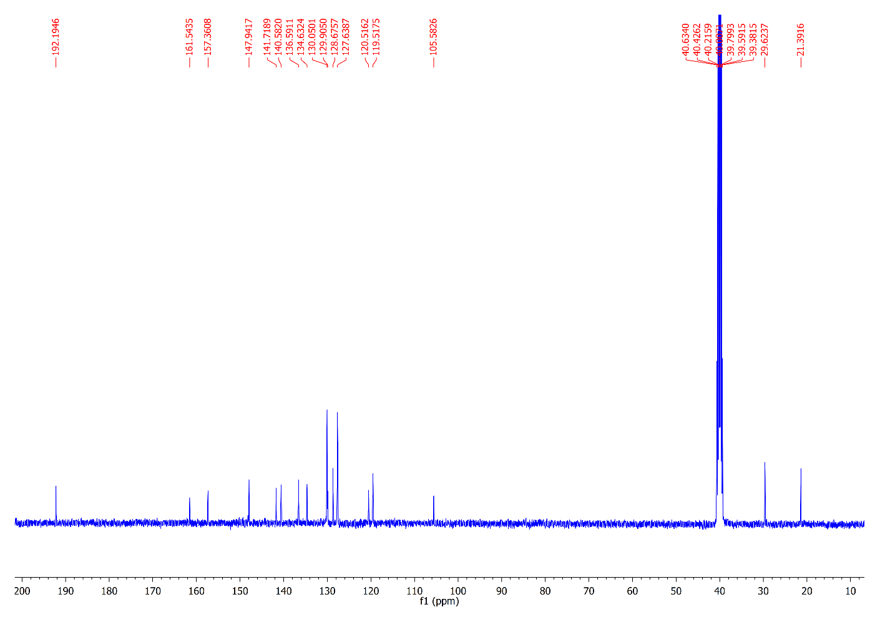
¹H NMR Spectrum of Compound 7b
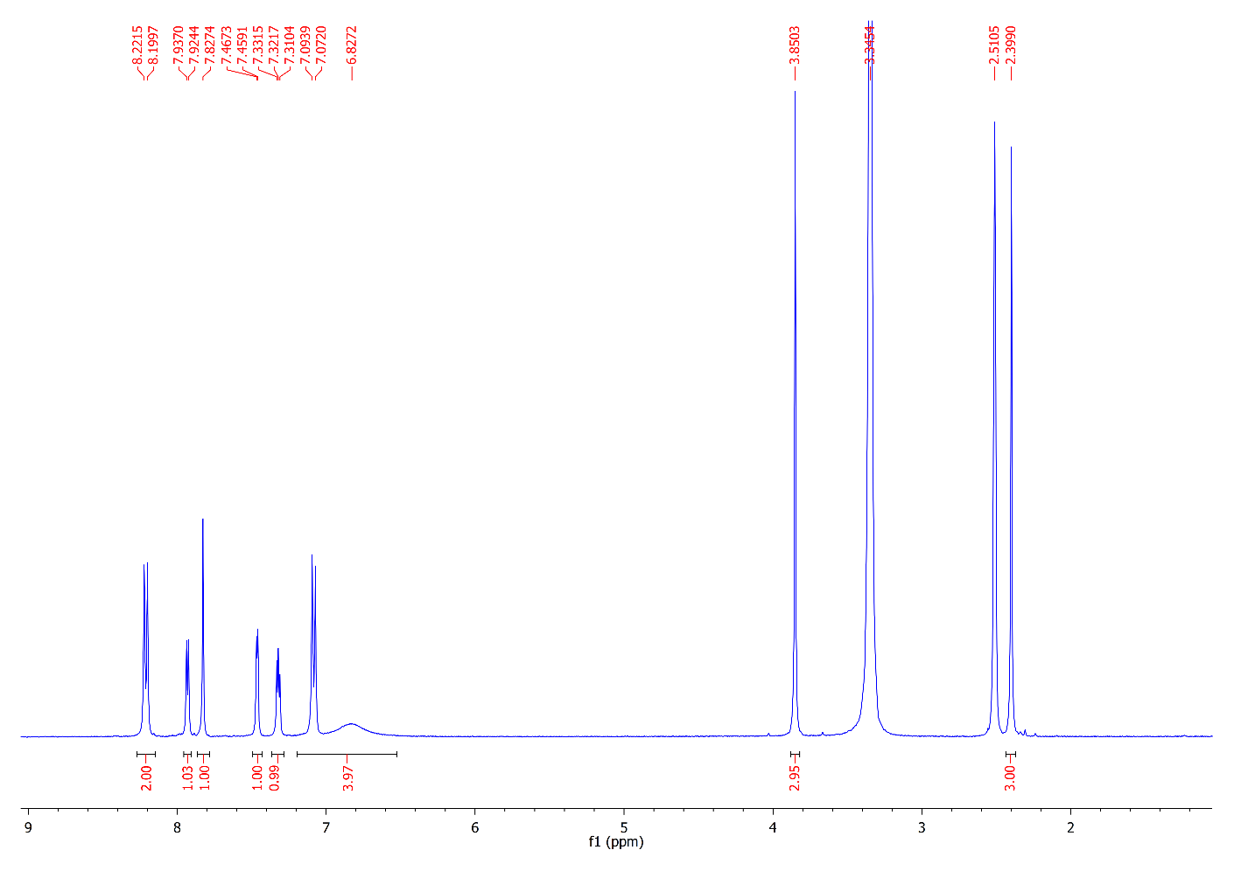
¹³C NMR Spectrum of Compound 7b
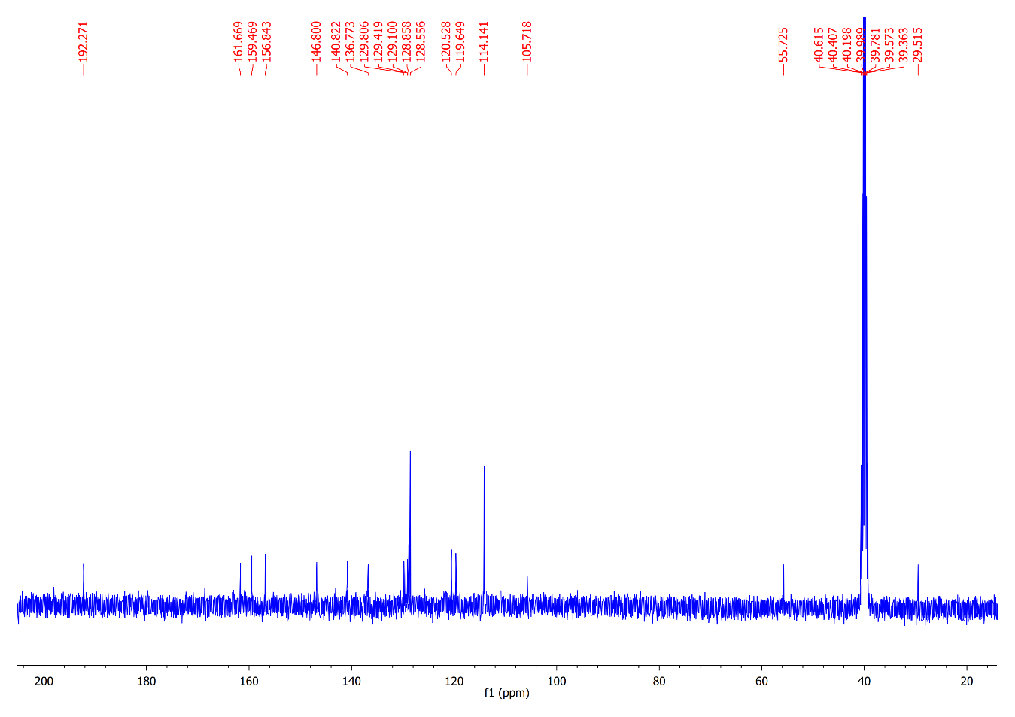
¹H NMR Spectrum of Compound 9a
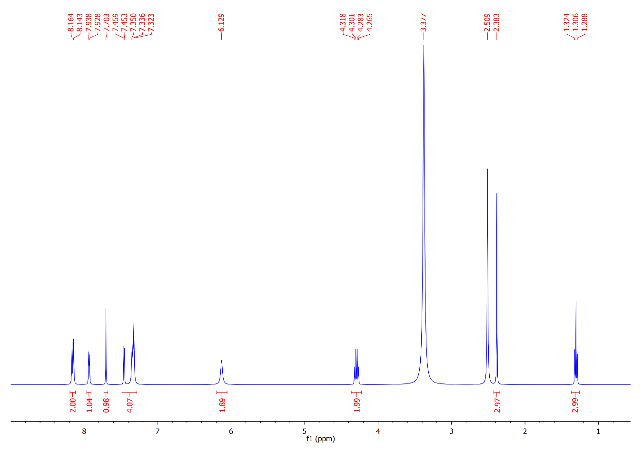
¹³C NMR Spectrum of Compound 9a
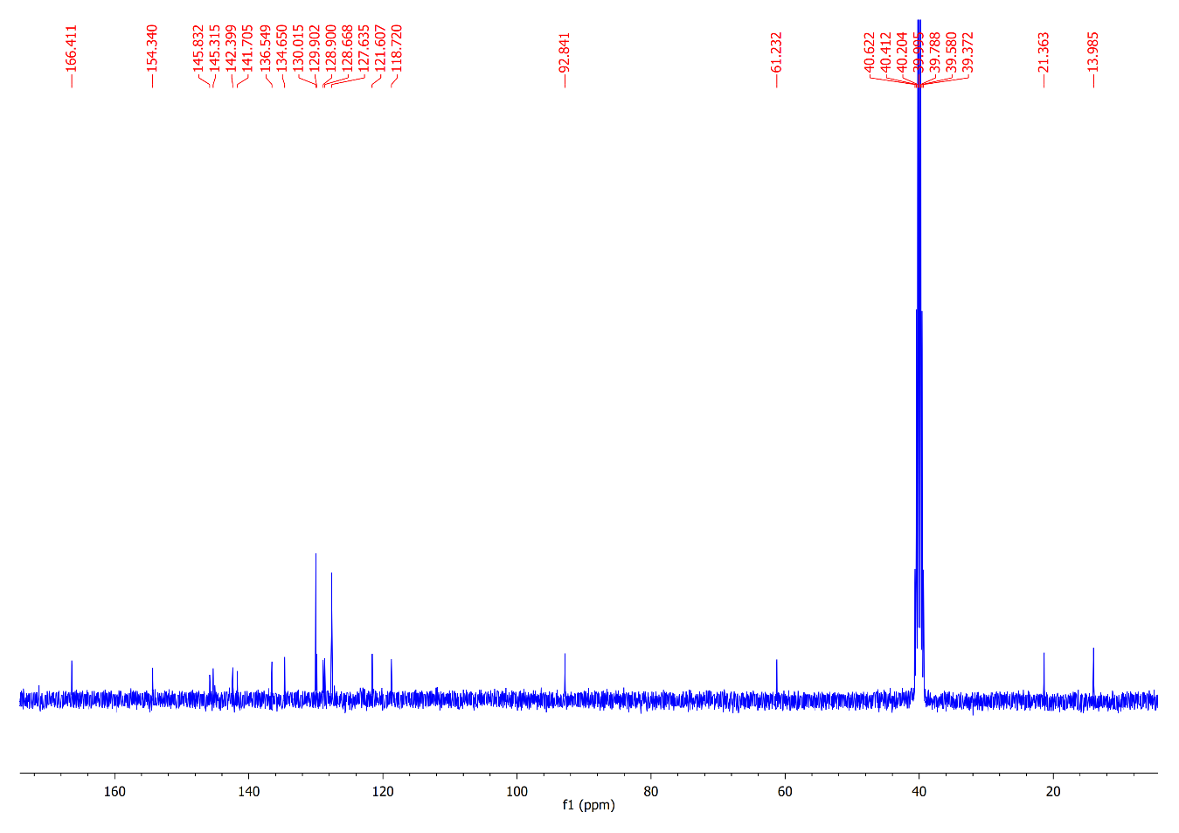
¹H NMR Spectrum of Compound 9b
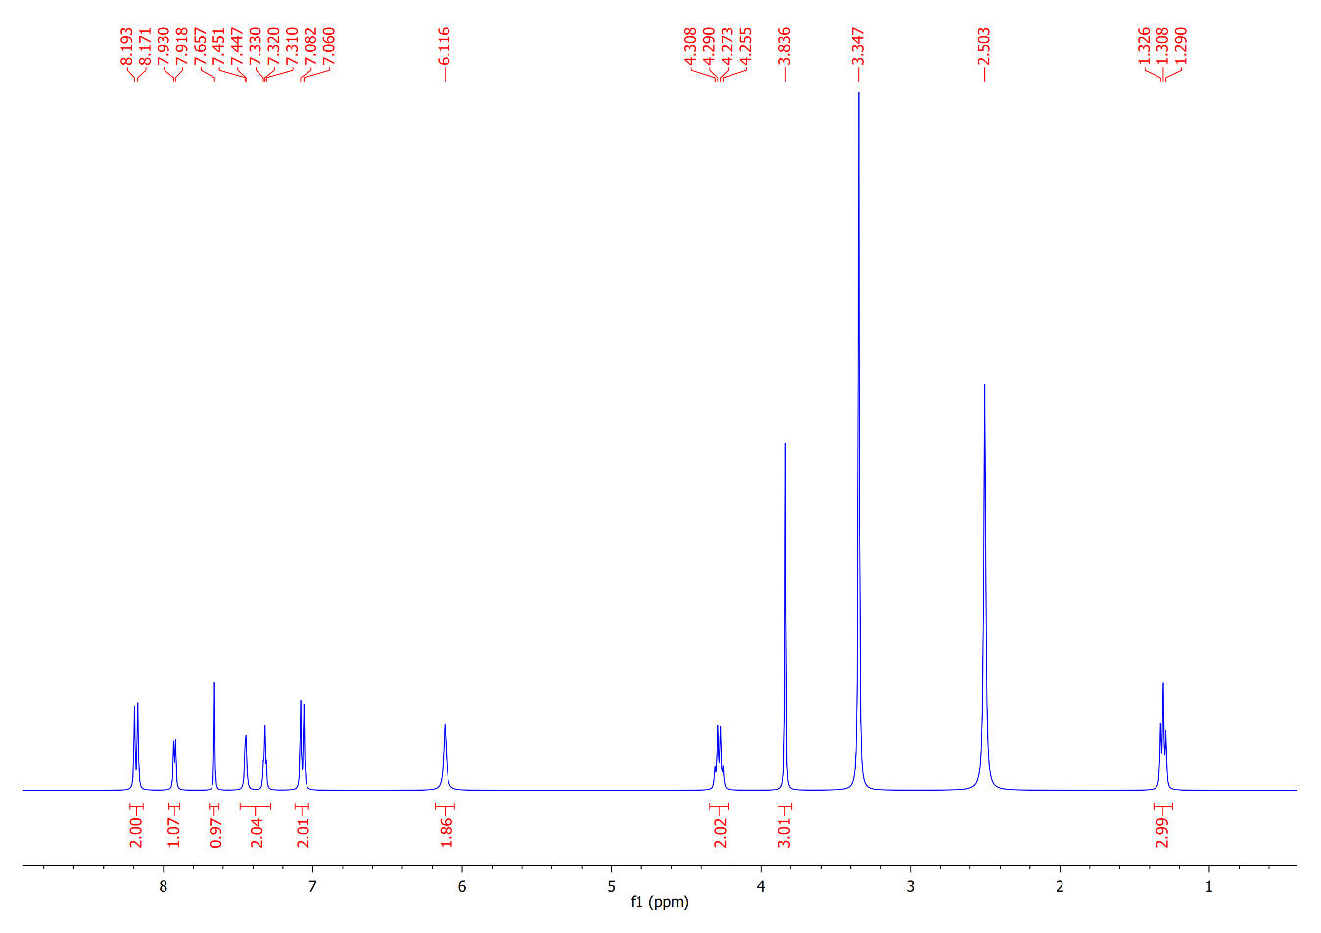
¹³C NMR Spectrum of Compound 9b
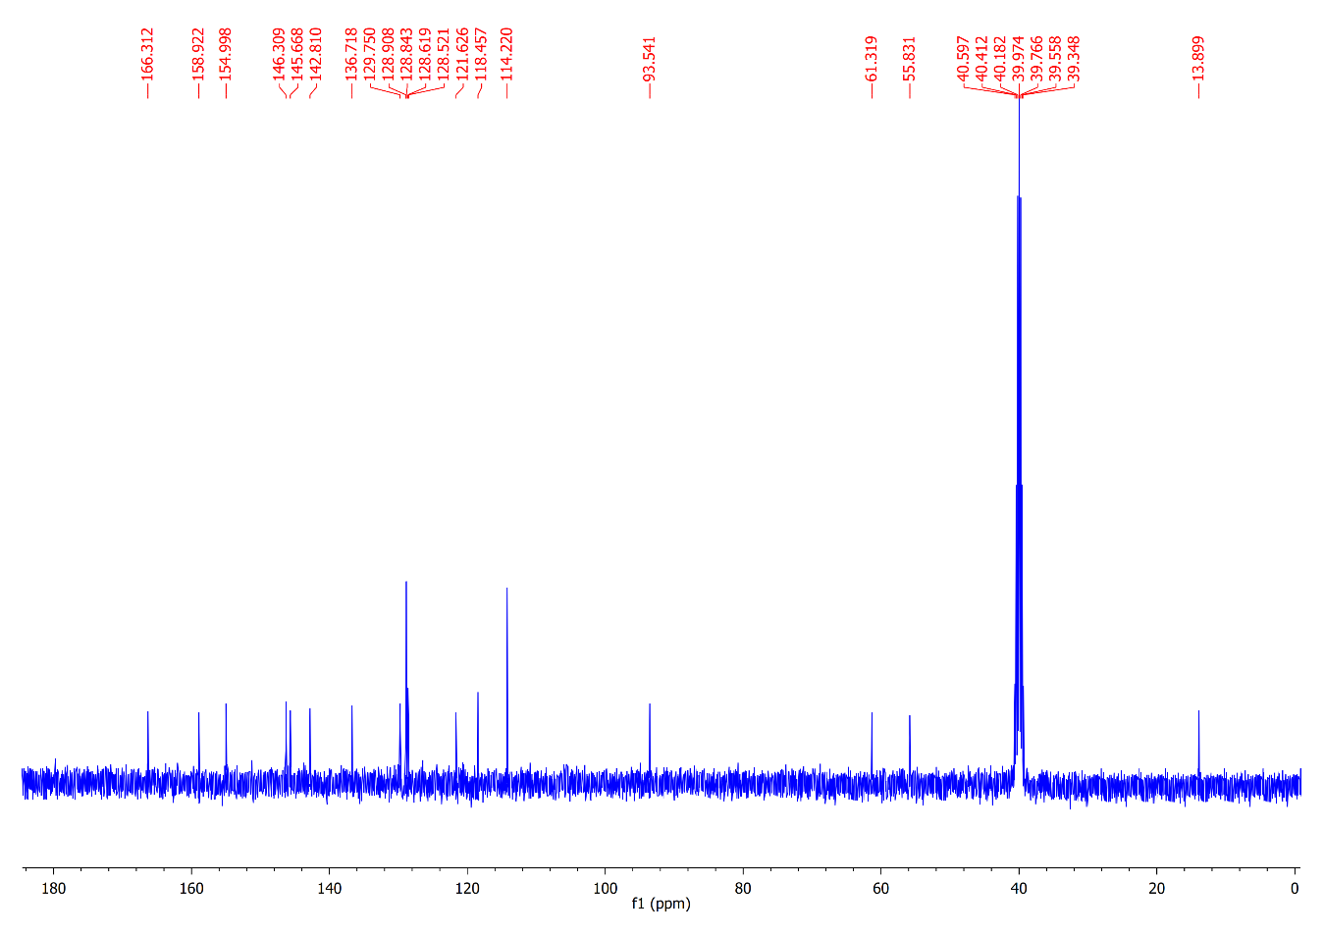
¹H NMR Spectrum of Compound 11a
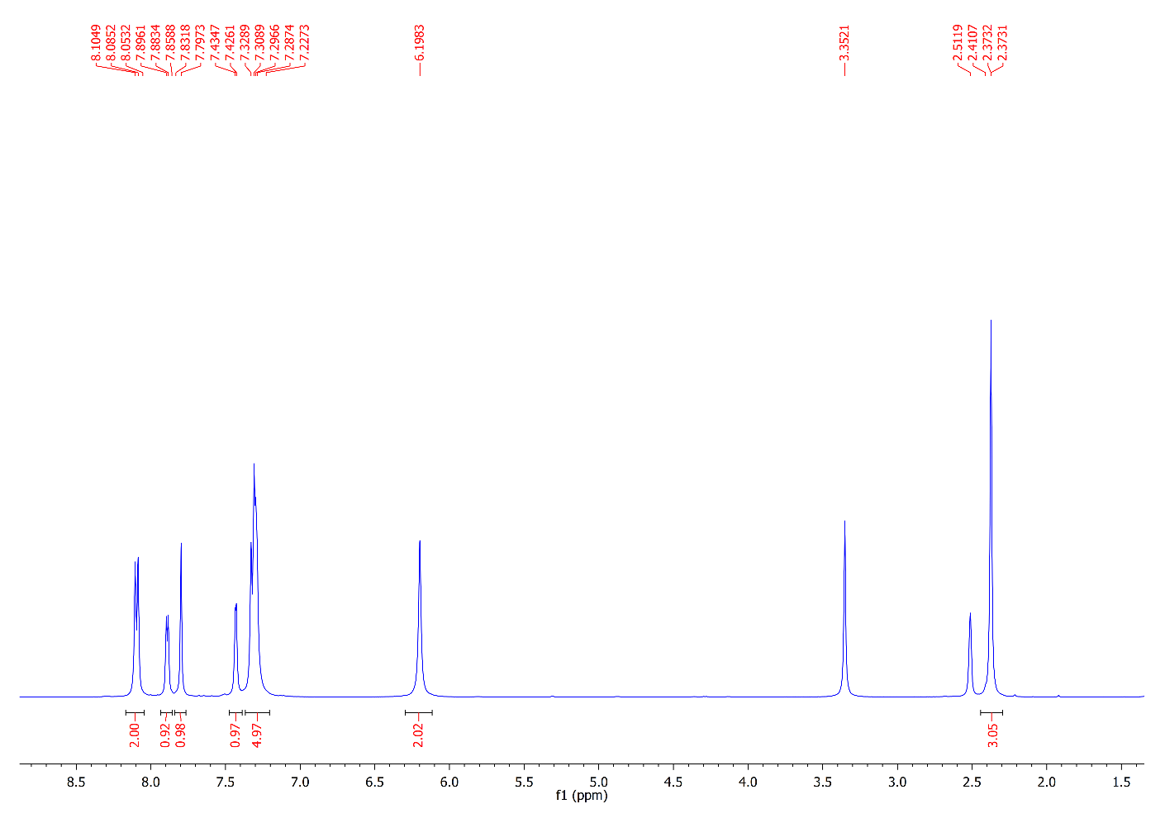
¹³C NMR Spectrum of Compound 11a
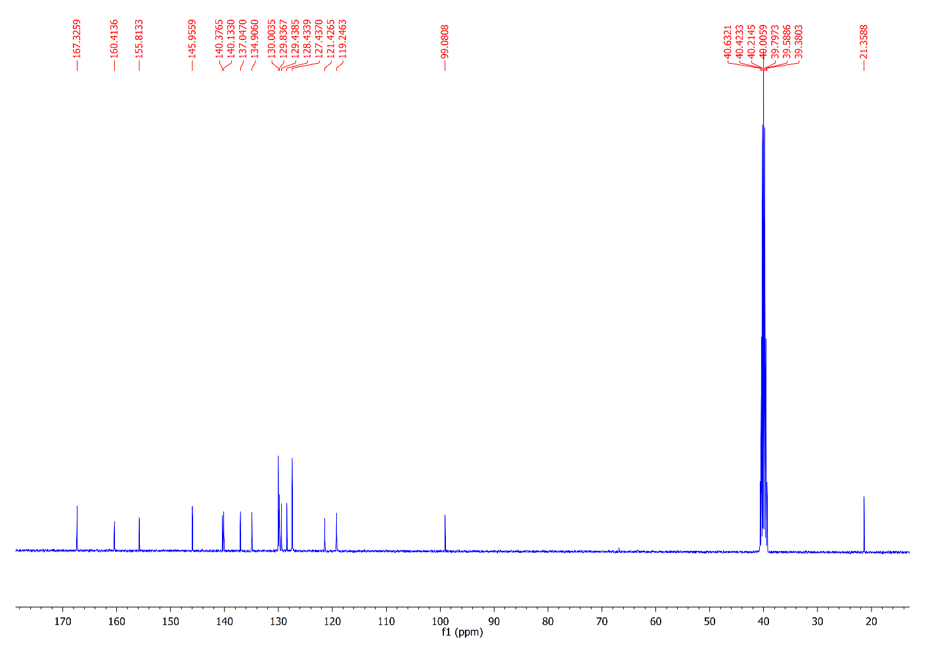
¹H NMR Spectrum of Compound 11b
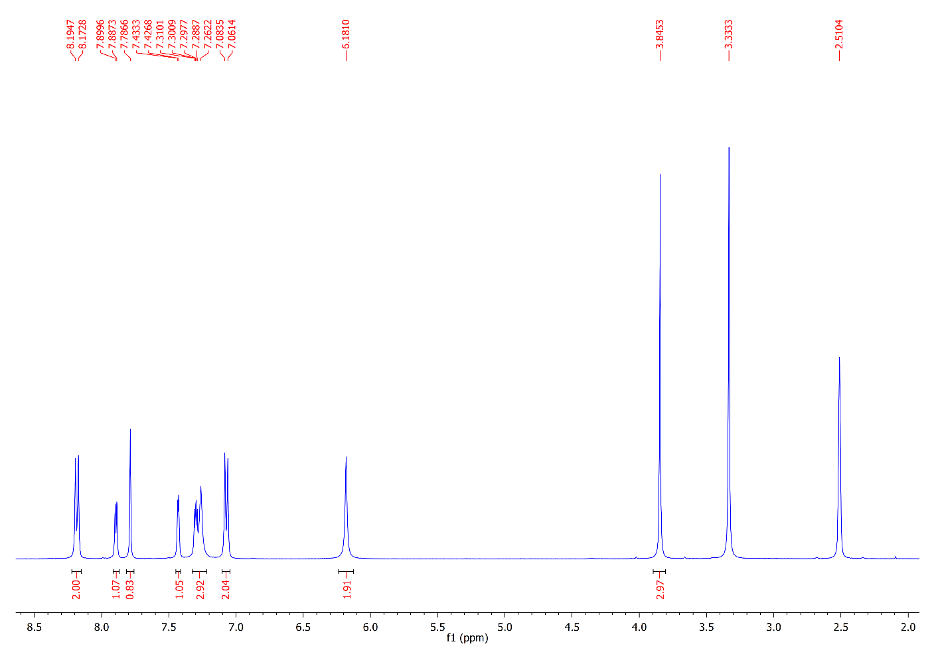
¹³C NMR Spectrum of Compound 11b
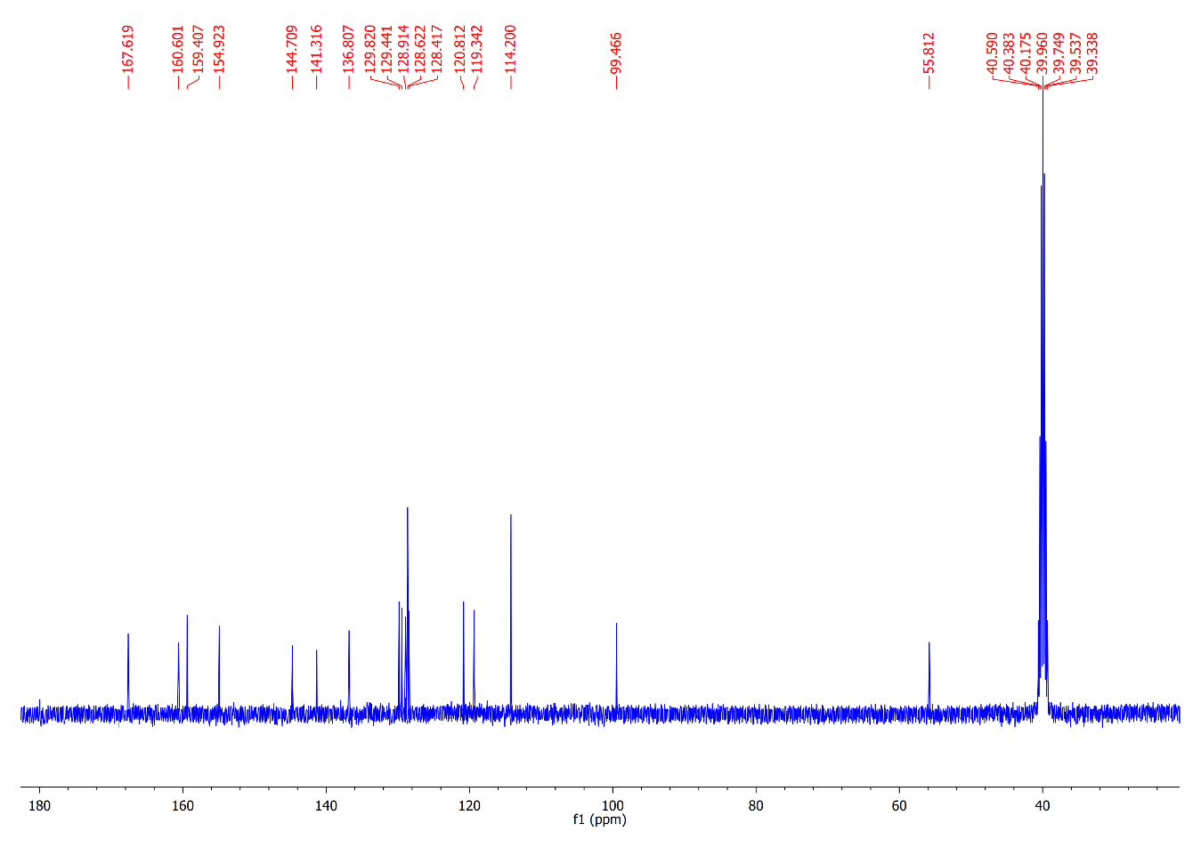
¹H NMR Spectrum of Compound 13a
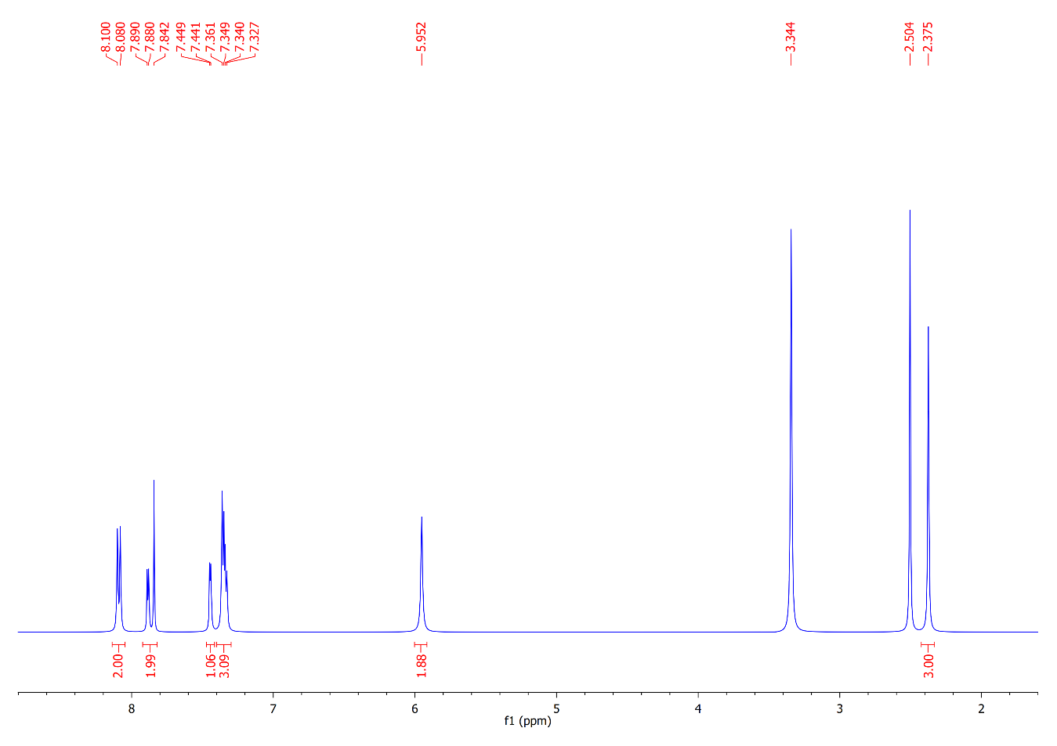
¹³C NMR Spectrum of Compound 13a
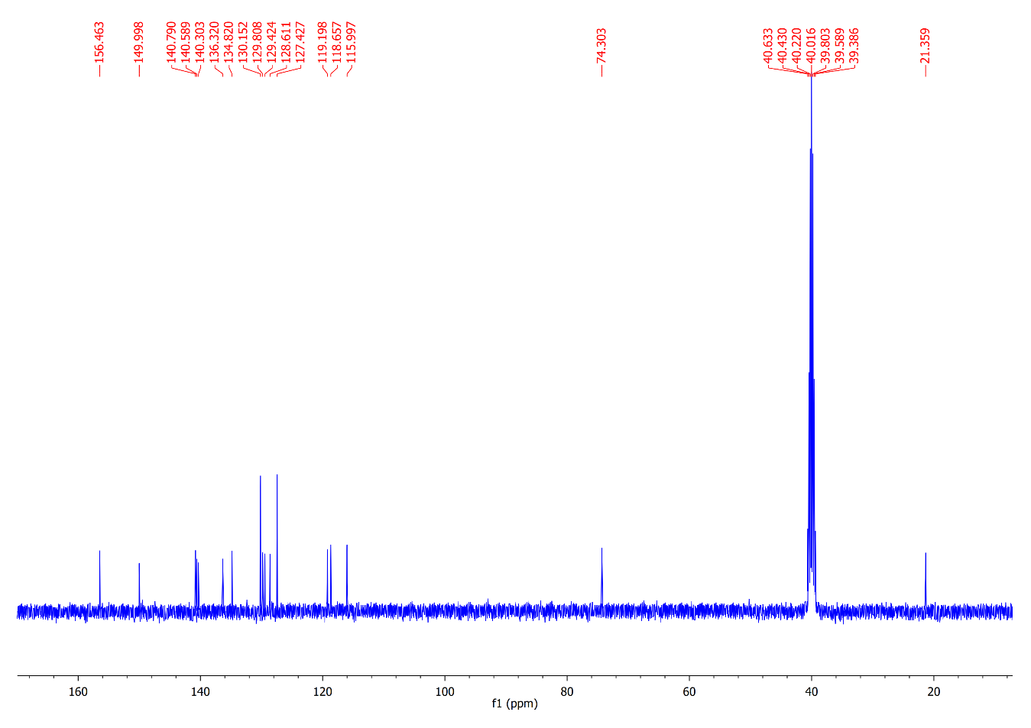
¹H NMR Spectrum of Compound 13b
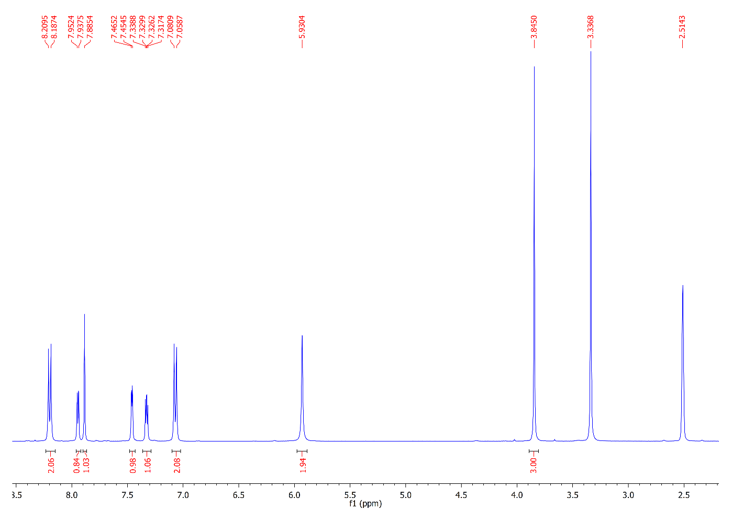
¹³C NMR Spectrum of Compound 13b
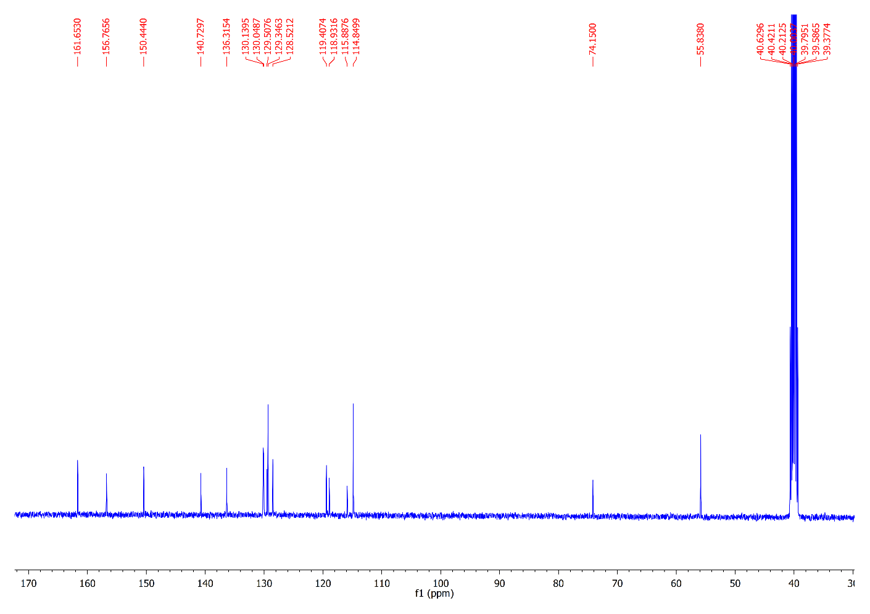
¹H NMR Spectrum of Compound 15a
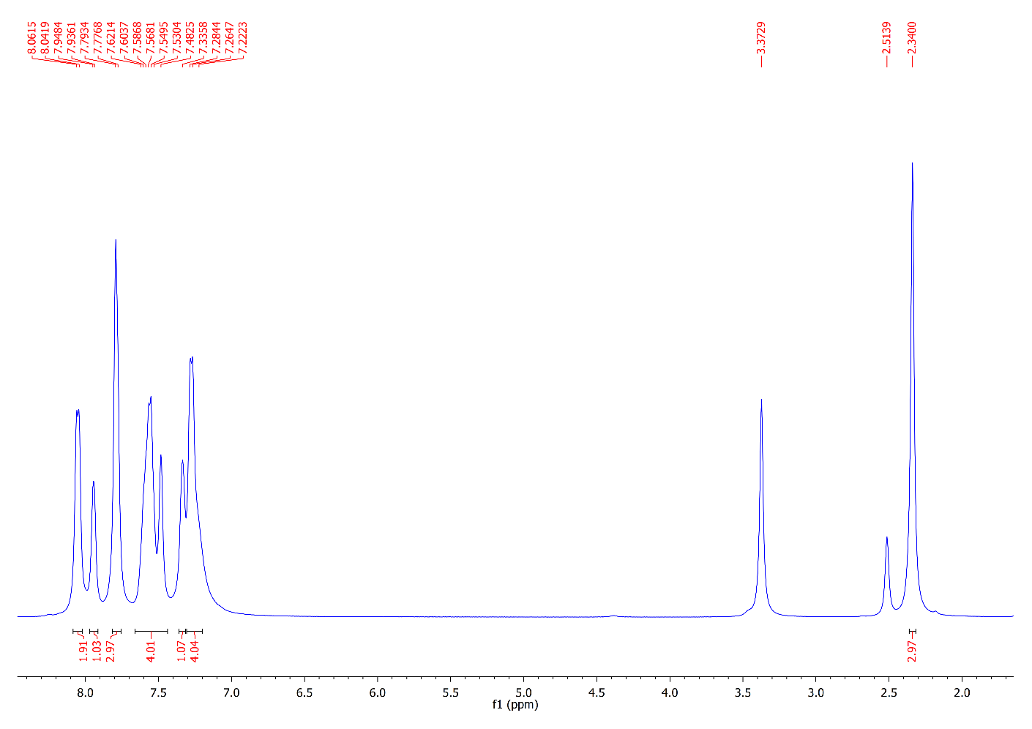
¹³C NMR Spectrum of Compound 15a
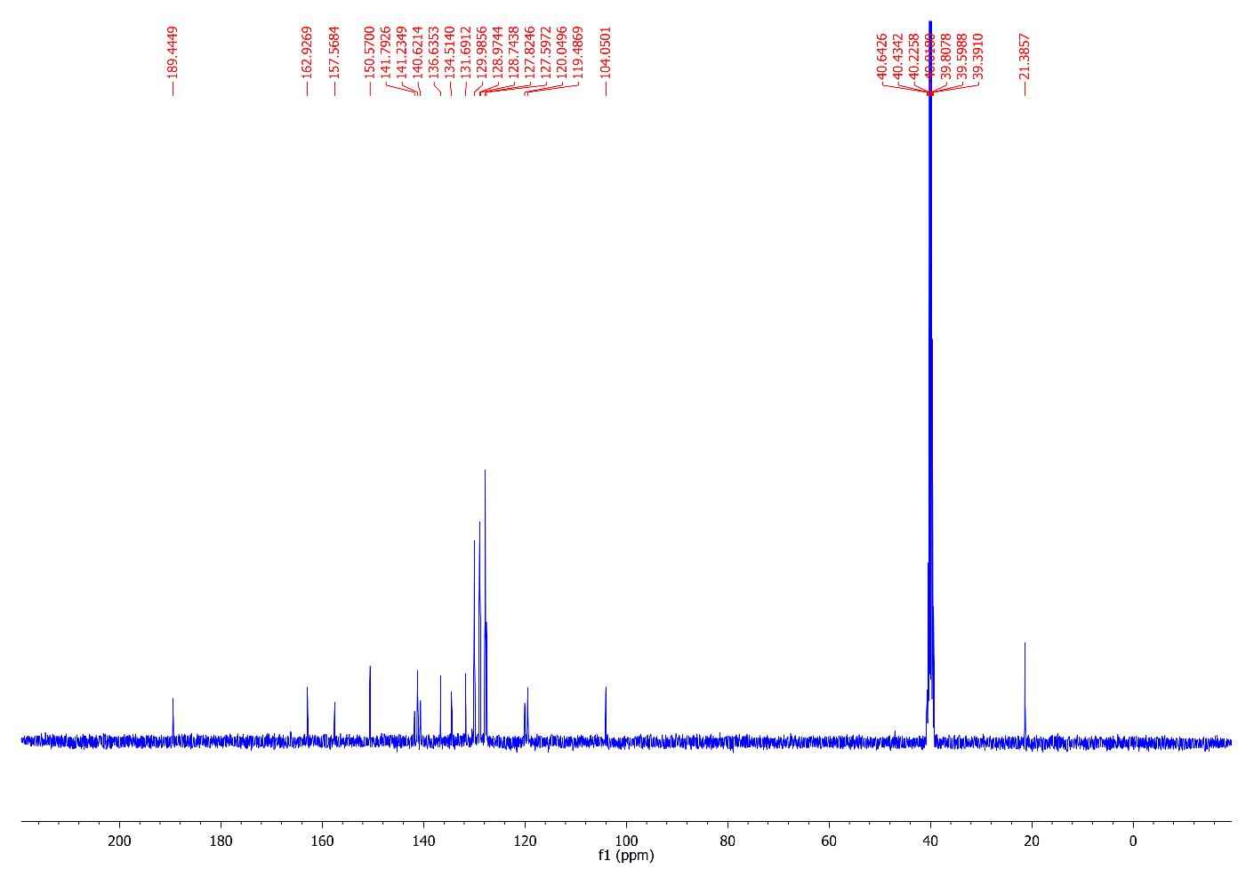
¹H NMR Spectrum of Compound 15b
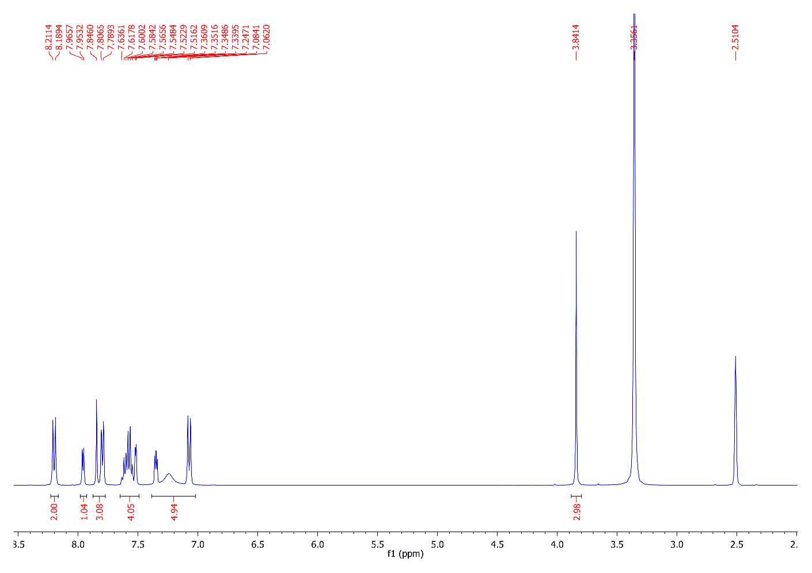
¹³C NMR Spectrum of Compound 15b
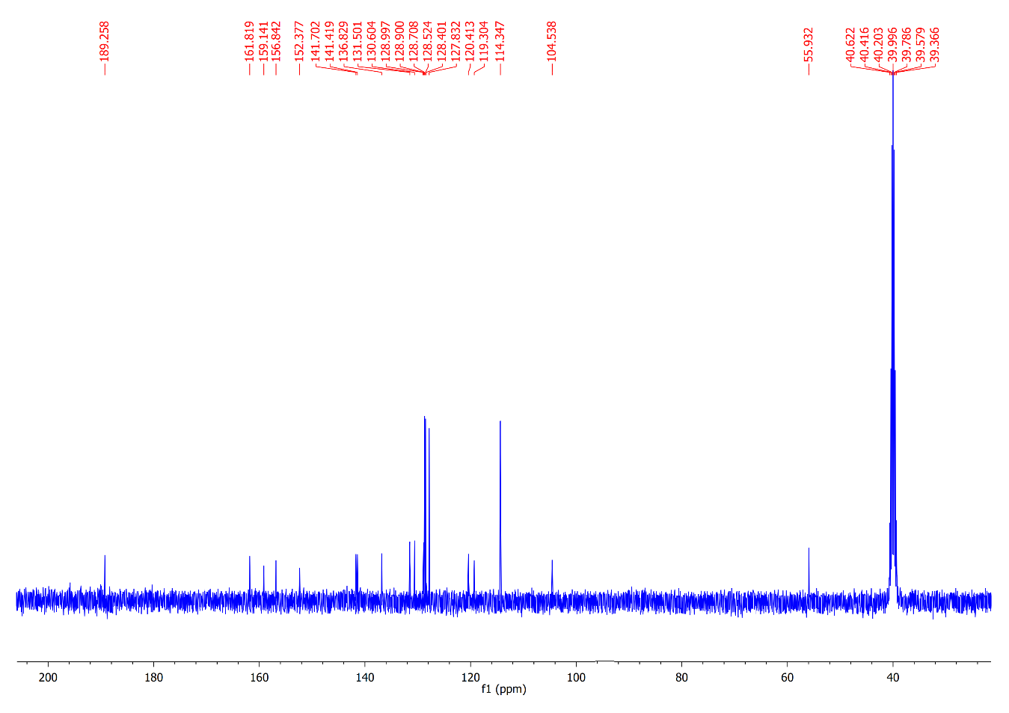
¹H NMR Spectrum of Compound 17a
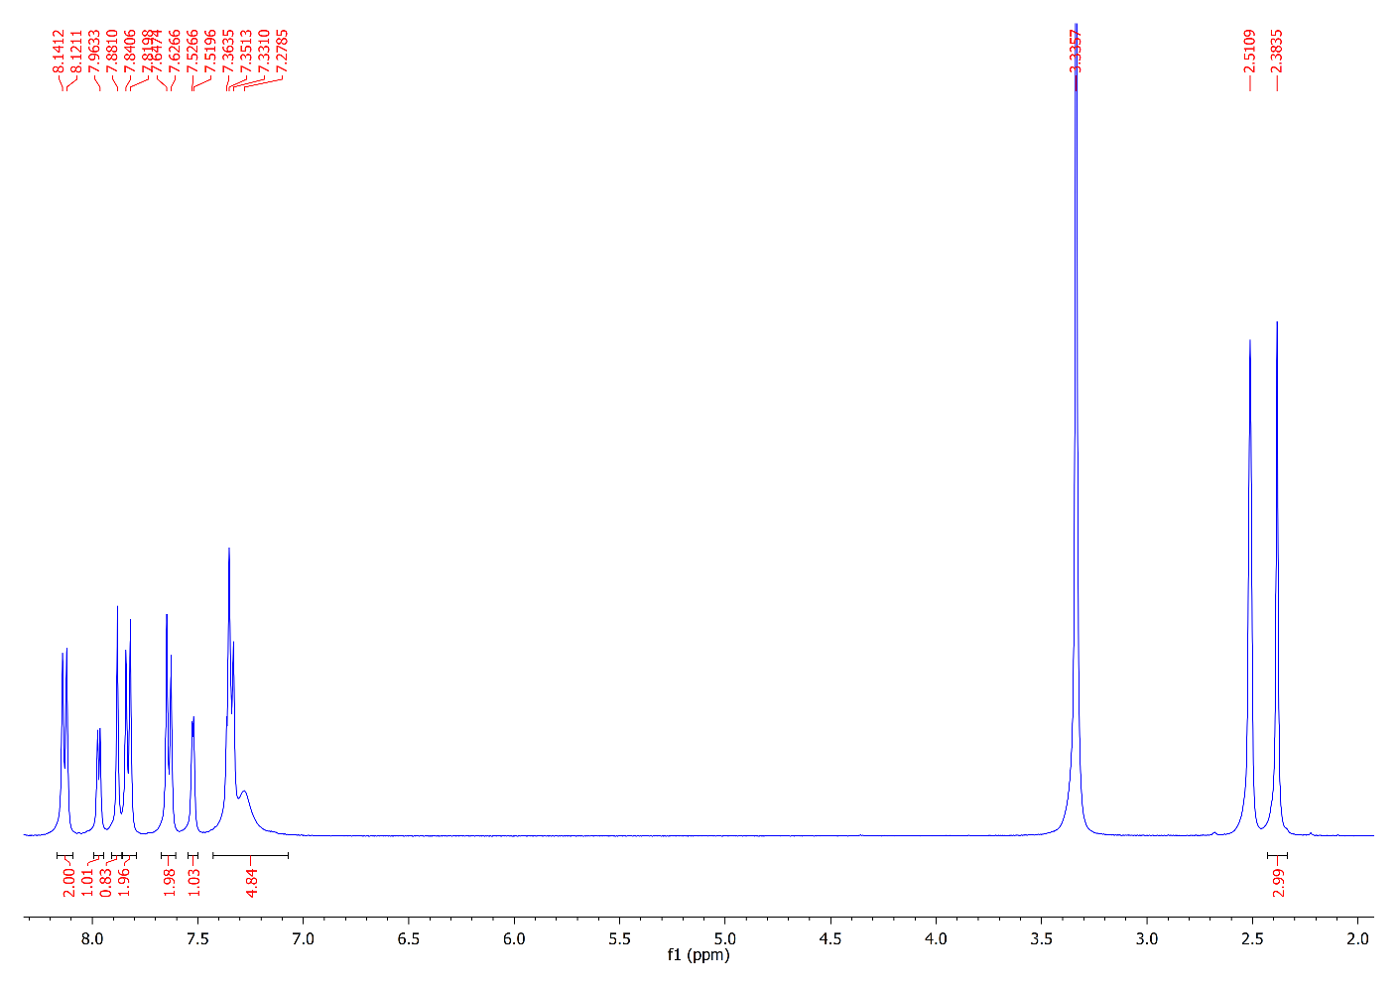
¹³C NMR Spectrum of Compound 17a
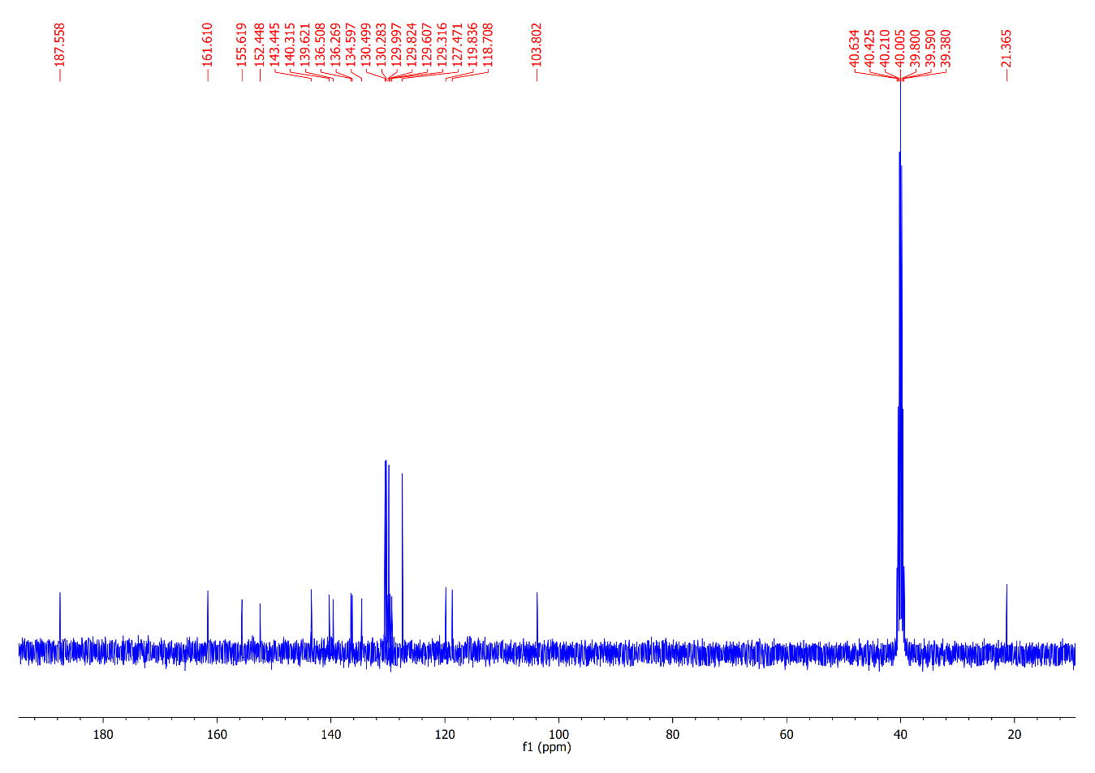
¹H NMR Spectrum of Compound 17b
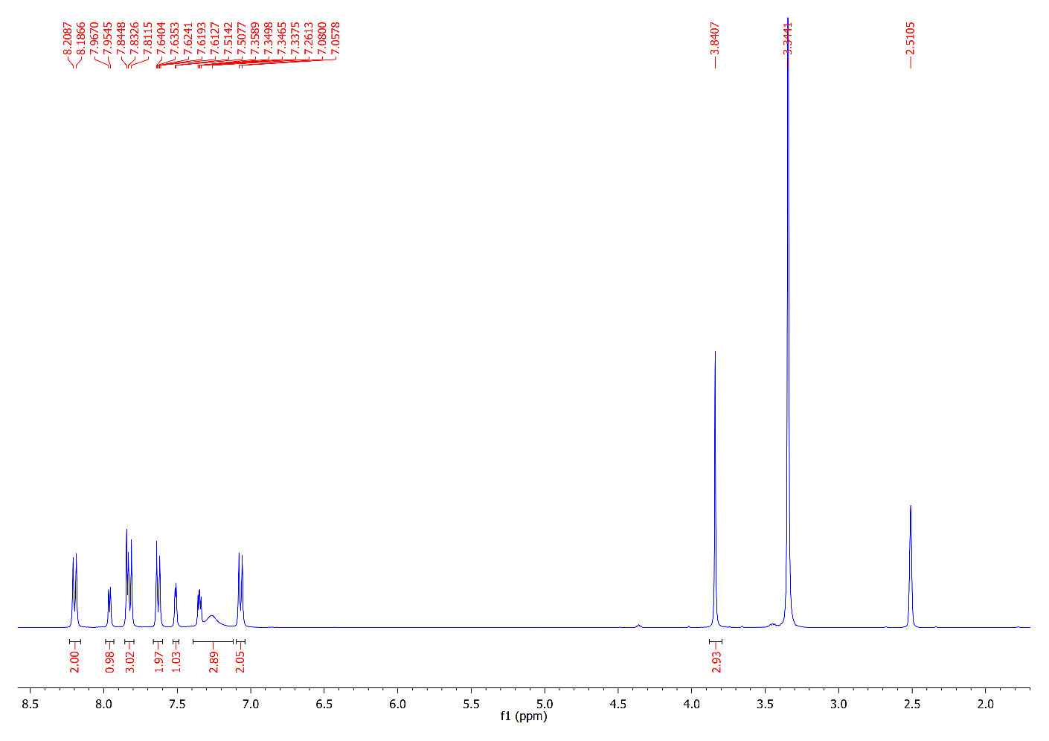
¹³C NMR Spectrum of Compound 17b
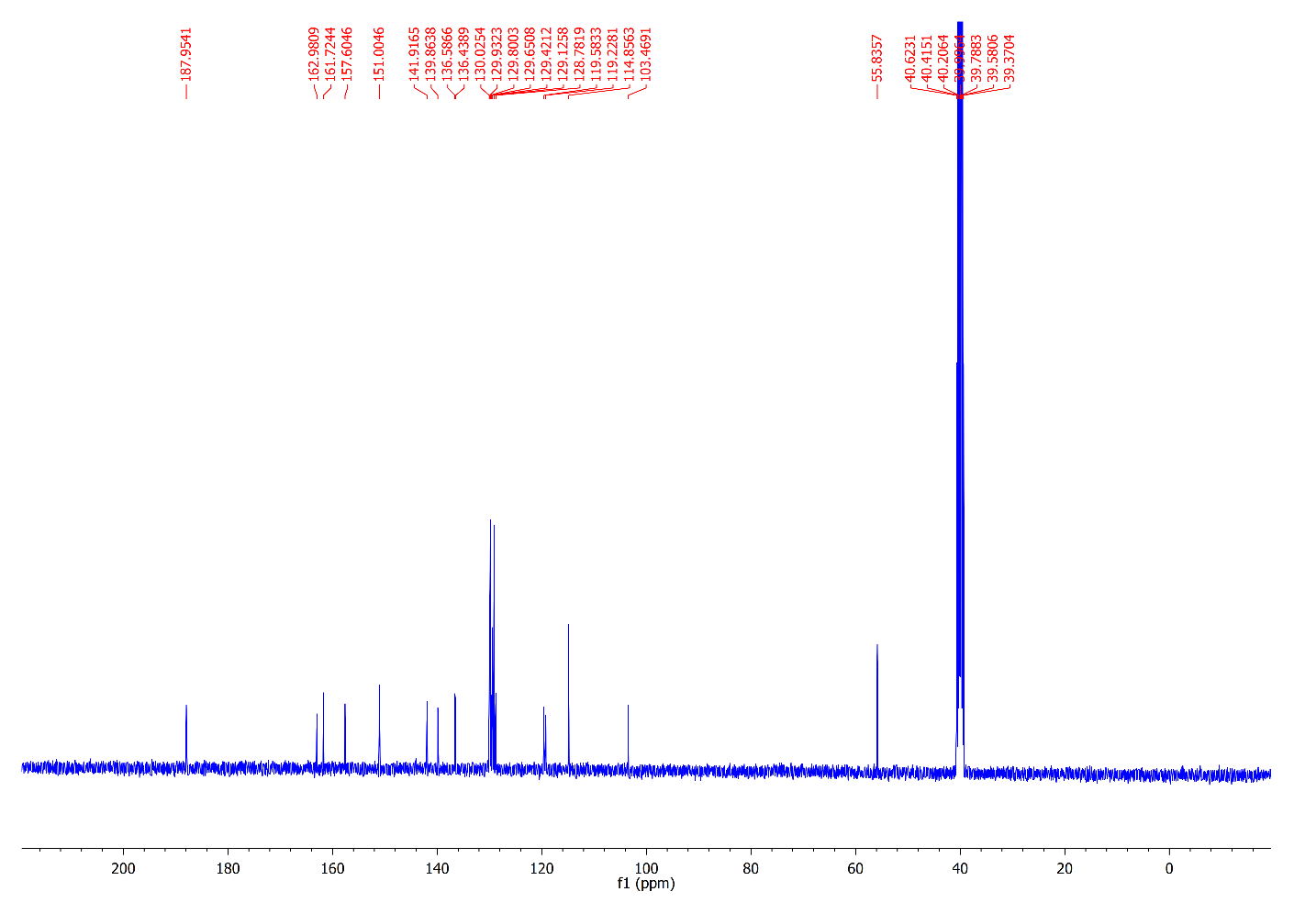
¹H NMR Spectrum of Compound 18
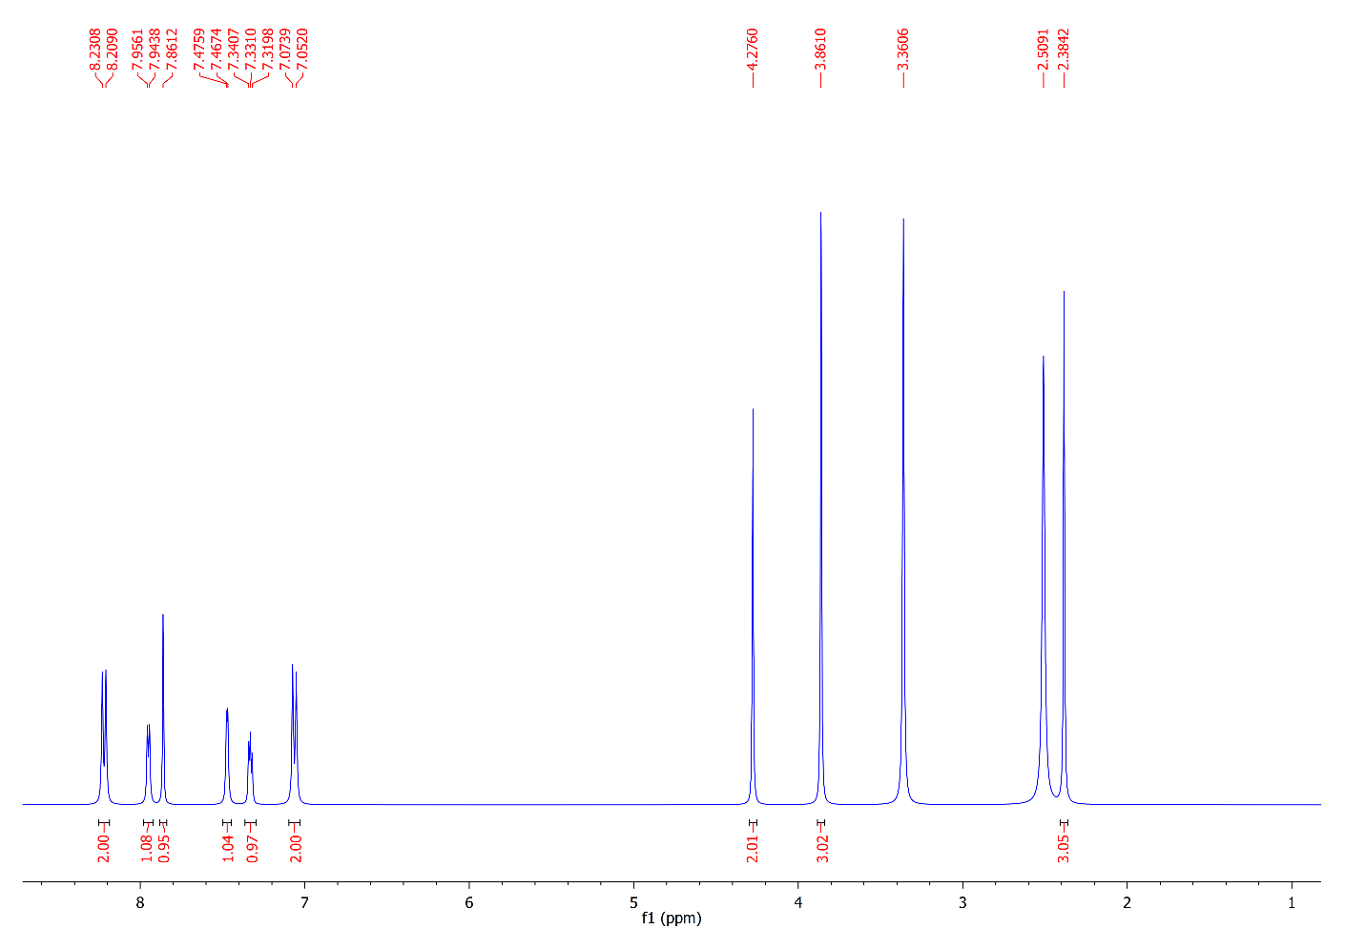
¹³C NMR Spectrum of Compound 18
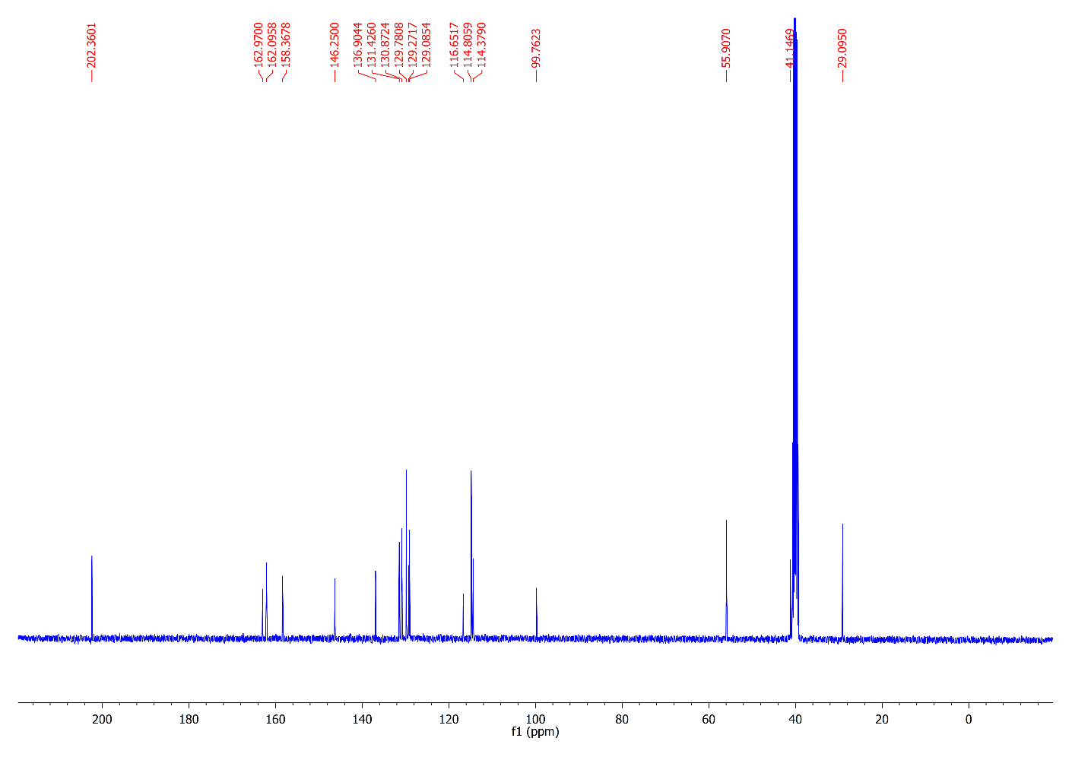
¹H NMR Spectrum of Compound 19
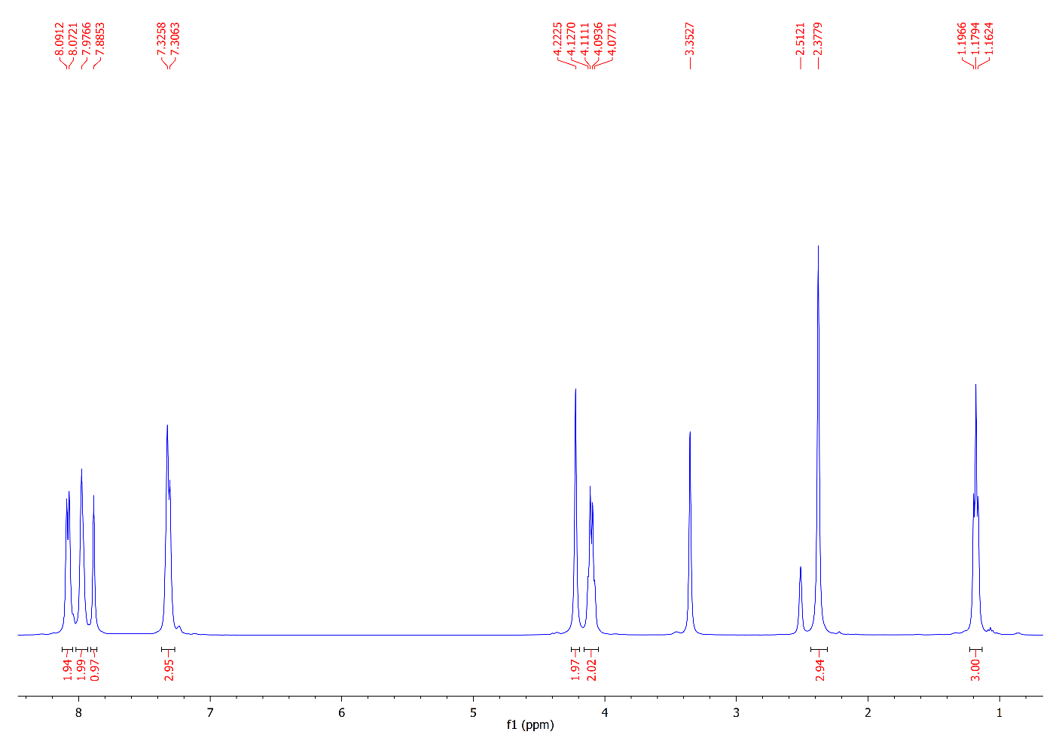
¹³C NMR Spectrum of Compound 19
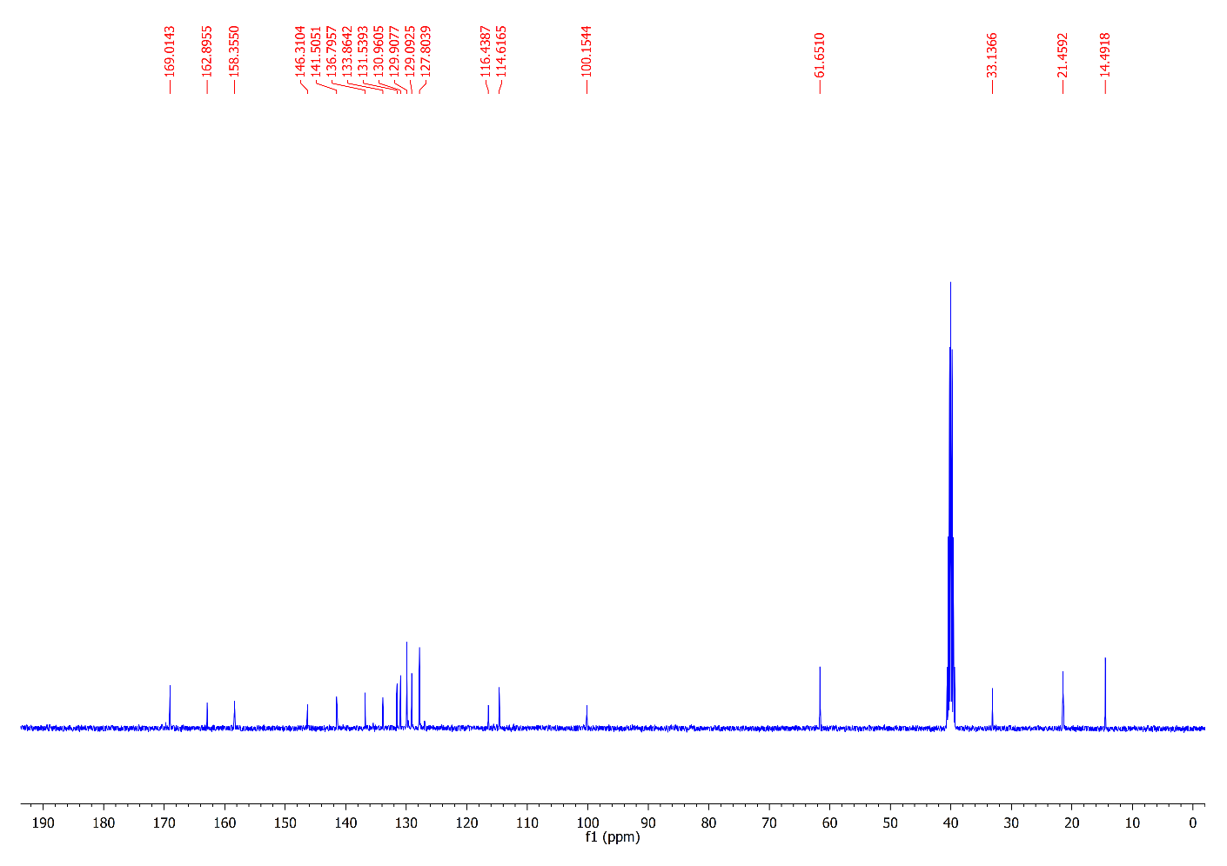
¹H NMR Spectrum of Compound 20
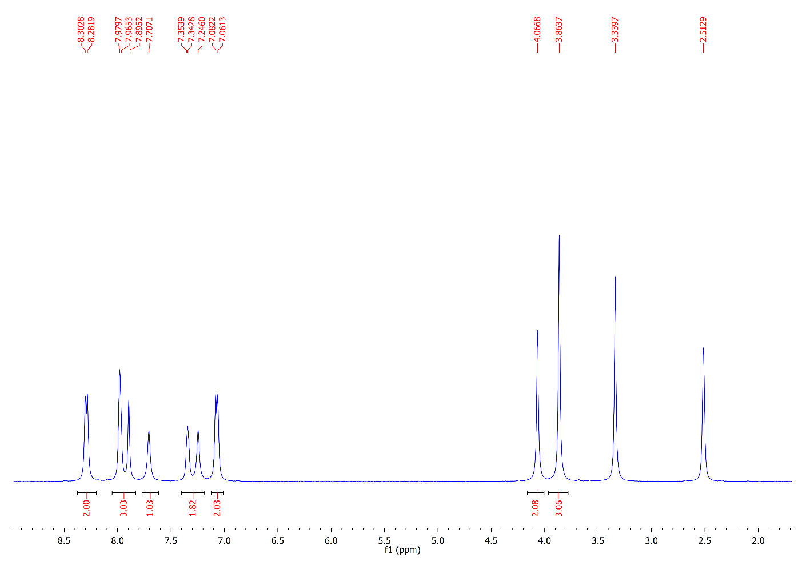
¹³C NMR Spectrum of Compound 20
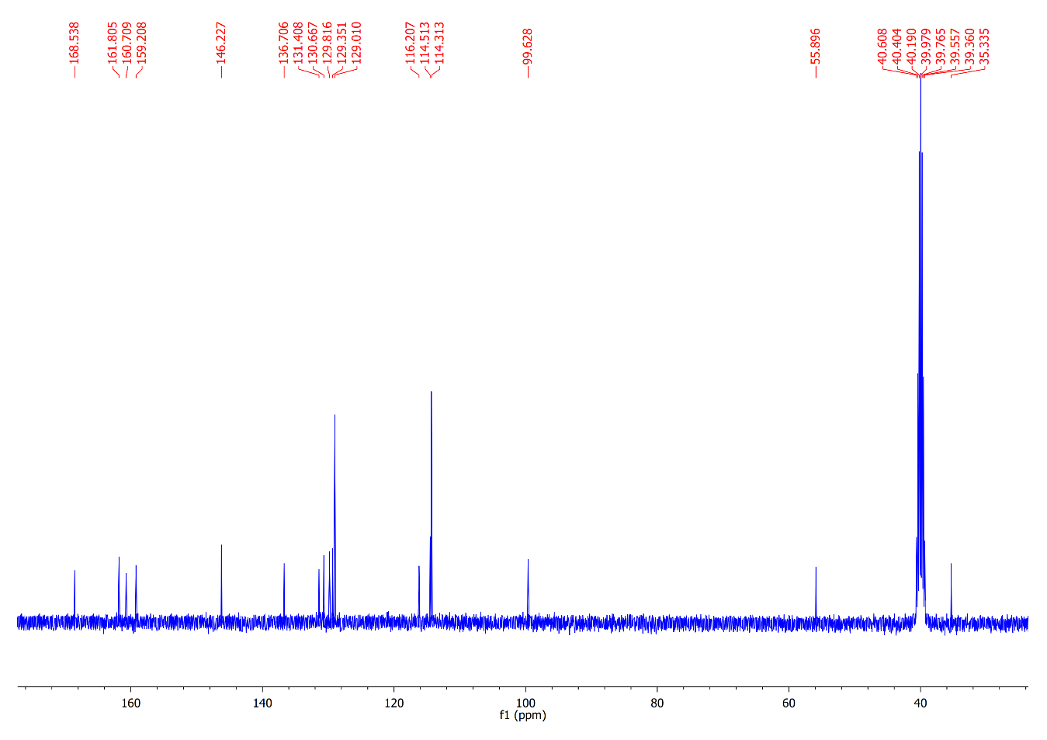
¹H NMR Spectrum of Compound 21
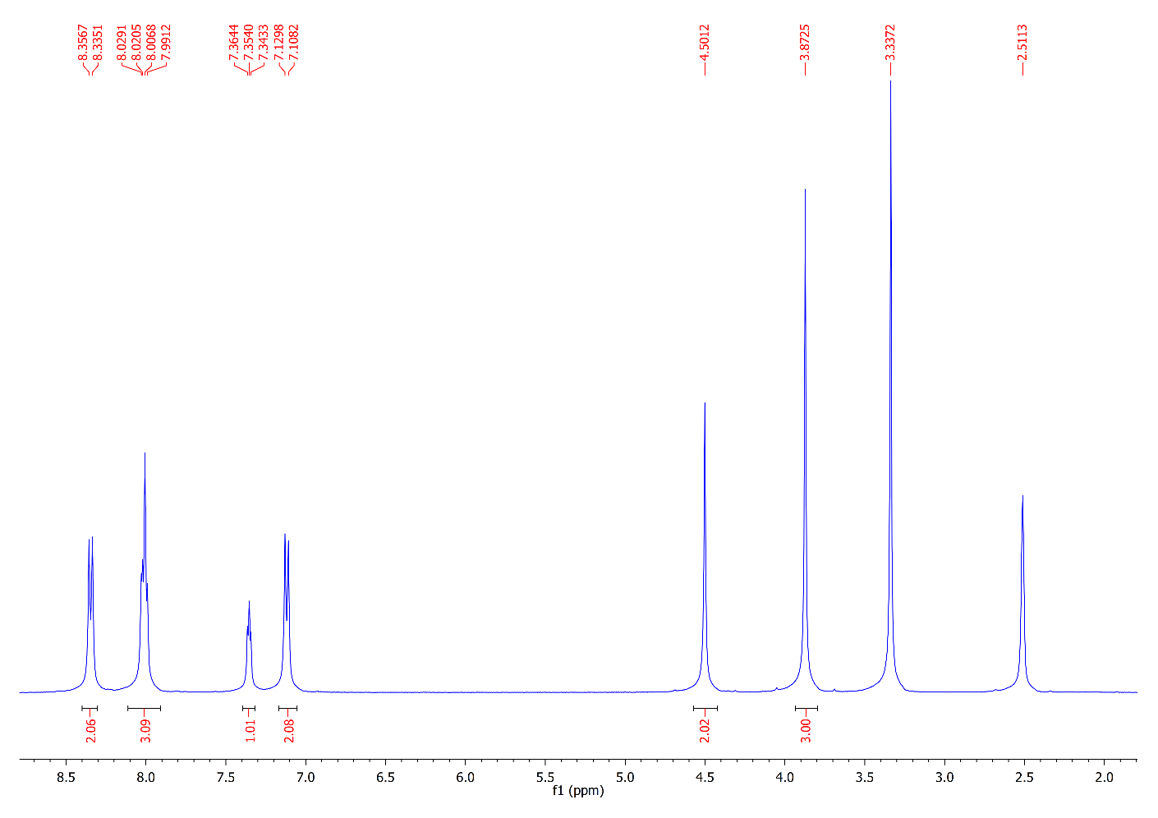
¹³C NMR Spectrum of Compound 21
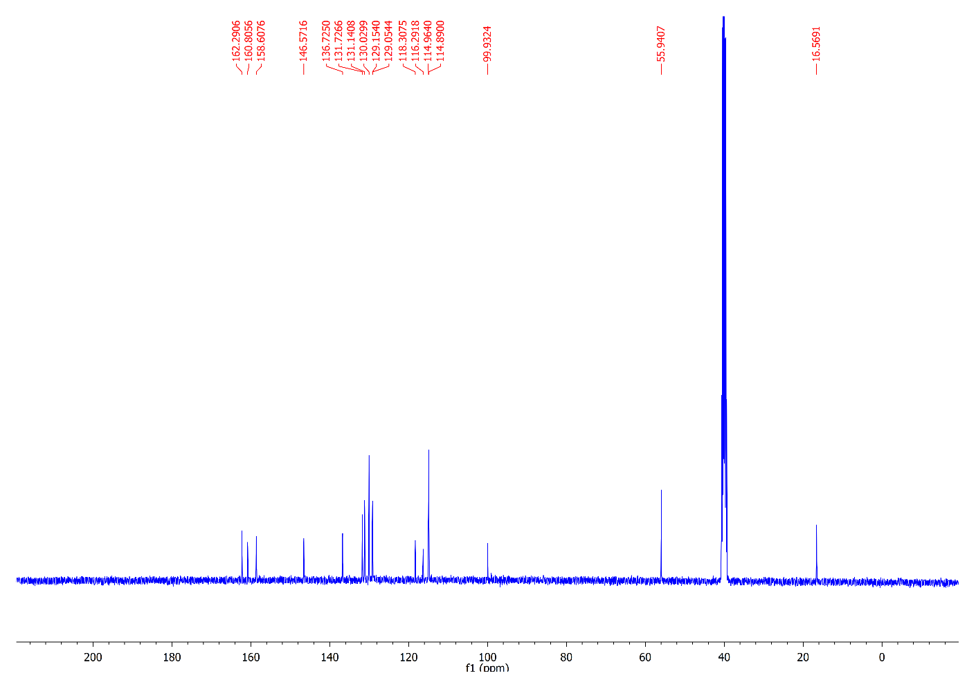
¹H NMR Spectrum of Compound 22
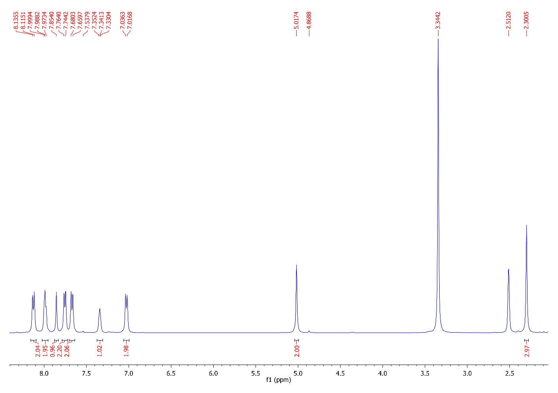
¹³C NMR Spectrum of Compound 22
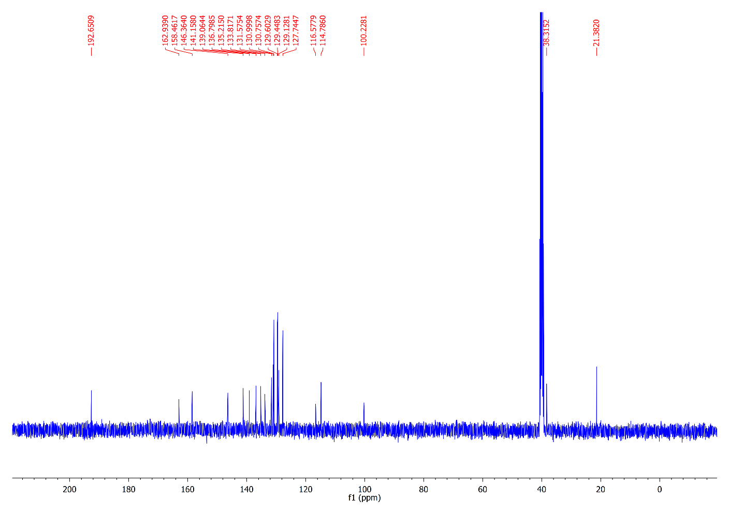
The 2D and 3D ligand interactions of 9a with pim-1 kinase (2OBJ).
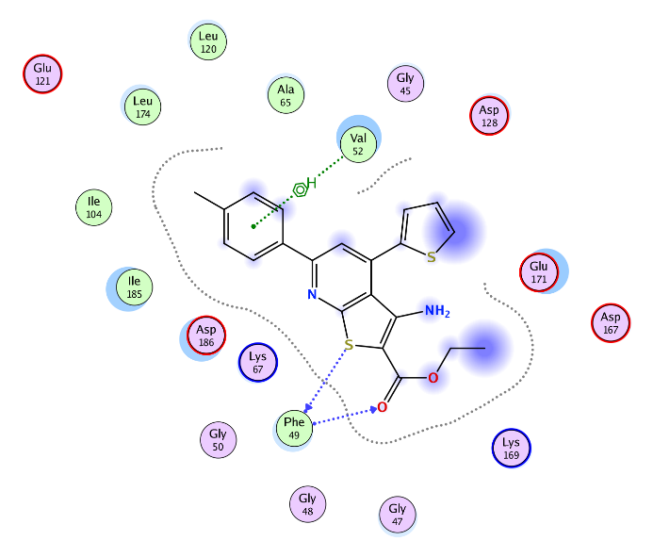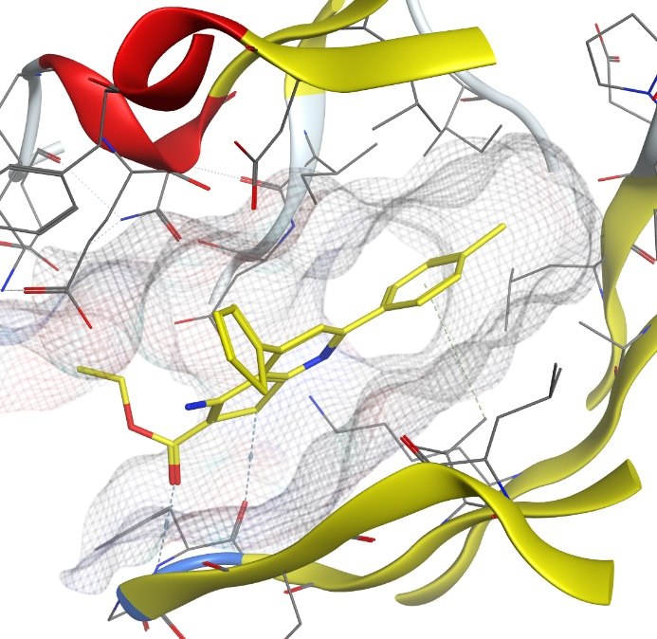

The 2D and 3D ligand interactions of 9b with pim-1 kinase (2OBJ).
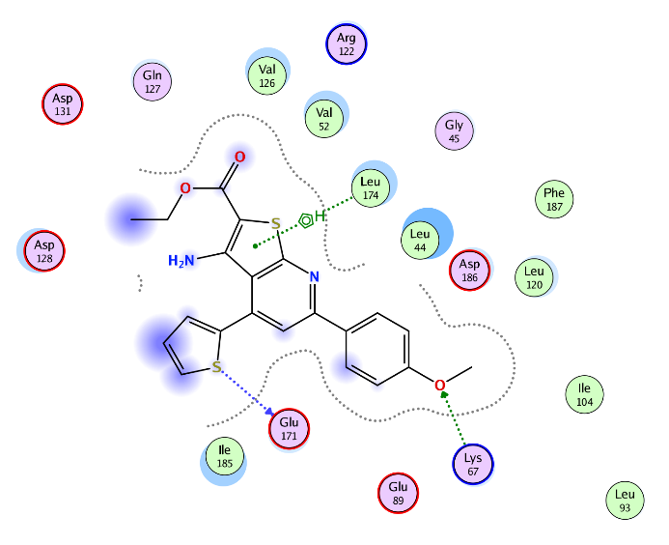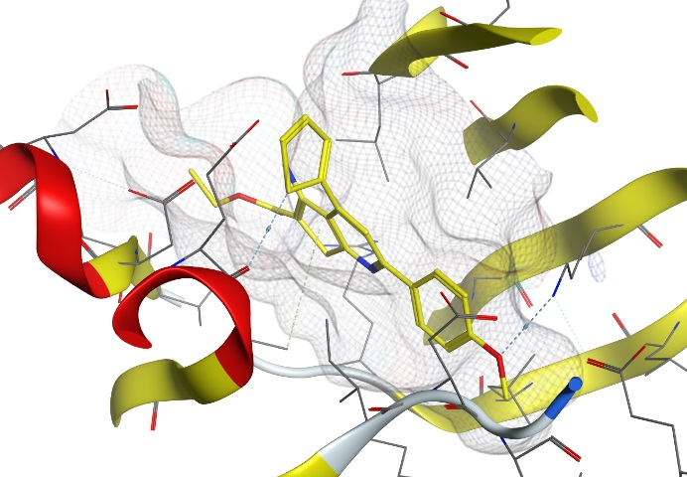

The 2D and 3D ligand interactions of 11a with pim-1 kinase (2OBJ).
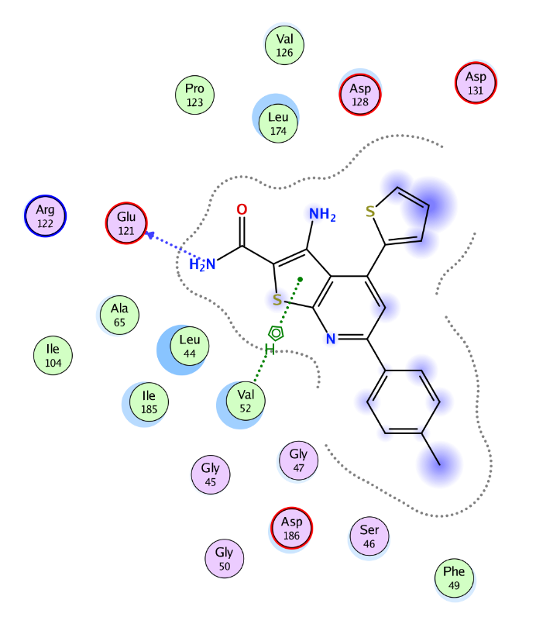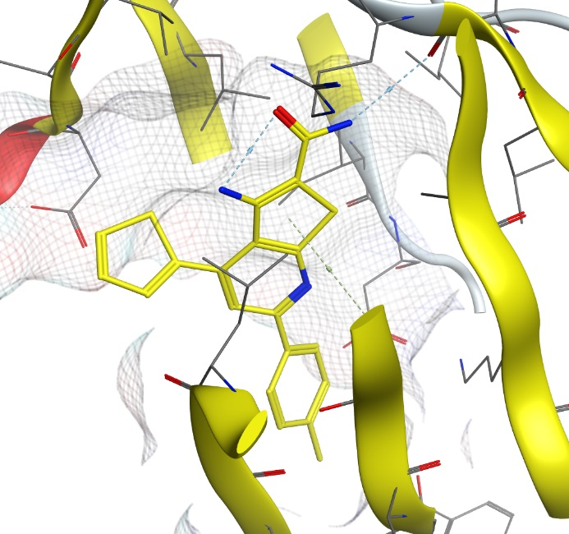

The 2D and 3D ligand interactions of 11b with pim-1 kinase (2OBJ).
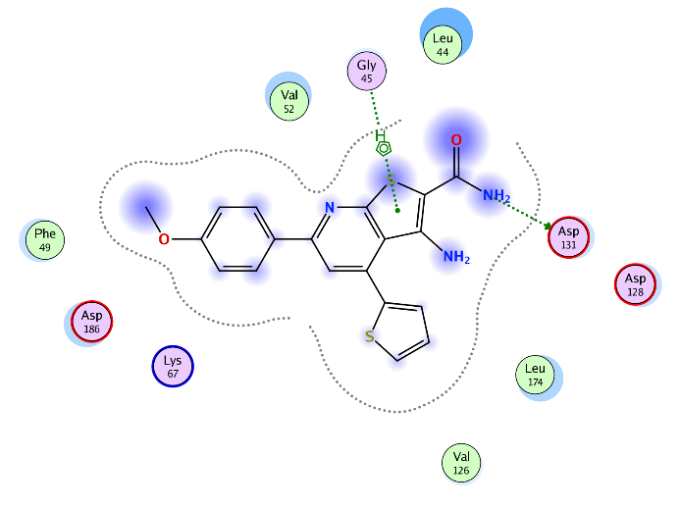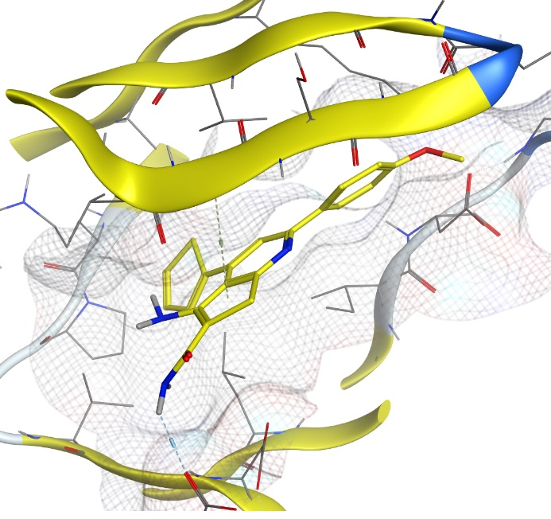

Figure 1. Cell viability% of MCF-7 cell line after treatment with some novel nicotinonitriles and thienopyridines for 24 h.

Figure 2. Cell viability% of HEPG2 cell line after treatment with some novel nicotinonitriles and thienopyridines for 24 h.

