Supplementary Data
Figure S1. Comparison of CFD simulated and ADCP measured depth averaged velocity at each cross-section during FVES off conditions. Errors near the shoreline are due to interpolation imposed when generating the computer model of the channel bed. The surface roughness parameter was set to 0.1 m in the CFD model to produce depth averaged velocity profiles that reasonably match measured profiles.
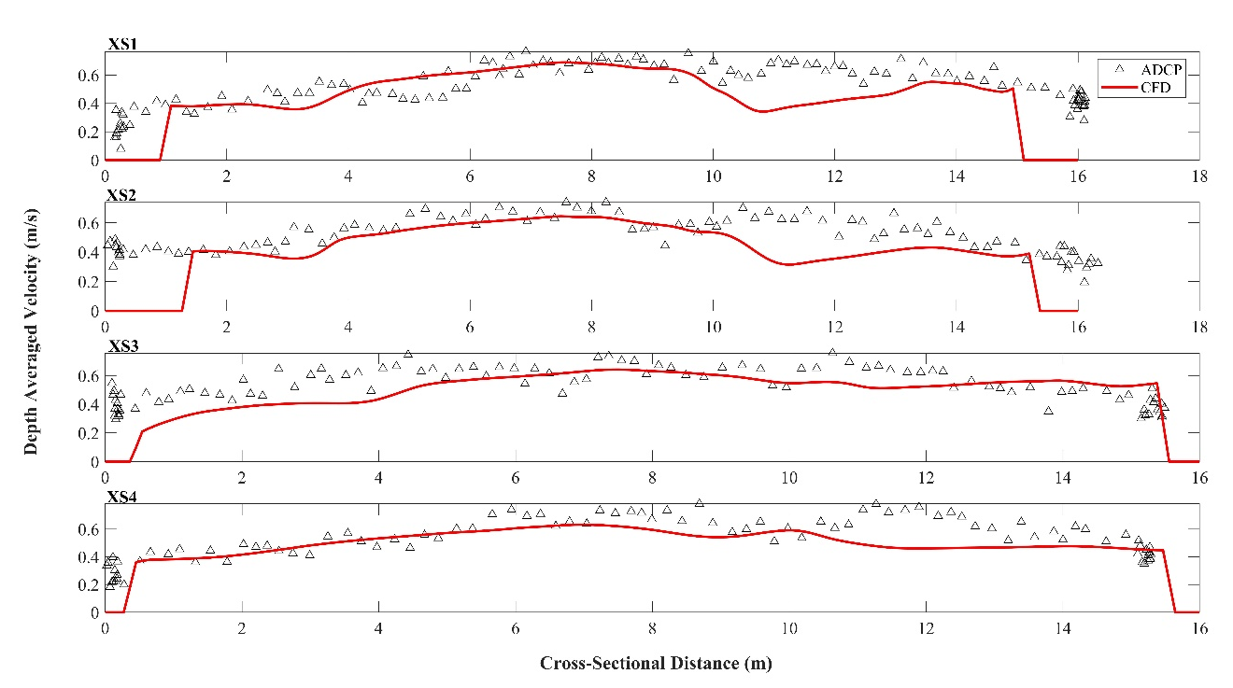
Figure S2. Comparison of CFD simulated and ADCP measured depth averaged velocity at each cross-section during FVES on conditions. Errors near the shoreline are due to interpolation imposed when generating the computer model of the channel bed. The CFD model used a surface roughness of 0.1 m and results match measured depth averaged velocity profiles at each cross-section.
