Table S1. The general characteristics of RB19 dye
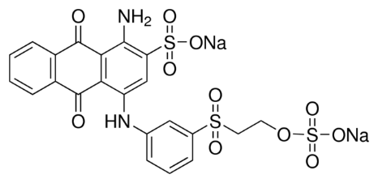
Chemical structure

Molecular formula C₂₂H₁₆N₂Na₂O₁₁S₃
C.I. number 61200
C.I. name Asit mavi 145
Chemical class Anyonik
Ionization Asidik
Dye content (%) 50
Molecular weight (g/mol) 626.54
λ_{max} (nm) 593

Table S2. Comparison of maximum sorption capacity of various sorbents for RB19 removal
Sorbents q_{m} (mg/g) References

Graphene oxide modified with polystyrene 39.07 Azizi et al. (2019)
Basic bismuth nitrate (BBN-EtOH) 1344.99 Najdanović et al. (2019)
Basic bismuth nitrate 1049.19 Najdanović et al. (2020)
Triple-metal nano sorbent (FeCuNi-280) 470.01 Kostić et al. (2018)
L-arginine-functionalized Fe₃O₄ nanoparticles 125.00 Dalvand et al. (2016)
Magnetite nanoparticles loaded tea waste 87.72 Madrakian et al. (2012)
Corn silk 71.60 Değermenci et al. (2019)
Wheat Bran 117.60 Çiçek et al. (2007)
Citrus sinensis biosorbent 37.45 Asgher and Bhatti (2012)
Rice straw fly ash 38.24 El-Bindary et al. (2016)
Sludge-rice husk biochar 38.46 Chen et al. (2019)
Green seaweed biochar 161.83 Gokulan et al. (2019)
Coconut shell activated carbon 2.78 Isah et al. (2015)
Alumina/carbon nanotube hybrid 3.75 Malakootian et al. (2015)
γ-Fe₂O₃/cross-linked chitosan 29.37 Zhua et al. (2010)
MgO nanoparticles 166.70 Moussavi and Mahmoudi (2009)
Chitosan/SiO₂/carbon nanocomposite 97.08 Abbasi et al. (2017)
TW 38.76 This study
MTW 58.14 This study

Table S3. The intra-particle diffusion constants for the adsorption at different initial concentrations of RB19 onto TW and MTW
C_{i} k_{id,1} I₁ R² ∆q(%) k_{id,2} I₂ R² ∆q(%) k_{id,3} I₃ R² ∆q(%)
TW
100 1.06 7.07 0.8754 9.04 0.30 6.47 0.9685 7.59 0.41 8.83 0.9113 12.16
150 1.03 8.88 0.9034 7.15 0.55 7.63 0.9944 6.17 0.45 10.01 0.8775 10.43
200 1.01 9.54 0.9218 6.93 0.62 9.45 0.9948 5.24 0.52 11.67 0.8919 9.46
300 0.98 12.44 0.9155 5.88 0.86 11.30 0.9969 4.11 0.73 13.01 0.8517 6.14
MTW
100 1.04 5.59 0.8974 6.25 0.31 4.95 0.9978 5.41 0.38 7.99 0.9123 8.14
150 1.00 7.97 0.9292 4.43 0.42 5.22 0.9905 3.55 0.50 11.34 0.8893 7.86
200 0.97 12.62 0.9311 4.04 0.61 9.45 0.9517 3.30 0.57 16.04 0.8812 5.14
300 0.96 19.34 0.9412 3.99 0.69 23.57 0.9781 2.87 0.62 19.53 0.9120 4.77
*C_{i}: mg/L; k_{id}: mg/g min; I: mg/g

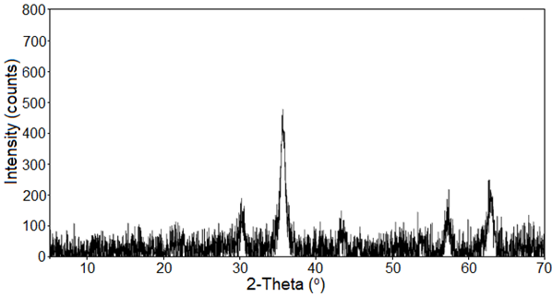

Figure S1. XRD pattern of MTW

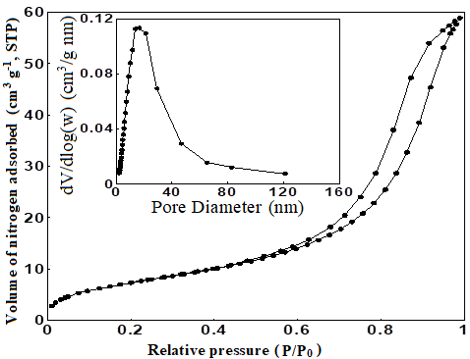
Figure S2. Nitrogen sorption-desorption isotherms and pore size distribution (inset) of MTW

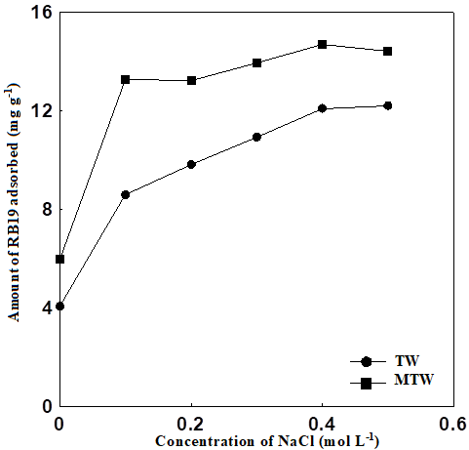
Figure S3. Effect of ionic strength on the sorption of RB19 dye onto TW and MTW

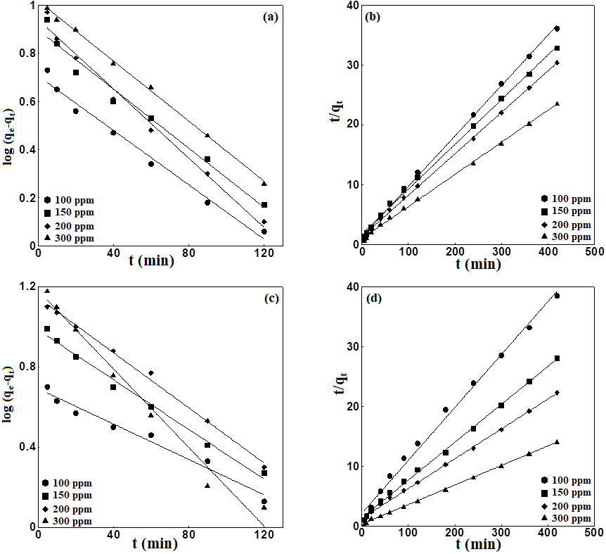

Figure S4. Linear plots of pseudo-first-order (a, c) and pseudo-second-order (b, d) kinetic models at various concentrations for RB19 adsorption onto TW and MTW.

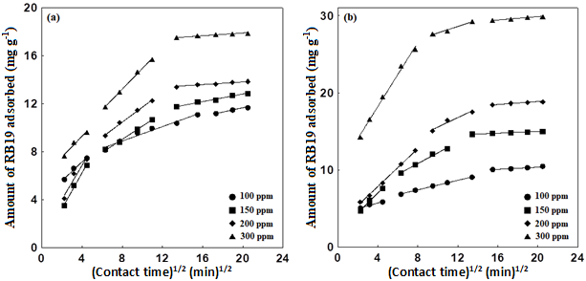

Figure S5. Intra-particle diffusion plots for RB19 dye sorption at various concentrations onto TW (a) and MTW (b)

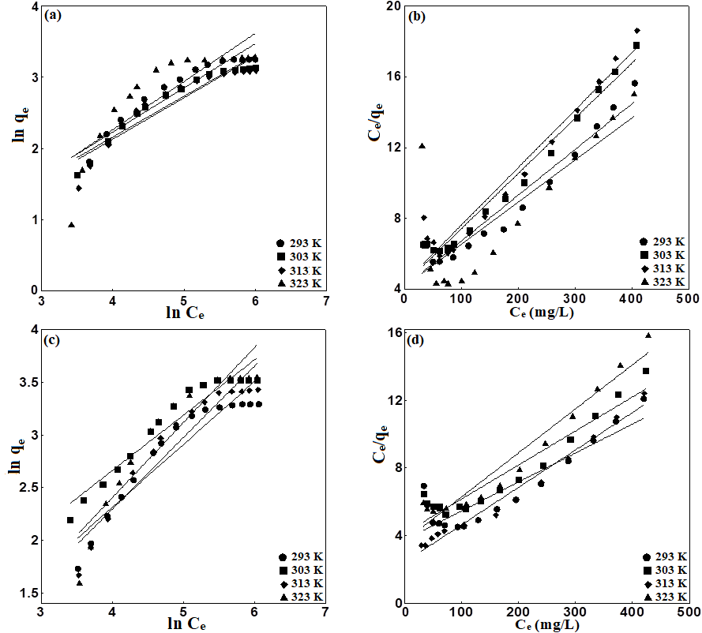

Figure S6. Linear plots of Freundlich (a, c) and Langmuir isotherm (b, d) models at various temperatures for RB19 adsorption onto TW and MTW.
References
Abbasi M. 2017. Synthesis and characterization of magnetic nanocomposite of chitosan/SiO₂/carbon nanotubes and its application for dyes removal. J Clean Prod. 145:105–113. doi:10.1016/j.jclepro.2017.01.046.

Asgher M, Bhatti HN. 2012. Removal of reactive blue 19 and reactive blue 49 textile dyes by citrus waste biomass from aqueous solution: equilibrium and kinetic study. Can J Chem Eng. 90(2):412–419. doi:10.1002/cjce.20531.
Chen S, Qin C, Wang T, Chen F, Li X, Hou H, Zhou M. 2019. Study on the adsorption of dyestuffs with different properties by sludge-rice husk biochar: adsorption capacity, isotherm, kinetic, thermodynamics and mechanism. J Mol Liq. 285:62–74. doi:10.1016/j.molliq.2019.04.035.

Çiçek F, Özer D, Özer A, Özer A. 2007. Low cost removal of reactive dyes using wheat bran. J Hazard Mater. 146(1–2):408–416. doi:10.1016/j.jhazmat.2006.12.037.

El-Bindary AA, Abd El-Kawi MA, Hafez AM, Rashed IGA, Aboelnaga EE. 2016. Removal of reactive blue 19 from aqueous solution using rice straw fly ash. J Mater Environ Sci. 7(3):1023–1036.

Isah U, Abdulraheem G, Bala S, Muhammad S, Abdullahi M. 2015. Kinetics, equilibrium and thermodynamics studies of CI Reactive Blue 19 dye adsorption on coconut shell based activated carbon. Int Biodeter Biodegr. 102:265–273. doi:10.1016/j.ibiod.2015.04.006.

Kostić M, Radović M, Velinov N, Najdanović S, Bojić D, Hurt A, Bojić A. 2018. Synthesis of mesoporous triple-metal nanosorbent from layered double hydroxide as an efficient new sorbent for removal of dye from water and wastewater. Ecotoxicol Environ Saf. 159:332–341. doi:10.1016/j.ecoenv.2018.05.015.

Malakootian M, Mansoorian HJ, Hosseini A, Khanjani N. 2015. Evaluating the efficacy of alumina/carbon nanotube hybrid adsorbents in removing Azo Reactive Red 198 and Blue 19 dyes from aqueous solutions. Process Saf Environ. 96:125–137. doi:10.1016/j.psep.2015.05.002.

Moussavi G, Mahmoudi M. 2009. Removal of azo and anthraquinone reactive dyes from industrial wastewaters using MgO nanoparticles. J Hazard Mater. 168(2-3):806–812. doi:10.1016/j.jhazmat.2009.02.097.

Najdanović SM, Petrović MM, Kostić MM, Mitrović JZ, Bojić DV, Antonijević MD, Bojić ALj. 2020. Electrochemical synthesis and characterization of basic bismuth nitrate [Bi₆O₅(OH)₃](NO₃)₅.2H₂O: a potential highly efficient sorbent for textile reactive dye removal. Res Chem Intermed. 46(1):661–680. doi:10.1007/s11164-019-03983-1.

Najdanović SM, Petrović MM, Kostić MM, Velinov ND, Vučić MDR, Matović BŽ, Bojić AL. 2019. New way of synthesis of basic bismuth nitrate by electrodeposition from ethanol solution: characterization and application for removal of RB19 from water. Arab J Sci Eng. 44(12):9939–9950. doi:10.1007/s13369-019-04177-y.

Zhua H-Y, Jiang R, Xiao L, Li W. 2010. A novel magnetically separable gamma-Fe₂O₃/crosslinked chitosan adsorbent: preparation, characterization and adsorption application for removal of hazardous azo dye. J Hazard Mater. 179(1–3):251–257. doi:10.1016/j.jhazmat.2010.02.087.

