Orthogonal experimental design for optimizing the synthesis of vinyl-tris(2,2,2-trifluoroethoxy)silane
Jiang Pan¹ Dong Hong¹ Luan Wengen¹ Chen Daowei² Zheng Yunfeng² Huang Liangbing² Qu Zhirong¹ Wu Chuan¹*
¹Key Laboratory of Organosilicon Chemistry and Material Technology, Ministry of Education, Hangzhou Normal University, Hangzhou 311121. ²Novel Silicone Research Institute Affiliated to Kaihua Synthetic Material Co. Ltd., Kaihua 324300 )
E-mail: chaunwu@yahoo.com (C. Wu).
Supplemental Materials
The yield of Vinyl-tris(2,2,2-trifluoroethoxy)silane (VTTFEOS) was influenced by four factors with different levels. Fourier transform infrared spectroscopy (FT-IR), gas chromatography-mass spectrometry (GC-MS) and nuclear magnetic resonance (NMR) were presented. A four-factor three-level orthogonal test table was designed and experiments were conducted based on this method. Variance analysis of orthogonal experimental results was conducted and the optimal experimental conditions were verified. Other physical properties like density and the refractive indexes of VTTFEOS at 20 and 25 °C were reported.

Figure S 1: Yield of VTTFEOS influenced by four factors with different levels

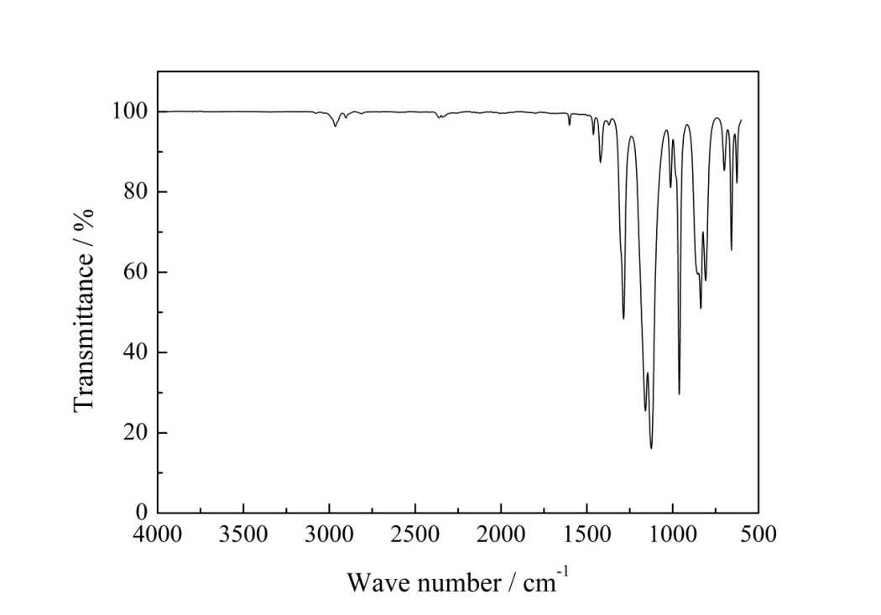
Figure S 2: FT-IR spectra of VTTFEOS

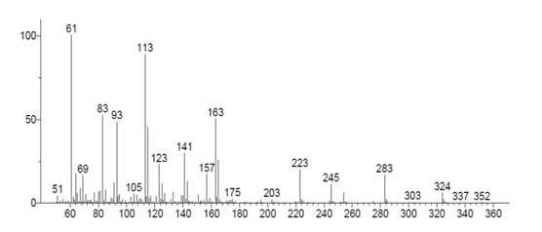
Figure S 3: Mass spectra of VTTFEOS

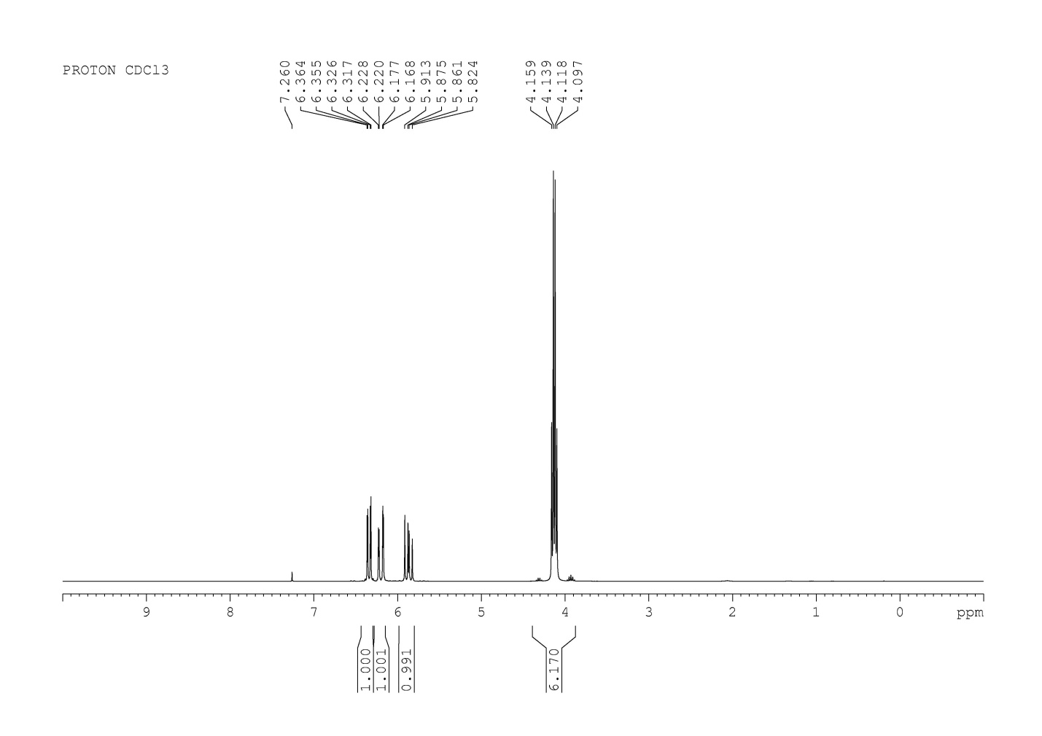
Figure S 4: ¹H NMR spectra of VTTFEOS

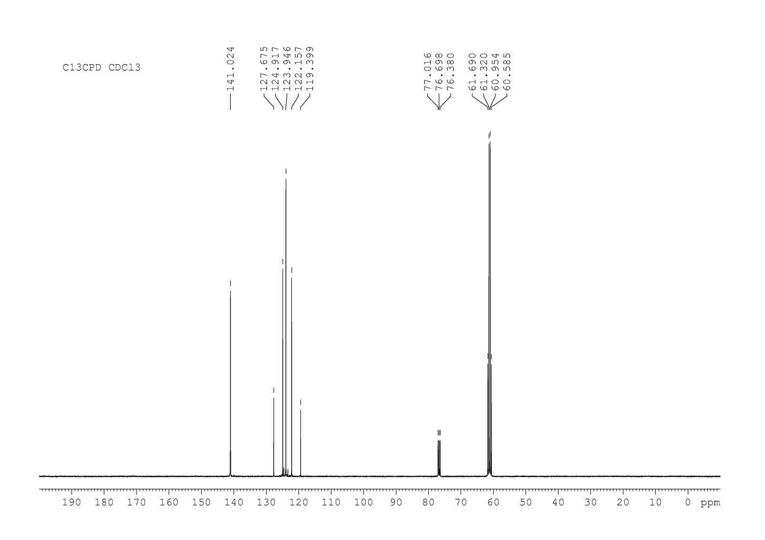
Figure S 5: ¹³C NMR spectra of VTTFEOS

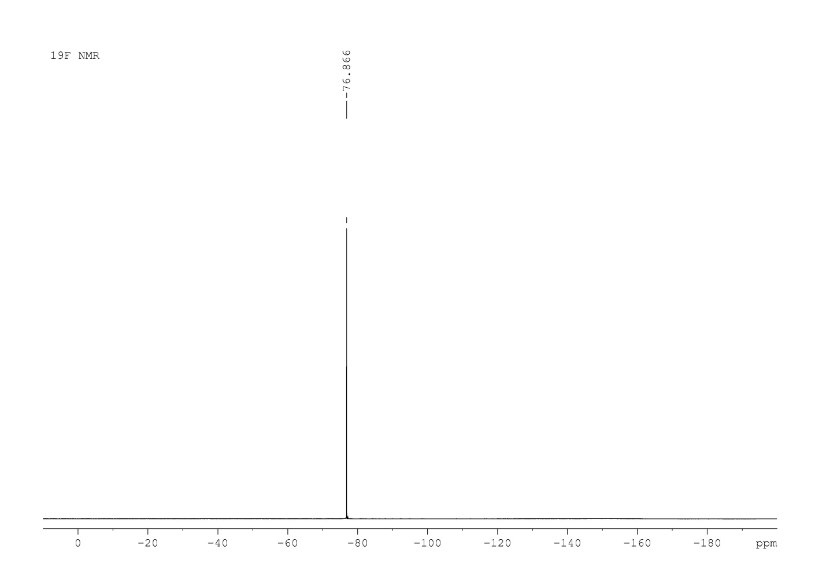
Figure S 6: ¹⁹F NMR spectra of VTTFEOS

Table S 1: Four-factor and three-level orthogonal tests
Factor Name  level | Feeding molar ratio(A) | Oil bath temp.(B)/ °C | Feeding time of TFE(C)/ min | Condensation temp.(D) / °C
Level 1 | 1: 3.0 | 30 | 60 | 0
Level 2 | 1: 3.25 | 50 | 120 | -10
Level 3 | 1: 3.5 | 70 | 180 | -20

Table S 2: Results of orthogonal experiments
Factor name | Feeding molar ratio | Oil bath temp/ °C | Feeding time of TFE / min | Condensation temp / °C | Yield/%
n.1 | 1: 3 | 30 | 60 | 0 | 89.6
n.2 | 1: 3 | 50 | 120 | -10 | 91.6
n.3 | 1: 3 | 70 | 180 | -20 | 92.3
n.4 | 1: 3.25 | 30 | 120 | -20 | 92.3
n.5 | 1: 3.25 | 50 | 180 | 0 | 90.4
n.6 | 1: 3.25 | 70 | 60 | -10 | 94.5
n.7 | 1: 3.5 | 30 | 180 | -10 | 98.2
n.8 | 1: 3.5 | 50 | 60 | -20 | 98.6
n.9 | 1: 3.5 | 70 | 120 | 0 | 92.0
K₁ | 91.167 | 93.367 | 94.233 | 90.667
K₂ | 92.400 | 93.533 | 91.967 | 94.767
K₃ | 96.267 | 92.933 | 93.633 | 94.400
R | 5.100 | 0.600 | 2.200 | 4.100

Table S 3: Variance analysis of orthogonal experimental results (α=0.05)
Factor name | Sum of squared deviation | Degree of freedom | Mean square | F value | F_{0.05}(2, 2) | Significance
Feeding molar ratio | 48.682 | 2 | 24.341 | 49.879 | 19.000 | Significant
Oil bath temp | 0.976 | 2 | 0.488 | 1.000 | 19.000 | Insignificant
Feeding time of TFE | 9.209 | 2 | 4.6045 | 9.435 | 19.000 | Insignificant
Condensation temp | 34.082 | 2 | 17.041 | 34.92 | 19.000 | Significant
Error | 0.98 | 2

Table S 4: Verification results of optimal experimental conditions
Entry | Feeding molar ratio | Oil bath temp / ºC | Feeding time of TFE/min | Condensation temp / ºC | Yield /%
1 | 1:3.5 | 50 | 60 | -10 | 98.3
2 | 1:3.5 | 50 | 60 | -10 | 98.5
3 | 1:3.5 | 50 | 60 | -10 | 97.9

Table S 5: The densities and the refractive indexes of VTTFEOS at 20 and 25 °C
Temp / °C | refraction index | density/g.cm⁻³
20 | 1.32427 | 1.38338
25 | 1.32212 | 1.37454

