One-pot Cascade Ring Enlargement of Isatin-3-Oximes to 2,4-Dichloroquinazolines Mediated by Bis(trichloromethyl)carbonate and Triarylphosphine Oxide
Jinjing Qin, Zhenhua Li*, Shengzhe Ma, Lixian Ye, Guoqiang Jin and Weike Su
College of Pharmaceutical Sciences, Zhejiang University of Technology, Hangzhou 310014, P.R. China
Email: lizhenhua@zjut.edu.cn
Supplemental Materials
Characterization data of 2

2,4-Dichloroquinazoline (2a)
Light yellow solid, 93% yield, mp 119-121 ºC (Lit.,^{[1]} mp 118 ºC). ¹H NMR (400MHz, CDCl₃) δ: 8.26 (d, J = 8.4 Hz, 1H), 8.01 – 7.97 (m, 2H), 7.76 – 7.70 (m, 1H). ¹³C NMR (100 MHz, CDCl₃) δ: 163.7, 154.9, 152.1, 135.9, 129.0, 127.8, 125.8, 122.2.

2,4-6-methoxyDichloroquinazoline (2b)
Light yellow solid, 94% yield, mp 170-171 °C (Lit.,^{[2]} mp 171 ºC). ¹H NMR (400 MHz, CDCl₃) δ: 7.89 (d, J = 9.2 Hz, 1H), 7.60 (dd, J = 9.2, 2.8 Hz, 1H), 7.40 (d, J = 2.8 Hz, 1H), 3.99 (s, 3H). ¹³C NMR (100 MHz, CDCl₃) δ: 161.5, 159.4, 152.5, 148.4, 129.3, 129.0, 123.3, 102.7, 56.0.

2,4-Dichloro-6-methylquinazoline (2c)
White solid, 93% yield, mp 140-141 °C (Lit.,^{[3]} mp 140-141 °C). ¹H NMR (400 MHz, CDCl₃) δ: 8.00 (s, 1H), 7.88 (d, J = 8.6 Hz, 1H), 7.80 (dd, J = 8.6, 1.8 Hz, 1H), 2.61 (s, 3H). ¹³C NMR (100 MHz, CDCl₃) δ: 162.9, 154.0, 150.7, 139.8, 138.2, 127.5, 124.5, 122.1, 22.0.

2,4-Dichloro-6,7-dimethoxyquinazoline (2d)
White solid, 92% yield, mp 161-162 °C (Lit.,^{[2]} mp 157-159 °C). ¹H NMR (400 MHz, CDCl₃) δ: 7.33 (s, 1H), 7.25 (s, 1H), 4.07 (s, 3H), 4.05 (s, 3H). ¹³C NMR (100 MHz, CDCl₃) δ: 159.9, 157.6, 153.4, 151.4, 150.4, 117.7, 106.2, 102.7, 56.8, 56.5.

2,4-Dichloro-5,7-dimethyquinazoline (2e)
White solid, 92% yield, mp 141-142 ºC (Lit.,^{[4]} mp 140-143 ºC). ¹H NMR (400 MHz, CDCl₃) δ: 7.59 (s, 1H), 7.30 (s, 1H), 2.96 (s, 3H), 2.52 (s, 3H). ¹³C NMR (100 MHz, CDCl₃) δ: 162.2, 154.6, 154.0, 146.5, 136.2, 134.2, 125.7, 120.0, 24.8, 21.9.

2,4,6-Trichloroquinazoline (2f)
White solid, 88% yield, mp 132-136°C (Lit.,^{[1]} mp 129-131 °C). ¹H NMR (400 MHz, CDCl₃) δ: 8.22 (d, J = 2.0 Hz, 1H), 7.98 – 7.88 (m, 2H). ¹³C NMR (100 MHz, CDCl₃) δ: 162.6, 155.2, 150.6, 136.9, 135.1, 129.5, 124.7, 122.8.

2,4,8-Trichloroquinazoline (2g)
Light yellow solid, 87% yield, mp 152-153 °C (Lit.,^{[5]} mp 151-153 °C). ¹H NMR (400 MHz, CDCl₃) δ: 8.19 (dd, J = 8.8, 1.2 Hz, 1H), 8.07 (dd, J = 7.6, 1.2 Hz, 1H), 7.65 (dd, J = 8.2, 7.8 Hz, 1H). ¹³C NMR (100 MHz, CDCl₃) δ: 164.2, 155.8, 148.9, 135.7, 132.6, 128.8, 124.7, 123.4.

2,4-Dichloro-7-fluoroquinazoline (2h)
White solid, 74% yield, mp 143-145 °C (Lit.,^{[5]} mp 142-145 °C). ¹H NMR (400 MHz, CDCl₃) δ: 8.29 (dd, J = 8.6, 5.8 Hz, 1H), 7.62 (d, J = 8.8 Hz, 1H), 7.49 (t, J = 8.6 Hz, 1H). ¹³C NMR (100 MHz, CDCl₃) δ: 161.5 (d, J₁ = 295 Hz), 158.1, 150.9, 148.7 (d, J₃ = 14 Hz), 123.8(d, J₃= 11 Hz), 114.5 , 114.2 (d, J₃=16 Hz), 106.9 (d, J₂ = 28 Hz).

2,4-Dichloro-6-fluoroquinazoline (2i)
White solid, 85% yield, mp 136-137 °C (Lit.,^{[1]} mp 136-137 °C). ¹H NMR (400 MHz, CDCl₃) δ: 8.03 (dd, J = 9.2, 4.8 Hz, 1H), 7.87 (dd, J = 8.0, 2.8 Hz, 1H), 7.75 (td, J =8.0, 2.8 Hz, 1H). ¹³C NMR (100 MHz, CDCl₃) δ: 163.0 (d, J₄ = 6 Hz), 161.1 (d, J₁ = 252 Hz), 154.5 (d, J₄ = 3 Hz), 149.2, 130.7 (d, J₄ = 9 Hz), 126.4 (d, J₂ = 26 Hz), 123.1 (d, J₃ = 10 Hz), 109.7 (d, J₂ = 24 Hz).

2,4-Dichloro-6-bromoquinazoline (2j)
White solid, 71% yield, mp 134-135 °C (Lit.,^{[6]} mp 131-136 °C). ¹H NMR (400MHz, CDCl₃) δ: 8.40 (d, J = 2.0Hz, 1H), 8.04 (dd, J = 8.8, 2.0 Hz, 1H), 7.86 (d, J = 8.8 Hz, 1H); ¹³C NMR (100 MHz, CDCl₃) δ: 162.5, 155.2, 150.8, 139.5, 129.5, 128.0, 123.2, 123.1.

2,4-Dichloro-6-nitroquinazoline (2k)
White solid, 63% yield, mp 121-123 °C (Lit.,^{[5]} mp 122-124 °C). ¹H NMR (400MHz, CDCl₃) δ: 9.16 (dd, J = 2.4, 0.4 Hz, 1H), 8.73 (dd, J = 9.2, 2.4 Hz, 1H), 8.16 (dd, J = 9.2, 0.4 Hz, 1H); ¹³C NMR (100 MHz, CDCl₃) δ: 162.3, 155.1, 151.0, 139.3, 129.3, 128.0, 123.0, 122.9.

2,4,5,7-Tetrachloroquinazoline (2l)
White solid, 66% yield, mp 100-101 °C. (Lit.,^{[5]} mp 100-101 °C). ¹H NMR (400MHz, CDCl₃) δ: 7.90 (d, J = 2.0 Hz, 1H), 7.73 (d, J = 2.0 Hz, 1H). ¹³C NMR (100 MHz, CDCl₃) δ: 162.0, 156.0, 154.5, 141.3, 132.5, 126.8, 118.8.

2,4-Dichloro-8-bromoquinazoline (2m)
White solid, 71% yield. mp 146-147 °C. (Lit.,^{[5]} mp 146-147 °C). ¹H NMR (400 MHz, CDCl₃) δ: 8.27 (m, 2H), 7.60 (dd, J = 8.3, 7.7 Hz, 1H). ¹³C NMR (100 MHz, CDCl₃) δ: 164.6, 156.2, 150.1, 139.6, 129.6, 125.8, 123.7, 123.2.

2,4,6-Trichloro-8-methylquinazoline (2n)
White solid, 82% yield. mp 143-144 °C. (Lit.,^{[1]} mp 143-145°C). ¹H NMR (400 MHz, CDCl₃) δ: 8.04 (d, J = 2.0 Hz, 1H), 7.78 – 7.70 (m, 1H), 2.71 (s, 3H). ¹³C NMR (100 MHz, CDCl₃) δ: 163.1, 154.5, 150.4, 139.4, 136.7, 134.7, 123.1, 122.5, 17.4.

Characterization data of 3

Tris(4-methylphenyl)phosphine oxide (3b)
Colourless solid, 39% yield. mp 141-144 ºC. (lit.^{[7]} mp 140 ºC). ¹H NMR (400 MHz, CDCl3) δ: 7.53 (dd, J = 11.8, 8.0 Hz, 6H), 7.26 – 7.22 (m, 6H), 2.38 (s, 9H).

Tris(3,4,5-trifluorophenyl)phosphine oxide (3c)
Colourless solid, 36% yield. mp 211-218 ºC.( (lit.^{[7]} mp 219-221 ºC). ¹H NMR (400 MHz, CDCl₃) δ: 7.34 – 7.21 (m, 6H).

Tris(4-methoxylphenyl)phosphine oxide (3d)
Colourless solid, 39% yield. mp 142-144 ºC. (lit.^{[7]} mp 142-143 ºC). ¹H NMR (400 MHz, Chloroform-d) δ 7.61 – 7.50 (m, 6H), 6.99 – 6.89 (m, 6H), 3.84 – 3.80 (m, 9H).

Tris([1,1’-biphenyl]-4-yl)phosphine oxide (3e)
Colourless solid, 33% yield. mp 230-238 ºC. (lit.^{[7]} mp 233-234 ºC). ¹H NMR (400 MHz, Chloroform-d) δ 7.83 (dd, J = 11.5, 8.2 Hz, 6H), 7.76 – 7.68 (m, 6H), 7.63 (d, J = 7.4 Hz, 6H), 7.47 (t, J = 7.4 Hz, 6H), 7.40 (t, J = 7.3 Hz, 3H).

Copies of ¹H NMR and ¹³C NMR spectra
Figure S 1: ¹H NMR of 2a
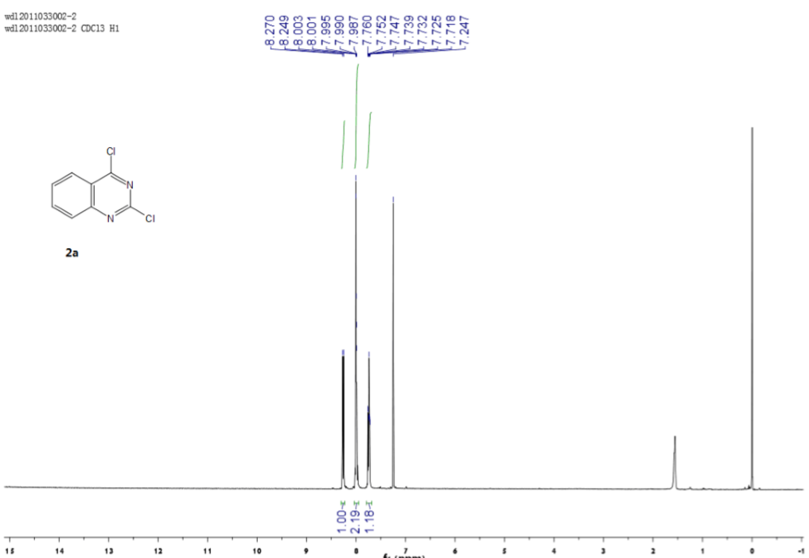
Figure S 2: ¹³C NMR of 2a
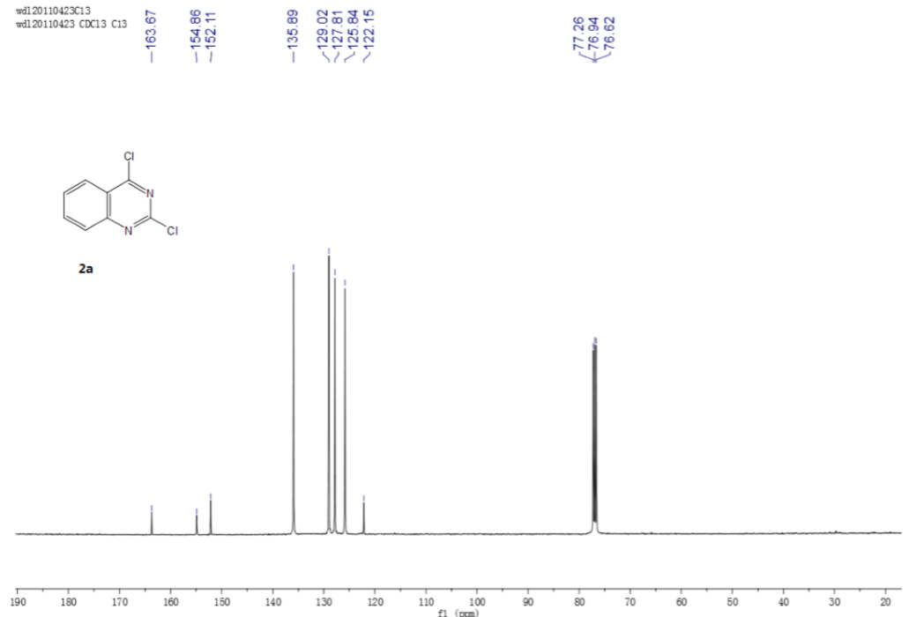
Figure S 3: ¹H NMR of 2b
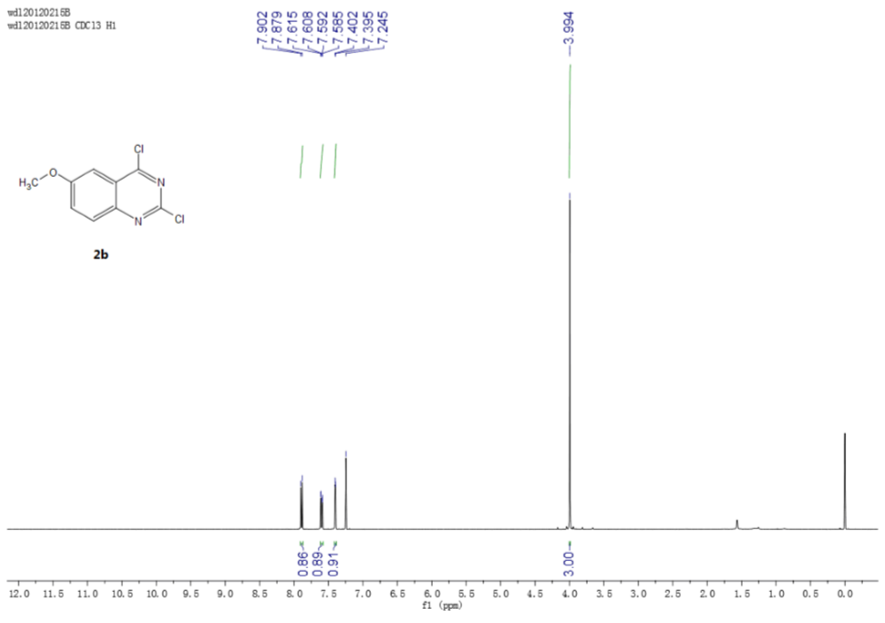
Figure S 4: ¹³C NMR of 2b
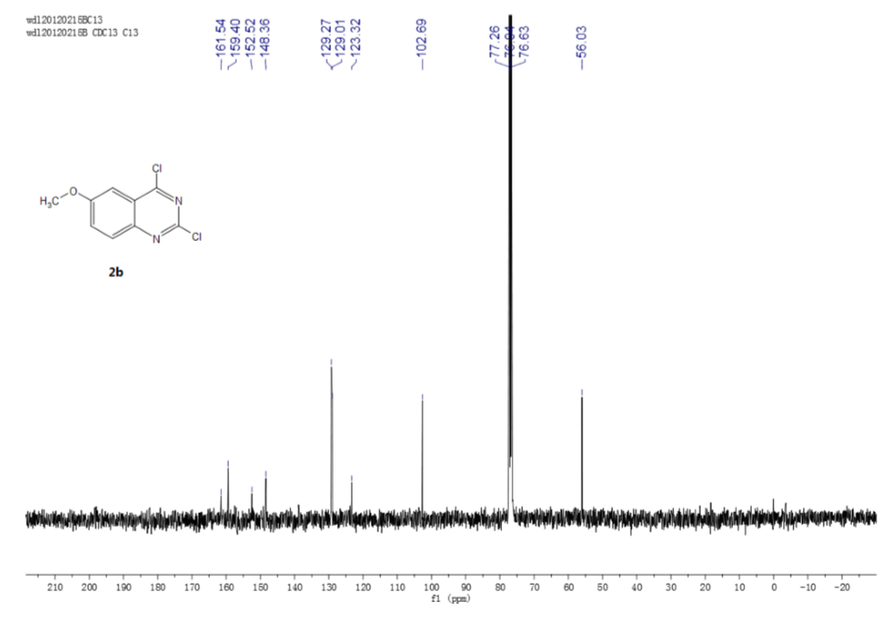
Figure S 5: ¹H NMR of 2c
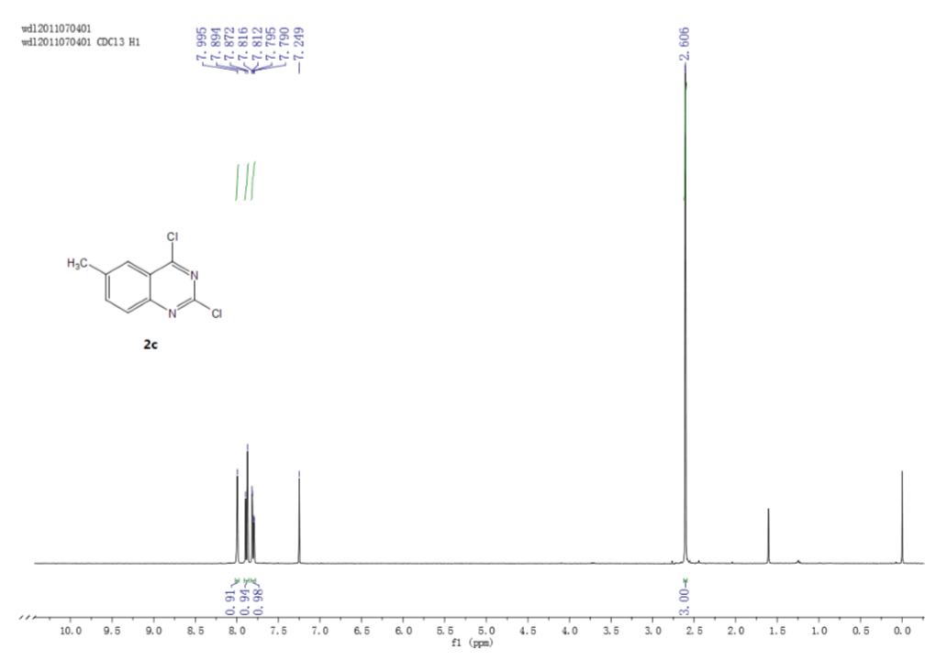
Figure S 6: ¹³C NMR of 2c
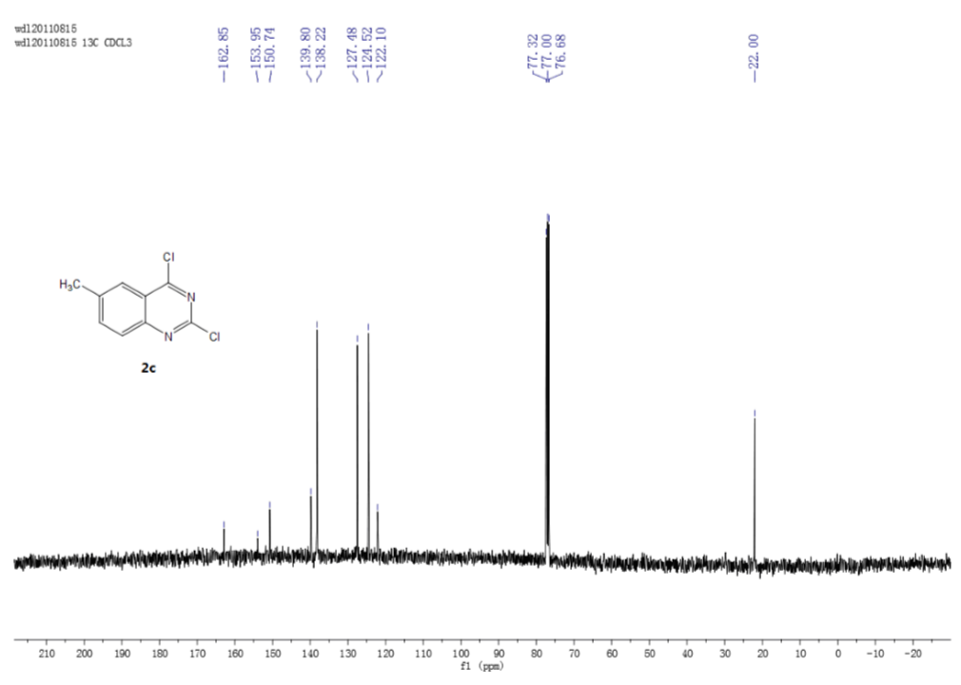
Figure S 7: ¹H NMR of 2d
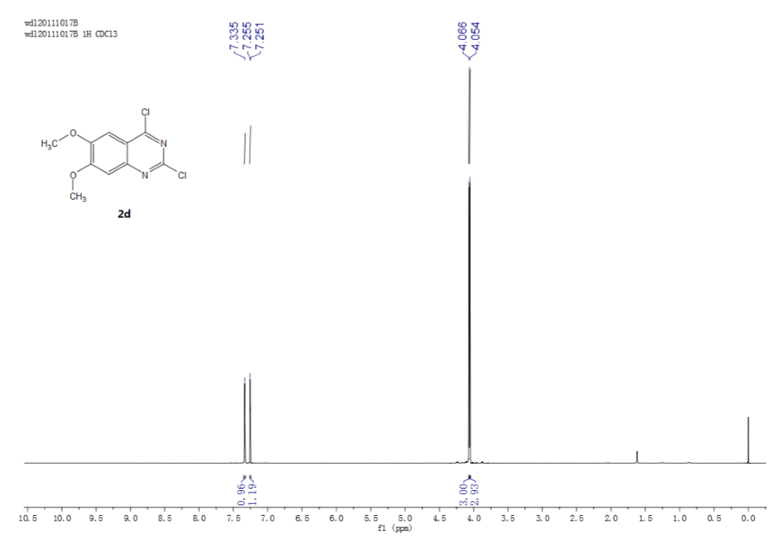
Figure S 8: ¹³C NMR of 2d
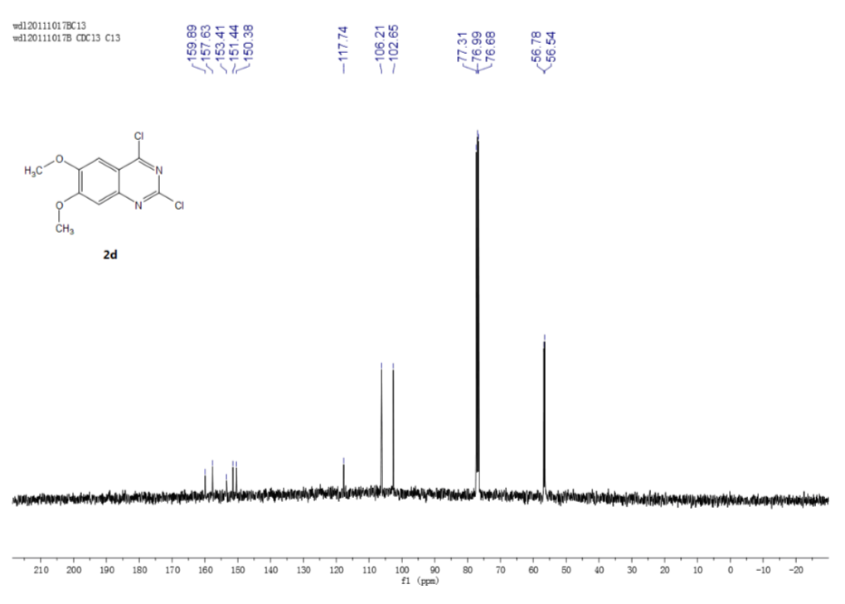
Figure S 9: ¹H NMR of 2e
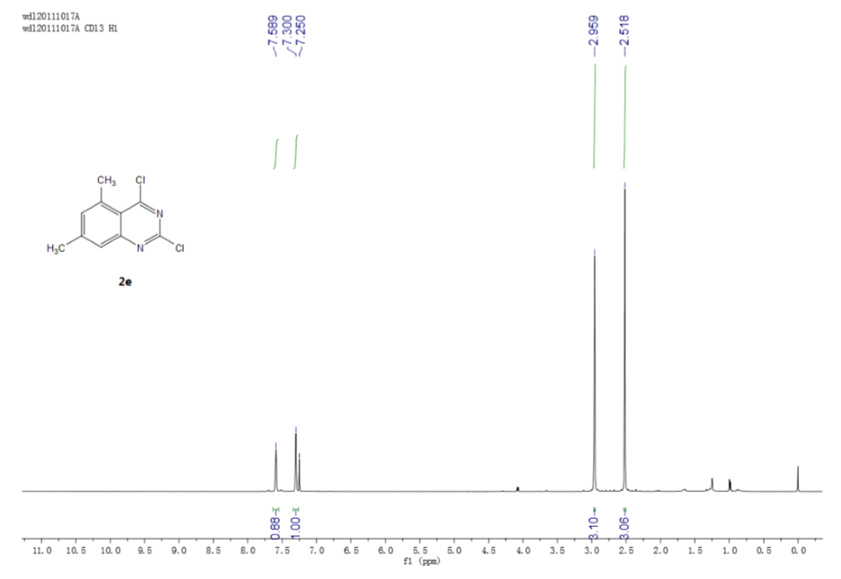
Figure S 10: ¹³C NMR of 2e
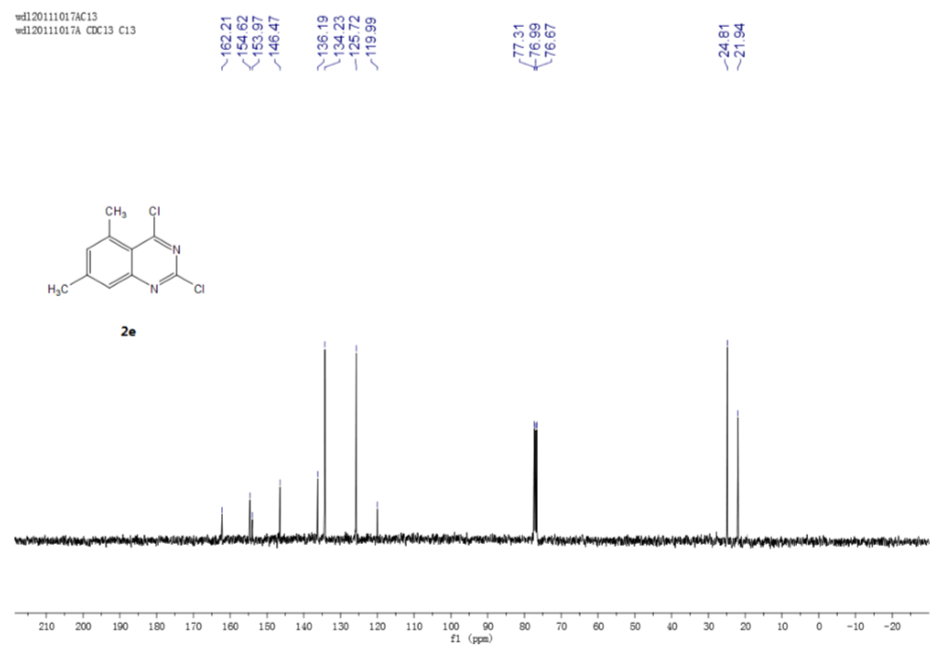
Figure S 11: ¹H NMR of 2f
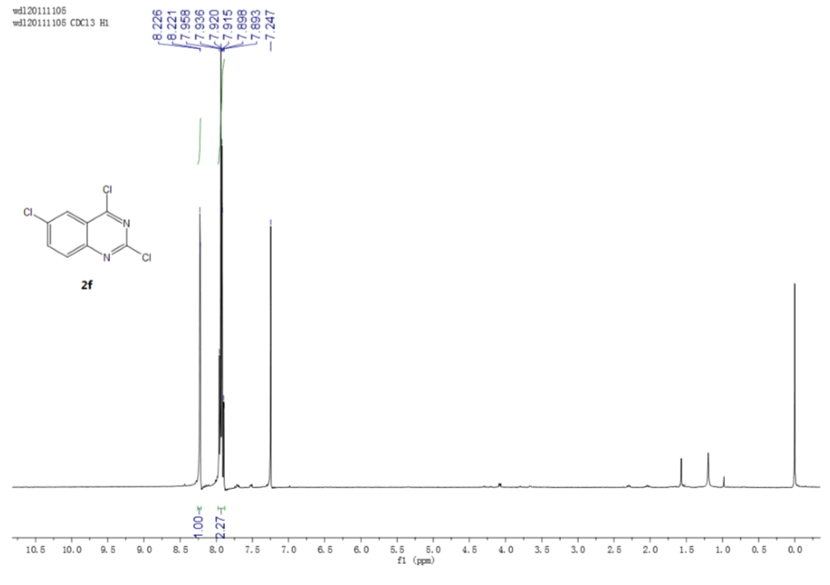
Figure S 12: ¹³C NMR of 2f
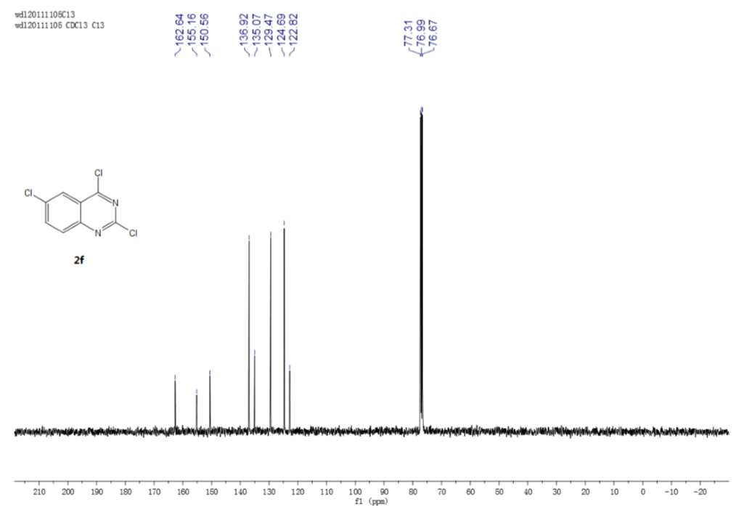
Figure S 13: ¹H NMR of 2g
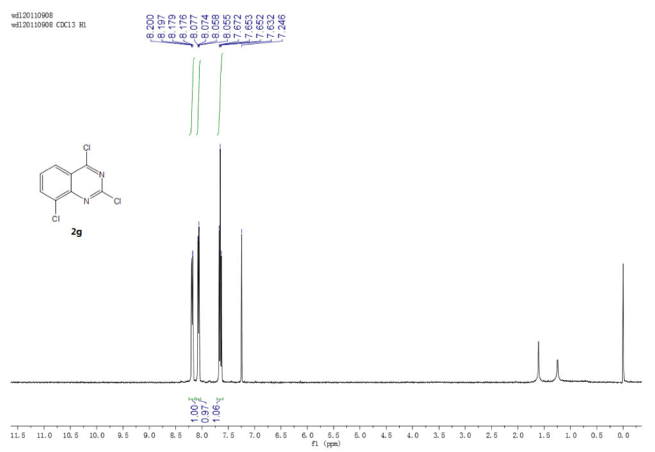
Figure S 14: ¹³C NMR of 2g
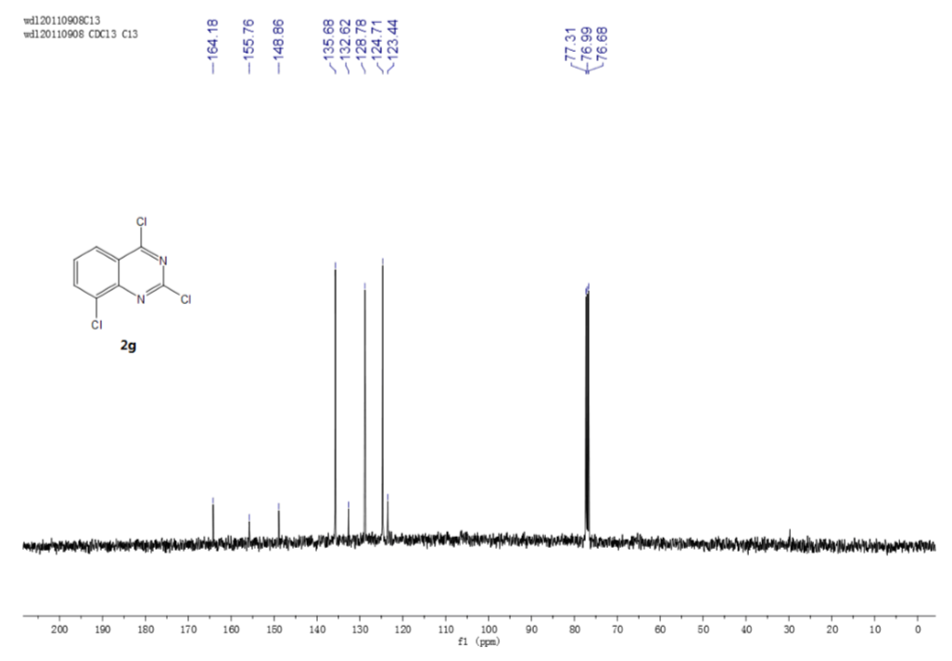
Figure S 15: ¹H NMR of 2h
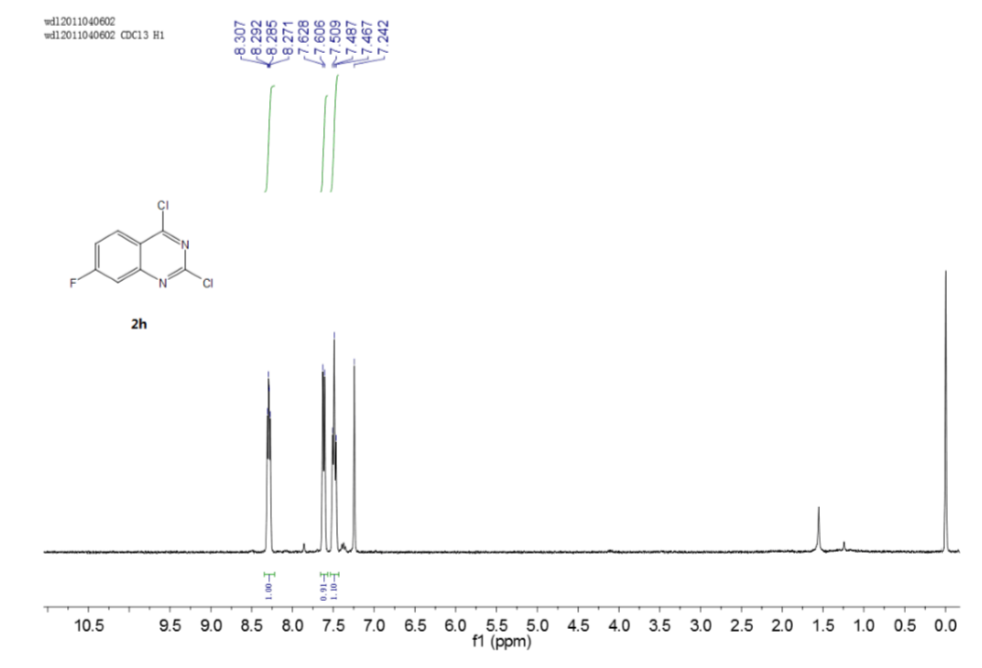
Figure S 16: ¹³C NMR of 2h
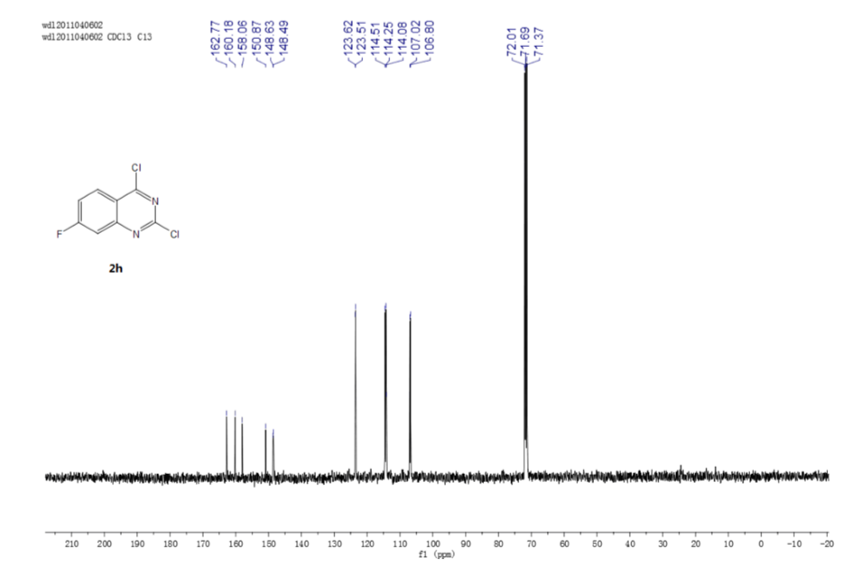
Figure S 17: ¹H NMR of 2i
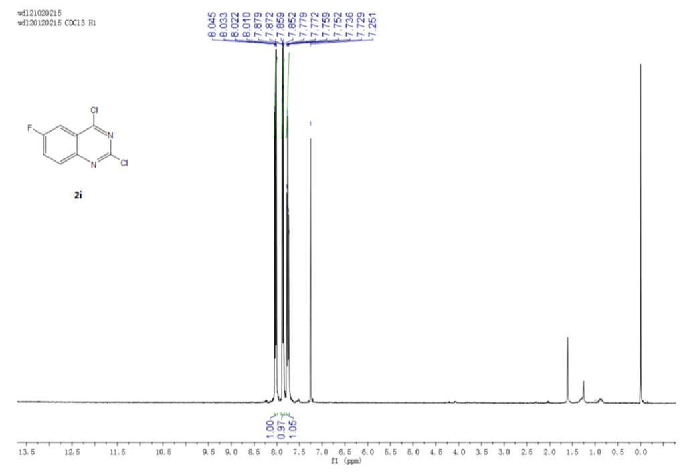
Figure S 18: ¹³C NMR of 2i
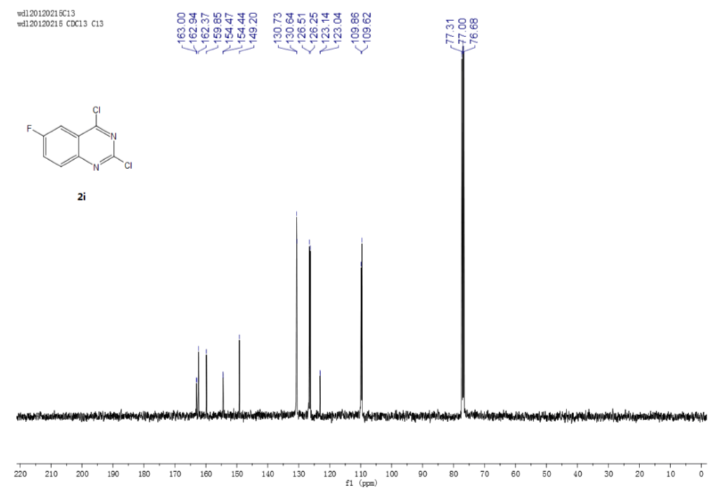
Figure S 19: ¹H NMR of 2j
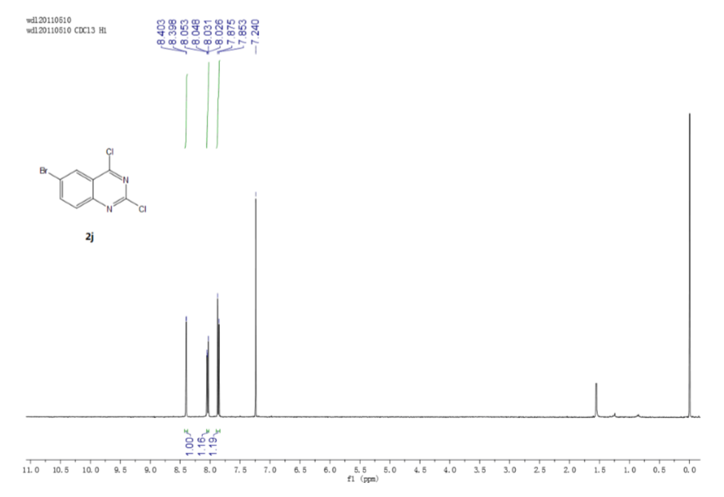
Figure S 20: ¹³C NMR of 2j
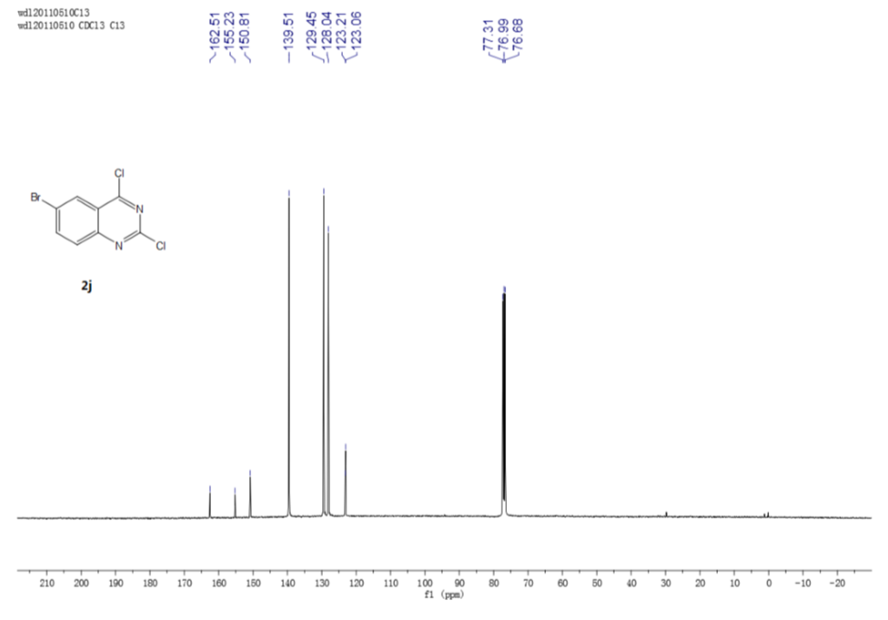

Figure S 21: ¹H NMR of 2k
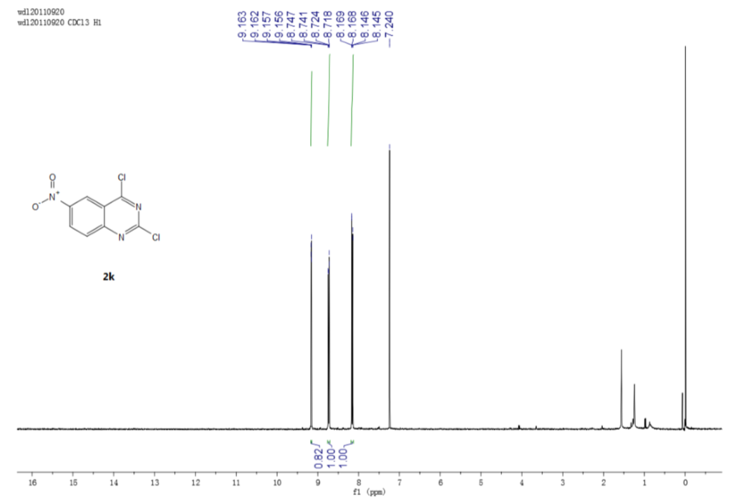
Figure S 22: ¹³C NMR of 2k
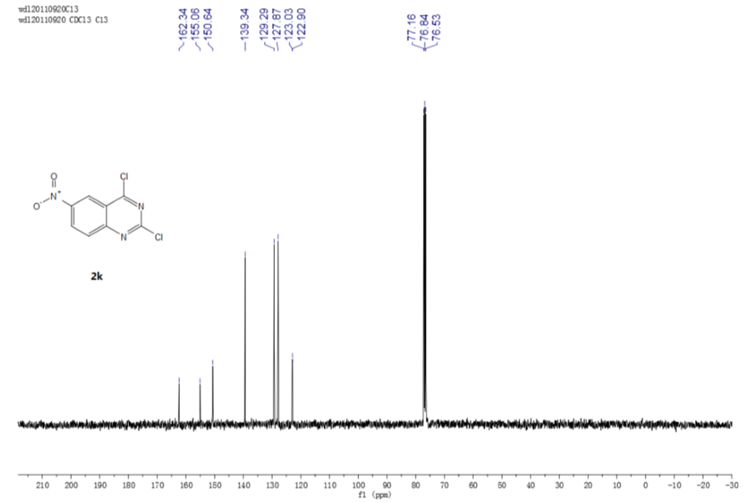

Figure S 23: ¹H NMR of 2l
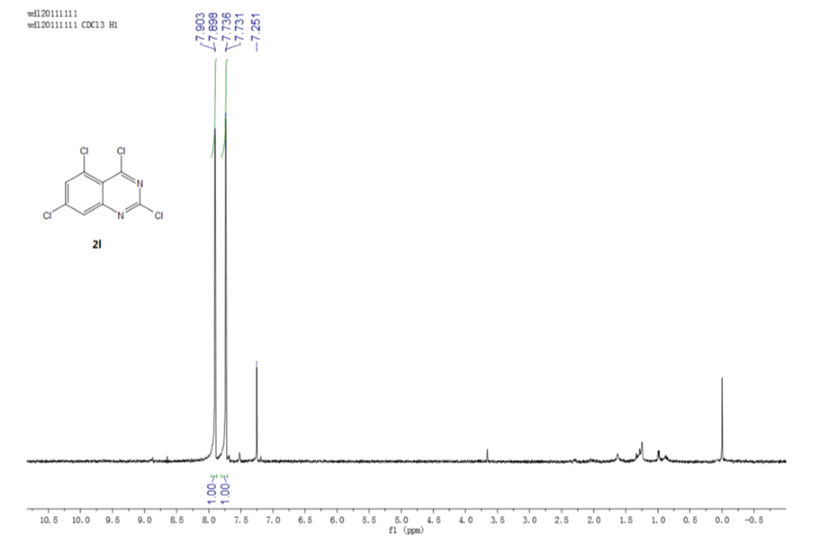
Figure S 24: ¹³C NMR of 2l
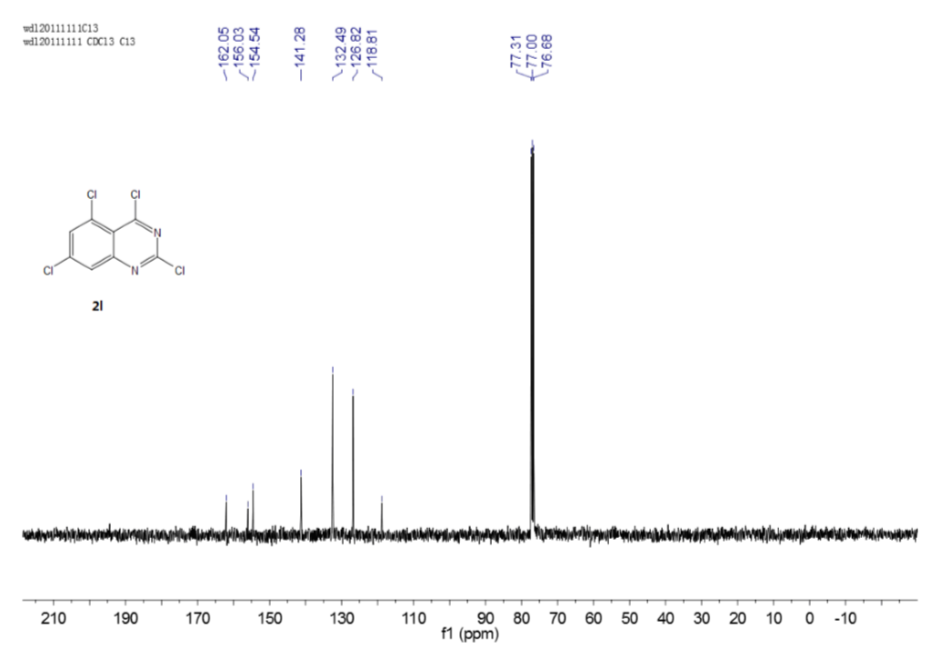
Figure S 25: ¹H NMR of 2m
Figure S 26: ¹³C NMR of 2m
Figure S 27: ¹H NMR of 2n
Figure S 28: ¹³C NMR of 2n
Figure S 29: ¹H NMR of 3b
Figure S 30: ¹H NMR of 3c
Figure S 31: ¹H NMR of 3d
Figure S 32: ¹H NMR of 3d
References
[1] Smits R. A., de Esch I. J., Zuiderveld O. P., Broeker J., Sansuk K., Guaita E., Coruzzi G., Adami M., Haaksma E., Leurs R. Discovery of quinazolines as histamine h4 receptor inverse agonists using a scaffold hopping approach. J. Med. Chem. 2008, 51, 7855-7865. doi: 10.1021/jm800876b
[2] Yokoyama K., Ishikawa N., Igarashi S., Kawano N., Hattori K., Miyazaki T., Ogino S., Matsumoto Y., Takeuchi M., Ohta M. Discovery of potent ccr4 antagonists: Synthesis and structure-activity relationship study of 2,4-diaminoquinazolines. Bioorg. Med. Chem. 2008, 16, 7021-7032. doi: 10.1016/j.bmc.2008.05.036
[3] Okano M., Mito J., Maruyama Y., Masuda H., Niwa T., Nakagawa S., Nakamura Y., Matsuura A. Discovery and structure-activity relationships of 4-aminoquinazoline derivatives, a novel class of opioid receptor like-1 (orl1) antagonists. Bioorg. Med. Chem. 2009, 17, 119-132. doi: 10.1016/j.bmc.2008.11.012
[4] Hess H. J., Cronin T. H., Scriabine A. Antihypertensive 2-amino-4(3h)-quinazolinones. J. Med. Chem. 1968, 11, 130-136. doi: 10.1021/jm00307a028
[5] Zhong W., Wu D., Li Z. Facile and efficient cyclization of anthranilonitrile to 2,4-dichloroquinazoline by bis(trichloromethyl) carbonate and catalytic amount triphenylphosphine oxide. Heterocycles 2012, 85. doi: 10.3987/com-12-12466
[6] Abbott J. R., Patel P. A., Howes J. E., Akan D. T., Kennedy J. P., Burns M. C., Browning C. F., Sun Q., Rossanese O. W., Phan J. et al. Discovery of quinazolines that activate sos1-mediated nucleotide exchange on ras. ACS Med. Chem. Lett. 2018, 9, 941-946. doi: 10.1021/acsmedchemlett.8b00296
[7] Denton R. M., An J., Adeniran B., Blake A. J., Lewis W., Poulton A. M. Catalytic phosphorus(v)-mediated nucleophilic substitution reactions: Development of a catalytic appel reaction. J. Org. Chem. 2011, 76, 6749-6767. doi: 10.1021/jo201085r

