Supplementary Materials

Methods

Patient population
Exclusion criteria
Patients were excluded from study participation if they met any of the following criteria: neurological (other than ALS) or non-neurological comorbidities (e.g. joint disease, respiratory disease) that limited mobility; clinically significant cognitive impairment (judged by the investigator); regionally restricted forms of ALS or other atypical variants, such as isolated corticobulbar pattern of ALS with normal ambulation, flail arm syndrome and primary lateral sclerosis; requiring mechanical ventilation (non-invasive ventilation for sleep apnoea was allowed); historical or current evidence of clinically significant uncontrolled disease which, in the opinion of the investigator, would put the safety of the patient at risk through participation or impact the study assessments; presence of an active implantable cardiac medical device (e.g. pacemaker or implantable cardioverter-defibrillator) or at a high risk for needing external defibrillation; history of skin hypersensitivity to adhesives. There were no prohibited medications or non-drug therapies, but enrolment into an investigational drug trial (in addition to participation in this trial) could be prohibited if, in the opinion of the investigator, the investigational drug might have impacted on the objectives of this study.
Withdrawal criteria
Patients could withdraw from the study at any time or be withdrawn at the discretion of the investigator. Reasons for premature discontinuation from the study included: AEs or SAEs related to study procedures or the devices used in the study; protocol deviation; non-compliance with study procedures; loss to follow-up; withdrawn consent; sponsor terminated study. If a patient was withdrawn from the study, the investigator was required to make every attempt to perform an early withdrawal visit to collect AE/SAE data, as a minimum. If a patient’s ALS progressed such that they were no longer able to attend the clinic for the scheduled visits, the patient continued with the study and with the home monitoring assessments.

Safety assessments
Safety assessments were restricted to the monitoring of AEs. Only AEs that were considered related (in the opinion of the investigator) to a protocol-mandated study procedure of one of the study devices were reported.

Devices/data collection
The accelerometer was an eMotion Bittium Faros 180° electrocardiogram sensor and the heartbeat sensing electrode was the commercially available Fast Fix electrode patch, both manufactured by Mega. The sensors were worn together on the patient’s chest during the monitoring periods (Supplementary Figure 1). The physical activity and heart rate data were transmitted from the Mega Faros sensor via a Bluetooth wireless signal every 2 minutes to the McLaren Applied Technologies (MAT) LifeInsight biotelemetry platform version 2.0.6. The hub then automatically uploaded the data every 10 minutes to secure servers at MAT via the 3G mobile phone network and also retained a copy of all data generated for a patient for the duration of the study.
The digital speech capture system comprised a high-fidelity microphone connected to a computer with bespoke software, which instructed patients to say a series of vowels, words and paragraphs. The speech was recorded and immediately transferred to a secure server via mobile data connectivity.

Functional measurements
Activity
A series of reference tasks (including sitting, standing, lying down, walking and climbing stairs) were performed at each clinic visit in both the Pilot and Core Study Phases, which served as a ‘blueprint’ for specific movements measured by the Faros sensor. The data generated were used to develop the algorithms by enabling classification of physical activity types, test whether the algorithms were correctly measuring the activities during home-monitoring and permit refinement of the algorithms, as required. If patients were unable to perform any reference task due to disease progression, it was omitted and re-attempted at the next session.
The study endpoints included:
- Daytime, night-time and 24-hour values for: duration of wear time and total activity score
- Daytime and night-time values for: time and % time spent active, sedentary (not lying), lying, sedentary, maximum activity score, mean maximum activity score, number and average duration of active periods (>1 minute). The number of active periods were also categorised into 5 categories of activity period duration: >1 to ≤2 minutes, >2 to ≤5 minutes, >5 to ≤15 minutes, >15 to ≤30 minutes and ≤30 minutes active.
- Night-time rest endpoints: % time lying down (at night), number of night-time movement episodes, number of night-time movement episodes per hour, % time night-time rest efficiency, rest fragmentation index (movement time divided by the number of movement episodes), average duration of movement episodes.
HRV
HRV was assessed throughout the study period using the LF/HF ratio (to quantify the degree of sympathovagal balance) and RMSSD (to represent short-term components of HRV). Computation of HRV metrics was done on 5-minute non-overlapping sliding windows using standard methods. Measurements included: mean HRV, HRV variance and LF/HF variation over 5 minutes. Mean and variance analyses were conducted for the ratio of LF/HF and for the 24 hours RMSSD. In addition, the effect of activity on mean HRV and HRV variance was calculated as: mean HRV while active minus mean HRV while lying (LF/HF analysis). The effect of being upright on HRV variance was calculated as: HRV variance while sedentary (not lying) minus HRV variance while lying (LF/HF analysis). Absolute values, as well as monthly and relative rates of change were assessed.
Speech
Digital speech assessments were performed at clinic visits only to allow a more sensitive and structured evaluation at this early exploratory stage. At these visits, patients followed simple prompts on a computer screen instructing them to say a series of vowels, words and to read paragraphs which were recorded using a high-definition digital microphone. There were four speech tests in total: the first two tests used the phonation of the ‘Ah’ sound; one being shortly sustained and repeated seven times, the other being a long-sustained sound continuously for 10 seconds. The third test was to pronounce the word ‘doily’ three times. Finally, the patients were asked to read a short 100-word passage about bamboo. The speech waveform data were sent via secure method for processing using exploratory algorithms.
The study endpoints included: central tendency of fundamental frequency, jitter, shimmer, speaking rate, average phoneme rate and % pause time.
The processing of speech was done offline using a MATLAB script to analyze the speech data. Mathematical algorithms were based on existing speech processing techniques and used, where possible, open source code that was adapted for optimum implementation.
- The central tendency of fundamental frequency was calculated using the Nearly Defect Free (NDF) algorithm. This used both time domain and frequency domain information to provide a smooth estimation of the fundamental frequency and periodicity information. The periodicity output from this algorithm was also used for the calculation of jitter and shimmer.
- Jitter – the cycle-to-cycle variation of the fundamental frequency – was calculated from the fundamental frequency vector. The values computed were given as a percentage by calculating the mean of the difference of output from the NDF algorithm.
- Shimmer – the cycle-to-cycle variations of amplitude – was calculated from the speech in 25 ms windows with a 75% overlap. The number computed as the endpoint value was the relative shimmer over the windows as a percentage.
- The pause time was computed as a percentage of the time taken to speak the first-to-last detected words minus the time spent in talking. The speaking rate assumed all 99 words were spoken and therefore used the time taken to speak the first-to-last detected words to report words per minute.

Statistical analyses
Rate of change
Both relative and monthly rates of change were calculated using the following equations:
Relative Rate of Change = Value at a time point – Value at baseline
Value at baseline
Monthly Rate of Change = Change from baseline at each Visit − Baseline Visit
Study Day/30.4
Definitions
The between-patient correlation described whether patients with higher values in each exploratory endpoint also tended to have a higher value in the gold-standard endpoint, while the within-patient correlation described whether a greater change in one exploratory endpoint value within an individual was associated with a greater change in their gold-standard endpoint value.

The matched completers population were patients who had both ALSFRS-R score and actigraphy quality data for each time point and completed the study.

Results

Safety
Pilot Phase
One AE of skin irritation was reported in the Pilot Phase. The event started on Day 1 and had a duration of 5 days. No patients had AEs that led to treatment discontinuation in the Pilot Phase. There were no reports of SAEs and no deaths in the Pilot Phase.
Core Phase
All AEs were skin reactions related to the use of the adhesive patch. The most commonly reported AE was dermatitis contact (4 patients), followed by rash (2 patients), pruritic rash
(1 patient) and skin irritation (1 patient).
The AEs leading to discontinuation were as follows:
- A 48-year-old female discontinued the study for an AE of contact dermatitis that started on Day 245 of the study (Week 4 of the Core Phase); the event lasted for
4 days, was of mild intensity and resolved. The patient also had a moderate AE of skin irritation during the Pilot Phase.
- A 53-year-old female discontinued the study for an AE of dermatitis contact that started on Day 28 of the study (Week 8 of the Core Phase); the event lasted for
15 days, was of moderate intensity and resolved.
The following medical device incidents were reported in the Core Phase:
- On 17 February 2016, it was found that in some circumstances, it was possible for the casing of the chargers used in this study to come apart, exposing the internal wires and components, posing a risk of electric shock. Although there were no reports of patients experiencing issues related to this, the sites were immediately informed, the chargers were recalled from all patients and new chargers were issued.
- On 6 May 2016, 1 patient reported that the charger made crackling noises and smelled of burning when it was plugged into the mains. The issue was reported to the manufacturer and the patient was issued with a replacement charger. Prior to receiving the new charger, the patient had been able to use a mobile phone charger, so no data were lost.
No incidents, near miss incidents or malfunctions were reported with the use of Mega Faros sensor, Fast Fix electrode or LifeInsight hub in this study.

Data collection
At baseline, 23/25 patients had home monitoring periods of ≥3 days according to the protocol and the mean sensor wear time per day ranged from 18.2 to 19.4 hours. At Week 48, these numbers reduced to 10/18 patients and 15.4–21.3 hours, respectively. At baseline, 24/25 patients provided quality activity data for ≥1 recording day; this decreased to 13/18 patients at Week 48.

Supplementary Figure 1. Schematic representation of the sensor being worn

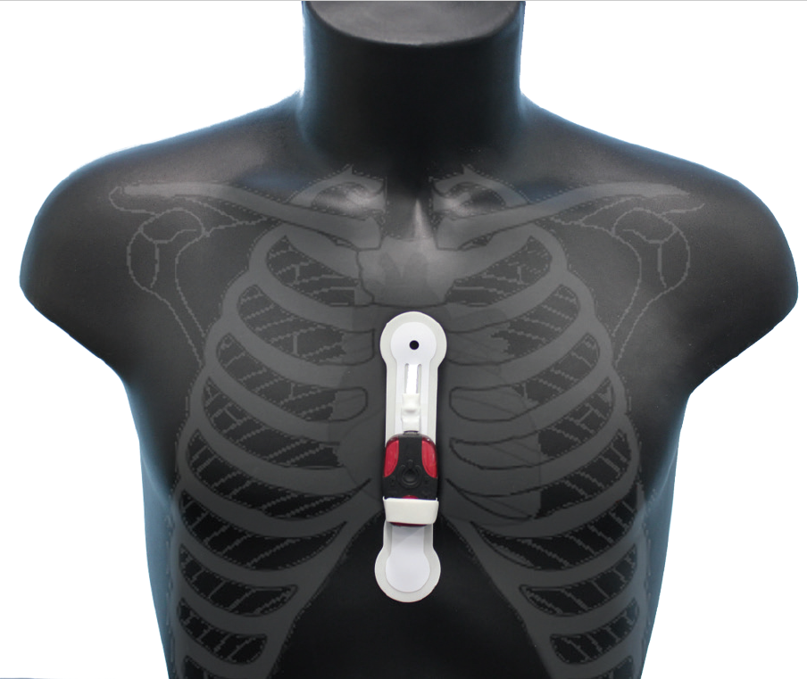

Supplementary Figure 2. Absolute values for average phoneme rate and speaking rate versus ALSFRS-R bulbar domain score (Core Phase; FAS)
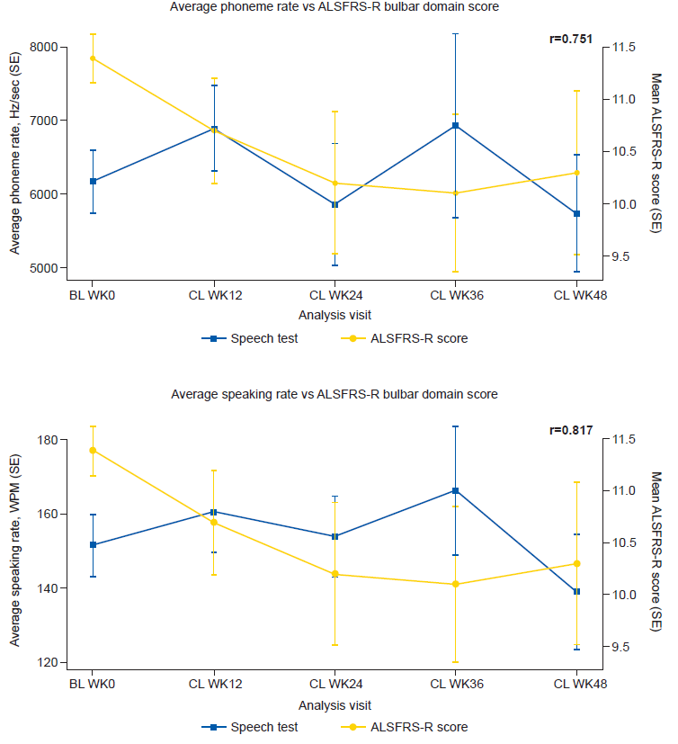
The between-patient correlations are indicated on each graph (r).
ALSFRS-R; amyotrophic lateral sclerosis functional rating scale – revised; FAS, full analysis set; BL, baseline; CL, clinic; SE, standard error; TC, telephone contact; WPM, words per minute.

