Supplementry Information:
A portable microfluidic device based Fe₃O₄-urease nanoprobe enhanced colorimetric sensor for the detection of heavy metals in fish tissue.
Krishna Kumari Swain¹ , R.Balasubramaniam ², Sunil Bhand ¹*
¹Biosensor Lab, Department of Chemistry, BITS Pilani KK Birla Goa Campus, Goa, PIN-403726 India.
²Precision Machining Section, PED, BARC, Mumbai -400085, India

* Corresponding author
Prof. Sunil Bhand, Ph.D.
Biosensor Lab. Department of Chemistry,
BITS Pilani K.K. Birla Goa Campus,
Goa - 403726, India
Ph: +91-832-2580332, Fax: + 91-832-2557030/33
Email:sunilbhand@goa.bits-pilani.ac.in

Supplementary Section 1:
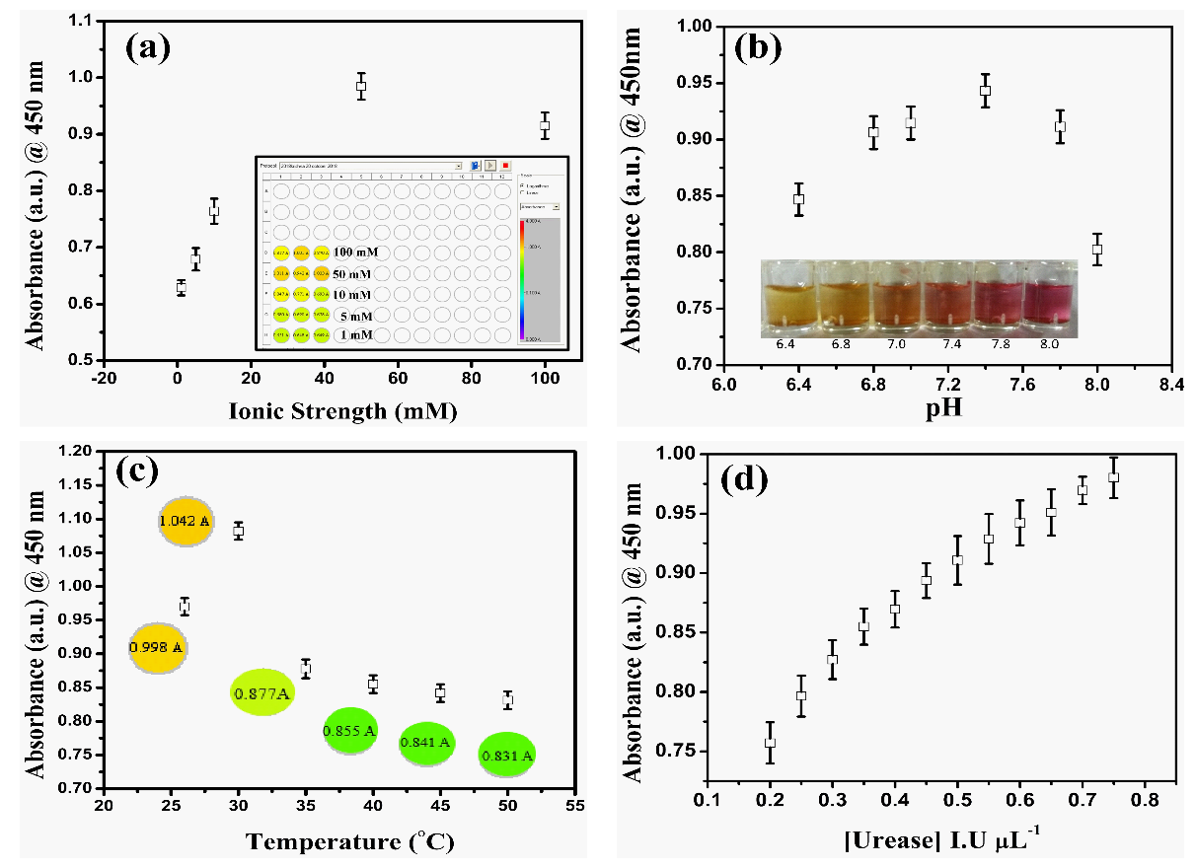
Supplemetary Figure 1. (a) Influence of ionic strength on the activity of Fe₃O₄MNPs-urease nanoprobe using a varying concentration of PB (1-100 mM) at 27° C (Inset: absorbance value with the color variation of individual concentration).(b) Influence of pH on the activity of Fe₃O₄MNPs-urease nanoprobe using the optimized concentration of PB (50 mM) at 27° C (Inset: color variation of respective pH).(c) Effect of temperature on the activity of Fe₃O₄MNPs-urease nanoprobe using an optimized concentration of PB (50 mM), pH 7.4 at 27° C (Inset: absorbance and color change of corresponding temperature) in triplicate format.(d) Impact of enzyme concentration on activity of Fe₃O₄MNPs-urease nanoprobe using optimized concentration of PB (50 mM), pH 7.4 at 27° C.

Supplemetary Figure 2. (a) Influence of ionic strength on the activity of free urease enzyme using varying concentration of PB (1- 100 mM) at 27° C in triplicate format.(b) Influence of pH on activity of free urease enzyme using optimized concetration of PB (50 mM) at 27° C in triplicate.(c) Effect of temperature on the activity of free urease enzyme using an optimized concentration of PB (50 mM), pH 7.4 at 27° C) in triplicate format. (d) Impact of enzyme concentration on activity of free urease enzyme using optimized concetration of PB (50 mM), pH 7.4 at 27° C.

Supplemetary Figure 3. Line weaver- Burk plot obtained for activity of free urease enzyme over urea hydrolysis under optimal conditions; 0.1 mM urea in 50 mM PB (pH 7.4) at 27° C recorded at 450 nm using a multi-plate reader in photometric mode (inset shows the linearity from 0.01-100 mM of urea concentrations with Km=0.1 mM , Vmax= 0.093 and R² of 0.959).

Table S1: Figures of merit for optimized assay using Fe₃O₄MNPs -Urease nanoprobe in 96-microwell plate format.

Parameter | Experimental range
Urease enzyme Concentration | 0.6 I.U. /assay
Substrate (Urea) | 0.1 mM
pH | 7.4
Ionic strength | 50 mM
Temperature | 27° C
K_{m} | 0.05 mM
V_{max} | 1.179
R² | 0.943

Table S2: The detailed comparison of the calibration curve of fish gill tissue against standard (PB) calibration curve.
Matrix |  | Metal ions (ng L⁻¹) |  |  | Dynamic range
 |  | Hg²⁺ | Cd²⁺ | Pb²⁺
Phosphate Buffer | R² | 0.974 | 0.920 | 0.950 | 0.5 to 50 ng L⁻¹
 | IC30 (ng L⁻¹) | 1 | 5 | 0.5
 | Sensitivity | 7.9 | 13 | 8.4
Fish gill tissue | R² | 0.971 | 0.924 | 0.959 | 0.5 to 50 ng L⁻¹
 | IC30 (ng L⁻¹) | 0.5 | 1 | 0.5
 | Sensitivity | 6.5 | 12.5 | 10.06

