**Lengend**

**Fig. S1** 1H NMR spectra of the ligand H2L.

**Fig. S2** Theinfrared spectra of H2L and its complex.

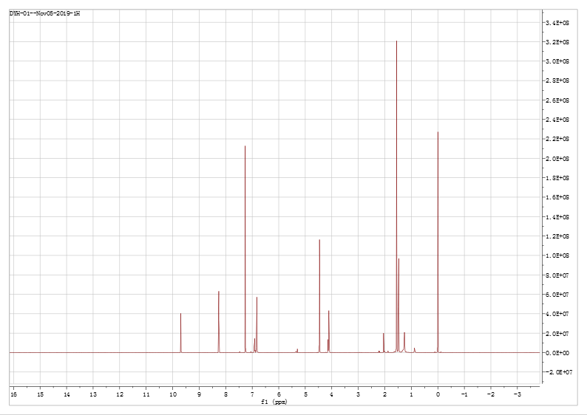

**Fig. S1**



**Fig. S2**