**A simple method for the reduction of Schiff bases using biosynthesized nickel oxide nanoparticles**

Alagesan Muthuvinothini1 and Selvaraj Stella1*

1 Research Scholar (Reg. No. 17211242032014), Department of Chemistry and Research Centre, Sarah Tucker College (Autonomous), Affiliated to Manonmaniam Sundaranar University, Abishekapatti, Tirunelveli-627012, Tamil Nadu, India.

1* Assistant Professor, Department of Chemistry and Research Centre, Sarah Tucker College (Autonomous), Affiliated to Manonmaniam Sundaranar University, Abishekapatti, Tirunelveli-627012, Tamil Nadu, India.

Corresponding author’s Email: [stella.selvaraj@gmail.com](mailto:stella.selvaraj@gmail.com).

**Supporting Information**

**Characterization**

FT-IR spectra of the products were recorded at room temperature on IR affinity (FT-IR spectrophotometer, Shimadzu, ANJA College, Sivakasi, Tamil Nadu, India) ranging from 4000 to 400 cm-1. Proton and carbon NMR was recorded at 400 MHz (Bruker) at VIT University, Vellore and Avance III HD Nanobay 400 MHz FT-NMR spectrometer at Gandhigram rural institute, Dindigul, Tamil Nadu, India. Mass spectrometer was recorded using the instrument Q-TOF at Pondicherry University, Puducherry, India.

**General procedure for the reduction of imines**

Imine **1a** (30 mg, 0.14mmol), biosynthesized NiO nanoparticles (1 mg) and ammonium formate (0.13 mmol), ethanol (2 ml) were mixed and stirred in a magnetic stirrer. NaOH (0.05 mmol) in 2 ml of water was added to the reaction mixture to maintain the pH at 8 and heated to about 45ºC. Completion of the reaction was confirmed by checking TLC. Then, the catalyst was removed through centrifugation and the organic layer was evaporated. The crude product was extracted with ethyl acetate and dried using anhydrous sodium sulphate. All the products were purified using column chromatography.

**Characterization data for the synthesized imines**

* 1. ***(E)-N*-(4-chlorobenzylidene)aniline**

1:1.2 molar ratio of 4-Chlorobenzaldehyde and aniline were dissolved in ethanol and stirred at room temperature to form (*E)-N*-(4-chlorobenzylidene)aniline and recrystallized from ethanol. Very pale yellow crystals.Yield: 97%, m. p: 60 - 62 ºC. 1H NMR (400 MHz, CDCl3): δ 8.40 (s, 1H, CH-imine), 7.82-7.84 (d, 2H, Ar-H), 7.37-7.44 (m, 4H, Ar-H), 7.16-7.25 (m, 3H, Ar). 13C NMR (CDCl3): δ 158.86 (N=C), 151.7, 137.4, 134.7, 130.9, 129.4, 126.2, 120.8. FT-IR: 3140 cm-1, 1622 cm-1, 1585 cm-1, 1565 cm-1, 1487 cm-1, 1087 cm-1, 828 cm-1, 761 cm-1, 695 cm-1.

**2.1 *(E)-*2-(((4-nitrophenyl)imino)methyl)phenol**

1:1 molar ratio of 2-Hydroxybenzaldehyde and 4-nitroaniline were dissolved in ethanol and stirred at room temperature to synthesize the product anditwas recrystallized from ethyl acetate: hexane mixture and an orange crystals were obtained when the mixture was cooled in ice. Yield: 94%, m. p: 150 - 152 ºC. 1H NMR (400 MHz, CDCl3): δ 8.63 (s, 1H, CH-imine), 8.28-8.31 (d, 2H, Ar-H), 7.46-7.47 (d, 1H, Ar-H), 7.43-7.45 (t, 1H, Ar-H), 7.35-7.37 (d, 2H, Ar-H), 7.26 (s, 1H, -OH), 7.04-7.06 (d, 1H, Ar-H), 6.97-7.01 (t, 1H, Ar-H). 13C NMR (CDCl3): δ 165.41, 161.34, 154.22, 146.12, 133.02, 126.35, 125.24, 121.91, 119.58, 118.73, 117.56. FT-IR: 3480 cm-1, 3360 cm-1, 2360 cm-1, 1630 cm-1, 1587 cm-1, 1506 cm-1, 1479 cm-1, 1337 cm-1, 1111 cm-1, 838 cm-1, 753 cm-1, 631 cm-1.

**3.1 *(E)-N*-(4-methoxybenzylidene)aniline**

1 mmol of 4-methoxybenzaldehyde and 1.2 mmol of Aniline were mixed and treated to microwave irradiation (MW power level 40 % for 6 minutes) and recrystallized from ethanol. White crystals. Yield: 90%, m. p: 61 – 64 ºC. 1H NMR (400 MHz, CDCl3): δ 8.37 (s, 1H, CH-imine), 7.82-7.85 (d, 2H, Ar-H), 7.35-7.39 (m, 2H, Ar-H), 7.18-7.22 (m, 3H, Ar-H), 6.96-6.98 (d, 2H, Ar-H), 3.86 (s, 3H, Ar-OCH3). 13C NMR (CDCl3): δ 162.28, 159.76, 152.44, 130.84, 129.30, 125.60, 120.92, 114.22, 55.45. FT-IR: 3128 cm-1, 1603 cm-1, 1573 cm-1, 1508 cm-1, 1400 cm-1, 1337 cm-1, 1107 cm-1, 835 cm-1, 751 cm-1, 694 cm-1, 611 cm-1.

**4.1 *(E)-N*-(4-methylbenzylidene)aniline**

1 mmol of 4-Methylbenzaldehyde and 1.2 mmol of Aniline were mixed and treated to microwave irradiation (MW power level 40% 5 minutes). Recrystallized from ethanol. Pale yellow crystals. Yield: 88%, m. p.: 46 - 48 ºC. 1H NMR (400 MHz, CDCl3): δ 8.41 (s, 1H, CH-imine), 7.80-7.82 (d, 2H, Ar-H), 7.36-7.40 (t, 1H, Ar-H), 7.19-7.24 (m, 4H, Ar-H), 7.26-7.28 (d, 2H, Ar-H), 2.41 (s, 3H, Ar-CH3). 13C NMR (CDCl3): δ 160.4, 152.29, 141.9, 133.7, 129.9, 129.5, 129.4, 129.2, 128.8, 125.7, 121.2, 21.7. FT-IR: 3127 cm-1, 1623 cm-1, 1585 cm-1, 1510 cm-1, 1401 cm-1, 1307 cm-1, 1105 cm-1, 815 cm-1, 749 cm-1, 693 cm-1, 606 cm-1.

**5.1 *(E)-*2-{[(4-chlorophenyl)imino]methyl}phenol**

1:1.2 ratio of 2-hydroxybenzaldehyde and 4-chloroaniline were mixed and treated to MW power level 40% for 20 minutes (2 minutes on and 2 minutes off mode). Yellow liquid was obtained. This was recrystallized from ethyl acetate: Hexane mixture and beautiful yellow crystals were obtained**.** Yield: 93%, m. p.: 92 - 95 ºC. 1H NMR (400 MHz, CDCl3): δ 13.01 (s, 1H, -OH), 8.54 (s, 1H, CH-imine), 7.33-7.38 (m, 4H, Ar-H), 7.16-7.18 (d, 1H, Ar-H), 6.99-7.01 (d, 2H, Ar-H), 6.90-6.93 (t, 1H, Ar-H). 13C NMR (CDCl3): δ 162.9, 161.13, 147.0, 132.4, 129.8, 122.8, 122.1, 119.2, 117.5. FT-IR: 3157 cm-1, 1610 cm-1, 1565 cm-1, 1485 cm-1, 1400 cm-1, 1356 cm-1, 1148 cm-1, 838 cm-1, 757 cm-1, 697 cm-1, 603 cm-1.

**6.1 *(E)-*4-chloro-*N*-(4-nitrobenzylidene)aniline**

1:1.2 molar ratio of 4-nitrobenzaldehyde and 4-chloroaniline were dissolved in 2 ml of ethanol and stirred at room temperature and yellow crystals were appeared. Yield: 97%. m. p.: 128 - 132ºC. 1H NMR (400 MHz, CDCl3): δ 8.54 (s, 1H, CH-imine), 8.32-8.35 (dd, 2H, Ar-H), 8.07-8.08 (dd, 2H, Ar-H), 7.39-7.41 (dd, 2H, Ar-H), 7.20-7.22 (dd, 2H, Ar-H). 13C NMR (CDCl3): δ 157.68, 149.40, 149.31, 141.29, 132.73, 129.50, 129.48, 124.06, 122.36. FT-IR: 3419 cm-1, 3071 cm-1, 1623 cm-1, 1595 cm-1, 1436 cm-1, 1143 cm-1, 1106 cm-1, 1013 cm-1, 819 cm-1, 773 cm-1, 685 cm-1.

**Characterization data for the reduced amines**

**1.2 *N*-(4-chlorobenzyl)aniline**

*N-*(4-Chlorobenzyl)aniline was obtained by the reduction of *(E)-N*-(4-chlorobenzylidene)aniline. Pale yellow solid. Yield: 94%. M. p: 90 - 94 ºC. 1H NMR (400 MHz, CDCl3): δ 7.80-7.82 (d, 2H, Ar-H), 7.36-7.43 (m, 2H, Ar-H), 7.13-7.29 (m, 2H, Ar-H), 6.69-6.72 (t, 1H, Ar-H), 6.57-6.59 (d, 2H, Ar-H), 4.26 (s, 2H, Ar-CH2), 4.02 (s, 1H, -NH). 13C NMR (CDCl3): δ 147.9, 138.1, 132.8, 129.8, 129.3, 129.1, 128.8, 128.7, 128.7, 120.6, 117.8, 112.9, 47.61. FT-IR: 3124 cm-1, 1602 cm-1, 1488 cm-1, 1401 cm-1, 1087 cm-1, 828 cm-1, 751 cm-1, 693 cm-1, 605 cm-1. ESI-MS: m/z Calculated: 217.07. Found: 218.07 (M+H).

**2.2 2-[{(4-nitrophenyl)amino}methyl]phenol**

This was obtained through the reduction of *(E)-*2-(((4-nitrophenyl)imino)methyl)phenol using biosynthesized NiO nanoparticles as catalyst. Yellow crystals. Yield: 97%. m. p: 136-140ºC. 1H NMR (400 MHz, CDCl3): δ 8.07 (d, 2H, Ar-H), 7.21-7.26 (m, 2H, Ar-H), 7.19 (s, 1H, -OH), 6.90-6.94 (t, 1H, Ar-H), 6.83-6.85 (d, 1H, Ar-H), 6.64-6.66 (d, 2H, Ar-H), 4.88 (s, 1H, -NH), 4.44 (s, 2H, Ar-CH2). 13C NMR (CDCl3): δ 154.3, 153.2, 129.4, 129.3, 126.3, 123.2, 120.9, 115.9, 112.1, 44.21. FT-IR: 3509 cm-1, 3363 cm-1, 2360 cm-1, 1598 cm-1, 1465 cm-1, 1285 cm-1, 1115 cm-1, 845 cm-1, 745 cm-1, 496 cm-1. ESI-MS: m/z calculated: 244.08, Found: 245.09 (M+H).

**3.2 *N*-(4-methoxybenzyl)aniline**

Obtained from the reduction of *(E)-N-*(4-methoxybenzylidene)aniline. Pale yellow crystals. Yield: 85%. m. p: 63 - 67 ºC. 1H NMR (400 MHz, CDCl3): δ 7.27-7.29 (d, 2H, Ar-H), 7.14-7.18 (t, 2H, Ar-H), 6.86-6.88 (d, 2H, Ar-H), 6.68-6.72 (t, 1H, Ar-H), 6.61-6.63 (d, 2H, Ar-H), 4.23 (s, 2H, Ar-CH2), 3.93 (s, 1H, -NH), 3.79 (s, 3H, -OCH3).13C NMR (CDCl3): δ 158.8, 148.2, 131.4, 129.6, 129.3, 128.9, 117.8, 117.5, 114.1, 113.2, 112.9, 55.3, 47.8. FT-IR: 3128 cm-1, 1602 cm-1, 1512 cm-1, 1401 cm-1, 1250 cm-1, 1108 cm-1, 1032 cm-1, 749 cm-1, 603 cm-1. ESI-MS: m/z calculated: 213.12 Found: 214.12 (M+H).

**4.2 *N*-(4-methylbenzyl)aniline**

Reduction of *(E)-N-*(4-methylbenzylidene)aniline gave the product amine. White solid. Yield: 89%. m. p.: 42-44 °C. 1H NMR (400 MHz, CDCl3): δ 7.23-7.26 (d, 2H, Ar-H), 7.12-7.17 (m, 4H, Ar-H), 6.67-6.72 (m, 1H, Ar-H), 6.61-6.62 (d, 2H, Ar-H), 4.25 (s, 2H, Ar-CH2), 3.95 (s, 1H, -NH), 2.33 (s, 3H, -CH3). 13C NMR (CDCl3): δ 148.3, 136.9, 136.4, 129.6, 129.3, 127.8, 117.8, 113.2, 48.1, 21.2. FT-IR: 3255 cm-1, 3056 cm-1, 1608 cm-1, 1430 cm-1, 1377 cm-1, 1219 cm-1, 1166 cm-1, 1081 cm-1, 807 cm-1, 691 cm-1, 623 cm-1, 584 cm-1. ESI-MS: m/z calculated: 197.12, Found: 198.12 (M+H).

**5.2 2-[{(4-chlorophenyl)amino}methyl]phenol**

Obtained through the reduction of *(E)*-2-{[(4-chlorophenyl)imino]methyl}phenol. Yellow crystals. Yield: 95% m. p.: 150-154 ºC. 1H NMR (400 MHz, CDCl3): δ 8.0 (d, 2H, Ar-H), 7.15-7.25 (m, 2H, Ar-H), 6.87-6.92 (t, 2H, Ar-H), 6.74-6.76 (d, 2H, Ar-H), 4.37 (s, 2H, Ar-CH2), 3.98 (s, -NH), 1.59 (s, -OH). 13C NMR (CDCl3): δ 156.4, 145.8, 129.4, 129.3, 128.9, 125.5, 122.7, 120.3, 116.8, 116.6, 48.4. FT-IR: 3257 cm-1, 2729 cm-1, 1593 cm-1, 1492 cm-1, 1453 cm-1, 1355 cm-1, 1180 cm-1, 865 cm-1, 797 cm-1, 625 cm-1, 583 cm-1, 513 cm-1. ESI-MS: m/z calculated: 233.06 Found: 234.06 (M+H).

**6.2 4-chloro-*N*-(4-nitrobenzyl)aniline**

Yellow crystals. Yield: 92 %. m. p.: 90 - 94 ºC. 1H NMR (400 MHz, CDCl3): δ 8.18-8.20 (d, 2H, Ar-H), 7.50-7.52 (d, 2H, Ar-H), 7.09-7.11 (d, 2H, Ar-H), 6.48-6.50 (d, 2H, Ar-H), 4.44 (s, 2H, Ar-CH2), 4.27 (s, -NH). 13C NMR (CDCl3): δ 147.3, 146.8, 145.8, 129.2, 127.7, 123.9, 122.9, 114.02, 47.7. FT-IR: 3428 cm-1, 2924 cm-1, 1600 cm-1, 1508 cm-1, 1420 cm-1, 1342 cm-1, 1181 cm-1, 1045 cm-1, 811 cm-1, 732 cm-1, 626 cm-1. ESI-MS calculated: 262.05, Found: 263.05 (M+H).

**References**

1. Shan, S.P.; Xiaoke, X.; Gnannaprakasam, B.; Dang, T.T.; Ramalingam, B.; Huynh, H.V.; Seayad, A.M.; *RSC Adv*., 2015, 5, 4434-4442.
2. Hania, M.M.; *E-Journal of Chemistry*, 2009, 6(3), 629-632.
3. Ge, C.; Sang, X.; Yao, W.; Zhang, L.; Wang, D.; Green Chem., 2018, 20, 1805-1812.
4. Maria del Rosario I Amado Sierra, Palladium-catalyzed PMHS reductions of imines (Master of Science thesis). (2011), Michigan State University, United states.

**Spectral data of compounds**

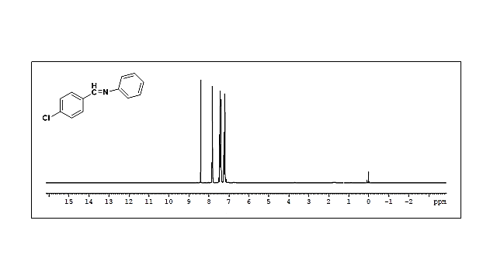

**Fig. 1 1H NMR spectrum of *(E)-N*-(4-chlorobenzylidene)aniline**

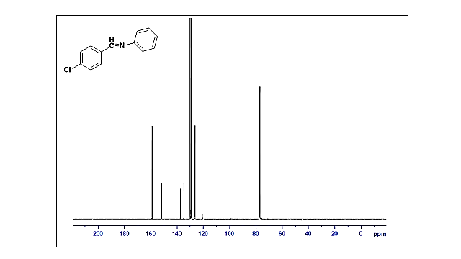

**Fig. 2 13C NMR spectrum of *(E)-N*-(4-chlorobenzylidene)aniline**



**Fig. 3 FT-IR spectrum of *(E)-N*-(4-chlorobenzylidene)aniline**

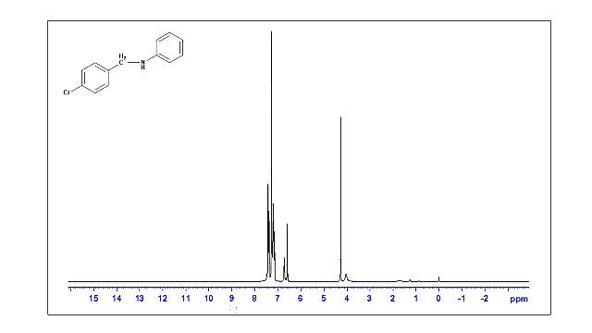

**Fig. 4 1H NMR spectrum of *N*-(4-chlorobenzyl)aniline**

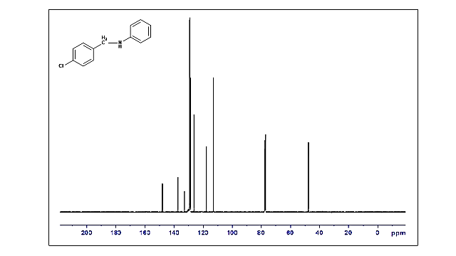

**Fig. 5 13C NMR spectrum of *N*-(4-chlorobenzyl)aniline**



**Fig. 6 FT-IR spectrum of *N*-(4-chlorobenzyl)aniline**

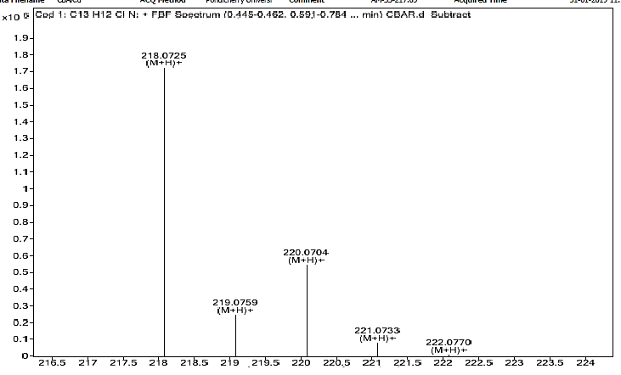

**Fig. 7 ESI-MS spectrum of *N*-(4-chlorobenzyl)aniline**

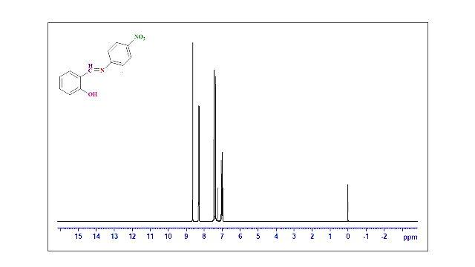

**Fig. 8 1H NMR spectrum of *(E)-*2-(((4-nitrophenyl)imino)methyl)phenol**

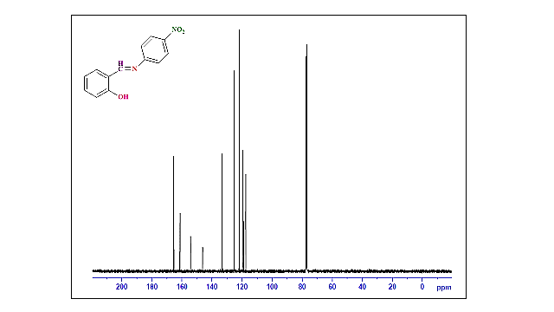

**Fig. 9 13C NMR spectrum of *(E)-*2-(((4-nitrophenyl)imino)methyl)phenol**



**Fig. 10 FT-IR spectrum of *(E)-*2-(((4-nitrophenyl)imino)methyl)phenol**

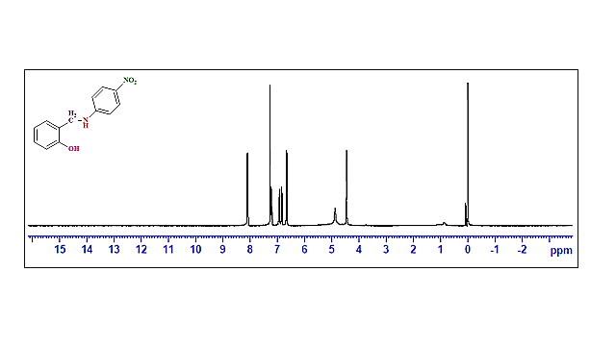

**Fig. 11 1H NMR spectrum of *(E)-*2-(((4-nitrophenyl)imino)methyl)phenol**

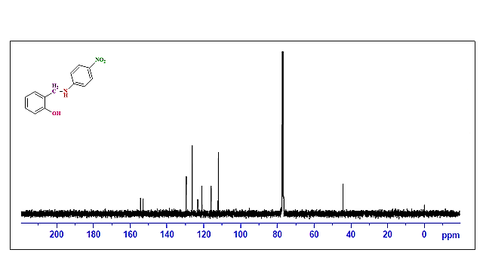

**Fig. 12 13C NMR spectrum of *(E)-*2-(((4-nitrophenyl)imino)methyl)phenol**



**Fig. 13 FT-IR spectrum of *(E)-*2-(((4-nitrophenyl)imino)methyl)phenol**

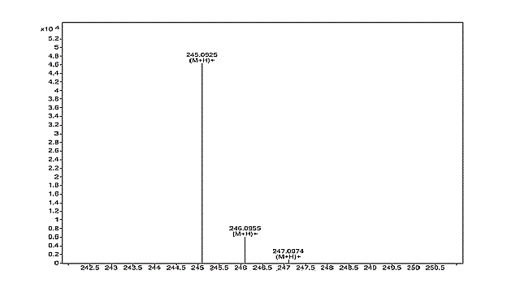

**Fig. 14 ESI-MS spectrum of *(E)-*2-(((4-nitrophenyl)imino)methyl)phenol**

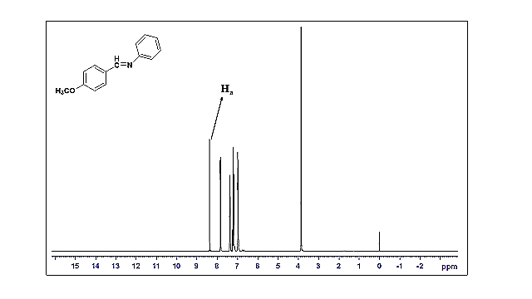

**Fig. 15 1H NMR spectrum of *(E)-N*-(4-methoxybenzylidene)aniline**

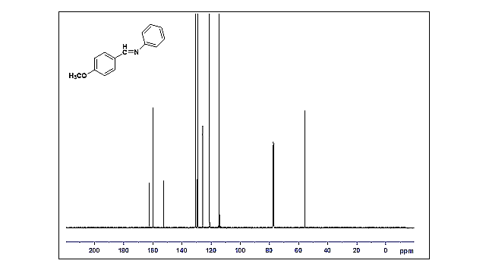

**Fig. 16 13C NMR spectrum of *(E)-N-*(4-methoxybenzylidene)aniline**



**Fig. 17 FT-IR spectrum of *(E)-N*-(4-methoxybenzylidene)aniline**

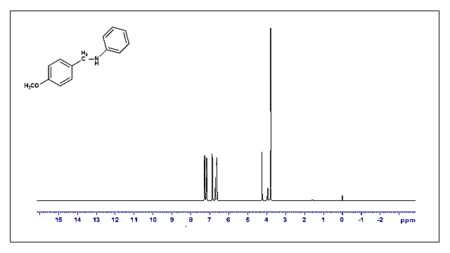

**Fig. 18 1H NMR spectrum of *N*-(4-methoxybenzyl)aniline**

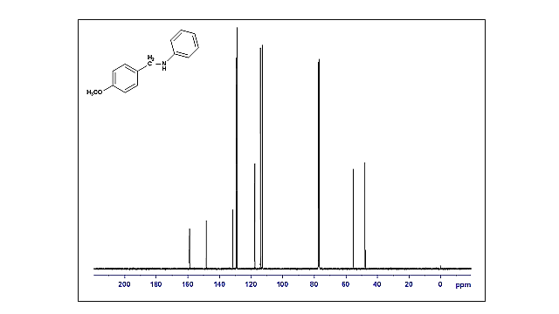

**Fig. 19 13C NMR spectrum of *N*-(4-methoxybenzyl)aniline**



**Fig. 20 FT-IR spectrum of *N*-(4-methoxybenzyl)aniline**

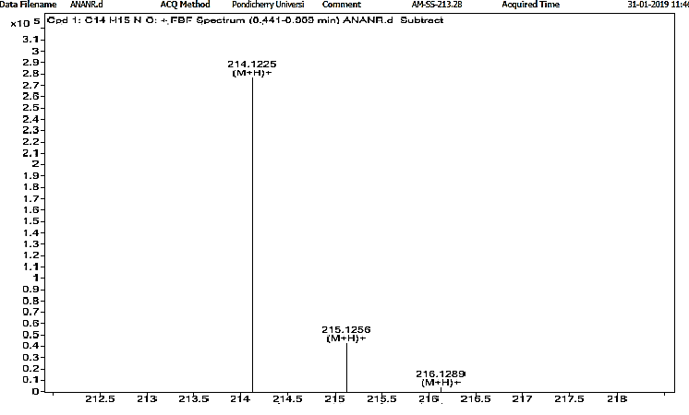

**Fig. 21 ESI-MS spectrum of *N*-(4-methoxybenzyl)aniline**

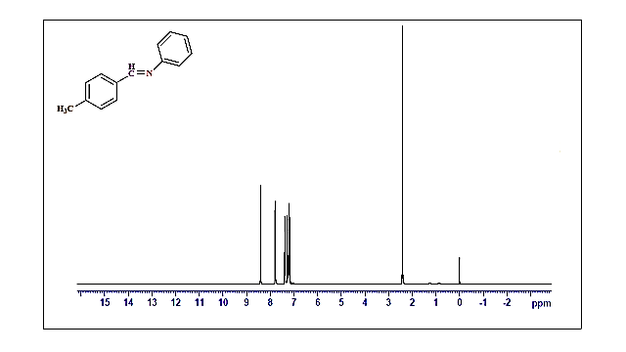

**Fig. 22 1H NMR spectrum of *(E)-N*-(4-methylbenzylidene)aniline**

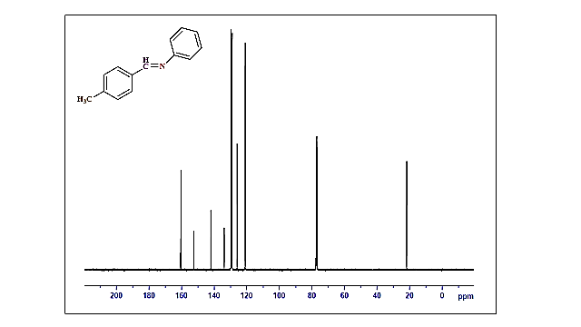

**Fig. 23 13C NMR spectrum of *(E)-N*-(4-methylbenzylidene)aniline**



**Fig. 24 FT-IR spectrum of *(E)-N*-(4-methylbenzylidene)aniline**

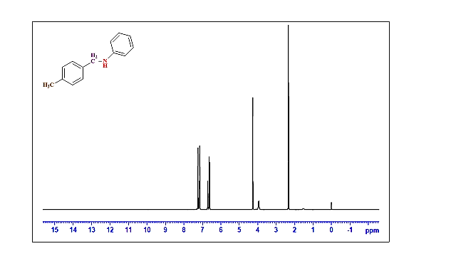

**Fig. 25 1H NMR spectrum of *N*-(4-methylbenzyl)aniline**

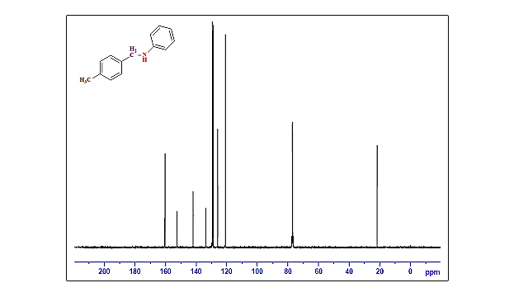

**Fig. 26 13C NMR spectrum of *N*-(4-methylbenzyl)aniline**



**Fig. 27 FT-IR spectrum of *N*-(4-methylbenzyl)aniline**

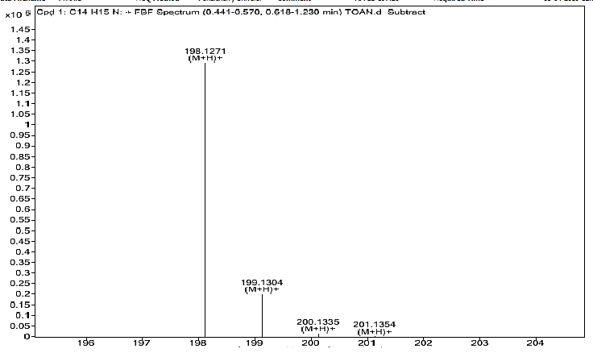

**Fig. 28 ESI-MS spectrum of *N*-(4-methylbenzyl)aniline**

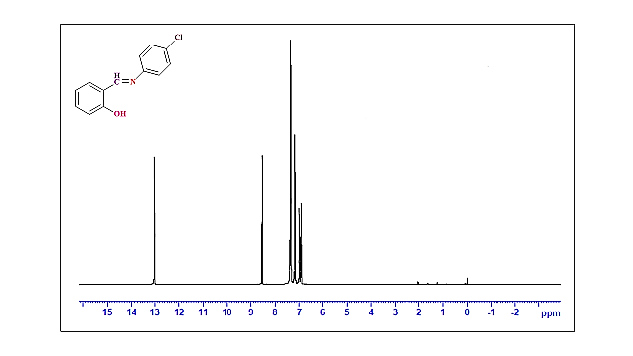

**Fig. 29 1H NMR spectrum of *(E)-*2-{[(4-chlorophenyl)imino]methyl}phenol**

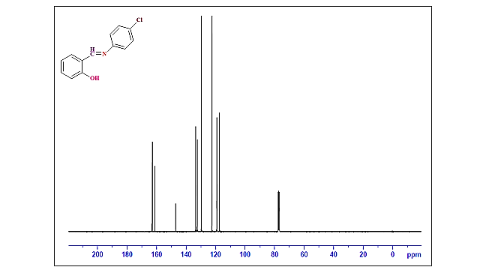

**Fig. 30 13C NMR spectrum of *(E)-*2-{[(4-chlorophenyl)imino]methyl}phenol**



**Fig. 31 FT-IR spectrum of *(E)-*2-{[(4-chlorophenyl)imino]methyl}phenol**

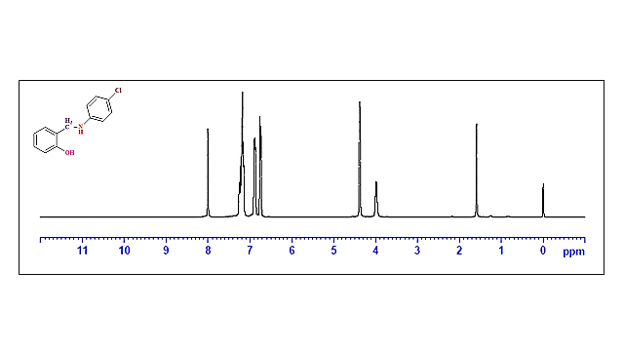

**Fig. 32 1H spectrum of 2-[{(4-chlorophenyl)amino}methyl]phenol**

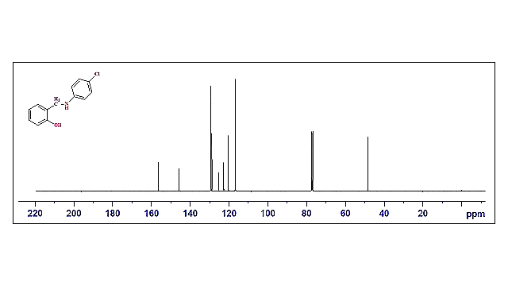

**Fig. 33 13C spectrum of 2-[{(4-chlorophenyl)amino}methyl]phenol**



**Fig. 34 FT-IR spectrum of 2-[{(4-chlorophenyl)amino}methyl]phenol**

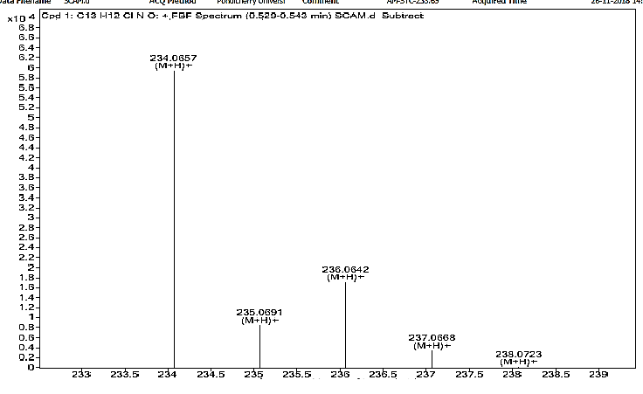

**Fig. 35 ESI-MS spectrum of 2-[{(4-chlorophenyl)amino}methyl]phenol**

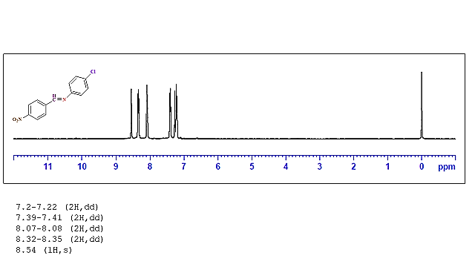

**Fig. 36 1H spectrum of *(E)-*4-chloro-N-(4-nitrobenzylidene)aniline**

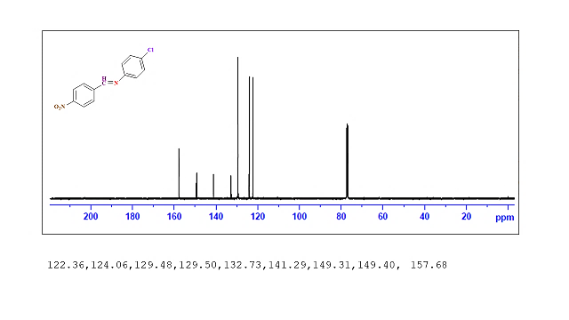

**Fig. 37 13C spectrum of *(E)-*4-chloro-N-(4-nitrobenzylidene)aniline**



**Fig. 38 FT-IR spectrum of *(E)-*4-chloro-N-(4-nitrobenzylidene)aniline**

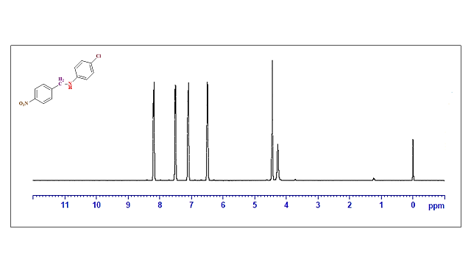

**Fig. 39 1H spectrum of 4-chloro-*N*-(4-nitrobenzyl)aniline**

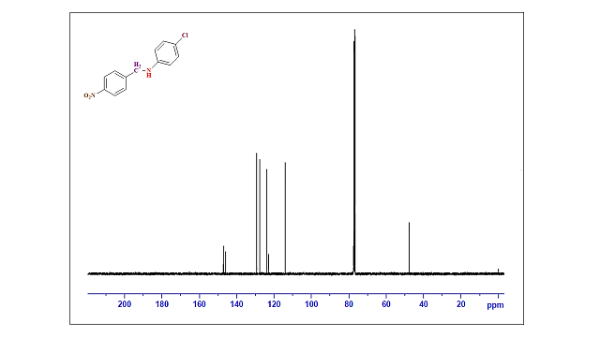

**Fig. 40 13C spectrum of 4-chloro-*N-*(4-nitrobenzyl)aniline**



**Fig. 41 FT-IR spectrum of 4-chloro-*N*-(4-nitrobenzyl)aniline**

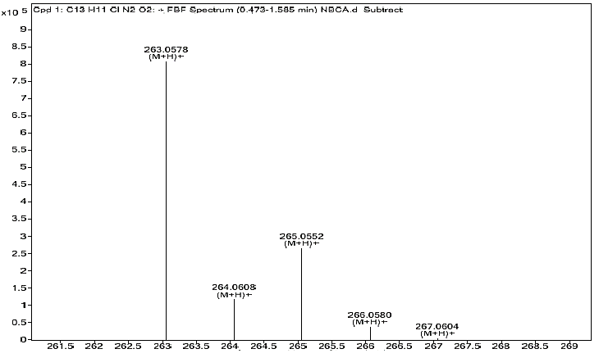

**Fig. 42 ESI-MS spectrum of 4-chloro-*N*-(4-nitrobenzyl)aniline**

**Acknowledgement**

The authors are grateful to DST-SERB, India (ECR/2016/001523) for the financial assistance.