**Supporting information for**

**Terpenoids from the Roots of *Alangium chinense***

Yan Zhang, Yun-Bao Liu,[1]* Yong Li, Li Li, Shuang-Gang Ma, Jing Qu, Jian-Dong Jiang, Xiao-Guang Chen, Dan Zhang, Shi-Shan Yu[2]*

State Key Laboratory of Bioactive Substance and Function of Natural Medicines, Institute of Materia Medica, Chinese Academy of Medical Sciences and Peking Union Medical College, Beijing 100050, People's Republic of China

**Lists of Supporting Information**

**Figure S1**. The HRESIMS spectrum of compound **1………………………………………….5**

**Figure S2**. The IR spectrum of compound **1………………………………………….……….5**

**Figure S3.** The 1HNMR spectrum of compound **1…………………………………………….6**

**Figure S4.** The 13CNMR spectrum of compound **1……………………………………………6**

**Figure S5.** The DEPT spectrum of compound **1…………………………………………….…7**

**Figure S6**. The COSY spectrum of compound **1……………………………………………….7**

**Figure S7.** The HSQC spectrum of compound **1…………………………………………….…8**

**Figure S8**. The HMBC spectrum of compound **1………………………………………………8**

**Figure S9.** The NOE spectrum of compound **1…………………………………………….…..9**

**Figure S10.** The NOESY spectrum of compound **1…………………………………………….9**

**Figure S11.** The CD spectrum of compound **1…………………………………………….……10**

**Figure S12.** The HRESIMS spectrum of compound **2…………………………………………..10**

**Figure S13.** The IR spectrum of compound **2…………………………………………….……..11**

**Figure S14.** The 1HNMR spectrum of compound **2……………………………………………..11**

**Figure S15.** The 13CNMR spectrum of compound **2……………………………………………12**

**Figure S16.** The DEPT spectrum of compound **2…………………………………………….…12**

**Figure S17.** The COSY spectrum of compound **2………………………………………………13**

**Figure S18.** The HSQC spectrum of compound **2………………………………………………13**

**Figure S19.** The HMBC spectrum of compound **2……………………………………………...14**

**Figure S20.** The NOE spectrum of compound **2…………………………………………….…..14**

**Figure S21.** The NOESY spectrum of compound **2……………………………………………..15**

**Figure S22.** The CD spectrum of compound **2…………………………………………….……15**

**Figure S23.** The HRESIMS spectrum of compound **3…………………………………………..16**

**Figure S24.** The IR spectrum of compound **3…………………………………………….……..16**

**Figure S25.** The 1HNMR spectrum of compound **3……………………………………………..17**

**Figure S26.** The 13CNMR spectrum of compound **3……………………………………………17**

**Figure S27.** The DEPT spectrum of compound **3…………………………………………….…18**

**Figure S28.** The COSY spectrum of compound **3………………………………………………18**

**Figure S29.** The HSQC spectrum of compound **3………………………………………………19**

**Figure S30.** The HMBC spectrum of compound **3……………………………………………...19**

**Figure S31.** The HREIMS spectrum of compound **4……………………………………………20**

**Figure S32.** The IR spectrum of compound **4…………………………………………….……..20**

**Figure S33.** The 1HNMR spectrum of compound **4……………………………………………..21**

**Figure S34.** The 13CNMR spectrum of compound **4……………………………………………21**

**Figure S35.** The DEPT spectrum of compound **4…………………………………………….…22**

**Figure S36.** The COSY spectrum of compound **4………………………………………………22**

**Figure S37.** The HSQC spectrum of compound **4………………………………………………23**

**Figure S38.** The HMBC spectrum of compound **4……………………………………………...23**

**Figure S39.** The NOE spectrum of compound **4…………………………………………….…..24**

**Figure S40.** The NOE spectrum of compound **4…………………………………………….…..24**

**Figure S41.** The NOESY spectrum of compound **4……………………………………………..25**

**Figure S42.** The CD spectrum of compound **4…………………………………………….……25**

**Figure S43.** The HRESIMS spectrum of compound **5…………………………………………..26**

**Figure S44.** The IR spectrum of compound **5…………………………………………….……..26**

**Figure S45.** The 1HNMR spectrum of compound **5……………………………………………..27**

**Figure S46.** The 13CNMR spectrum of compound **5……………………………………………27**

**Figure S47.** The DEPT spectrum of compound **5…………………………………………….…28**

**Figure S48.** The COSY spectrum of compound **5………………………………………………28**

**Figure S49.** The HSQC spectrum of compound **5………………………………………………29**

**Figure S50.** The HMBC spectrum of compound **5……………………………………………...29**

**Figure S51.** The NOE spectrum of compound **5…………………………………………….…..30**

**Figure S52.** The NOESY spectrum of compound **5……………………………………………..30**

**Figure S53.** The CD spectrum of compound **5…………………………………………….……31**

**Figure S54.** The HRESIMS spectrum of compound **6………………………………………..…31**

**Figure S55.** The IR spectrum of compound **6…………………………………………….……..32**

**Figure S56.** The 1HNMR spectrum of compound **6……………………………………………..32**

**Figure S57.** The 13CNMR spectrum of compound **6……………………………………………33**

**Figure S58.** The COSY spectrum of compound **6………………………………………………33**

**Figure S59.** The HSQC spectrum of compound **6………………………………………………34**

**Figure S60.** The HMBC spectrum of compound **6……………………………………………...34**

**Figure S61.** The NOESY spectrum of compound **6……………………………………………..35**

**Figure S62.** The Calculated CDs of (5*S*, 8*R*)-isomer and (5*R*, 8*S*)-isomer and experimental CD of compound **6** in DCM. **………………………………………………………………………..35**

**Figure S63.** The Calculated CDs of (5*S*, 8*S*)-isomer and (5*R*, 8R)-isomer and experimental CD of compound **6** in DCM. **………………………………………………………………………..36**

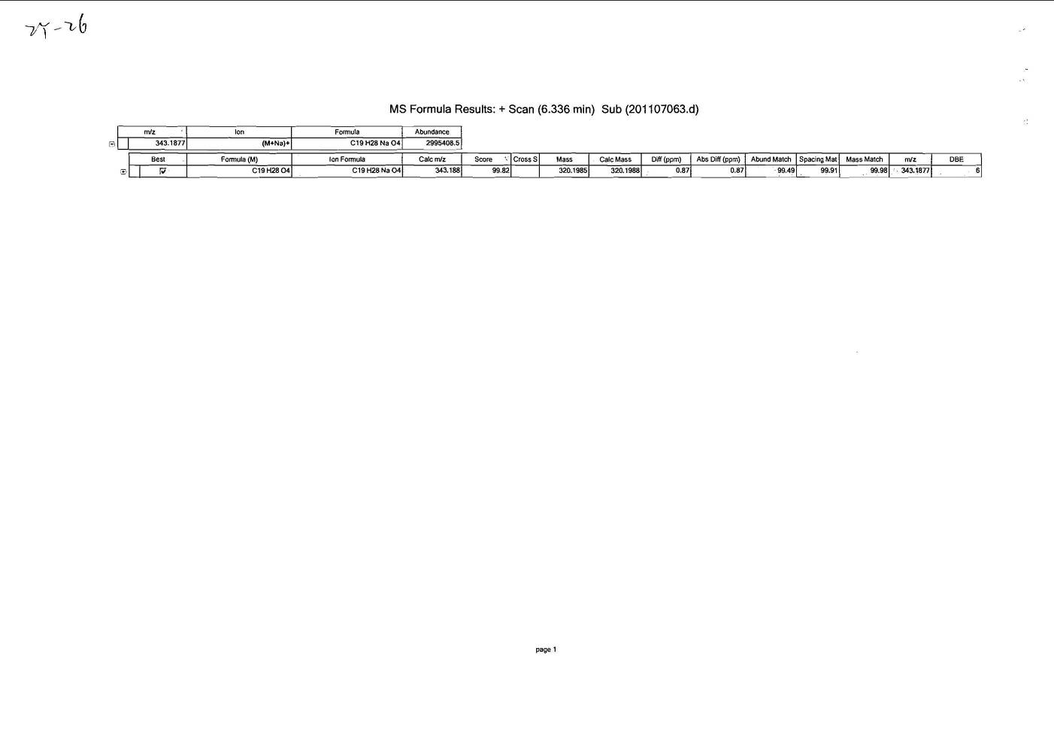

**Figure S1**. The HRESIMS spectrum of compound **1**

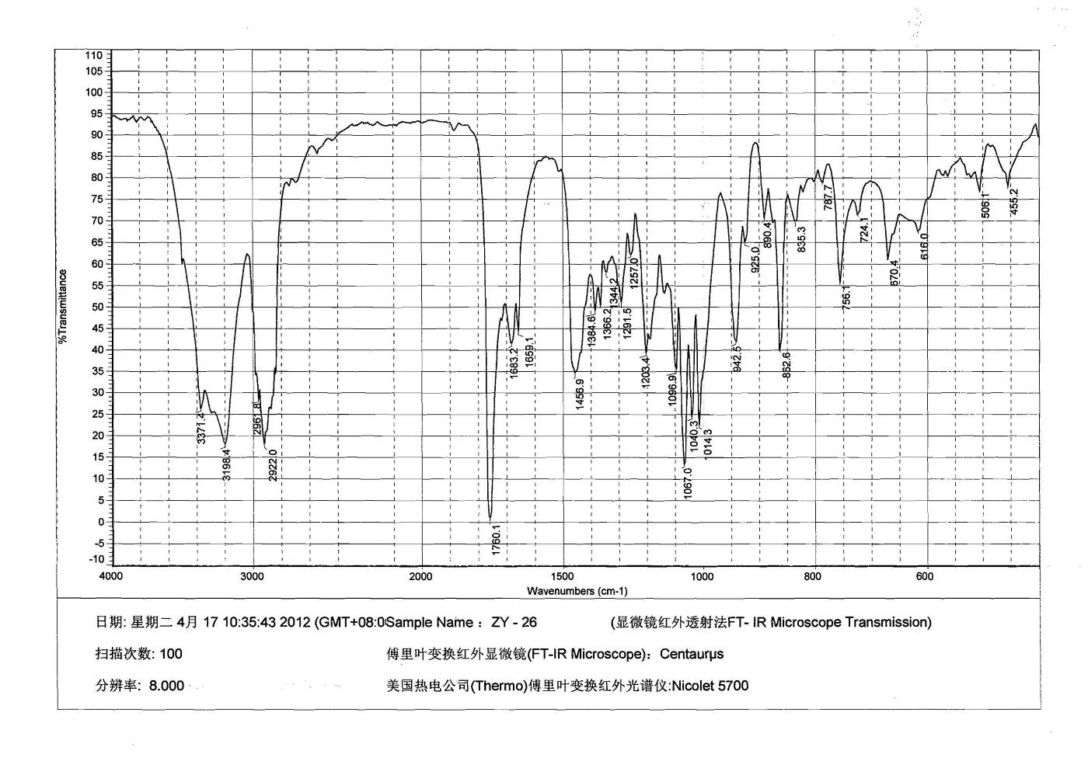

**Figure S2**. The IR spectrum of compound **1**

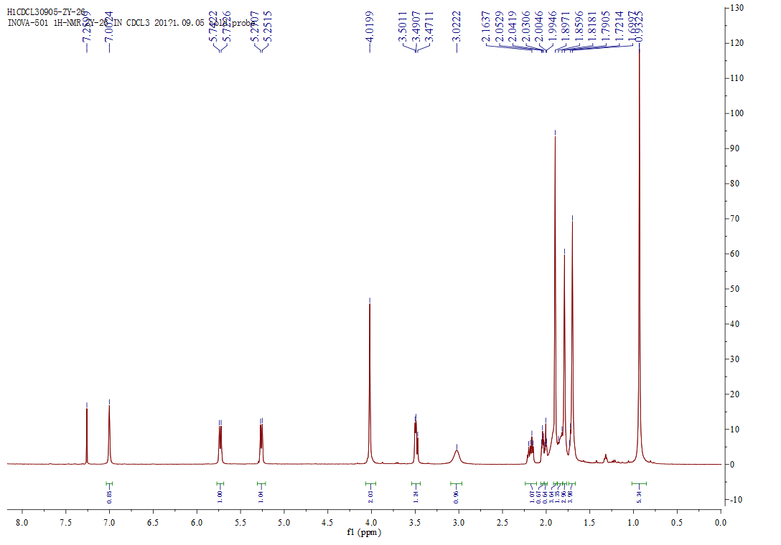



**Figure S3**. The 1HNMR spectrum of compound **1**

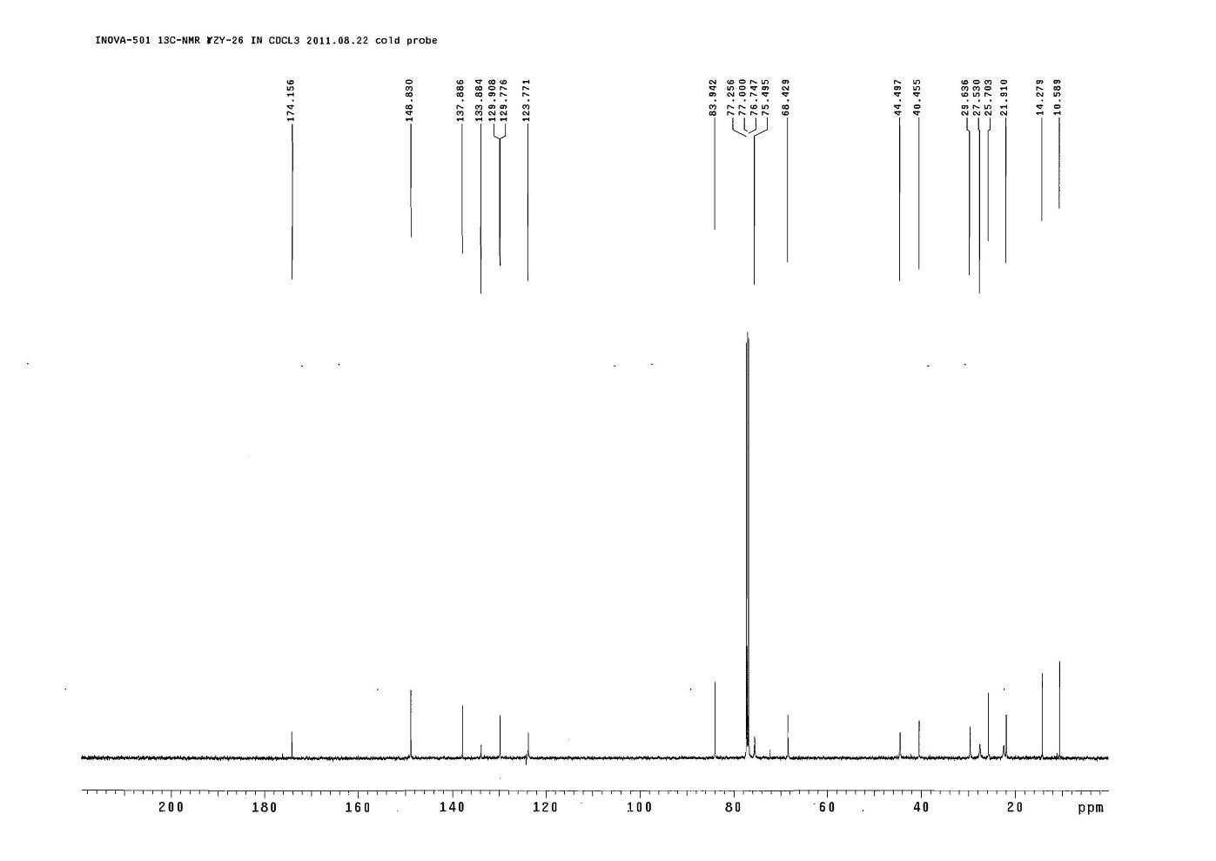



**Figure S4**. The 13CNMR spectrum of compound **1**

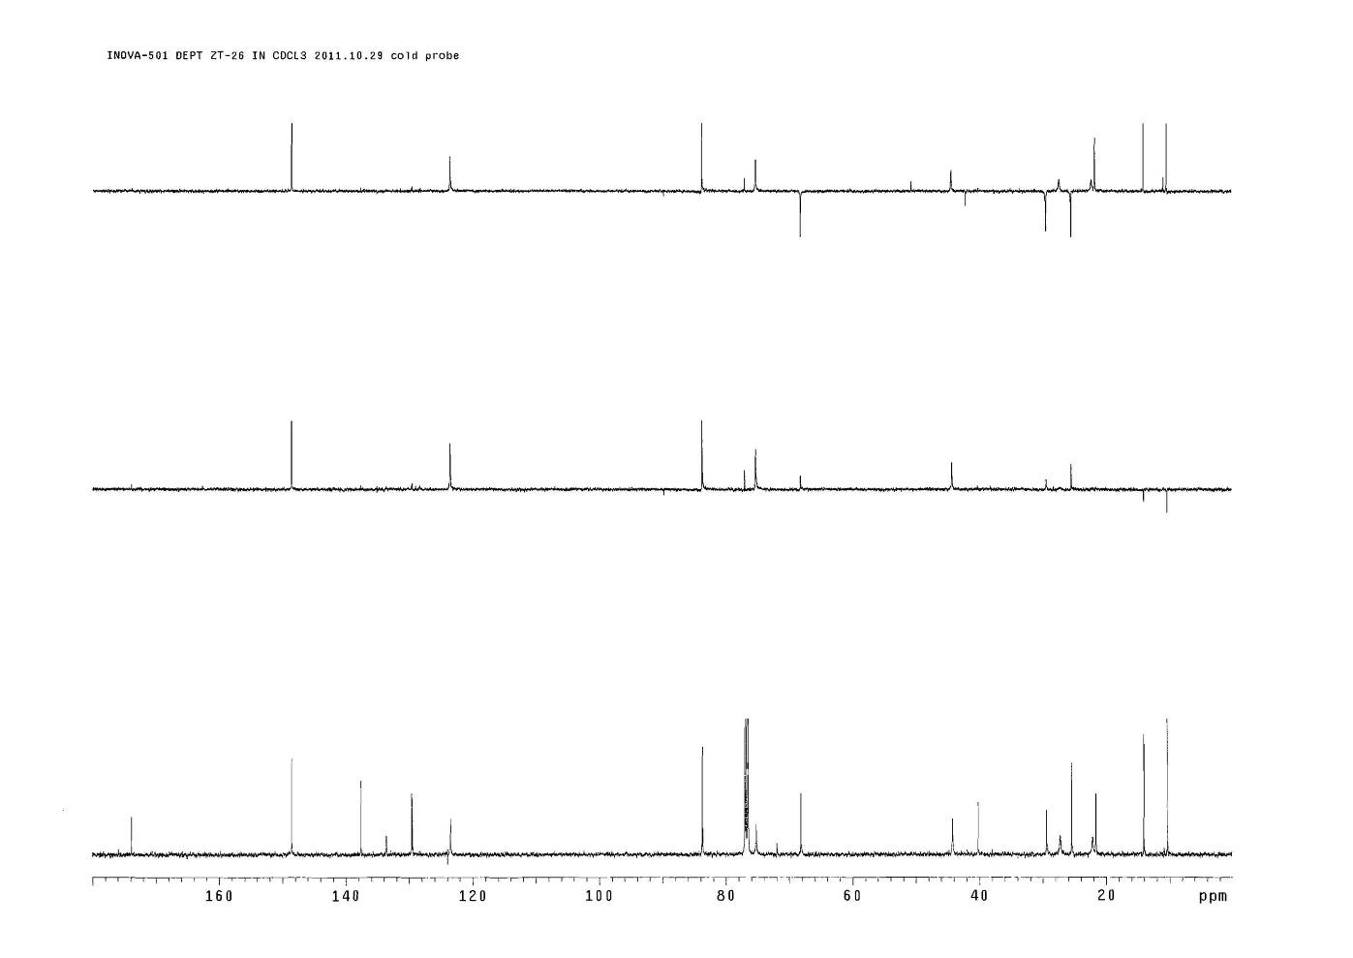



**Figure S5**. The DEPT spectrum of compound **1**

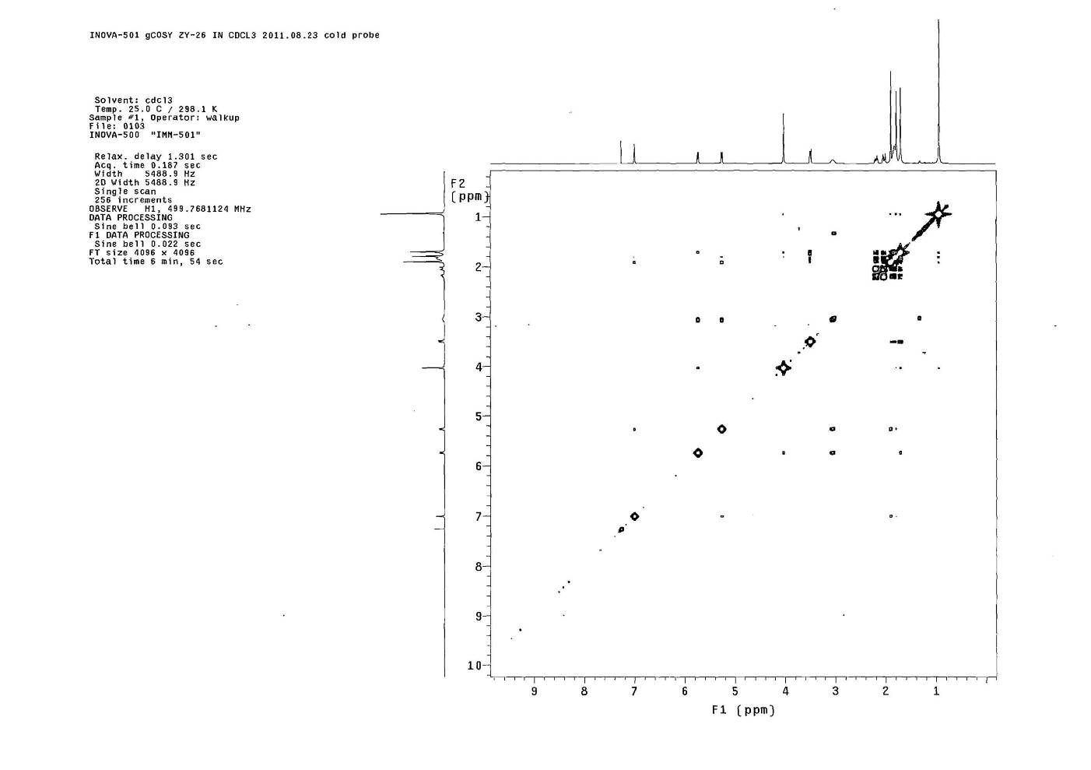



**Figure S6**. The COSY spectrum of compound **1**

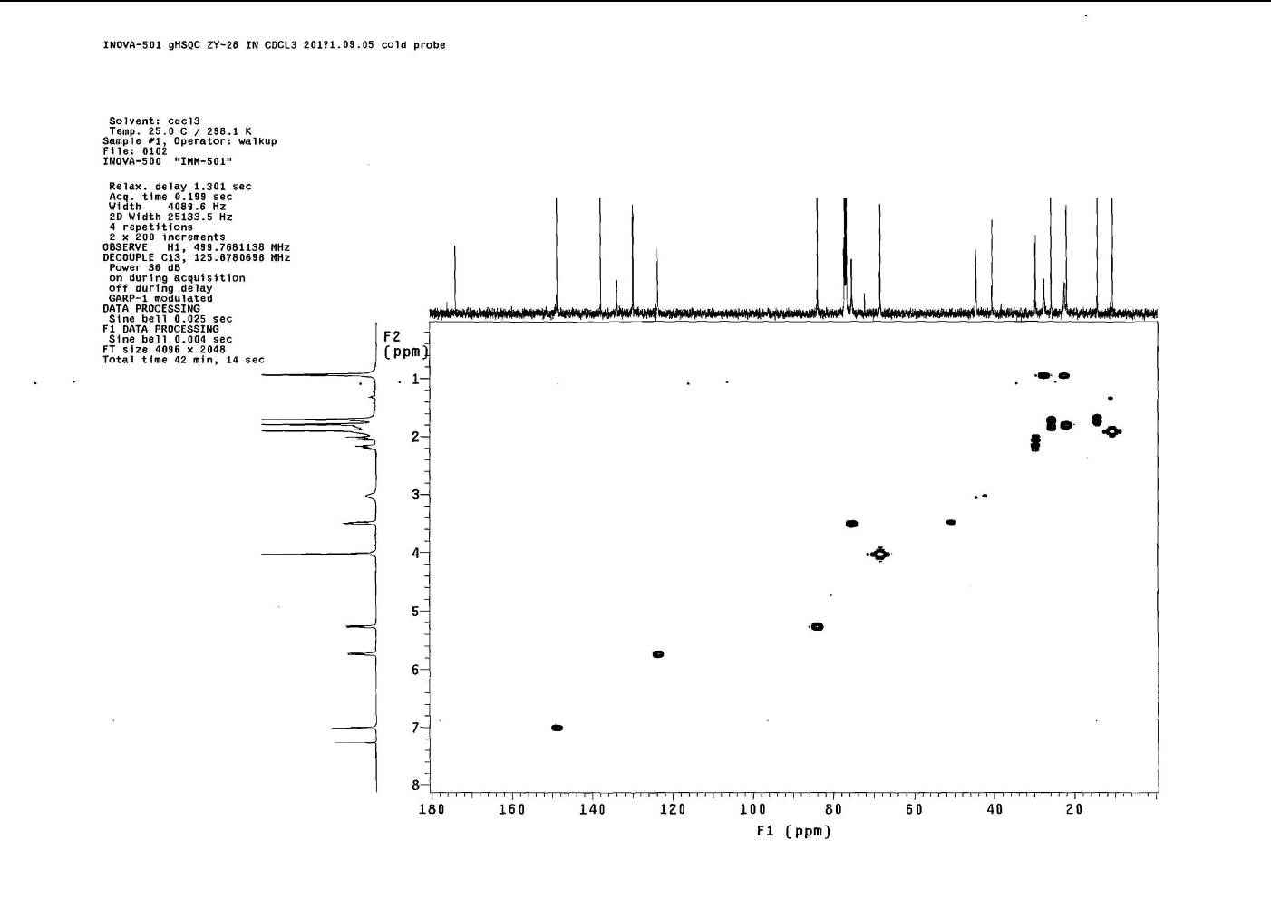



**Figure S7**. The HSQC spectrum of compound **1**



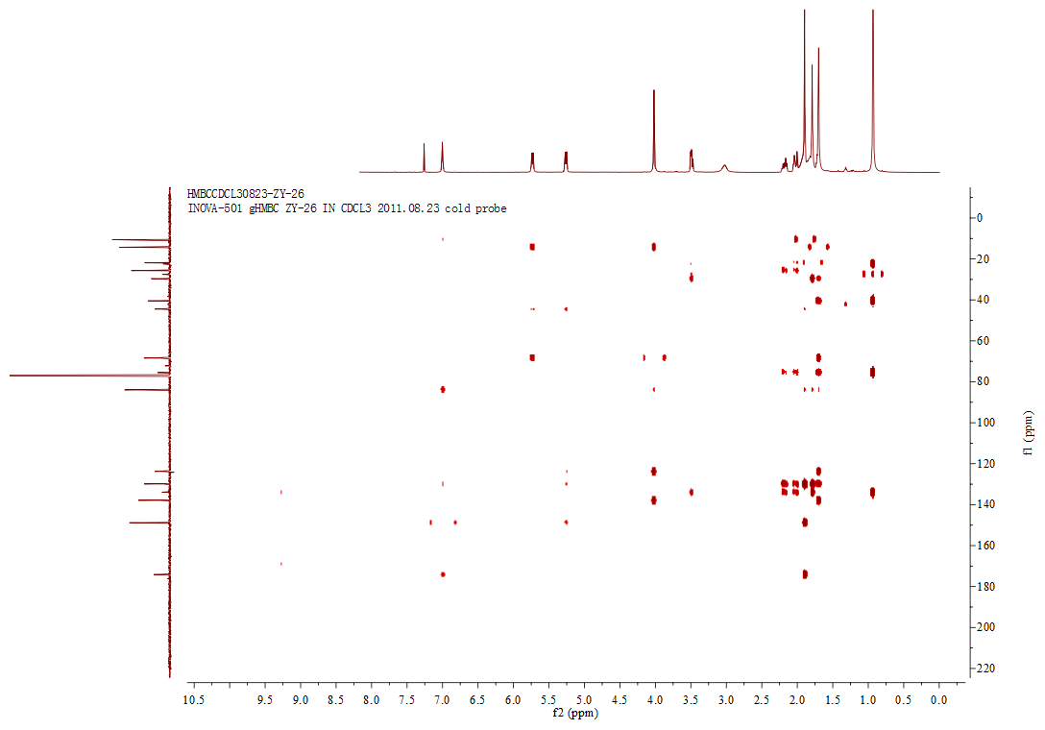

**Figure S8**. The HMBC spectrum of compound **1**

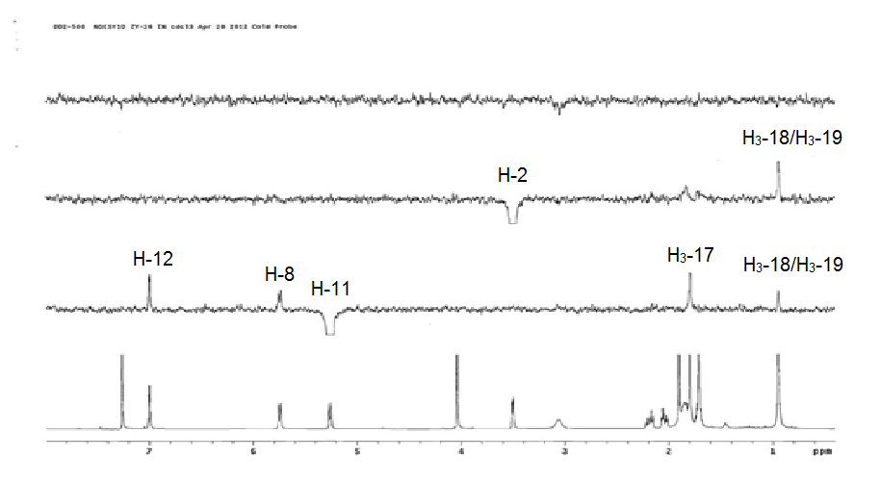



**Figure S9**. The NOE spectrum of compound **1**

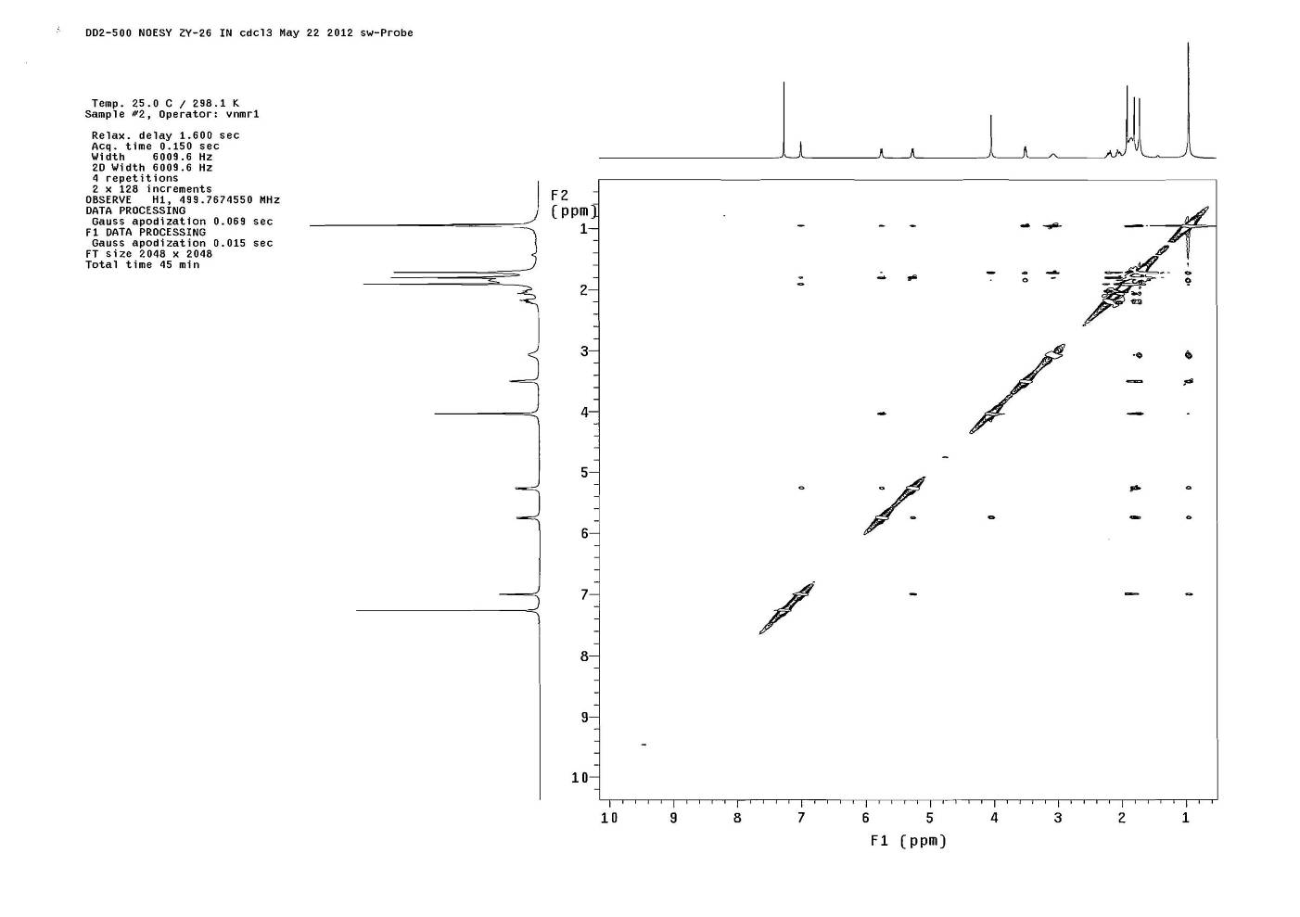

**Figure S10**. The NOESY spectrum of compound **1**

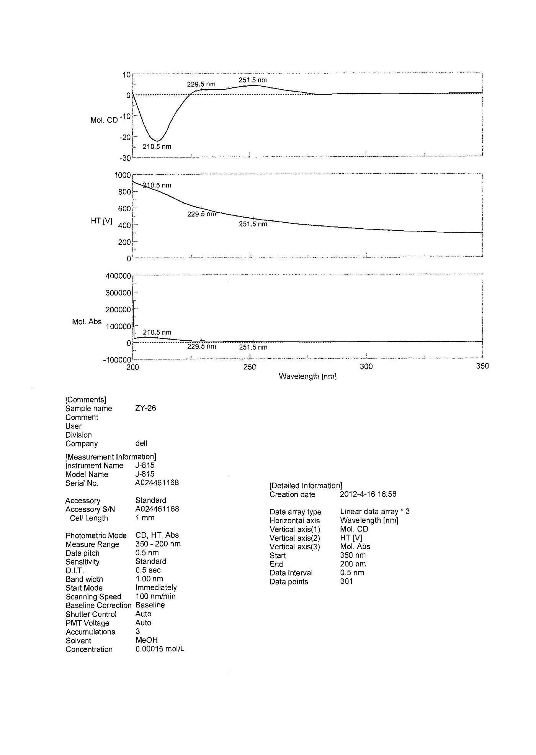

**Figure S11**. The CD spectrum of compound **1**

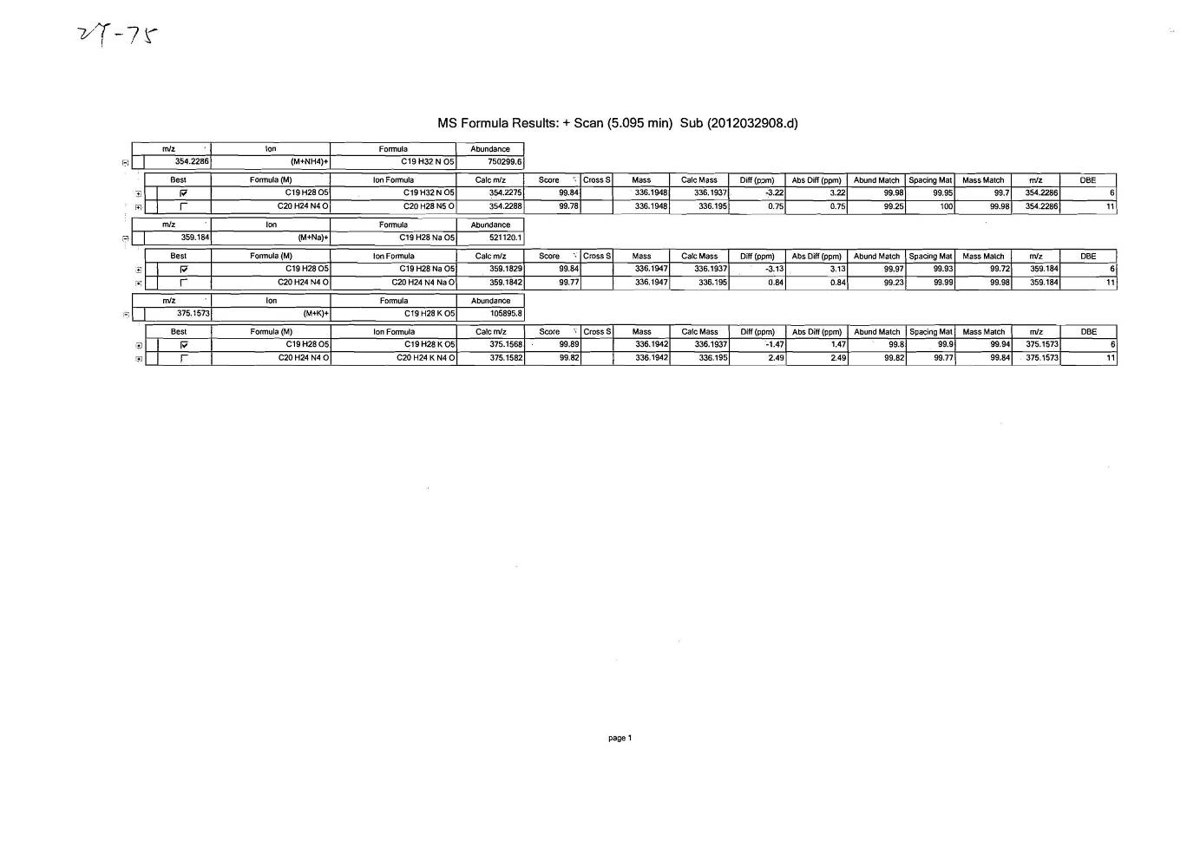

**Figure S12**. The HR ESIMS spectrum of compound **2**

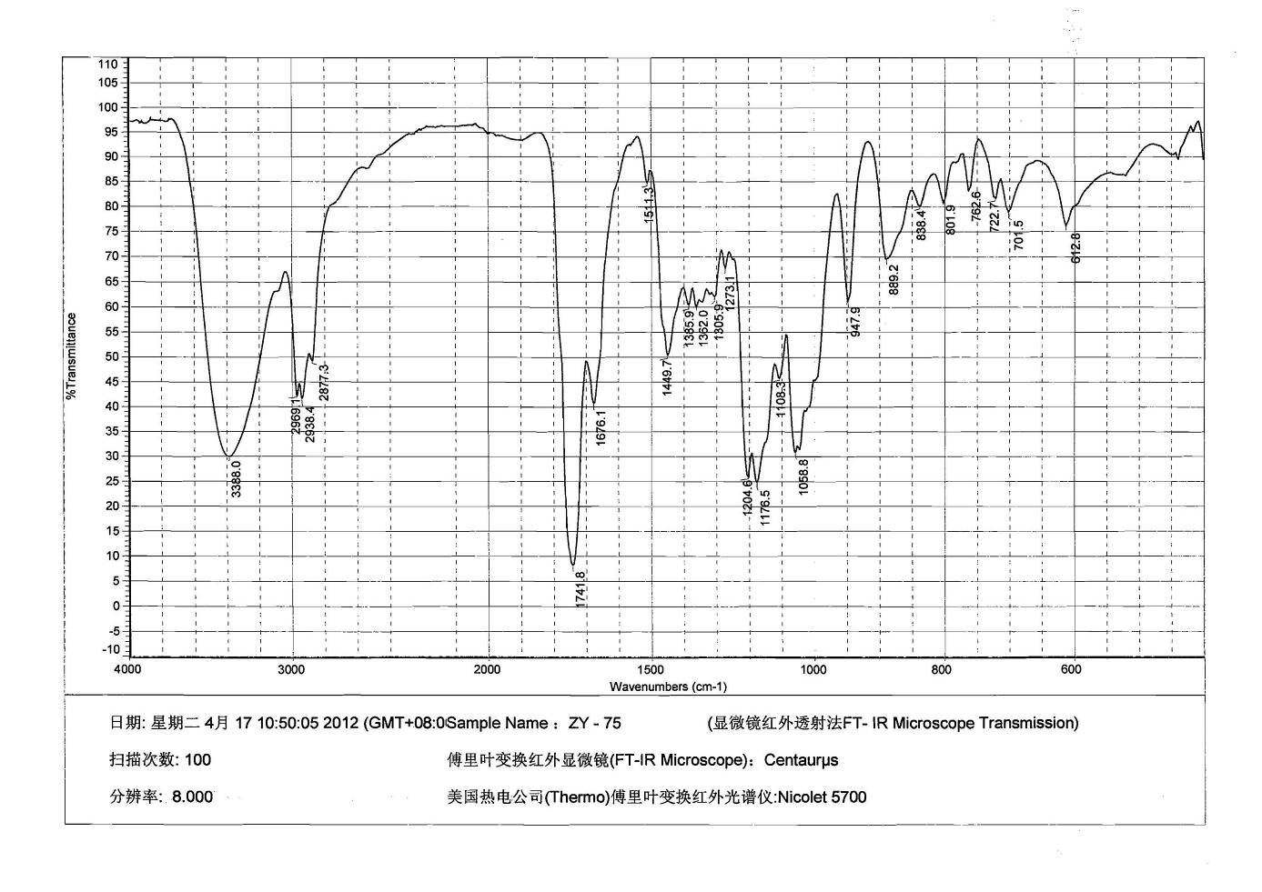

**Figure S13**. The IR spectrum of compound **2**

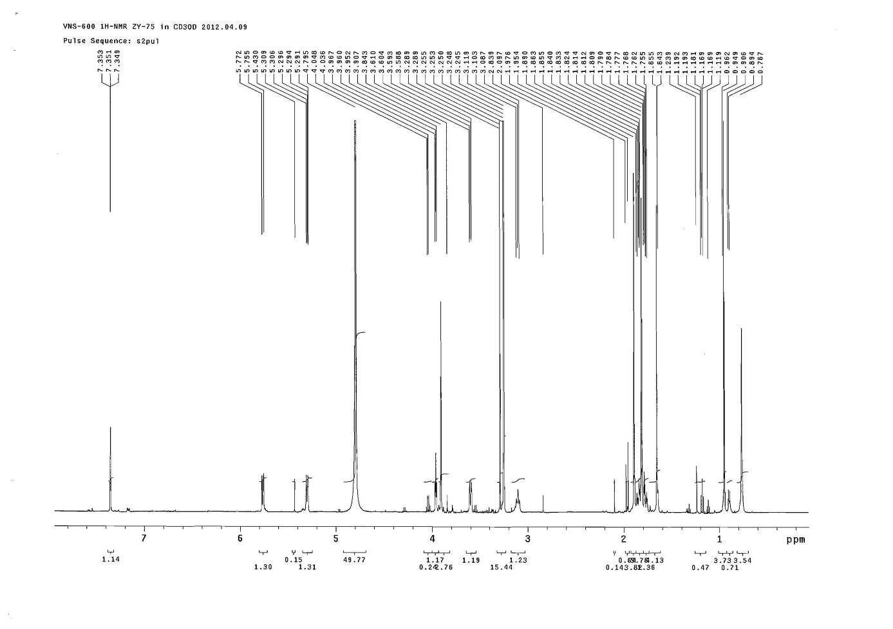



**Figure S14**. The 1HNMR spectrum of compound **2**

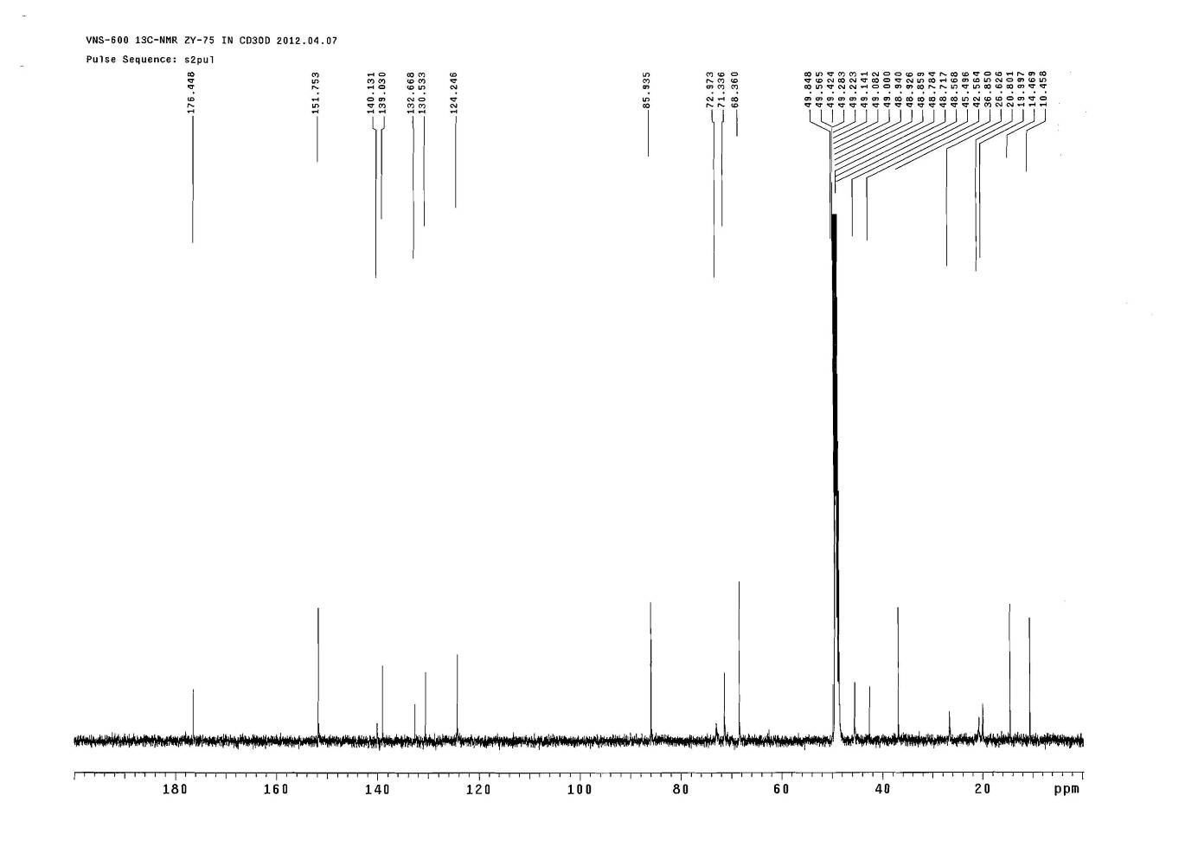



**Figure S15**. The 13CNMR spectrum of compound **2**

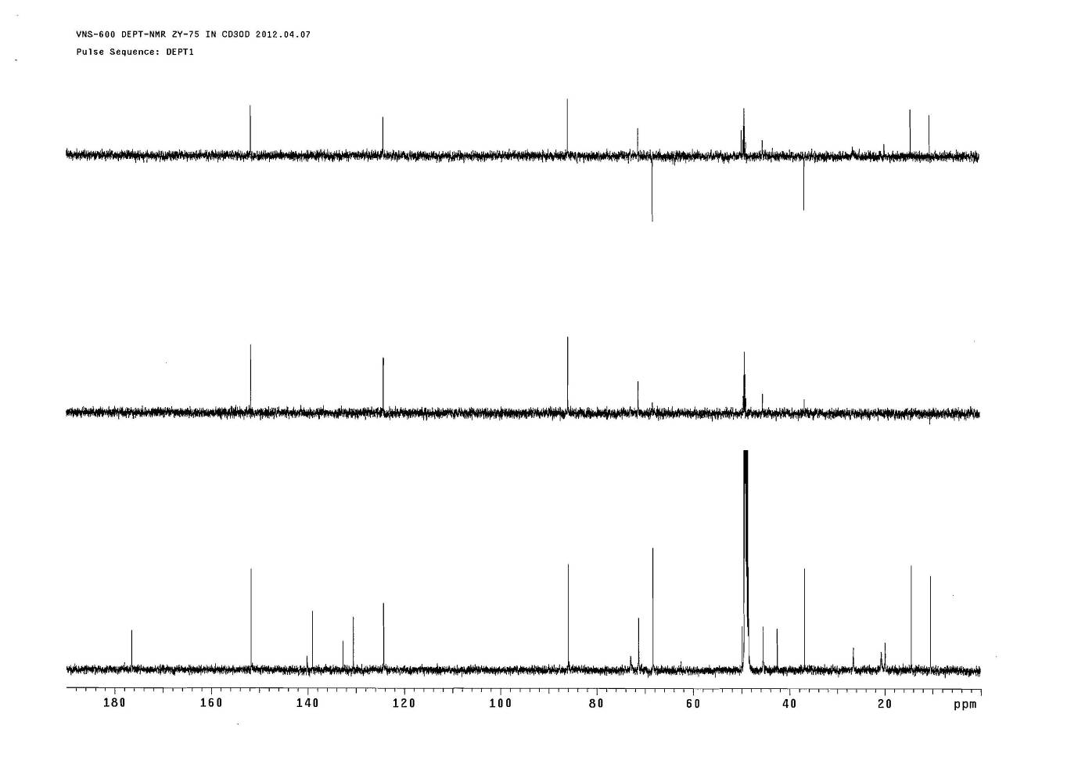



**Figure S16**. The DEPT spectrum of compound **2**

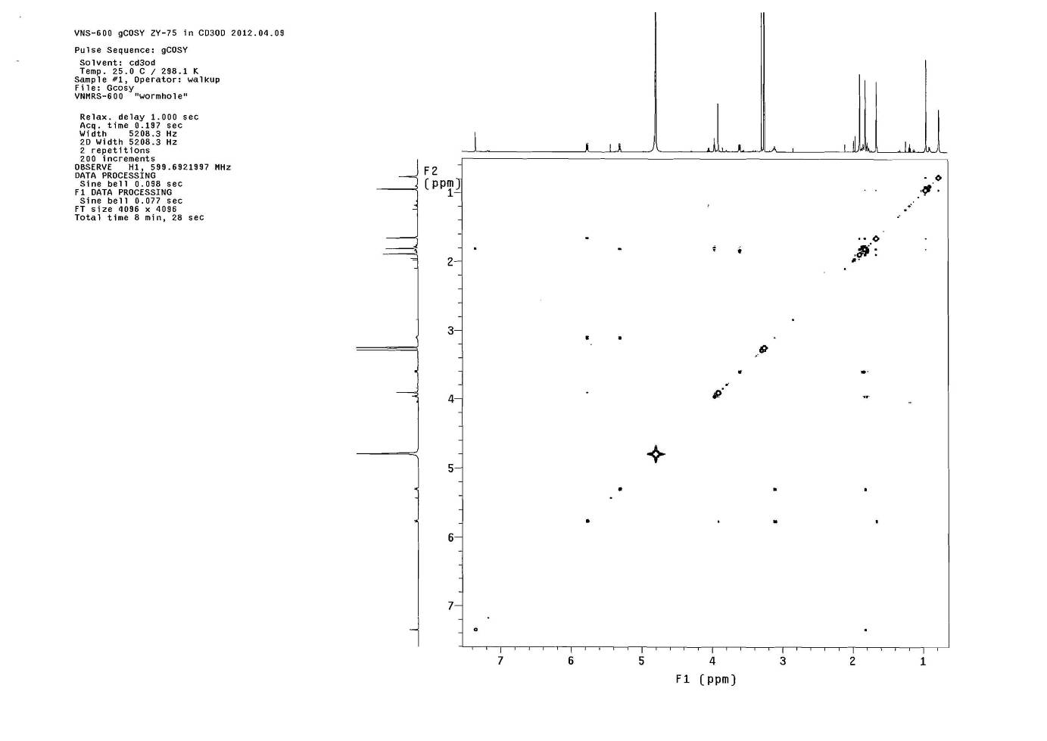



**Figure S17**. The COSY spectrum of compound **2**

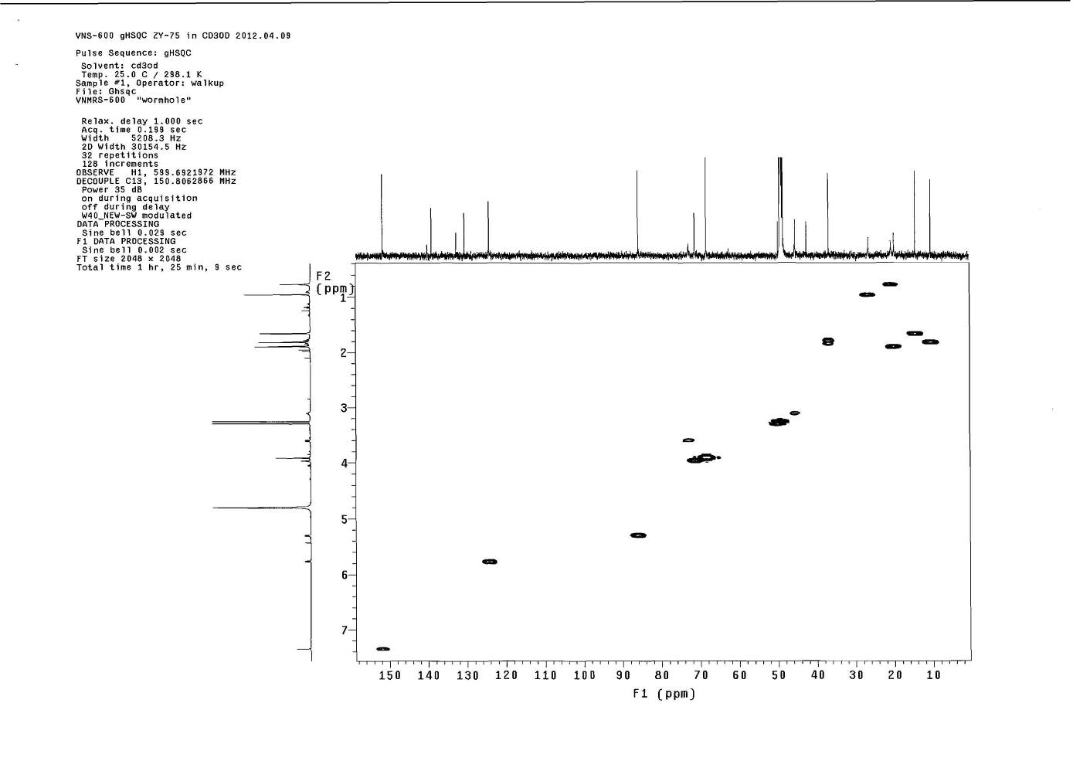



**Figure S18**. The HSQC spectrum of compound **2**

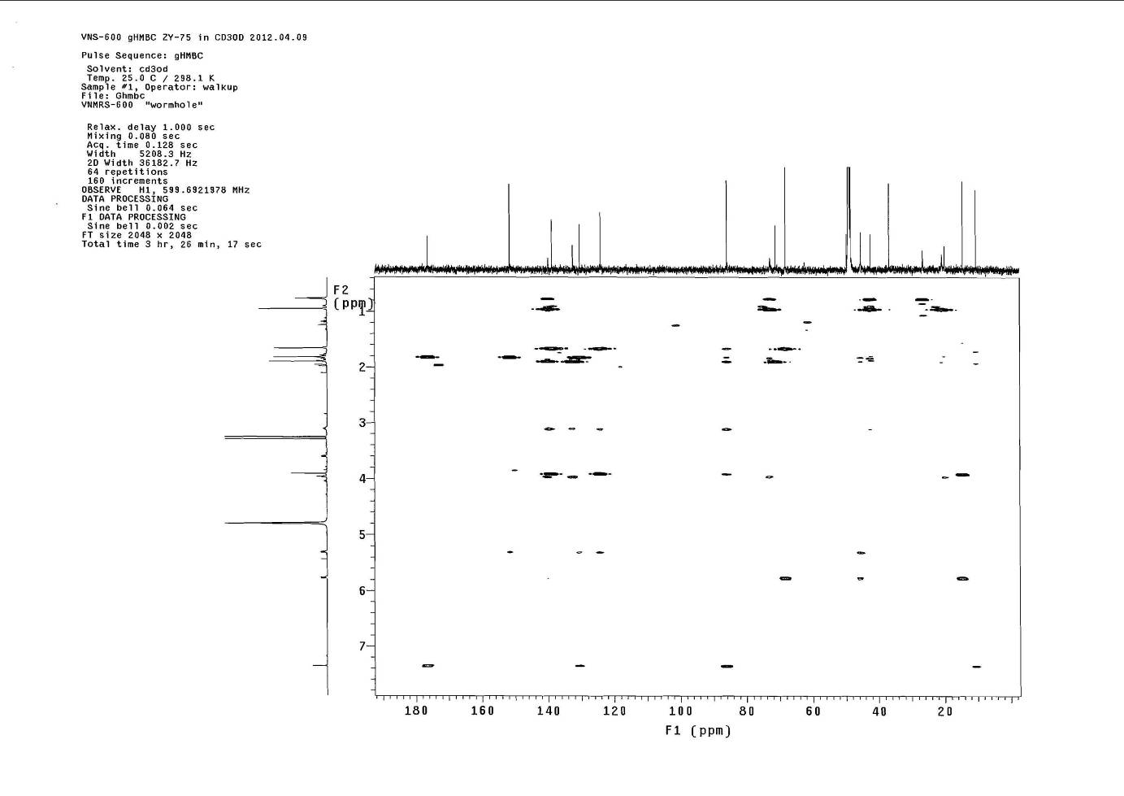



**Figure S19**. The HMBC spectrum of compound **2**

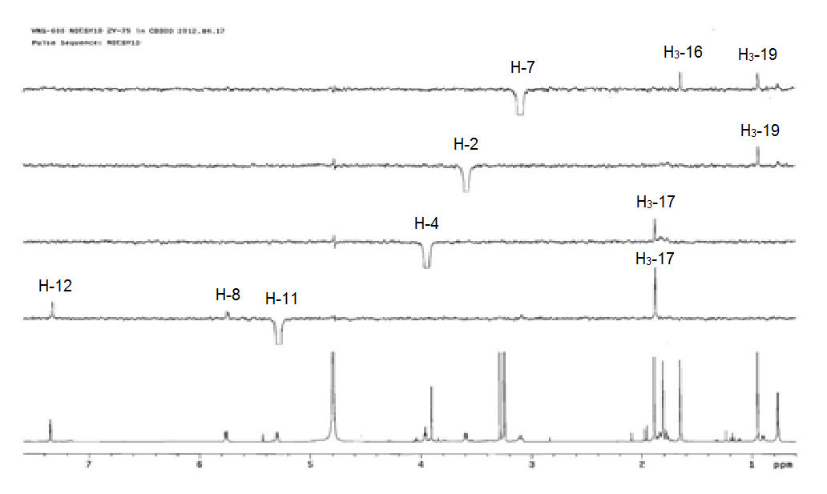



**Figure S20**. The NOE spectrum of compound **2**

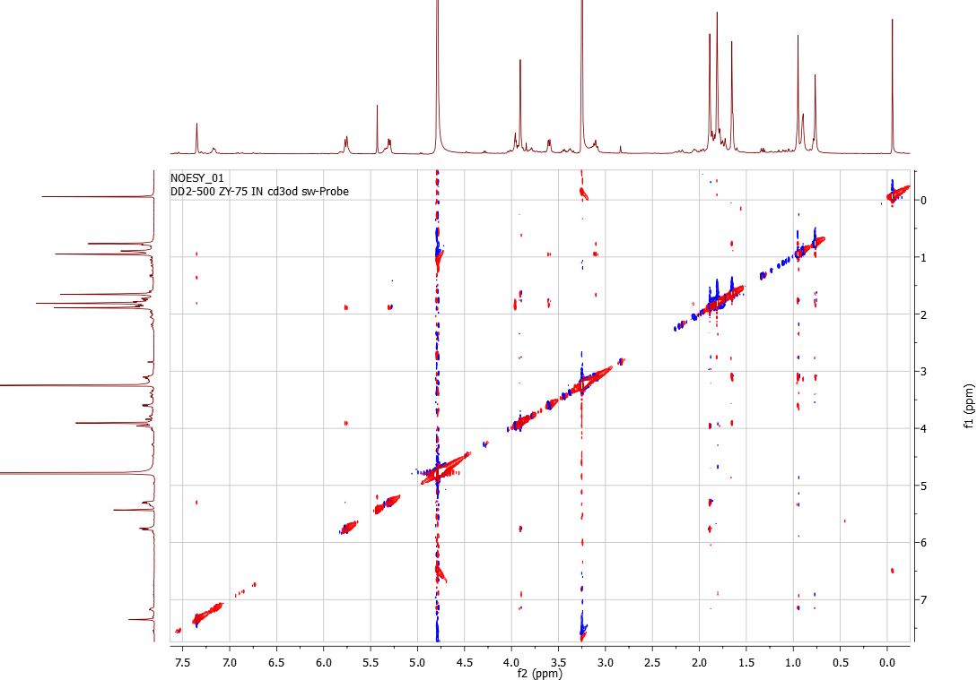

**Figure S21**. The NOESY spectrum of compound **2**

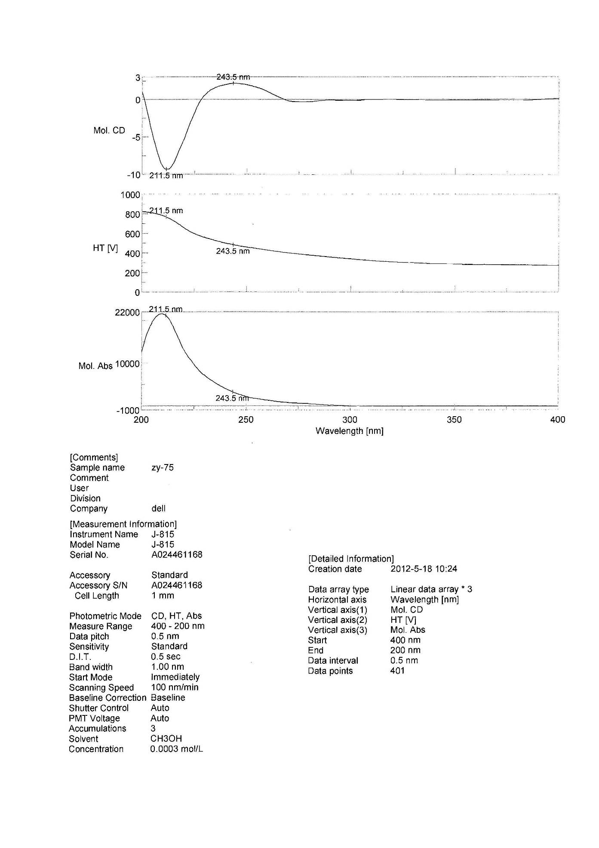



**Figure S22**. The CD spectrum of compound **2**

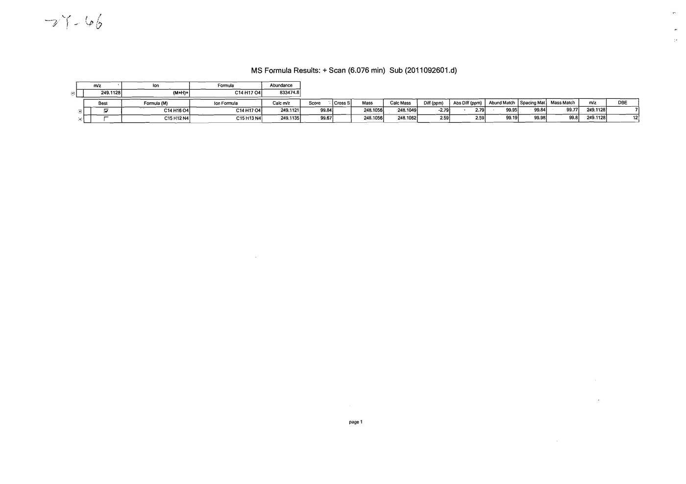

**Figure S23**. The HR ESIMS spectrum of compound **3**

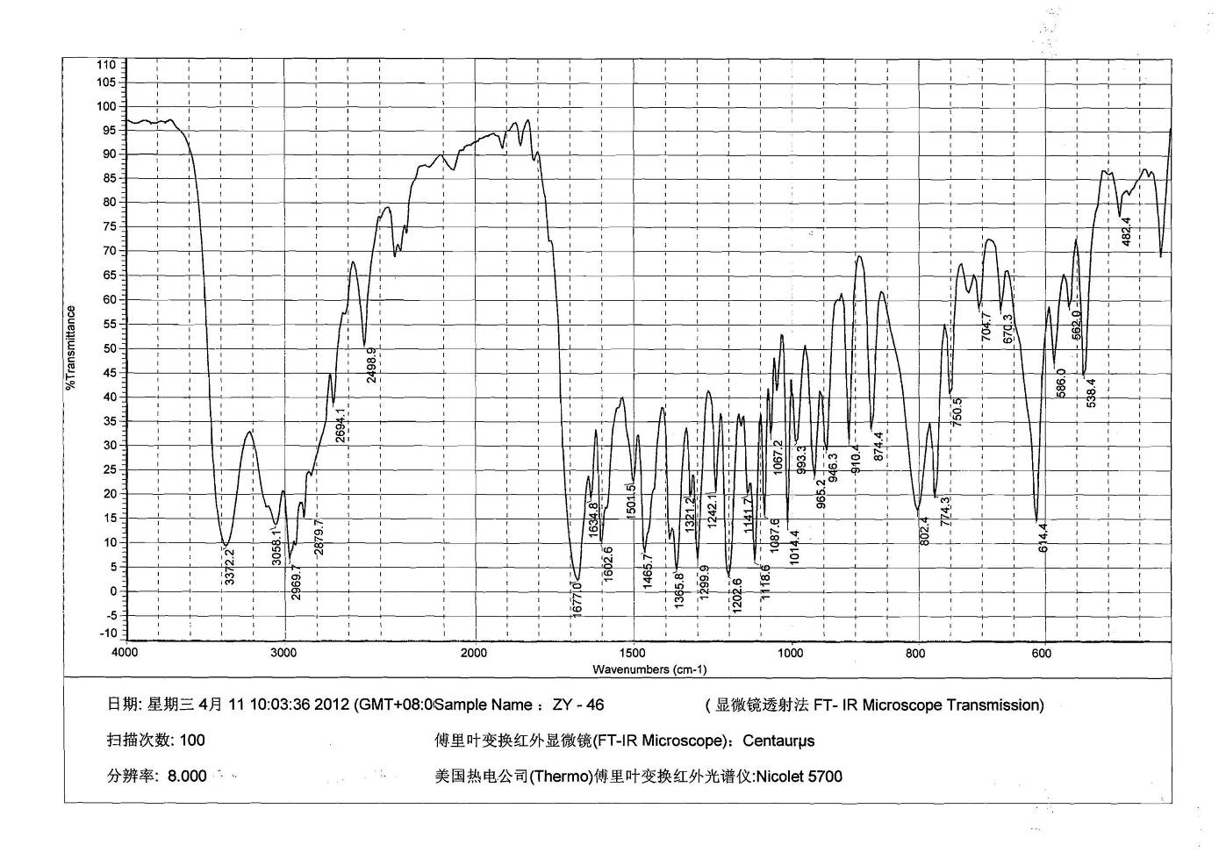

**Figure S24**. The IR spectrum of compound **3**

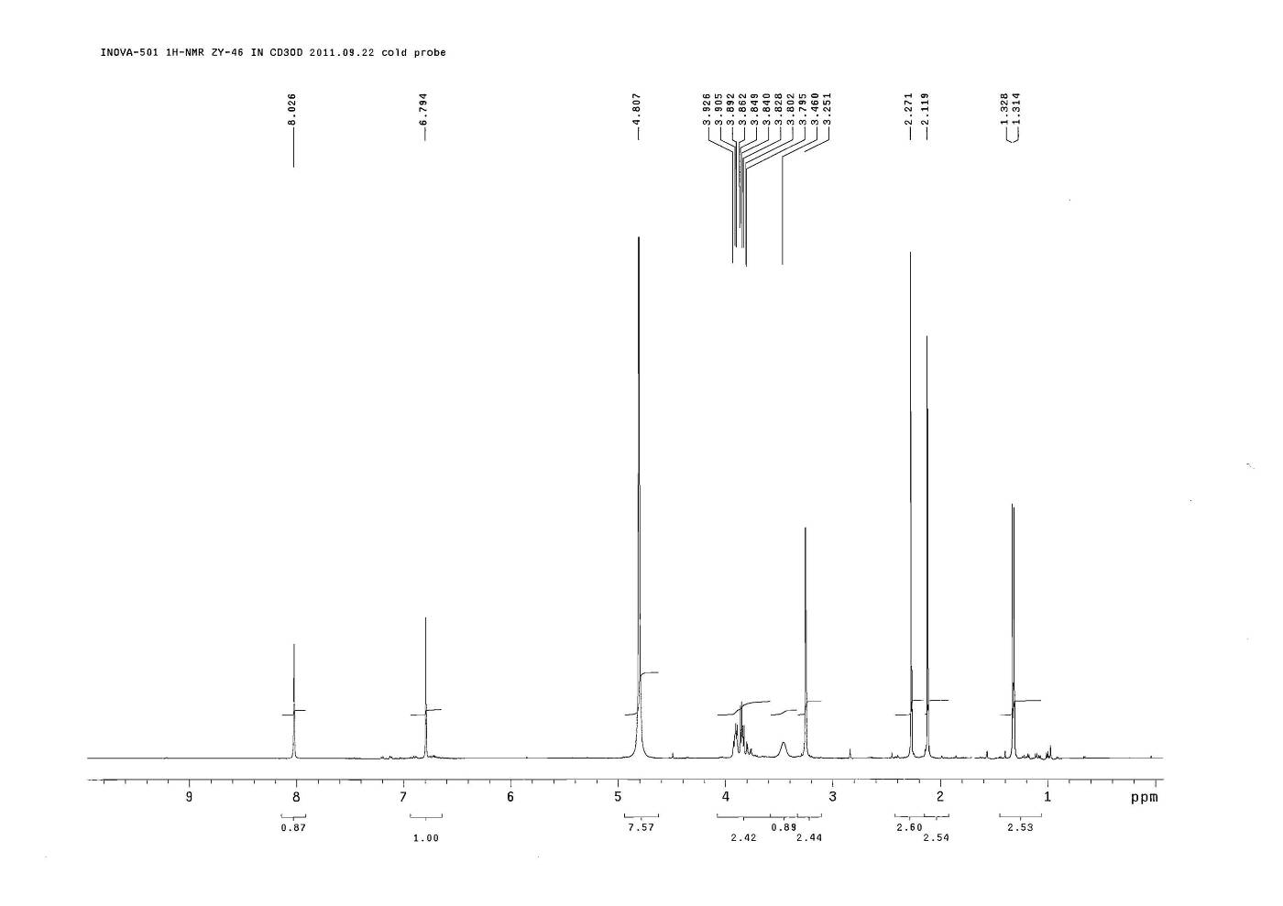



**Figure S25**. The 1HNMR spectrum of compound **3**

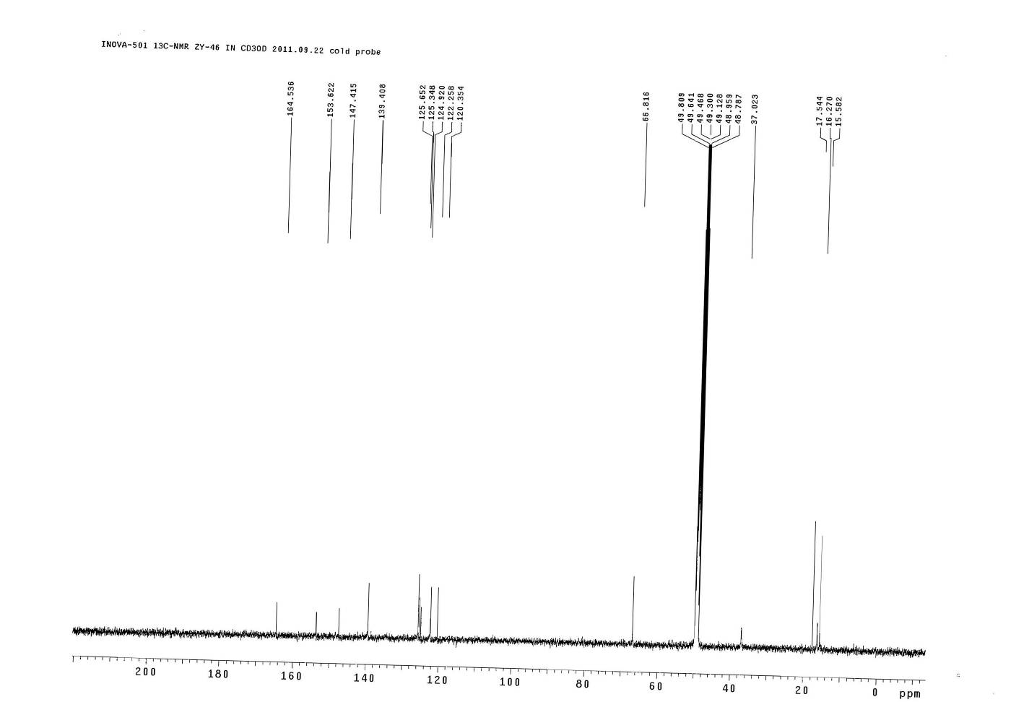



**Figure S26**. The 1CNMR spectrum of compound **3**

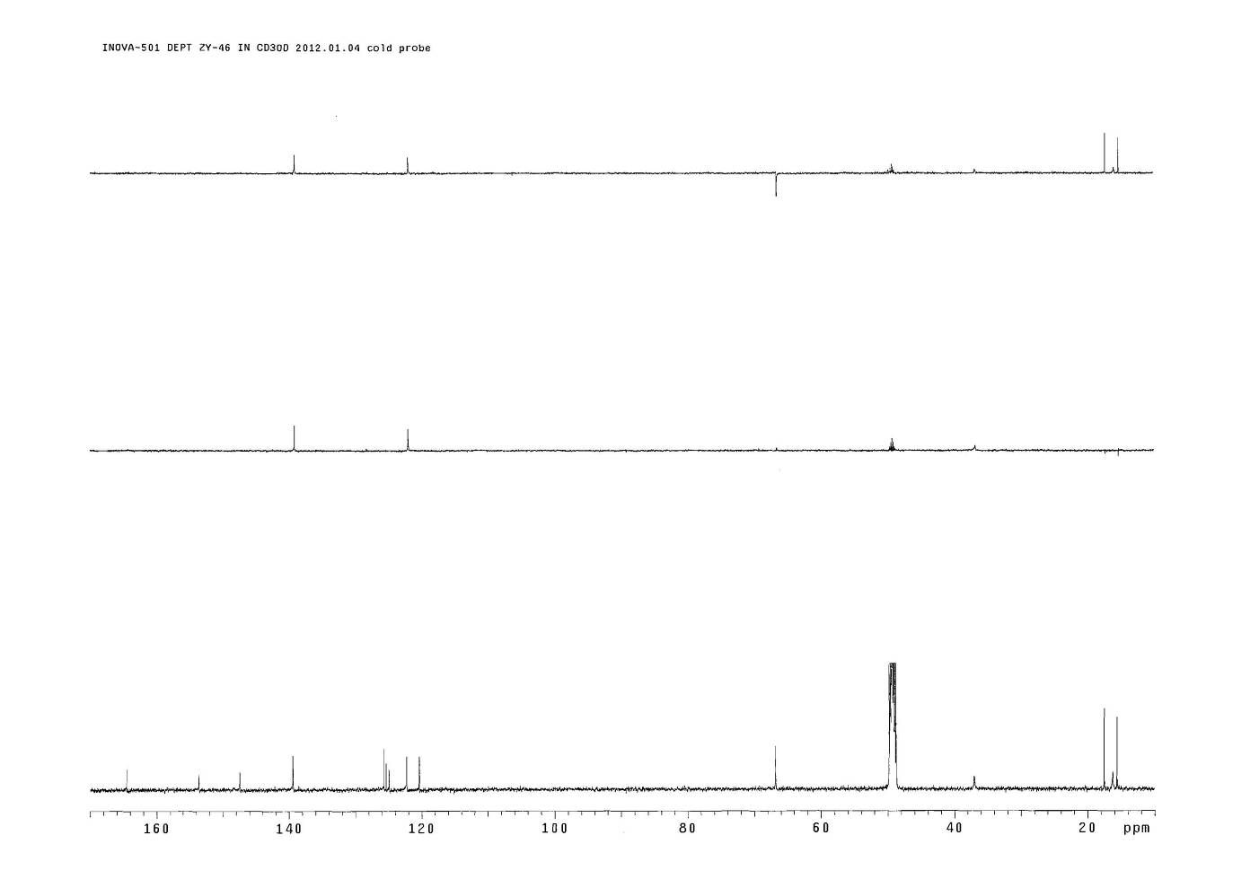



**Figure S27**. The DEPT spectrum of compound **3**

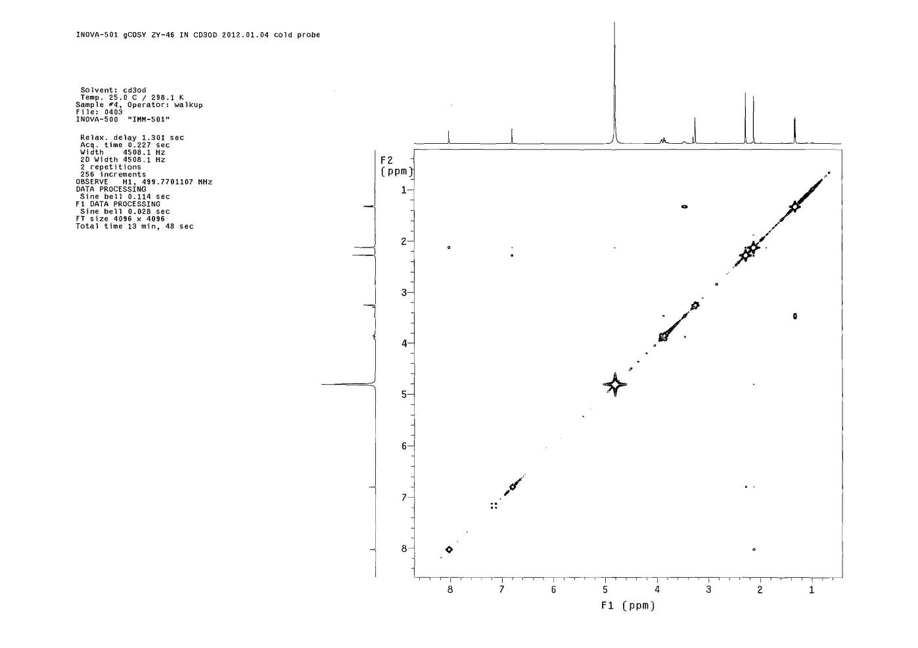



**Figure S28**. The COSY spectrum of compound **3**



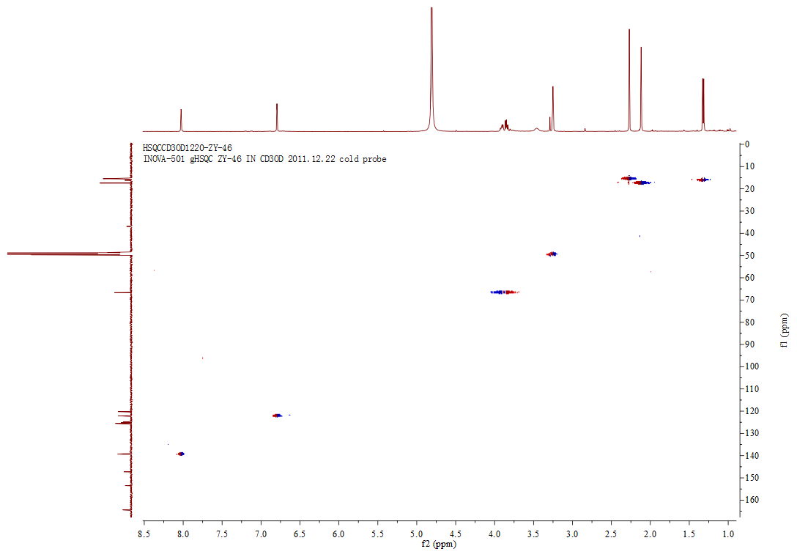

**Figure S29**. The HSQC spectrum of compound **3**



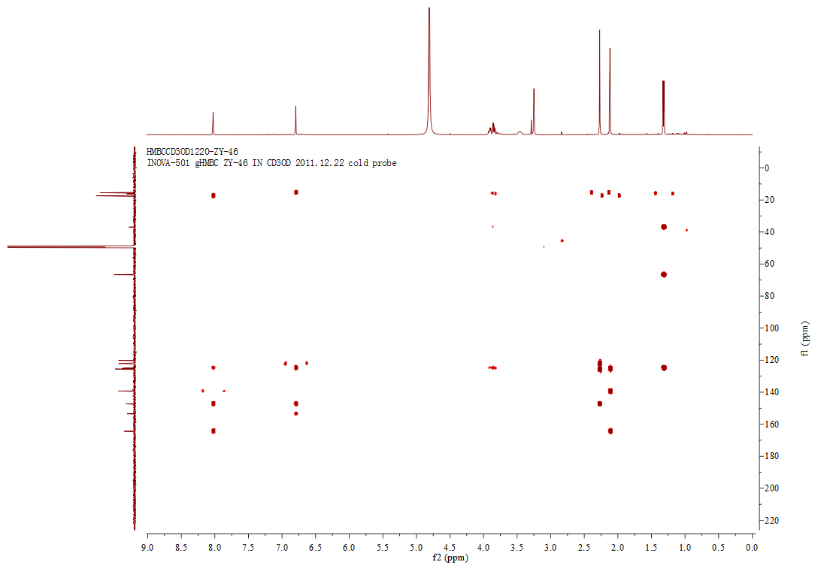

**Figure S30**. The HMBC spectrum of compound **3**

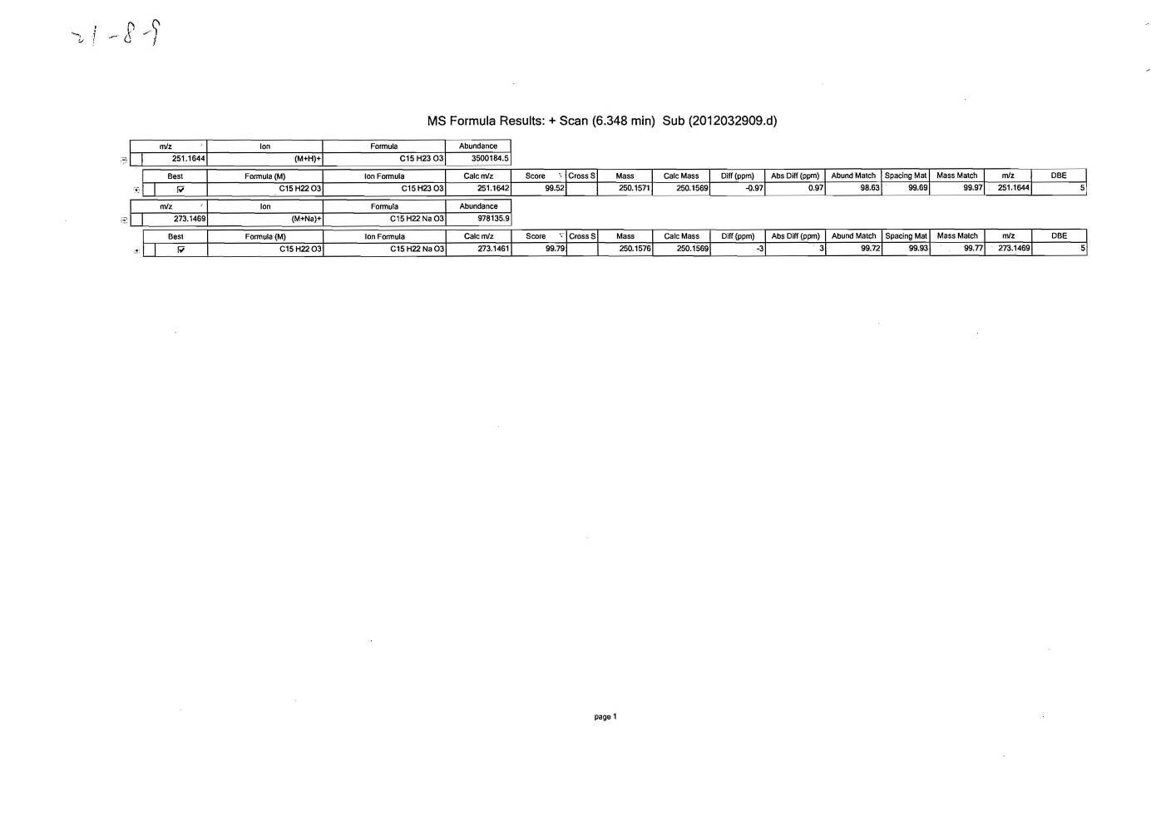

**Figure S31**. The HRESIMS spectrum of compound **4**

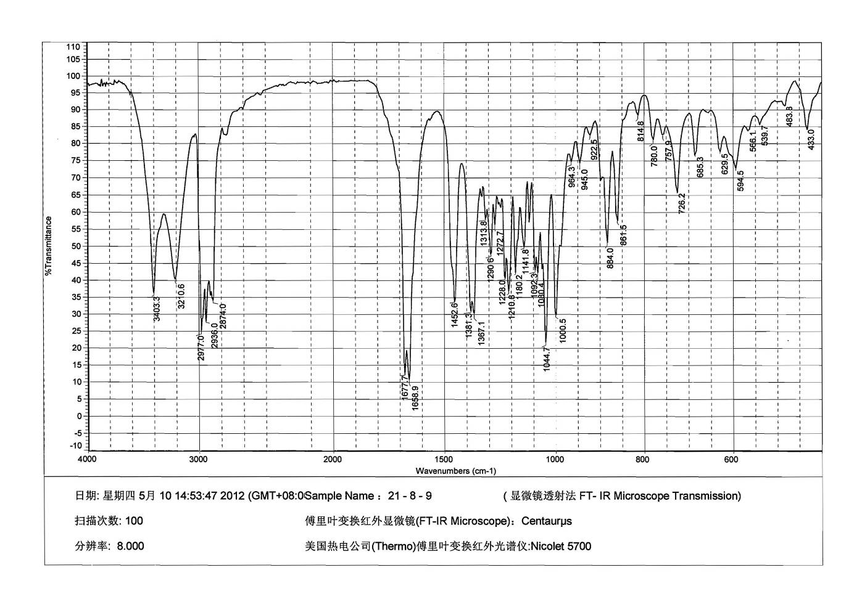

**Figure S32**. The IR spectrum of compound **4**

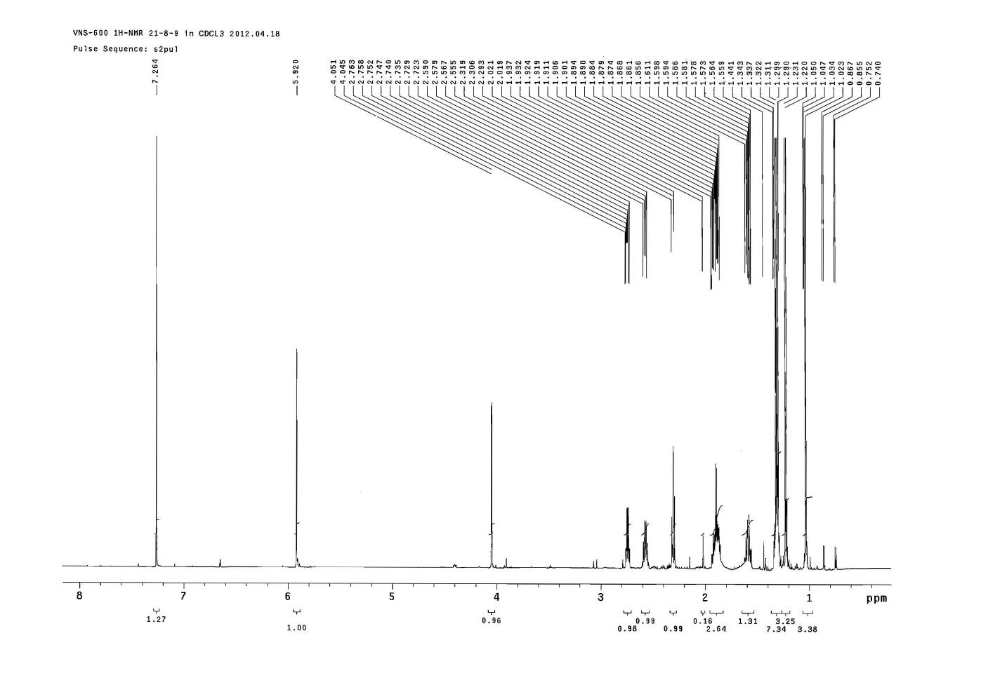



**Figure S33**. The 1HNMR spectrum of compound **4**

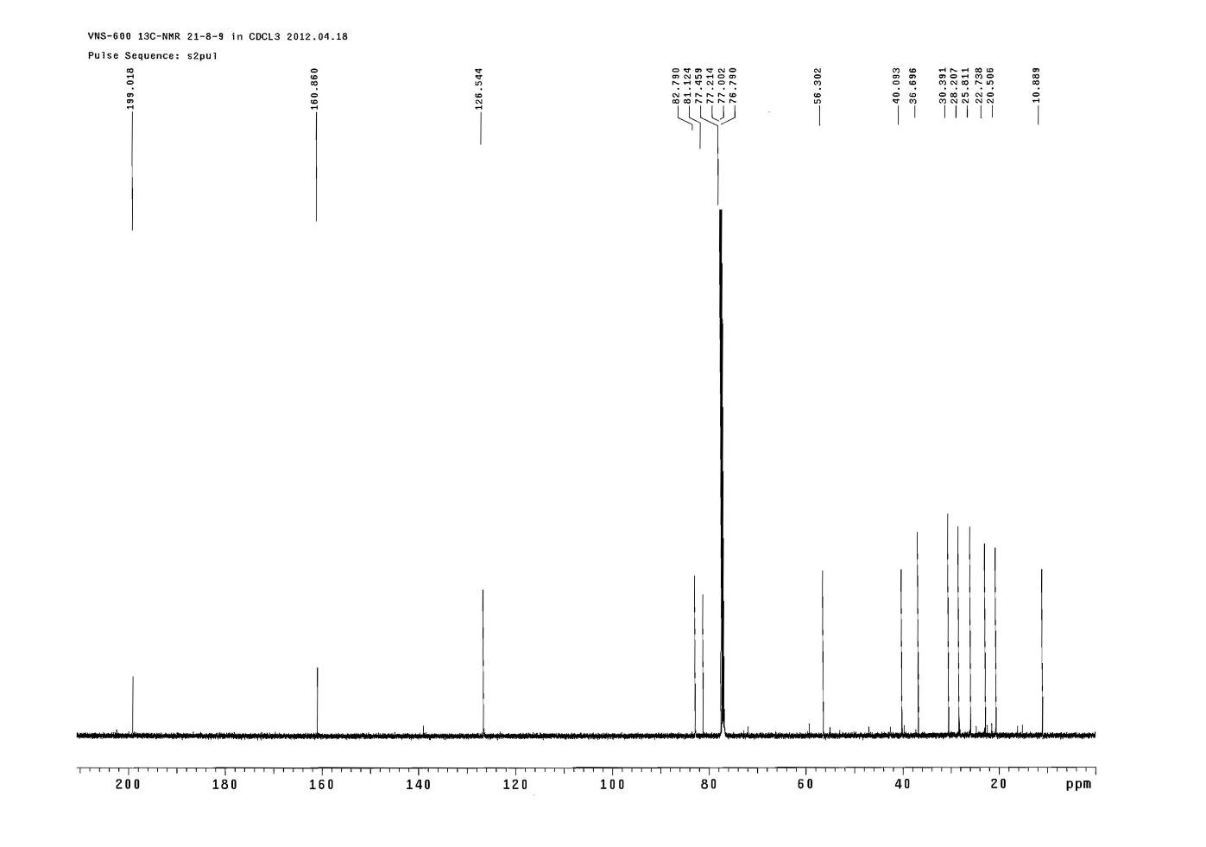



**Figure S34**. The 13CNMR spectrum of compound **4**

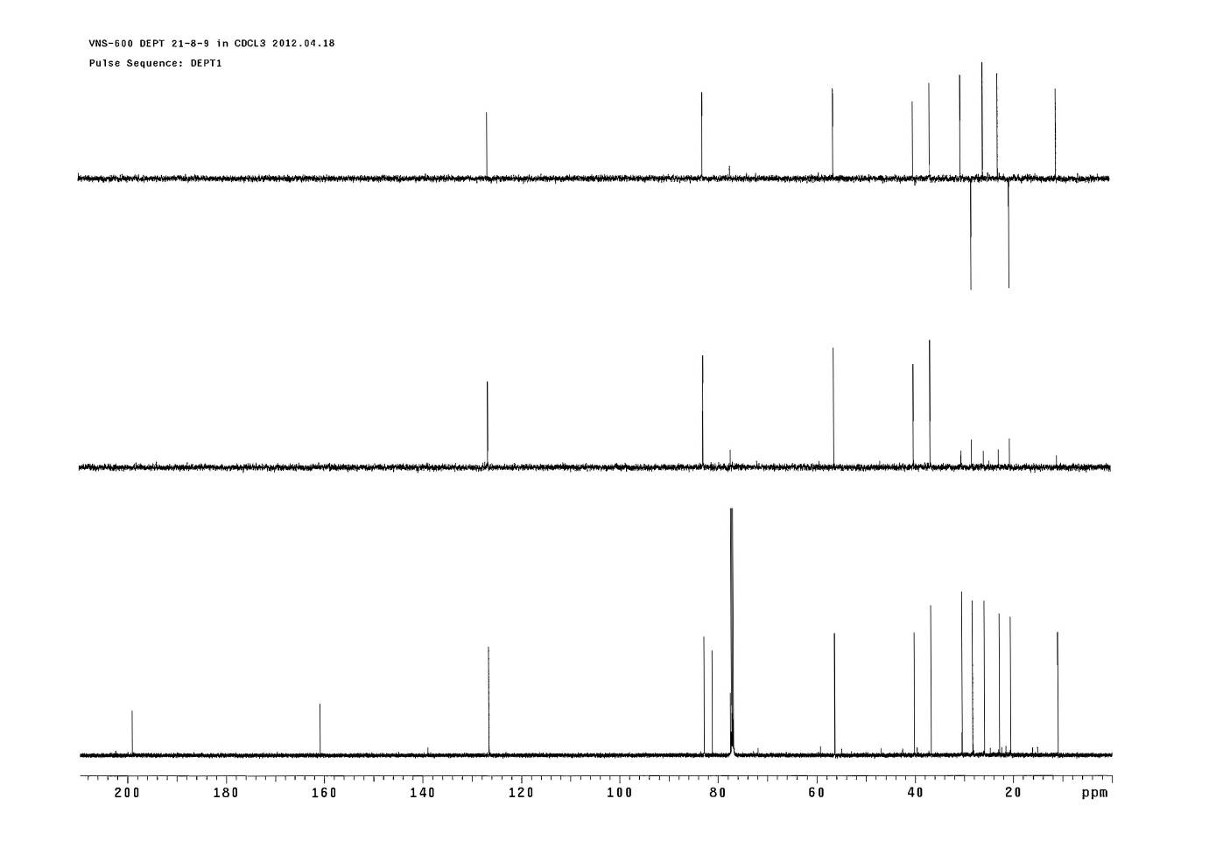



**Figure S35**. The DEPT spectrum of compound **4**

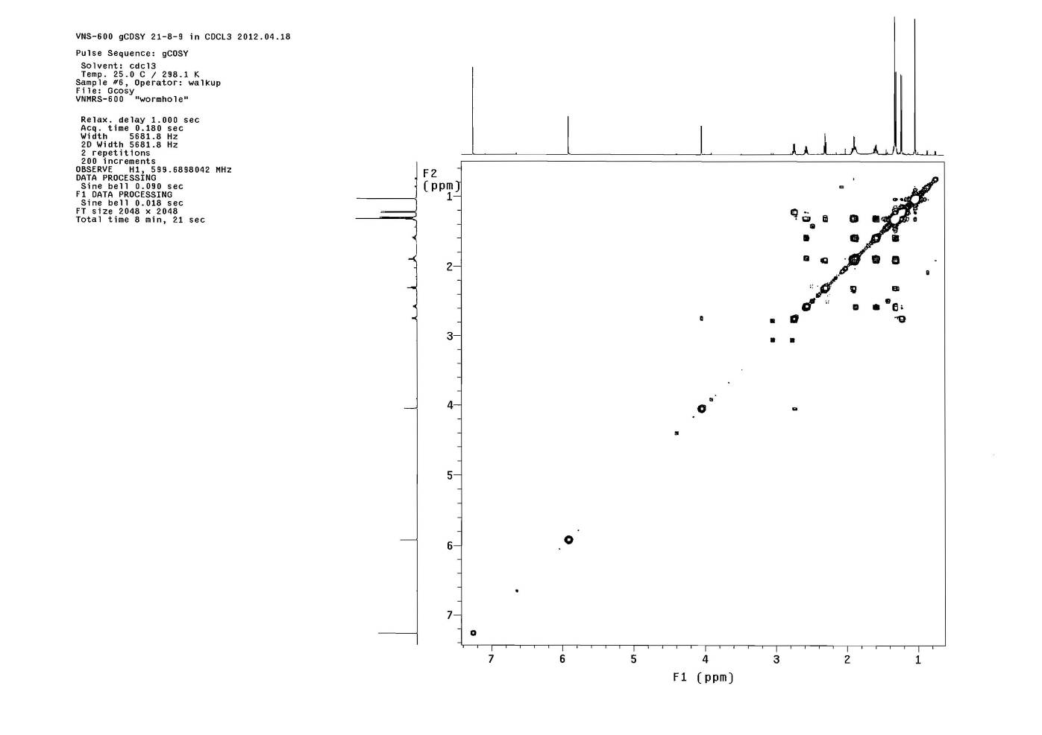



**Figure S36**. The COSY spectrum of compound **4**

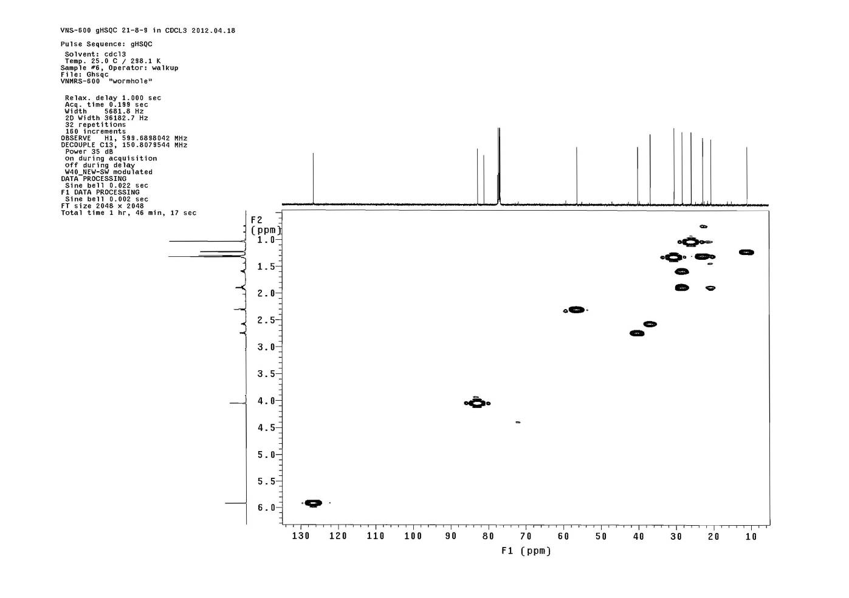



**Figure S37**. The HSQC spectrum of compound **4**

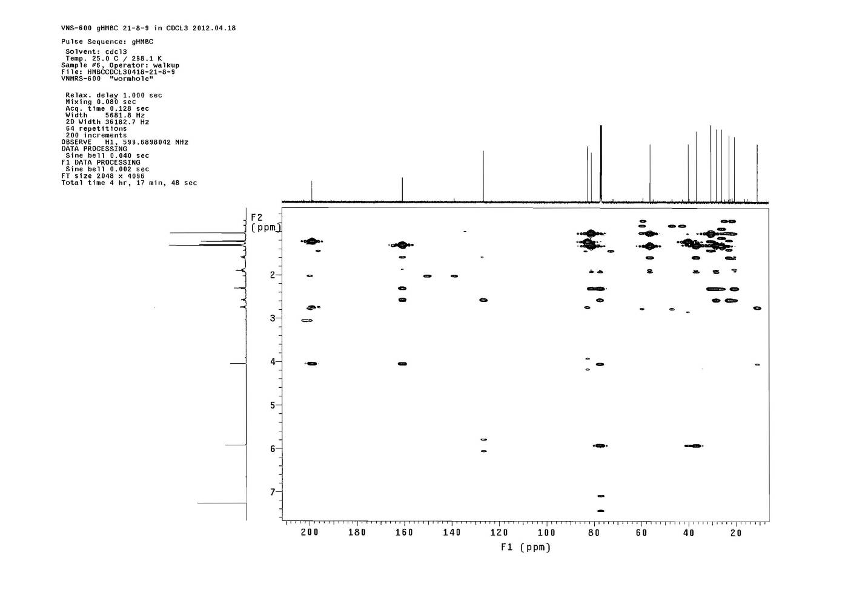



**Figure 38**. The HMBC spectrum of compound **4**

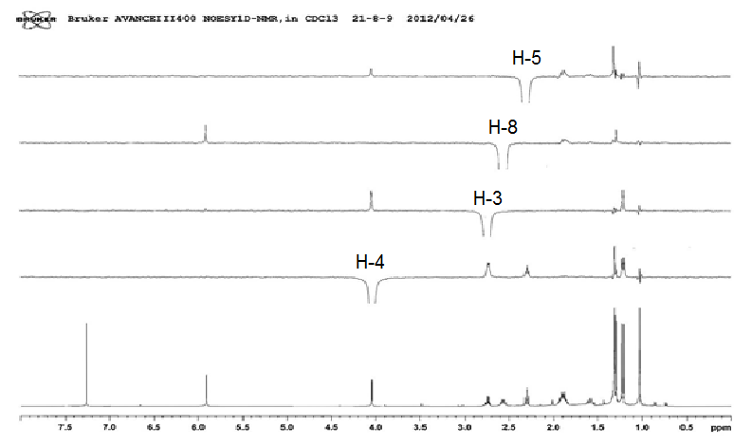

Me-14

Me-15

Me-15

H-1



**Figure S39**. The NOE spectrum of compound **4**

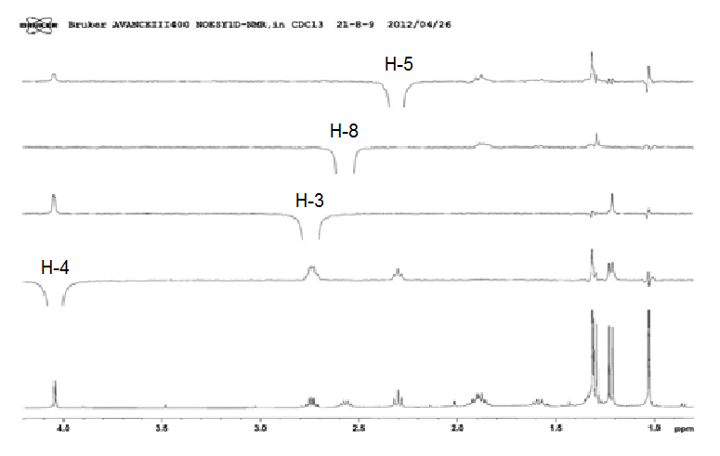

**Figure S40**. The NOE spectrum of compound **4**

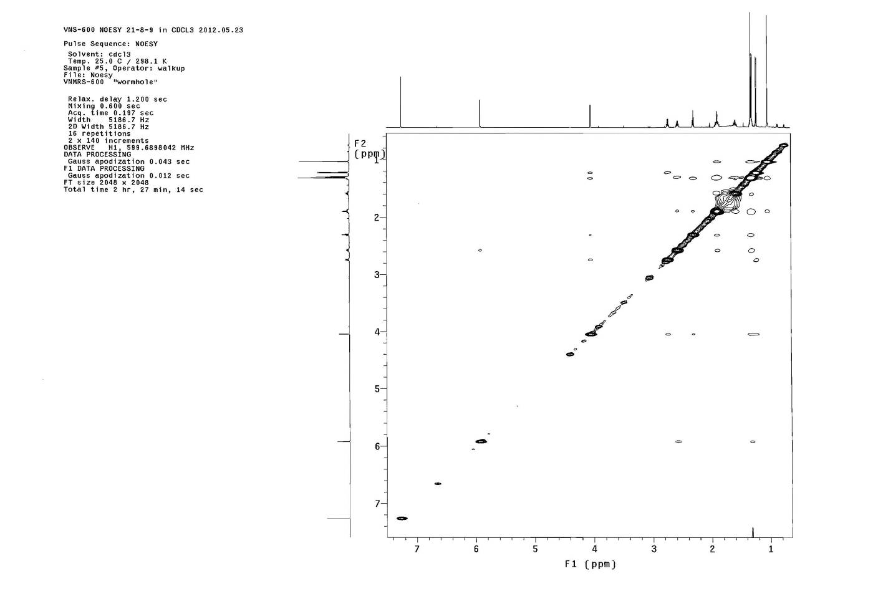



**Figure S41**. The NOESY spectrum of compound **4**



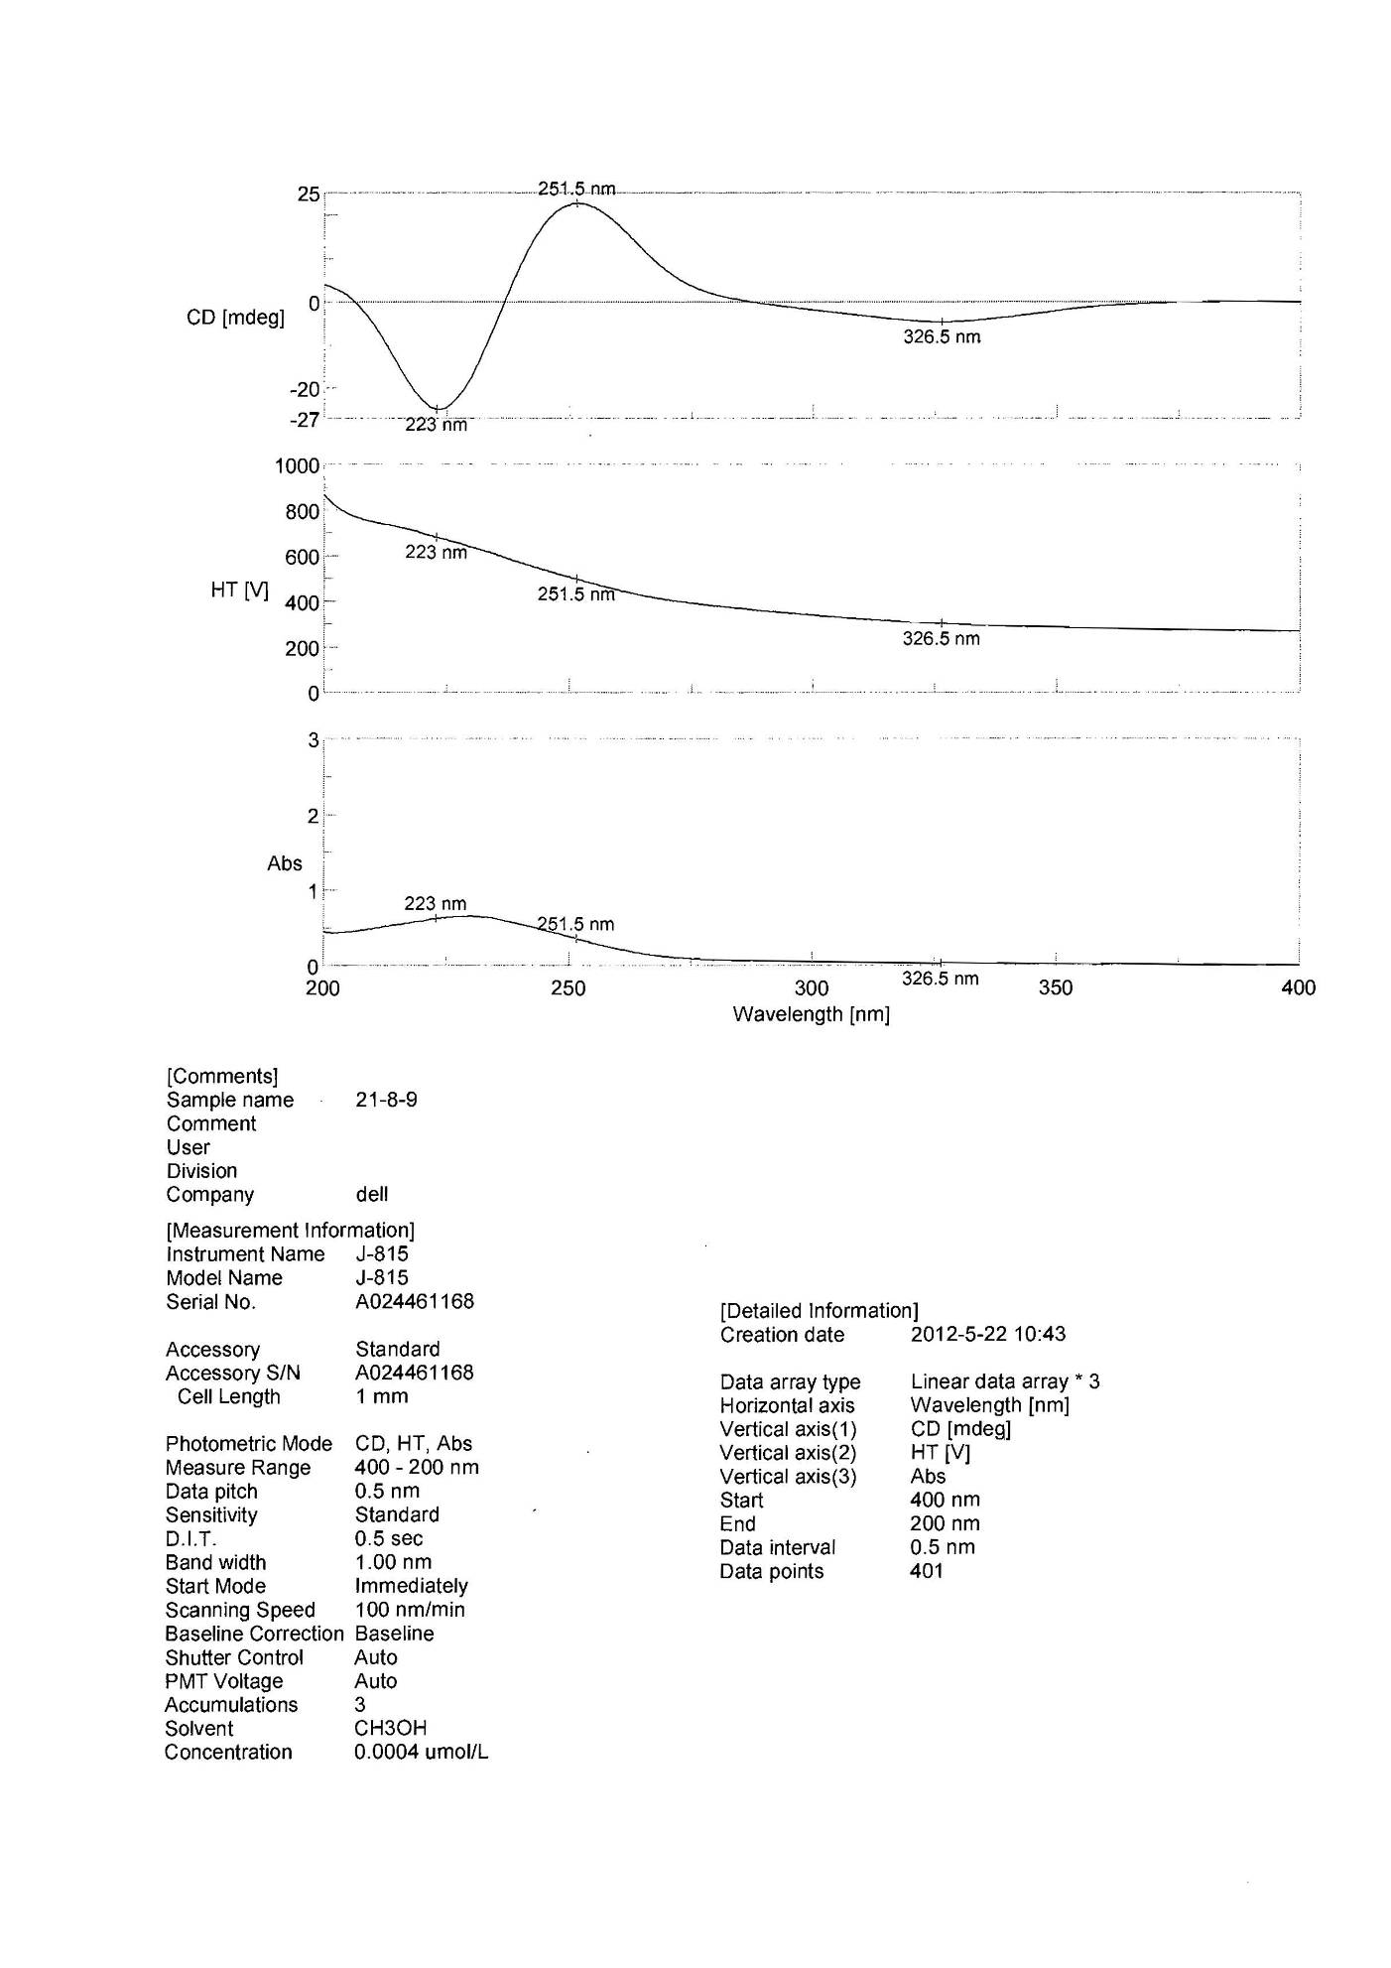

**Figure S42**. The CD spectrum of compound **4**

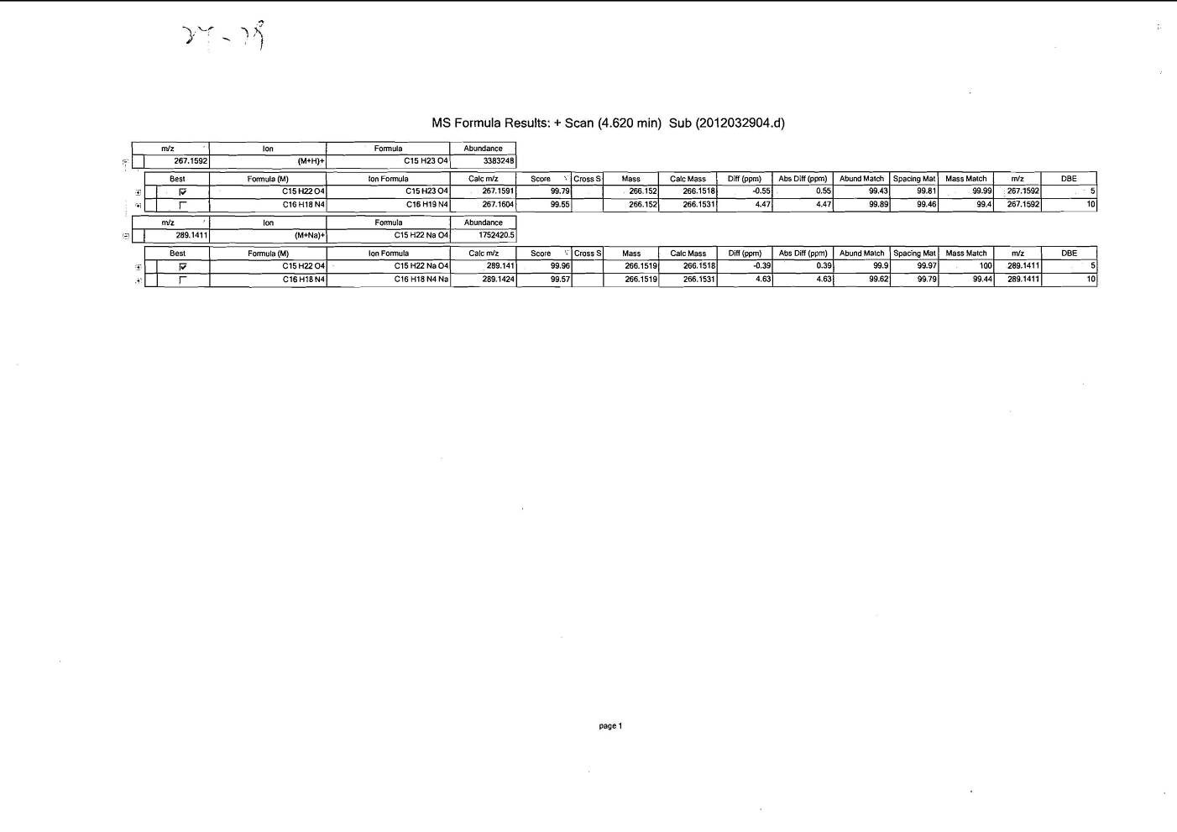

**Figure S43**. The HRESIMS spectrum of compound **5**

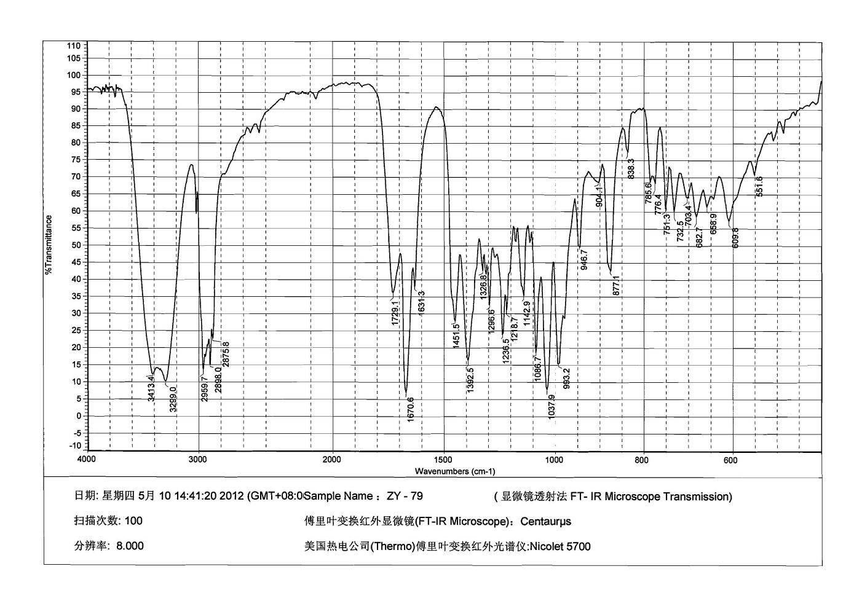

**Figure S44**. The IR spectrum of compound **5**

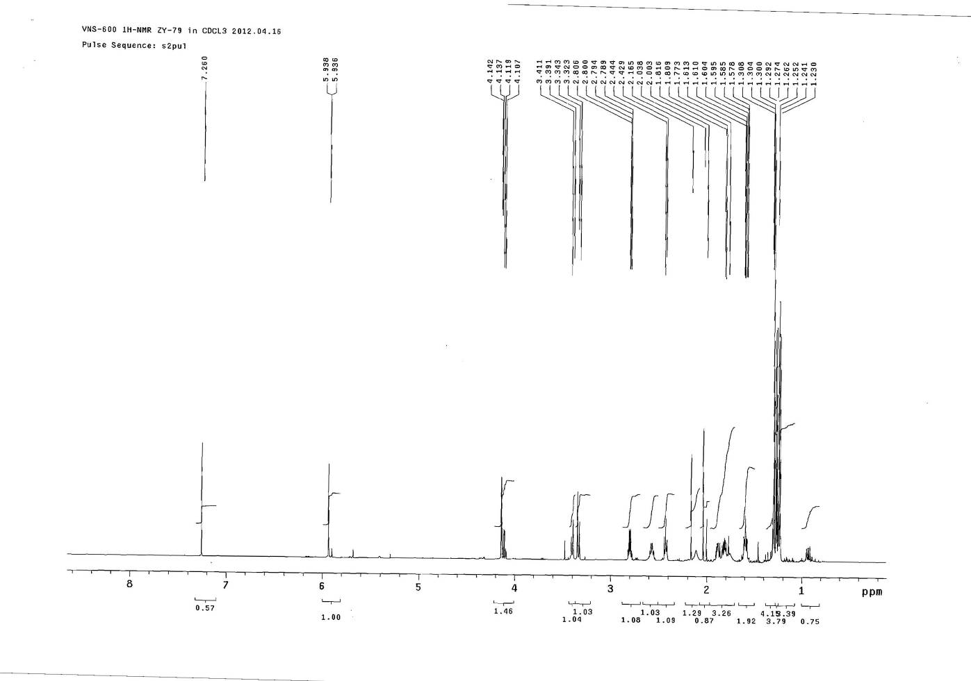



**Figure S45**. The 1HNMR spectrum of compound **5**

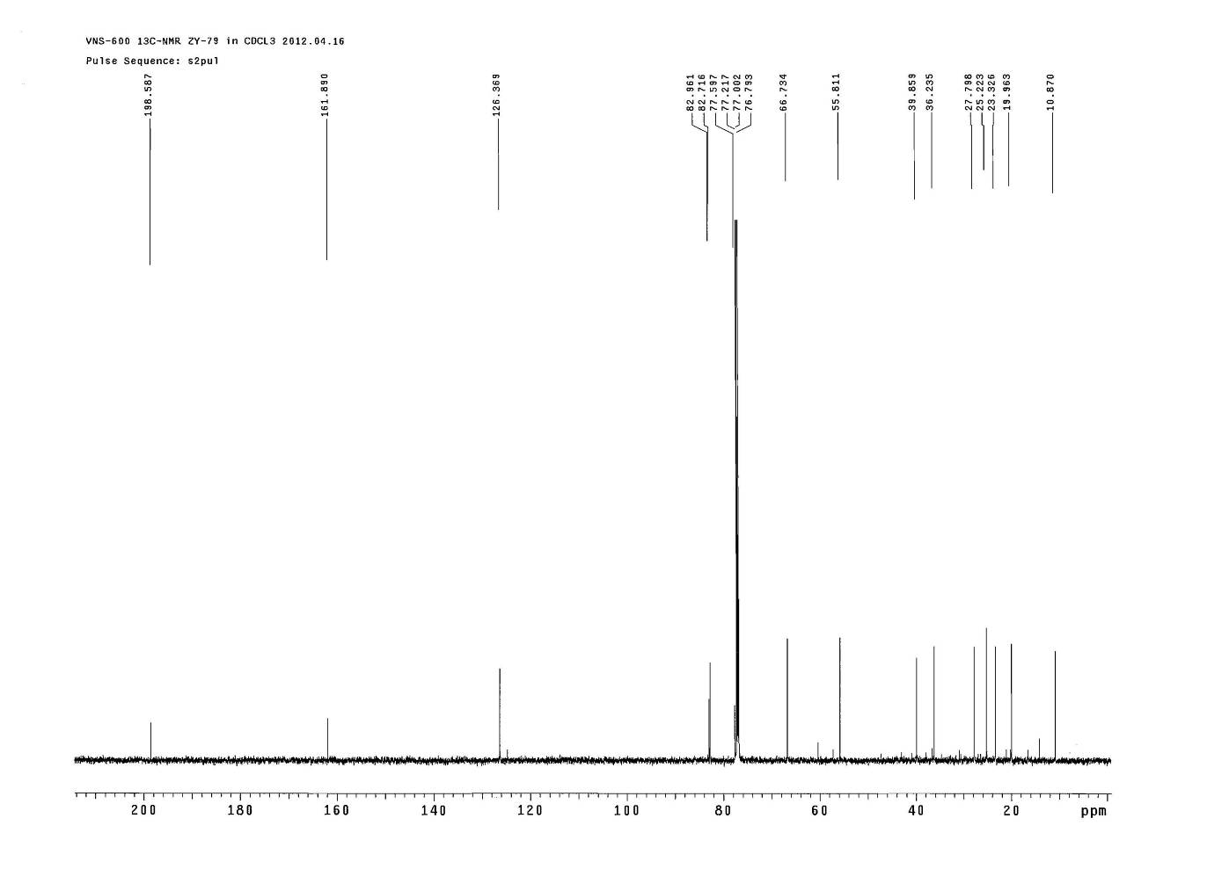



**Figure S46**. The 13CNMR spectrum of compound **5**

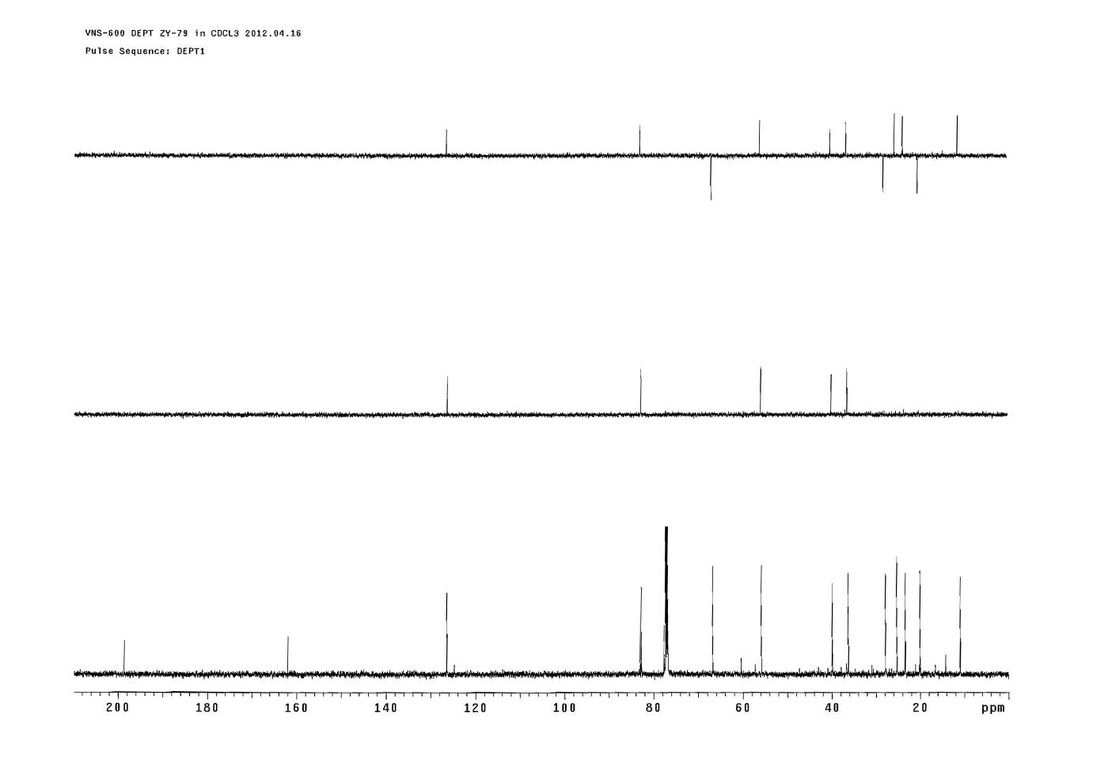



**Figure S47**. The DEPT spectrum of compound **5**

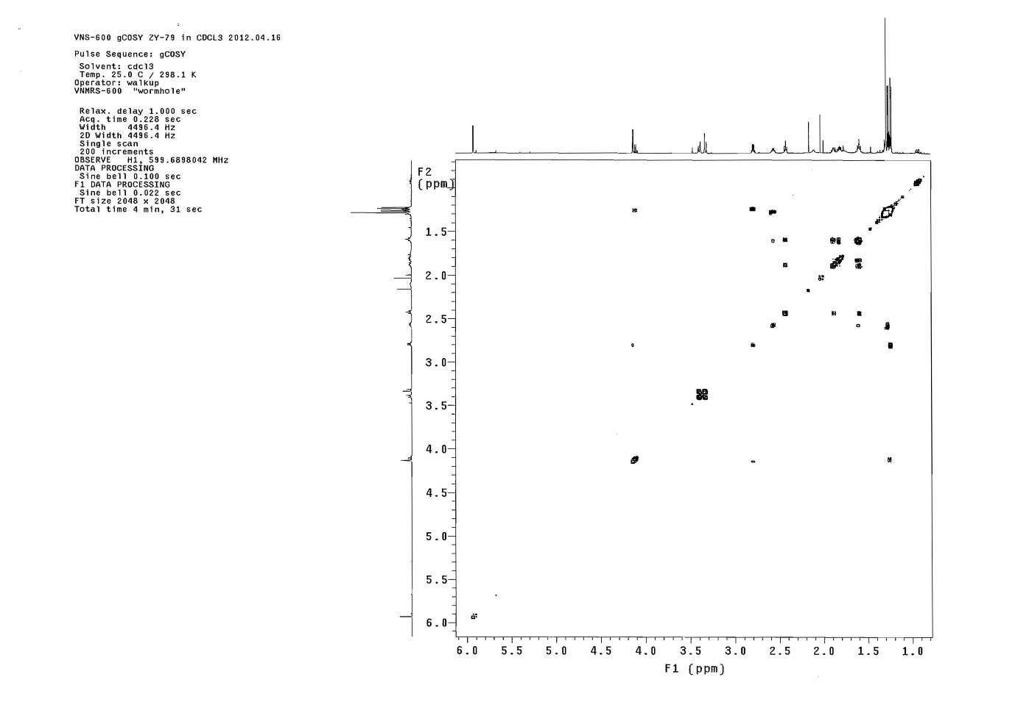



**Figure S48**. The COSY spectrum of compound **5**

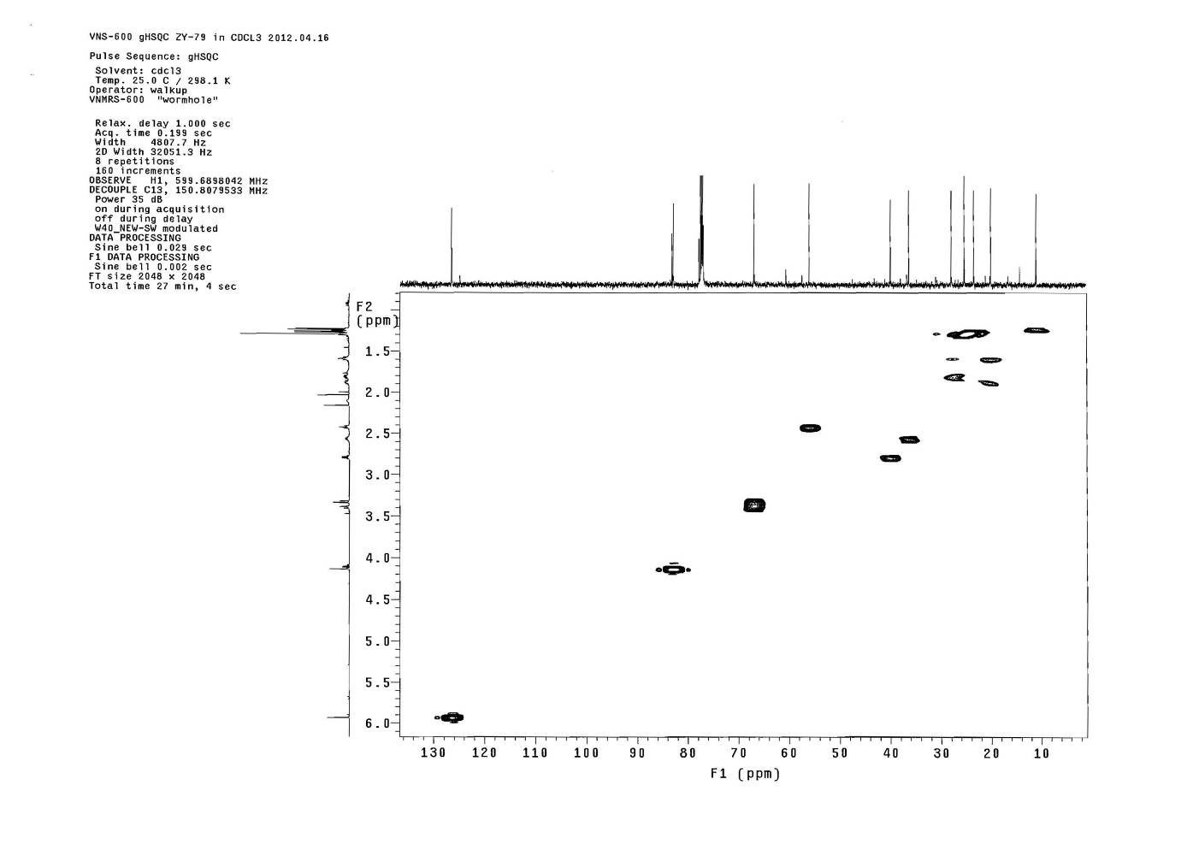



**Figure S49**. The HSQC spectrum of compound **5**

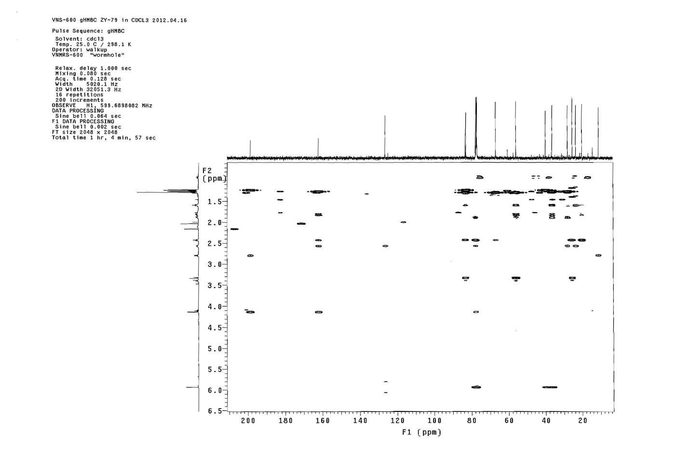



**Figure S50**. The HMBC spectrum of compound **5**

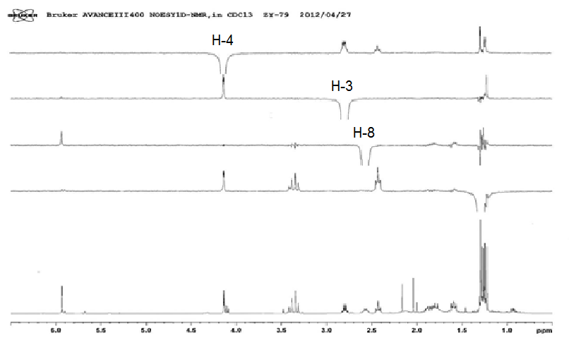

**Figure S51**. The NOE spectrum of compound **5**

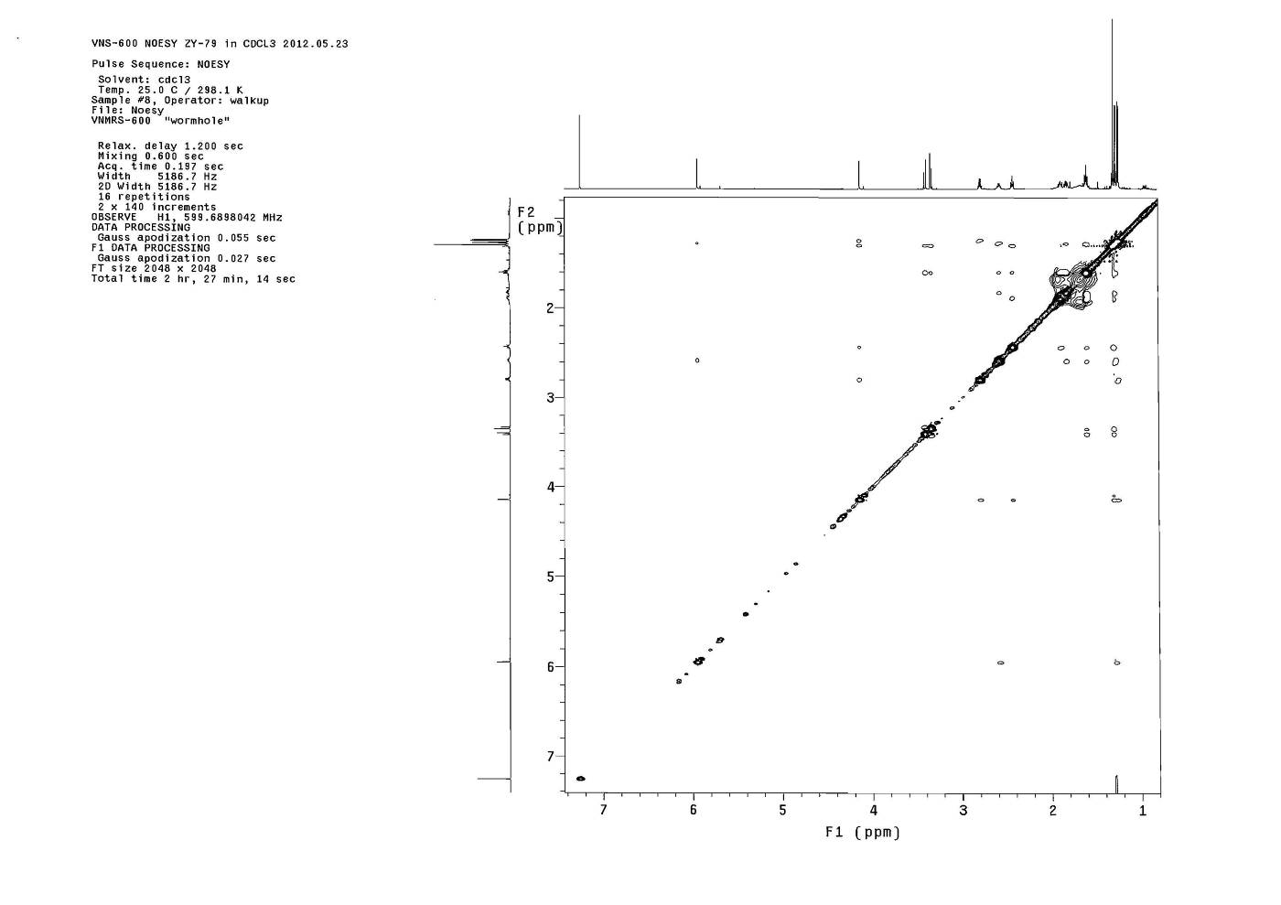



**Figure S52**. The NOESY spectrum of compound **5**

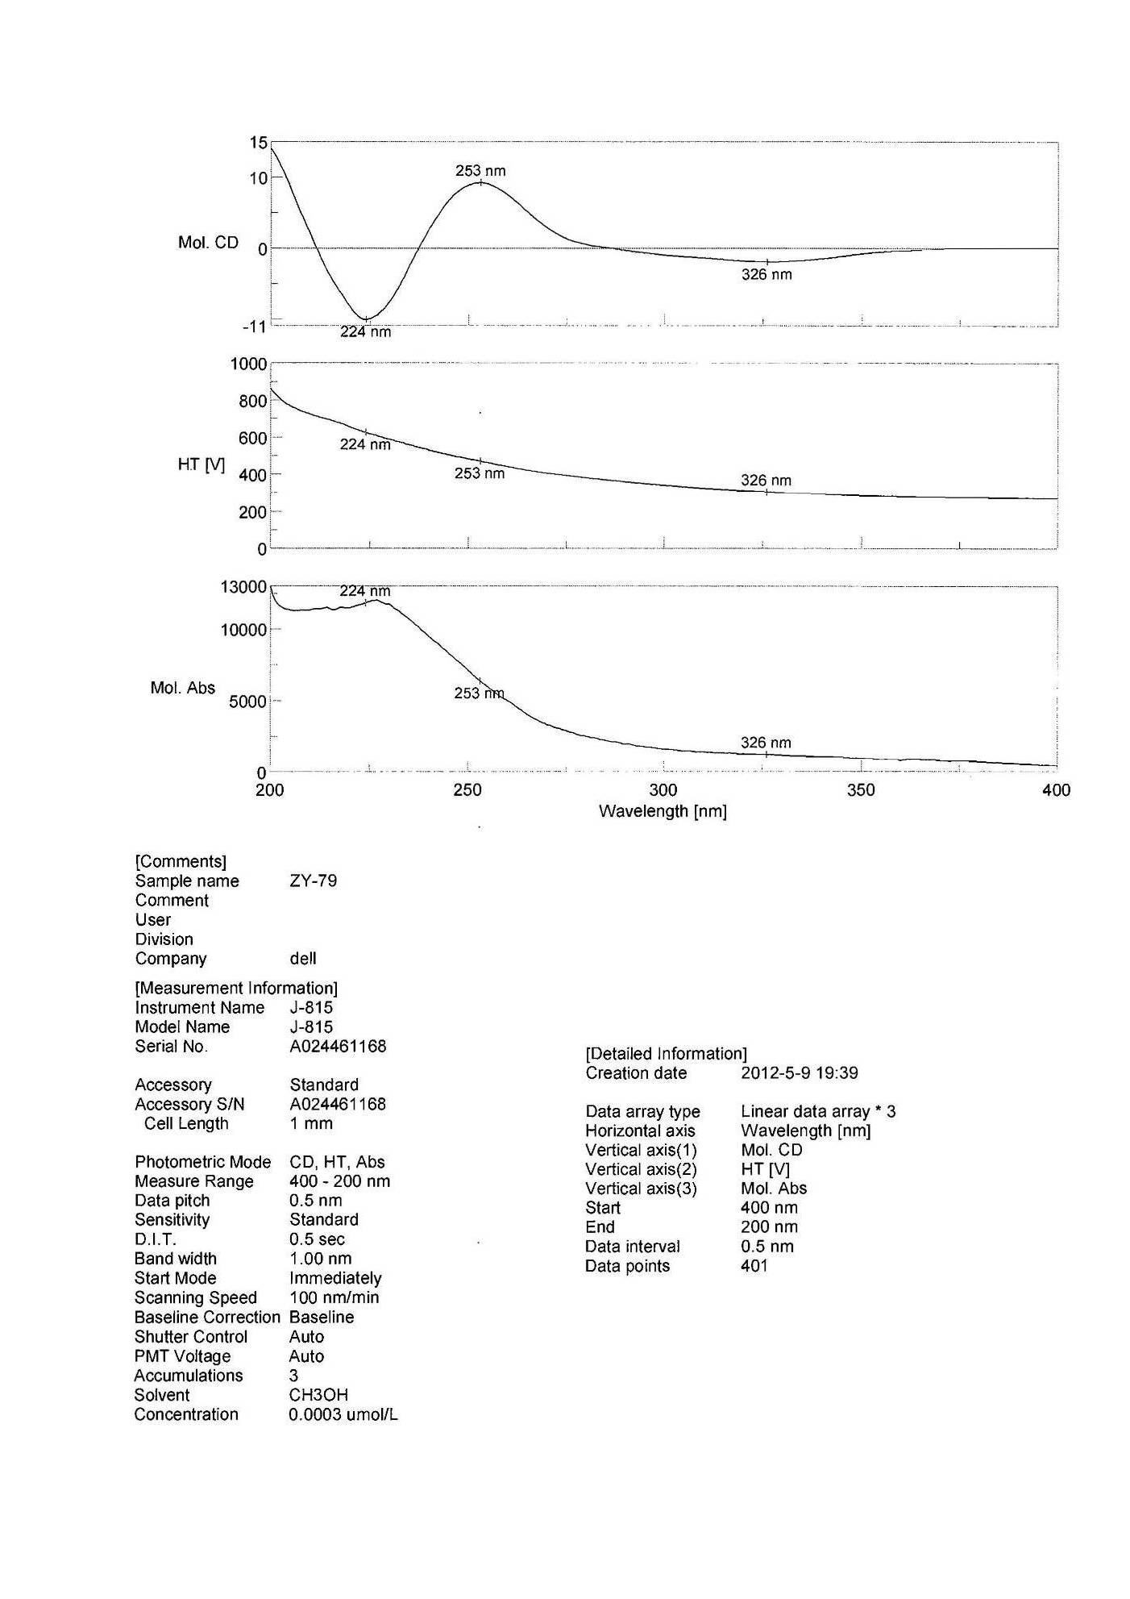



**Figure S53**. The CD spectrum of compound **5**

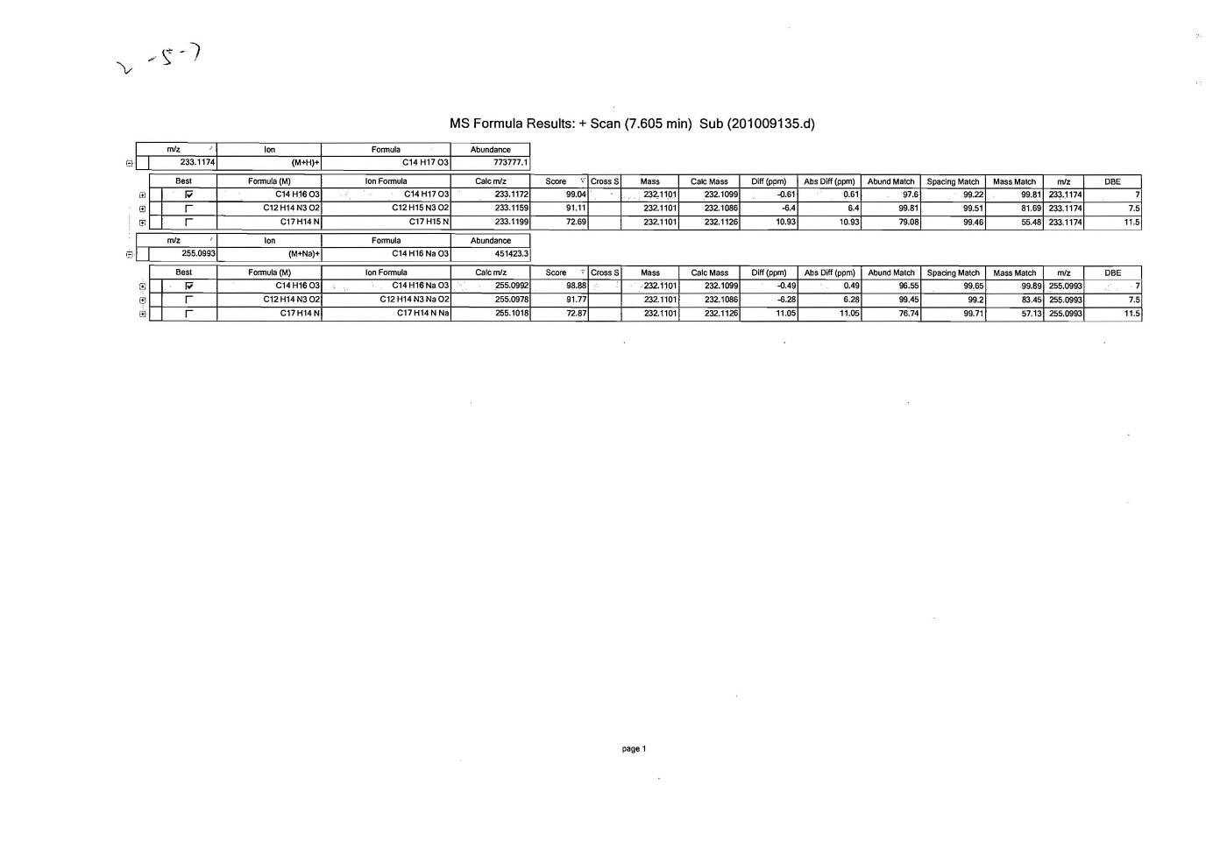 **Figure S54**. The HRESIMS spectrum of compound **6**

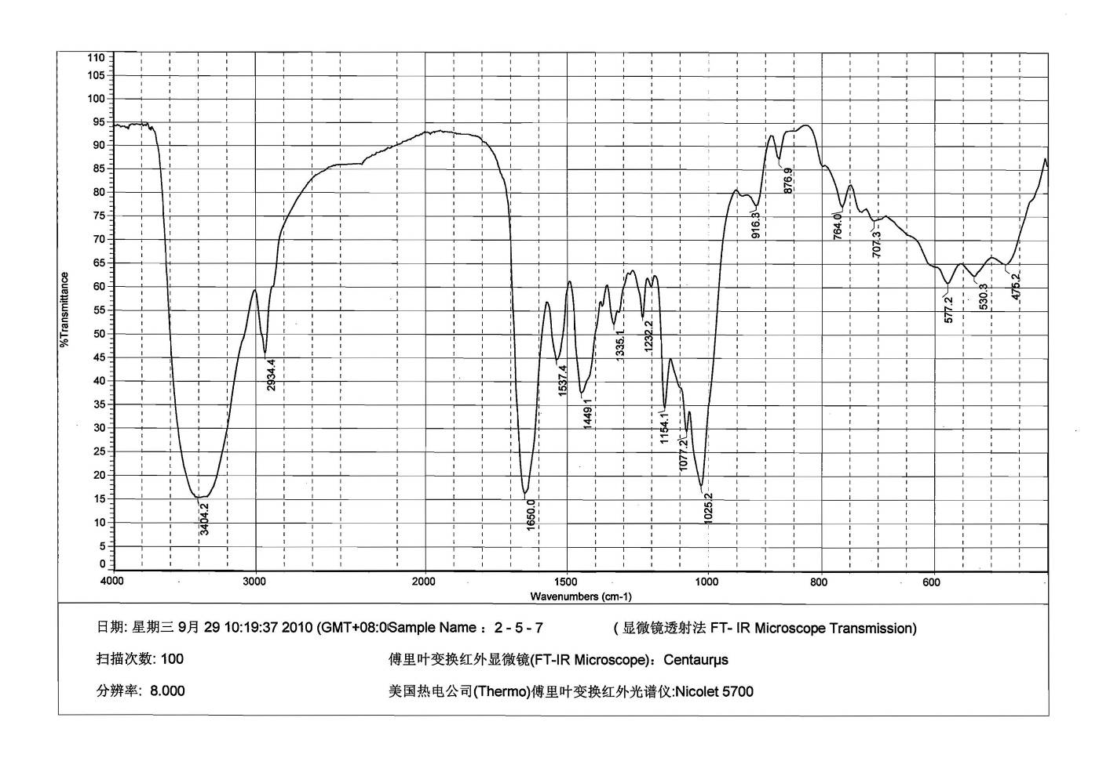

**Figure S55**. The IR spectrum of compound **6**

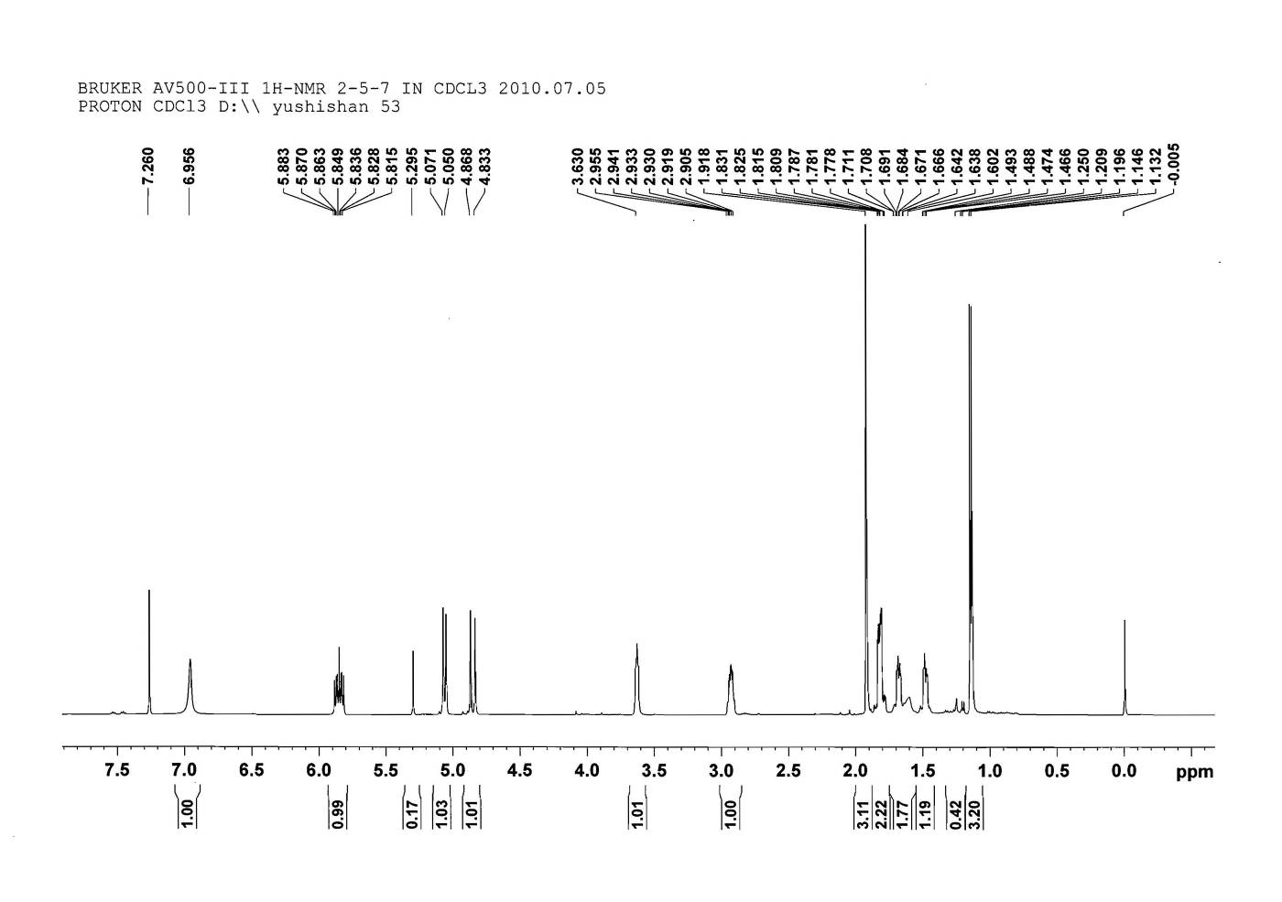



**Figure S56**. The 1HNMR spectrum of compound **6**

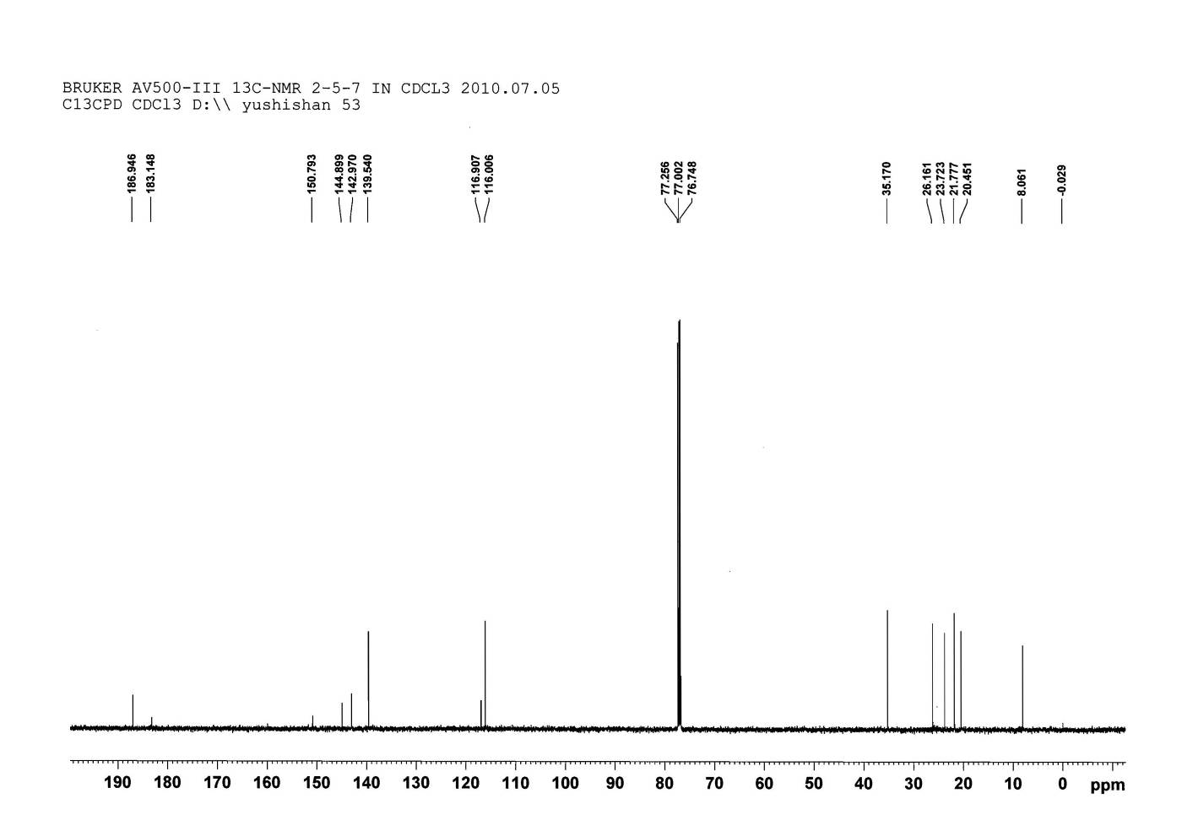



**Figure S57**. The 13CNMR spectrum of compound **6**

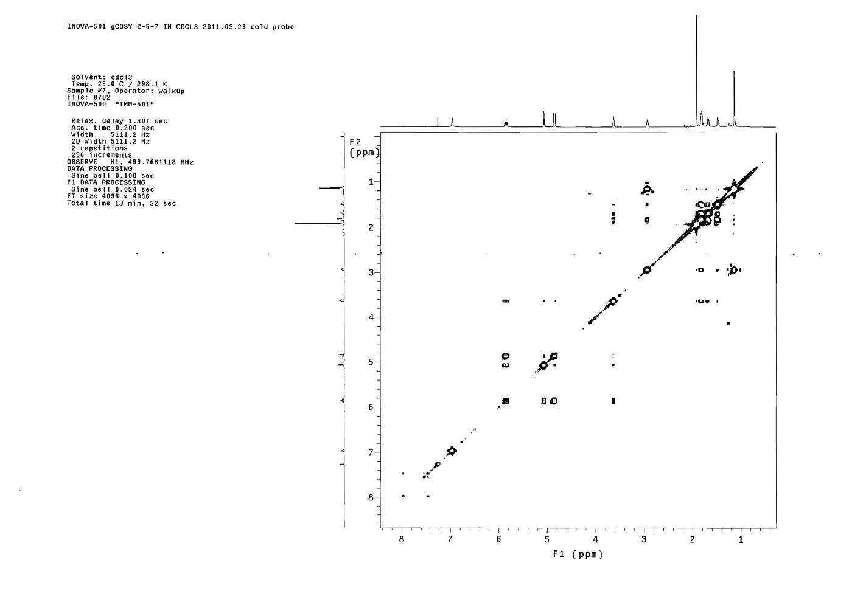



**Figure S58**. The COSY spectrum of compound **6**

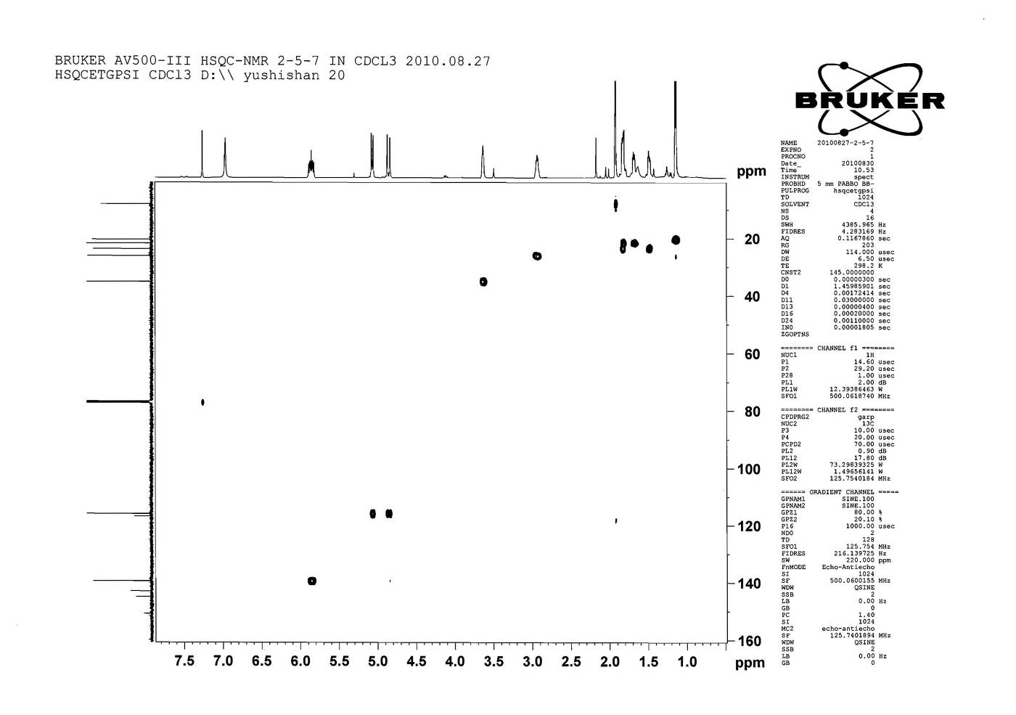



**Figure S59**. The HSQC spectrum of compound **6**

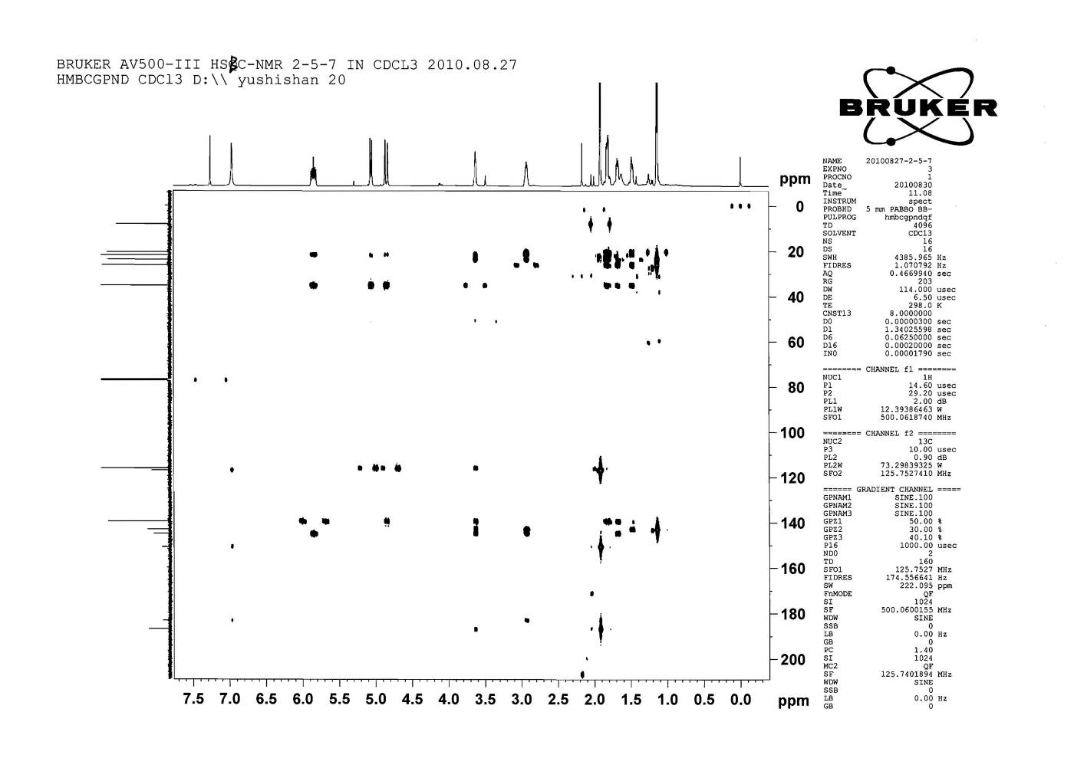



**Figure S60**. The HMBC spectrum of compound **6**

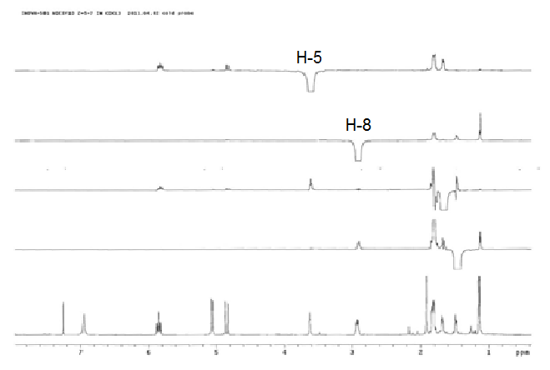



**Figure S61**. The NOESY spectrum of compound **6**

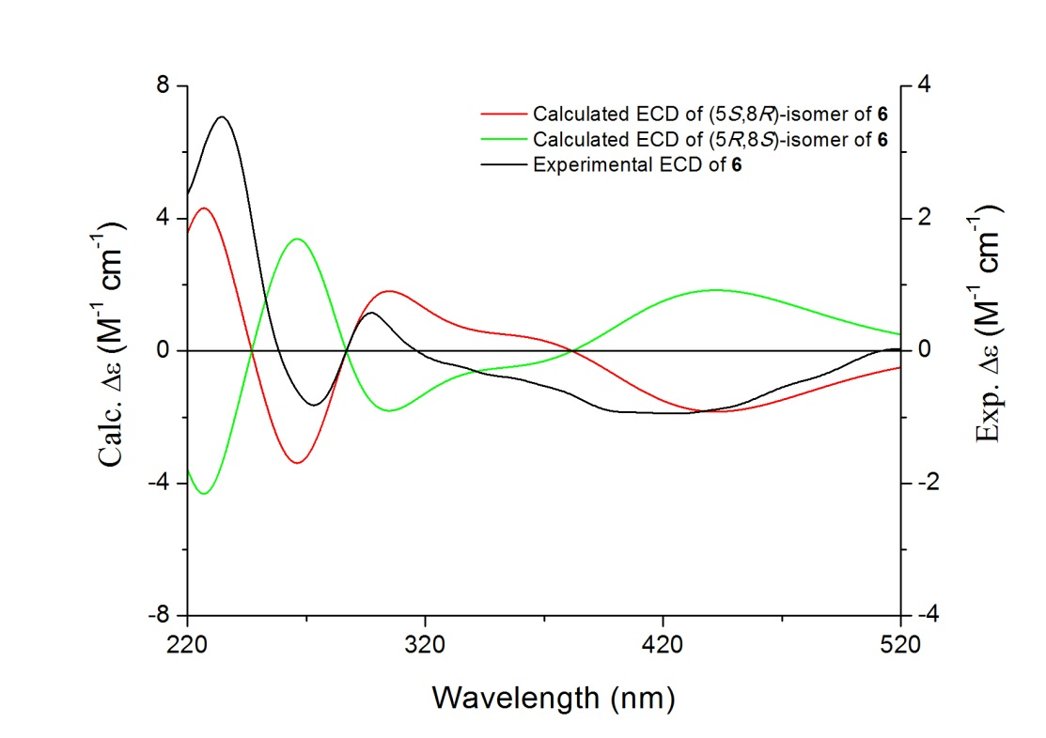

**Figure S62.** The Calculated CDs of (5*S*, 8*R*)-isomer and (5*R*, 8*S*)-isomer and experimental CD of compound **6** in DCM.

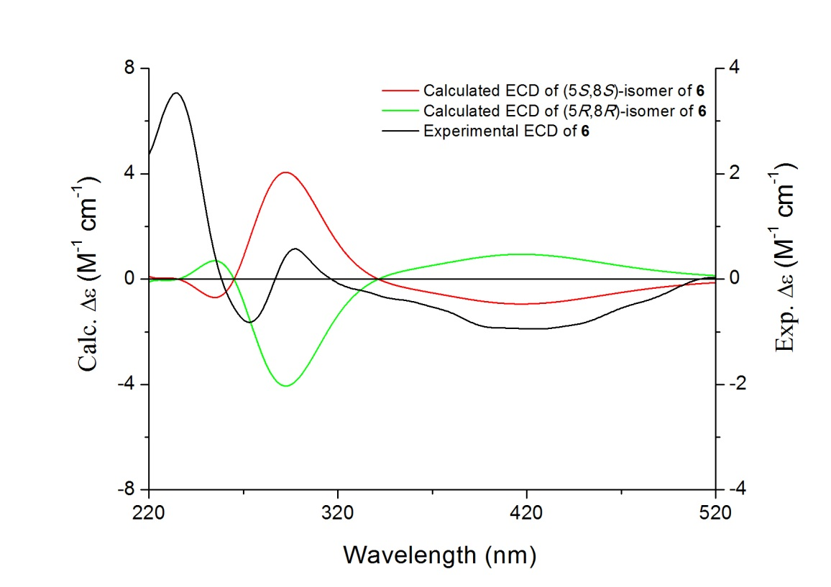

**Figure S63.** The Calculated CDs of (5*S*, 8*S*)-isomer and (5*R*, 8*R*)-isomer and experimental CD of compound **6** in DCM.

1. * To whom correspondence should be addressed. Tel.: +86-10-63165326. fax: +86-10-63017757. E-mail: [yushishan@imm.ac.cn](mailto:yushishan@imm.ac.cn), [liuyunbao@imm.ac.cn](mailto:liuyunbao@imm.ac.cn).
2.