Table S1. Baseline (pre-departure) demographic characteristics (n = 2,086)
 | Study population (n= 2,086) | Lost to follow up (n= 159)
 | Mean(SD) or %(n) | Mean(SD) or %(n)
Age
18–19 years | 21% (441) | 29% (46)
20 | 52% (1078) | 49% (78)
21 | 22% (449) | 17% (27)
22–26 | 6% (118) | 5% (8) | X²(3)=5.87, p 0.12
Gender
Female | 77% (1609) | 80% (127)
Male | 23% (470) | 20% (32)
Did not identify* | <1% (7) | 0% (0) | X²(1)=0.52, p 0.47
Race/ethnicity
Non-Latinx White | 68% (1428) | 68% (110)
Non-Latinx Asian/Pacific Islander | 11% (225) | 6% (10)
Non-Latinx Other | 7% (150) | 9% (14)
Latinx | 14% (283) | 16% (25) | X²(3)=3.89, p 0.27
Greek
No involvement | 68% (1415) | 58% (92)
Member | 30% (621) | 40% (64)
Intend to join | 2% (45) | 2% (3) | X²(2)=7.54, p 0.02
Class
Freshma | 3% (62) | 4% (7)
Sophomore | 17% (363) | 16% (25)
Junior | 61% (1273) | 65% (103)
Senior | 19% (388) | 15% (24) | X²(3)=2.55, p 0.47
Location of study abroad program*
Australia | 10% (199) | 9% (15)
China | 5% (106) | 6% (9)
Costa Rica | 2% (39) | 1% (1)
France | 8% (175) | 8% (13)
Germany | 5% (113) | 4% (6)
Ireland | 7% (136) | 4% (6)
Italy | 18% (369) | 19% (30)
Japan | 4% (73) | 3% (5)
Mexico | 1% (22) | 0% (0)
South Africa | 2% (41) | 4% (6)
Spain | 22% (462) | 24% (38)
United Kingdom | 17% (351) | 19% (30) | X²(11)=8.62, p 0.66
Duration of study abroad program* (in weeks) | 12.5 (8.4) | 14.1 (8.8) | t(2224)=-2.24, p 0.03
Note: Location of study abroad and duration of program were measured at predeparture for all participants. In analysis, location and duration of study abroad program were measured at follow up. Therefore, location and duration data in this table for participants included in the study (n=2,086) do not match data in Table 1.

Figure S1. Average adjusted predictions of current cigarette smoking by location of study abroad*
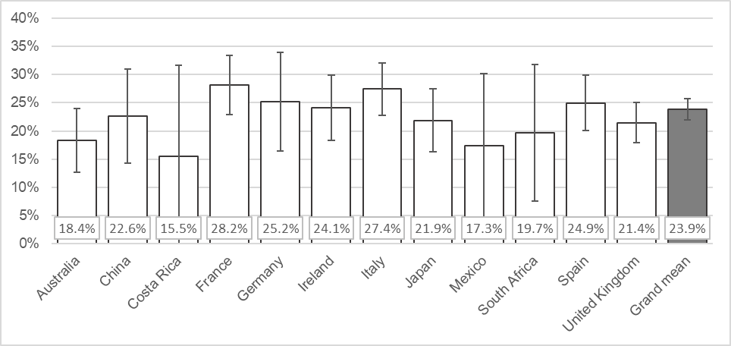
*Prevalence was estimated from the margins of a logistic model of any past 30-day cigarette smoking while students were abroad.

Figure S2. Average adjusted predictions of current e-cigarette use by location of study abroad*
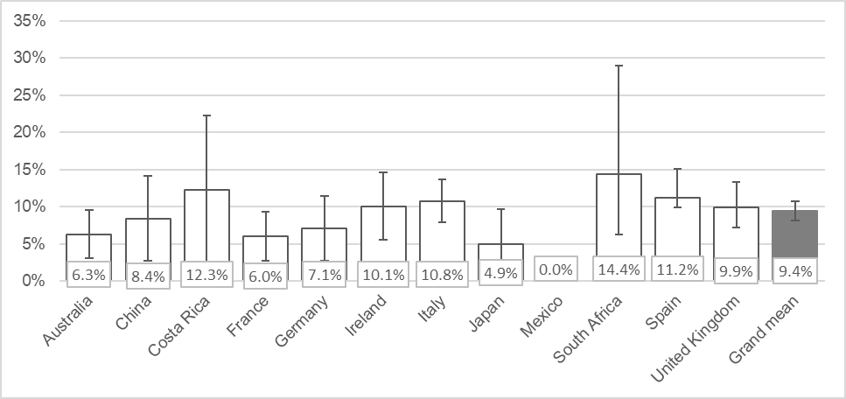
*Prevalence was estimated from the margins of a logistic model of any past 30-day e-cigarette use while students were abroad.

Figure S3. Average adjusted predictions of current cannabis use by location of study abroad*
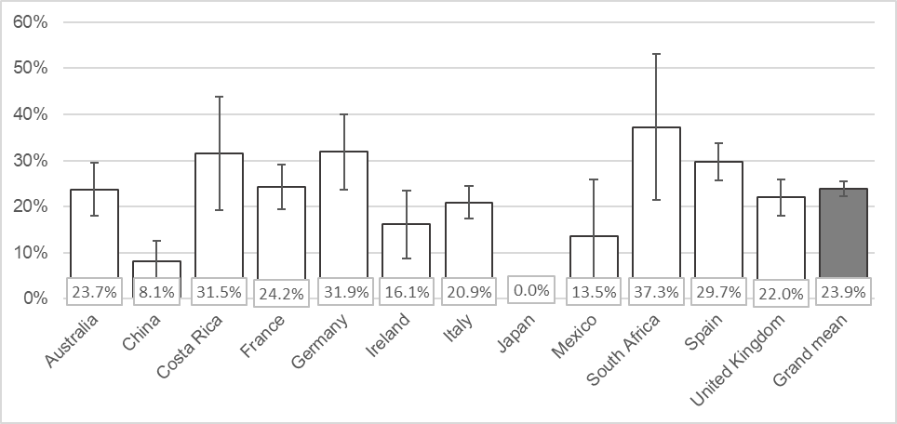
*Prevalence was estimated from the margins of a logistic model of any past 30-day cannabis use while students were abroad.

