Supplementary Appendix

Appendix Table 1. Three-class model: Estimated probabilities by latent class membership
# | Help-seeking preference indicators (Total n=815) | Population proportion  (Total n = 815) | Class 1 [Multiple source]  (n=137, 17%) | Class 2 [Non-seekers]  (n=251, 31%) | Class 3 [MHPCP]  (n=427,52%)
1 | Friends | 0.799 | 0.968 | 0.606 | 0.859
2 | Intimate partners (e.g. girlfriend/boyfriend and husband/wife) | 0.737 | 0.919 | 0.548 | 0.792
3 | Family | 0.731 | 0.929 | 0.515 | 0.797
4 | Mental health professionals (e.g. psychologist, social worker, counselor, psychiatrist) | 0.690 | 0.994 | 0.093 | 0.943
5 | Classmates | 0.507 | 0.848 | 0.339 | 0.495
6 | School counselors in the Student Counseling Center, University of Macau | 0.492 | 0.970 | 0.034 | 0.611
7 | Phone helpline | 0.355 | 0.868 | 0.020 | 0.387
8 | Other helpers in Mental Health Organization in Macao (e.g. Sheng Kung Hui Macau, Caritas, Education, and Youth Affairs Bureau) | 0.331 | 0.878 | 0.000 | 0.351
9 | General medical practitioners | 0.309 | 0.888 | 0.012 | 0.297
10 | Colleagues | 0.293 | 0.735 | 0.121 | 0.251
11 | Teachers | 0.282 | 0.884 | 0.030 | 0.235
12 | Religious leaders (e.g. Priest, Rabbi, Chaplain, monk) | 0.168 | 0.527 | 0.035 | 0.130
13 | Traditional Chinese medicine (TCM) doctors | 0.160 | 0.609 | 0.024 | 0.092
14 | Fortune-tellers | 0.095 | 0.341 | 0.023 | 0.056
Note: MHPCP = mental health professionals and close people

Appendix Table 2. Multicollinearity diagnostic test results
Variables(correlation matrix of coefficients) | VIF | Self-stigma | Public stigma | Losing face concern | Perceived social support | Depression | Anxiety | Stress | PTSD
Self-stigma | 3.36 | 1.000
Public stigma | 2.92 | -0.557 | 1.000
Losing face concern | 2.84 | -0.026 | -0.153 | 1.000
Perceived social support | 1.67 | 0.050 | 0.156 | -0.238 | 1.000
Depression | 1.61 | -0.053 | 0.010 | -0.119 | 0.207 | 1.000
Anxiety | 1.27 | 0.022 | -0.028 | -0.060 | -0.059 | -0.275 | 1.000
Stress | 1.20 | -0.005 | -0.027 | 0.016 | -0.037 | -0.464 | -0.491 | 1.000
PTSD | 1.14 | -0.081 | -0.015 | 0.092 | 0.095 | -0.022 | -0.182 | -0.076 | 1.000
Note: this table displayed the VIF (variance inflation factor) and correlation matrix of coefficients between main variables.

Appendix Table 3 Correlations and covariance between help-seeking preferences indicators
# | Help-seeking preferences indicators  [r (covariance)] | 1 | 2 | 3 | 4 | 5 | 6 | 7 | 8 | 9 | 10 | 11 | 12 | 13 | 14
1 | Intimate partners (e.g. girlfriend/boyfriend and husband/wife) | 1.000  (0.194)
2 | Friends | 0.424  (0.075) ** | 1.000  (.160932)
3 | Family | 0.242  (0.047) ** | 0.262  (0.047) ** | 1.000  (0.197)
4 | Mental health professionals (e.g. psychologist, social worker, counselor, psychiatrist) | 0.245  (0.050) ** | 0.280  (0.052) ** | 0.305  (0.063) ** | 1.000  (0.216)
5 | Phone helpline | 0.198  (0.042) ** | 0.193  (0.037) ** | 0.230  (0.049) ** | 0.457  (0.102) ** | 1.000  (0.229)
6 | General medical practitioners | 0.133  (0.027) ** | 0.144  (0.027) ** | 0.184  (0.038) ** | 0.384  (0.083) ** | 0.420  (0.093) ** | 1.000  (0.214)
7 | Teachers | 0.164  (0.032) ** | 0.206  (0.037) ** | 0.202  (0.040) ** | 0.348  (0.073) ** | 0.310  (0.067) ** | 0.483  (0.101) ** | 1.000  (0.203)
8 | Religious leaders (e.g. Priest, Rabbi, Chaplain, monk) | 0.060  (0.010) | 0.095  (0.014) * | 0.080  (0.013) * | 0.233  (0.041) ** | 0.250  (0.045) ** | 0.303  (0.052) ** | 0.352  (0.059) ** | 1.000  (0.140)
9 | Traditional Chinese medicine (TCM) doctors | 0.146  (0.024) ** | 0.143  (0.021) ** | 0.143  (0.023) ** | 0.237  (0.040) ** | 0.322  (0.056) ** | 0.405  (0.069) ** | 0.352  (0.058) ** | 0.324  (0.044) ** | 1.000  (0.134)
10 | Fortune-tellers | 0.097  (0.013) * | 0.058  (0.007) | 0.044  (0.006) | 0.1553  (0.021) ** | 0.217  (0.030) ** | 0.229  (0.031) ** | 0.264  (0.035) ** | 0.304  (0.033) ** | 0.341  (0.037) ** | 1.000  (0.086)
11 | School counselors in the Student Counseling Center, University of Macau | 0.242  (0.053) ** | 0.280  (0.056) ** | 0.187  (0.041) ** | 0.560  (0.130) ** | 0.409  (0.098) ** | 0.351  (0.081) ** | 0.354  (0.080) ** | 0.214  (0.040) ** | 0.295  (0.054) ** | 0.211  (0.031) ** | 1.000  (0.250)
12 | Other helpers in Mental Health Organization in Macao (e.g. Sheng Kung Hui Macau, Caritas, Education, and Youth Affairs Bureau) | 0.207  (0.043) ** | 0.191  (0.036) ** | 0.215  (0.045) ** | 0.448  (0.098) ** | 0.481  (.108) ** | 0.392 (0.085) ** | 0.375  (0.080) ** | 0.290  (0.051) ** | 0.356  (0.061) ** | 0.201  (0.028) ** | 0.585  (0.138) ** | 1.000  (0.222)
13 | Colleagues | 0.231  (0.046) ** | 0.229  (0.042) ** | 0.159  (0.032) ** | 0.215  (0.098) ** | 0.210  (0.046) ** | 0.275  (0.058) ** | 0.375  (0.077) ** | 0.215  (0.037) ** | 0.294  (0.049) ** | 0.216  (0.029) ** | 0.207  (0.047) ** | 0.240  (0.051) ** | 1.000  (0.208)
14 | Classmates | 0.2367  (0.052) ** | 0.380  (0.076) ** | 0.260  (0.058) ** | 0.189  (0.044) ** | 0.131  (0.031) ** | 0.150  (0.035) ** | 0.324  (0.073) ** | 0.142  (0.027) ** | 0.148  (0.027  ) ** | 0.101  (0.015) * | 0.161  (0.040) ** | 0.168  (0.040) ** | 0.533  (0.121) ** | 1.000  (0.250)
Note: *p< .05; ** p< .001, r = magnitude of the correlation coefficient

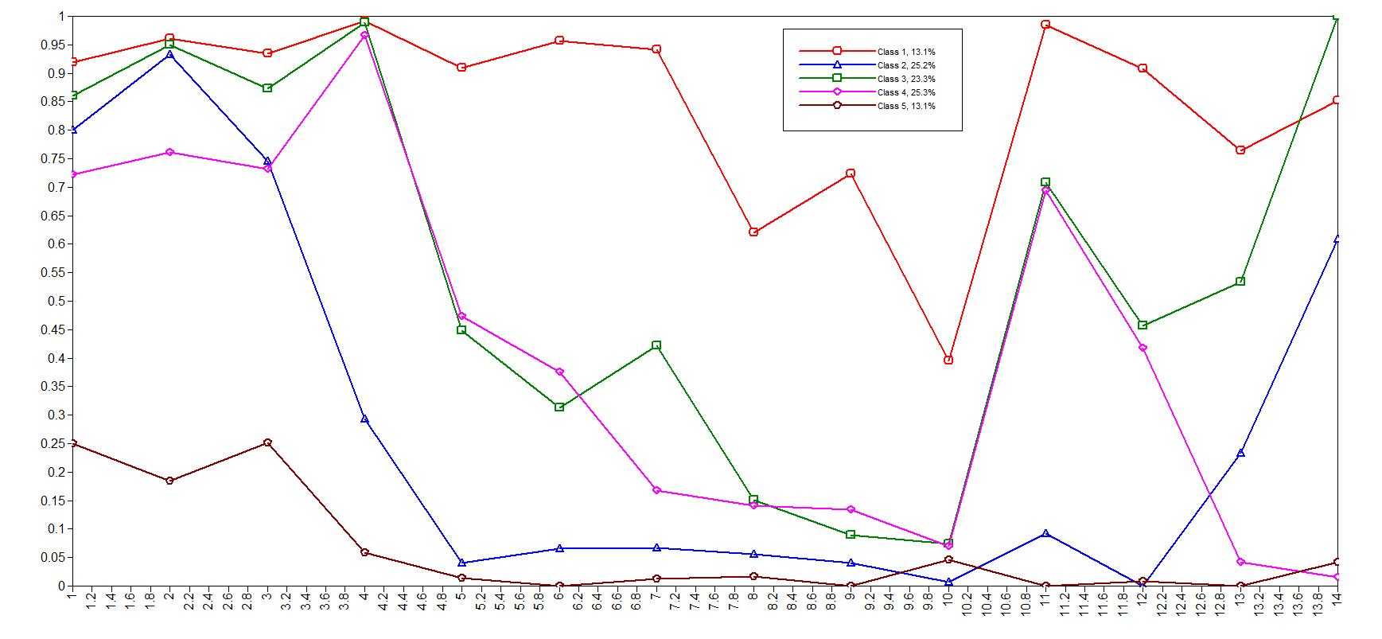
Appendix Figure 1: Estimated indicator probabilities for the five-class model in the help-seeking preferences

