Supplementary information for
Potential interferences in photolytic nitrogen dioxide converters for ambient air monitoring: Evaluation of a prototype

Nick Jordan, Natasha M. Garner, Laura C. Matchett,ª Travis W. Tokarek, and Hans D. Osthoff*
Department of Chemistry, 2500 University Drive NW, University of Calgary, Calgary, AB T2N 1N4, Canada

Charles A. Odame-Ankrah, Charles E. Grimm, Kelly N. Pickrell, Christopher Swainson, and Brian W. Rosentreter
Global Analyzer Systems Ltd., #5, 1411 – 25th Avenue N.E., Calgary AB T2E 7L6, Canada

* Author to whom correspondence should be addressed
email hosthoff@ucalgary.ca, phone 403-220-8689

ªnow at: Department of Chemistry, 11227 Saskatchewan Drive, University of Alberta, Edmonton, AB T6G 2G2, Canada

For the Journal of the Air & Waste Management Association
April 17, 2020

Experimental setup
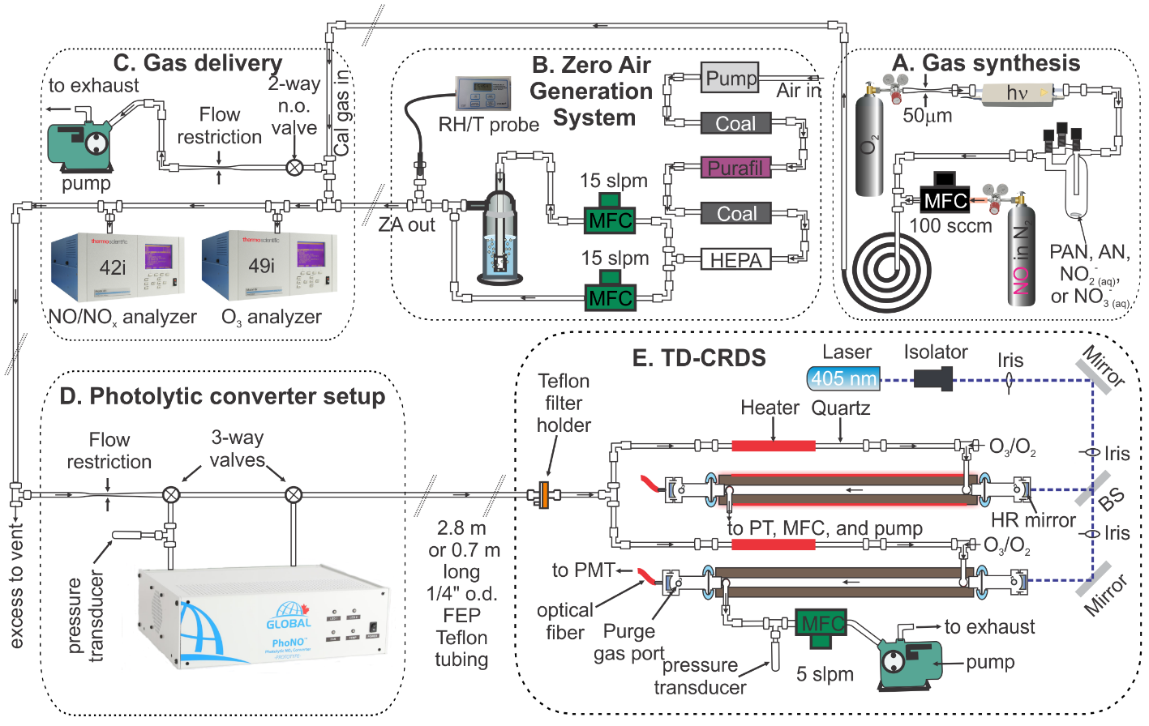
Figure S1. Experimental setup. MFC = mass flow controller; slpm = standard liter per minute; RH/T = relative humidity and temperature; ZA = zero air; n.o. = normally open; FEP = fluorinated ethylene propylene; PMT = photomultiplier tube; PT = pressure transducer; HR = high reflectivity; BS = beam splitter
Generation and delivery of NO_{z} species
Generation of gas streams containing PAN. Peroxyacetic nitric anhydride was synthesized by combining 2.5 mL of 32% peracetic solution (Sigma-Aldrich) with 20 mL of tridecane (Sigma-Aldrich) in a 100 mL round bottom flask, which was cooled externally using an ice-water bath. Approximately 5 mL of pre-cooled, concentrated H₂SO₄ (Sigma-Aldrich, fuming) were added dropwise to the stirred solution, followed by dropwise addition of ice-cold, concentrated HNO₃ (Sigma-Aldrich, ACS reagent, 90%). After 15 min, the mixture was transferred to a pre-cooled separatory funnel. The organic layer was washed with three 50 mL batches of ice-cold deionized water and dried with anhydrous MgSO₄ (EMD). Aliquots of PAN in tridecane were filtered into 2 mL centrifuge vials (VWR), which were stored in a freezer until use. To generate gas streams containing PAN, the contents of a vial containing PAN in tridecane were transferred to a 3-neck flask cooled externally with water-ice and eluted using a stream of ~100 sccm oxygen (Praxair).¹
Generation of gas streams containing HONO. Mixtures of HONO in air were generated by placing 100 mg of sodium nitrite (Sigma-Aldrich) and 5 mL of a solution buffered to pH 3.74 using sodium oxalate / oxalic acid in a 3-neck flask. The head space of this solution initially contained high concentrations of NO_{x}, which was removed through continuous flushing with N₂ gas over periods of several days and by keeping the solution in the dark.
Generation of gas streams containing isopropyl nitrate (IPN). Isopropyl nitrate was purchased from Sigma-Aldrich and used as received. A permeation source was constructed by filling a "low emission" polytetrafluoroethylene (PTFE) permeation tube (Chromatographic Specialties) with IPN and sealing both ends using solid PTFE plugs that were externally compressed using stainless steel rings.² The permeation tube was place inside 3/4" (1.9 cm) o.d. FEP Teflon™ tubing, which was continuously flushed with ~100 sccm oxygen (Praxair). This assembly was operated at room temperature but could be externally heated if a higher emission rate was desired.
Generation of gas streams containing HNO₃. A permeation tube filled by a commercial vendor (KIN-TEK Analytical) with 68% HNO₃ was placed inside a flow chamber (VICI Dynacalibrator) heated to a temperature of 60.0 °C and operated at a flow of 0.15 Liters per minute. Its output was immediately diluted in ~100 sccm of oxygen.
Box model simulations

A macro was written in Igor Pro 6 (Wavemetrics, Lake Oswego, Oregon) to rationalize the experiment shown in Figure 5B. The simulation models the chemistry that occurs in a parcel of air as it travels through the photolytic converter and the tubing connected to the analyzer at a mass flow rate of 903 sccm. The reactions are summarized in Table S1. The model assumes a pressure of 420 Torr throughout, a room temperature of 298 K, a temperature of 318 K inside the converter, and t_{res} = 3.5 sec, calculated from the inner dimensions of the photolysis cell and volumetric flow rate. Photolysis was assumed to be uniform inside the converter and turned off outside. Simulations were initialized with 21 ppbv NO₂ (2.9×10¹¹ molecules cm⁻³), 79% N₂ (1.1×10¹⁹ molecules cm⁻³), 21% O₂ (2.8×10¹⁸ molecules cm⁻³), H₂O (1×10¹⁷ molecules cm⁻³), CH₄ (3×10¹³ molecules cm⁻³), CO (2×10¹² molecules cm⁻³), and NO mixing ratios of 0, 4, 43, 111, and 194 ppbv (0, 5.6×10¹⁰, 6.0×10¹¹, 1.5×10¹², and 2.7×10¹² molecules cm⁻³, respectively).

Table S1: Mechanism used in box model simulations. n/a = not applicable. F_{c} = 0.6 unless noted otherwise.
# | Reaction | Rate constant or expression | Ref.
1 | NO₂ + hν → NO + O(³P) | 4.2 sec⁻¹ | n/a
2 | HONO+ hν → HO + NO | 0.137 sec⁻¹ | n/a
3 | O₃ + hν → O(³P) + O₂ | 1.46×10⁻⁴ sec⁻¹ | n/a
4 | O₃ + hν → O(¹D) + O₂ | 5.45×10⁻¹⁰ sec⁻¹ | n/a
5 | O(³P) + O₂ (+ M)  → O₃ (+ M) | k_{o}³⁰⁰=6.0×10⁻³¹ cm⁶ molecule⁻² sec⁻¹, n=2.6  k∞³⁰⁰=3.6×10⁻¹¹ cm³ molecule⁻¹ sec⁻¹, m=0.1 | ³
6 | O(³P) + O₃ → 2O₂ | 8.0×10⁻¹²×e^{-2060/T} cm³ molecule⁻¹ sec⁻¹ | ⁴
7 | O(¹D) + N₂ → O(³P) + N₂ | 2.15×10⁻¹¹×e^{110/T} cm³ molecule⁻¹ sec⁻¹ | ⁴
8 | O(¹D) + O₂ → O(³P) + O₂ | 3.3×10⁻¹¹×e^{55/T} cm³ molecule⁻¹ sec⁻¹ | ⁴
9a | O(¹D) + O₃ → 2O₂ | 1.2×10⁻¹⁰ cm³ molecule⁻¹ sec⁻¹ | ⁴
9b | O(¹D) + O₃  → 2O(³P) + O₂ | 1.2×10⁻¹⁰ cm³ molecule⁻¹ sec⁻¹ | ⁴
10 | O(¹D) + H₂O → 2 HO | 1.63×10⁻¹⁰×e^{60/T} cm³ molecule⁻¹ sec⁻¹ | ⁴
11 | NO + O₃ → NO₂ + O₂ | 3.0×10⁻¹²×e^{-1500/T} cm³ molecule⁻¹ sec⁻¹ | ⁴
12 | NO₂ + O(³P) → NO + O₂ | 1.04×10⁻¹¹×e^{210/T} cm³ molecule⁻¹ sec⁻¹ | ⁴
13 | HO + NO (+ M)  → HONO (+ M) | k_{o}³⁰⁰=7.0×10⁻³¹ cm⁶ molecule⁻² sec⁻¹, n=2.6  k∞³⁰⁰=3.6×10⁻¹¹ cm³ molecule⁻¹ sec⁻¹, m=0.1 | ⁴
14 | HO + NO₂ (+ M)  → HNO₃ (+ M) | k_{o}³⁰⁰= 1.8×10⁻³⁰ cm⁶ molecule⁻² sec⁻¹, n=3.0  k∞³⁰ = 2.8×10⁻¹¹ cm³ molecule⁻¹ sec⁻¹, m=0 | ⁴
15 | NO + HO₂ → NO₂ + HO | 3.3×10⁻¹²×e^{270/T} cm³ molecule⁻¹ sec⁻¹ | ⁴
16 | OH + HONO  → H₂O + NO₂ | 1.8×10⁻¹¹×e^{-390/T} cm³ molecule⁻¹ sec⁻¹ | ⁴
17 | HO + O₃ → HO₂ + O₂ | 1.7×10⁻¹²×e^{-940/T} cm³ molecule⁻¹ sec⁻¹ | ⁴
18 | HO₂ + O₃ → HO + 2O₂ | 1.0×10⁻¹⁴×e^{-490/T} cm³ molecule⁻¹ sec⁻¹ | ⁴
19 | HO + HO₂ → H₂O + O₂ | 4.8×10⁻¹¹×e^{250/T} cm³ molecule⁻¹ sec⁻¹ | ⁴
20 | NO₂ + O₃ → NO₃ + O₂ | 1.2×10⁻¹³×e^{-2450/T} cm³ molecule⁻¹ sec⁻¹ | ⁴
21 | NO + NO₃ → 2NO₂ | 1.5×10⁻¹¹×e^{170/T} cm³ molecule⁻¹ sec⁻¹ | ⁴
22 | NO₂ + NO₃ (+ M)  → N₂O₅ (+ M) | k_{o}³⁰⁰=2.4×10⁻³⁰ cm⁶ molecule⁻² sec⁻¹, n=3.0  k∞³⁰⁰=1.6×10⁻¹² cm³ molecule⁻¹ sec⁻¹, m=-0.1 | ⁴
23 | NO₃ + hν → NO₂ + O(³P) | 0.149 sec⁻¹ | n/a
24 | N₂O₅ → NO₂ + NO₃ | k₂₂ / (5.8×10⁻²⁷× e^{10840/T} cm³ molecule⁻¹ sec⁻¹) | ⁴
25 | HO + CO (+ O₂)  → CO₂ + HO₂ | 1.5×10⁻¹³ cm³ molecule⁻¹ sec⁻¹ | ⁴
26 | N₂O₃ (+ M)  → NO + NO₂(+ M) | k_{o}=1.9×10⁻⁷×(T/300)^{-8.7} e^{-4880/T} [M] sec⁻¹  k∞=4.7×10¹⁵×(T/300)^{0.4} e^{-4880/T} sec⁻¹ | ^{5*}
27 | N₂O₃ + H₂O → 2HONO | 6.29×10⁻¹¹×e^{-4470/T} cm³ molecule⁻¹ sec⁻¹ | ⁶
28 | NO + NO₂ (+ M)  → N₂O₃ (+ M) | k_{o}=3.1×10⁻³⁴×(T/300)^{-7.7}×[M] cm³ molecule⁻¹ sec⁻¹  k∞=7.9×10⁻¹²×(T/300)^{-1.4} cm³ molecule⁻¹ sec⁻¹ | ^{5*}
29 | HO + CH₄ (+ O₂)  → CH₃O₂ + H₂O | 2.45×10⁻¹²×e^{-1775/T} cm³ molecule⁻¹ sec⁻¹ | ⁴
30 | CH₃O₂ + NO (+ O₂)  → NO₂ + HO₂ (+ HCHO) | 2.8×10⁻¹²×e^{300/T} cm³ molecule⁻¹ sec⁻¹ | ⁴
31 | 2NO₂ → N₂O₄ | k_{o}=1.44×10⁻³³×(T/298)^{-3.8}×[M] cm³ molecule⁻¹ sec⁻¹  k∞=1.0×10⁻¹² cm³ molecule⁻¹ sec⁻¹ | ^{5*}
32 | N₂O₄ (+ M)  → 2NO₂(+ M) | k₀=1.3×10⁻⁵×(T/300)^{-3.8}×e^{-6400/T} [M] sec⁻¹  k∞=7.7×10¹⁵×(T/300)^{-1.1}×e^{-6460/T} sec⁻¹ | ^{5*}
33 | N₂O₄ + H₂O  → HONO + HNO₃ | 4.18×10⁻¹⁰×e^{-5830/T} cm³ molecule⁻¹ sec⁻¹ | ⁶
* data downloaded from http://iupac.pole-ether.fr/

Interference from selected NO_{z} species.
Alkyl nitrates. The ANs are not expected to photodissociate in this wavelength region, but since they are an important component of photochemical smog, their inertness was experimentally verified. In Figure S2, the CRDS sampled 70±1 ppbv of IPN from 19:49 to 19:56, which was quantified by heating the TD-CRDS quartz inlet to 420 °C. The IPN diffusion source co-emitted a small amount (average of 0.455 ppbv) of NO_{x}. When the converter's LEDs were turned on from 19:52 to 19:54, the NO_{x} mixing ratio increased to 0.74±0.12 ppbv. The difference (0.74±0.12 - 0.48±0.10 = 0.26±0.16 ppbv) is of the same magnitude as the UV-induced artifact (0.3±0.1 ppbv, measured at 19:45 - 19:47), indicating there that IPN did not photodissociate to yield NO, as expected.
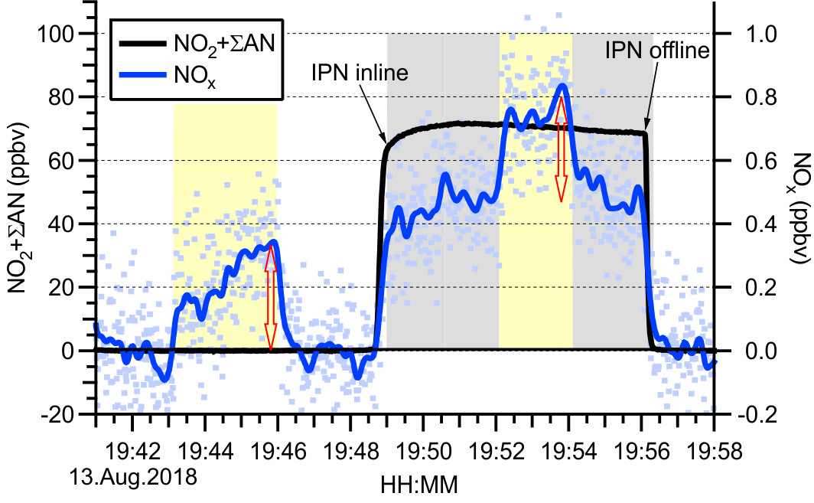
Figure S2. Time series of NO production in zero air and from isopropyl nitrate photolysis. The 1 sec NO_{x} data are shown in light blue. The solid blue line was obtained after applying a 60 sec binomial filter to the 1 sec data. The arrow (shown in red color) indicates the size of the UV artifact. Flow rate = 0.90 slpm. Pressure = 478 Torr.

Nitrous acid. As outlined in the main manuscript, HONO is a molecule expected to directly interfere in the photolytic conversion of NO₂. Figure S3 shows a time series probing this interference experimentally. About 40% of HONO was expected to convert with the converter residence time set at 3.6 sec, equivalent to a photolysis frequency of 0.14 sec⁻¹ (Table 2). From 18:09 to 18:13, the output of the diffusion source was sampled in parallel by the CEAS (which was teed in prior to the photolytic converter), a regular CRDS (NO₂) channel, and a TD-CRDS channel operated at 600 °C and with O₃ after the quartz tube to oxidize the thermal dissociation product of HONO, NO, to NO₂; this channel corresponds to an NO_{y} measurement.⁷ In this example, the diffusion source emitted a mixture of HONO (0.6±0.1 ppbv) and HNO₃ (0.5±0.1 ppbv) and a negligible amount of NO_{x} (0.01±0.05 ppbv). Following a brief zeroing period, the two CRDS channels sampled through the converter at 18:15, which was turned on at 18:16:30, while the CEAS continued to sample the test gas mixture entering the photolytic converter. At 18:19, the O₃ addition was switched from the NO_{y} to the NO₂ channel, converting the latter into a NO_{x} measurement. An average of (0.75±0.05) ppbv of NO_{x} was observed. Subtracting a UV-induced-artifact of ~(0.3±0.1) ppbv (Figure S2) and subtracting the amount of NO_{x} produced from HNO₃, calculated assuming that ~14% (see section titled "HNO₃" below) of the (0.5±0.1) ppbv HNO₃ converted to NO_{x}, or (0.07±0.02) ppbv) suggests that (0.38±0.11) ppbv of NO was produced from HONO, a yield of (63±21)%.
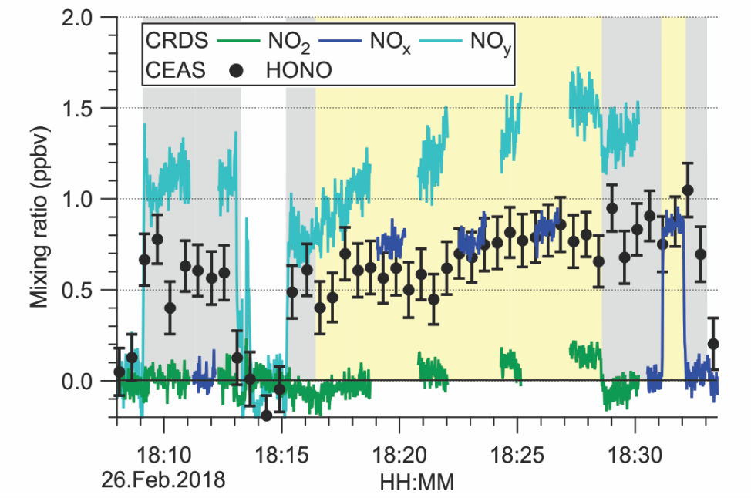
Figure S3. Photochemical conversion of HONO to NO. At 18:09, the CRDS and CEAS sampled the HONO source, which emitted ~0.6 ppbv of HONO (shown in black), ~0.0 ppbv NO₂ (shown in green) and NO_{x} (shown in blue), and ~0.5 ppbv of HNO₃ (calculated relative to NO_{y}). The instruments sampled zero air from 18:13 to 18:15. At 18:15:15, the CRDS sampled through the converter (Pressure ~580 Torr; residence time ~3.6 sec), which was turned on at 18:16:30.

The experiment shown in Figure S3 was repeated with shorter photolysis residence times. A fit of eq 7 (with k[Ox] = 0 sec⁻¹) to a plot of NO against t_{res} (not shown) indicates a HONO photolysis frequency of 0.25 sec⁻¹, slightly larger than predicted from the overlap of the LED emission spectrum with the absorption spectrum of HONO.

PAN. Reed et al.⁸ examined interferences in their photolytic converter and reported thermal dissociation of PAN to NO₂, leading to measurement artifacts that are highly elevated in remote environments.
CH₃C(O)O₂NO₂ ⇌ CH₃C(O)O₂ + NO₂ (12)
Hence, the stability of PAN within the converter was investigated. Figure S4 shows a time series of the response to sampling PAN. Here, one of the TD-CRDS quartz inlets was heated to 250 °C; this channel was used to monitor NO₂+ΣPAN (shown in red color) ⁹, while O₃ was added to the other CRDS channel which monitored NO_{x} (shown in blue color). Both channels sampled through the converter. After the usual zeroing period, (18.8±0.1) ppbv of PAN were added to the inlet at 22:54. The LEDs were turned on at 22:56. Initially, there was no change, but over time, the observed NO₂+ΣPAN mixing ratio decreased, while the NO_{x} mixing ratio increased.
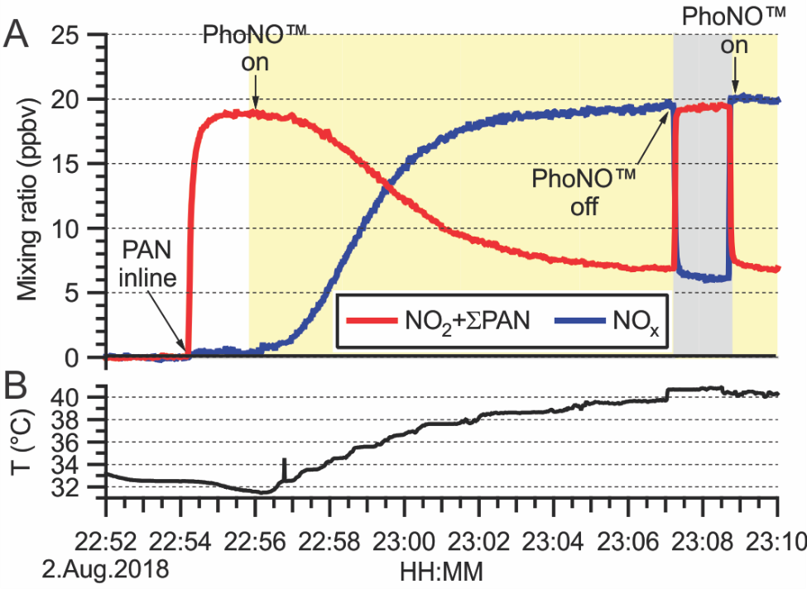
Figure S4. (a) Time series of NO₂+ΣPAN (shown in red color) and of NO_{x} (shown in blue color). (18.8±0.1) ppbv of PAN were added at 22:54. The converter was operated at a pressure of 417 Torr (3.3 sec residence time) and turned on at 22:56. Over time, more and more PAN dissociated to NO₂, which photodissociated and was observed as NO in the NO_{x} channel. When the converter was turned off at 23:07, (19.3±0.1) ppbv of NO₂+ΣPAN and 6.2±0.2 NO_{x} (NO₂) were observed. The amount of NO₂ was less during this time than before because the thermal dissociation of PAN is reversible; the NO generated by photolysis titrates the PA radical, speeding up the thermal dissociation. (b) Time series of temperature next to the photoreactor cell, measured using a K-type thermocouple inserted into the converter.

Shown in the bottom panel of Figure S4 is the corresponding time series of temperature, measured via a K-type thermocouple whose junction was located on the outside of the photolysis cell. The decrease in NO₂+ΣPAN was accompanied by an increase in temperature, thermally dissociating higher amounts of PAN to NO₂, which in turn photodissociated to NO and was observed in the NO_{x} channel.
When the converter was turned off at 23:07, (19.3±0.1) ppbv of NO₂+ΣPAN and (6.2±0.2) NO_{x} (mostly NO₂) were observed. From the extent of thermal dissociation (~31% dissociated at 23:08) and using a recent expression for TD of PAN, 2.8×10¹⁶ sec⁻¹ × e^{(-113 kJ/mol)/(RT)}, ¹⁰ and a residence time of 3.3 sec, we estimate that the internal temperature within the photolysis chamber in this particular experiment was 66 °C. However, this temperature is a lower estimate since the reverse of reaction (12) converts some NO₂ back to PAN. The converter's LEDs are cooled using high-efficiency fans; these likely have transferred some of the heat to the surrounding tubing, such that the effective residence time was likely longer (and the temperature needed to achieve the effect lower).
When the converter's LEDs were turned back on at 23:09, the ratio of NO₂+ΣPAN to NO_{x} (=NO) was considerably lower (~66% dissociated), consistent with an internal temperature of 75 °C. The greater extent of dissociation is rationalized by photodissociation of NO₂ to NO which in turn titrates the PA radical, driving equilibrium (12) towards the right, i.e., towards dissociation.
CH₃C(O)O₂ + NO $\underset{→}{O_{2}}$ CH₃O₂ + CO₂ + NO₂ (13)
CH₃O₂ + NO$\underset{→}{O_{2}}$ HCHO + HO₂ + NO₂ (14)

Nitric acid. Figure S5 shows a time series of an experiment in which the photo-conversion of HNO₃ was investigated. A challenge with HNO₃ was its slow equilibration with respect to partitioning to the inner walls of the Teflon™ tubing, manifesting itself with long equilibration times before stable mixing ratios were observed. An additional complication was that the permeation tube co-emitted some NO and NO₂.

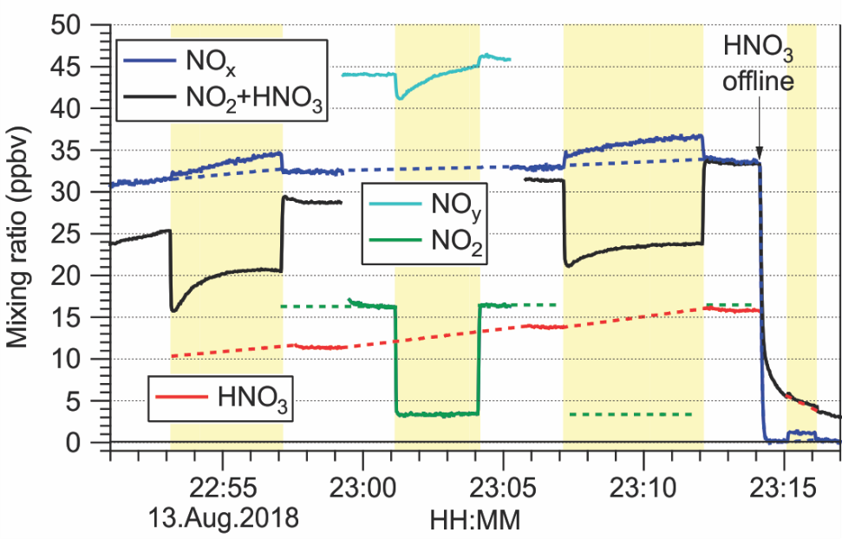

Figure S5. Time series of NO production from HNO₃ photolysis at a cell pressure of 480 Torr. The solid lines indicate observed data, whereas the dashed lines indicate interpolated data.

In the experiment shown in Figure S5, the CRDS sampled the output of the Dynacalibrator from 22:43 onwards (the time series was truncated for clarity). One CRDS channel was operated in NO_{x} mode (i.e., with O₃), while the other sampled from a quartz inlet heated to 600 °C and quantified NO₂+HNO₃. From 22:59 to 23:06, the O₃ addition point was switched, such that one channel quantified NO₂ and the other NO_{y}. Between 22:58 and 23:00, the following mixing ratios were observed: NO_{x} = 32.6 ppbv, NO₂ = 16.2 ppbv, and NO_{y} = 44.1 ppbv. From this, we calculate NO = NO_{x} - NO₂ = 16.4 ppbv and NO_{z} = NO_{y} - NO_{x} = 11.5 ppbv ≈ HNO₃. The NO₂+HNO₃ channel measured 28.8 ppbv, which is greater than the sum of NO₂ and NO_{z} (27.7 ppbv); this difference is due to partial oxidation of NO in the quartz inlet heated to 600 °C.
When the converter's LEDs were turned on at 22:53 and again at 23:07, the mixing ratio in the NO_{x} channel increased by up to 2.7 ppbv, indicating that a molecule other than NO₂ photo-dissociated to NO. The response was not instantaneous. Rather, the NO_{x} mixing ratio slowly increased during the irradiation. The NO₂+HNO₃ signal, while not quantitative, showed an initial sharp decrease in signal, which was followed by what seemed like a recovery period. The decrease in signal is mainly due to NO₂ photolysis but was less (maximum of ~9 and ~10 ppbv) than the decrease observed in the pure NO₂ channel at 23:02 (~15.4 ppbv). It is unclear if this shape is due to a process in the heated quartz inlet of the TD-CRDS or if it is the result of a process within the converter, or a combination thereof.
The NO_{y} signal observed during the photolysis period from 23:01 to 23:04 showed an initial decrease and a recovery qualitatively similar to what was observed in the NO₂+HNO₃ channel. In contrast, the change in NO₂ mixing ratio (by 12.9 ppbv), when the LEDs were switched on or off, was immediate and constant.
When the source was taken offline at 23:13, HNO₃ was still observed as it outgassed from the inner walls of the Teflon™ tubing. Most of this HNO₃ originated from the transfer tubing between the calibration gas addition point and the flow restriction (as this region has a larger surface area); it is therefore likely that this concentration was also flowing through the converter. No other components of NO_{y} (e.g., NO, NO₂, or HONO) would have been present during this time as they are all "better behaved" on Teflon™ tubing. At 23:15, the LEDs were turned on one more time, and an increase of 1.1 ppbv of NO_{x} was observed. The ratio of produced NO_{x} to gas-phase HNO₃ was ~0.14 in this experiment.
The experiment was repeated the following day with higher HNO₃ mixing ratios (up to 28 ppbv). When the converter's LEDs were turned on, NO_{x} mixing ratios increased by up to 1.6 ppbv (ratio relative to HNO₃ of ~0.06). This shows that the amount of NO_{x} produced does not scale with the gas-phase HNO₃ concentration entering the photolysis cell and suggests that the observed NO_{x} was likely generated by a surface-driven process.

References

1. Mielke, L. H.; Osthoff, H. D., On quantitative measurements of peroxycarboxylic nitric anhydride mixing ratios by thermal dissociation chemical ionization mass spectrometry. Int. J. Mass Spectrom. 2012, 310, 1-9.
2. Ye, C. Z. Development of Purge-and-Trap Sample Preconcentrator for Enhanced Detection of Alkyl Nitrates by Thermal Dissociation Cavity Ring-Down Spectroscopy. University of Calgary, http://hdl.handle.net/11023/3510, 10.5072/PRISM/25688, Calgary, 2016.
3. Atkinson, R.; Baulch, D. L.; Cox, R. A.; Hampson, R. F.; Kerr, J. A.; Troe, J., Evaluated Kinetic And Photochemical Data For Atmospheric Chemistry.3. Iupac Subcommittee On Gas Kinetic Data Evaluation For Atmospheric Chemistry. J. Phys. Chem. Ref. Data 1989, 18 (2), 881-1097.
4. Burkholder, J. B.; Sander, S. P.; Abbatt, J. P. D.; Barker, J. R.; Huie, R. E.; Kolb, C. E.; Kurylo, M. J.; Orkin, V. L.; Wilmouth, D. M.; Wine, P. H., Chemical Kinetics and Photochemical Data for Use in Atmospheric Studies, Evaluation Number 18. National Aeronautics and Space Administration, Jet Propulsion Laboratory, California Institute of Technology: Pasadena, California, 2015.
5. Atkinson, R.; Baulch, D. L.; Cox, R. A.; Crowley, J. N.; Hampson, R. F.; Hynes, R. G.; Jenkin, M. E.; Rossi, M. J.; Troe, J., Evaluated kinetic and photochemical data for atmospheric chemistry: Volume I - gas phase reactions of O_{x}, HO_{x}, NO_{x} and SO_{x} species. Atmos. Chem. Phys. 2004, 4, 1461-1738.
6. England, C.; Corcoran, W. H., The Rate and Mechanism of the Air Oxidation of Parts-per-Million Concentrations of Nitric Oxide in the Presence of Water Vapor. Ind. Eng. Chem. Fundamen. 1975, 14 (1), 55-63.
7. Wild, R. J.; Edwards, P. M.; Dube, W. P.; Baumann, K.; Edgerton, E. S.; Quinn, P. K.; Roberts, J. M.; Rollins, A. W.; Veres, P. R.; Warneke, C.; Williams, E. J.; Yuan, B.; Brown, S. S., A Measurement of Total Reactive Nitrogen, NO_{y}, together with NO₂, NO, and O₃ via Cavity Ring-down Spectroscopy. Environm. Sci. Technol. 2014, 48 (16), 9609-9615.
8. Reed, C.; Evans, M. J.; Di Carlo, P.; Lee, J. D.; Carpenter, L. J., Interferences in photolytic NO₂ measurements: explanation for an apparent missing oxidant? Atmos. Chem. Phys. 2016, 16 (7), 4707-4724.
9. Paul, D.; Osthoff, H. D., Absolute Measurements of Total Peroxy Nitrate Mixing Ratios by Thermal Dissociation Blue Diode Laser Cavity Ring-Down Spectroscopy. Anal. Chem. 2010, 82 (15), 6695-6703.
10. Kabir, M.; Jagiella, S.; Zabel, F., Thermal Stability of n-Acyl Peroxynitrates. Internat. J. Chem. Kin. 2014, 46 (8), 462-469.

