Supplementary information to the paper
Aartsma et al. Surface albedo of alpine lichen heaths and shrub vegetation. Arctic, Antarctic, and Alpine Research.

Appendix S1. Picture of the set up for the field study. The radiometer in the front measures the albedo of a lichen-dominated plot and the radiometer in the back measures the albedo of a shrub-dominated plot. The radiometers are directed to the south.

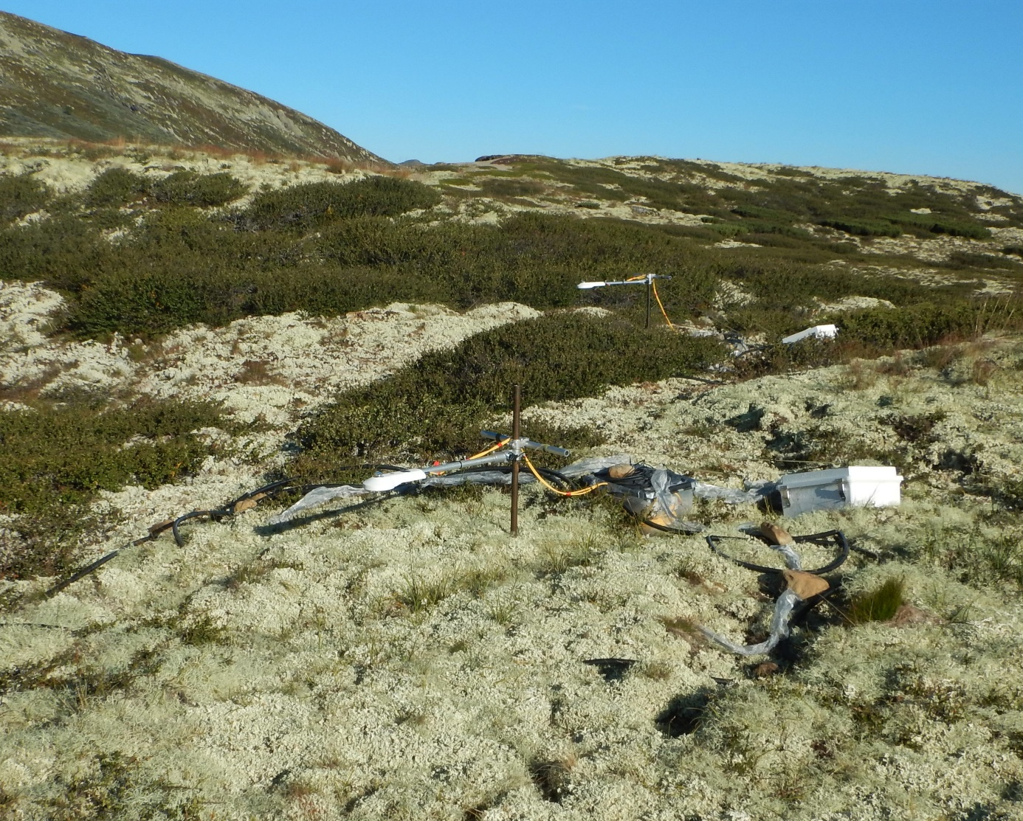

Supplementary information to the paper
Aartsma et al. Surface albedo of alpine lichen heaths and shrub vegetation. Arctic, Antarctic, and Alpine Research.

Appendix S2. Examples of daily variation of 2 paired lichen- and shrub plots. Measurements between the dashed lines (9:00 and 18:00 hours) were used for the analyses.
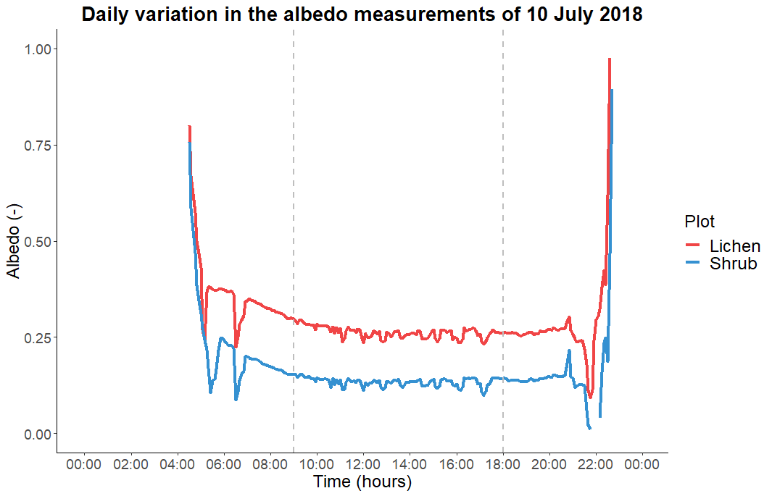
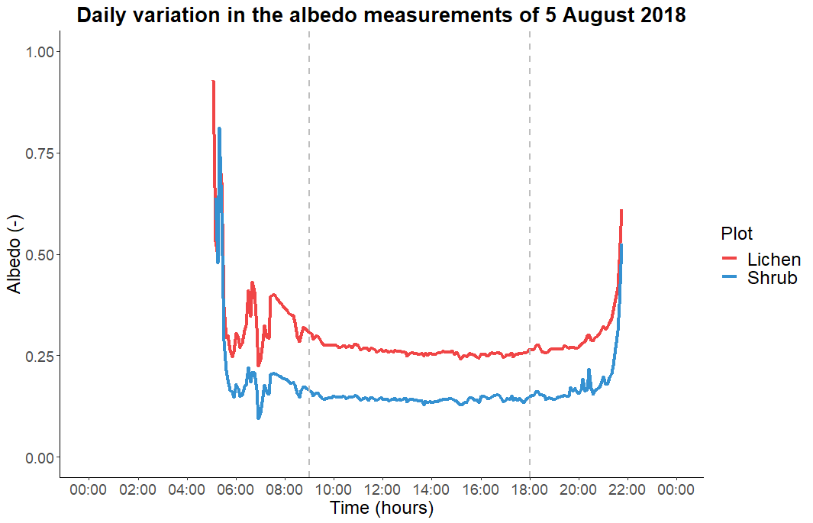
Supplementary information to the paper
Aartsma et al. Surface albedo of alpine lichen heaths and shrub vegetation. Arctic, Antarctic, and Alpine Research.

Appendix S3. Difference between the albedo of the randomly selected half an hour and the two-day average albedo.
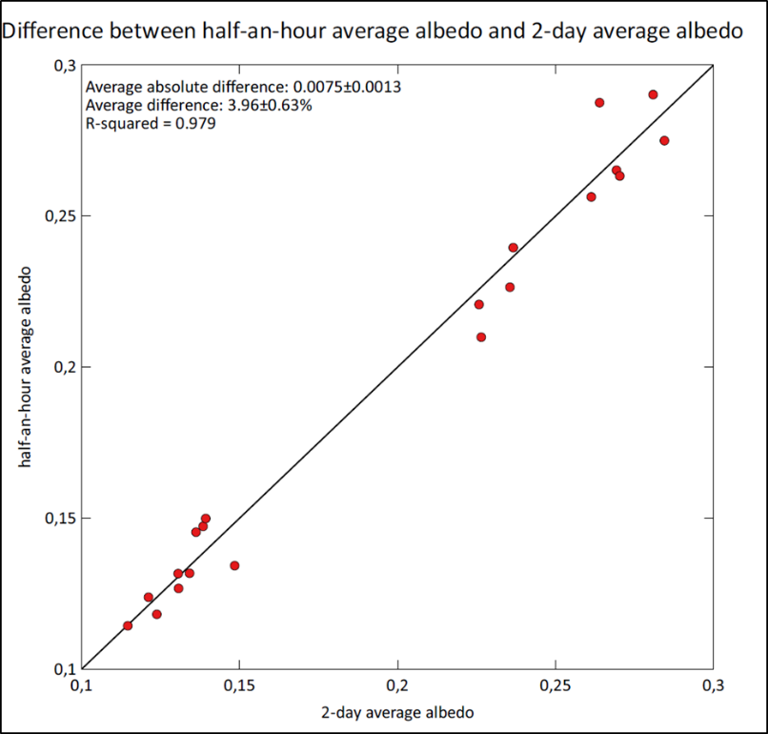

Supplementary information to the paper
Aartsma et al. Surface albedo of alpine lichen heaths and shrub vegetation. Arctic, Antarctic, and Alpine Research.

Appendix S4. Relation between cloud cover and the albedo of the two-day plots

The two-day plots have been measured for two days. Therefore, the only difference between the measurements of both days per plot, are the weather conditions. We estimated cloud cover between 9:00 and 18:00 with a three hour interval at a standard octal scale of 0/8 (clear sky) to 8/8 (complete overcast). To determine the influence of the cloud cover on the albedo, we calculated the difference in average daily cloud cover between the two measurement days per plot. We correlated this difference in cloud cover with the difference in average daily albedo between the two measurement days per plot. The correlation between the difference in cloud cover and the difference in lichen albedo was -0.064. The correlation between the difference in cloud cover and the difference in shrub albedo was -0.13. These low correlations imply that the cloud cover did not have an influence on the measured albedo.
 | ________Cloud cover______ |  |  |  | ________Lichen albedo______ |  |  |  | ________Shrub albedo_______
Plot | Day 1 | Day 2 | Difference |  | Day 1 | Day 2 | Difference |  | Day 1 | Day 2 | Difference
1 | 0.75 | 0.50 | 0.25 |  | 0.226 | 0.227 | -0.001 |  | 0.123 | 0.124 | 0.001
2 | 0.00 | 0.25 | -0.25 |  | 0.227 | 0.224 | 0.003 |  | 0.131 | 0.131 | 0.000
3 | 4.75 | 6.75 | -2.00 |  | 0.263 | 0.260 | 0.002 |  | 0.134 | 0.134 | 0.000
4 | 3.75 | 4.00 | -0.25 |  | 0.244 | 0.227 | 0.016 |  | 0.116 | 0.113 | 0.003
5 | 0.25 | 3.75 | -3.50 |  | 0.280 | 0.289 | -0.008 |  | 0.140 | 0.137 | 0.004
6 | 4.00 | 3.00 | 1.00 |  | 0.238 | 0.235 | 0.002 |  | 0.122 | 0.120 | 0.001
7 | 5.00 | 6.25 | -1.25 |  | 0.282 | 0.280 | 0.002 |  | 0.136 | 0.136 | 0.000
8 | 7.50 | 4.50 | 3.00 |  | 0.265 | 0.274 | -0.008 |  | 0.131 | 0.130 | 0.000
9 | 5.75 | 5.25 | 0.50 |  | 0.262 | 0.266 | -0.004 |  | 0.144 | 0.135 | 0.009
10 | 6.25 | 3.00 | 3.25 |  | 0.270 | 0.270 | 0.000 |  | 0.148 | 0.149 | 0.000

Supplementary information to the paper
Aartsma et al. Surface albedo of alpine lichen heaths and shrub vegetation. Arctic, Antarctic, and Alpine Research.

Appendix S5: To analyze if the zenith angle has a structural influence on the albedo of our lichen plots, we compared the albedo of the random 30 min period with the average albedo around solar noon (minimum zenith angles) of the same day. If the zenith angle has a structural influence, we would expect that the difference in albedo between these two periods would increase with increasing difference in zenith angle. However, the figure and linear regression show no systematic relation between the two variables (R-squared: 0.09, p-value=0.40).
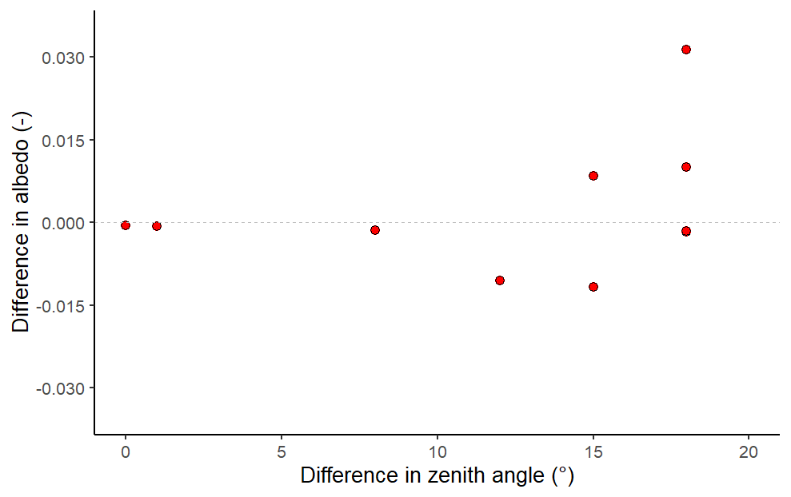

Supplementary information to the paper
Aartsma et al. Surface albedo of alpine lichen heaths and shrub vegetation. Arctic, Antarctic, and Alpine Research.

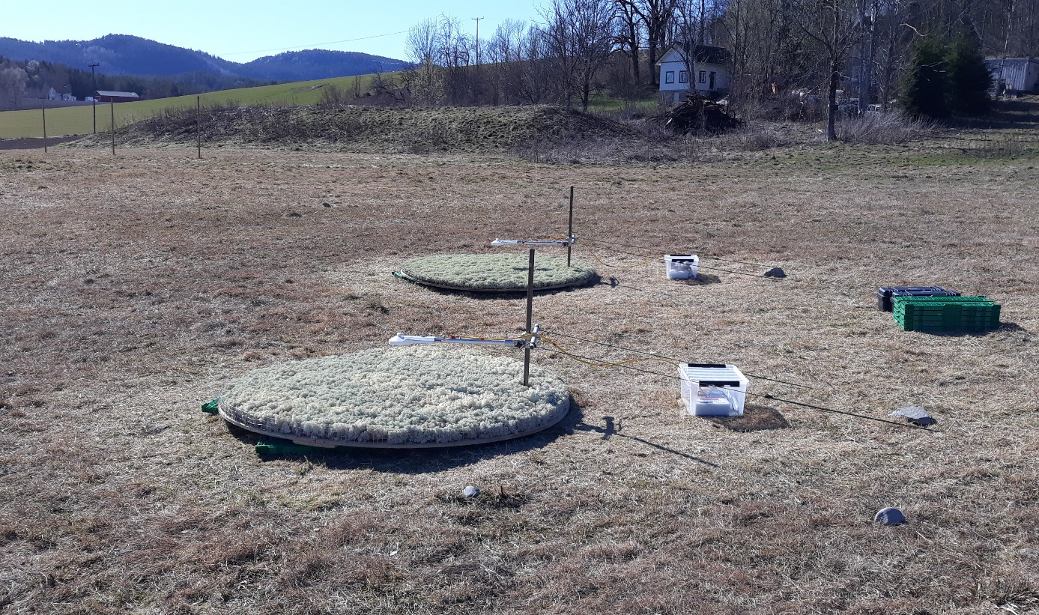
Appendix S6. Picture of the set up for the controlled experiment. The radiometer in the front measures the albedo of Cladonia stellaris and the radiometer in the back measures the albedo of Flavocetraria nivalis. The radiometers are directed to the south.

Supplementary information to the paper
Aartsma et al. Surface albedo of alpine lichen heaths and shrub vegetation. Arctic, Antarctic, and Alpine Research.

Appendix S7. Species composition of the two-day plots in percentages. Plot numbers starting with an L are lichen-dominated plots and plot numbers starting with an S are shrub-dominated plots. Lichen and shrub plots with the same number are paired. Column headers consist of the first three letters of the genus and the first three letters of the species (see supplementary information 9 for clarification).
Plot  nr | Fla  niv | Fla  cuc | Ale  och | Cla  arb | Cla  ran | Cla  gra | Cet  eri | Cet  isl | Cla  ste | Cla  unc | Bry  div | Tha  ver | Cla  sp | Ste  sp | Ale  nig | Bet  nan | Emp  nig | Vac  myr | Vac  vit | Vac  uli | Ave  fle | Fes  ovi | Car  big | Jun  tri | Loi  pro | Arc  alp | Tri  eup | Dip  alp | Sol  vir
L1 | 30 | 5 | 5 | 20 | 20 | 15 | 10 | 0 | 25 | 5 | 0 | 1 | 0 | 0 | 0 | 20 | 5 | 0 | 1 | 0 | 1 | 1 | 0 | 5 | 1 | 0 | 0 | 0 | 0
L2 | 20 | 5 | 0 | 15 | 30 | 15 | 10 | 0 | 20 | 10 | 0 | 1 | 5 | 0 | 0 | 10 | 5 | 0 | 5 | 0 | 0 | 0 | 0 | 5 | 10 | 5 | 0 | 0 | 0
L3 | 60 | 15 | 45 | 15 | 5 | 10 | 15 | 0 | 5 | 5 | 5 | 5 | 5 | 0 | 0 | 10 | 15 | 0 | 0 | 0 | 5 | 0 | 5 | 1 | 15 | 5 | 0 | 0 | 0
L4 | 15 | 0 | 0 | 60 | 10 | 20 | 30 | 0 | 50 | 30 | 0 | 1 | 10 | 5 | 0 | 0 | 15 | 0 | 1 | 5 | 10 | 0 | 1 | 5 | 0 | 0 | 0 | 5 | 0
L5 | 70 | 20 | 20 | 5 | 5 | 5 | 5 | 0 | 0 | 0 | 5 | 5 | 0 | 1 | 0 | 5 | 25 | 0 | 0 | 0 | 0 | 0 | 0 | 5 | 30 | 0 | 0 | 0 | 0
L6 | 70 | 15 | 45 | 5 | 5 | 10 | 15 | 0 | 25 | 5 | 5 | 1 | 0 | 0 | 0 | 10 | 15 | 5 | 5 | 0 | 0 | 0 | 0 | 0 | 0 | 0 | 0 | 0 | 0
L7 | 85 | 20 | 55 | 5 | 0 | 5 | 5 | 0 | 0 | 0 | 5 | 10 | 0 | 0 | 1 | 5 | 15 | 0 | 5 | 0 | 1 | 5 | 0 | 0 | 0 | 5 | 0 | 0 | 0
L8 | 90 | 5 | 60 | 5 | 0 | 0 | 5 | 0 | 0 | 0 | 10 | 5 | 0 | 0 | 1 | 5 | 5 | 0 | 5 | 0 | 0 | 5 | 10 | 5 | 0 | 0 | 0 | 0 | 0
L9 | 85 | 20 | 65 | 15 | 5 | 15 | 5 | 0 | 5 | 5 | 5 | 5 | 0 | 0 | 1 | 10 | 5 | 0 | 5 | 0 | 0 | 5 | 5 | 0 | 0 | 5 | 0 | 0 | 0
L10 | 85 | 15 | 35 | 5 | 5 | 5 | 10 | 0 | 5 | 0 | 5 | 5 | 0 | 0 | 0 | 10 | 5 | 0 | 1 | 0 | 5 | 5 | 10 | 5 | 0 | 0 | 0 | 0 | 0
S1 | 1 | 0 | 0 | 5 | 5 | 5 | 0 | 10 | 10 | 0 | 0 | 0 | 0 | 0 | 0 | 85 | 40 | 0 | 10 | 0 | 1 | 0 | 0 | 0 | 0 | 0 | 0 | 0 | 0
S2 | 0 | 1 | 0 | 5 | 5 | 5 | 0 | 20 | 10 | 0 | 0 | 0 | 0 | 0 | 0 | 75 | 45 | 15 | 10 | 5 | 10 | 0 | 0 | 0 | 0 | 0 | 0 | 0 | 0
S3 | 5 | 5 | 5 | 10 | 15 | 5 | 0 | 15 | 20 | 0 | 1 | 0 | 0 | 0 | 0 | 75 | 30 | 5 | 10 | 1 | 5 | 0 | 5 | 0 | 0 | 0 | 0 | 0 | 0
S4 | 0 | 0 | 0 | 5 | 5 | 1 | 0 | 40 | 0 | 1 | 0 | 0 | 0 | 1 | 0 | 85 | 50 | 0 | 25 | 0 | 10 | 0 | 0 | 0 | 0 | 0 | 5 | 0 | 0
S5 | 0 | 0 | 0 | 5 | 5 | 5 | 0 | 10 | 15 | 0 | 0 | 0 | 0 | 0 | 0 | 85 | 60 | 0 | 20 | 0 | 10 | 0 | 0 | 0 | 0 | 0 | 0 | 0 | 0
S6 | 1 | 0 | 0 | 10 | 5 | 5 | 0 | 25 | 10 | 0 | 0 | 0 | 0 | 0 | 0 | 65 | 70 | 0 | 10 | 0 | 5 | 0 | 0 | 0 | 0 | 0 | 0 | 0 | 0
S7 | 5 | 5 | 0 | 10 | 5 | 5 | 0 | 10 | 10 | 0 | 0 | 0 | 0 | 0 | 0 | 95 | 0 | 0 | 15 | 0 | 5 | 0 | 1 | 0 | 0 | 0 | 5 | 0 | 0
S8 | 1 | 5 | 0 | 10 | 5 | 10 | 0 | 25 | 20 | 5 | 0 | 0 | 0 | 0 | 0 | 80 | 20 | 0 | 5 | 0 | 5 | 0 | 0 | 0 | 0 | 0 | 0 | 0 | 0
S9 | 5 | 5 | 0 | 15 | 5 | 10 | 0 | 35 | 10 | 0 | 0 | 0 | 0 | 0 | 0 | 90 | 25 | 1 | 10 | 0 | 5 | 0 | 0 | 0 | 0 | 0 | 5 | 0 | 0
S10 | 1 | 5 | 0 | 10 | 10 | 15 | 20 | 35 | 0 | 0 | 0 | 0 | 0 | 0 | 0 | 90 | 0 | 0 | 10 | 0 | 10 | 0 | 1 | 1 | 5 | 0 | 0 | 0 | 0

Supplementary information to the paper
Aartsma et al. Surface albedo of alpine lichen heaths and shrub vegetation. Arctic, Antarctic, and Alpine Research.

Appendix S8. Species composition of the 30 min plots in percentages. Plot numbers starting with an L are lichen-dominated plots and plot numbers starting with an S are shrub-dominated plots. Lichen and shrub plots with the same number are paired. Column headers consist of the first three letters of the genus and the first three letters of the species (see supplementary information 9 for clarification).
Plot  nr | Fla  niv | Fla  cuc | Ale  och | Cla  arb | Cla  ran | Cla  gra | Cet  eri | Cet  isl | Cla  ste | Cla  unc | Bry  div | Tha  ver | Cla  sp | Ste  sp | Ale  nig | Bet  nan | Emp  nig | Vac  myr | Vac  vit | Vac  uli | Ave  fle | Fes  ovi | Car  big | Jun  tri | Loi  pro | Arc  alp | Tri  eup | Dip  alp | Sol  vir
L101 | 70 | 20 | 15 | 5 | 5 | 10 | 5 | 0 | 10 | 0 | 1 | 0 | 0 | 0 | 1 | 10 | 1 | 0 | 0 | 0 | 10 | 5 | 5 | 0 | 0 | 0 | 0 | 0 | 0
L102 | 65 | 10 | 0 | 25 | 25 | 10 | 20 | 0 | 55 | 0 | 0 | 0 | 5 | 0 | 0 | 15 | 5 | 0 | 0 | 0 | 5 | 0 | 5 | 0 | 0 | 0 | 0 | 0 | 0
L103 | 30 | 10 | 15 | 15 | 20 | 10 | 10 | 0 | 20 | 0 | 1 | 0 | 1 | 0 | 0 | 15 | 10 | 0 | 5 | 0 | 1 | 1 | 5 | 0 | 0 | 0 | 0 | 0 | 0
L104 | 60 | 10 | 70 | 1 | 0 | 0 | 10 | 0 | 0 | 0 | 15 | 1 | 1 | 0 | 0 | 10 | 5 | 0 | 0 | 0 | 0 | 5 | 10 | 5 | 0 | 0 | 0 | 0 | 0
L105 | 60 | 10 | 30 | 10 | 5 | 0 | 15 | 0 | 10 | 0 | 5 | 0 | 0 | 0 | 0 | 0 | 20 | 0 | 5 | 0 | 1 | 5 | 10 | 5 | 0 | 0 | 0 | 0 | 0
L106 | 55 | 25 | 40 | 10 | 15 | 0 | 15 | 0 | 30 | 0 | 5 | 0 | 0 | 0 | 1 | 20 | 1 | 0 | 1 | 0 | 10 | 0 | 5 | 1 | 0 | 0 | 0 | 0 | 0
L107 | 35 | 5 | 0 | 45 | 15 | 15 | 10 | 0 | 60 | 10 | 0 | 0 | 1 | 0 | 0 | 25 | 0 | 0 | 0 | 0 | 5 | 0 | 5 | 5 | 20 | 0 | 0 | 0 | 0
L108 | 65 | 15 | 20 | 10 | 10 | 5 | 20 | 0 | 0 | 0 | 5 | 5 | 0 | 0 | 0 | 10 | 10 | 0 | 5 | 0 | 0 | 5 | 5 | 10 | 5 | 0 | 0 | 0 | 0
L109 | 30 | 35 | 10 | 10 | 5 | 5 | 5 | 0 | 1 | 10 | 5 | 0 | 0 | 0 | 1 | 5 | 10 | 0 | 0 | 5 | 0 | 1 | 5 | 1 | 5 | 10 | 0 | 0 | 0
L110 | 75 | 5 | 50 | 5 | 1 | 0 | 10 | 0 | 5 | 0 | 10 | 5 | 0 | 0 | 0 | 0 | 0 | 0 | 15 | 0 | 0 | 5 | 5 | 0 | 0 | 0 | 0 | 0 | 0
S101 | 1 | 0 | 0 | 10 | 1 | 0 | 0 | 5 | 5 | 0 | 0 | 0 | 0 | 0 | 0 | 95 | 0 | 10 | 5 | 0 | 5 | 5 | 1 | 0 | 0 | 0 | 0 | 0 | 0
S102 | 0 | 0 | 0 | 5 | 0 | 0 | 0 | 25 | 5 | 0 | 0 | 0 | 0 | 0 | 0 | 80 | 50 | 5 | 10 | 0 | 10 | 0 | 1 | 0 | 0 | 0 | 5 | 0 | 0
S103 | 0 | 0 | 0 | 1 | 1 | 20 | 0 | 25 | 0 | 0 | 0 | 0 | 0 | 0 | 0 | 85 | 50 | 10 | 5 | 0 | 15 | 0 | 0 | 0 | 0 | 0 | 0 | 0 | 0
S104 | 0 | 1 | 0 | 1 | 5 | 5 | 0 | 20 | 15 | 0 | 0 | 0 | 0 | 0 | 0 | 85 | 0 | 25 | 5 | 0 | 10 | 0 | 0 | 0 | 0 | 0 | 5 | 0 | 0
S105 | 5 | 5 | 0 | 5 | 1 | 5 | 0 | 10 | 0 | 0 | 0 | 0 | 0 | 0 | 0 | 90 | 5 | 0 | 5 | 0 | 15 | 5 | 5 | 1 | 0 | 1 | 5 | 0 | 5
S106 | 0 | 0 | 0 | 1 | 0 | 5 | 0 | 15 | 0 | 0 | 0 | 0 | 0 | 0 | 0 | 90 | 60 | 20 | 15 | 10 | 25 | 0 | 0 | 0 | 0 | 0 | 0 | 0 | 0
S107 | 0 | 0 | 0 | 5 | 0 | 0 | 0 | 10 | 5 | 0 | 0 | 0 | 0 | 0 | 0 | 90 | 50 | 15 | 10 | 0 | 5 | 0 | 0 | 1 | 0 | 0 | 0 | 0 | 0
S108 | 5 | 0 | 0 | 15 | 5 | 10 | 0 | 30 | 10 | 5 | 0 | 0 | 0 | 0 | 0 | 85 | 0 | 0 | 30 | 0 | 5 | 5 | 0 | 1 | 0 | 0 | 0 | 0 | 0
S109 | 5 | 15 | 5 | 5 | 1 | 5 | 5 | 0 | 1 | 0 | 0 | 0 | 0 | 0 | 0 | 80 | 15 | 0 | 5 | 5 | 0 | 5 | 5 | 0 | 0 | 0 | 5 | 0 | 0
S110 | 1 | 5 | 0 | 5 | 5 | 5 | 0 | 35 | 10 | 0 | 0 | 0 | 0 | 0 | 0 | 95 | 0 | 0 | 10 | 0 | 5 | 0 | 1 | 0 | 0 | 0 | 0 | 0 | 0

Supplementary information to the paper
Aartsma et al. Surface albedo of alpine lichen heaths and shrub vegetation. Arctic, Antarctic, and Alpine Research.

Appendix S9. Clarification of the species labels in the DCA diagram, Supplementary Information 7 and Supplementary Information 8.

Alenig | Alectoria nigricans
Aleoch | Alectoria ochroleuca
Brydiv | Bryocaulon divergens
Ceteri | Cetraria ericetorum
Cetisl | Cetraria islandica
Claarb | Cladonia arbuscula
Clagra | Cladonia gracilis
Claran | Cladonia rangiferina
Clasp | Cladonia sp.
Claste | Cladonia stellaris
Claunc | Cladonia uncialis
Flacuc | Flavocetraria cucullata
Flaniv | Flavocetraria nivalis
Stesp | Stereocaulon sp.
Thaver | Thamnolia vermicularis
Arcalp | Arctous alpinous
Avefle | Avenella flexuosa
Betnan | Betula nana
Carbig | Carex bigelowii
Dipalp | Diphasiastrum alpinum
Empnig | Empetrum nigrum
Fesovi | Festuca ovina
Juntri | Juncus trifidus
Loipro | Loiseleuria procumbens
Solvir | Solidago virgaurea
Trieup | Trientalis europaea
Vacmyr | Vaccinium myrtillus
Vaculi | Vaccinium uliginosum
Vacvit | Vaccinium vitis-idaea

Supplementary information to the paper
Aartsma et al. Surface albedo of alpine lichen heaths and shrub vegetation. Arctic, Antarctic, and Alpine Research.

Appendix S10. Difference in albedo between the paired measurements of the two lichen species for all measurements grouped by the distribution of the radiometers.
Distribution A: radiometer 1 above Cladonia stellaris, radiometer 2 above Flavocetraria nivalis.
Distribution B: radiometer 1 above Flavocetraria nivalis, radiometer 2 above Cladonia stellaris.
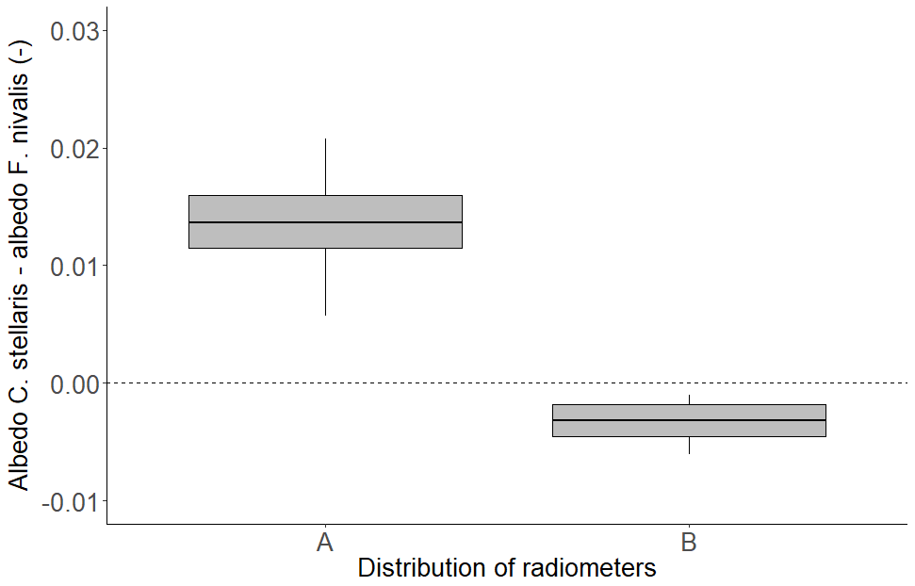

Supplementary information to the paper
Aartsma et al. Surface albedo of alpine lichen heaths and shrub vegetation. Arctic, Antarctic, and Alpine Research.

Appendix S11. Schematic drawing of a south-facing set-up (left) and a north-facing set-up (right). The measured incoming shortwave radiation (orange, dotted arrow) is for both situations the same because the sensors are placed in a levelled position. However, the actual incoming shortwave radiation (yellow, gridded arrow) reaching the vegetation is higher for the south-facing set-up than for the north-facing set-up. The measured incoming shortwave radiation is therefore underestimated for the south-facing situation and overestimated for the north-facing situation. Consequently, we calculated a higher albedo for south-facing plots than for north-facing plots.

North
North

