a

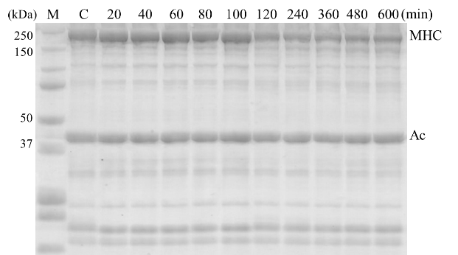

b

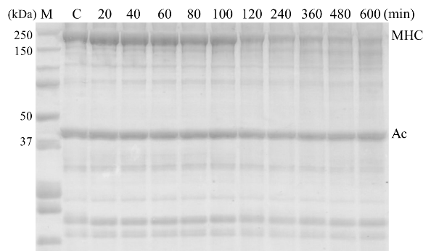

c

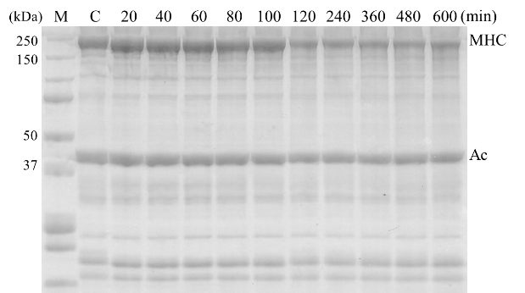

d

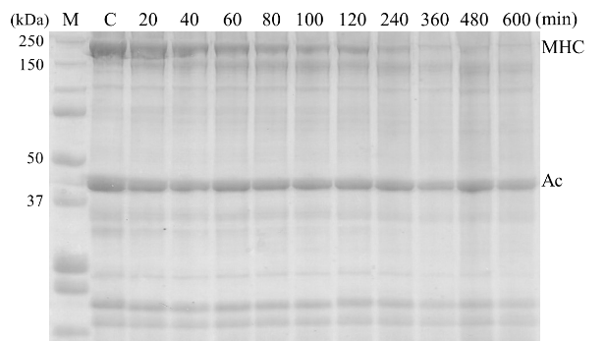

e

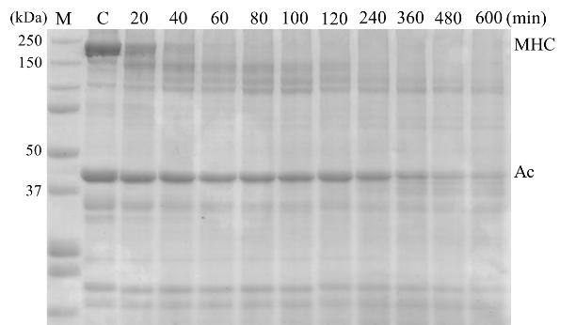

f

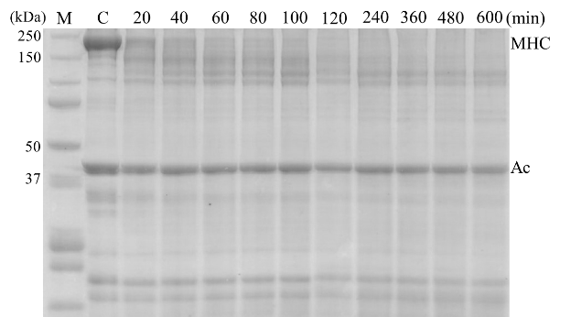

Supplement Data-1 SDS-PAGE pattern of Alaska pollock at Modori heating

a: 40oC of SA grade b: 50oC of SA grade c: 60oC of SA grade

d: 40oC of RA grade e: 50oC of RA grade f: 60oC of RAgrade

M: molecular weight marker MHC: myosin heavy chain Ac: actin

a

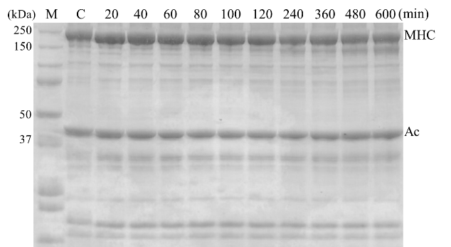

b

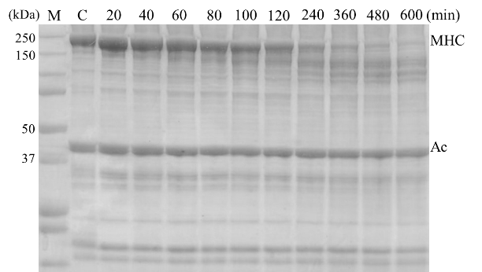

c

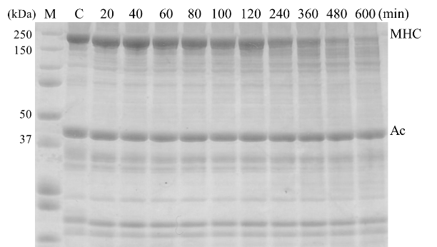

d

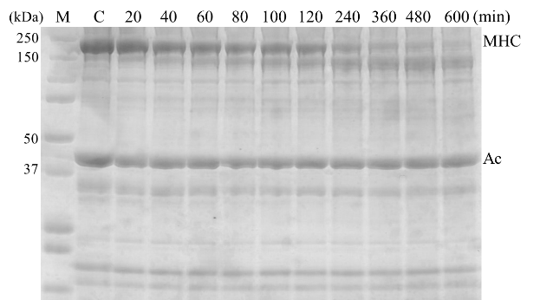

e

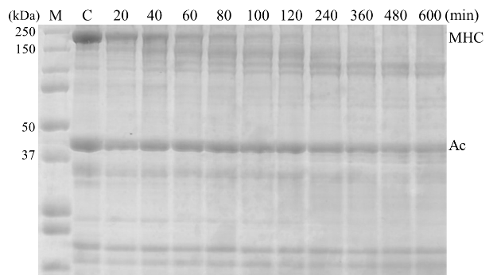

f

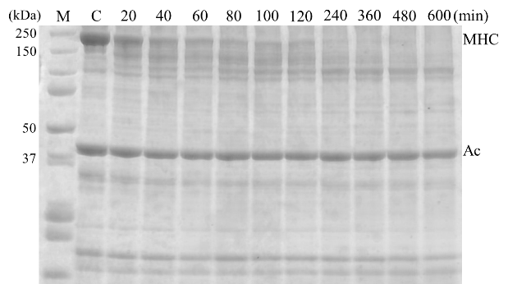

Supplement Data-2 SDS-PAGE of Alaska pollock with E-64 at Modori heating

a: 40oC of SA grade b: 50oC of SA grade c: 60oC of SA grade

d: 40oC of RA grade e: 50oC of RA grade f: 60oC of RA grade

M: molecular weight marker MHC: myosin heavy chain Ac: actin

a

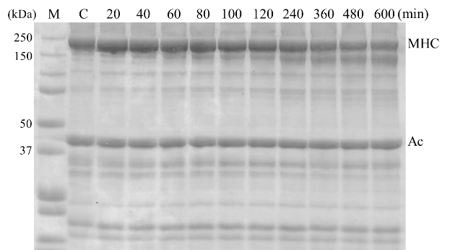

b

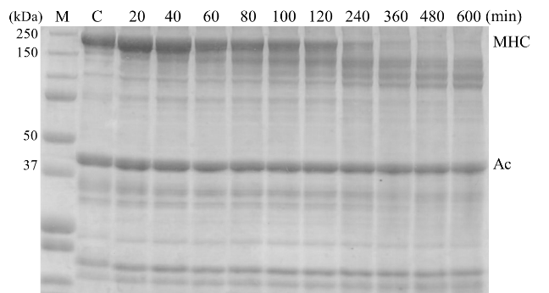

c

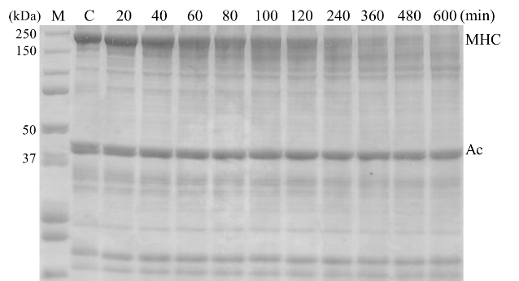

d

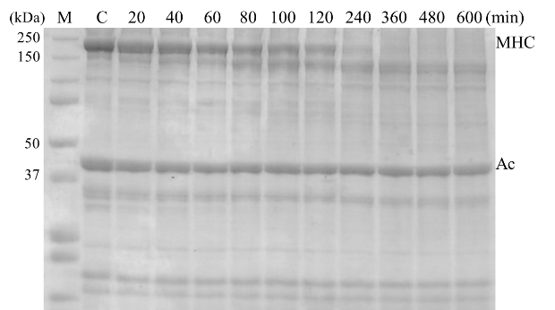

e

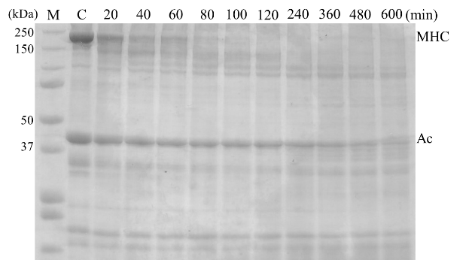

f

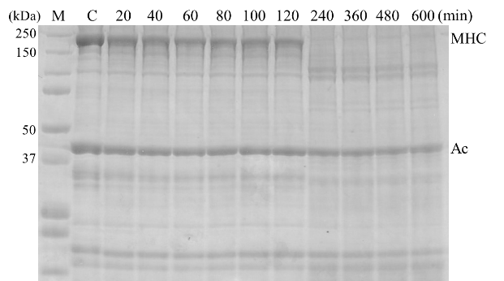

Supplement Data-3 SDS-PAGE pattern of Alaska pollock with EDTA at Modori heating

a: 40oC of SA grade b: 50oC of SA grade c: 60oC of SA grade

d: 40oC of RA grade e: 50oC of RA grade f: 60oC of RA grade

M: molecular weight marker MHC: myosin heavy chain Ac: actin

a

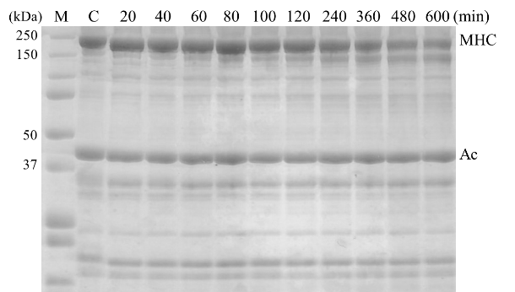

b

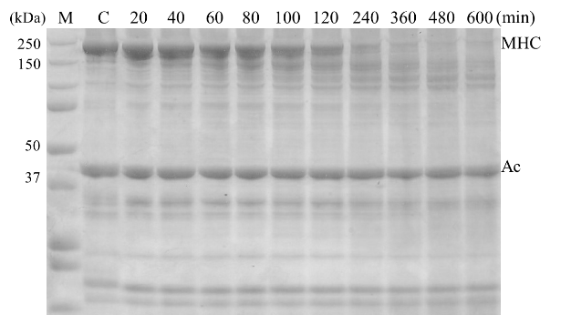

c

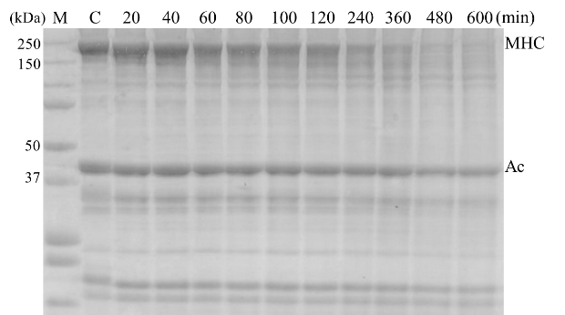

d

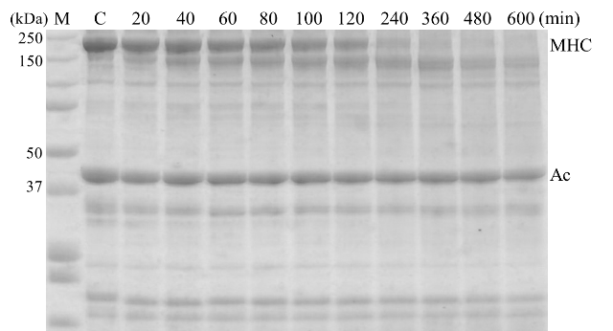

e

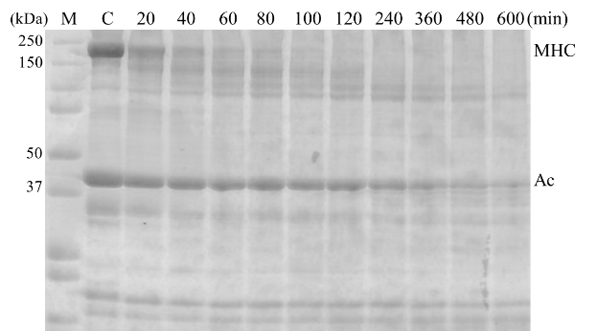

f

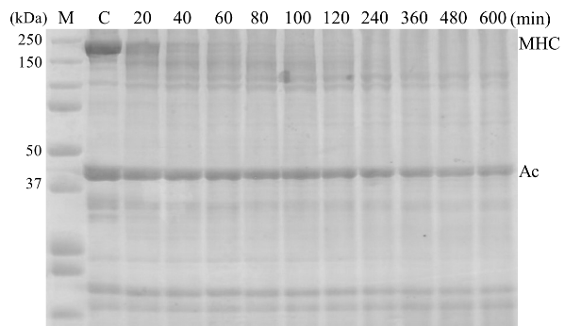

Supplement Data-4 SDS-PAGE pattern of Alaska pollock with phenanthrolin at Modori heating

a: 40oC of SA grade b: 50oC of SA grade c: 60oC of SA grade

d: 40oC of RA grade e: 50oC of RA grade f: 60oC of RA grade

M: molecular weight marker MHC: myosin heavy chain Ac: actin

a

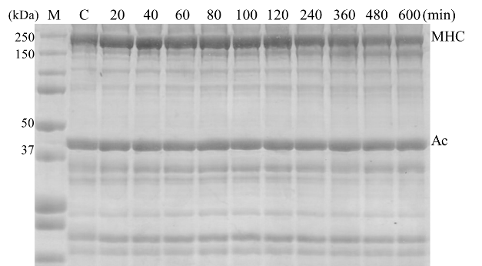

b

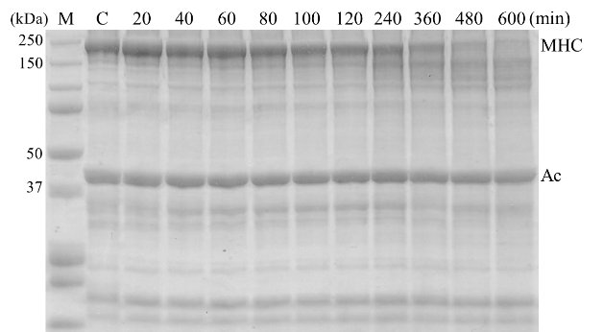

c

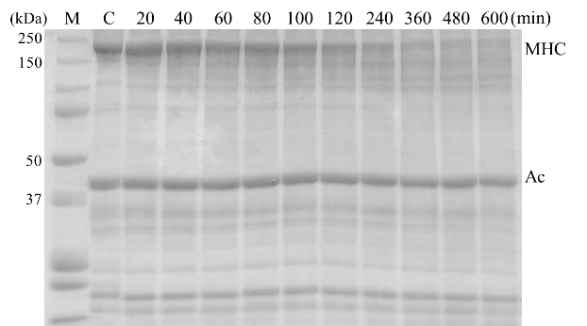

d

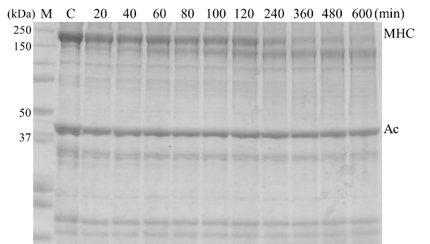

e

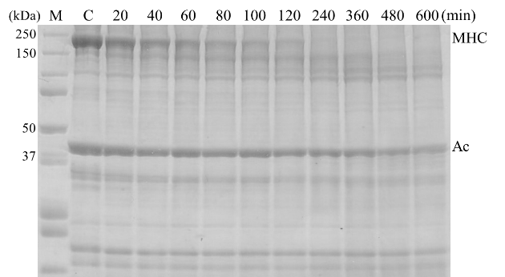

f

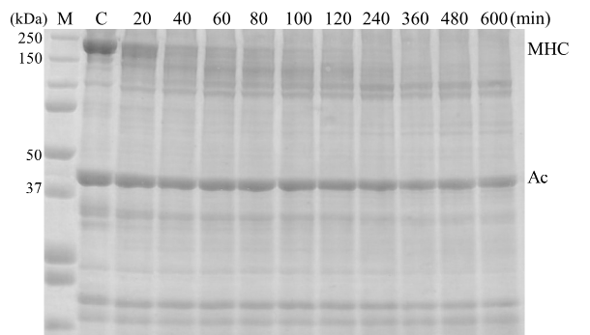

Supplement Data-5 SDS-PAGE pattern of Alaska pollock with aprotinin at Modori heating

a: 40oC of SA grade b: 50oC of SA grade c: 60oC of SA grade

d: 40oC of RA grade e: 50oC of RA grade f: 60oC of RA grade

M: molecular weight marker MHC: myosin heavy chain Ac: actin

a

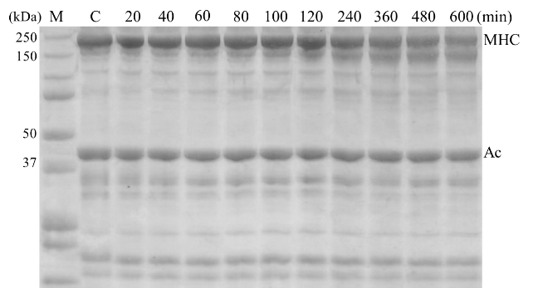

b

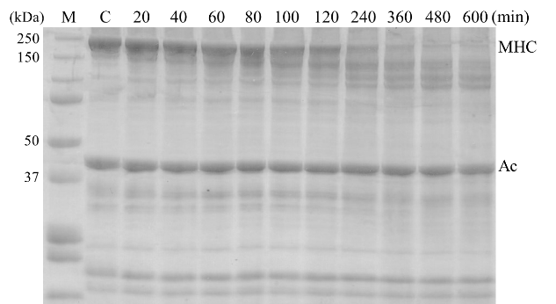

c

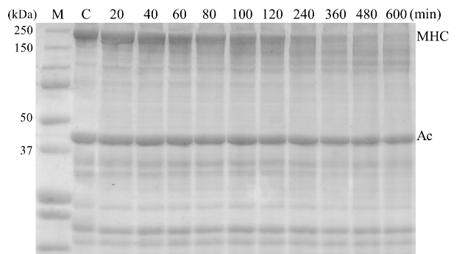

d

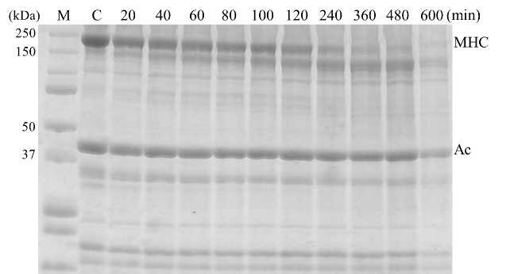

e

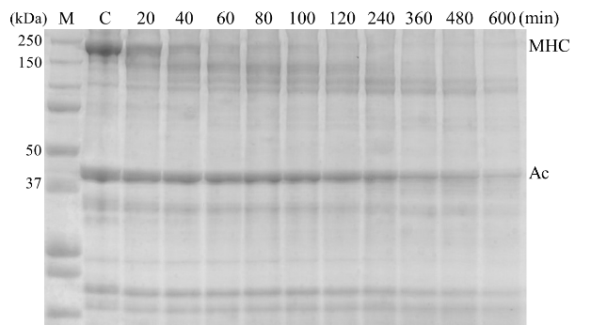

f

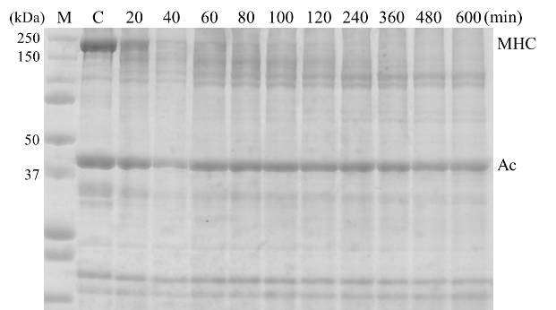

Supplement Data-6 SDS-PAGE pattern of Alaska pollock with PMSF at Modori heating

a: 40oC of SA grade b: 50oC of SA grade c: 60oC of SA grade

d: 40oC of RA grade e: 50oC of RA grade f: 60oC of RA grade

M: molecular weight marker MHC: myosin heavy chain Ac: actin

a

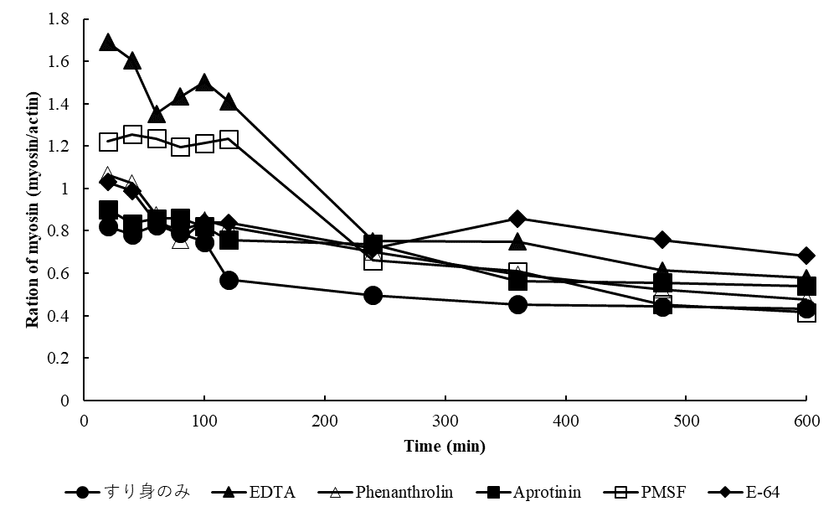

b

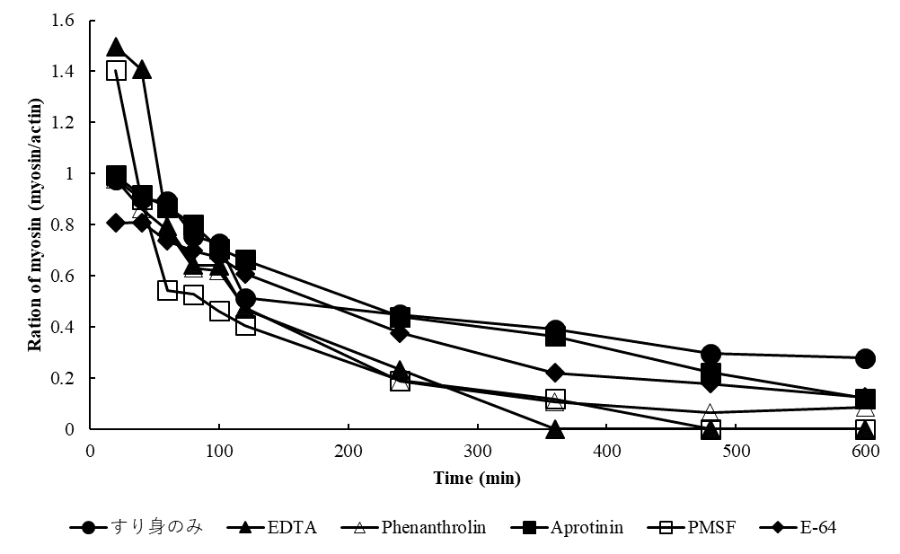

c

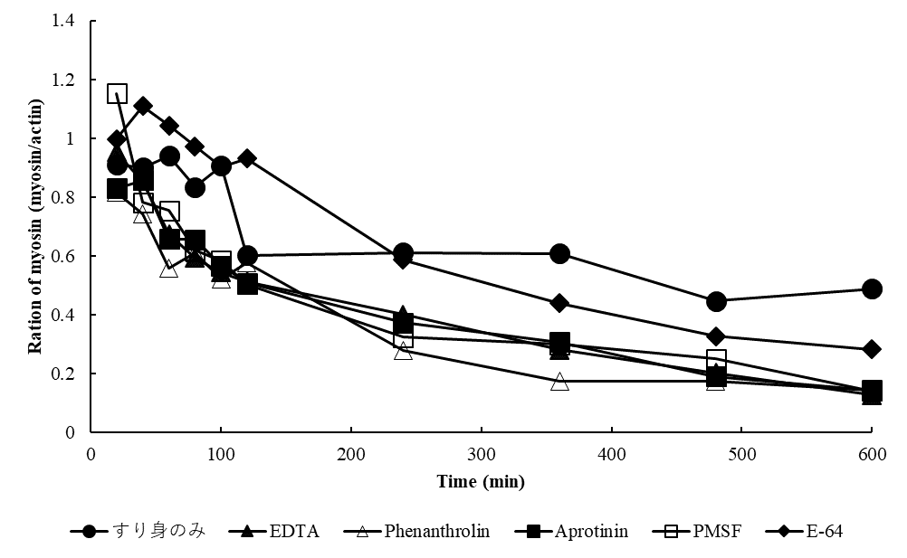

d

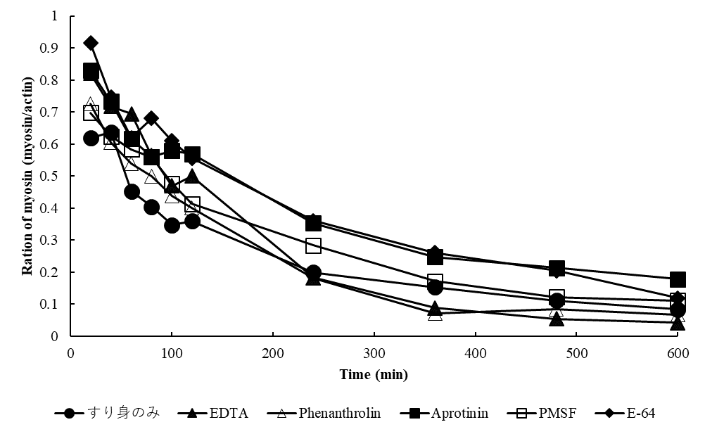

e

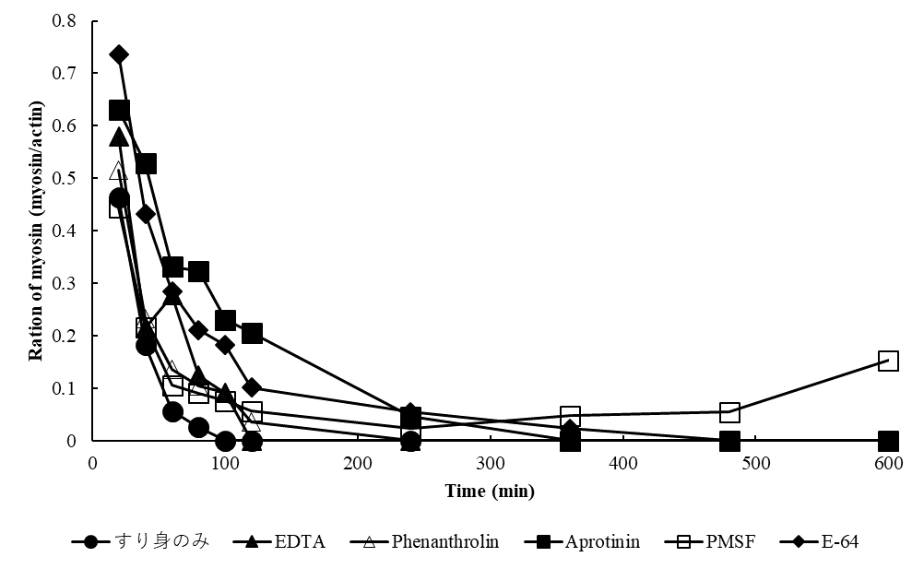

f

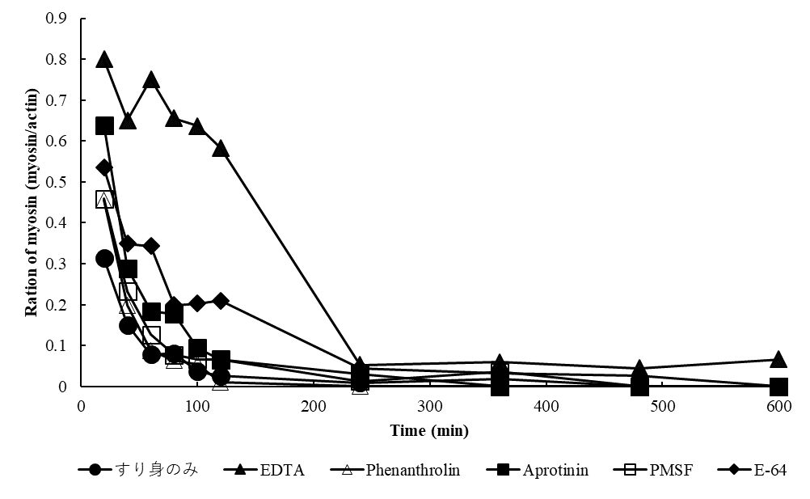

Supplement Data-7 Ration of myosin of Alaska pollock

a: 40oC of SA grade b: 50oC of SA grade c: 60oC of SA grade

d: 40oC of RA grade e: 50oC of RA grade f: 60oC of RA grade

●: non-added ◆: E-64 ▲: EDTA △: Phenanthroline

■: Aprotinin □: PMSF