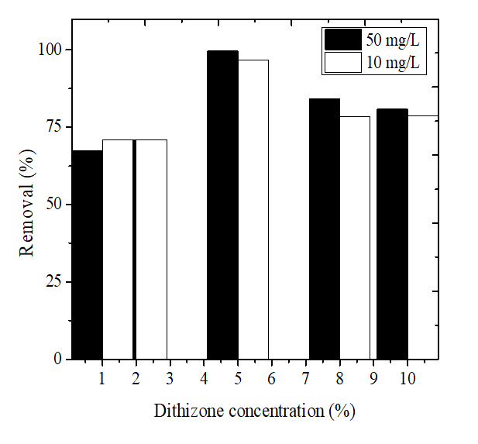
Figure S1. Effect of dithizone concentration on Hg²⁺ removal at the initial concentration of 10 and 50 mg/L

