Supplementary Figures
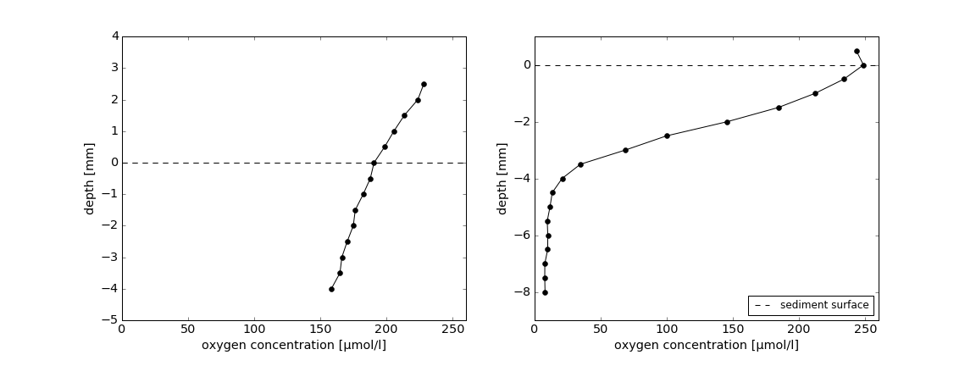
Figure S1: Oxygen profiles in additional examples of ‘classic’ and ‘partly drained and accumulated’ cryoconite debris from camp Black and Bloom (see main text for definitions)
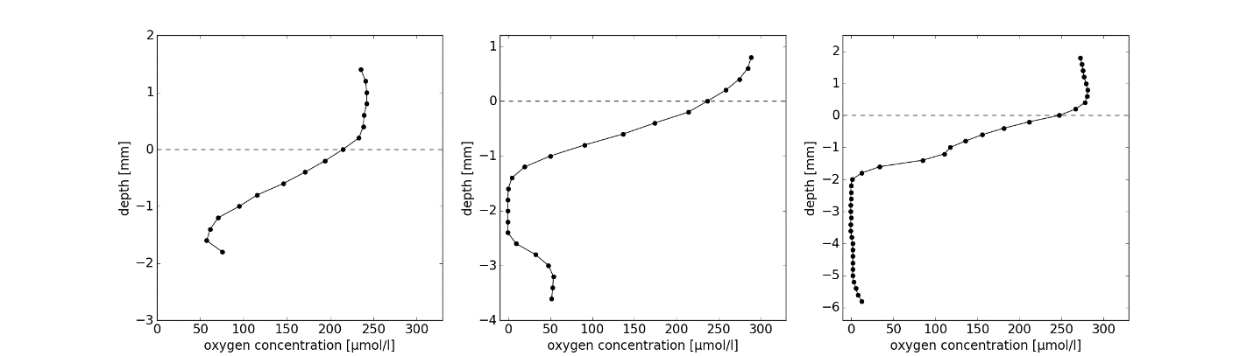
Figure S2: Oxygen profile measured using a microsensor within spherical cryoconite granules.
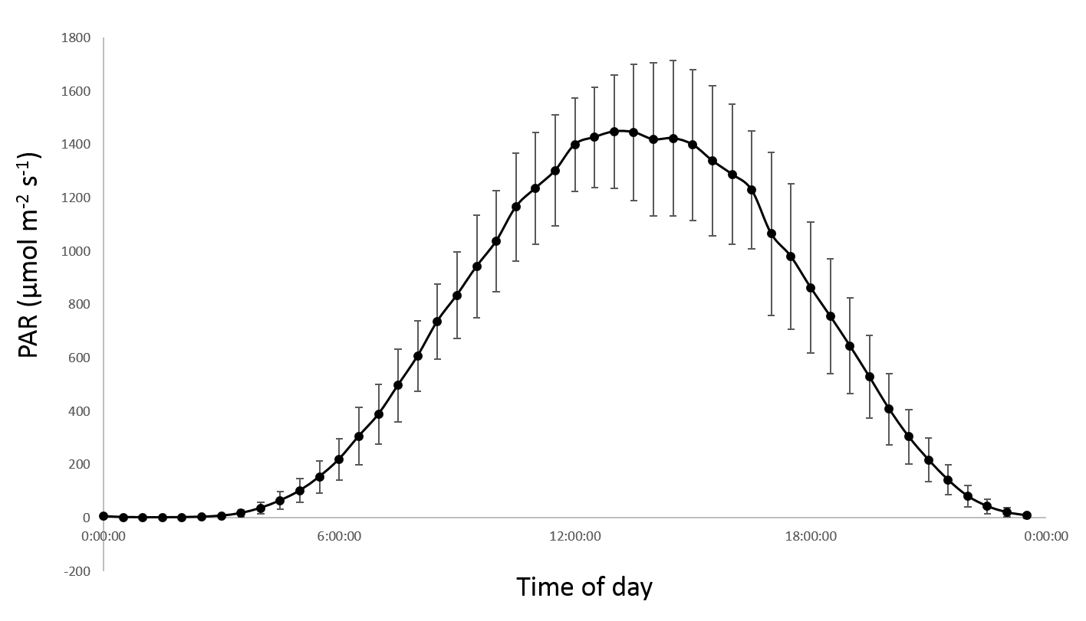
Figure S3: Typical mean PAR receipt at Camp Black and Bloom over 24 hr in July 2016.

