Supplementary materials

The Effect of Reflective Property of a Reflection Film on the Performances of Backlight Units with Quantum-dot films for LCD Applications

Figure S1. Reflectance of four reflectors in the visible range (Specular 1: Windmöller & Hölscher, Specular 2: 3M, Diffuse 1: emboss-type, Diffuse 3: adhesive-type).

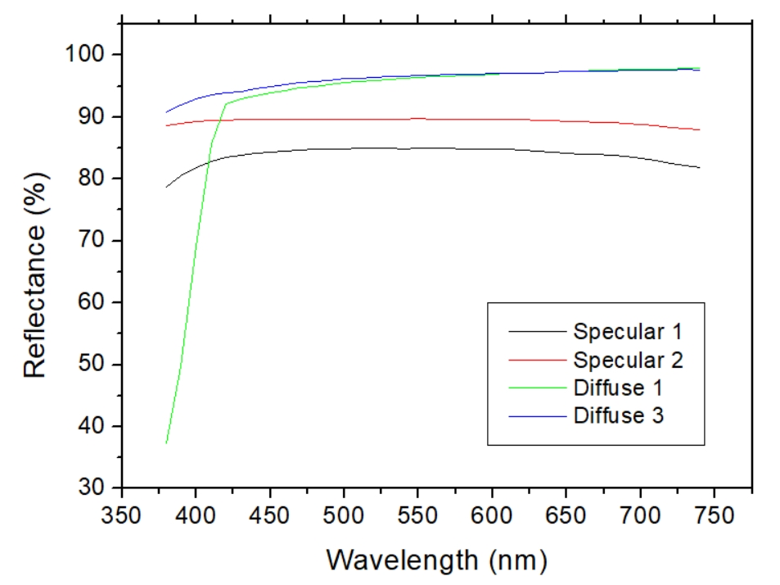

Figure S2. Angular dependence of luminance of QD-backlights with five kinds of reflectors: (a) Specular 1: Windmöller & Hölscher, (b) Specular 2: 3M, (c) Diffuse 1: emboss-type, (d) Diffuse 2: default film in the notebook, (e) Diffuse 3: adhesive-type.

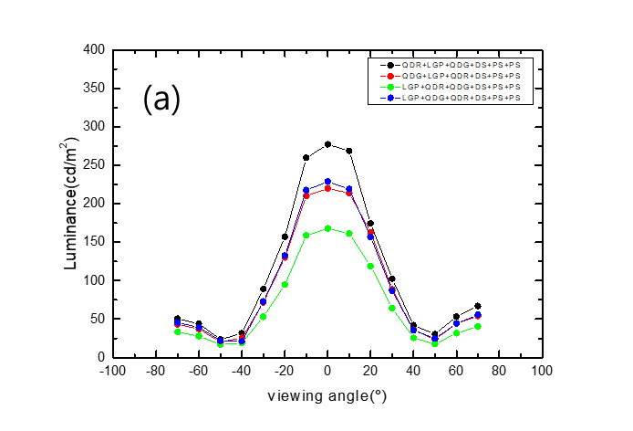

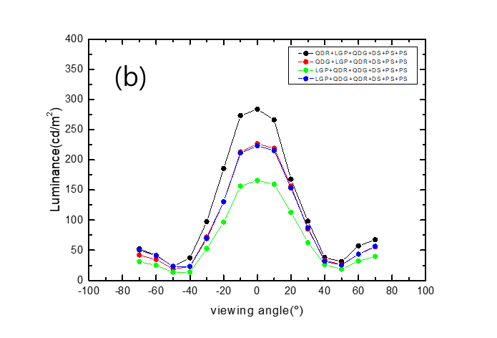

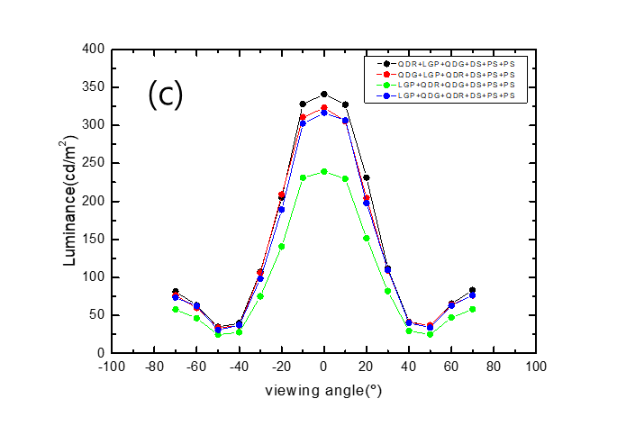

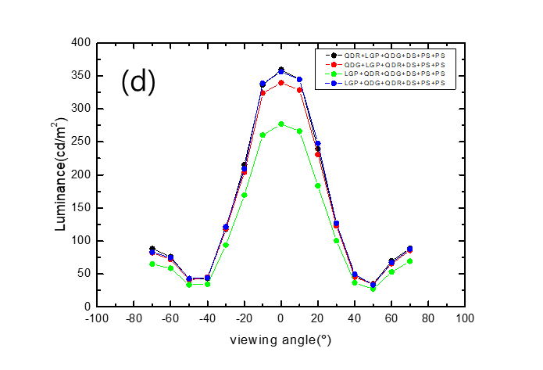

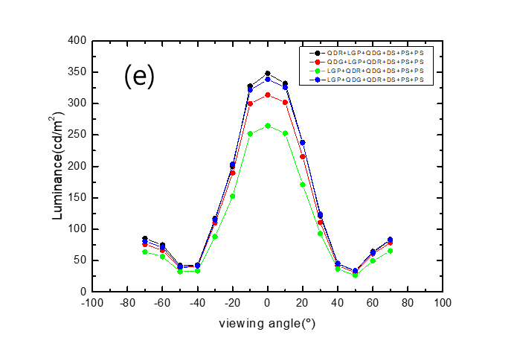

Figure S3. Angular dependence of color coordinates of QD-backlights with five kinds of reflectors: (a) Specular 1: Windmöller & Hölscher, (b) Specular 2: 3M, (c) Diffuse 1: emboss-type, (d) Diffuse 2: default film in the notebook, (e) Diffuse 3: adhesive-type.

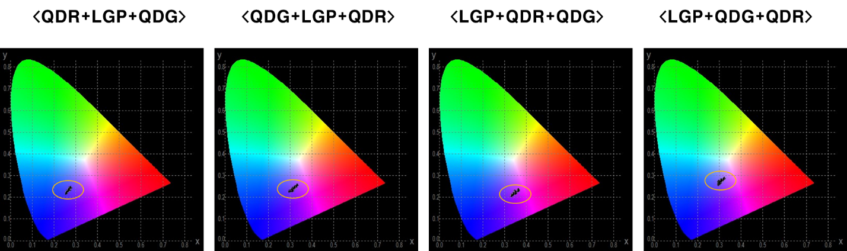

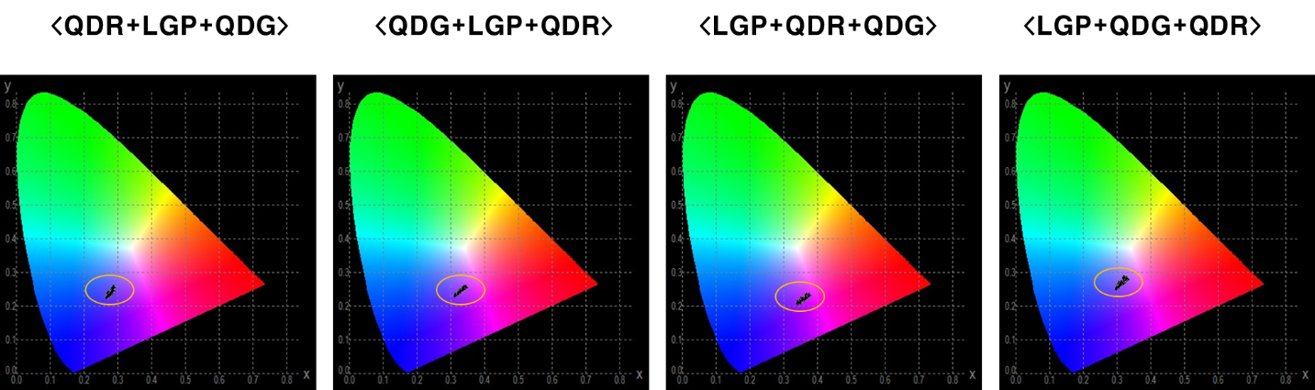

(b)

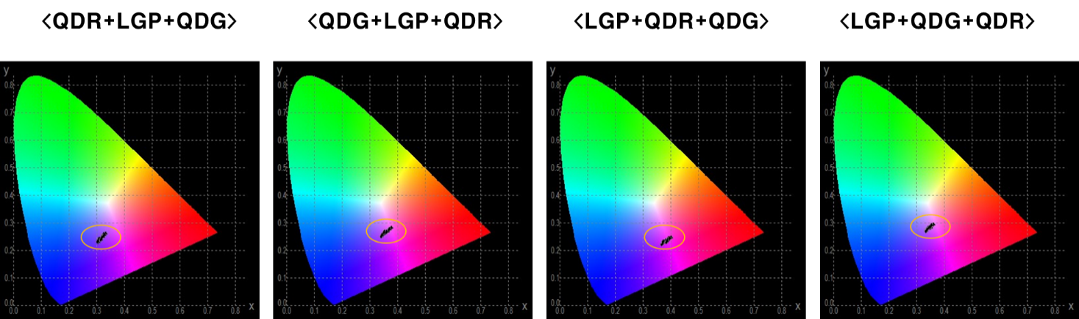

(c)

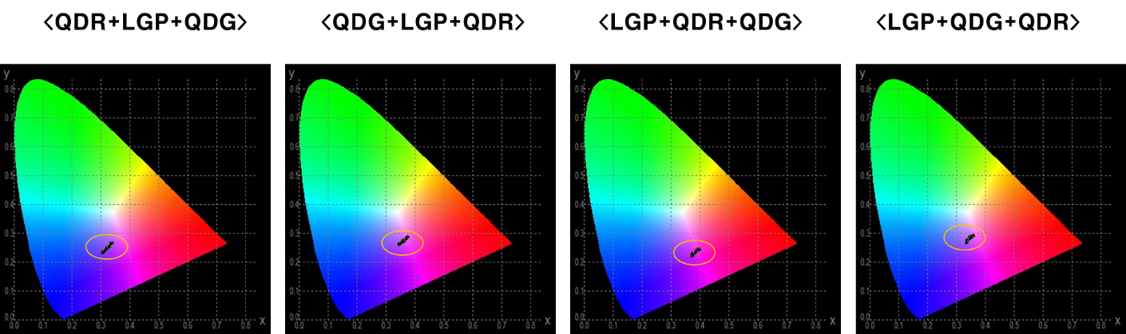

(d)

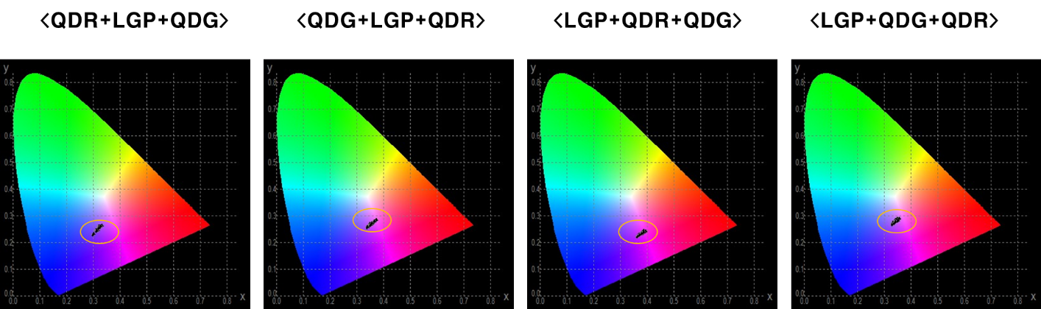

(e)

Figure S4. The intensity polar plot monitored on the backlight with QD films with (a) a specular and (b) a diffuse reflector obtained from optical simulation under the condition of the same reflectance of 95%.

