Annex 1 – Survey Paper Version

 | FOR BALKANS
Stakeholder Survey - Forests and Rivers Perceptions, to build a Decision Support System for Sustainable Management in some study areas in the Balkans.
All collected information would be processed anonymously and aggregated, and they would be used only for scientific purposes of this project.
THANK YOU FOR YOUR IMPORTANT CONTRIBUTION!
FOR BALKANS is a partnership between ATB , F360 and DICAM, funded by Trento Autonomous Province (IT)

STUDY AREA: xxxx
Section 1: Stakeholder ID
1.1 | ID UNIQUE VALUE (CAddmm##):
1.2 | Date (dd/mm/yyyy):
1.3 | Your Company/Association name:
1.4 | City (registered office)
1.5 | Your Background studies
1.6 | How long are you working in the company?
 | Less than 1 year
 | Between 1 and 5 years
 | Between 5 and 10 years
 | More than 10 years
1.7 | How long are you living in this area?
 | Less than 1 year
 | Between 1 and 5 years
 | Between 5 and 10 years
 | More than 10 years
1.8 | How long your reality is working in the valley?
 | < 5 years
 | 5 - 10 years
 | 10 - 15 years
 | 15 - 20 years
 | > 20 years
1.9 | Describe in the specific your activity in the valley (in the past and in the present) [max 300 words]
1.10 | Have you already participated to a Forest/River Survey?
 | yes
 | no
 | I don't know
Section 2: FOREST MANAGEMENT Preferences.
2 | Please select your preferences regarding FOREST MANAGEMENT
2.1 | LANDSCAPE
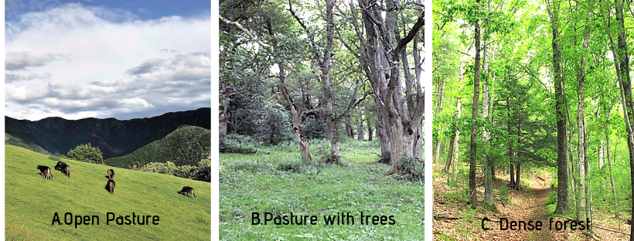

 | A. Open Pasture
 | B. Pasture with trees
 | C. Dense forest
2.2 | FOREST TYPES
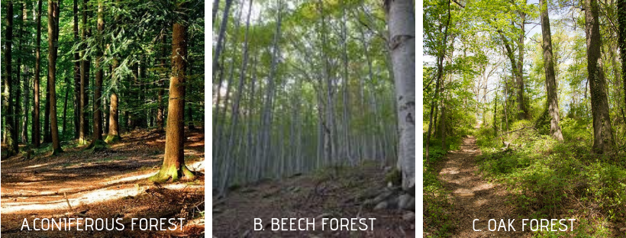

 | A. Coniferous Forest
 | B. Beech Forest
 | C. Oak Forest
2.3 | FOREST MANAGEMENT
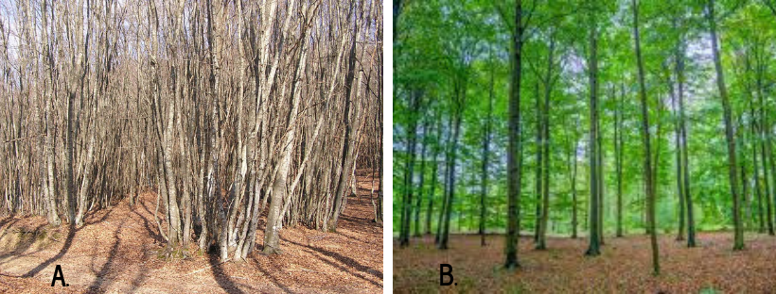

 | A. Coppice
 | B. High Forest
2.4 | SPATIAL TREE DISTRIBUTION
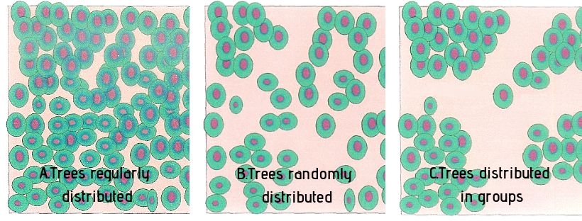

 | A. Trees regularly distributed
 | B. Trees randomly distributed
 | C. Trees distributed in groups
2.5 | VERTICAL TREE DISTRIBUTION
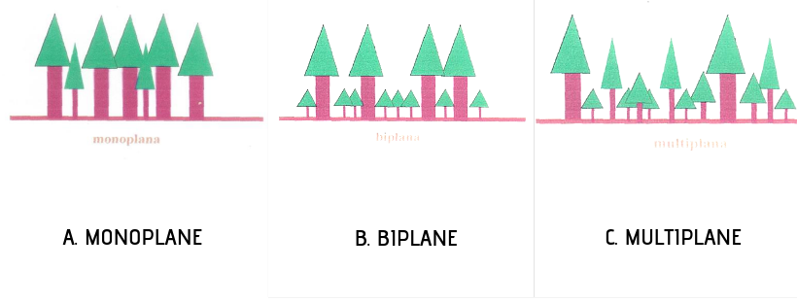

 | A. Monoplane
 | B. Biplane
 | C. Multiplane
Section 3: Forest functions in the Valley: please select and compare the most important ones
3.1 | Which is the most important PROVISIONING function provided by forest and river in the Valley?
 | Fuelwood | P1
 | Wood for manufacturing | P2
 | Water and fish | P3
 | Non wood forest products | P4
3.2 | Which is the most important REGULATING function provided by forest and river in the Valley?
 | Water flow regulation | R1
 | Erosion and Landslides Protection | R2
 | Climate Change Mitigation | R3
 | Bioremediation | R4
3.3 | Which is the most important SUPPORTING function provided by forest and river in the Valley?
 | Lifecycle maintenance | S1
 | Maintenance of nursery population | S2
 | Habitat Protection | S3
 | Disease Control | S4
3.4 | Which is the most important CULTURAL function provided by forest and river in the Valley?
 | Tourism and outdoor activities | C1
 | Historical and cultural Heritage | C2
 | Landscape Aesthetic | C3
 | Spiritual Value | C4
3.5 | Considering the function chosen in the previous question, can you compare them in terms of importance?
 |  |  | P__ | R__ | S__
 | Provisioning P__ |  |  |  |  | M =more important than
 | Regulating R__ |  |  |  |  | A = as important as
 | Supporting S__ |  |  |  |  | L = less important than
 | Cultural C__
Section 4: Management Practices: Please choose and compare the most important ones for the Valley
4.1 | Management Practices: Which could be enhanced in the valley in order to support the functions you selected? (4 choices)
P1 | Enhancing wood residues (woodchips) for the bioenergy production
P2 | Do not remove dead wood on the ground and dead plants of large dimensions (diameter minimum 30 cm)
P3 | Promoting mixed forests rather than pure conifer or broadleaved forests through silvicultural interventions
P4 | Improving recreational attractiveness through cleaning of path network in the forests, set up refreshment and picnic areas, developing environmental education trails
P5 | Monitoring river and forest ecosystem quality
P6 | Changing forest governance though transformation from coppices to high forests
P7 | Implementing phytosanitary cuttings
P8 | Thinning in forests and rivers to promote the active management
P9 | Monitoring and cleaning of riverbeds from excessive vegetation and sediments
4.2 | Considering the PRACTICES chosen in the previous question, can you compare them in terms of importance?
 |  |  | P__ | P__ | P__
P__ | _______________________________________ | P__ |  |  |  | M =more important than
P__ | _______________________________________ | P__ |  |  |  | A = as important as
P__ | _______________________________________ | P__ |  |  |  | L = less important than
P__ | _______________________________________ | P__
THANK YOU FOR YOUR IMPORTANT CONTRIBUTION!

