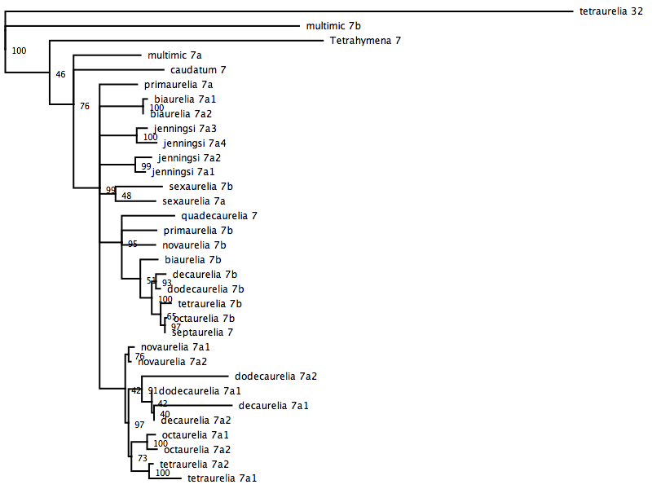
Figure S1. Neighbor joining phylogeny showing evolutionary relationships between P. aurelia Rab7 coding sequences. P. tetraurelia Rab32 gene was designated as an outgroup.

