Supplementary Data
1. Supplementary Figure and Legend
Figure S1. A. The mRNA expressions of E-cadherin and vimentin did not alter after KLF5 over-expression or knock-down in p53 wild-type Hep G2 cells. B. In p53 null Hep 3B cells, the mRNA expression of E-cadherin increased and the mRNA expression of vimentin decreased in KLF5 over-expressed cells, and the mRNA expression of E-cadherin decrease and the mRNA expression of vimentin increased in KLF5 knock-down cells. *P<0.05, data are presented as the means ± SD.
Figure S2. KLF5 did not influence the cell migration of BEL-7402 cells harboring wild type p53.
Figure S3. The mRNA expression of ZEB2 did not exhibit significant changes in Hep G2 and Hep 3B cells after KLF5 over-expresssion or knock-down.
2. Supplementary Table

Table S1. The characteristics of liver cancer patients
Gender | Age | p53 expression | KLF5 expression | Metastasis | Application
 |  | (T compared to A) | (T compared to A) | (N/Y)
Male | 52 | + | = | N | IHC
Male | 44 | = | + | N | IHC
Female | 51 | + | - | Y | IHC
Male | 57 | - | - | Y | IHC
Male | 42 | - | - | Y | IHC
Female | 73 | + | = | N | IHC
Female | 65 | + | + | N | IHC
Male | 56 | - | - | Y | IHC
Male | 62 | + | = | N | IHC
Male | 60 | + | + | N | IHC
Male | 61 | - | - | Y | WB (sample 1)
Female | 47 | = | - | N | WB (sample 2)
Male | 37 | + | + | N | WB (sample 3)
+:the expression of p53/KLF5 in cancer tissue (T) is higher than adjacent normal liver tissue (A); =: the expression of p53/KLF5 in cancer tissue (T) is similar to adjacent normal liver tissue (A); -: the expression of p53/KLF5 in cancer tissue (T) is lower than adjacent normal liver tissue (A), N: liver cancer without metastasis; Y: liver cancer with metastasis, IHC: Immunohistochemistry, WB: Western blotting.

Table S2. Primers used for PCR
Name | Accession No. |  | Sequences (5'-3') | Product Size, bp
E-cad | NM_004360.3 | Forward | CGAGAGCTACACGTTCACGG | 119
 |  | Reverse | GGGTGTCGAGGGAAAAATAGG
vimentin | NM_003380.2 | Forward | AGTCCACTGAGTACCGGAGAC | 98
 |  | Reverse | CATTTCACGCATCTGGCGTTC
ZEB2 | NM_014795.3 | Forward | CCCTGGCACAACAACGAGAT | 104
 |  | Reverse | ATTGCGGTCTGGATCGTGG
KLF5 | NM_001730.4 | Forward | ACACCAGACCGCAGCTCCA | 165
 |  | Reverse | TCCATTGCTGCTGTCTGATTTGTAG
GAPDH | NM_002046.5 | Forward | GAGTCAACGGATTTGGTCGT | 185
 |  | Reverse | GACAAGCTTCCCGTTCTCAG
miR-192 promoter  Site 1 for ChIP |  | Forward | TCCTGGGTTCAAGCGATTCT | 81
 |  | Reverse | AAATTAGCTGGGCATGGTGG
miR-192 promoter  Site 2 for ChIP |  | Forward | CACACAGTCCTCCCATCTCA | 101
 |  | Reverse | GTGAAACCCCATCTCTACGAA
miR-192 promoter  Site 3 for ChIP |  | Forward | ATTGAGCCCTTTCTGTCTGC | 90
 |  | Reverse | CTGTGTCCTCCTGTCCCAAA

3. The densitometry of immunoblot
The densitometry of Figure 1
*P<0.05, ns P>0.05, data are presented as the means ± SD.

The densitometry of Figure 3
*P<0.05, ns P>0.05, data are presented as the means ± SD.

The densitometry of Figure 4C
*P<0.05, data are presented as the means ± SD.

4. The amplification plot of real time PCR
The amplification plot of Figure 4
A
Hep G2
miR-200a
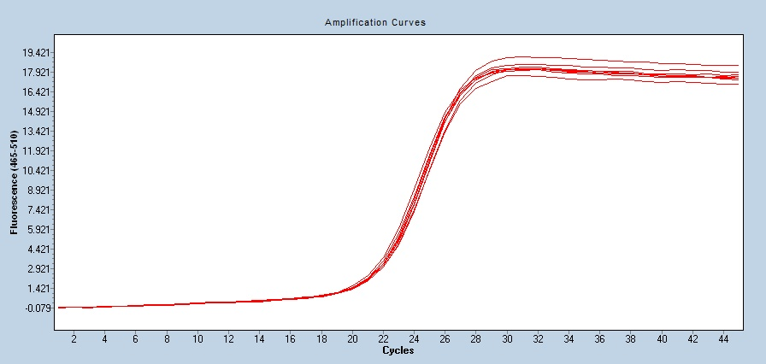
miR-200c
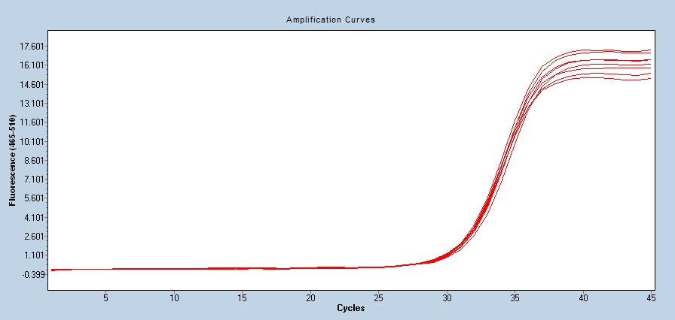
miR-153
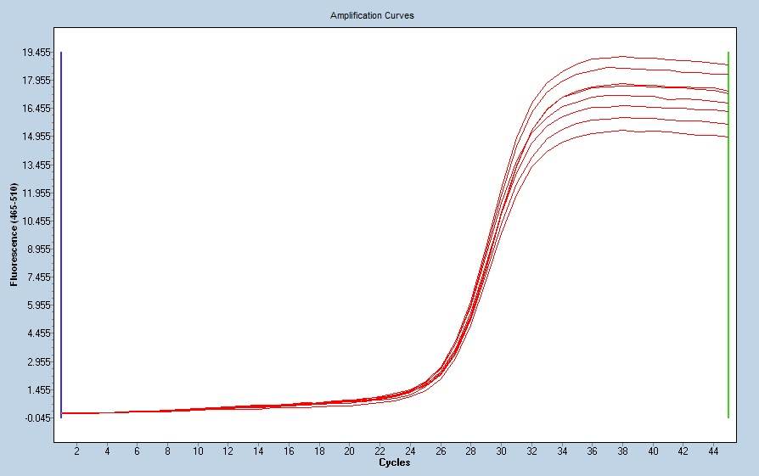
miR-192
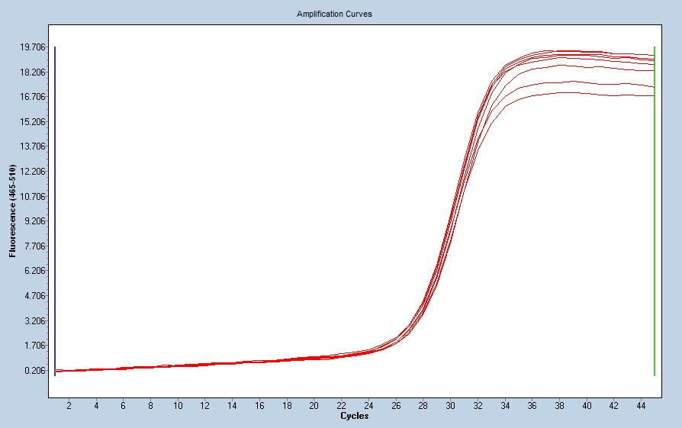

Hep 3B
miR-200a
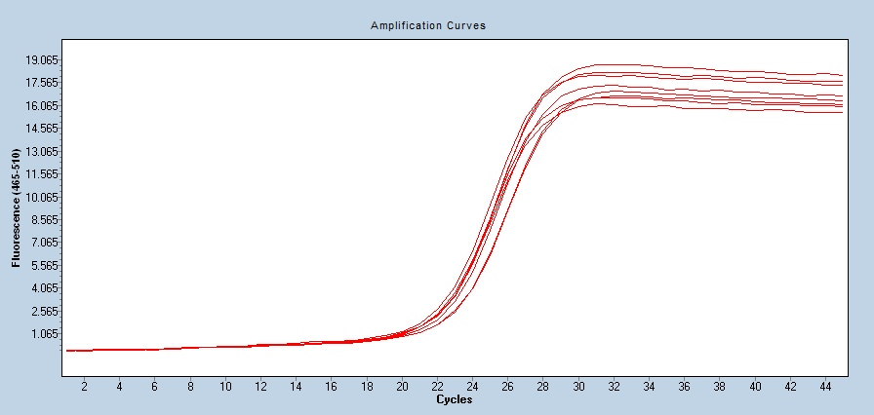
miR-200c
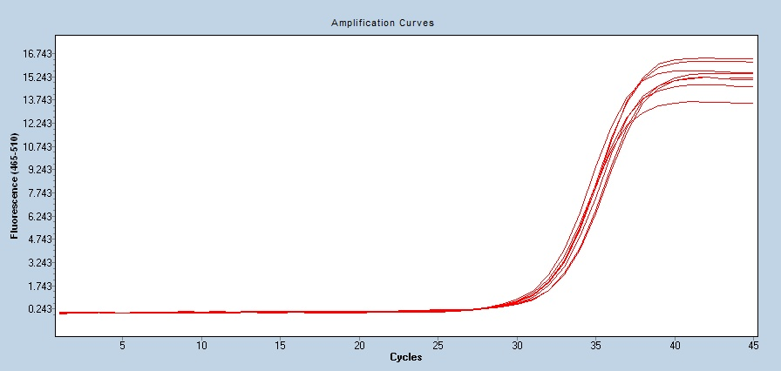
miR-153
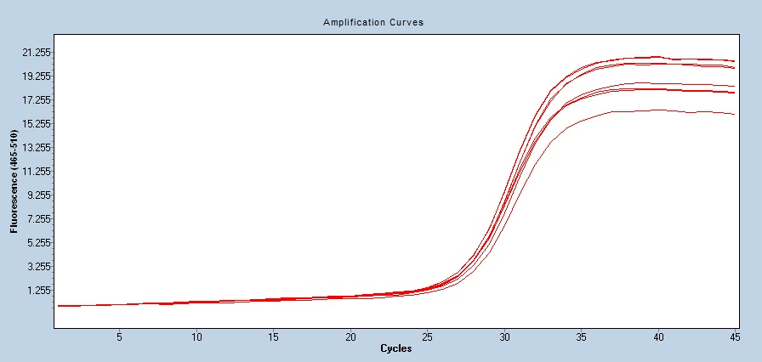
miR-192
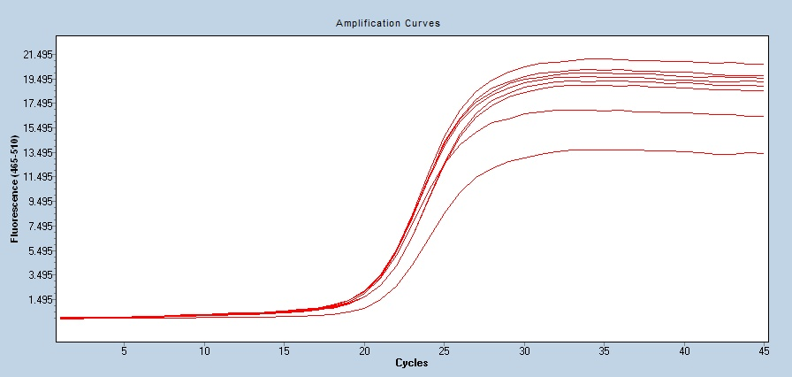

B
Hep G2
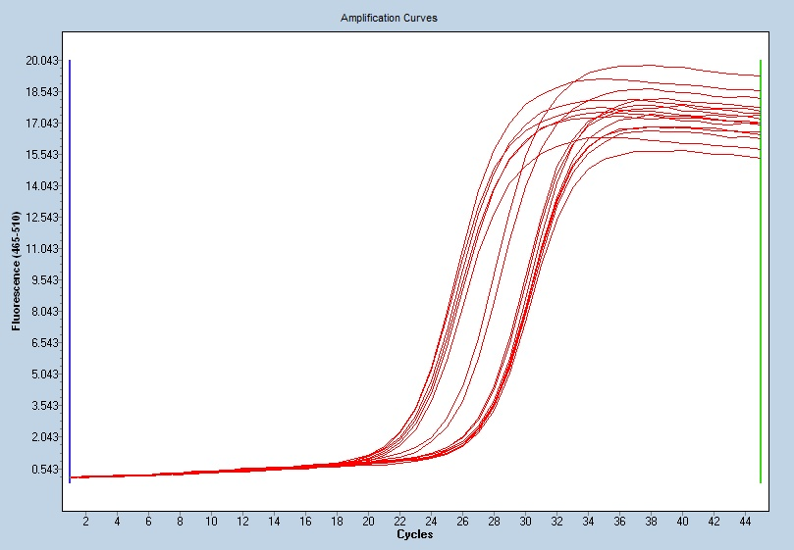
BEL-7402
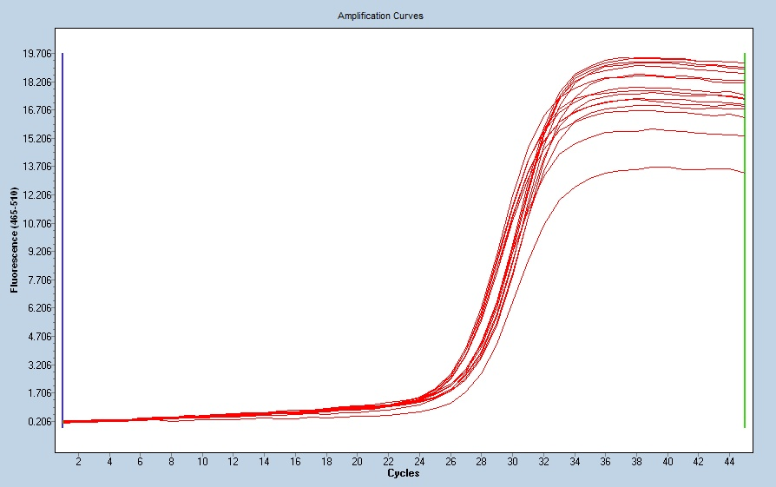

The amplification plot of Figure 5
B
Hep G2
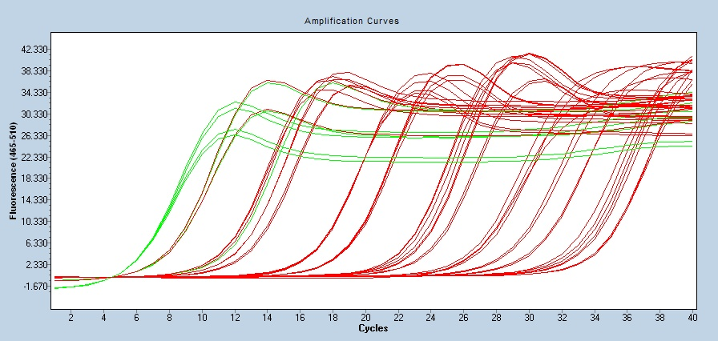

BEL-7402
