Supplementary Material for JAWMA Submission

(to be made accessible to all readers; material to be professionally typeset)

The Comprehensive Fire Information Reconciled Emissions (CFIRE) Inventory: Wildland Fire Emissions Developed for the 2011 and 2014 U.S. National Emissions Inventory.
Narasimhan K. Larkin, Sean M. Raffuse, ShihMing Huang, Nathan Pavlovic, Peter Lahm, Venkatesh Rao
May 1, 2020

Supplemental Appendix A: Datasets Collected
Table A.1 presents a full list of the various satellite, national ground reporting system, and regional ground reporting system databases collected and utilized in the 2011 and 2014 efforts. In some cases, data sources were collected but, upon examination, were not able to be utilized in the inventory; these data sources are omitted here. In general, data sources were not able to be utilized because they did not contain one or more critical pieces of information, namely:
- a specific fire location (latitude / longitude point or polygonal data);
- a specific fire time period (at least a start date); and
- a specific fire size.
In other cases, pile burn data were provided. However, due to the lack of uniformity in data format, as well as an agreed-upon and efficient methodology to quantify pile burn emissions, pile burn data sources were not incorporated in this work.
In 2014, collection of data sources was accompanied by a request for the data source owner/provider to complete a questionnaire that covered the extent and completeness of the data source provided. The questionnaire was derived from the experience gained in the 2011 process, where it was determined that such information was valuable in assessing how to deal with conflicts across datasets, particularly in the case of a fire being represented in one database but not another.
Overall 20 agencies return the questionnaire. For the states, specifically South Carolina and Alaska, the state data was indicated as being complete, covering all fires within that area. This was double checked and found to be plausibly correct.

Table A.1. Data sources collected and used in the 2011 and 2014 efforts.
Data Source | Coverage | 2011 | 2014
Satellite Detection Databases
NOAA Hazard Mapping System | National | ✓ | ✓
National Ground Report Datasets
ICS-209 Reports | National | ✓ | ✓
GeoMAC | National | ✓ | ✓
FACTS | National  (USFS Rx) | ✓ | ✓
FWS | National | ✓ | ✓
NASF | National | ✓ | ✓
NFPORS | National  (DOI Rx) |  | ✓
Regional Ground Report Datasets
Western Regional Air Partnership  Fire Emissions Tracking System | Regional | ✓  (10 states) | ✓  (8 states)
Alaska Dept. of Environmental Conservation | AK |  | ✓
Alabama Dept. of Environmental Management | AL | ✓ | ✓
Ventura County Air Pollution Control District | CA, Ventura County | ✓ | ✓
Delaware Dept. of Natural Resources and Environmental Control | DE | ✓ | ✓
Florida Forest Service | FL | ✓ | ✓
Georgia Environmental Protection Division | GA | ✓ | ✓
Iowa Department of Natural Resources | IA |  | ✓
Kaw Nation Environmental Department | Kaw Nation |  | ✓
State of Kansas | KS | ✓
Michigan Dept. of Environmental Quality | MI | ✓ | ✓
Minnesota Dept. of Natural Resources | MN | ✓ | ✓
Minnesota Fish and Wildlife Service | MN | ✓
North Carolina Department of Environment and Natural Resources | NC |  | ✓
North Carolina Forest Service | NC | ✓
New Jersey Department of Environmental Protection | NJ |  | ✓
Nevada Division of Environmental Protection | NV |  | ✓
Washoe County Health District | NV, Washoe County | ✓ | ✓
Oregon Dept. of Forestry | OR | ✓
South Carolina Department of Health & Environmental Control | SC | ✓ | ✓
Texas A&M Forest Service | TX | ✓
Vermont Dept. of Environmental Conversation | VT | ✓
Virginia Dept. of Environmental Quality | VA |  | ✓
Wisconsin Dept. of Natural Resources | WI | ✓
West Virginia Dept. of Environmental Protection | WV | ✓
Wyoming Dept. of Environmental Quality | WY | ✓

FIRE TYPES AND SIZES OF FIRES INCLUDED |  | Included: | Expected completeness | Min size (acres or piles) for inclusion if any: | Comments if any:
 | Type:
F1 | WILDFIRES
F2 | PRESCRIBED BURNS (BROADCAST BURNS)
F3 | PRESCRIBED BURNS (PILE BURNS)
F4 | RANGELAND BURNING
F5 | AGRICULTURAL BURNING
PRIMARY AGENCIES OR ACTORS INCLUDED |  | Included: | Expected completeness | Comments if any:
 | Type:
A1 | State Forestry Agencies
A2 | State Department of Transportation
A3 | State Wildland Firefighting
A4 | State Agencies (all other)
A5 | County / Local Governments
A6 | Tribal Governments
A7 | Military
A8 | Federal (non-Military)
A9 | Private Landowners (Forestry Companies)
A10 | Private Landowners (All Others)
A11 | Other. Specify in comments as needed.
LAND OWNERSHIPS INCLUDED |  | Included: | Expected completeness | Comments if any:
 | Ownership:
L1 | State Lands
L2 | County / Local Lands
L3 | Tribal Lands
L4 | Military Bases
L5 | Federal Lands (non-military)
L6 | Private Lands (Forestery Companies)
L7 | Private Lands (All Others)
L8 | Other. Specify in comments as needed.
OPTIONAL: SPECIFY WILDFIRE SEASONALITY IN THIS REGION FOR 2014
 |  | Started (date) if known: | Ended (date) if known: | Comments if any:
T1 | Wildfire Season Span:
Figure A.1. Questionnaire used in 2014. Each data provider was asked for this form with their data. Answers were used to identify how to reconcile various datasets.

Supplemental Appendix B: Association of Satellite Detects into Burning Areas and Tracking Across Days

The HMS satellite hot spots were preprocessed by aggregating spatiotemporal clusters into single fire objects, in SF2 referred to simply as “fires.” These HMS-derived fires are then reconciled with fires from other data sources as detailed in Section 3.3 of the main text.
Figure B.1 illustrates the aggregation method using an example wildfire from the 2014 inventory. The first day of satellite-detected burning is shown on the left (Day 1) and the fifth day is shown on the right (Day 5). The final fire perimeter from the GeoMAC data set is shown for context, but is not relevant to the aggregation process, which depends on HMS data alone.
On Day 1, the fire was detected as two satellite hot spots, several kilometers apart. A 800m radius buffer is drawn around each satellite detection to represent the daily fire shape. A 2500m radius envelope is drawn around each detection to associate detections into a single fire event. In this case, the two detections are associated into a single fire event with two distinct burning areas.
Each day new detections are processed and new envelopes are intersected with the envelopes from the previous two days. By Day 5, the fire was detected by HMS over much of the same area as the final GeoMAC perimeter. There are four distinct burning areas on Day 5, but all are within the same cumulative association envelope and so are considered part of the same fire. The end result is a day-by-day history, in terms of number of detections and fire shape, of individual fires.

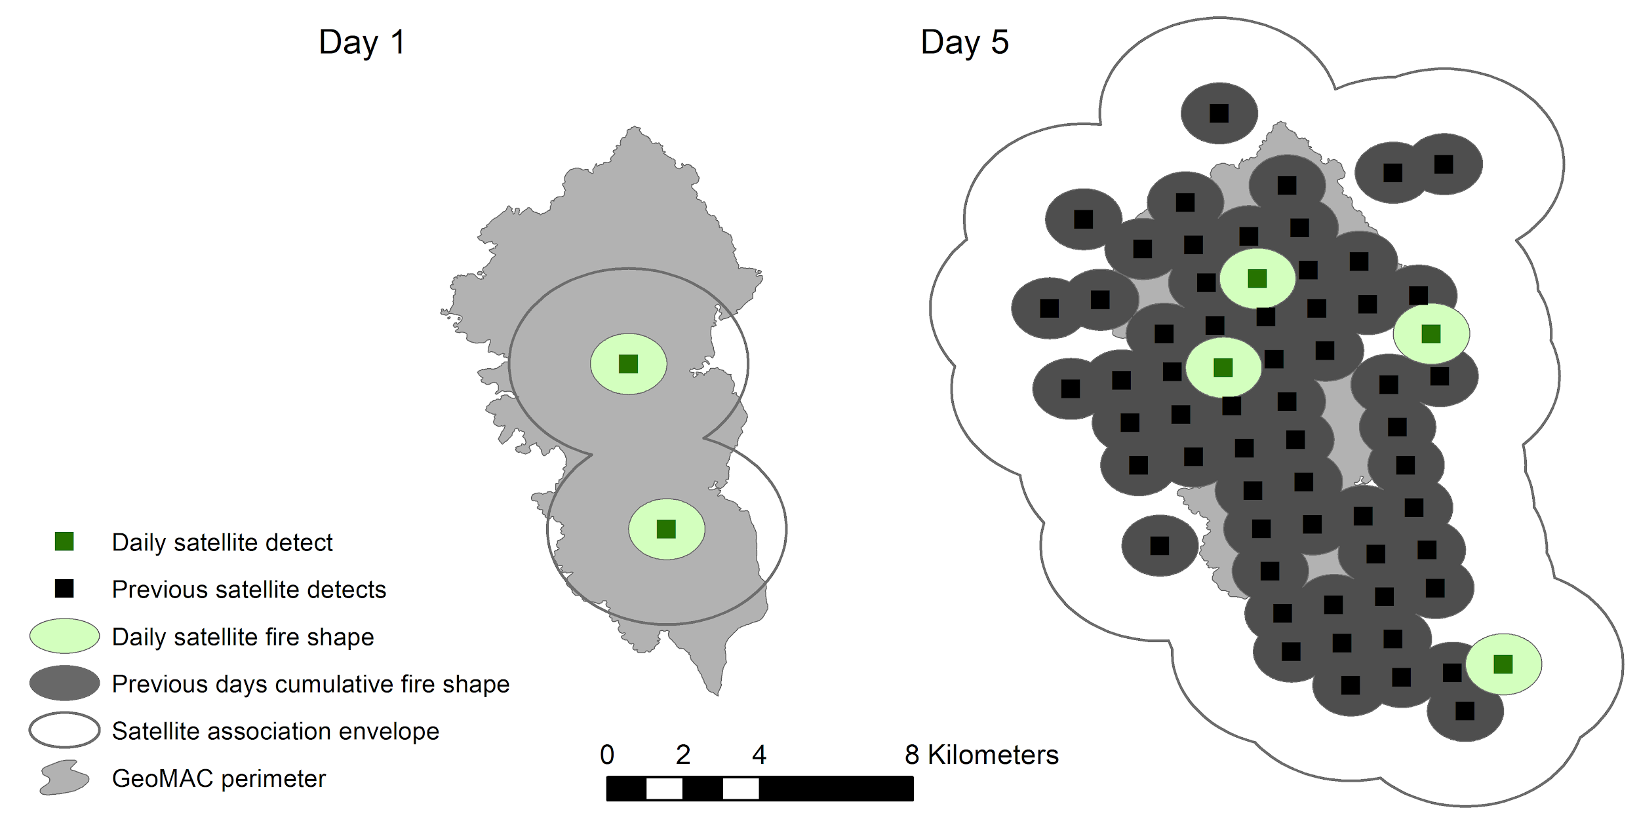
Figure B1. Illustration of aggregation of satellite data into daily shapes and tracking fires across days.

Supplemental Appendix C: Emissions Inventory Files and Supporting Documents

We have posted a collection of associated material for the CFIRE emissions inventories of 2011 and 2014 at:
- https://ei.airfire.org/data/cfire.
This collection includes the emissions inventory datafiles, as well as supporting documents. We have also placed the SmartFire 2 code in GitHub (see link Section C.3)

C.1 Emissions Inventory Files
The emissions inventory datafiles are listed in Table C.1. The emission inventory is reported on a daily fire location basis. One or more locations are reported daily for each fire event based on the processed fire information data (see Section 2 and Section 3). The fire location files include data columns describing the date and location of the fire, the area burned, fuel loading and vegetation type, fuel moisture, fuel consumption and emissions. A complete description of each data file is provided in the emissions field description file. Note that the inventory files reports quantities in U.S. customary units, including short tons and acres.
As a convenience for data review, we also provide a fire event inventory file for each inventory. The fire event files include aggregated quantities over a complete fire event. The fire event names assigned by SmartFire 2 sometimes deviate from the final name of a fire as it is commonly known. This may arise due to changes to the fire name over time or administrative integration of a fire into a larger complex. This can also occur when buffered aggregation by SmartFire 2 combines distinct fires that were close to one another in time or space. While these cases impact how the fire event is named and aggregated in the event files, they do not affect the underlying emissions themselves. To aid in interpretation of the event inventory files, we include a file crosswalking the names, as reported for the final fire perimeter in the GeoMAC data set, of the largest fires with fire event names reported in CFIRE for each inventory year.
To illustrate the emissions provided in the fire event summary files, emissions totals for the top three fire events with the largest area for both the 2011 and the 2014 CFIRE inventory are shown in table C.2.

Table C.1. List of emissions inventory files in repository.

File Name | CFIRE Year | Description
CFIRE_2011_FieldDescriptions.xlsx | 2011 | Data set description for fire location file for the 2011 CFIRE inventory.
CFIRE_2014_FieldDescriptions.xlsx | 2014 | Data set description for fire location file for the 2014 CFIRE inventory.
CFIRE_2011_FireEmissions.csv | 2011 | Complete CFIRE emissions for 2011.
CFIRE_2014_FireEmissions.csv | 2014 | Complete CFIRE emissions for 2014.
CFIRE_2011_FireEvents.csv | 2011 | CFIRE emissions for 2011 aggregated to the fire event level.
CFIRE_2014_FireEvents.csv | 2014 | CFIRE emissions for 2014, aggregated to the fire event level.

Table C.2. Example fire output collected at the fire event level for the top 3 fires by area in the 2014 CFIRE inventory. Additional data columns (not shown here) are provided for each fire event as described in the emissions field description files for each inventory year.
Name | Type | Dates | Area | CO2 | CO | CH4 | PM2.5
 |  |  | Acres | Short Tons | Short Tons | Short Tons | Short Tons
Buzzard Complex | WF | 7/14 – 7/25 | 416319 | 1418747 | 74806 | 3865 | 7177
Carleton Complex | WF | 7/15 – 8/13 | 278437 | 6578179 | 603655 | 29333 | 51287
100 Mile Creek Fire | WF | 5/20 – 6/11 | 196611 | 8069331 | 810090 | 39075 | 67794

C.2 Supporting Documents
In the repository we also include supporting documentation that can provide more information on the processing of the emissions. It also includes copies of presentations and technical report documents associated with each NEI. This includes the full emissions factors used in the inventory comprising the FEPS emissions factors used to calculate the eight species discussed in this paper, also shown in Table C.3, and the additional emissions factors used to calculate hazardous air pollutants (HAPs) not discussed here, but accounted for in the emissions inventory datafilesin the repository.

C.3 SmartFire 2 Codebase
In addition to the repository, we have placed the SmartFire 2 codebase as used in GitHub at the location:
- https://github.com/pnwairfire/SmartFire2

The codebase is made freely available under GNU Public License 3.

Table C.3 Emissions factors used from the Fire Emissions Production Simulator, as well the overall effective emissions factors for the 2011 inventory.
Species | Flaming EF (g/kg) | Smoldering EF (g/kg) | Overall EF (g/kg)
CO2 | 1650 | 1390 | 1558
CO | 71.8 | 210 | 121
CH4 | 3.82 | 9.87 | 5.98
PM2.5 | 7.28 | 16.6 | 10.6
PM10 | 8.59 | 19.6 | 12.5
NOx | 2.42 | 0.91 | 1.88
SO2 | 0.98 | 0.98 | 0.98
NH3 | 1.21 | 3.41 | 1.99
VOCs | 17.3 | 49.0 | 28.7

