On-Line Appendix for

Encouraging Living Shorelines Over Shoreline Armoring:

Insights from Property Owners Choices in the Chesapeake Bay

Robustness Analysis of Any Permit Logit Results
The results presented in Table 2 of the paper are based on a logit regression of the variable Any Permit which indicates whether or not a waterfront property filed a shoreline modification permit application during the 1990-2017 period. Of the 3,661 waterfront properties, 799 (22 percent) filed a permit modification during this time frame. However, based on a visual shoreline inventory conducted by the Virginia Institute of Marine Science (VIMS) between 2009 and 2011, there are an additional 663 properties that have visible shoreline modification (bulkheads, revetments, bulkheads, groins, breakwaters, etc.) for which there is not a record of a shoreline modification permit application from 1990-2017. There are a number of possible explanations for this. Not all permits in the Virginia Marine Resource Commission (VMRC) database could be geolocated (155 out of 1,167 could not be matched to a particular property). Additionally, prior to 1972 property owners were not required to submit modification permits and maintenance of exiting modifications does not require a permit. Finally, while property owners are required to submit applications prior to modifying the shoreline, there is little formal enforcement of that requirement and it is likely, particularly in the early years of the program, that some property owners modified their shorelines without permits.
To better understand what potential biases might be introduced by only using geolocated permits submitted in 1990 or later, this appendix includes reports the results of a second regression with the dependent variable Any Modification which is equal to 1 either if there is a permit for that parcel or if the shoreline inventory reports a modification on the parcel, and 0 otherwise. The results of the original regression using Any Permit as the dependent variable (i.e., the regression presented in the paper as Table 2) are presented in Table A-1 along with the results for the regression using Any Modification as the dependent variable. The qualitative results (that is, the sign and statistical significance the coefficients) are generally consistent across the two regressions, with a couple of exceptions. First, in the Any Modification regression, the coefficient on Years Owned is no longer significant which is consistent with long-time owners being more likely to have filed a permit prior to 1990 or to have modified their shoreline prior to permits being required. Next, in the Any Modification regression, Hurricane Storm Surge Category 3 is positive and statistically significant while Hurricane Storm Surge Category 4 is not significant. However, in both regressions the result for all four of the storm surge variables are generally consistent with the expectation that as the hurricane storm surge category increases, there is a lower net benefit to modifications at parcels in that category relative to the lower categories. In the Any Modification regression, the coefficient on Structure Elevation is positive, as it is in the Any Permit regression, although it is no longer statistically significant. Conversely, while the coefficient on Percent Low Bank is negative in both regressions, it is only statistically significant in the Any Modification regression.

Table A-1. Comparative Results of Logit Analyses of Any Permit and Any Modification
Variable | Any Permit: Permit Modification 1990-2017 | Any Modification: Permit Mod. 1990-2017 or Visible Mod.
 | Coefficient  (Std Error) | Coefficient  (Std Error)
Years Owned | -0.006*  (0.003) | -0.002  (0.003)
Acreage | 0.004***  (0.004) | -0.004***  (0.001)
Conservation | -0.39***  (0.13) | -0.68***  (0.12)
Rural | -0.09  (0.32) | 0.14  (0.31)
Business | -0.53  (0.57) | -0.38  (0.66)
Hurricane Storm Surge Category 1 | 1.02***  (0.13) | 1.44***  (0.14)
Hurricane Storm Surge Category 2 | 0.91***  (0.17) | 1.11***  (0.18)
Hurricane Storm Surge Category 3 | -0.04  (0.30) | 0.61*  (0.30)
Hurricane Storm Surge Category 4 | 0.60**  (0.28) | 0.20  (0.30)
Special Flood Hazard Area | 0.92***  (0.34) | 2.12***  (0.34)
Structure Elevation | 0.031***  (0.008) | 0.011  (0.009)
Structure Distance to Shore | -0.002***  (0.001) | -0.004***  (0.001)
Total Shoreline | 0.005  (0.009) | -0.005  (0.011)
Percent Moderate Wave Energy | 1.15***  (0.16) | 1.46***  (0.15)
Percent High Wave Energy | 1.65***  (0.12) | 2.85***  (0.15)
Percent Low Bank | -0.16  (0.15) | -0.41***  (0.15)
Average Annual Hours Inundated | 0.005  (0.005) | 0.064  (0.047)
Percent Natural Cover | -0.015***  (0.003) | -0.017***  (0.002)
Percent Agriculture Use | -0.007*  (0.004) | -0.011***  (0.003)
Percent Paved Area | -0.010  (0.011) | -0.002  (0.007)
Neighbor House Value | 1.20**  (0.26) | 1.42**  (0.30)
Neighbor Land Value | 0.13  (0.18) | -0.03  (0.30)
Constant | -3.09***  (0.33) | -3.10***  (0.33)
Standard errors clustered by owner, *Indicates significance at 90% level,
**Indicates significance at 95% level, ***Indicates significance at 99% level.

Table A-2 presents an overview of the predictions resulting from these two regressions. To calculate the results for this table, for each of the two logit analyses presented in Table A-1, I predicted the probability that the dependent variable would be equal to 1 (i.e., either a permit would be filed in the 1990 to 2017 period or that there would be a visible modification). For all observations where the predicted probability was greater than 0.5, the observation is categorized as having a positive prediction that Any Permit/Any Modification is equal to 1. Of the 799 parcels that submitted shoreline modification permits between 1990 and 2017, 167 parcels had a predicted probability of having applied for a permit greater than 0.5 using the results from the Any Permit regression as well as a predicted probability of a visible modification or a permit greater than 0.5 using the results from the Any Modification regression. Thus, for these 167 observations, both models correctly predict the true outcome. There are an additional 376 observations that submitted a permit modification, but are not predicted to have a permit based on the Any Permit regression although the Any Modification regression does predict a modification for these observations. Finally, there are 256 observations that submitted a permit modification, but are not predicted to have a permit based on either of the two regressions.
Looking at the results a slightly different way, according to the Any Permit regression results, 167 parcels were correctly identified by that regression as having a permit while 2,707 parcels (283+263+282+1,879) were correctly identified by that regression as not having a permit. Thus, for 79 percent of all parcels, the Any Permit regression correctly predicted the results. The percentage of false positives or Type I errors was 4 percent (155 parcels) while the percentage of false negatives or Type II errors was 17 percent (632 parcels).
In comparison, the Any Modification regression correctly identified 943 parcels (167+376+117+283) with visible modifications or permits and 1,879 parcels with no visible modifications or permits for a 77 percent accuracy rate. False-positive results represent 9 percent (320 parcels) while false-negative results represent 14 percent (519 parcels). Overall the Any Modification regression is slightly less accurate. While it does result in a somewhat lower percentage of false negative results, it generates more false-positive results.

Table A-2. Predictions of the Any Permit and Any Modification Regressions
 | Permit Submitted 1990-2017 | Visible Modification but No Permit | No Visible Modification and No Permit | Total
Predicted to have modification in both regressions | 167 | 117 | 38 | 322
Predicted not to have modification in Any Permit regression but to have one in Any Modification Regression | 376 | 283 | 282 | 941
Predicted not to have modification in both regressions | 256 | 263 | 1,879 | 2,398
Total | 799 | 663 | 2,199 | 3,661

Robustness Analysis of Pooled Cross-Section Results
Table 4 in the body of the paper presents the results of a pooled cross-section analysis of permit modification choices. Three key variables in this regression indicate whether any neighbors had already installed bulkheads, revetments or breakwaters on their property at the time of a property owner’s shoreline modification. These variables are constructed by determining whether the neighbor has filed a shoreline modification permit prior to the year in question as well as whether the neighbor has any inventoried modification without a post-1990 permit. This approach assumes that all non-permitted but inventoried modifications were made prior to 1990, which is consistent with such modifications having been grandfathered in prior to the permit requirements or having been implemented prior to 1990. As a robustness check, Table A-3 repeats this analysis with revised neighbor variables that only indicate whether the neighbour has filed a shoreline modification permit prior to the year in question. Variables with a qualitative difference from the original results – that is a change in sign if the variable is statistically significant or a change in whether the variable is significant at the 10% level – are indicated in bold face.
The coefficients on most of the variables have the same sign and significance in both regressions. None of the results for living shoreline differ qualitatively between the two analysis. For breakwaters, the only qualitative change is that the coefficient for Percent Low Bank is positive and statistically significant in the regression presented in Table A-3, while it was positive but not statistically significant in Table 4 in the paper. For groins, two coefficients that were significant in Table 4 and are not significant in Table A-3 – the coefficients on Hurricane Storm Surge Category 2 and Neighbors with Permitted Bulkheads. However, the signs of these two coefficients are consistent across both regressions. Finally, for revetments, there are two coefficients that are significant in Table 4 and are not significant in Table A-3 – the coefficients on Special Flood Hazard Area and Neighbors with Permitted Breakwaters – and two coefficients that are not significant in Table 4 and are significant in Table A-3 – the coefficients on Rural and Hurricane Storm Surge Category 3. However, for all four of these coefficients the signs are consistent across regressions. Taken as a whole, these changes do not dramatically change the interpretation of the results of the pooled cross-section analysis presented in the paper.

Table A-3. Multinomial Logit Pooled Cross-Section Analysis of Permits Submitted 1991-2017
Variable | Living Shoreline  Coefficient (SE) | Breakwater  Coefficient (SE) | Groin  Coefficient (SE) | Revetment  Coefficient (SE)
Acreage | -0.002  (0.013) | 0.0006  (0.0078) | -0.036  (0.024) | -0.0003  (0.0044)
Conservation | 0.94**  (0.44) | 0.08  (0.37) | -1.45**  (0.57) | 0.30  (0.22)
Rural | -0.44  (1.06) | -1.02  (1.23) | 2.17**  (1.09) | -1.25**  (0.53)
Hurricane Storm Surge  Category 1 | -1.02**  (0.47) | -0.39  (0.38) | 1.26**  (0.51) | -0.24  (0.21)
Hurricane Storm Surge  Category 2 | -0.44  (0.59) | -0.23  (0.53) | 0.62  (0.51) | -0.11  (0.26)
Hurricane Storm Surge  Category 3 | -1.36  (1.68) | -1.15  (1.32) | -14.85***  (0.51) | -1.14**  (0.55)
Hurricane Storm Surge  Category 4 | -15.55***  (2.39) | 0.66  (0.73) | 0.81  (0.88) | -0.94  (0.62)
Special Flood Hazard Area | 13.79***  (0.78) | 13.73***  (0.63) | 13.46***  (0.68) | -0.61  (0.63)
Structure Elevation | -0.04  (0.04) | -0.01  (0.02) | -0.004  (0.024) | -0.01  (0.01)
Structure Distance to Shore | 0.002  (0.002) | -0.0002  (0.0013) | 0.004**  (0.002) | 0.0005  (0.0010)
Total Shoreline | 0.16  (0.36) | 0.57**  (0.24) | 0.31  (0.40) | 0.28  (0.15)
Percent Moderate Wave Energy | 0.78  (0.59) | 1.42**  (0.63) | 3.72***  (0.98) | 0.35  (0.27)
Percent High Wave Energy | -0.21  (0.48) | 2.06***  (0.47) | 4.72***  (1.12) | -0.03  (0.22)
Percent Low Bank | -0.21  (0.61) | 0.93**  (0.46) | -0.004  (0.005) | -0.30  (0.24)
Neighbors with Permitted Bulkheads | -1.35***  (0.47) | -0.72*  (0.41) | -0.63  (0.49) | -0.90***  (0.23)
Neighbors with Permitted Revetments | 0.30  (0.44) | 0.34  (0.40) | 0.49  (0.44) | 0.78***  (0.22)
Neighbors with Permitted Breakwaters | 1.58**  (0.73) | 2.17***  (0.72) | 2.39***  (0.80) | 0.75  (0.56)
FEMA Declaration | -1.17*  (0.60) | -0.20  (0.32) | 0.32  (0.41) | 0.07  (0.17)
Current Hours of Inundation | 0.003***  (0.001) | 0.0002  (0.0003) | 0.0007  (0.0004) | 0.0002  (0.0002)
Last Year’s Hours of Inundation | 0.002***  (0.001) | 0.0002  (0.0003) | 0.0003  (0.0004) | 0.0001  (0.0002)
Constant | -34.57***  (4.16) | -19.27***  (1.28) | -24.18***  (1.73) | -0.11  (0.84)
Base outcome is Bulkhead permit, standard errors clustered by owner, *Indicates significance at 90% level, **Indicates significance at 95% level, ***Indicates significance at 99% level.
Boldface indicates results are qualitatively different from results in Table 3 in the body of the paper.

Figure A-1: Shoreline Modification Options

Bulkhead
A wall placed along the shoreline between the land and the water. The plants and land above the wall do not often get wet.

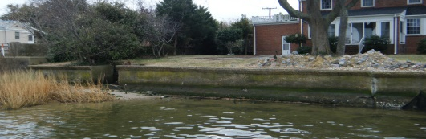

Revetment/Riprap

Rocks placed on a slope along the shoreline. The water does not often rise above the rocks.

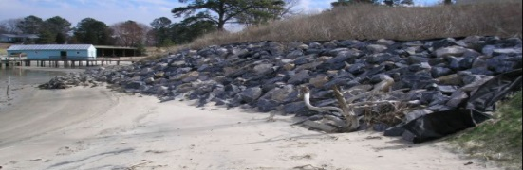

Groin

A wall that is perpendicular from the land, and goes into the water.

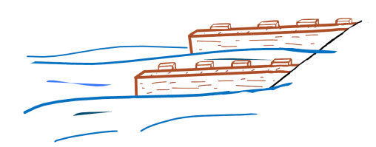

Breakwater

A pile (sill) of rocks placed in the water, away from the shore. The shore is a beach.

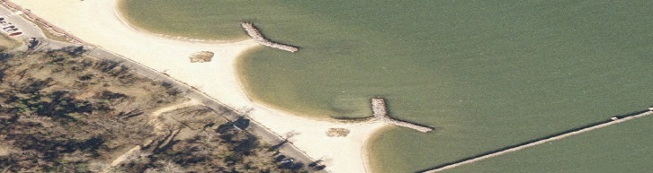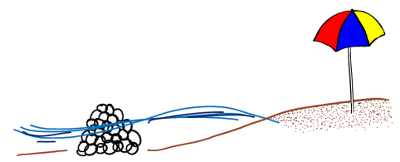

Living Shoreline
A pile (sill) of rocks, oyster bags, oyster reef structures, or fiber logs placed in front of a marsh, or in front of a planted marsh. The plants and land behind the sill get wet daily.

