Supplemental material:

Table 1 presents basic regression models where the dependent variable is the difference in the percentage of votes between the 2017 and 2013 elections (the higher numbers show the increase in the 2017 elections). The set of predictors are sociodemographic variables from the map. In addition, the log of the municipal population has been added (logging the number of inhabitants). In the last model, the dependent variable is the sum of the difference in percentage of the votes for ANO and the SPD party. The predictors are the differences in percentage of the vote for ČSSD and KSČM. We have also included the difference in the votes for ODS in order to account for the fact that in the 2013 election a small percentage of ANO 2011 voters were recruited from an ODS electorate that reverted to voting for ODS in 2017. The model shows the same result if the sociodemographic variables are added. From the simple OLS the residuals were saved to shapefile and the HAS was conducted (Figure 1 – Main map).

Table 1. Percentage vote share difference 2017-2013 as dependent variable
 | ANO 2017-13 | SPD 2017-13 | CSSD 2017-13 | KSČM 2017-13 | ANO+SPD 17-13
College degree (%) | -0.270*** | -0.036*** | 0.143*** | 0.134*** | -0.045***
 | (0.013) | (0.008) | (0.009) | (0.007) | (0.013)
Self-employed (%) | -1.260*** | -0.315*** | 0.856*** | 0.304*** | -0.373***
 | (0.028) | (0.017) | (0.020) | (0.016) | (0.024)
Unemployed (%) | -0.001 | 0.386*** | -0.190*** | -0.198*** | 0.107***
 | (0.024) | (0.014) | (0.018) | (0.014) | (0.024)
65+ years (%) | 0.173*** | -0.015** | -0.107*** | -0.005 | 0.040***
 | (0.008) | (0.005) | (0.006) | (0.004) | (0.007)
Catholics (%) | 0.029*** | -0.006 | -0.004 | 0.057*** | 0.047***
 | (0.006) | (0.004) | (0.004) | (0.003) | (0.005)
Distraints (%) | 0.212*** | 0.047*** | -0.034*** | -0.119*** | 0.127***
 | (0.011) | (0.007) | (0.008) | (0.007) | (0.011)
Number of inhabitants (log) | -0.178** | 0.458*** | -0.268*** | 0.579*** | 0.364***
 | (0.066) | (0.040) | (0.049) | (0.038) | (0.062)
ČSSD change |  |  |  |  | -0.763***
 |  |  |  |  | (0.009)
KSČM change |  |  |  |  | -0.754***
 |  |  |  |  | (0.011)
ODS change |  |  |  |  | -0.562***
 |  |  |  |  | (0.013)
(Constant) | 15.965*** | 2.401*** | -15.008*** | -11.231*** | -0.495
 | (0.371) | (0.223) | (0.275) | (0.214) | (0.394)
R2 | 0.405 | 0.156 | 0.298 | 0.309 | 0.616
Adj.R2 | 0.405 | 0.155 | 0.298 | 0.309 | 0.616
Number of cases | 14687 | 14687 | 14687 | 14687 | 14687
RMSE | 130.373 | 78.392 | 96.432 | 75.118 | 5.694
Note: Standard errors in parentheses, significance at: ***p < 0.001, **p < 0.01, *p < 0.05.

The map 1 shows the HAS from the GWR model based on the same predictors as in table 1. Compared to the OLS results, the GWR will eliminate much of the unexplained variance and the clusters of spatially autocorrelated residuals. As a result, GWR seems to be an analytically less useful tool in mapping electoral patterns when compared to standard OLS. Yet GWR can be utilized for an analysis of a specific contextual effect that might be attributable to the neighbourhood effect of a local candidate, or to an unmeasured specific local context that could be examined by means of a qualitative approach. Further maps of single coefficient variations in space can be requested from the authors, as well as maps of R2 from the GWR model. The limited space of the journal prevents a further explanation of the analyses that were conducted yet not presented. The preliminary results show that there are higher level contextual explanations on the regional level that can account for the unexplained variance in the models that are only based on sociodemographic variables. Thus there is potential for future research.
All analyses can be obtained from Dataverse as Lysek, Jakub, 2020, "Replication Data for: Who are the voters and where are they? Using spatial statistics to analyse voting patterns in the parliamentary elections of the Czech Republic", https://doi.org/10.7910/DVN/FD0RYS, Harvard Dataverse.

Map 1: Comparing GWR and OLS results – ANO2011 percentage vote share difference 2017-2013
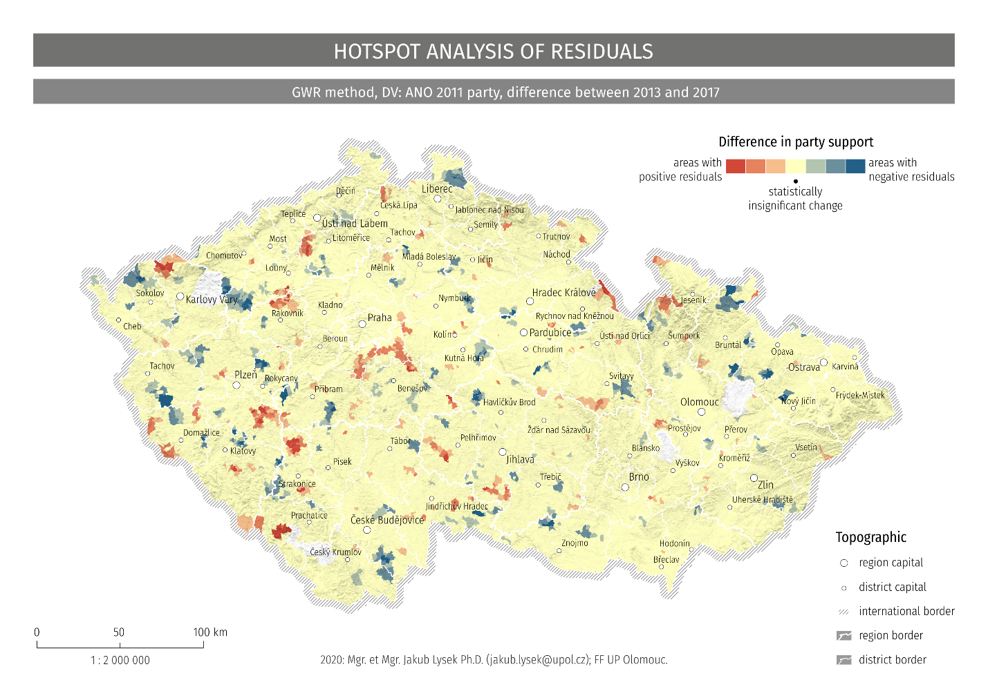

The dynamic of change in the left-wing electorate can be demonstrated in the series of regression models (Table 2 and 3) where the dependent variable is the simple percentage of votes for a party in a given election. Generally, the associations with sociodemographic variables decreases. This is also mirrored in the decreasing explained variance. This can be interpreted as meaning that the traditional left-wing parties lose their voter base in cases where societies are polarised.

Table 2: Regression model explaining ČSSD support

 | ČSSD 2017 | ČSSD 2013 | ČSSD 2010 | ČSSD 2006 | ČSSD 2002 | ČSSD 1998 | ČSSD 1996
College degree (%) | 0.003 | -0.070*** | -0.157*** | -0.125*** | 0.170*** | -0.164*** | -0.060***
 | (0.005) | (0.009) | (0.009) | (0.011) | (0.011) | (0.011) | (0.011)
Self-employed (%) | -0.414*** | -1.317*** | -1.421*** | -1.636*** | -0.965*** | -1.184*** | -1.205***
 | (0.014) | (0.026) | (0.026) | (0.031) | (0.030) | (0.031) | (0.031)
Unemployed (%) | 0.035** | 0.269*** | 0.532*** | 0.387*** | 0.168*** | 0.482*** | 0.583***
 | (0.011) | (0.020) | (0.021) | (0.024) | (0.023) | (0.025) | (0.024)
65+ years (%) | 0.074*** | 0.214*** | 0.257*** | 0.123*** | 0.070*** | -0.004 | -0.001
 | (0.004) | (0.007) | (0.008) | (0.009) | (0.009) | (0.009) | (0.009)
Catholics (%) | 0.033*** | 0.013** | 0.010* | 0.031*** | -0.047*** | -0.093*** | -0.092***
 | (0.002) | (0.005) | (0.005) | (0.006) | (0.005) | (0.006) | (0.006)
(Constant) | 7.595*** | 23.008*** | 23.878*** | 38.663*** | 32.543*** | 40.261*** | 32.711***
 | (0.161) | (0.306) | (0.315) | (0.366) | (0.352) | (0.370) | (0.367)
R2 | 0.132 | 0.293 | 0.368 | 0.276 | 0.101 | 0.213 | 0.205
Adj.R2 | 0.132 | 0.293 | 0.368 | 0.276 | 0.101 | 0.213 | 0.205
Number of cases | 13637 | 13606 | 13586 | 13552 | 13528 | 13495 | 13487
RMSE | 61.817 | 116.902 | 120.220 | 139.545 | 133.883 | 140.273 | 139.304
***p < 0.001, **p < 0.01, *p < 0.05

Table 3: Regression model explaining KSČM support
 | KSČM 2017 | KSČM 2013 | KSČM 2010 | KSČM 2006 | KSČM 2002 | KSČM 1998 | KSČM 1996
College degree (%) | -0.047*** | -0.063*** | -0.059*** | -0.057*** | -0.054*** | -0.038*** | -0.029***
 | (0.001) | (0.001) | (0.001) | (0.001) | (0.001) | (0.001) | (0.001)
Self-employed (%) | -0.083*** | -0.102*** | -0.070*** | -0.061*** | -0.075*** | -0.043*** | -0.026***
 | (0.003) | (0.003) | (0.003) | (0.003) | (0.004) | (0.004) | (0.004)
Unemployed (%) | 0.042*** | 0.057*** | 0.034*** | 0.041*** | 0.064*** | 0.033*** | 0.022***
 | (0.003) | (0.003) | (0.003) | (0.003) | (0.003) | (0.003) | (0.003)
65+ years (%) | 0.025*** | 0.018*** | 0.023*** | 0.022*** | 0.017*** | 0.019*** | 0.023***
 | (0.001) | (0.001) | (0.001) | (0.001) | (0.001) | (0.001) | (0.001)
Catholics (%) | -0.009*** | -0.017*** | -0.011*** | -0.013*** | -0.018*** | -0.013*** | -0.018***
 | (0.001) | (0.001) | (0.001) | (0.001) | (0.001) | (0.001) | (0.001)
(Constant) | 0.049 | 0.495*** | 0.191*** | 0.126** | 0.288*** | 0.016 | -0.114*
 | (0.041) | (0.039) | (0.040) | (0.041) | (0.042) | (0.046) | (0.047)
R2 | 0.278 | 0.397 | 0.307 | 0.288 | 0.304 | 0.150 | 0.123
Adj.R2 | 0.278 | 0.397 | 0.307 | 0.288 | 0.304 | 0.150 | 0.123
Number of cases | 13637 | 13606 | 13586 | 13552 | 13528 | 13495 | 13487
RMSE | 15.532 | 14.904 | 15.287 | 15.631 | 16.167 | 17.419 | 18.004
***p < 0.001, **p < 0.01, *p < 0.05

