Supplementary data

Supplementary data Table 1. Model parameters describing the absorption fraction (_{Fabs}) and metabolism (m₁ and m₂) and compartmental distribution (t₁₂,₂₁,₃₄,_{43,56,65}) of dietary pirimiphos-methyl (PM) in Atlantic salmon (Salmo salar). See main text Figure 1 for definition of model parameters. Parameter values after back-transformation (inverse log = exponential).
Model parameters | Fabs | m1 | m2 | t12 | t21 | t34 | t43 | t56 | t65
Estimated | 0.0239 | 0.032 | 0.0037 | 0.0030 | 0.0030 | 0.0017 | 0.0054 | 0.0002 | 0.0360
lower 95% confidence interval | 0.029 | 0.0295 | 0.0025 | 0.0021 | 0.0021 | 0.0000 | 0.0001 | 0.000 | 0.0010
higher 95% confidence interval | 0.0247 | 0.0353 | 0.0064 | 0.0044 | 0.0044 | 0.1234 | 0.2795 | 0.0069 | 0.9356

Supplementary data Table 2. Model parameters with a pre-set, fixed, high absorption (F_{abs} =0.20) metabolism (m₁ and m₂), compartmental distribution (t₁₂, ₂₁,₃₄,_{43,56,65}), and excretion (e_{1,2,3}) of dietary pirimiphos-methyl (PM) in Atlantic salmon (Salmo salar). See main text Figure 1 for definition of model parameters. Parameter values after back-transformation (inverse log = exponential)
model parameters | m1 | m2 | t12 | t21 | t34 | t43 | t56 | t65 | e1 | e2 | e3
Estimated | 0.2937 | 0.0562 | 0.0076 | 0.0054 | 0.0008 | 0.0076 | 0.008 | 0.0076 | 0.1679 | 0.1679 | 0.1679
lower 95% confidence interval | 0.1852 | 0.0218 | 0.0018 | 0.0000 | 0.0002 | 0.0018 | 0.002 | 0.0018 | 0.1398 | 0.1398 | 0.1398
higher 95% confidence interval | 0.4758 | 0.1283 | 0.0323 | 0.4477 | 0.0032 | 0.0323 | 0.0323 | 0.0323 | 0.1967 | 0.1967 | 0.1967

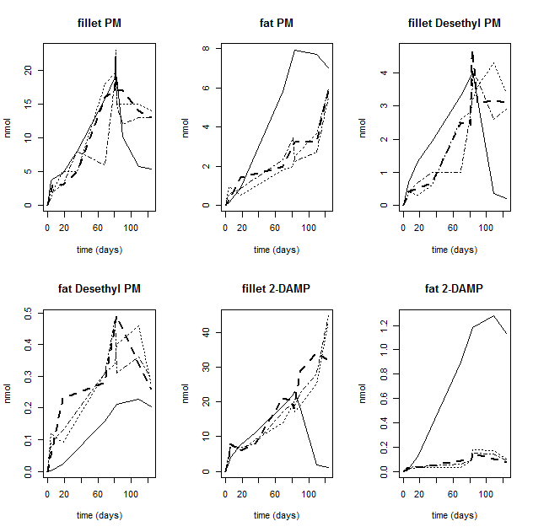

Supplementary data Figure 1. Model-predicted total fillet concentration (nmol) (even line) with a fixed high absorption (20%) compared to experimental data (three broken lines for the three different experimental tanks) for PM and the two metabolites (2-DAMP and Desethyl-PM) in the fillet and adipose tissue (fat) from Atlantic salmon fed PM-spiked feed (5 mg kg⁻¹) in triplicate tanks for 81 days followed by a 39 day depuration period.

