Supporting Information
Warmer temperatures promote shrub radial growth but not cover in the Central Canadian Arctic

Regional comparisons

Location of the field site and weather stations
We collected shrubs from the Walker Bay field reasearch station over three years (Table 1), which is located on the Kent Penninsula (Figure 1). The climate data came from (1) a weather station operational at Walker Bay for ~5 years, (2) Environment Canada weather data from Cambridge Bay, (3) Environment Canada weather data from Byron Bay, and (4) Environment Canada weather data from Kugluktuk (Figure 1). Byron Bay is closest to Walker Bay, but has limited climate data and a somewhat different vegatation structure (D. Morris, personal observation). We expected that Cambridge Bay weather data would be the best match for Walker Bay.
To confirm that Cambridge Bay was the most appropriate climate data, we also downloaded data from two other nearby weather stations at Kugluktuk and Byron Bay.
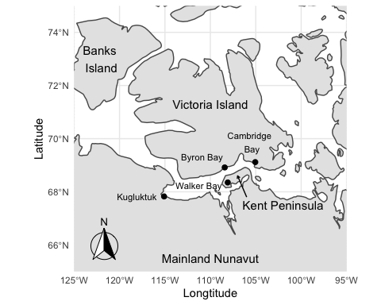
Figure 1: The location of our field site at Walker Bay and the nearby weather stations at Cambridge Bay and Kugluktuk. The black dots represent locations of each site/weather station. The weather stations at Walker Bay, Kugluktuk, Byron Bay, and Cambridge Bay were active from 1996 to 2007, 1930 to 2014, 1957 to 1993, and 1949 to present, respectively.

Walker Bay Climate Data
The temperature and precipitation data from a weather station at Walker Bay are available from 1996 to 2007. Annual average temperature did not change during this interval (Figure 2a). The shrub growth recorded at Walker Bay from 1996 to 2007 was not significantly related to annual temperature (p > 0.5; Figure 2b) although there was a marginally significant relationship with July temperature (p = 0.051; Figure 2c).
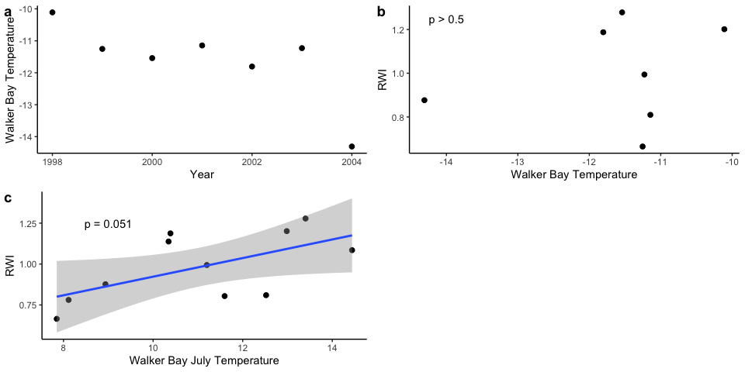
Figure 2: The climate data from Walker Bay and its relationship with shrub growth, which is measured as ring width index (RWI). Air temperature (a), annual temperature versus shrub growth (b), and July temperature versus shrub growth (c). The analysis includes data from 1996 to 2007.

Kugluktuk Climate Data
The temperature and precipitation data from a weather station at Kugluktuk are available from 1930 to 2014. Annual average temperature significantly increased over this interval (p < 0.001). The shrub growth at Walker Bay from 1930 to 2014 was not significantly related to Kugluktuk annual temperature (p > 0.5) although there was a significant relationship with July temperature (p < 0.04; Figure 3a).
There were enough data for Kugluktuk to repeat the response function analysis comparing Walker Bay shrubs to Kugluktuk climate records. No significant relationships were observed (Figure 4).
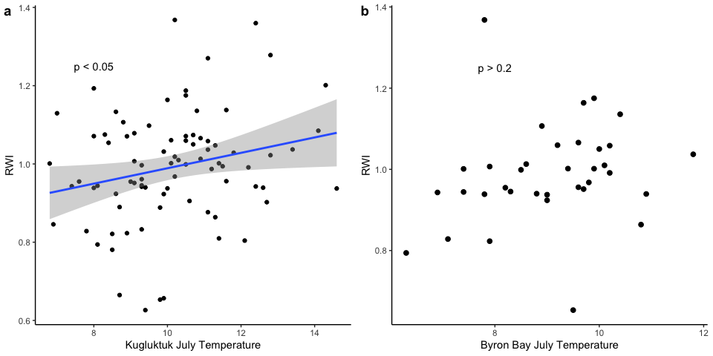
Figure 3: Kugluktuk (a) and Byron Bay (b) July temperature versus Walker Bay shrub growth. The analyses for Kugluktuk and Byron Bay include data from 1930 to 2014 and 1957 to 1993, respectively. RWI is the ring width index calculated for the shrubs at Walker Bay.
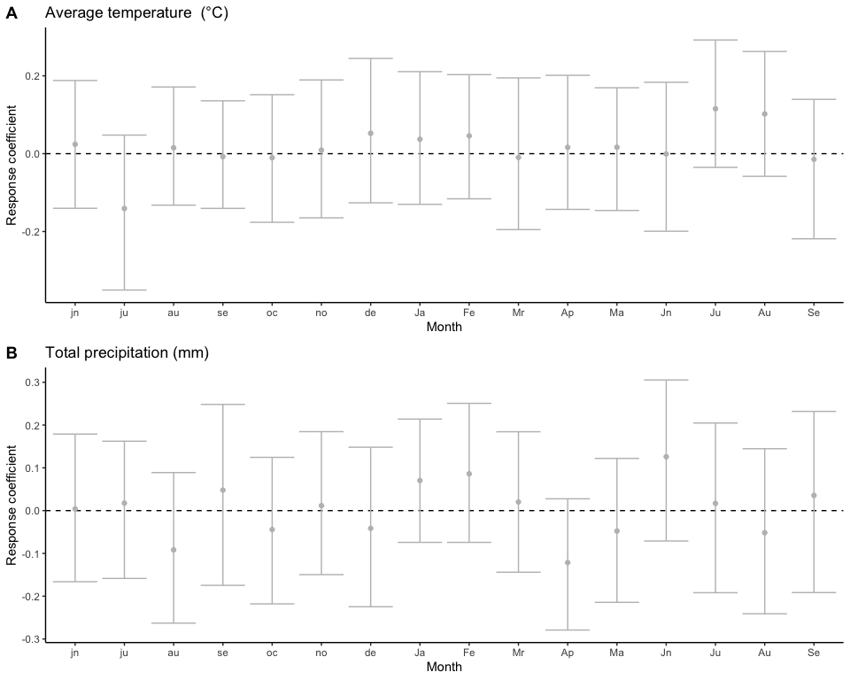
Figure 4: No significant response functions for Kugluktuk. Lower case letters indicate months in the year before shrub growth, while capital letters indicate months in the year of shrub growth. The analysis includes data from 1930 to 2014.

Byron Bay Climate Data
The temperature and precipitation data from a weather station at Byron Bay are available from 1957 to 1993. Annual average temperature did not change over this interval (p > 0.78). The shrub growth at Walker Bay from 1957 to 1993 was not significantly related to Byron Bay annual temperature (p > 0.7) nor was there a significant relationship with July temperature (p > 0.2; Figure 3b).
There were enough data for Byron Bay to repeat the response function analysis comparing Walker Bay shrubs to Byron Bay climate records. April temperature during the growth year at Byron Bay was a significant predictor of shrub radial growth at Walker Bay. All other response function coefficients were not significant (Figure 5). We are cautious to interpret the significant response function coefficient for April as mechanistic, because the climate time series for Byron Bay (1962 - 1991) is much shorter than the one available for Cambridge Bay (1949 - present). In fact, reanalyzing the climate-growth relationship for Cambridge Bay using the same years as there are data for Byron Bay produces a new significant response function coefficient (April total percipitation) that is not significant for the full dataset. In summary, there is limited evidence that spring temperature might be important for shrubs at Walker Bay, but it is not strong enough to be conclusive with the current dataset.
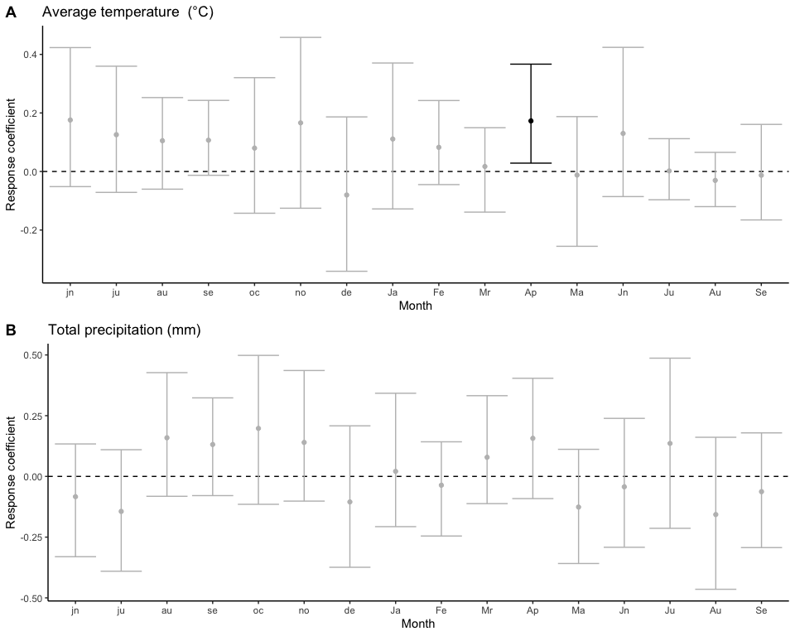
Figure 5: April temperature in the growth year at Byron Bay had a significant response function coefficient. Lower case letters indicate months in the year before shrub growth, while capital letters indicate months in the year of shrub growth. The analysis includes data from 1957 to 1993.

Comparison with other regional chronologies
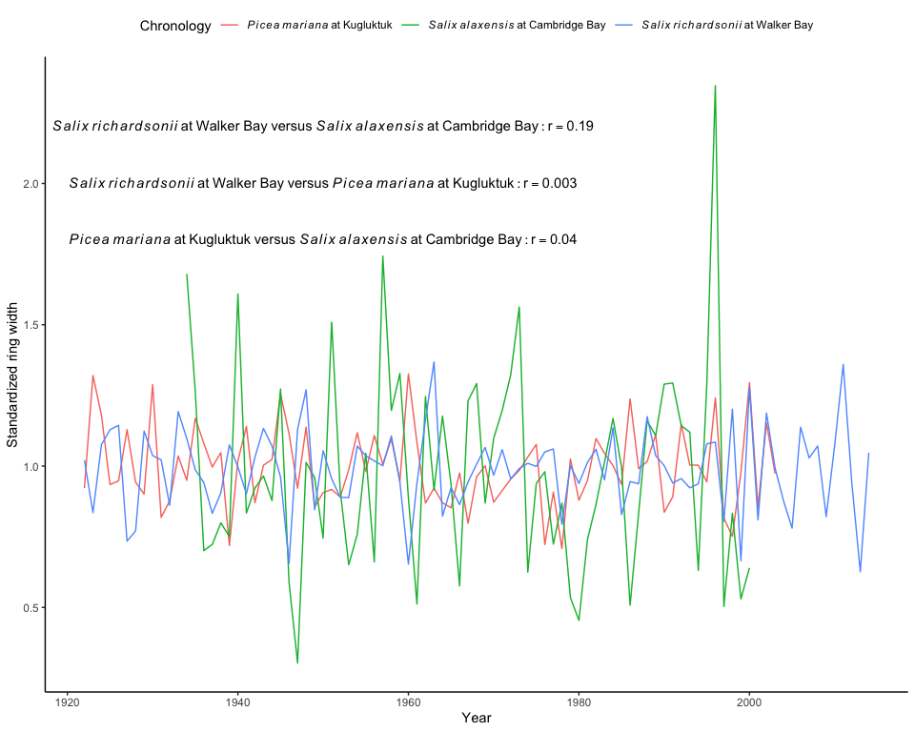
Figure 6: Relationship between Central Canadian Arctic chronologies.
Two other chronologies exist for our study region, which can be compared with ours at Walker Bay (Figure 6). One was collected for Salix alaxensis on Victoria Island near Cambridge Bay. This chronology is relatively well correlated with ours from Walker Bay (r = 0.19, p = 0.12, years from 1934 to 2000). Another chronology is available for Picea mariana from Kugluktuk, which is poorly correlated with our chronology from Walker Bay (r = 0.003, p = 0.98, years from 1922 to 2003). The comparison with P. mariana is not as relevant as with S. alaxensis, because P. mariana is a tree species and we expect it to have different climate relationships than the shrubs. The data are included here because the P. mariana chronology is one of the few close to our sampling sites at Walker Bay.

Table 1: Sampling regime for the shrubs used in our dendrochronological analysis. N is the number of shrub stems sampled, each fram an individual shrub.
Month | Year | N | Description | References
June | 2010 | 17 | We randomly sampled one shrub from 12 lemming sampling grids, one shrub from four quardats of a predator field exclosure, and one shrub from a snap-trap transect. | Morris et al. 2000; Krebs et al., 2012; Dupuch et al., 2014
June | 2011 | 41 | We randomly sampled forty shrubs at four random transects (500m long and 100m apart). We added one shrub that was much older than the others to extend our chronology. | No currently published work
June | 2015 | 12 | We randomly sampled one shrub adjacent to the same 12 lemming sampling grids that were sampled in 2010. | Dupuch et al., 2014

Raw ring width and area data
The raw ring width data demonstrate a strong decrease in growth during the first years for most shrubs (Figure 7). This age-dependent growth trend encouraged us to use a ring area method for assessing growth over time. Using the ring area instead of the ring width removed the age-based growth trend in the data and allowed us to analyze growth over time without removing any temporal signal with standardization (Figure 8).
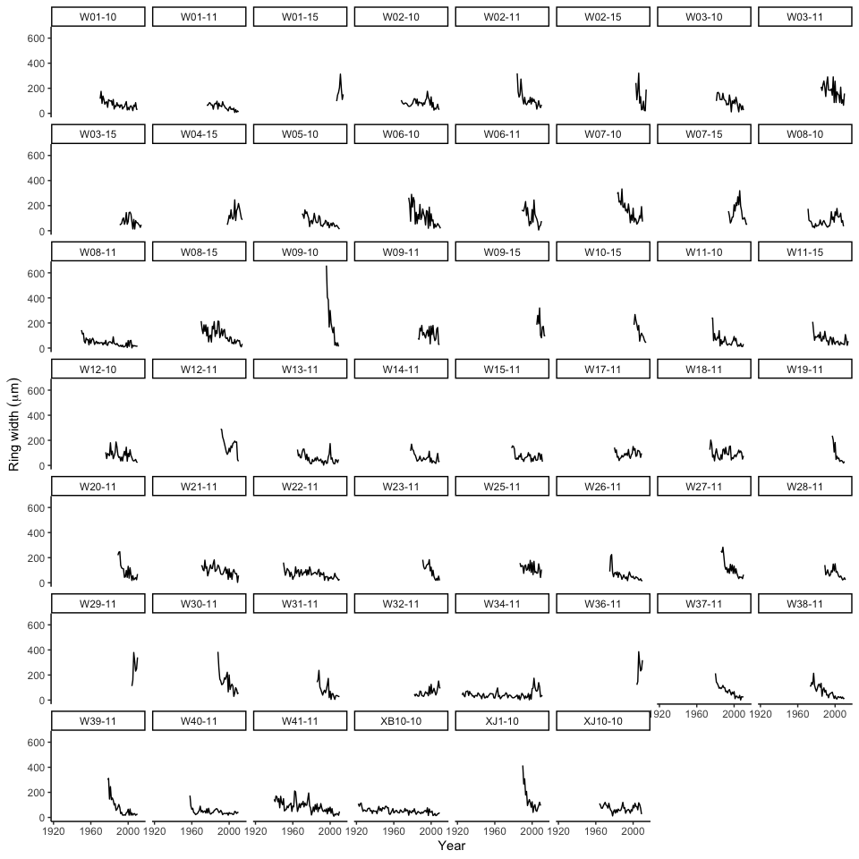
Figure 7: Raw ring width data for all the shrubs used in our analysis.
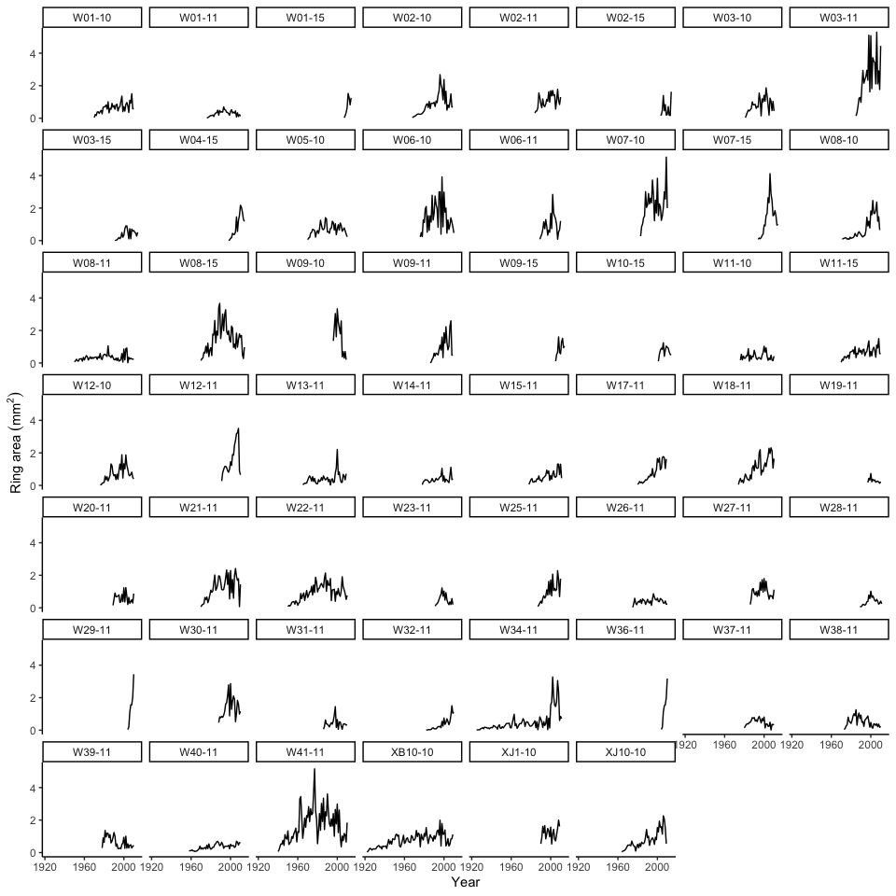
Figure 8: Raw ring area data for all the shrubs used in our analysis. Notice that ring area removes the strong age-based growth trend present in the raw data.

Significant response functions 1996 to 2010
The response function analysis conducted with data from 1996 to 2010 produced significant coefficients for May, July, and August total precipitaiton. The univariate relationship was strongest and negative for July precipitation during this period (Figure 9).
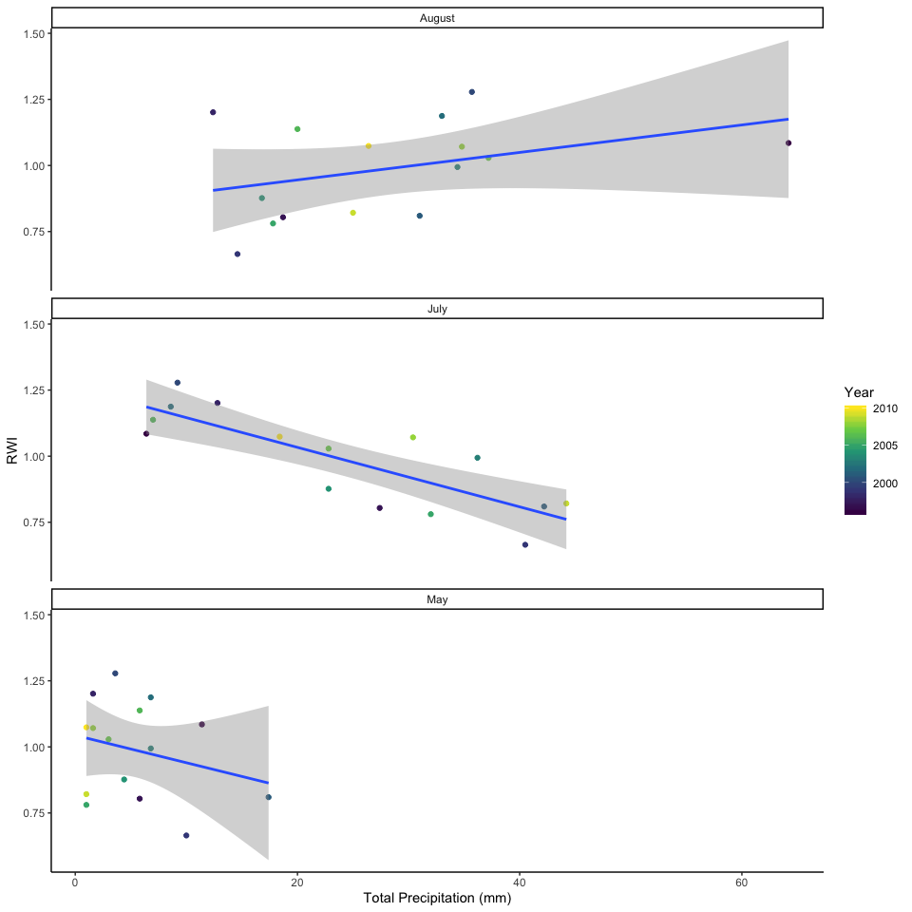
Figure 9: The relationship between the ring width index (RWI) and May, July, and August total precipitation of the growing year from 1996 to 2010. These three monthly precipitation variables were significant in a response function analysis.

Shrub cover estimates
We have estimates of short and tall shrub cover from Walker Bay in 1996 and 2010. For tall shrubs (over 25cm tall) the data produce a contingency table (Table 2) which shows no significant change in tall shrub cover (p = 0.41). There was no change in the number of transects with shrubs (Table 3; p = 0.14).
For short shrubs the data produce a contingency table (Table 4) which shows no significant change in short shrub cover (p = 0.22). Significantly fewer transects had short shurbs in 2010 than 1996 (Table 5; p = 0.01).
Table 2: Tall shrub abundance for two years at 3000 points.
Year | 1996 | 2010
Shrub | 115 | 2885
None | 102 | 2898

Table 3: Tall shrub abundance for two years on 300 transects.
Year | 1996 | 2010
Shrub | 61 | 239
None | 46 | 254

Table 4: Short shrub abundance for two years at 3000 points.
Year | 1996 | 2010
Shrub | 529 | 2471
None | 567 | 2433

Table 5: Short shrub abundance for two years on 300 transects.
Year | 1996 | 2010
Shrub | 216 | 84
None | 184 | 116

References
Dupuch, A., Morris, D. W., Ale, S. B., Wilson, D. J., and Moore, D. E.,2014: Landscapes of fear or competition? Predation did not alter habitat choiceby Arctic rodents. Oecologia, 174:403-412.
Krebs, C. J., Bilodeau, F., Reid, D., Gauthier, G., Kenney, A. J., Gilbert, S., … Wilson, D. J. 2012: Are lemming winter nest counts a good index of population density? Journal of Mammalogy, 93: 87–92.
Morris, D.W., Davidson, D.L. & Krebs, C.J., 2000. Measuring the ghostof competition: insights from density-dependent habitat selection on theco-existence and dynamics of lemmings. EvolutionEcology Research, 2: 69-80.

