Supplemental Information for:
Air Quality and Source Apportionment Modeling of Year 2017 Ozone Episodes in Albuquerque/Bernalillo County, New Mexico

Kenneth Craig*, Garnet Erdakos, Shih Ying Chang, and Lynn Baringer
Sonoma Technology, Inc., Petaluma, CA USA
* Corresponding author: kcraig@sonomatech.com
Table S-1. WRF physics options.
Option | Package
Boundary layer parameterization | Asymmetric Convection Model 2 (ACM2)
Land surface physics | Pleim-Xiu with soil temperature and moisture nudging
Microphysics | WRF Single-moment 6-class (WSM6)
Shortwave radiation | Rapid Radiative Transfer Model (RRTMG)
Longwave radiation | RRTMG
Cumulus parameterization | Kain-Fritsch in the 36/12-km domains  None in the 4-km domain
FDDA Analysis Nudging | Applied to winds, temperature, and moisture in the 36-km and 12-km domains, with no temperature and moisture nudging within the PBL
FDDA Observation Nudging | None
Input gridded data for initial and boundary conditions | North American Regional Reanalysis  (32-km resolution)

Table S-2. CAMx model configuration.
Science Option | Configuration
Model Code | CAMx version 6.40
Grid Interaction | Two-way continuous nesting
Boundary Conditions | 36 km: from MOZART  12 km and 4 km: From parent domains
Plume-in-Grid Sources | None
Gas Phase Chemistry | CB06r2
Aerosol Chemistry | Coarse/Fine (CF) 2-mode model with SOAP organic chemistry, ISORROPIA inorganic thermodynamics, and RADM aqueous chemistry
Meteorological Processor | WRFCAMx
Horizontal Diffusion | K-theory 1st order closure
Vertical Diffusion | CMAQ-like in WRF2CAMx with Kz_min = 0.1 m²/s (except up to 2.0 m²/s in urban areas via KVPATCH)
Dry Deposition | Zhang
Wet Deposition | Scavenging model
Gas Phase Chemistry Solver | Euler Backward Iterative
Vertical Advection Scheme | Implicit backward-Euler integration
Integration Time Step | Wind speed dependent, but generally 5 to 60 s for the 4-km grid, 1-5 min for the 12-km grid, and 5-15 min for the 36-km grid
Horizontal Advection Scheme | Piecewise Parabolic Method
Source Apportionment | OSAT/APCA

Table S-3. Modeled MDA8 ozone source contributions (ppb and percentage) in Albuquerque/Bernalillo County due to anthropogenic emissions from Albuquerque/Bernalillo County (ABQ), New Mexico (NM), the Denver Front Range areas (DEN), Texas (TX), California (CA), other western states (West), other eastern states (East), Canada and Mexico (Intl), fire, offshore sources (Ofsh), biogenic sources (Biog), and boundary conditions (BC). The total indicates the peak modeled 8-hr ozone concentration in Albuquerque/Bernalillo County. Bold values indicate days when the monitored peak 8-hr average ozone was greater than or equal to 65 ppb, and data from these days are the basis for Figure 3 and Figure 6. Data for 6/13 and 7/4 are not bold and were excluded from consideration for Figures 3 and 6 as the model did not reasonably represent observed ozone concentrations on these days. Daily contributions were calculated by multiplying the modeled relative contributions by the highest monitored MDA8 ozone concentration in Albuquerque/Bernalillo County. Percentages in the table are relative to the peak monitored value (Total) and rounded to the nearest whole percent.

Date | ABQ | NM | DEN | TX | CA | West | East | Intl | Fire | Ofsh | Biog | BC | Total
6/12 | 2.45 (5%) | 1.15 (2%) | 0.00 (0%) | 0.00 (0%) | 0.00 (0%) | 0.32 (1%) | 0.00 (0%) | 0.72 (1%) | 0.92 (2%) | 0.56 (1%) | 0.62 (1%) | 44.25 (87%) | 51
6/13 | 2.19 (3%) | 1.89 (3%) | 0.00 (0%) | 0.00 (0%) | 1.49 (2%) | 1.82 (3%) | 0.04 (0%) | 0.69 (1%) | 0.33 (0%) | 0.56 (1%) | 0.96 (1%) | 57.03 (85%) | 67
6/14 | 6.90 (9%) | 3.05 (4%) | 0.00 (0%) | 0.00 (0%) | 1.41 (2%) | 2.77 (4%) | 0.02 (0%) | 0.33 (0%) | 0.59 (1%) | 0.50 (1%) | 1.49 (2%) | 58.93 (78%) | 76
6/15 | 7.74 (11%) | 2.63 (4%) | 0.00 (0%) | 0.00 (0%) | 1.21 (2%) | 5.26 (7%) | 0.01 (0%) | 0.30 (0%) | 1.67 (2%) | 0.26 (0%) | 1.59 (2%) | 51.32 (71%) | 72
6/16 | 4.59 (7%) | 5.74 (9%) | 0.00 (0%) | 0.00 (0%) | 1.98 (3%) | 5.72 (9%) | 0.01 (0%) | 0.20 (0%) | 2.07 (3%) | 0.28 (0%) | 2.38 (4%) | 44.06 (66%) | 67
7/3 | 6.33 (10%) | 2.04 (3%) | 0.00 (0%) | 0.08 (0%) | 2.10 (3%) | 2.49 (4%) | 0.01 (0%) | 2.31 (4%) | 1.45 (2%) | 1.59 (3%) | 2.01 (3%) | 40.58 (67%) | 61
7/4 | 5.61 (8%) | 10.16 (15%) | 0.00 (0%) | 0.03 (0%) | 2.51 (4%) | 4.73 (7%) | 0.01 (0%) | 1.87 (3%) | 1.69 (2%) | 1.33 (2%) | 3.18 (5%) | 36.90 (54%) | 68
7/5 | 11.06 (16%) | 3.41 (5%) | 0.99 (1%) | 0.01 (0%) | 1.97 (3%) | 5.66 (8%) | 0.02 (0%) | 0.62 (1%) | 0.93 (1%) | 0.55 (1%) | 3.63 (5%) | 41.15 (59%) | 70
7/6 | 12.87 (19%) | 3.79 (6%) | 0.85 (1%) | 0.73 (1%) | 0.93 (1%) | 3.72 (5%) | 0.22 (0%) | 0.60 (1%) | 0.71 (1%) | 0.30 (0%) | 4.92 (7%) | 39.35 (57%) | 69
7/7 | 10.61 (14%) | 4.75 (6%) | 0.59 (1%) | 3.33 (4%) | 0.68 (1%) | 2.62 (3%) | 0.87 (1%) | 1.28 (2%) | 0.64 (1%) | 0.30 (0%) | 6.42 (8%) | 43.92 (58%) | 76
7/8 | 7.96 (14%) | 5.16 (9%) | 0.78 (1%) | 2.39 (4%) | 0.61 (1%) | 2.68 (5%) | 0.58 (1%) | 1.36 (2%) | 0.86 (1%) | 0.44 (1%) | 4.18 (7%) | 30.99 (53%) | 58
7/9 | 8.91 (14%) | 4.15 (7%) | 0.48 (1%) | 0.99 (2%) | 1.06 (2%) | 5.77 (9%) | 0.24 (0%) | 1.37 (2%) | 1.29 (2%) | 0.47 (1%) | 3.95 (6%) | 33.31 (54%) | 62
7/10 | 17.30 (23%) | 5.21 (7%) | 1.43 (2%) | 0.70 (1%) | 1.02 (1%) | 6.10 (8%) | 0.32 (0%) | 1.16 (2%) | 1.53 (2%) | 0.40 (1%) | 4.84 (6%) | 36.00 (47%) | 76
7/11 | 16.06 (23%) | 5.00 (7%) | 0.75 (1%) | 0.98 (1%) | 0.68 (1%) | 4.14 (6%) | 0.30 (0%) | 1.20 (2%) | 1.12 (2%) | 0.33 (0%) | 4.08 (6%) | 35.38 (51%) | 70
7/12 | 10.45 (17%) | 4.45 (7%) | 0.32 (1%) | 1.75 (3%) | 1.31 (2%) | 3.38 (5%) | 0.22 (0%) | 2.25 (4%) | 0.98 (2%) | 0.61 (1%) | 3.51 (6%) | 32.76 (53%) | 62
7/13 | 8.00 (13%) | 5.40 (9%) | 0.22 (0%) | 1.23 (2%) | 2.78 (4%) | 3.29 (5%) | 0.20 (0%) | 2.58 (4%) | 1.35 (2%) | 1.04 (2%) | 3.69 (6%) | 33.20 (53%) | 63
7/14 | 4.92 (10%) | 4.03 (8%) | 0.06 (0%) | 2.54 (5%) | 0.59 (1%) | 0.65 (1%) | 0.26 (1%) | 3.09 (6%) | 0.40 (1%) | 0.71 (1%) | 2.66 (5%) | 31.08 (61%) | 51

Table S-4. Modeled MDA8 ozone source contributions (ppb and percentage relative to the anthropogenic ozone contribution) in Albuquerque/Bernalillo County due to on-road mobile source emissions from Albuquerque/Bernalillo County (ABQ Onroad) and New Mexico (NM Onroad), other anthropogenic emissions groups in Albuquerque/Bernalillo County (ABQ Other Anthro) and New Mexico (NM Other Anthro), the three individual EGU point sources that were tagged, the Western Refining Gallup facility, and anthropogenic emissions outside of New Mexico (Other Anthro). Total Anthro indicates the total modeled U.S. and non-U.S. (Canada and Mexico) anthropogenic ozone contribution in Albuquerque/Bernalillo County. Bold values indicate days when the monitored MDA8 ozone was greater than or equal to 65 ppb, and data from these days are the basis for Figure 3 and Figure 6. MDA8 ozone was greater than 65 ppb on 6/13 and 7/4 but these days are not bold as the model did not reasonably represent observed ozone concentrations on these days. Daily contributions were calculated by multiplying the modeled relative contributions by the highest monitored MDA8 ozone concentration in Albuquerque/Bernalillo County.

 | ABQ Onroad | ABQ  Anthro  Other | Prewitt Escalante EGU | San Juan EGU | Four Corners EGU | Western Refining | NM Onroad | NM Anthro Other | Other Anthro | Total  Anthro
6/12 | 1.13 (22%) | 1.32 (25%) | 0.00  (0%) | 0.00  (0%) | 0.00  (0%) | 0.00  (0%) | 0.69 (13%) | 0.46 (9%) | 1.6 (31%) | 5.20
6/13 | 1.06 (12%) | 1.13 (13%) | 0.16  (2%) | 0.00  (0%) | 0.00  (0%) | 0.02  (0%) | 1.02 (12%) | 0.69 (8%) | 4.59 (53%) | 8.67
6/14 | 3.23 (22%) | 3.67 (25%) | 0.07  (0%) | 0.07 (0%) | 0.06 (0%) | 0.01  (0%) | 1.86 (12%) | 0.99 (7%) | 5.03 (34%) | 14.98
6/15 | 3.88 (22%) | 3.86 (22%) | 0.04  (0%) | 0.02 (0%) | 0.02 (0%) | 0.01  (0%) | 1.68 (10%) | 0.87 (5%) | 7.06 (40%) | 17.43
6/16 | 2.37 (13%) | 2.22 (12%) | 0.23  (1%) | 0.49 (3%) | 0.47 (3%) | 0.02  (0%) | 2.98 (16%) | 1.56 (8%) | 8.18 (44%) | 18.50
7/3 | 2.97 (18%) | 3.36 (20%) | 0.20  (1%) | 0.02 (0%) | 0.04 (0%) | 0.04  (0%) | 1.02 (6%) | 0.71 (4%) | 8.58 (51%) | 16.96
7/4 | 2.62 (10%) | 3.00  (11%) | 0.04  (0%) | 1.24 (5%) | 1.69 (6%) | 0.00  (0%) | 4.15 (16%) | 3.03 (12%) | 10.48 (40%) | 26.25
7/5 | 5.37 (22%) | 5.69 (23%) | 0.01  (0%) | 0.13 (1%) | 0.16 (1%) | 0.00  (0%) | 2.26 (9%) | 0.85 (4%) | 9.82 (40%) | 24.29
7/6 | 6.57 (27%) | 6.3 (26%) | 0.01  (0%) | 0.10  (0%) | 0.14 (1%) | 0.00  (0%) | 2.18 (9%) | 1.39 (6%) | 7.36 (31%) | 24.02
7/7 | 5.06 (20%) | 5.55 (22%) | 0.00  (0%) | 0.02 (0%) | 0.03 (0%) | 0.00  (0%) | 2.78 (11%) | 1.92 (8%) | 9.66 (39%) | 25.01
7/8 | 3.89 (18%) | 4.07 (19%) | 0.00  (0%) | 0.03 (0%) | 0.04 (0%) | 0.00  (0%) | 3.15 (14%) | 1.93 (9%) | 8.85 (40%) | 21.97
7/9 | 4.03 (17%) | 4.89 (21%) | 0.07  (0%) | 0.13 (1%) | 0.13 (1%) | 0.00  (0%) | 1.92 (8%) | 1.92 (8%) | 10.38 (44%) | 23.45
7/10 | 7.87 (23%) | 9.44 (28%) | 0.18  (1%) | 0.29 (1%) | 0.18 (1%) | 0.02  (0%) | 2.37 (7%) | 2.17 (6%) | 11.11 (33%) | 33.62
7/11 | 7.66 (26%) | 8.4 (29%) | 0.10  (0%) | 0.28 (1%) | 0.09 (0%) | 0.01  (0%) | 2.43 (8%) | 2.10 (7%) | 8.36 (28%) | 29.42
7/12 | 4.88 (20%) | 5.57 (23%) | 0.06  (0%) | 0.35 (1%) | 0.06 (0%) | 0.01  (0%) | 2.09 (8%) | 1.88 (8%) | 9.86 (40%) | 24.75
7/13 | 4.05 (16%) | 3.96 (16%) | 0.14  (1%) | 0.91 (4%) | 0.07 (0%) | 0.01  (0%) | 2.16 (9%) | 2.11 (9%) | 11.34 (46%) | 24.75
7/14 | 2.35 (14%) | 2.57 (15%) | 0.05  (0%) | 0.09 (1%) | 0.01 (0%) | 0.01  (0%) | 1.83 (11%) | 2.06 (12%) | 7.89 (47%) | 16.85

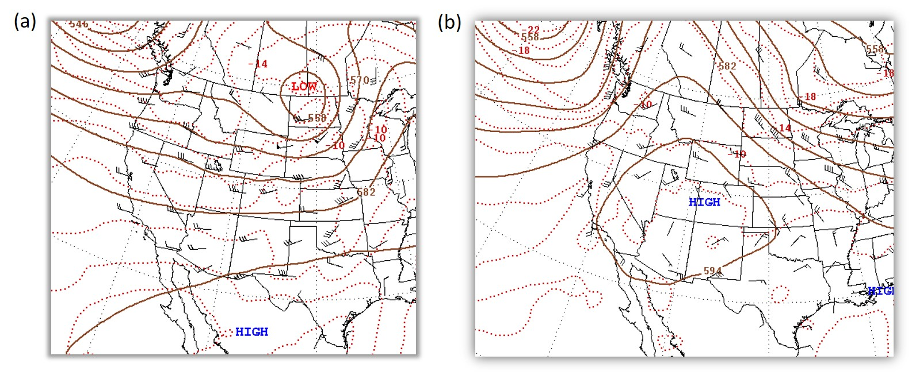
Figure S-1. Weather maps for 500 mb on (a) June 14, 2017 and (b) July 7, 2017. From NCEP Daily Weather Map archive (http://www.wpc.ncep.noaa.gov/dwm).

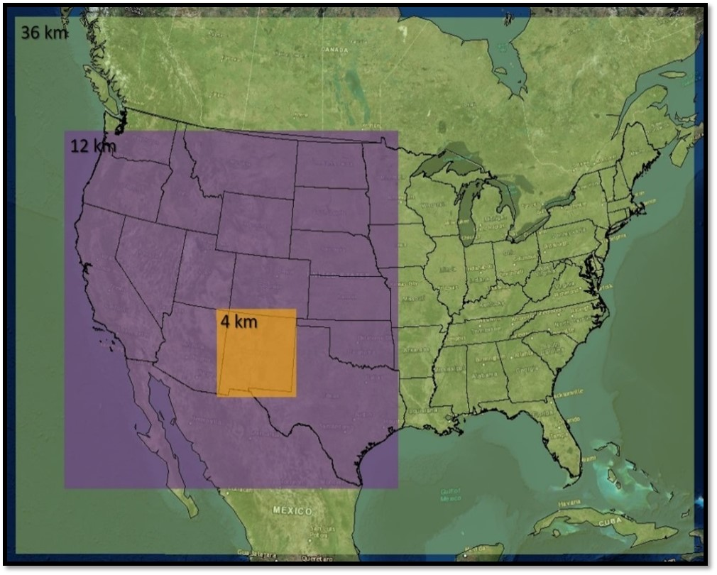
Figure S-2. Air quality modeling domains.

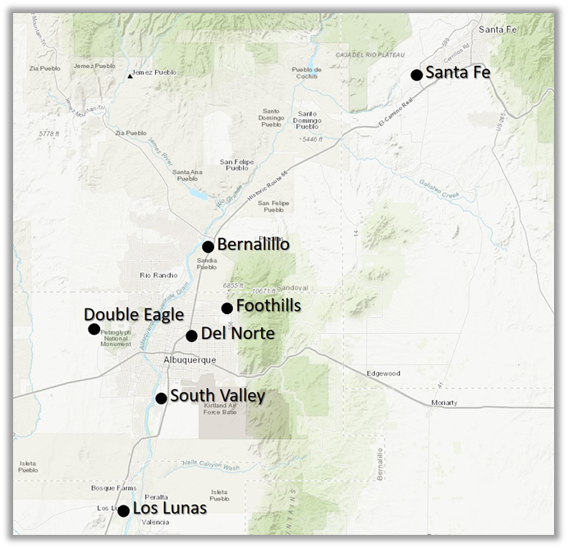
Figure S-3. Location of ozone monitoring sites in Albuquerque/Bernalillo County and neighboring counties.
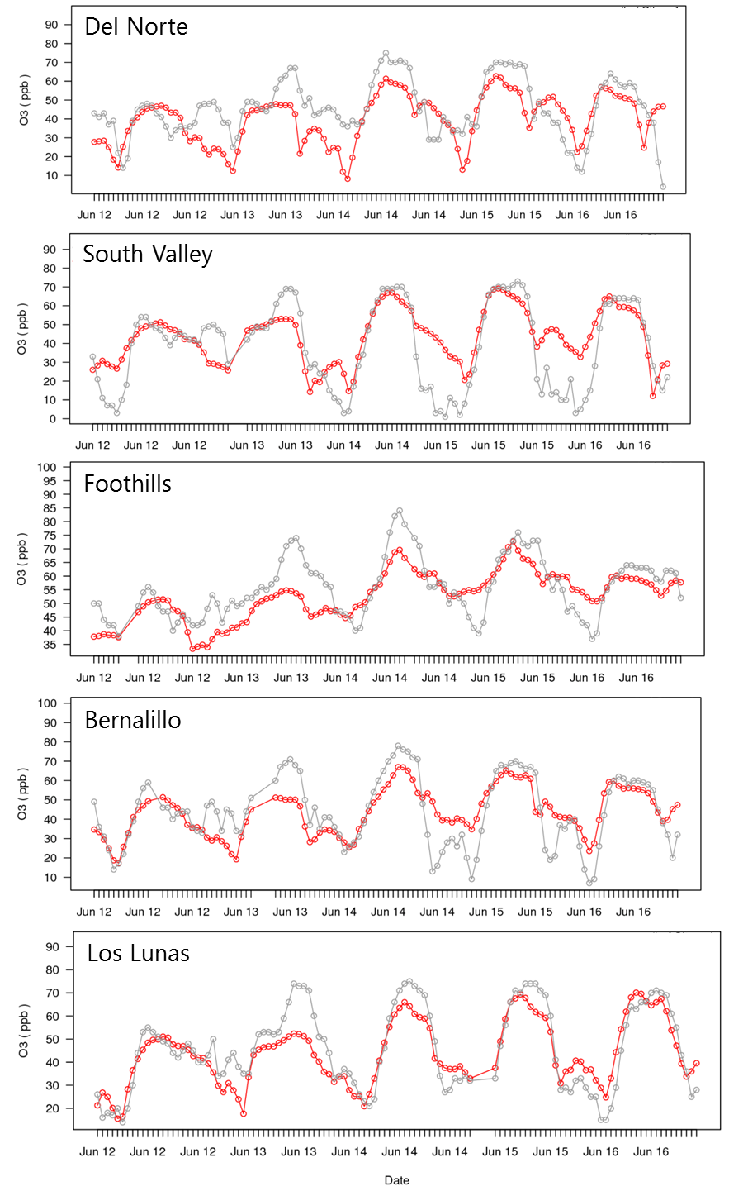
Figure S-4. Time series of hourly observed (gray line) and modeled (red line) ozone concentrations in the Albuquerque area during June 12-16, 2017.
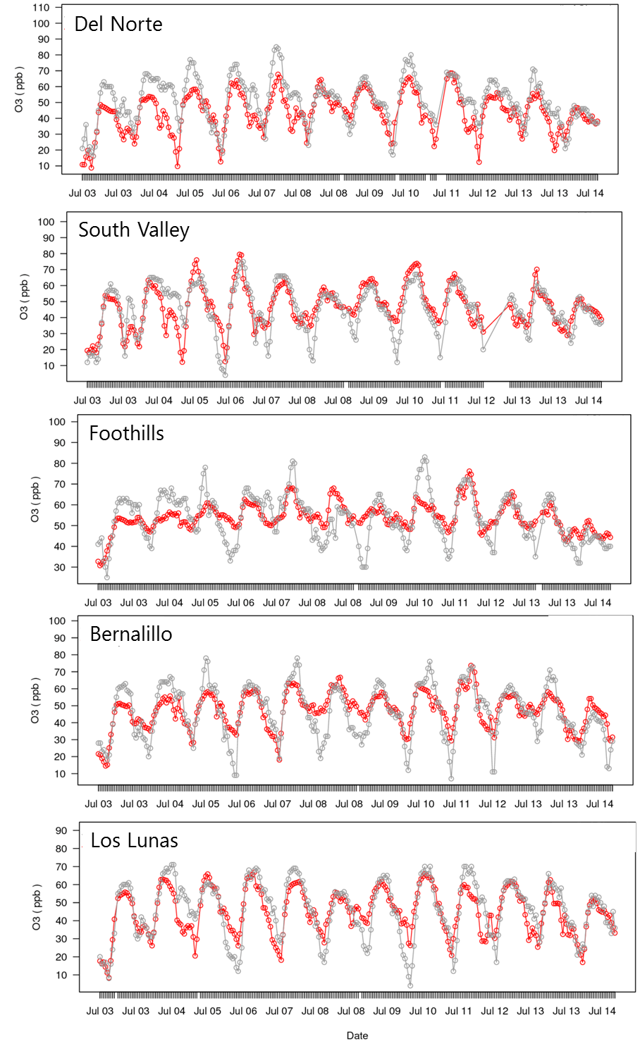
Figure S-5. Time series of hourly observed (gray line) and modeled (red line) ozone concentrations in the Albuquerque area during July 3-14, 2017.
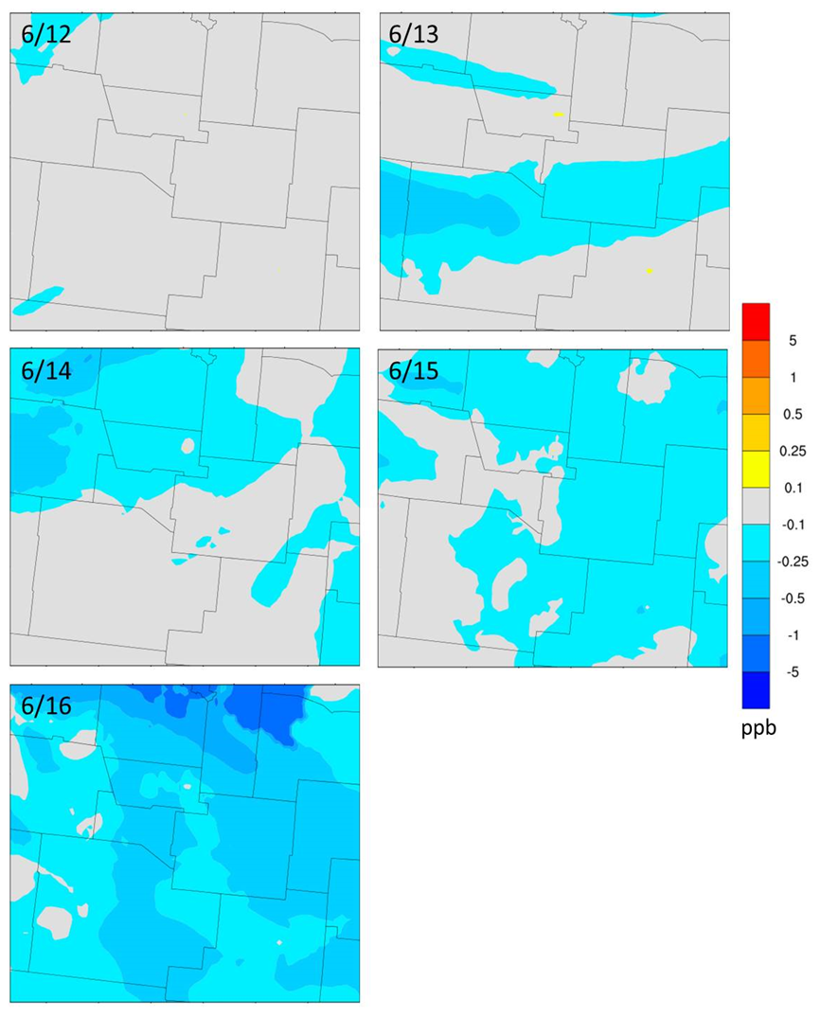
Figure S-6. Differences between MDA8 ozone concentrations modeled in the 25% reductions in NOx and VOC emissions from the oil and gas sector sensitivity simulation and in the base-case simulation for the June episode. Warm colors indicate an increase in ozone, while cool colors indicate a decrease.

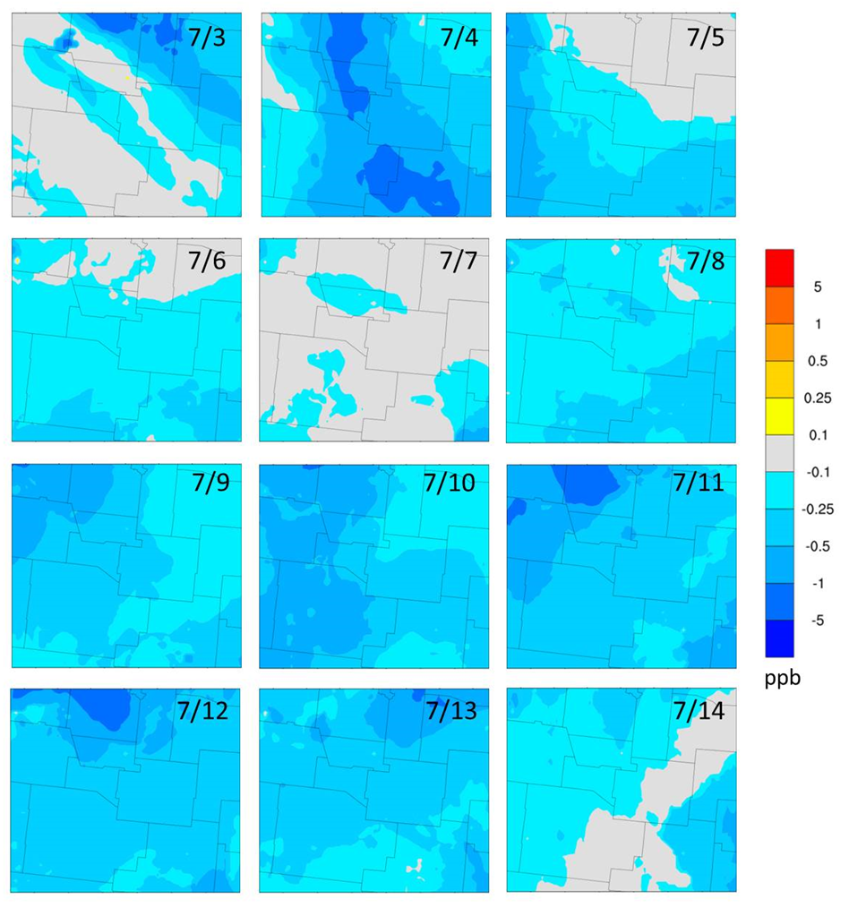
Figure S-7. Differences between MDA8 ozone concentrations modeled in the 25% reductions in NOx and VOC emissions from the oil and gas sector sensitivity simulation and in the base-case simulation for the July episode. Warm colors indicate an increase in ozone, while cool colors indicate a decrease.
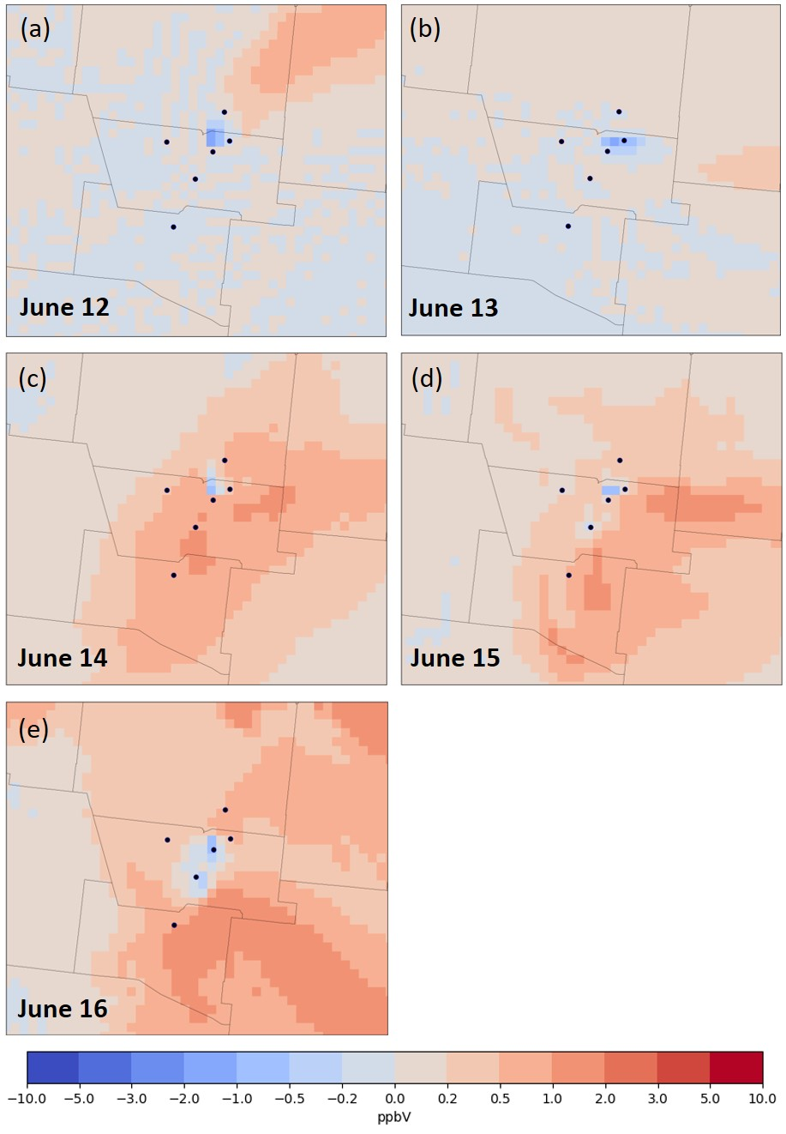
Figure S-8. Differences between modeled peak 8-hr ozone concentrations in the 2025 peak-demand EGUs sensitivity modeling and the 2025 future-year simulation for all days in the June ozone episode: (a) June 12; (b) June 13; (c) June 14; (d) June 15; (e) June 16. Black circles represent the ozone monitoring sites in Albuquerque/Bernalillo County and neighboring counties.
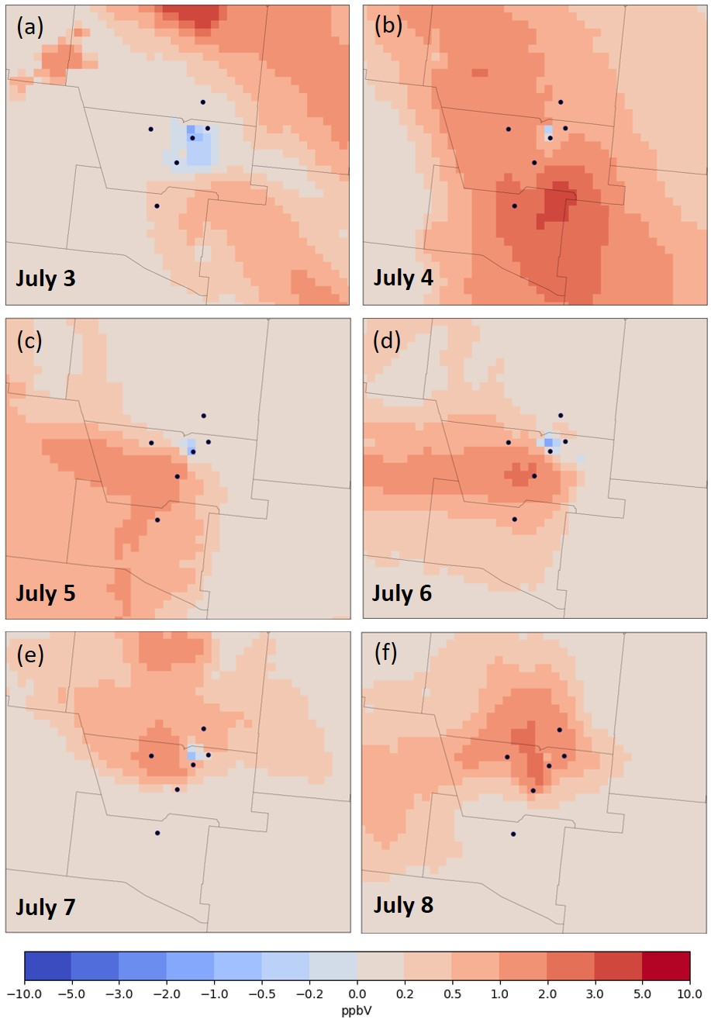
Figure S-9. Differences between modeled peak 8-hr ozone concentrations in the 2025 peak-demand EGUs sensitivity modeling and the 2025 future-year simulation for six days in the July ozone episode: (a) July 3; (b) July 4; (c) July 5; (d) July 6; (e) July 7; (f) July 8. Black circles represent ozone monitoring sites in Albuquerque/Bernalillo County and neighboring counties.
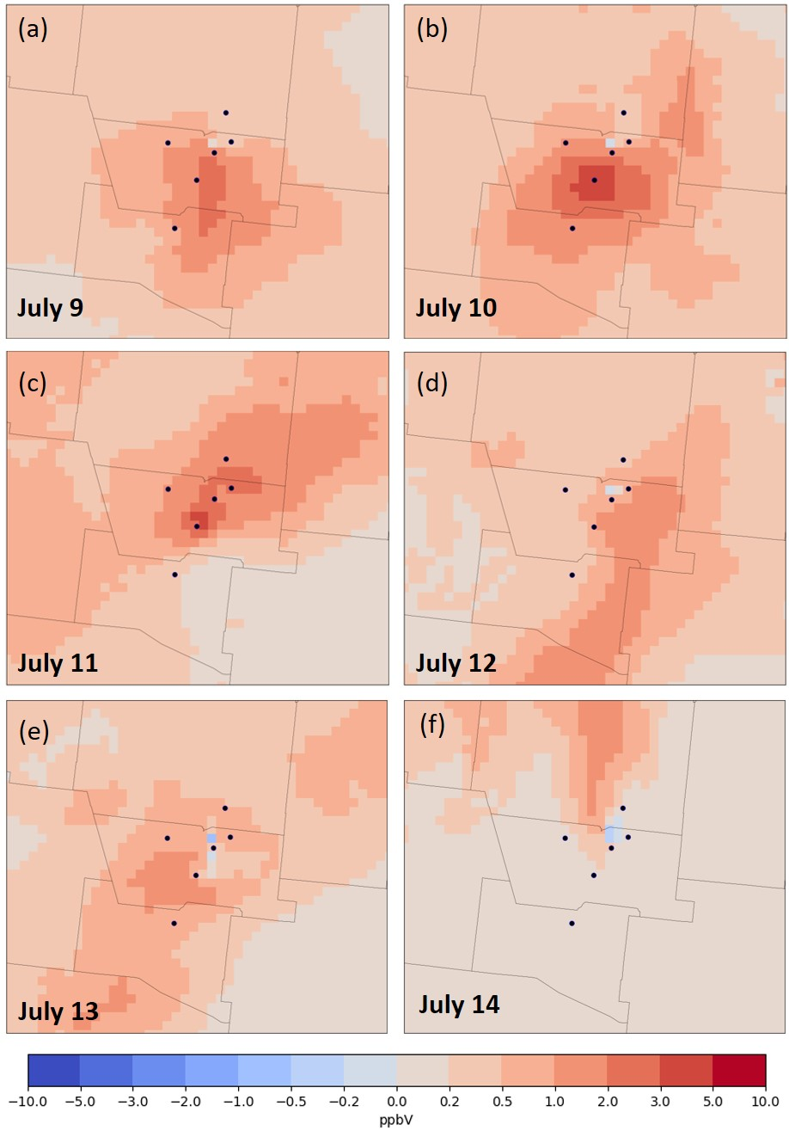
Figure S-10. Differences between modeled peak 8-hr ozone concentrations in the 2025 peak-demand EGUs sensitivity modeling and the 2025 future-year simulation for six days in the July ozone episode: (a) July 9; (b) July 10; (c) July 11; (d) July 12; (e) July 13; (f) July 14. Black circles represent ozone monitoring sites in Albuquerque/Bernalillo County and neighboring counties.
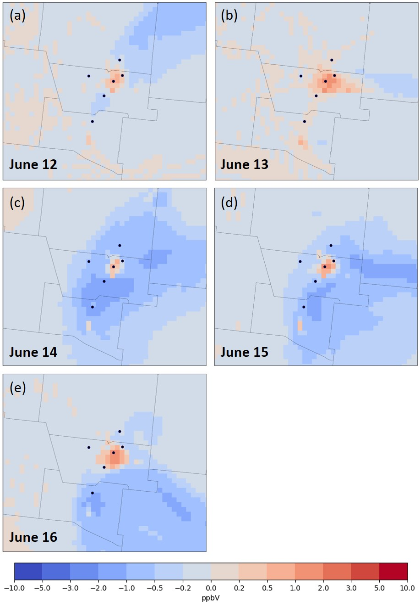
Figure S-11. Differences between modeled peak 8-hr ozone concentrations in the 2025 emission reduction in Albuquerque/Bernalillo County and neighboring counties sensitivity modeling and the 2025 future-year simulation for all days in the June ozone episode: (a) June 12; (b) June 13; (c) June 14; (d) June 15; (e) June 16. Black circles represent ozone monitoring sites in Albuquerque/Bernalillo County and neighboring counties.
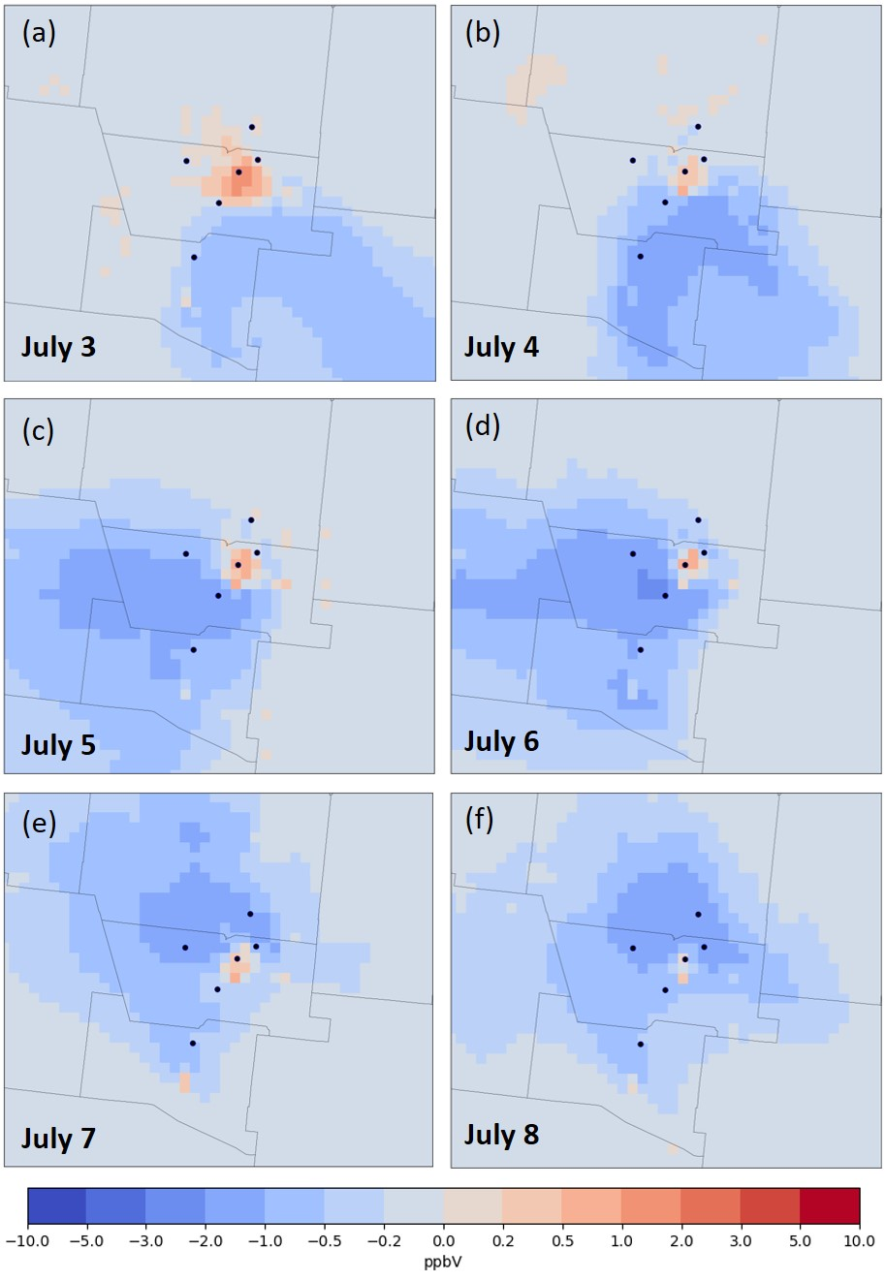
Figure S-12. Differences between modeled peak 8-hr ozone concentrations in the 2025 emission reduction in Albuquerque/Bernalillo County and neighboring counties sensitivity modeling and the 2025 future-year simulation for six days in the July ozone episode: (a) July 3; (b) July 4; (c) July 5; (d) July 6; (e) July 7; (f) July 8. Black circles represent ozone monitoring sites in Albuquerque/Bernalillo County and neighboring counties.
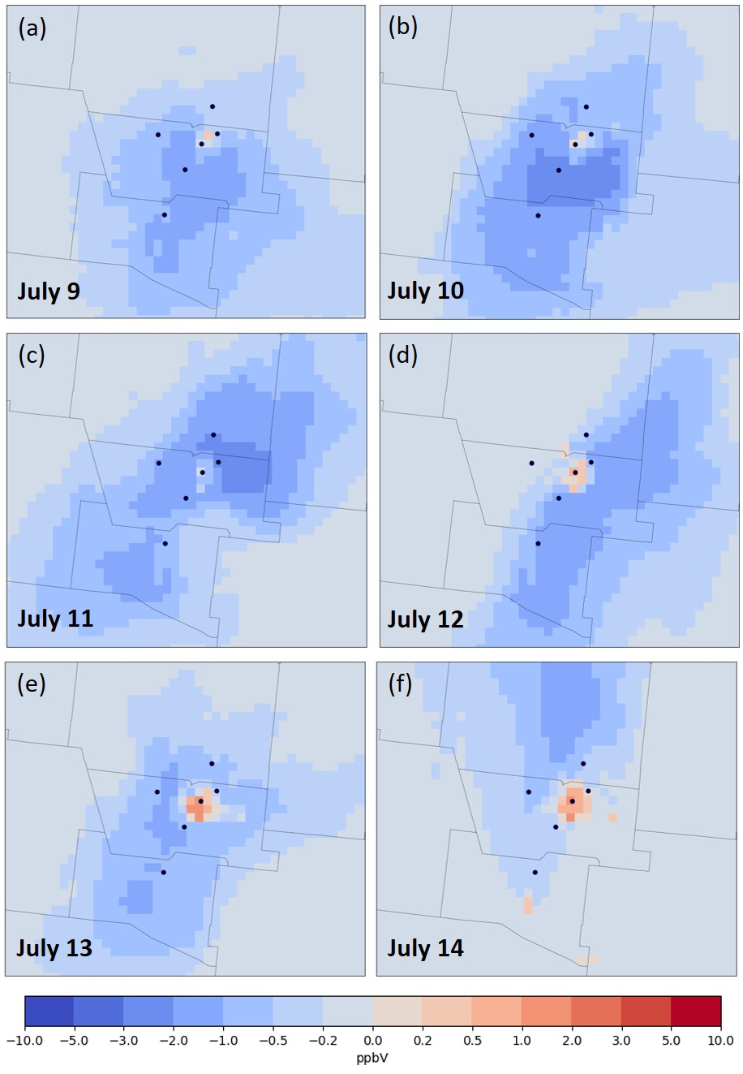
Figure S-13. Differences between modeled peak 8-hr ozone concentrations in the 2025 emission reduction in Albuquerque/Bernalillo County and neighboring counties sensitivity modeling and the 2025 future-year simulation for six days in the July ozone episode: (a) July 9; (b) July 10; (c) July 11; (d) July 12; (e) July 13; (f) July 14. Black circles represent ozone monitoring sites in Albuquerque/Bernalillo County and neighboring counties.
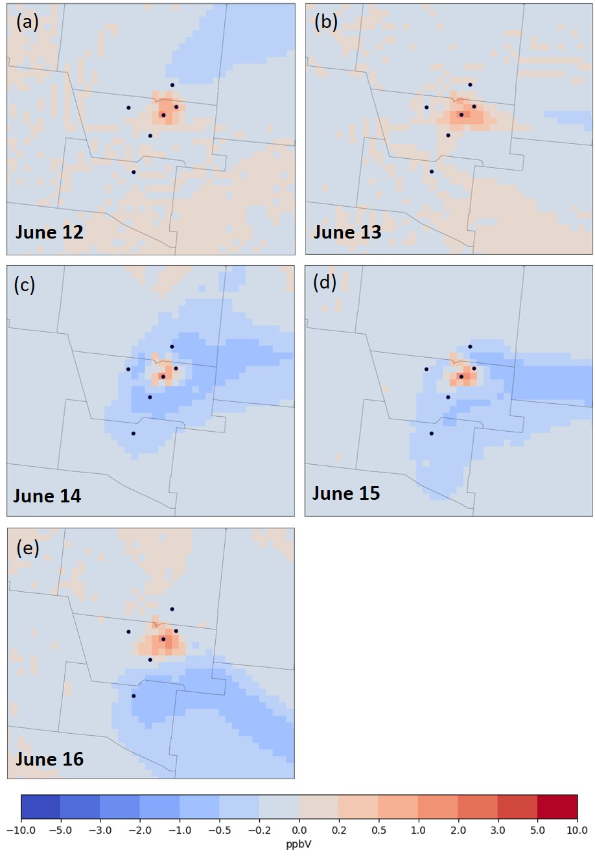
Figure S-14. Differences between modeled peak 8-hr ozone concentrations in the 2025 electrification of the light-duty gasoline vehicle fleet sensitivity modeling and the 2025 future-year simulation for all days in the June ozone episode: (a) June 12; (b) June 13; (c) June 14; (d) June 15; (e) June 16. Black circles represent the Albuquerque MSA monitoring sites.
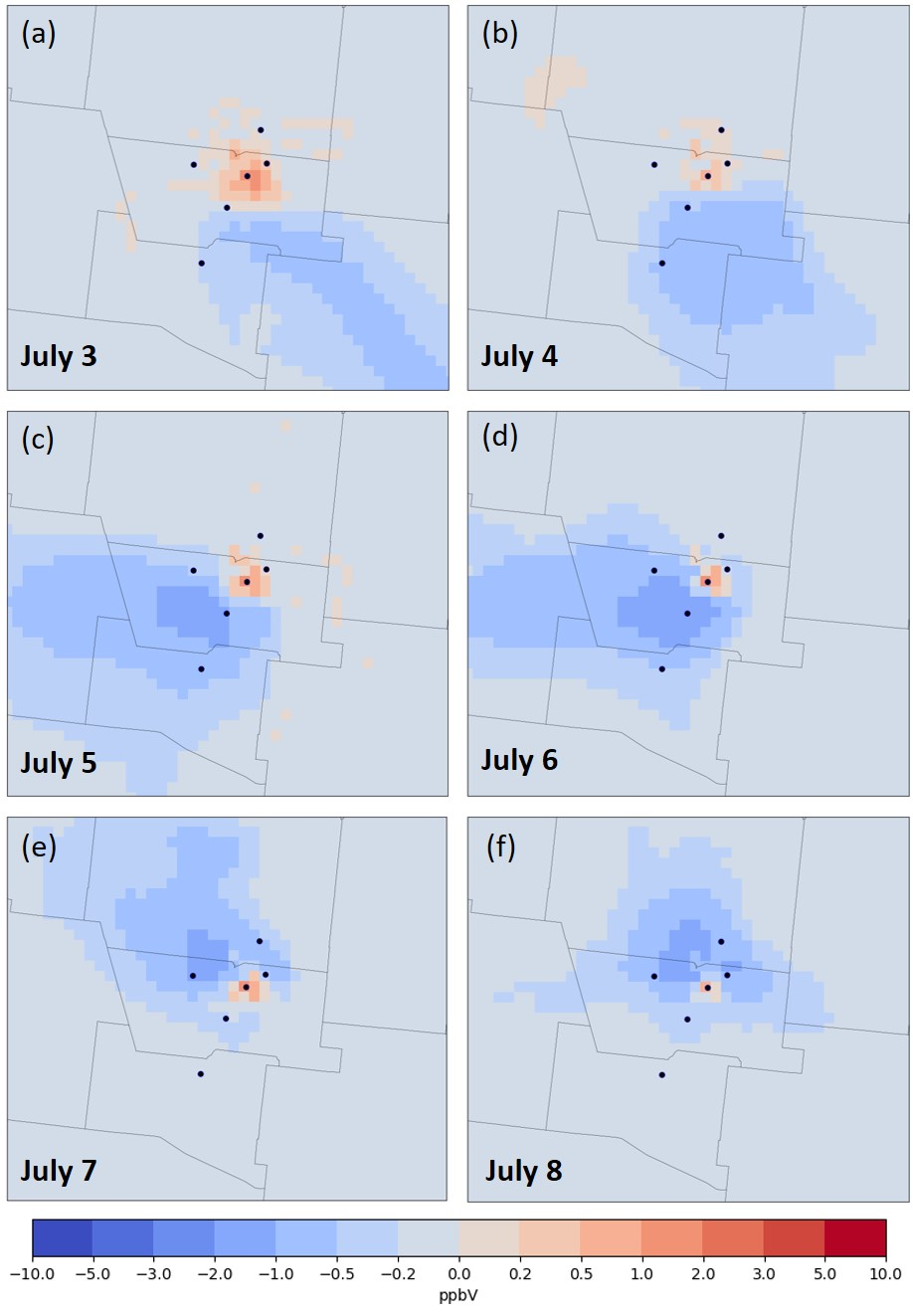
Figure S-15. Differences between modeled peak 8-hr ozone concentrations in the 2025 electrification of the light-duty gasoline vehicle fleet sensitivity modeling and the 2025 future-year simulation for six days in the July ozone episode: (a) July 3; (b) July 4; (c) July 5; (d) July 6; (e) July 7; (f) July 8. Black circles represent the Albuquerque MSA monitoring sites.
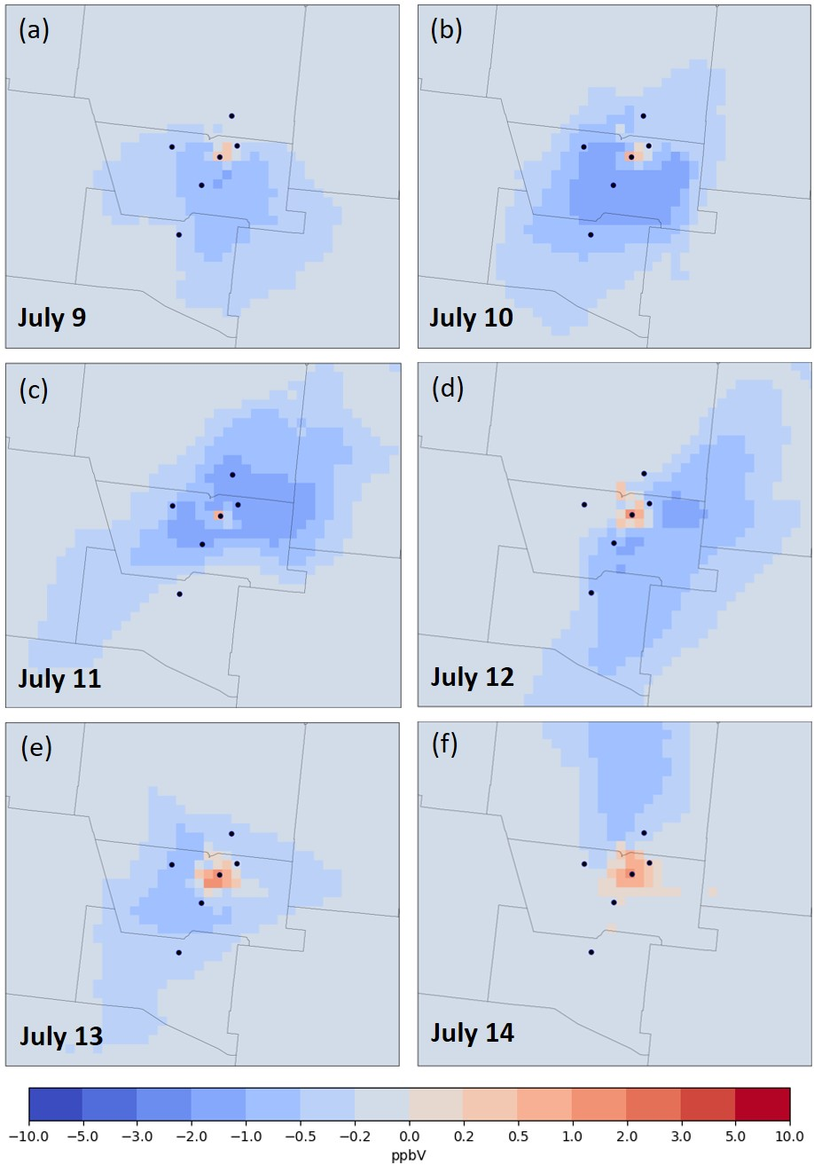
Figure S-16. Differences between modeled peak 8-hr ozone concentrations in the 2025 electrification of the light-duty gasoline vehicle fleet sensitivity modeling and the 2025 future-year simulation for six days in the July ozone episode: (a) July 9; (b) July 10; (c) July 11; (d) July 12; (e) July 13; (f) July 14. Black circles represent the Albuquerque MSA monitoring sites.

