Appendix A – supplementary results
Here we describe the results of the supplementary analysis in which we tested whether excluding the participants with a large difference between their baseline and follow-up mGES score had a substantial effect on the construct validity and reliability of the mGES as determined with the analysis described in the main manuscript. In this supplementary analysis, we included these 10 participants after we inverted their follow-up mGES scores
From Table A1 it can be seen that none of the participants, who had a large difference in mGES score, showed a large difference in FES score, from baseline to follow-up. Furthermore, FES-I scores were relatively high. Therefore, we assumed that the mGES score at follow-up was incorrect and we inverted the scores of these 10 participants in this supplementary analysis.
Including these 10 additional participants had no major effects on the participant characteristics, which can be observed in Table A2. However, it may be relevant to note that nine out of the ten participants whose mGES scores differed by more than 40 points filled out the follow-up questionnaire via internet instead of on paper.

Table A1. GES and FES scores. GES and FES-I scores of the participants whose GES scores differed more than 40 points between baseline and follow-up.
Participant | Baseline mGES | Follow-up mGES | Baseline FES-I | Follow-up FES-I
1 | 84 | 14 | 23 | 22
2 | 97 | 12 | 18 | 17
3 | 83 | 13 | 22 | 18
4 | 93 | 11 | 16 | 16
5 | 97 | 13 | 19 | 18
6 | 100 | 10 | 16 | 16
7 | 100 | 10 | 17 | 17
8 | 96 | 10 | 17 | 18
9 | 85 | 14 | 22 | 17
10 | 84 | 17 | 20 | 20

Table A2. Participant characteristics. All values are means (standard deviation (SD)) unless otherwise noted. Fall history is the number of participants that reported to have fallen at least twice in the 12 months prior to the baseline assessment. Percentages at ceiling (mGES) and floor (FES-I) are given, there were no participants at floor (mGES) or ceiling (FES-I).
 |  | N = 234
 | General
 | Age (years), median [IQR] | 69.9 [67.7 – 74.5]
 | Female, N (%) | 161 (68.8)
 | GDS, median [IQR] | 1 [0 – 2]
 | Height (cm) | 169.22 (8.36)
 | Weight (cm) | 73.96 (13.11)
 | Fall history, N (%) | 58 (24.8)
 | Education level, N (%)
 | Higher forms of education | 186 (79.5)
 | Lower and general intermediate vocational education | 41 (17.5)
 | Elementary education | 6 (2.6)
 | Did not answer | 1 (0.4)
 | Baseline
 | mGES, median [IQR] | 92 [83 – 98]
 | mGES at ceiling, N (%) | 46 (19.7)
 | FES-I, median [IQR] | 19 [17 – 22]
 | FES-I at ceiling, N (%) | 40 (17.1)
 | Follow-up
 | mGES, median [IQR] | 95 [84 – 99]
 | mGES at ceiling, N (%) | 49 (21.0)
 | Electronic questionnaire, N (%) | 98 (41.9)

Construct validity
Construct validity did not differ substantially. As can be seen from Figure A1, the correlation between the mGES and the FES-I remained excellent.
Figure A1. Scatter plot of the mGES and FES-I. The size of the dots represents the number of participants (n).

Internal consistency and test re-test reliability
Internal consistency did also not change when we added the additional participants and remained equal at α = 0.945. Test re-test reliability decreased, though in no way substantially. The ICC remained excellent (ICC(2,1) = 0.887, 95% CI = [0.855 – 0.912]), the SEM was 4.9 and the lower and upper LoA were -14.36 and 11.93, respectively. FigureA2 shows the Bland-Altman plot of the mGES scores. Differences between assessments still seem to be equally present for people with high and low mGES scores.
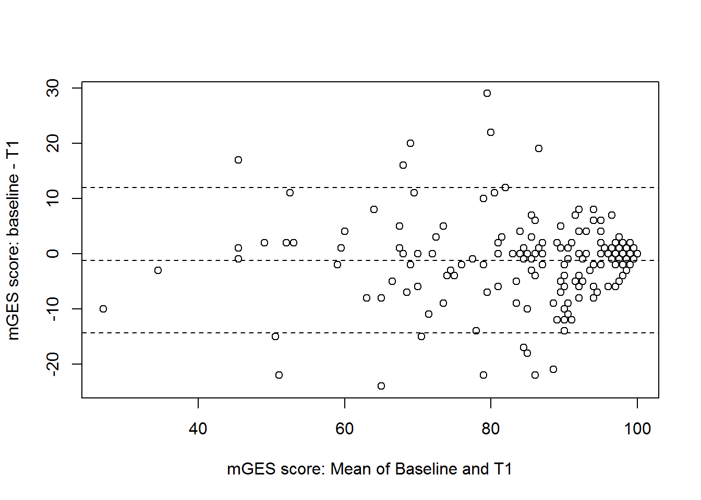
Figure A2. Bland-Altman plot showing the difference between baseline and follow-up mGES scores as a function of the mean of baseline and follow-up scores. The centre dotted line represents the mean difference in mGES score between the two assessments. The outer dotted lines represent the upper and lower LoA.

