Supplementary Information: Tarleton and Lamb. Modification of plant communities by bison in Riding Mountain National Park

Sampling Plot Layout
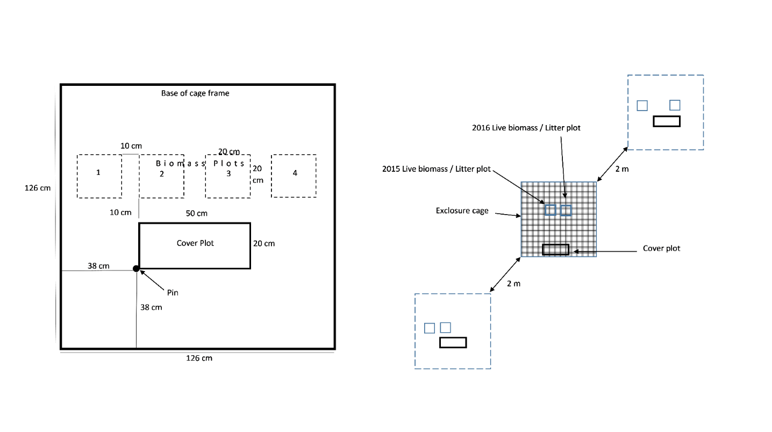
Figure S1. Configuration of range exclosure experiment plots. Two control (uncaged) plots with identical layouts were situated 2m distance from the central caged plot.

Initial SEM model
The initial SEM model (Figure S2) included a path from Historic Bison to Browsing to account for the effects of the pre-experimental fence configuration on the behaviour and movement of the major browsers (cervids). A path from Historic Bison to Bison density accounted for effects of the previous fence configuration on bison distribution during the experiment, such as avoidance of the new portion of their range due to philopatry. The path from Current Bison to Bison Density was included because bison did not have access to the control plots. Therefore, the bison density in these plots would automatically be zero, regardless of other variables. The potential effect that the current configuration of the fence and bison occupancy could have on the browsing behaviour of wild cervids accounted for with path from Current Bison to Browsing.
A path from Ecotone Distance to Browsing was included to account for variation in the browsing behavior of cervids with the distance from the cover of the forest canopy. A path from ecotone distance to height was incorporated into the model on the assumption that the height of shrubs and saplings would change in response to differences in competition and the availability of resources within and outside the forest canopy. As well, species associated with forest communities grow to different heights than those associated with grassland communities, as they are adapted to different conditions. A path from Ecotone Distance and Bison Density was included in the model to reflect the habitat preferences of bison. The path from Ecotone Distance and woody stem density was included as a directional path in the model. As with Height, this path reflected both the separate environmental conditions inside and outside the forest canopy as well as the different species composition. The path from Ecotone Distance and Change in Density was included to account for any difference growth or decline of shrub and sapling populations along the ecotone, for example due to forest encroachment into the grassland. The path from Ecotone Distance to Canopy accounts for the fact that where the forest canopy is present (negative ecotone distance), the abundance of aerial woody tissue (Canopy) will, by definition, be higher.
To account for the potential for shrubs and saplings to reach a browse escape height, and preferred foraging heights for browsing cervids, a path from Height and Browsing was included. A path from Height to Bison density was included under the assumption that shrub height would have an effect on bison behaviour. A path from Height to Change in Density was included to account for the effect of plant height on mortality and recruitment. A path from Height to Canopy was included as plant height contributes to overall plant size and thereby the amount of light blocked. A non-directional path between Height and Density was included to account for the correlation between the height and density of shrub stems.
A path from Density to Browsing was included as the density of stems might influence the selection of those stems for browsing. A path from Density to Bison Density was included under the assumption stem density influences bison behaviour by impeding their movement or otherwise influencing the suitability of habitat. A path from Density to Change in Density was included, as stem density is expected to influence the ongoing recruitment and mortality of stems in a plot. A path from Density to Canopy was included, as the overall number of stems in a plot will directly affect the total abundance of woody tissue in that plot and how much light it blocks.
A path from Canopy to Bison Density was included, as the overall abundance of woody tissue could influence the distribution of bison by impeding their movement or influencing the overall suitability of habitat. A path from Canopy to Browsing was included as the overall abundance of woody tissue in a plot would influence the probability that the terminal buds were browsed by cervids. A path from Canopy to Change in Density was included under the assumption that the availability of light would influence mortality and recruitment of individual stems.
A path from Bison Density to Browsing was included to account for how bison would influence the distribution of browsing cervids, for example by creating pathways facilitating their movement through dense cover. To account for how bison directly influence the mortality or recruitment of woody plants, for example by trampling and uprooting individual stems, a path from Bison Density to Change in Density was included. Finally, a path from Browsing to Change in Density was included, as browsing may either directly cause stem death or trigger a compensatory response and suckering.

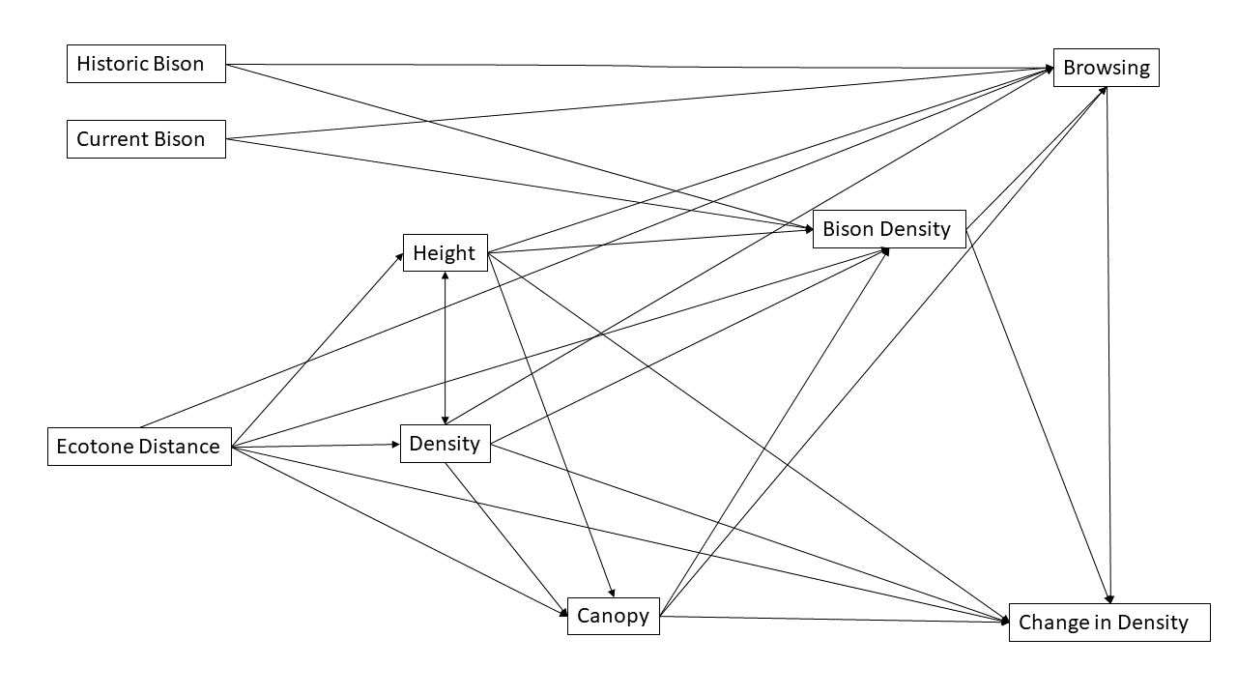
Figure S2. The initial structural equation model of the relationship between bison and the shrub community in the Lake Audy bison enclosure. Variables in boxes are linked by pathways that reflect causal relationships described above.

Table S1. Unstandardized path coefficients, standard error of path coefficients, tests of path significance for a structural equation model of the shrub and sapling community in the Lake Audy bison enclosure and its relationship with bison.

Path | Unstand. coefficient | Std Error | z-value | p | Stand. coefficient
Bison Density ~
Current Bison | 3.661 | 1.135 | 3.227 | 0.001 | 0.376
Historic Bison | -1.126 | 1.157 | -0.974 | 0.330 | -0.113
Ecotone Distance | 0.372 | 0.280 | 1.329 | 0.184 | 0.176
Plant Height | -0.413 | 0.191 | -2.161 | 0.031 | -0.269
Density | -0.068 | 0.052 | -1.295 | 0.195 | -0.178
Canopy | 2.020 | 3.293 | 0.613 | 0.540 | 0.108
Height ~
Ecotone Distance | -0.529 | 0.152 | -3.488 | <0.001 | -0.385
Density ~
Ecotone Distance | -0.803 | 0.655 | -1.225 | 0.220 | -0.145
Canopy ~
Ecotone Distance | -0.045 | 0.009 | -5.246 | <0.001 | -0.399
Density | 0.010 | 0.001 | 6.501 | <0.001 | 0.477
Plant Height | 0.021 | 0.006 | 3.231 | 0.001 | 0.254
Browsing ~
Ecotone Distance | 0.001 | 0.008 | 0.128 | 0.898 | 0.018
Canopy | -0.100 | 0.099 | -1.016 | 0.310 | -0.190
Density | -0.001 | 0.002 | -0.816 | 0.414 | -0.120
Plant Height | -0.005 | 0.006 | -0.855 | 0.392 | -0.116
Bison Density | -0.002 | 0.004 | -0.544 | 0.587 | -0.069
Current Bison | 0.035 | 0.036 | 0.952 | 0.341 | 0.126
Historic Bison | 0.039 | 0.035 | 1.127 | 0.260 | 0.140
Change in Density ~
Bison Density | 0.124 | 0.175 | 0.710 | 0.477 | 0.082
Ecotone Distance | 0.031 | 0.444 | 0.071 | 0.944 | 0.010
Canopy | -6.220 | 5.231 | -1.189 | 0.234 | -0.221
Density | -0.149 | 0.083 | -1.783 | 0.075 | -0.258
Plant Height | 0.913 | 0.310 | 2.944 | 0.003 | 0.394
Browsing | -2.730 | 6.109 | -0.447 | 0.655 | -0.051
Plant Height ~~
Density | 8.874 | 4.201 | 2.112 | 0.035 | 0.261

Relationships Between Poa pratensis abundance and bison use frequency
Table S2. ANCOVA model results testing the impacts of bison abundance (collar counts near plots) and pasture (North vs. South) on Poa pratensis abundance and change in abundance.
Model term | Poa abundance | Poa abundance change
Bison abundance | F= 6.738, p=0.012 | F= 0.233, p=0.633
Pasture | F= 5.314, p=0.025 | F= 0.507, p=0.483
Bison abundance x pasture | F= 0.790, p=0.378 | F= 1.445, p=0.241

